Appendix A: Learning Activity and Activity Sheet
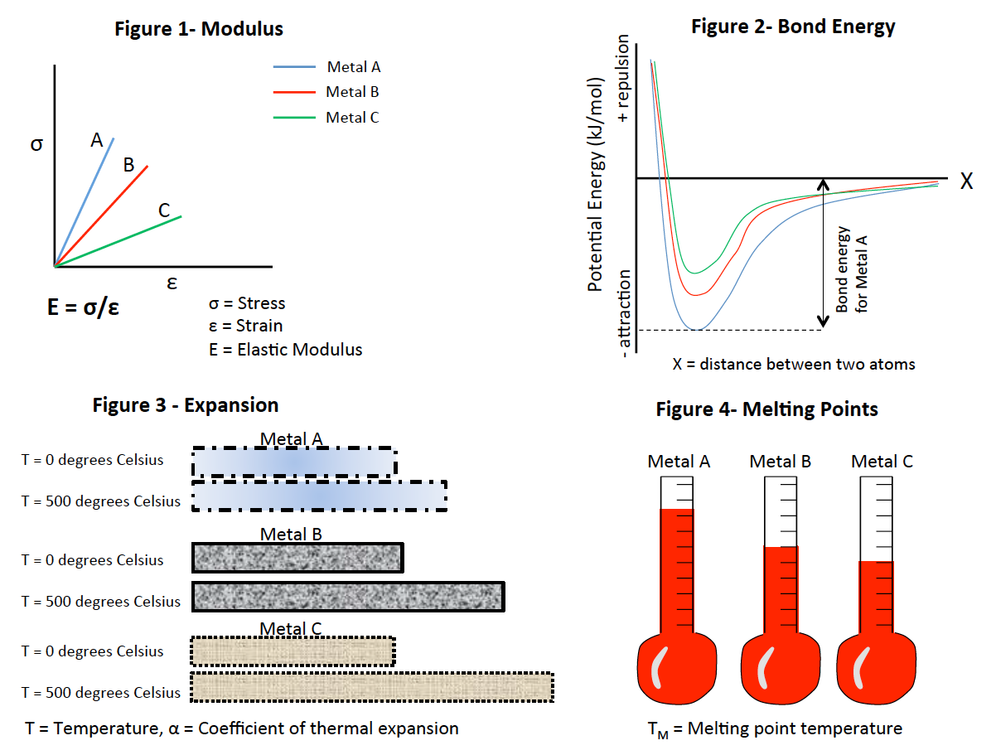

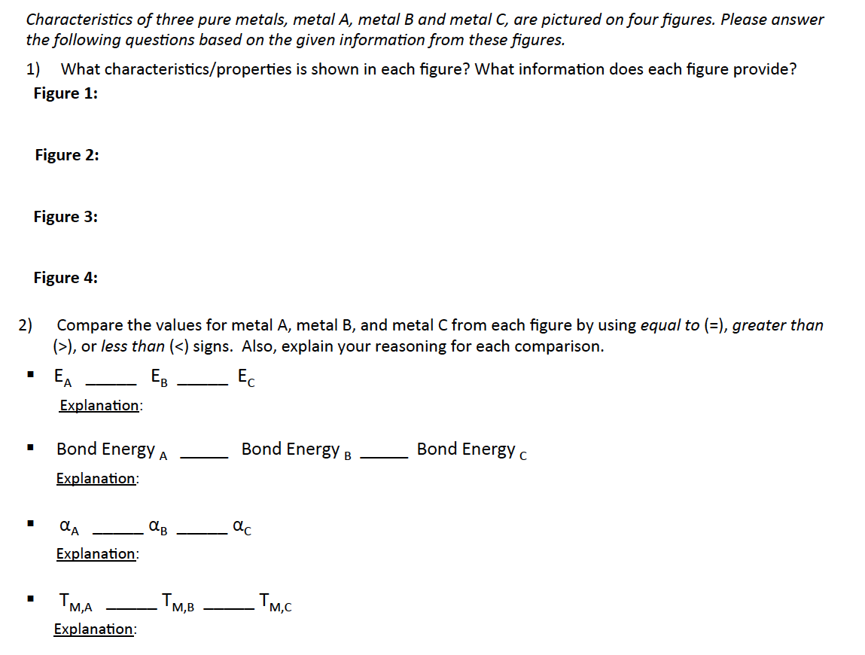

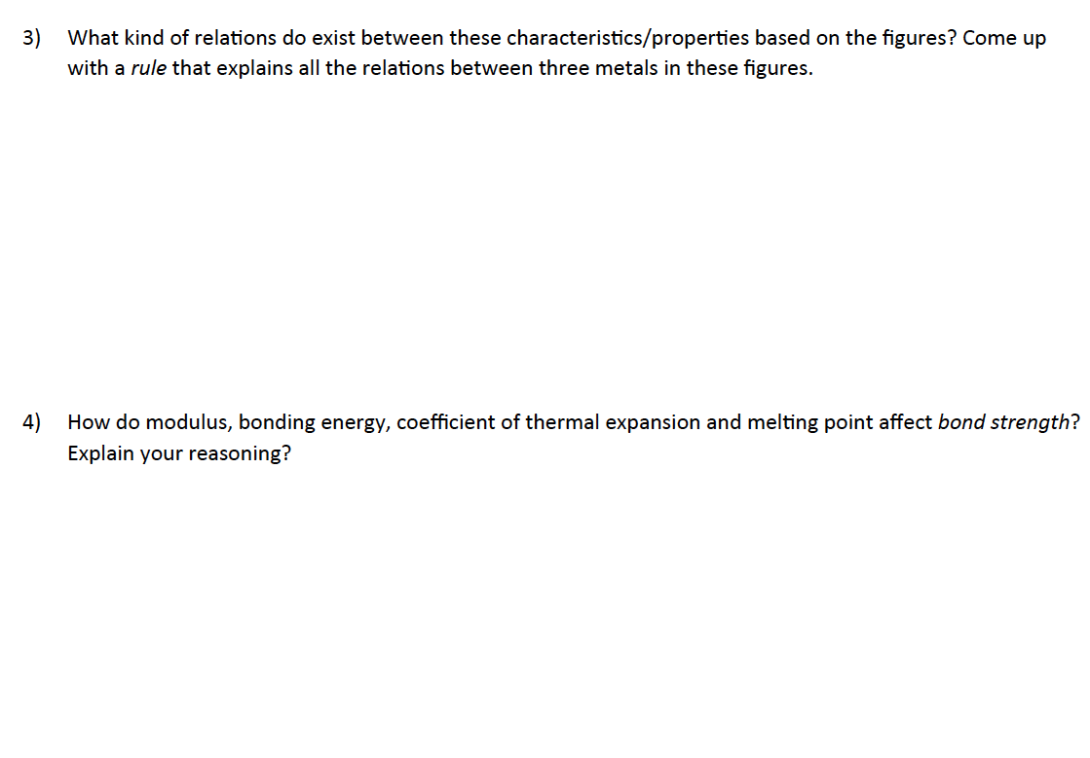

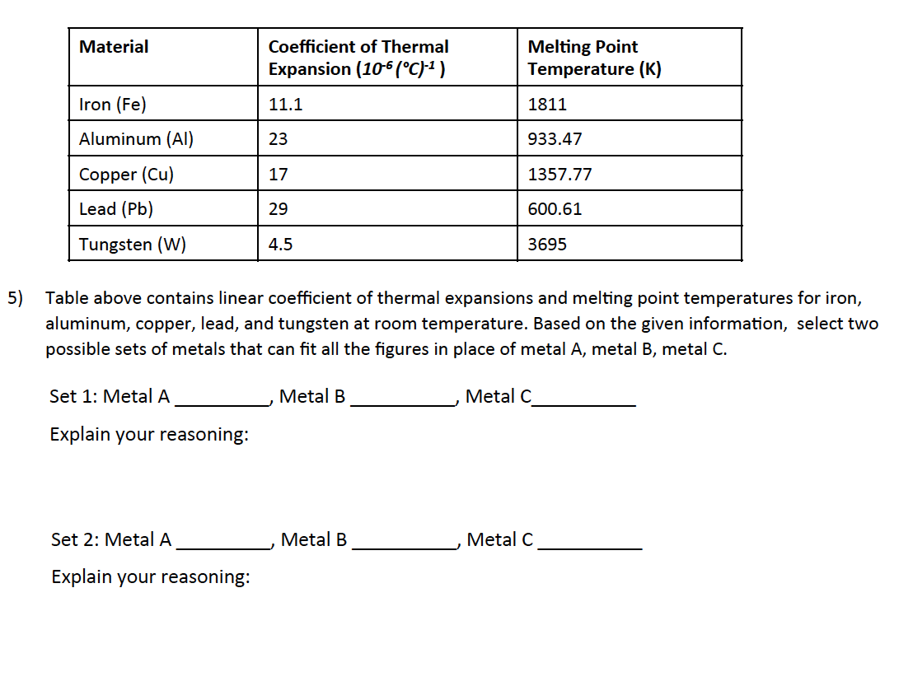
APPENDIX B
The following examples illustrate how interactional quality scores were assigned. Each number represents a new turn by one of the partners. The first example is an episode with a Score of 1, second example is an episode with a score of 2, and third example is an episode with a score of 3.
1) Exemplary episode with interactional quality score of 1:
- Student A1: Have you seen this first graph before?
- Student A2: No.
- Student A1: I learned this in my material class before; strain and stress. It shows the relationship between these two.
- Student A2: So, E is the energy?
- Student A1: E is the elastic modulus.
- Student A2: Oh elastic modulus.
- Student A1: It is elastic modulus and it was elastic modulus in the pre-test.
- Student A2: Yeah.
- Student A1: But that number is just the relationship. It shows the relationship between these two. And so it is the slope. A has the higher elastic modulus because it has a greater slope.
- Student A2: Yeah, relationship.
- Student A1: Does that make sense?
- Student A2: Yeah.
- Student A1: So, It is a really easy graph if you know what it is looking for.
- Student A2: Yeah. It was in the pre-test. I do not know what…
- Student A1: Yeah, you do not know but it is really easy.
- Student A2: Ok…
- Student A1: So the characteristics in figure 1. It shows the relationship between stress and strain.
- Student A2: What information does each figure provide? Figure 1 [Reading the question 1 from worksheet].
- Student A1: It is this one.
- Student A2: Figure 1 is this one. The relationship between strain and stress, which is elastic modulus.
- Student A1: Modulus, yeah. What characteristics…
- Student A2: The relationship between strain and stress.
- Student A1: yeah. [Starts writing] What information does each figure provide? This provides that A has the highest elastic modulus. Elastic modulus of A is greater than B which is greater than C.
- Student A2: Okay…

The episode above is representative of a unit scored with the lowest interaction score. In this episode, student A1 is initiating all the ideas and student A2 is simply accepting the initiated ideas without discussing and expanding. Also, student A2 is asking only one question which is a yes/no type question that does not add anything new to discussion.

2) Exemplary episode with an interactional quality score of 2:
- Student B2: [Reading question 4] How do modulus, bond energy, coefficient of thermal expansion again modulus… I do not know. Ohh...uhmmm… A greater modulus probably means the greater bond strength, right?
- Student B1: Yeah
- Student B2: Okay so, bonding energy lower that’s so except for coefficient of thermal expansion. The greater modulus, greater bonding energy and a greater melting point all relate to higher bond strength.
- Student B1: Okay so, a greater modulus has greater bond energy and…
- Student B2: uhhmmm will result in a higher melting point.
- Student B1: Yeah…well yeah… will result in a higher melting point
- Student B2: And this all relates to a higher bond strength, greater bond strength
- Student B1: What? Okay… All characteristics…
- Student B2: All relates to…
- Student B1: Relates to…
- Student B2: Higher bond energy bond strength
- Student B1: All relates to higher bond energy, uhmmm…
- Student B2: But the coefficient of thermal expansion…
- Student B1: It has an inverse relationship so that’s negative
- Student B2: Yeah.
- Student B1: As bond energy increases it decreases.
- Student B2: Explain your reasoning.
- Student B1: Yeah.
- Student B2: Yeah.
- Student B1: Coefficient of thermal expansion decreases as the modulus…
- Student B2: As the bond energy increases.
- Student B1: As the bond … yeah…
- Student B2: Related to bond strength.
- Student B1: Yeah, as the bond strength increases.
- Student B2: So, as the bond strength increases. So, Here it can be reasoning it will probably mean that greater bond strength means more amount of temperature is required to break it
- Student B1: Okay…
- Student B2: And uhh... I do not know how to relate it modulus again I was not sure. It just means the thing is more elastic, I think.
- Student B1: Which one? This one?
- Student B2: No, relation between bond strength and elastic modulus.
- Student B1: Oh yeah.
- Student B2: Is that like that makes it more elastic? Because that would make sense if greater bond strength means
- Student B1: Haha…
- Student B2: Metal is more elastic
- Student B1: Okay.
- Student B2: Okay. The reasoning will be greater bond strength means that metal will be more elastic.
- Student B1: Yeah. That’s good.
- Student B2: And more temperature is required to break the bonds so a higher melting point.
- Student B1: Cool.
- Student B2: Did you write for this one? [Showing figure 3]
- Student B1: Ohh... I did
- Student B2: No like. Did you give any explanation for that?
- Student B1: Okay, okay uhmmm… so, it expands because the bond
- Student B2: Weaker the bond, more expansion
- Student B1: Weaker the bond more expansion yeah. The weaker the bonds have higher expansion. Thermal expansion.

The second example above is a representative episode which was scored with the score 2. In this episode, similar to the first example, one of the students, student B2, is initially proposing most of the ideas. Even though student B1 is not expanding or opposing most of student B2’s statements, she/he is not simply accepting the proposed ideas with comments like “yes” and/or “I agree”, but restating and repeating B2’s proposed ideas. So, B1 is acting actively in terms of the ICAP framework rather than passively voicing agreement with B2. Also, student B1 is adding critical information at comment lines #14, #16, #24, and #42.

3) Exemplary episode with an interactional quality score of 3:
- Student C2: [Reading Question 4] how do modulus, bonding energy, coefficient of thermal expansion and melting point affect bond strength? Explain your reasoning?
- Student C2: It is just intuitively, metal A is the strongest because it does not deform as much when you apply the same strain to it and it takes a lot more ripped part of a bond, I guess.
- Student C1: And its melting point, more energy is required to melt.
- Student C2: Make it destabilize, yeah.
- Student C1: So,
- Student C2: And when you heat it, it does not change its shape as easily as metal C.
- Student C1: So, how do we handle bond… metal A would be strongest per se. All four contributing the bond strength…
- Student C2: How about elastic modulus, bond energy and melting point all increase bond strength while high coefficient of thermal expansion decreases bond strength?
- Student C1: How this decreases bond strength? [Showing figure 3]
- Student C2: I am not sure it decreases it directly; I just notice it is the opposite of these three.
- Student C1: So, I guess thermal expansion does not contribute to the other three.
- Student C2: Possibly, I am remembering that the thing we read mentions that thermal expansion means the molecules are getting further apart, like I guess that would also means it is easier to tear down apart because there is like metallic attraction
- Student C1: Ok, so, these three would help, but this not…
- Student C2: You want these to be high and this to be low to maximize bond strength
- Student C1: Yes.
- Student C2: Alright [Writing on the worksheet]. And then for explaining that…
- Student C1: Less stress, more is energy is required, uhmm, more… more energy is required for this…
- Student C2: Take more energy for any change happens, whereas this means less energy is needed for change.
- Student C1: Yes.
- Student C2: Okay [Writing on the worksheet].
In the third example above, both students propose fairly equal amounts of substantive statements and responses and each student builds upon those of the other. For example, as student C2 initiates the statement “Metal A is the strongest because it does not deform as much when you apply the same strain to it and it takes a lot more ripped part of a bond, I guess”, student C1 is expanding this statement by adding “And its melting point, more energy is required to melt.” Also, both students are asking information seeking questions by referring to each other’s comments like “How this decreases bond strength?” Note that while the interactional quality score for each segment indicates the degree of shared line of reasoning between dyads, these scores are not exclusively dependent on the number of turns. In other words, although the number of turns between dyads is correlated with the interactional quality score, these scores were not assigned by counting the frequency of turns.

