SUPPORTING INFORMATION
Patterns of phylogenetic community structure of sand dune plant communities in the Yucatan Peninsula: the role of deterministic and stochastic processes in community assembly

Diego F. Angulo¹, Juan Tun-Garrido², Gerardo Arceo-Gómez³, Miguel A. Munguía-Rosas⁴ and Victor Parra-Tabla¹

¹Departamento de Ecología Tropical, Campus de Ciencias Biológicas y Agropecuarias, Universidad Autónoma de Yucatán, Mérida, Yucatán, México; ²Departamento de Botánica, Campus de Ciencias Biológicas y Agropecuarias, Universidad Autónoma de Yucatán, Mérida, Yucatán, México; ³Department of Biological Sciences, East Tennessee State University, Johnson City, TN, USA; ⁴Laboratorio de Ecología Terrestre, Centro de Investigación y de Estudios Avanzados del Instituto Politécnico Nacional, Mérida, México

Table S1. GenBank accession numbers for the plants used in the phylogenetic analysis.
Family | Species collected | Surrogate species | matK | rbcL
Acanthaceae | Bravaisia berlandierianaa (Nees) T.F.Daniel | Barleria oenotheroides Dum. Cours. (1) | JQ586383 | JQ590037
 | Dicliptera sexangularis (L.) Juss. | Justicia carthagenensis Jacq. (1) | JQ586402 | JQ590056
Agavaceae | Agave angustifolia Haw. |  | JQ586433 | JQ590092
Aizoaceae | Sesuvium portulacastrum (L.) L. |  | KC185420 | KJ773883
Amaranthaceae | Alternanthera microcephala (Moq.) Schinz | Alternanthera flavescens Kunth (1) | AM887484
 | Amaranthus dubius Mart. ex Thell. | Amaranthus spinosus L. (1) | JQ586447
 | Atriplex tampicensis Standl. | Atriplex canescens (Pursh) Nutt. (1) | JX517608 | JX572316
 | Blutaparon vermiculare (L.) Mears. |  | AY514798 | AY270067
 | Suaeda linearis (Elliott) Moq. |  | KJ773192 | KJ773937
Amaryllidaceae | Hymenocallis littoralis (Jacq.) Salisb. |  | JX464595 | JX903156
Anacardiaceae | Metopium brownei (Jacq.) Urb. |  |  | GU935434
Apocynaceae | Metastelma schlechtendalii Decne. | Cynanchum racemosum (Jacq.) Jacq. (1) | JQ586764 | JQ590529
 | Echites umbellatus Jacq. |  | EF456303
Arecaceae | Pseudophoenix sargentii H. Wendl. ex Sarg. |  |  | AJ404779
 | Thrinax radiata Lodd. ex Schult. & Schult.f. |  | AM114561 | AY012459
Asteraceae | Ambrosia hispida Pursh | Ambrosia artemisiifolia L. (2) | HQ593164 | HQ589948
 | Bidens pilosa L. |  | AY551477 | HM849815
 | Flaveria linearis Lag. |  | KJ772792 | HQ534142
 | Melanthera nivea (L.) Small. |  | AY215826 | KJ773678
 | Porophyllum punctatum (Mill.) |  | KJ525314
Boraginaceae | Tournefortia gnaphalodes (L.) R.Br. ex Roem. & Schult. | Tournefortia glabra L. (1) | JQ587135 | JQ590937
Brassicaceae | Cakile edentula (Bigelow) Hook. |  | JN584957 | HM849832
Burseraceae | Bursera simaruba (L.) Sarg. |  | JQ587167 | KJ773325
Cactaceae | Acanthocereus tetragonus (L.) Hummelinck |  | HM041645
 | Opuntia stricta (Haw.) Haw. |  | JF786853 | KJ773705
Capparaceae | Capparis flexuosa (L.) L. |  | EU371760
 | Capparis incana Kunth |  |  | JQ591019
Celastraceae | Crossopetalum rhacoma Crantz |  | KJ772685 | KJ773411
 | Maytenus phyllanthoides Benth. | Maytenus schippii Lundell (1) | GQ982041 | GQ981797
Combretaceae | Conocarpus erectus L. |  | JQ589989 | KU761908
Commelinaceae | Commelina erecta L. |  | KJ772671 | KR736605
Convolvulaceae | Ipomoea pes-caprae (L.) R. Br. |  |  | JQ812690
Euphorbiaceae | Croton punctatus Jacq. |  |  | EF405851
 | Enriquebeltrania crenatifolia (Miranda) Rzed. |  |  | AY794975
 | Euphorbia cyathophora Mur. | (= Euphorbia heterophylla L.) (1) | GU214861 | KU569187
 | Euphorbia mesembryanthemifolia Jacq. |  | HQ645757 | AY794820
Fabaceae | Caesalpinia vesicaria L. | Caesalpinia bonduc (L.) Roxb. (1) | JQ587520 | JQ591591
 | Canavalia rosea (Sw.) DC. |  | HQ707524 | AB045793
 | Centrosema virginianum (L.) Benth. |  |  | AF308706
 | Pithecellobium keyense Britton in Britton & Rose. |  | KJ773009 | KJ773753
 | Sophora tomentosa L. |  |  | AY725481
Gentianaceae | Eustoma exaltatum (L.) Salisb. | Eustoma grandiflorum (Raf.) Shinners (1) | AJ010514 | Z68825
Goodeniaceae | Scaevola plumieri (L.) Vahl |  | JQ711557 | EU841126
Lauraceae | Cassytha filiformis L. |  | GU117739 | KJ773368
Malvaceae | Gossypium hirsutum L. |  | JN201459 | M77700
 | Malvaviscus arboreus Cav. |  | AY589061 | JQ592522
 | Waltheria rotundifolia Schrank | Waltheria indica L. (1) | JQ589310 | JQ594224
Nyctaginaceae | Commicarpus scandens (L.) Standl. |  | FN868306 | FN868319
 | Okenia hypogaea Schltdl. & Cham |  | FR775279 | FR775297
Papaveraceae | Argemone mexicana L. |  | LN614543 | U86621
Passifloraceae | Passiflora foetida L. |  |  | DQ123337
Poaceae | Aristida adscensionis L. |  | AF164412
 | Cenchrus incertus M.A. Curtis |  | HM850551 | HM849872
 | Dactyloctenium aegyptium (L.) Willd |  | KF357745 | EF125106
 | Distichlis spicata (L.) E. Greene. |  | HE573968 | AY632363
 | Eustachys petraea (Sw.) Desv. |  | KJ772779
 | Fimbristylis cymosa R. Br. |  | KJ772789 | KJ773512
 | Fimbristylis spadicea (L.) Vahl |  | KJ772791 | KJ773515
 | Melinis repens (Willd.) Zizka |  | HE574080 | EF125133
 | Sporobolus virginicus (L.) Kunth |  | HE573975 | KJ773930
 | Bouteloua americana (L.) Scribn. | Bouteloua dimorpha Columbus (1) | HE575864
 | Sporobolus pyramidatuss (Lam.) Hitchc. | Sporobolus atrovirens (Kunth) Kunth (1) | JF729145
Polygonaceae | Coccoloba uvifera (L.) L. |  | EF437996 | AJ312255
Portulacaceae | Portulaca oleracea L. |  | DQ855850 | HM850279
Primulaceae | Bonellia macrocarpa (Cav.) B.Ståhl & Källersjö |  |  | KU176146
Rubiaceae | Ernodea littoralis Sw. |  |  | AJ288601
Sapotaceae | Sideroxylon americanum (Mill.) T.D.Penn. | Sideroxylon celastrinum (Kunth) T.D. Penn. (1) | KJ773145 | KJ773890
Solanaceae | Lycium carolinianum Walter |  | AB036635
Surianaceae | Suriana maritima L. |  | AY386950 | U07680
Verbenaceae | Lantana involucrata L. |  | KJ012653 | KJ082380
 | Phyla nodiflora (L.) Greene |  | FN773553 | KJ773739
Zygophyllaceae | Tribulus cistoides L. |  | GU135025 | GU135188
Gymnosperms | Ephedra aspera (3) |  | AY492010 | AF489532
 | Pinus ayacahuite (3) |  | KP128381 | AY497221
 | Pinus caribaea (3) |  | AY497280 | AY497244
 | Pinus patula (3) |  | AB080944 | AY497248

Surrogate sources classified as: (1) species distributed in the same biogeographical region (Yucatan Peninsula) as the substituted species; (2) species distributed in different biogeographical region (outside the Yucatan Peninsula), but in coastal habitats. (3) used as the outgroup.

Table S2. Regression analysis among phylogenetic diversity (MPD) and climatic variables.
Phylogenetic diversity | Climatic variables | F-stat | r² | p
 | Temperature seasonality | 4.39 | 0.23 | 0.05
MPD | Annual mean precipitation | 4.61 | 0.24 | < 0.05
 | Annual mean temperature | 1.005 | 0.06 | 0.33

Figure S1

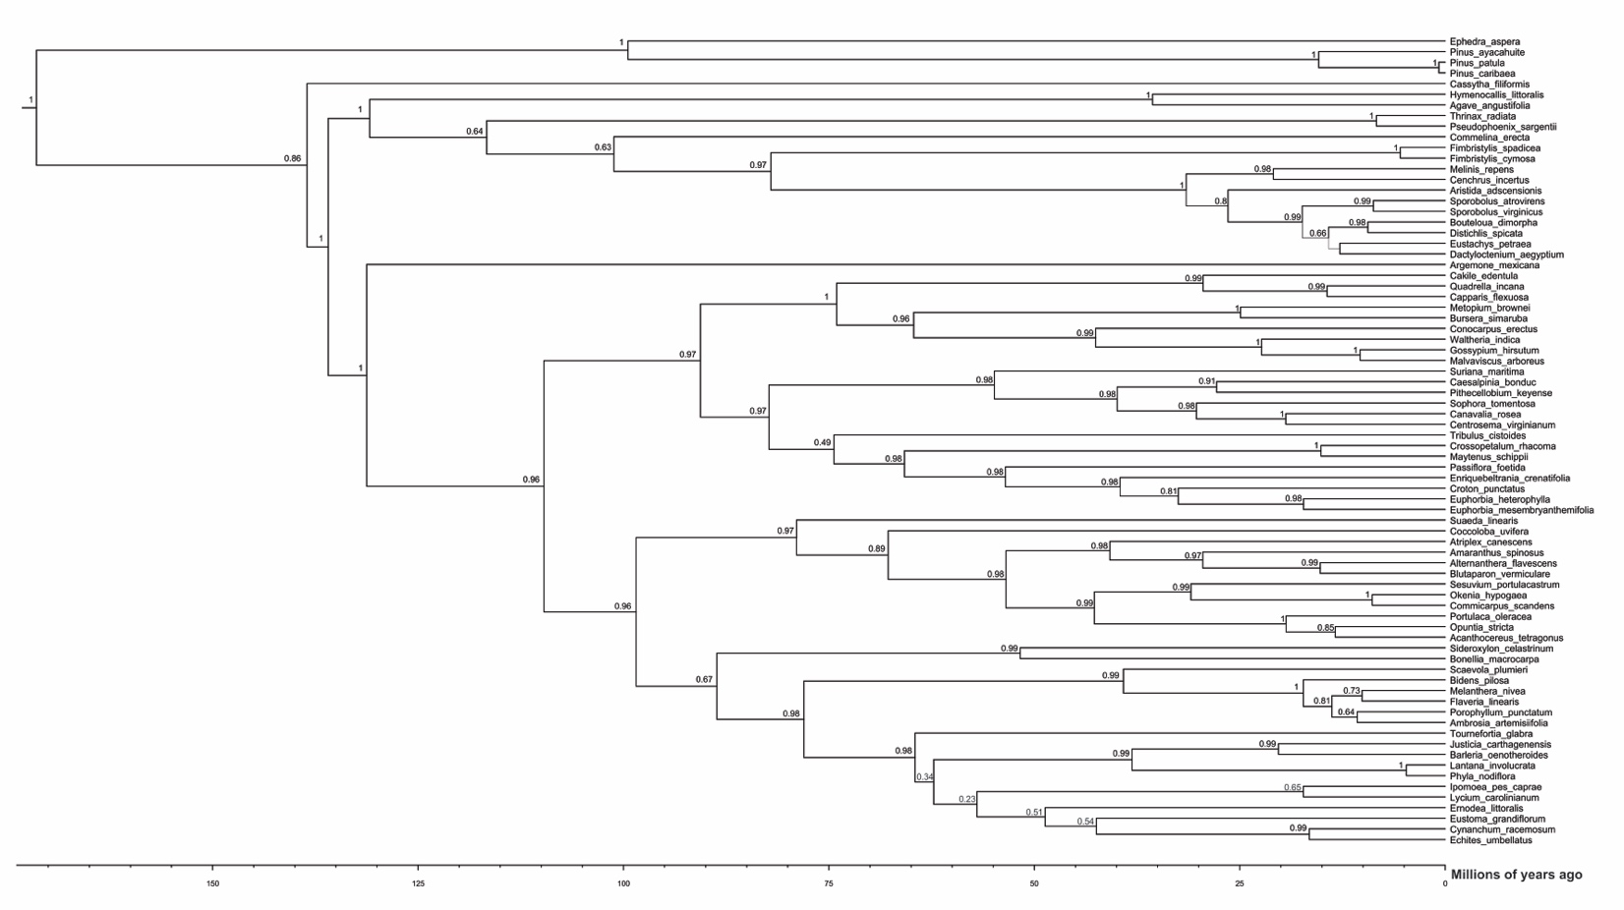

Figure S2

