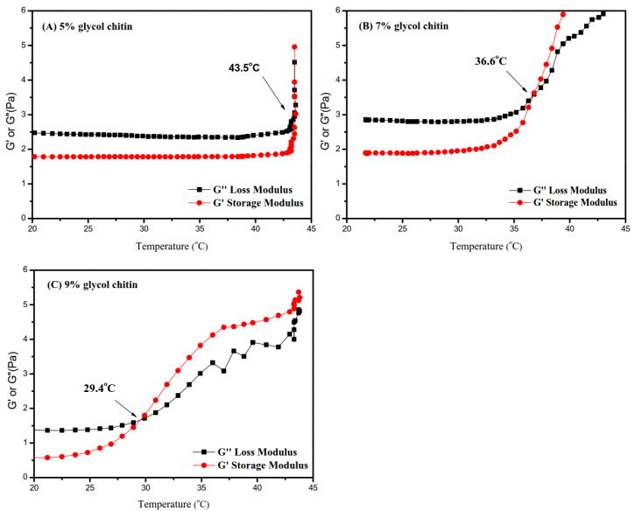

Fig.S1 Rheological behavior of glycol chitin with different concentrations: (A) 5%, (B) 7%, and (C) 9% glycol chitin.

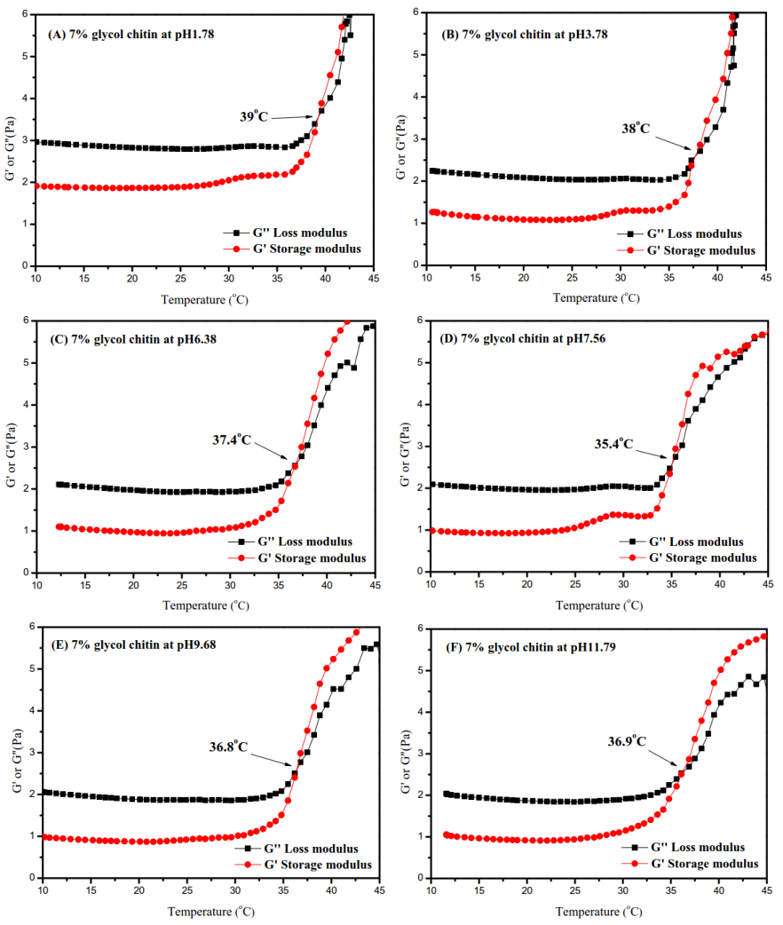
Fig. S2 Rheological behavior of 7% glycol chitin with different pH: (A) pH 1.78, (B) pH 3.78, (C) pH 6.38, (D) pH 7.56, (E) pH 9.68, and (F) pH 11.79.

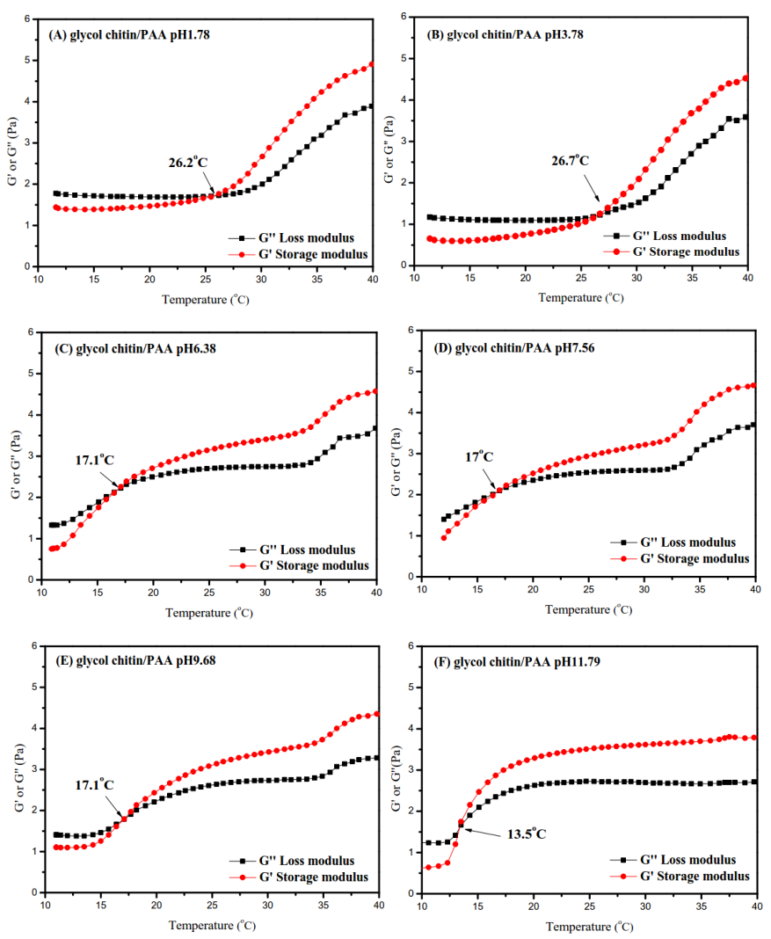
Fig. S3 Rheological behavior of glycol chitin/PAA with different pH (with fixed concentration of 7 wt% glycol chitin): (A) pH 1.78, (B) pH 3.78, (C) pH 6.38, (D) pH 7.56, (E) pH 9.68, and (F) pH 11.79.

