Appendices

Appendix 1: Survey questionnaire for Pilot Study
The following is the modified version of the Nordic questionnaire. This was used to interview the pannists from the Petrotrin Siparia Deltones during the pilot study. This questionnaire was further revised for collection of information from the working sample.

Complete the following in block letters

- Name

- Band name

- Date of birth

- How much do you weigh?

- How tall are you?

___________ _____________
First Last

_______________________________

__________________
Year month day

____kg

____cm

Circle the number that represents the most appropriate answer

- Sex

- How many years you been playing the pan professionally?

- On average, how many hours a day do you practise?

- Male
- Female

- 1–9 years
- 10–14 years
- 15–20 years
- more than 20 years

- 1–2 hours
- 3–5 hours
- more than 5 hours

SECTION 2: BODY CHART
The following chart shows an illustrated diagram of the human body divided into the following regions:

- Neck
- Shoulders
- Upper back
- Elbows
- Wrists/Hands
- Hips/Thighs
- Knees
- Ankles/Feet

This allows the user to easily distinguish and record the region(s) where pain or discomfort is being experienced.

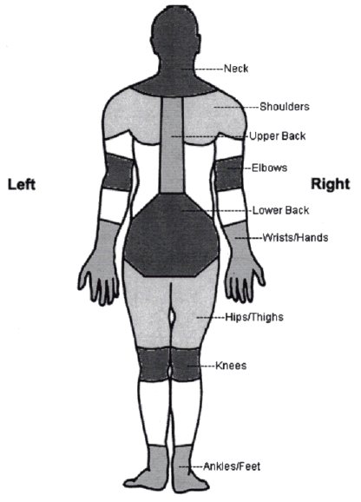
Circle the number that represents the most appropriate answer.

To be answered by everyone | To be answered only by those who have had trouble
Have you at any time during the last 12 months had trouble (ache, pain , discomfort, numbness) in | Have you at anytime during the last 12 months been prevented from doing your normal work (at home or away from home) because of the trouble? | Have you had trouble at any time during the last 7 days?
Neck  - No 2. Yes | - No 2. Yes | - No 2. Yes
Shoulders  - No 2. Yes, in the right shoulder  3. Yes, in the left shoulder  4. Yes, in both shoulders | - No 2. Yes | - No  - Yes
Elbows  - No 2. Yes, in the right elbow  3. Yes, in the left elbow  4. Yes, in both elbow | - No 2. Yes | - No  - Yes
Wrists/Hands  - No 2. Yes, in the right wrist/hand  3. Yes, in the left wrist/hand  4. Yes, in both wrist/hand | - No 2. Yes | - No  - Yes
Upper back  - No 2. Yes | - No 2. Yes | - No  - Yes
Low back (small of back)  - No 2. Yes | - No 2. Yes | - No  - Yes
One or both hips/thighs  - No 2. Yes | - No 2. Yes | - No  - Yes
One or both knees  - No 2. Yes | - No 2. Yes | - No  - Yes
One or both ankles/feet  - No 2. Yes | - No 2. Yes | - No  - Yes

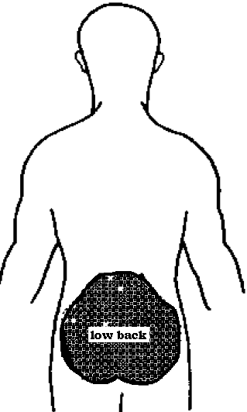

- Have you ever had lower back trouble (ache, pain or discomfort)?
- No 2. Yes
If you answer No to question 1, do not answer questions 2–8
- Have you ever been hospitalized because of lower back trouble?
- No 2. Yes
- Have you ever had to change jobs or duties because of lower back troubles?
- No 2. Yes
- What is the total length of time, that you have had lower back trouble during the last 12 months?
- 0 days
- 1–7 days
- 8–30 days
- More than 30 days but not everyday
- Everyday
If you answered 0 days for question 4, do not answer questions 5–8

- Has lower back trouble caused you to reduce your activity during the last 12 months?
- Work activity (at home or away from home)?
- No 2. Yes
- Leisure activity?
- No 2. Yes
- What is the total length of time, that lower back trouble has prevented you from doing your normal work (at home or away from home) during the last 12 months?
- 0 days
- 1–7 days
- 8–30 days
- More than 30 days
- Have you been seen by a doctor, physiotherapist, chiropractor or other such persons because of lower back trouble during the last 12 months?
- No 2. Yes
- Have you had lower back trouble at any time during the last 7 days?
- No 2. Yes

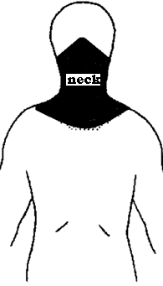

- Have you ever had neck trouble (ache, pain or discomfort)?
- No 2. Yes
If you answer No to question 1, do not answer questions 2–8
- Have you ever hurt your neck in an accident?
- No 2. Yes
- Have you ever had to change jobs or duties because of neck troubles?
- No 2. Yes
- What is the total length of time, that you have had neck trouble during the last 12 months?
- 0 days
- 1–7 days
- 8–30 days
- More than 30 days but not everyday
- Everyday
If you answered 0 days for question 4, do not answer questions 5–8

- Has neck trouble caused you to reduce your activity during the last 12 months?
- Work activity (at home or away from home)?
- No 2. Yes
- Leisure activity?
- No 2. Yes
- What is the total length of time that the neck trouble has prevented you from doing your normal work (at home or away from home) during the last 12 months?
- 0 days
- 1–7 days
- 8–30 days
- More than 30 days
- Have you been seen by a doctor, physiotherapist, chiropractor or other such persons because of neck trouble during the last 12 months?
- No 2. Yes
- Have you had neck trouble at any time during the last 7 days?
- No 2. Yes

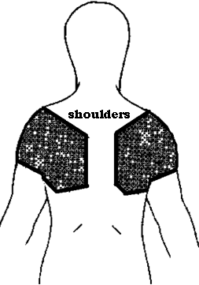

- Have you ever had shoulder trouble (ache, pain or discomfort)?
- No 2. Yes
If you answer No to question 1, do not answer questions 2–8
- Have you ever hurt your shoulder in an accident?
- No 2. Yes, my right shoulder
3. Yes, my left shoulder
4. Yes, both shoulders
- Have you ever had to change jobs or duties because of shoulder trouble?
- No 2. Yes
- Have you had shoulder trouble during the last 12 months?
- No 2. Yes, my right shoulder
3. Yes, my left shoulder
4. Yes, both shoulders
If you answered No to question 4, do not answer questions 5–9
- What is the total length of time, that you have had shoulder trouble during the last 12 months?
- 1–7 days
- 8–30 days
- More than 30 days but not everyday
- Everyday
- Has shoulder trouble caused you to reduce your activity during the last 12 months?
- Work activity (at home or away from home)?
- No 2. Yes
- Leisure activity?
- No 2. Yes
- What is the total length of time that shoulder trouble has prevented you from doing your normal work (at home or away from home) during the last 12 months?
- 0 days
- 1–7 days
- 8–30 days
- More than 30 days
- Have you been seen by a doctor, physiotherapist, chiropractor or other such persons because of shoulder trouble during the last 12 months?
- No 2. Yes
- Have you had shoulder trouble at any time during the last 7 days?
- No 2. Yes

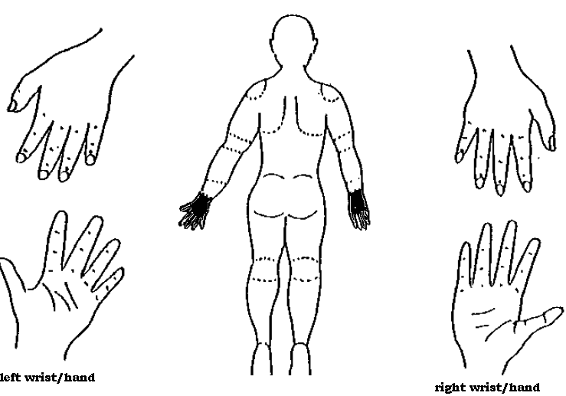

- Have you ever had wrist/hand trouble (ache, pain or discomfort)?
- No 2. Yes
If you answer No to question 1, do not answer questions 2–8
- Have you ever hurt your wrist/hand in an accident?
- No 2. Yes, my right wrist/hand
3. Yes, my left wrist/hand
4. Yes, both wrists/hands
- Have you ever had to change jobs or duties because of wrist/hand trouble?
- No 2. Yes
- Have you had wrist/hand trouble during the last 12 months?
- No 2. Yes, my right wrist/hand
3. Yes, my left wrist/hand
4. Yes, both wrists/hands
If you answered No to question 4, do not answer questions 5–9
- What is the total length of time, that you have had wrist/hand trouble during the last 12 months?
- 1–7 days
- 8–30 days
- More than 30 days but not everyday
- Everyday
- Has wrist/hand trouble caused you to reduce your activity during the last 12 months?
- Work activity (at home or away from home)?
- No 2. Yes
- Leisure activity?
- No 2. Yes
- What is the total length of time, that wrist/hand trouble has prevented you from doing your normal work (at home or away from home) during the last 12 months?
- 0 days
- 1–7 days
- 8–30 days
- More than 30 days
- Have you been seen by a doctor, physiotherapist, chiropractor or other such persons because of wrist/hand trouble during the last 12 months?
- No 2. Yes
- Have you had wrist/hand trouble at any time during the last 7 days?
- No 2. Yes

Appendix 2: Survey questionnaire for Pannists
The following is the final version of the Nordic questionnaire (modified) that was administered to the thirteen (13) pannists that made up the study sample.

Complete the following in block letters

- Name

- Band name

- Date of birth

- How much do you weigh?

- How tall are you?

___________ ___________
First Last

__________________
Year month day

____kg

____cm

Tick the most appropriate answer in the box provided

- Sex

- How many years you been playing the pan professionally?

- On average, how many hours a day do you practise during the off season?

Male
Female

1–9 years
10–14 years
15–20 years
More than 20 years

1–2 hours
3–5hours
More than 5 hours
- On average, how soon before a major event or performance (e.g. Panorama) does practice sessions start?
List the events and approximate duration.

Events:
- ___________________

- ___________________

- __________________

Duration:
- ___________ months

- ___________ months

- ___________ months

- On average, how many hours a day do you practise when preparing for a major event or performance (major preparation period)?

1–2 hours
3–5hours
More than 5 hours

11. Outline your average cycle of steel band playing during the major preparation period:

Weekday: Start time _____am/pm Stop time _____am/pm

Weekend: Start time _____am/pm Stop time _____am/pm

SECTION 2: BODY CHART

The following chart shows an illustrated diagram of the human body divided into the following regions:

- Neck
- Shoulders
- Upper back
- Elbows

- Wrists/Hands
- Hips/Thighs
- Knees
- Ankles/Feet

This allows the user to easily distinguish and record the region(s) where pain or discomfort is being experienced
Circle the number that represents the most appropriate answer. Tick the most relevant answer(s) for the questions where a check box is provided.

To be answered by everyone | To be answered only by those who have had trouble
Have you at any time during the last 18 months had trouble (ache, pain , discomfort, numbness) in | Tick the most appropriate period(s) within the last 18 months when you experienced the trouble? | Do you think that your trouble is directly related to pan practice/playing?
Neck  - No 2. Yes | Jan –Mar Apr–Jun  Jul–Sept Oct–Dec | - No  - Yes
Shoulders  - No 2. Yes, in the right shoulder  3. Yes, in the left shoulder  4. Yes, in both shoulders | Jan –Mar Apr–Jun  Jul–Sept Oct–Dec | - No  - Yes
Elbows  - No 2. Yes, in the right elbow  3. Yes, in the left elbow  4. Yes, in both elbow | Jan –Mar Apr–Jun  Jul–Sept Oct–Dec | - No  - Yes
Wrists/Hands  - No 2. Yes, in the right wrist/hand  3. Yes, in the left wrist/hand  4. Yes, in both wrist/hand | Jan –Mar Apr–Jun  Jul–Sept Oct–Dec | - No  - Yes
Upper back  - No 2. Yes | Jan –Mar Apr–Jun  Jul–Sept Oct–Dec | - No  - Yes
Low back (small of back)  - No 2. Yes | Jan –Mar Apr–Jun  Jul–Sept Oct–Dec | - No  - Yes
One or both hips/thighs  - No 2. Yes | Jan –Mar Apr–Jun  Jul–Sept Oct–Dec | - No  - Yes
One or both knees  - No 2. Yes | Jan –Mar Apr–Jun  Jul–Sept Oct–Dec | - No  - Yes
One or both ankles/feet  - No 2. Yes | Jan –Mar Apr–Jun  Jul–Sept Oct–Dec | - No  - Yes

Were you involved in any accidents/incidents that may have resulted in the injuries described above?

Neck
1. No 2. Yes
Shoulders
- No 2. Yes, in the right shoulder
3. Yes, in the left shoulder
4. Yes, in both shoulders
Elbows
- No 2. Yes, in the right elbow
3. Yes, in the left elbow
4. Yes, in both elbow

Wrists/Hands
- No 2. Yes, in the right wrist/hand
3. Yes, in the left wrist/hand
4. Yes, in both wrist/hand
Upper back
- No 2. Yes

Low back (small of back)
- No 2. Yes

One or both hips/thighs
- No 2. Yes

One or both knees
- No 2. Yes

One or both ankles/feet
- No 2. Yes

- Have you ever had neck trouble (ache, pain or discomfort)?
- No 2. Yes
If you answer No to question 1, do not answer questions 2–8
- Have you ever been hospitalized because of neck trouble?
- No 2. Yes
- Have you ever had to change jobs or duties because of neck troubles?
- No 2. Yes
- What is the total length of time, that you have had neck trouble during the last 18 months?
- 0 days
- 1–7 days
- 8–30 days
- More than 30 days but not everyday
- Everyday
If you answered 0 days for question 4, do not answer questions 5–8

- Has neck trouble caused you to reduce your activity during the last 18 months?
- Work activity (at home or away from home)?
- No 2. Yes
- Leisure activity?
- No 2. Yes
- What is the total length of time that the neck trouble has prevented you from doing your normal work (at home or away from home) during the last 18 months?
- 0 days
- 1–7 days
- 8–30 days
- More than 30 days
- Have you been seen by a doctor, physiotherapist, chiropractor or other such persons because of neck trouble during the last 18 months?
- No 2. Yes
- During which time of the year is your neck trouble most persistent?
Jan–Mar Apr–Jun
Jul–Sept Oct–Dec
All the time

- Have you ever had shoulder trouble (ache, pain or discomfort)?
- No 2. Yes
If you answer No to question 1, do not answer questions 2 –8
- Have you ever been hospitalized because of shoulder trouble?
- No 2. Yes, my right shoulder
3. Yes, my left shoulder
4. Yes, both shoulders
- Have you ever had to change jobs or duties because of shoulder trouble?
- No 2. Yes
- Have you had shoulder trouble during the last 18 months?
- No 2. Yes, my right shoulder
3. Yes, my left shoulder
4. Yes, both shoulders
If you answered No to question 4, do not answer questions 5–9
- What is the total length of time, that you have had shoulder trouble during the last 18 months?
- 1–7 days
- 8–30 days
- More than 30 days but not everyday
- Everyday
- Has shoulder trouble caused you to reduce your activity during the last 18 months?
- Work activity (at home or away from home)?
- No 2. Yes
- Leisure activity?
- No 2. Yes
- What is the total length of time, that shoulders trouble has prevented you from doing your normal work (at home or away from home) during the last 18 months?
- 0 days
- 1–7 days
- 8–30 days
- More than 30 days
- Have you been seen by a doctor, physiotherapist, chiropractor or other such persons because of shoulder trouble during the last 18 months?
- No 2. Yes
- During which time of the year is your shoulder trouble most persistent?
Jan –Mar Apr–Jun
Jul–Sept Oct–Dec
All the time

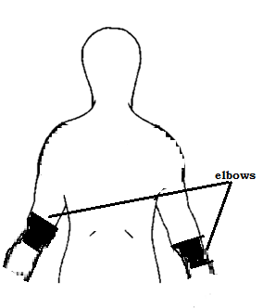

- Have you ever had elbow trouble (ache, pain or discomfort)?
  - No 2. Yes
If you answer No to question 1, do not answer questions 2 –8
- Have you ever been hospitalized because of elbow trouble?
- No 2. Yes, my right elbow
3. Yes, my left elbow
4. Yes, both elbows
- Have you ever had to change jobs or duties because of elbow trouble?
- No 2. Yes
- Have you had elbow trouble during the last 18 months?
- No 2. Yes, my right elbow
3. Yes, my left elbow
4. Yes, both elbows
If you answered No to question 4, do not answer questions 5–9
- What is the total length of time, that you have had elbow trouble during the last 18 months?
- 1–7 days
- 8–30 days
- More than 30 days but not everyday
- Everyday
- Has elbow trouble caused you to reduce your activity during the last 18 months?
- Work activity (at home or away from home)?
- No 2. Yes
- Leisure activity?
- No 2. Yes
- What is the total length of time that elbows trouble has prevented you from doing your normal work (at home or away from home) during the last 18 months?
- 0 days
- 1–7 days
- 8–30 days
- More than 30 days
- Have you been seen by a doctor, physiotherapist, chiropractor or other such persons because of elbow trouble during the last 18 months?
- No 2. Yes
- During which time of the year is your elbow trouble most persistent?
Jan –Mar Apr–Jun
Jul–Sept Oct–Dec
All the time

- Have you ever had wrist/hand trouble (ache, pain or discomfort)?
  - No 2. Yes
If you answer No to question 1, do not answer questions 2–8
- Have you ever been hospitalized because of wrist/hand trouble?
- No
- Yes, my right wrist/hand
3. Yes, my left wrist/hand
4. Yes, both wrist/hand
- Have you ever had to change jobs or duties because of wrist/hand trouble?
- No 2. Yes
- Have you had wrist/hand trouble during the last 18 months?
- No
- Yes, my right wrist/hand
3. Yes, my left wrist/hand
4. Yes, both wrist/hand
If you answered No to question 4, do not answer questions 5–9
- What is the total length of time, that you have had wrist/hand trouble during the last 18 months?
- 1–7 days
- 8–30 days
- More than 30 days but not everyday
- Everyday

- Has wrist/hand trouble caused you to reduce your activity during the last 18 months?
- Work activity (at home or away from home)?
- No 2. Yes
- Leisure activity?
- No 2. Yes
- What is the total length of time, that wrist/hand trouble has prevented you from doing your normal work (at home or away from home) during the last 18 months?
- 0 days
- 1–7 days
- 8–30 days
- More than 30 days
- Have you been seen by a doctor, physiotherapist, chiropractor or other such persons because of wrist/hand trouble during the last 18 months?
- No 2. Yes
- During which time of the year is your wrist/hand trouble most persistent?
Jan –Mar Apr–Jun
Jul–Sept Oct–Dec
All the time

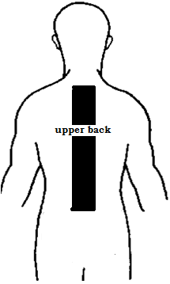

- Have you ever had upper back trouble (ache, pain or discomfort)?
- No 2. Yes
If you answer No to question 1, do not answer questions 2–8
- Have you ever been hospitalized because of upper back trouble?
- No 2. Yes
- Have you ever had to change jobs or duties because of upper back troubles?
- No 2. Yes
- What is the total length of time, that you have had upper back trouble during the last 18 months?
- 0 days
- 1–7 days
- 8–30 days
- More than 30 days but not everyday
- Everyday
If you answered 0 days for question 4, do not answer questions 5–8

- Has upper back trouble caused you to reduce your activity during the last 18 months?
- Work activity (at home or away from home)?
- No 2. Yes
- Leisure activity?
- No 2. Yes
- What is the total length of time, that upper back trouble has prevented you from doing your normal work (at home or away from home) during the last 18 months?
- 0 days
- 1–7 days
- 8–30 days
- More than 30 days
- Have you been seen by a doctor, physiotherapist, chiropractor or other such persons because of upper back trouble during the last 18 months?
- No 2. Yes
- During which time of the year is your upper back trouble most persistent?
Jan –Mar Apr–Jun
Jul–Sept Oct–Dec
All the time

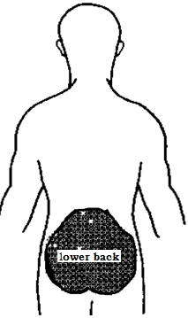

- Have you ever had lower back trouble (ache, pain or discomfort)?
    - No 2. Yes
If you answer No to question 1, do not answer questions 2–8
- Have you ever been hospitalized because of lower back trouble?
- No 2. Yes
- Have you ever had to change jobs or duties because of lower back troubles?
- No 2. Yes
- What is the total length of time, that you have had lower back trouble during the last 18 months?
- 0 days
- 1–7 days
- 8–30 days
- More than 30 days but not everyday
- Everyday
If you answered 0 days for question 4, do not answer questions 5–8

- Has lower back trouble caused you to reduce your activity during the last 18 months?
- Work activity (at home or away from home)?
- No 2. Yes
- Leisure activity?
- No 2. Yes
- What is the total length of time, that lower back trouble has prevented you from doing your normal work (at home or away from home) during the last 18 months?
- 0 days
- 1–7 days
- 8–30 days
- More than 30 days
- Have you been seen by a doctor, physiotherapist, chiropractor or other such persons because of lower back trouble during the last 18 months?
- No 2. Yes
- During which time of the year is your lower back trouble most persistent?
Jan –Mar Apr–Jun
Jul–Sept Oct–Dec
All the time

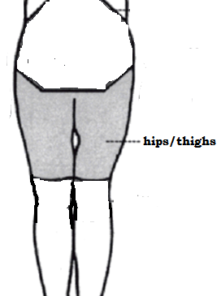

- Have you ever had hips/thighs trouble (ache, pain or discomfort)?
      - No 2. Yes
If you answer No to question 1, do not answer questions 2–8
- Have you ever been hospitalized because of hip/thigh trouble?
- No

2. Yes, my right hip/thigh
3. Yes, my left hip/thigh
4. Yes, both hips/thighs
- Have you ever had to change jobs or duties because of hips/thighs trouble?
- No 2. Yes
- Have you had hips/thighs trouble during the last 18 months?
- No

2. Yes, my right hip/thigh
3. Yes, my left hip/thigh
4. Yes, hips/thighs
If you answered No to question 4, do not answer questions 5–9
- What is the total length of time, that you have had hips/thighs trouble during the last 18 months?
- 1–7 days
- 8–30 days
- More than 30 days but not everyday
- Everyday
- Has hips/thighs trouble caused you to reduce your activity during the last 18 months?
- Work activity (at home or away from home)?
- No 2. Yes
- Leisure activity?
- No 2. Yes
- What is the total length of time, that hips/thighs trouble has prevented you from doing your normal work (at home or away from home) during the last 18 months?
- 0 days
- 1–7 days
- 8–30 days
- More than 30 days
- Have you been seen by a doctor, physiotherapist, chiropractor or other such persons because of hips/thighs trouble during the last 18 months?
- No 2. Yes
- During which time of the year is your hips/thighs trouble most persistent?
Jan –Mar Apr–Jun
Jul–Sept Oct–Dec
All the time

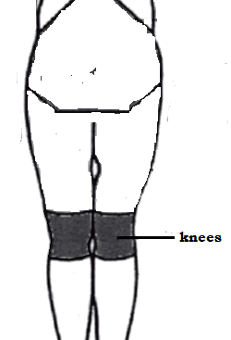

- Have you ever had knee trouble (ache, pain or discomfort)?
1. No 2. Yes
If you answer No to question 1, do not answer questions 2–8
- Have you ever been hospitalized because of knee trouble?
- No 2. Yes, my right knee
3. Yes, my left knee
4. Yes, both knee
- Have you ever had to change jobs or duties because of knee trouble?
- No 2. Yes
- Have you had knee trouble during the last 18 months?
- No 2. Yes, my right knee
3. Yes, my left knee
4. Yes, both knee
If you answered No to question 4, do not answer questions 5–9
- What is the total length of time, that you have had knee trouble during the last 18 months?
- 1–7 days
- 8–30 days
- More than 30 days but not everyday
- Everyday

- Has knee trouble caused you to reduce your activity during the last 18 months?
- Work activity (at home or away from home)?
- No 2. Yes
- Leisure activity?
- No 2. Yes
- What is the total length of time, that knee trouble has prevented you from doing your normal work (at home or away from home) during the last 18 months?
- 0 days
- 1–7 days
- 8–30 days
- More than 30 days
- Have you been seen by a doctor, physiotherapist, chiropractor or other such persons because of knee trouble during the last 18 months?
- No 2. Yes
- During which time of the year is your knee trouble most persistent?
Jan –Mar Apr–Jun
Jul–Sept Oct–Dec
All the time

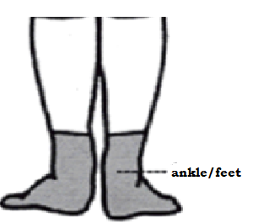

- Have you ever had ankles/feet trouble (ache, pain or discomfort)?
- No 2. Yes
If you answer No to question 1, do not answer questions 2–8
- Have you ever been hospitalized because of ankle/feet trouble?
- No
- Yes, my right ankle/foot
3. Yes, my left ankle/foot
4. Yes, both ankles/feet
- Have you ever had to change jobs or duties because of ankles/feet trouble?
- No 2. Yes
- Have you had ankles/feet trouble during the last 18 months?
- No
- Yes, my right ankle/foot
3. Yes, my left ankle/foot
4. Yes, both ankles/feet
If you answered No to question 4, do not answer questions 5–9
- What is the total length of time, that you have had ankles/feet trouble during the last 18 months?
- 1–7 days
- 8–30 days
- More than 30 days but no everyday
- Everyday

- Has ankles/feet trouble caused you to reduce your activity during the last 18 months?
- Work activity (at home or away from home)?
- No 2. Yes
- Leisure activity?
- No 2. Yes
- What is the total length of time, that ankles/feet trouble has prevented you from doing your normal work (at home or away from home) during the last 18 months?
- 0 days
- 1–7 days
- 8–30 days
- More than 30 days
- Have you been seen by a doctor, physiotherapist, chiropractor or other such persons because of ankles/feet trouble during the last 18 months?
- No 2. Yes
- During which time of the year is your ankles/feet trouble most persistent?
Jan –Mar Apr–Jun
Jul–Sept Oct–Dec
All the time

Appendix 3: Survey questionnaire for General Public
The following is the final version of the Nordic questionnaire that was administered to the thirteen (13) members of the General Public (non–pannists) that made up the study sample.

Complete the following in block letters

- Name

- Band name

- Date of birth

- How much do you weigh?

- How tall are you?

- Sex

___________ ___________
First Last

__________________
Year month day

____kg

____cm

_________

SECTION 2: BODY CHART

The following chart shows an illustrated diagram of the human body divided into the following regions:

- Neck
- Shoulders
- Upper back
- Elbows

- Wrists/Hands
- Hips/Thighs
- Knees
- Ankles/Feet

This allows the user to easily distinguish and record the region(s) where pain or discomfort is being experienced
Circle the number that represents the most appropriate answer. Tick the most relevant answer(s) for the questions where a check box is provided.

To be answered by everyone | To be answered only by those who have had trouble
Have you at any time during the last 18 months had trouble (ache, pain , discomfort, numbness) in | Tick the most appropriate period(s) within the last 18 months when you experienced the trouble? | Have you had trouble at any time during the last 7 days?
Neck  - No 2. Yes | Jan –Mar Apr–Jun  Jul–Sept Oct–Dec | - No  - Yes
Shoulders  - No 2. Yes, in the right shoulder  3. Yes, in the left shoulder  4. Yes, in both shoulders | Jan –Mar Apr–Jun  Jul–Sept Oct–Dec | - No  - Yes
Elbows  - No 2. Yes, in the right elbow  3. Yes, in the left elbow  4. Yes, in both elbow | Jan –Mar Apr–Jun  Jul–Sept Oct–Dec | - No  - Yes
Wrists/Hands  - No 2. Yes, in the right wrist/hand  3. Yes, in the left wrist/hand  4. Yes, in both wrist/hand | Jan –Mar Apr–Jun  Jul–Sept Oct–Dec | - No  - Yes
Upper back  - No 2. Yes | Jan –Mar Apr–Jun  Jul–Sept Oct–Dec | - No  - Yes
Low back (small of back)  - No 2. Yes | Jan –Mar Apr–Jun  Jul–Sept Oct–Dec | - No  - Yes
One or both hips/thighs  - No 2. Yes | Jan –Mar Apr–Jun  Jul–Sept Oct–Dec | - No  - Yes
One or both knees  - No 2. Yes | Jan –Mar Apr–Jun  Jul–Sept Oct–Dec | - No  - Yes
One or both ankles/feet  - No 2. Yes | Jan –Mar Apr–Jun  Jul–Sept Oct–Dec | - No  - Yes

Were you involved in any accidents/incidents that may have resulted in the injuries described above?

Neck
1. No 2. Yes
Shoulders
- No 2. Yes, in the right shoulder
3. Yes, in the left shoulder
4. Yes, in both shoulders
Elbows
- No 2. Yes, in the right elbow
3. Yes, in the left elbow
4. Yes, in both elbow
Wrists/Hands
- No 2. Yes, in the right wrist/hand
3. Yes, in the left wrist/hand
4. Yes, in both wrist/hand

Upper back
- No 2. Yes

Low back (small of back)
- No 2. Yes

One or both hips/thighs
- No 2. Yes

One or both knees
- No 2. Yes

One or both ankles/feet
- No 2. Yes

- Have you ever had neck trouble (ache, pain or discomfort)?
- No 2. Yes
If you answer No to question 1, do not answer questions 2–8
- Have you ever been hospitalized because of neck trouble?
- No 2. Yes
- Have you ever had to change jobs or duties because of neck troubles?
- No 2. Yes
- What is the total length of time, that you have had neck trouble during the last 18 months?
- 0 days
- 1–7 days
- 8–30 days
- More than 30 days but not everyday
- Everyday
If you answered 0 days for question 4, do not answer questions 5–8

- Has neck trouble caused you to reduce your activity during the last 18 months?
- Work activity (at home or away from home)?
- No 2. Yes
- Leisure activity?
- No 2. Yes
- What is the total length of time that the neck trouble has prevented you from doing your normal work (at home or away from home) during the last 18 months?
- 0 days
- 1–7 days
- 8–30 days
- More than 30 days
- Have you been seen by a doctor, physiotherapist, chiropractor or other such persons because of neck trouble during the last 18 months?
- No 2. Yes
- During which time of the year is your neck trouble most persistent?
Jan –Mar Apr–Jun
Jul–Sept Oct–Dec
All the time

- Have you ever had shoulder trouble (ache, pain or discomfort)?
- No 2. Yes
If you answer No to question 1, do not answer questions 2–8
- Have you ever been hospitalized because of shoulder trouble?
- No 2. Yes, my right shoulder
3. Yes, my left shoulder
4. Yes, both shoulders
- Have you ever had to change jobs or duties because of shoulder trouble?
- No 2. Yes
- Have you had shoulder trouble during the last 18 months?
- No 2. Yes, my right shoulder
3. Yes, my left shoulder
4. Yes, both shoulders
If you answered No to question 4, do not answer questions 5–9
- What is the total length of time, that you have had shoulder trouble during the last 18 months?
- 1–7 days
- 8–30 days
- More than 30 days but not everyday
- Everyday
- Has shoulder trouble caused you to reduce your activity during the last 18 months?
- Work activity (at home or away from home)?
- No 2. Yes
- Leisure activity?
- No 2. Yes
- What is the total length of time, that shoulders trouble has prevented you from doing your normal work (at home or away from home) during the last 18 months?
- 0 days
- 1–7 days
- 8–30 days
- More than 30 days
- Have you been seen by a doctor, physiotherapist, chiropractor or other such persons because of shoulder trouble during the last 18 months?
- No 2. Yes
- During which time of the year is your shoulder trouble most persistent?
Jan –Mar Apr–Jun
Jul–Sept Oct–Dec
All the time

- Have you ever had elbow trouble (ache, pain or discomfort)?
  - No 2. Yes
If you answer No to question 1, do not answer questions 2–8
- Have you ever been hospitalized because of elbow trouble?
- No 2. Yes, my right elbow
3. Yes, my left elbow
4. Yes, both elbows
- Have you ever had to change jobs or duties because of elbow trouble?
- No 2. Yes
- Have you had elbow trouble during the last 18 months?
- No 2. Yes, my right elbow
3. Yes, my left elbow
4. Yes, both elbows
If you answered No to question 4, do not answer questions 5–9
- What is the total length of time, that you have had elbow trouble during the last 18 months?
- 1–7 days
- 8–30 days
- More than 30 days but not everyday
- Everyday
- Has elbow trouble caused you to reduce your activity during the last 18 months?
- Work activity (at home or away from home)?
- No 2. Yes
- Leisure activity?
- No 2. Yes
- What is the total length of time that elbows trouble has prevented you from doing your normal work (at home or away from home) during the last 18 months?
- 0 days
- 1–7 days
- 8–30 days
- More than 30 days
- Have you been seen by a doctor, physiotherapist, chiropractor or other such persons because of elbow trouble during the last 18 months?
- No 2. Yes
- During which time of the year is your elbow trouble most persistent?
Jan –Mar Apr–Jun
Jul–Sept Oct–Dec
All the time

- Have you ever had wrist/hand trouble (ache, pain or discomfort)?
- No 2. Yes
If you answer No to question 1, do not answer questions 2–8
- Have you ever been hospitalized because of wrist/hand trouble?
- No
- Yes, my right wrist/hand
3. Yes, my left wrist/hand
4. Yes, both wrist/hand
- Have you ever had to change jobs or duties because of wrist/hand trouble?
- No 2. Yes
- Have you had wrist/hand trouble during the last 18 months?
- No
- Yes, my right wrist/hand
3. Yes, my left wrist/hand
4. Yes, both wrist/hand
If you answered No to question 4, do not answer questions 5–9
- What is the total length of time, that you have had wrist/hand trouble during the last 18 months?
- 1–7 days
- 8–30 days
- More than 30 days but not everyday
- Everyday

- Has wrist/hand trouble caused you to reduce your activity during the last 18 months?
- Work activity (at home or away from home)?
- No 2. Yes
- Leisure activity?
- No 2. Yes
- What is the total length of time, that wrist/hand trouble has prevented you from doing your normal work (at home or away from home) during the last 18 months?
- 0 days
- 1–7 days
- 8–30 days
- More than 30 days
- Have you been seen by a doctor, physiotherapist, chiropractor or other such persons because of wrist/hand trouble during the last 18 months?
- No 2. Yes
- During which time of the year is your wrist/hand trouble most persistent?
Jan –Mar Apr–Jun
Jul–Sept Oct–Dec
All the time

- Have you ever had upper back trouble (ache, pain or discomfort)?
- No 2. Yes
If you answer No to question 1, do not answer questions 2–8
- Have you ever been hospitalized because of upper back trouble?
- No 2. Yes
- Have you ever had to change jobs or duties because of upper back troubles?
- No 2. Yes
- What is the total length of time, that you have had upper back trouble during the last 18 months?
- 0 days
- 1–7 days
- 8–30 days
- More than 30 days but not everyday
- Everyday
If you answered 0 days for question 4, do not answer questions 5–8

- Has upper back trouble caused you to reduce your activity during the last 18 months?
- Work activity (at home or away from home)?
- No 2. Yes
- Leisure activity?
- No 2. Yes
- What is the total length of time, that upper back trouble has prevented you from doing your normal work (at home or away from home) during the last 18 months?
- 0 days
- 1–7 days
- 8–30 days
- More than 30 days
- Have you been seen by a doctor, physiotherapist, chiropractor or other such persons because of upper back trouble during the last 18 months?
- No 2. Yes
- During which time of the year is your upper back trouble most persistent?
Jan –Mar Apr–Jun
Jul–Sept Oct–Dec
All the time

- Have you ever had lower back trouble (ache, pain or discomfort)?
    - No 2. Yes
If you answer No to question 1, do not answer questions 2–8
- Have you ever been hospitalized because of lower back trouble?
- No 2. Yes
- Have you ever had to change jobs or duties because of lower back troubles?
- No 2. Yes
- What is the total length of time, that you have had lower back trouble during the last 18 months?
- 0 days
- 1–7 days
- 8–30 days
- More than 30 days but not everyday
- Everyday
If you answered 0 days for question 4, do not answer questions 5–8

- Has lower back trouble caused you to reduce your activity during the last 18 months?
- Work activity (at home or away from home)?
- No 2. Yes
- Leisure activity?
- No 2. Yes
- What is the total length of time, that lower back trouble has prevented you from doing your normal work (at home or away from home) during the last 18 months?
- 0 days
- 1–7 days
- 8–30 days
- More than 30 days
- Have you been seen by a doctor, physiotherapist, chiropractor or other such persons because of lower back trouble during the last 18 months?
- No 2. Yes
- During which time of the year is your lower back trouble most persistent?
Jan –Mar Apr–Jun
Jul–Sept Oct–Dec
All the time

- Have you ever had hips/thighs trouble (ache, pain or discomfort)?
      - No 2. Yes
If you answer No to question 1, do not answer questions 2–8
- Have you ever been hospitalized because of hip/thigh trouble?
- No
2. Yes, my right hip/thigh
3. Yes, my left hip/thigh
4. Yes, both hips/thighs
- Have you ever had to change jobs or duties because of hips/thighs trouble?
- No 2. Yes
- Have you had hips/thighs trouble during the last 18 months?
- No
2. Yes, my right hip/thigh
3. Yes, my left hip/thigh
4. Yes, hips/thighs
If you answered No to question 4, do not answer questions 5–9
- What is the total length of time, that you have had hips/thighs trouble during the last 18 months?
- 1–7 days
- 8–30 days
- More than 30 days but not everyday
- Everyday
- Has hips/thighs trouble caused you to reduce your activity during the last 18 months?
- Work activity (at home or away from home)?
- No 2. Yes
- Leisure activity?
- No 2. Yes
- What is the total length of time, that hips/thighs trouble has prevented you from doing your normal work (at home or away from home) during the last 18 months?
- 0 days
- 1–7 days
- 8–30 days
- More than 30 days
- Have you been seen by a doctor, physiotherapist, chiropractor or other such persons because of hips/thighs trouble during the last 18 months?
- No 2. Yes
- During which time of the year is your hips/thighs trouble most persistent?
Jan –Mar Apr–Jun
Jul–Sept Oct–Dec
All the time

- Have you ever had knee trouble (ache, pain or discomfort)?
1. No 2. Yes
If you answer No to question 1, do not answer questions 2–8
- Have you ever been hospitalized because of knee trouble?
- No 2. Yes, my right knee
3. Yes, my left knee
4. Yes, both knee
- Have you ever had to change jobs or duties because of knee trouble?
- No 2. Yes
- Have you had knee trouble during the last 18 months?
- No 2. Yes, my right knee
3. Yes, my left knee
4. Yes, both knee
If you answered No to question 4, do not answer questions 5–9
- What is the total length of time, that you have had knee trouble during the last 18 months?
- 1–7 days
- 8–30 days
- More than 30 days but not everyday
- Everyday

- Has knee trouble caused you to reduce your activity during the last 18 months?
- Work activity (at home or away from home)?
- No 2. Yes
- Leisure activity?
- No 2. Yes
- What is the total length of time, that knee trouble has prevented you from doing your normal work (at home or away from home) during the last 18 months?
- 0 days
- 1–7 days
- 8–30 days
- More than 30 days
- Have you been seen by a doctor, physiotherapist, chiropractor or other such persons because of knee trouble during the last 18 months?
- No 2. Yes
- During which time of the year is your knee trouble most persistent?
Jan –Mar Apr–Jun
Jul–Sept Oct–Dec
All the time

- Have you ever had ankles/feet trouble (ache, pain or discomfort)?
- No 2. Yes
If you answer No to question 1, do not answer questions 2–8
- Have you ever been hospitalized because of ankle/feet trouble?
- No
- Yes, my right ankle/foot
3. Yes, my left ankle/foot
4. Yes, both ankles/feet
- Have you ever had to change jobs or duties because of ankles/feet trouble?
- No 2. Yes
- Have you had ankles/feet trouble during the last 18 months?
- No
- Yes, my right ankle/foot
3. Yes, my left ankle/foot
4. Yes, both ankles/feet
If you answered No to question 4, do not answer questions 5–9
- What is the total length of time, that you have had ankles/feet trouble during the last 18 months?
- 1–7 days
- 8–30 days
- More than 30 days but no everyday
- Everyday

- Has ankles/feet trouble caused you to reduce your activity during the last 18 months?
- Work activity (at home or away from home)?
- No 2. Yes
- Leisure activity?
- No 2. Yes
- What is the total length of time, that ankles/feet trouble has prevented you from doing your normal work (at home or away from home) during the last 18 months?
- 0 days
- 1–7 days
- 8–30 days
- More than 30 days
- Have you been seen by a doctor, physiotherapist, chiropractor or other such persons because of ankles/feet trouble during the last 18 months?
- No 2. Yes
- During which time of the year is your ankles/feet trouble most persistent?
Jan –Mar Apr–Jun
Jul–Sept Oct–Dec
All the time

Appendix 4 – Table A.

Table A: Estimated number of total hours of practice per month per respondent and corresponding indication of pain experienced in their wrist/ hand and lower back.

ID# | Total practice time* (hours) | Total practice time/100  (hours) | Region of the body
 |  |  | W/H | LB
01 | 309.3 | 3.1 | 4 | 2
02 | 68 | 0.7 | 4 | 2
03 | 264 | 2.6 | 4 | 2
04 | 210 | 2.1 | 1 | 1
07 | 141 | 1.4 | 2 | 2
08 | 141 | 1.4 | 2 | 2
09 | 180 | 1.8 | 2 | 1
10 | 198 | 2.0 | 1 | 1
11 | 240 | 2.4 | 2 | 2
13 | 210 | 2.1 | 1 | 1
* The following assumptions were made for the estimation of the minimum hours of practice per month: Practice on a minimum of three days during the period Monday – Friday, practice on Saturday and Sunday and four weeks in a month.

Appendix 5 – Picture 1

Picture 1: Tenor Player bending forward at 30° angle while playing
To calculate the compressive force being applied on a pannist’s lower back, the human back was modelled as a lever; the L5/S1 vertebrae acting as a pivot and the erector spinae muscles along the vertebrae acting as the counter balancing force when bending.

