An Energetic Derivative of 2,2′,4,4′,6,6′-Hexanitrostilbene (HNS) and its DMF Solvate Crystallized from HNS Solution with Tertiary Amine Additives
Xiong Cao,ª Yuxiang Guan,^{a,b} Liyuan Yang,^{a,b} Mi Yan,^{b} Qing Ma,^{b} Guijuan Fan,^{b} Yu Liu*^{b} and Shiliang Huang*^{b}
- School of Environment and Safety Engineering, North University of China, Taiyuan, 030051, China.
- Institute of Chemical Materials, China Academy of Engineering Physics, Mianyang, 621900, China. Fax: +86 816 1521 87; Tel: +86 816 2493145; E-mail: shilianghuang@caep.cn`; liuyu307@caep.cn.

List of Contents
1. Details of the theoretical calculation.
2. Figures
Figure S1. SEM image of TNBF·2DMF single crystals.
Figure S2. Experimental and simulated X-ray powder diffractions of TNBF·2DMF.
Figure S3. Negative ESI mass spectrum of TNBF·2DMF.
Figure S4. The π-stacking and H-bonding interactions in TNBF∙2DMF based on the crystal structure determined from the single-crystal X-ray diffraction of the sample synthesized with BME.
Figure S5. TG-DSC curves of TNBF∙2DMF measured from the sample synthesized with BME in air and in a heating rate of 10°C/min..
3. Tables
Table S1. Bond length (Å) of the TNBF molecule obtained from the single-crystal X-ray diffraction data of TNBF·2DMF synthesized with PMP.
Table S2. Geometric parameters for the π-stacking interactions in the structure model of the TNBF·2DMF single crystal synthesized with PMP.
Table S3. Geometric parameters for the π-stacking interactions in the structure model of the TNBF·2DMF single crystal synthesized with BME.
Table S4. Geometric parameters of H-bonds in the structure model of the TNBF·2DMF single crystal synthesized with PMP.
Table S5. Geometric parameters of H-bonds in the structure model of the TNBF·2DMF single crystal synthesized with BME.
1. Details of the theoretical calculation.
All calculations were carried out at Gaussian 09 package. All molecules were optimized at DFT/B3LYP functional 6-311++G** basis set, and the optimized structures were conformed to be true local-energy minima on the potential-energy surface with frequency analysis. The change of enthalpy for the reactions at 298 K can be expressed as
ΔH₂₉₈ = ∑Δ_{f}H_{P} – ∑Δ_{f}H_{R} (1)
where Δ_{f}H_{R} and Δ_{f}H_{P} are the HOF of reactants and products at 298 K, respectively, and ΔH₂₉₈ can be calculated using the following expression:
ΔH₂₉₈=ΔE₂₉₈+Δ(PV) =ΔE₀+ΔZPE+ΔH_{T}+ΔnRT (2)
where ΔE₀ is the change in total energy between the products and the reactants at 0 K; ΔZPE is the difference between the zero-point energies (ZPE) of the products and the reactants at 0 K; ΔH_{T} is thermal correction from 0 to 298 K. The Δ(PV) value in eq (2) is the PV work term. It equals Δ(nRT) for the reactions of ideal gas. For the isodesmic reactions, Δn = 0, so Δ(PV) = 0. On the left side of Eq. (1), apart from target compound, all the others are called reference compounds. The HOF of reference compounds are available either from the experiments¹ or from the atomization CBS-4M method.² Molar enthalpy of formation in solid state calculated by Δ_{f}H_{s} = Δ_{f}H_{g} – Δ_{f}H_{sub}, enthalpy of formation in gas state (Δ_{f}H_{g}) was calculated by DFT method in combination with the isodesmic reactions, the sublimation enthalpy (Δ_{f}H_{sub}) was evaluated by the electrostatic potential method.
The detonation velocity and detonation pressure were calculated by EXPLO5 V6.02.
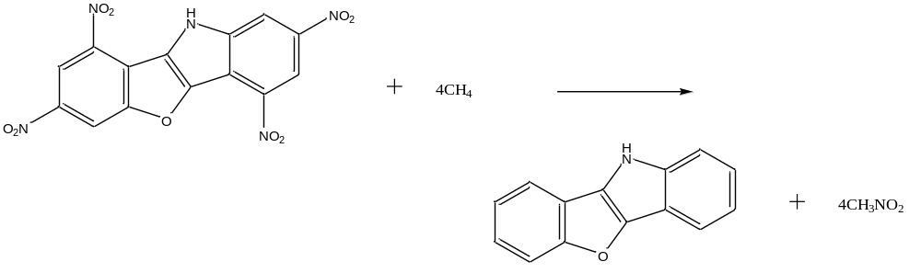
Scheme 1 Isodesmic reaction

Table 1 Calculated total energy (E₀), zero point energy (ZPE), and thermal correction (H_{T}) and experimental gaseous heat of formation (Δ_{f}H_{gas}) for the reference compounds. E₀ and ZPE are in (a.u.), H_{sub} and HOF are in (kJ mol⁻¹).
Compd. | ZPE | H_{T} | E₀ | E_{cor.} | ΔH_{T} |  | Δ_{f}H_{gas} | ΔH_{sub} | ΔH_{f,solid}
CH₄ | 0.04452 | 0.04833 | -40.489438 | -40.4458084 | 10.01 |  | -74.6ª
CH₃NO₂ | 0.04958 | 0.05400 | -245.042075 | -244.993487 |  | 11.60 | -81.0ª
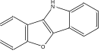 | 0.19214 | 0.20413 | -668.853525 | -668.665232 |  | 31.48 | 40.3
TNBF | 0.20073 | 0.22314 | -1487.088239 | -1486.891528 |  | 58.84 | -57.7 | 263.1 | -320.8
ª The experimental data are taken from Ref.1.
Table 2 Predicted heats of formation (ΔH_{f,solid}), densities (ρ), detonation velocities (D), detonation pressures (P), and oxygen balance (OB) for the title compounds together.
Comp. | ΔH_{f,solid}(kJ mol⁻¹) | ρ(g cm⁻³) | D(km s⁻¹) | P(GPa) | OB(%)
TNBF | -320.8 | 1.734 | 6.802 | 17.4 | -88.89

References
- D. R. Lide, Handbook of Chemistry and Physics, 84th ed., CRC Press, Boca Raton, FL, 2003-2004.
- L. A. Curtiss, K. Raghavachari, P. C. Redfern, J. A. Pople, J. Chem. Phys., 1997, 106, 1063-1079.
2. Figures
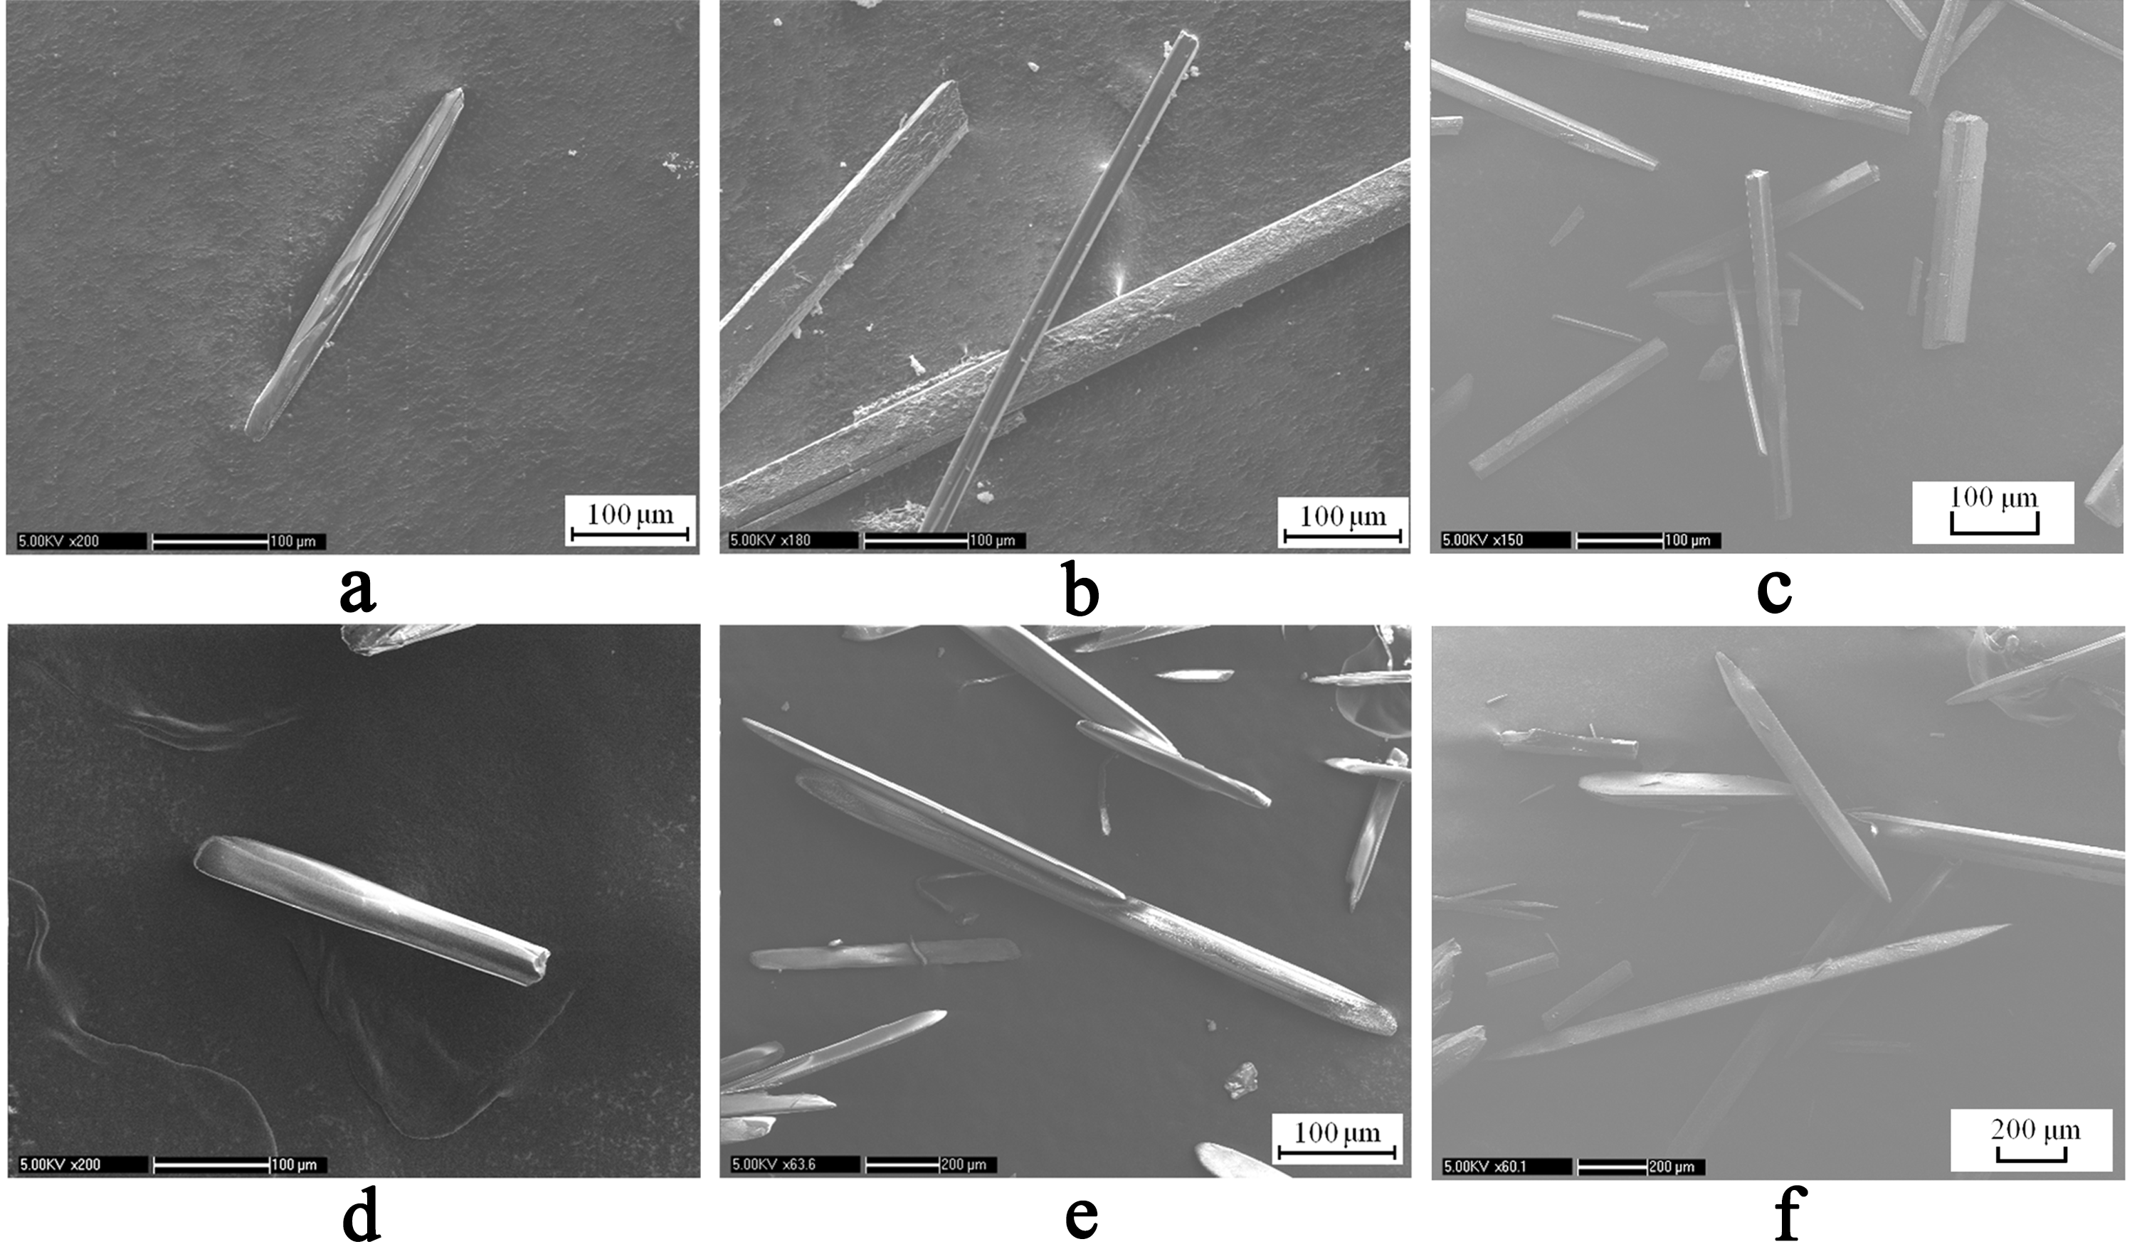
Figure S1. SEM images for the single crystals of TNBF·2DMF synthesized with (a)(b)(c) PMP and (d)(e)(f) BME.
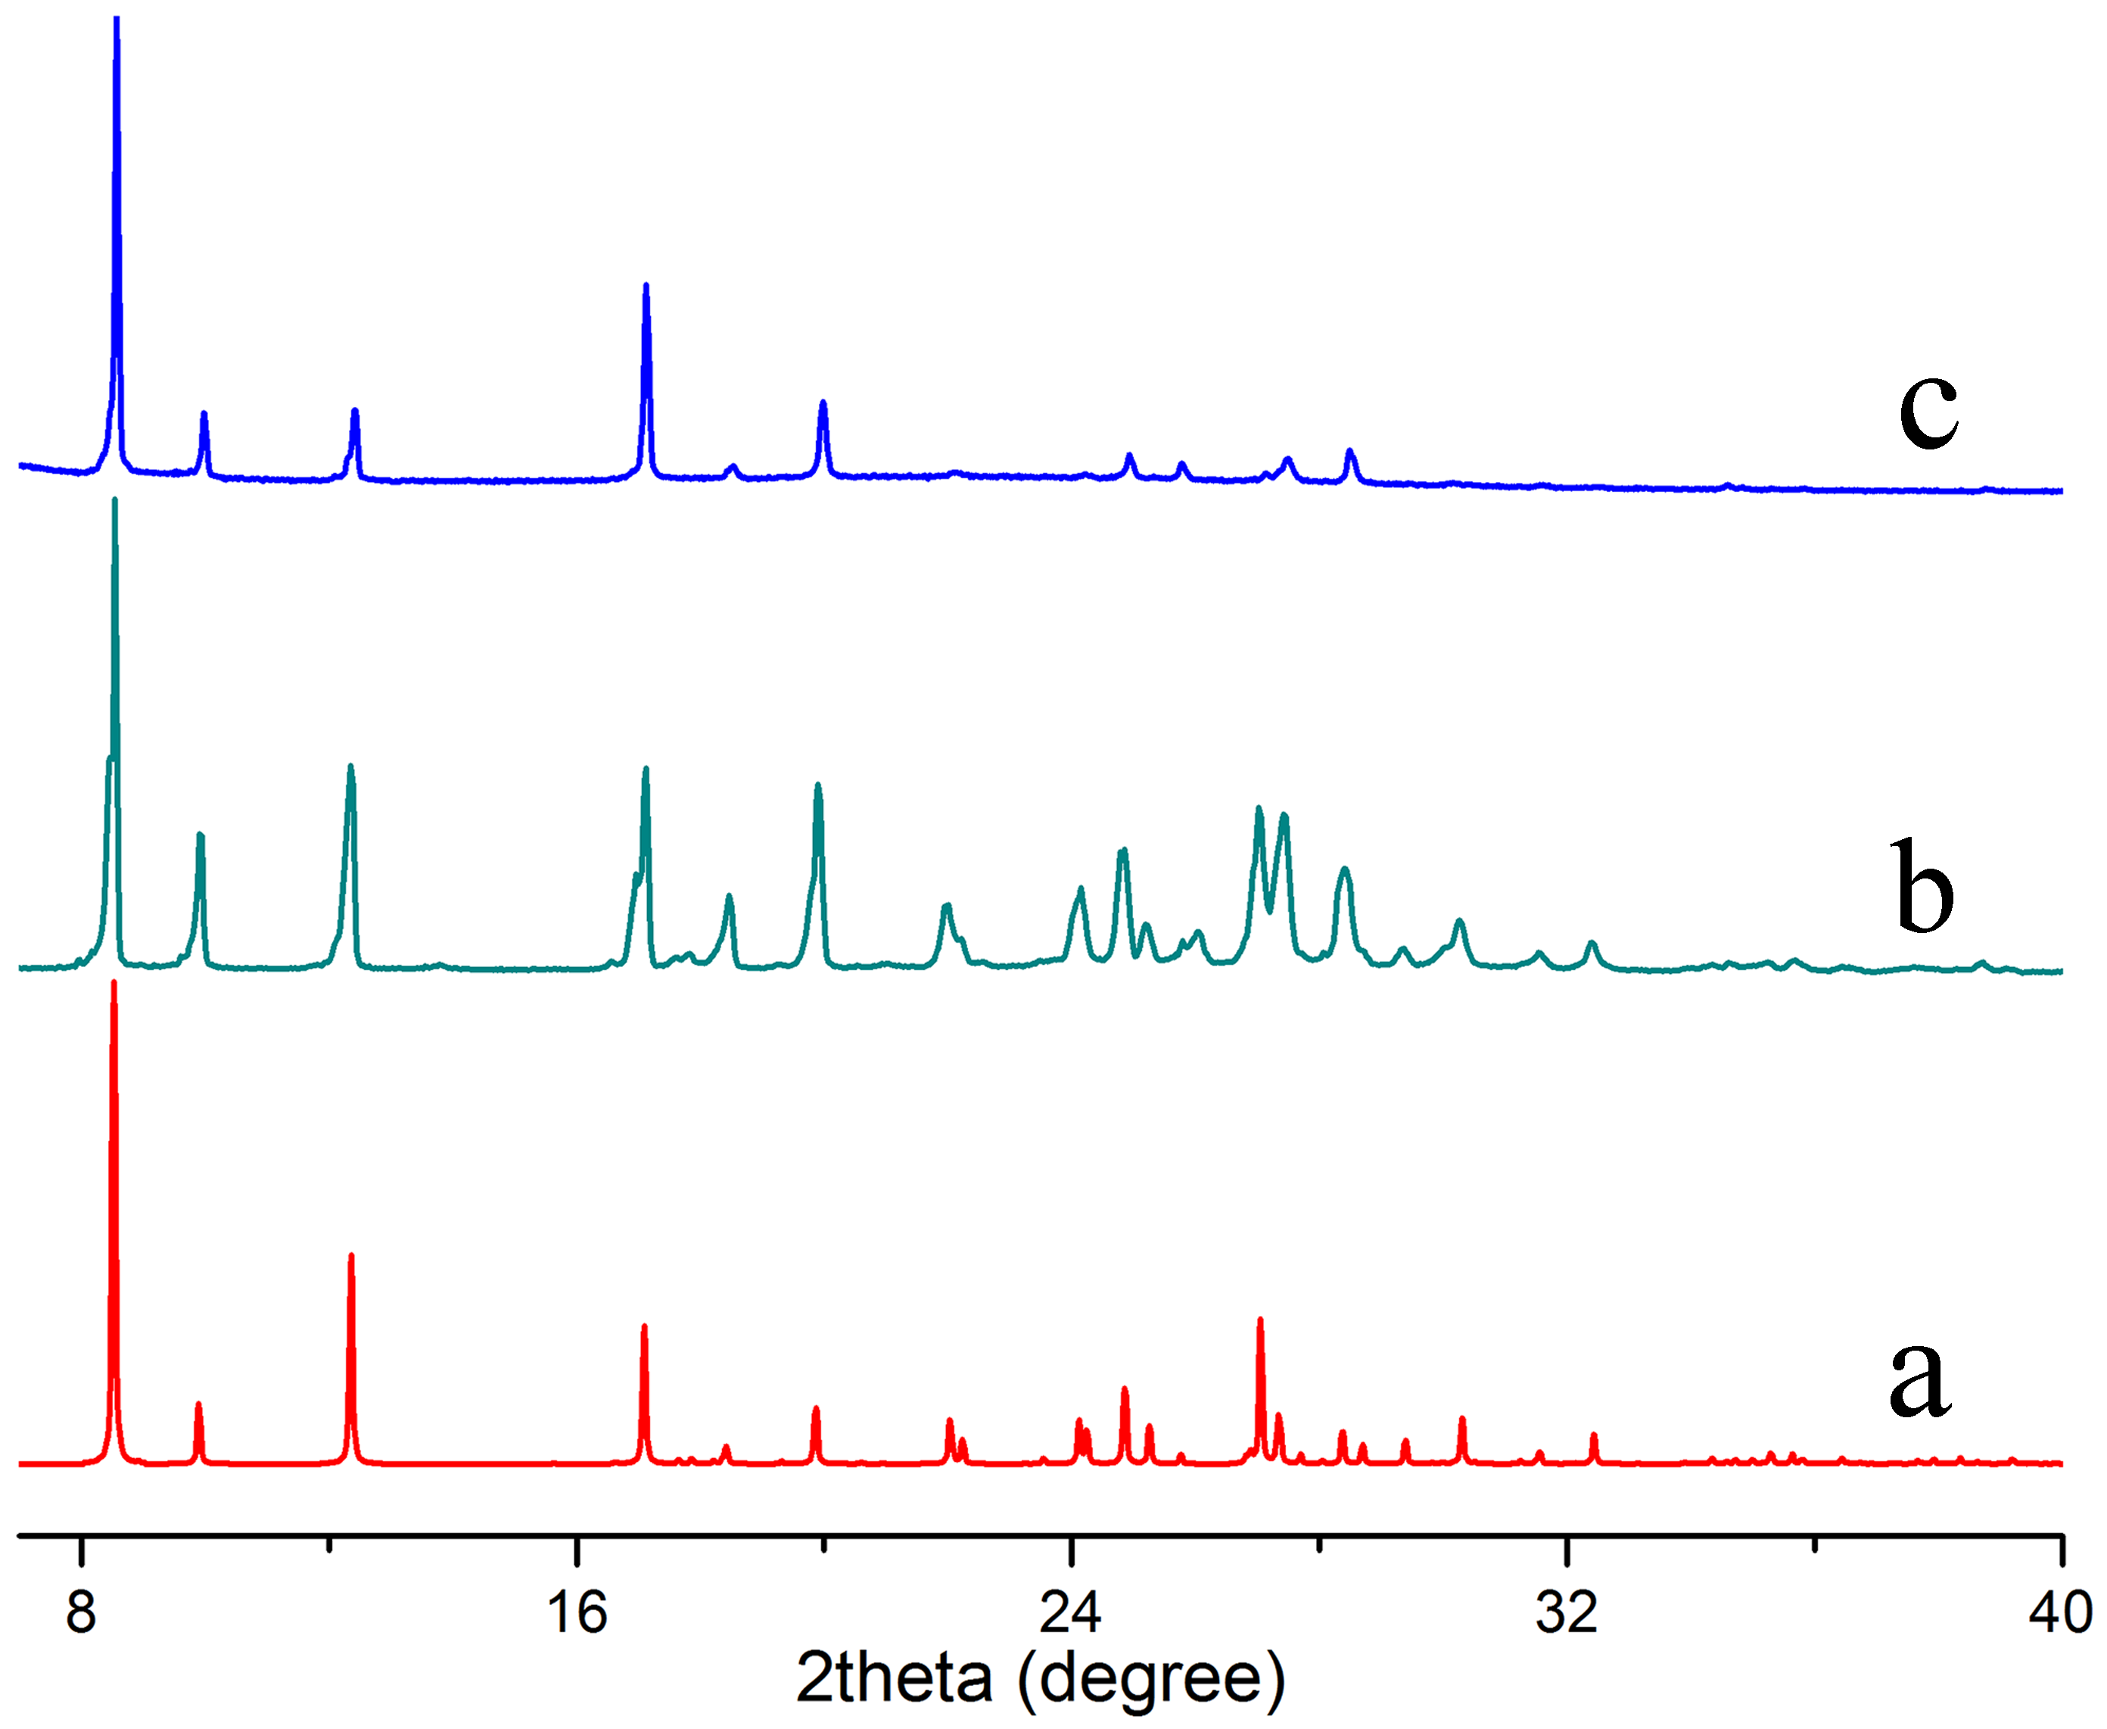
Figure S2. Simulated and experimental X-ray powder diffraction patterns of TNBF·2DMF. (a) Simulated patterns from structure mode; experimental patterns of the samples synthesized with (b) PMP and (c) BME. Because the crystals have needle-like morphology, preferred orientation 100 were involved in the simulation in Powder Cell program (http://www.ccp14.ac.uk/ccp/web-mirrors/powdcell/a_v/v_1/powder/e_cell.html).
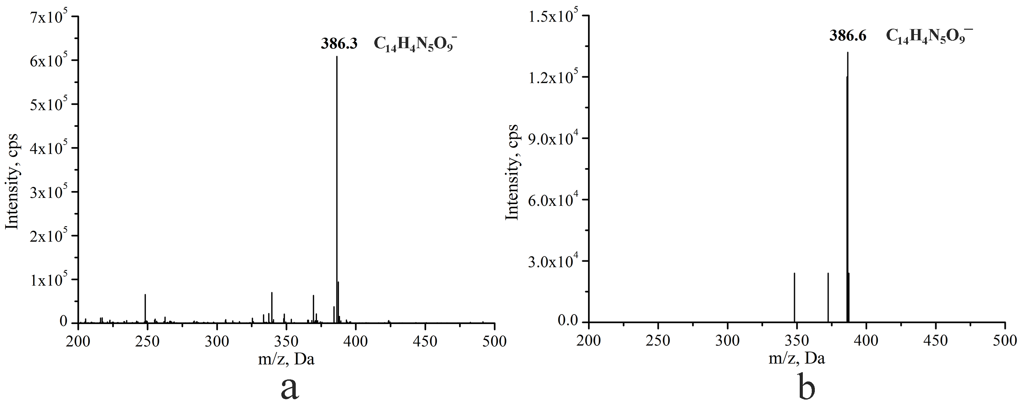
Figure S3. Negative ESI mass spectrum of TNBF·2DMF synthesized with (a) PMP and (b) BME obtained in AB Sciex API 3200 LS/MS/MS System. The signals at m/z = 386.3 and 386.6 were assigned as deprotonated TNBF.

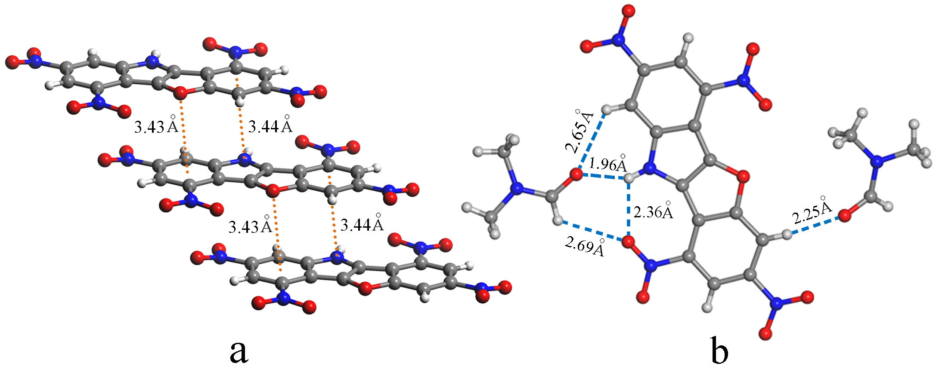
Figure S4. The π-stacking and H-bonding interactions in TNBF∙2DMF based on the crystal structure determined from the single-crystal X-ray diffractions of the sample synthesized with BME.

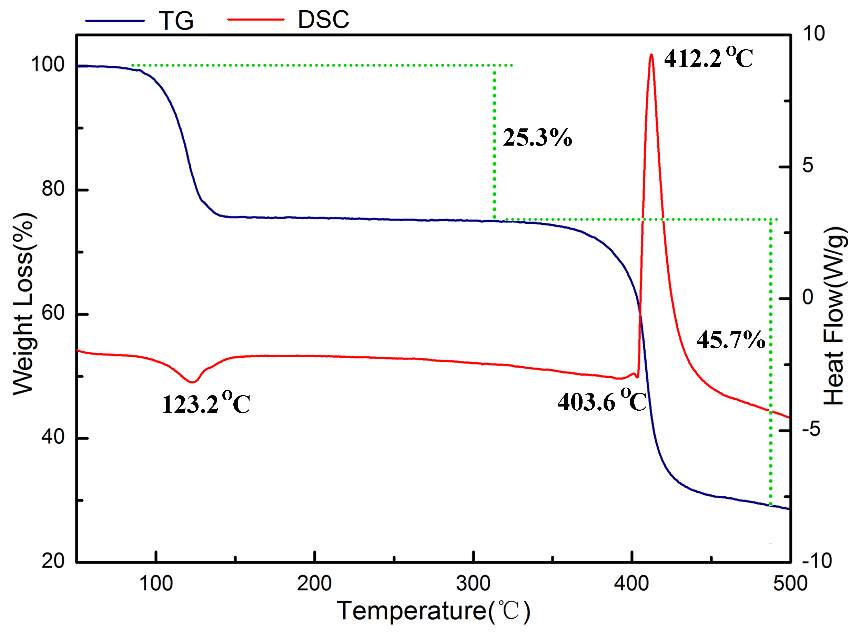
Figure S5. TG-DSC curves of TNBF∙2DMF measured from the sample synthesized with BME in air and in a heating rate of 10°C/min.
3. Tables
Table S1. Bond length (Å) of the TNBF molecule obtained from the single-crystal X-ray diffraction data of TNBF·2DMF synthesized with PMP.
O1-C1 | 1.382(6) | C10-C11 | 1.382(7) | N3-O5 | 1.218(6)
C1-C2 | 1.382(7) | C11-C12 | 1.375(7) | C5-N4 | 1.455(7)
C2-C3 | 1.379(7) | C12-C13 | 1.421(7) | N4-O6 | 1.222(6)
C3-C4 | 1.383(7) | C13-C8 | 1.421(7) | N4-O7 | 1.225(6)
C4-C5 | 1.376(7) | C13-C14 | 1.391(7) | C3-N5 | 1.462(7)
C5-C6 | 1.398(7) | C14-C7 | 1.393(6) | N5-O8 | 1.202(6)
C6-C1 | 1.412(7) | C14-O1 | 1.378(6) | N5-O9 | 1.239(7)
C6-C7 | 1.418(7) | C10-N2 | 1.467(7) | N1-H1 | 0.86
C7-N1 | 1.358(6) | N2-O2 | 1.228(7) | C2-H2 | 0.93
N1-C8 | 1.366(6) | N2-O3 | 1.208(7) | C4-H4 | 0.93
C8-C9 | 1.378(7) | C12-N3 | 1.445(7) | C9-H9 | 0.93
C9-C10 | 1.387(7) | N3-O4 | 1.221(6) | C11-H11 | 0.93

Table S2. Geometric parameters of the π-stacking interactions in the structure model of the TNBF·2DMF single crystal synthesized with PMP.
The distance between the center of the pyrrole ring and the benzene ring | 3.82 Å
The distance between the center of the furan ring and the benzene ring | 3.80 Å
The distance between N1 atom and the center of the benzene ring | 3.44 Å
The distance between O1 atom and the center of the benzene ring | 3.41 Å

Table S3. Geometric parameters of the π-stacking interactions in the structure model of the TNBF·2DMF single crystal synthesized with BME.
The distance between the center of the pyrrole ring and the benzene ring | 3.79 Å
The distance between the center of the furan ring and the benzene ring | 3.81 Å
The distance between N1 atom and the center of the benzene ring | 3.44 Å
The distance between O1 atom and the center of the benzene ring | 3.43 Å

Table S4. Geometric parameters of H-bonds in the structure model of the TNBF·2DMF single crystal synthesized with PMP.
D―H···A | d(H···A) | d(D···A) | ∠DHA
N1―H1···O10 | 1.96 Å | 2.74 Å | 150.0°
N1―H1···O6 | 2.35 Å | 2.83 Å | 115.6°
C9―H9···O10 | 2.62 Å | 3.26 Å | 126.7°
C15―H15···O6 | 2.63 Å | 3.24 Å | 124.1°
C2―H2···O11 | 2.23 Å | 3.15 Å | 169.4°

Table S5. Geometric parameters of H-bonds in the structure model of the TNBF·2DMF single crystal synthesized with BME.
D―H···A | d(H···A) | d(D···A) | ∠DHA
N1―H1···O10 | 1.96 Å | 2.73 Å | 149.5°
N1―H1···O6 | 2.36 Å | 2.84 Å | 115.9°
C9―H9···O10 | 2.65 Å | 3.29 Å | 126.3°
C15―H15···O6 | 2.69 Å | 3.29 Å | 123.2°
C2―H2···O11 | 2.25 Å | 3.17 Å | 171.5°

