Zn(ANA)₂Cl₂ complex as efficient catalyst for the synthesis of dihydropyrano[2,3-c]pyrazoles in aqueous medium via one-pot multicomponent reaction: a green approach
Ramaiah Konakanchiª, Venkata Bharat Nishtalaª, Shravankumar Kankala^{b*}, Laxma Reddy Kothaª*
ªDepartment of Chemistry, National Institute of Technology, Warangal-506 004, Telangana, India.
^{b}Department of Chemistry, Kakatiya University, Warangal-506009, Telangana, India.

1. Experimetal procedure and spectral data of [Zn(ANA)₂Cl₂] complex and Pyranopyrazoles

General procedure for the synthesis of [Zn(ANA)₂Cl₂ ] complex
The freshly purified ligand (0.488 g, 4 mmol) was dissolved in EtOH (20 mL) and added ethanolic solution of ZnCl₂.4H₂O (0.273 g, 2 mmol) were stirred at reflux temperature after mixing the solution for about 3 h. At the end of the reaction the excess ethanol was removed in vacuum and filtered after cooling without further purification to obtain 75% yield. Yellow solid: mp 288-290 ˚C; IR (KBr, cm⁻¹): 3412 (N-H), 1678 (C=O), 1564(C=N (py)). ¹H NMR (400 MHz, DMSO): δ: 6.73-6.76 (m, 2H), 7.56 (s, 4H), 8.00 (d, J = 8.0 Hz, 2H), 8.24 (d, J = 8.0 Hz, 2H), 9.85 (s, 2H) ppm. ¹³C NMR (100 MHz, DMSO): δ: 112.69, 113.49, 145.08, 155.31, 158.68, 194.10 ppm. Anal. calcd (%) for Zn(C₆H₆N₂O)₂Cl₂: Calcd: C, 37.85; H, 3.17; N, 14.72. Found: C, 37.80; H, 3.15; N 14.69.
General procedure for the synthesis of the dihydropyrano[2,3-c]pyrazoles (4a-l)
A mixture of aromatic aldehydes (1 mmol), malononitrile (1 mmol) and 3-Methyl-1-phenyl-2-pyrazoline-5-one (1 mmol) were stirred water at room temperature in the presence of 10 mol% of Zn(ANA)₂Cl₂ complex for appropriate time to produce dihydropyrano[2,3-c]pyrazoles. Reaction progress was monitored by TLC. After completion of the reaction the product was filtered. The residue was washed with ethyl acetate. The ethyl acetate was evaporated under vacuum and the obtained solid was purified by recrystalization process in ethyl acetate.
- Spectral data of the compound 4a-l
  - 6-amino-3-methyl-1,4-diphenyl-1,4-dihydropyrano[2,3-c]pyrazole-5-carbonitrile (4a): Colour: White solid; M. P.: 168-170 ˚C; Anal. Calcd. For C₂₀H₁₆N₄O: C, 73.15; H, 4.91; N, 17.06; found: C, 73.37; H, 4.98; N, 17.29. ¹H NMR (DMSO-d₆, 400 MHz) δ: 1.79 (s, 3H), 4.89 (s, 1H), 7.22-7.36 (m, 8H), 7.5 (d, 2H, J = 7.6 Hz), 7.8 (d, 2H, J = 7.6 Hz). ¹³C NMR (100 MHz, DMSO) δ: 159.90, 145.75, 144.36, 144.08, 138.02, 129.80, 129.00, 128.25, 127.52, 126.63, 120.43, 99.11, 58.68, 37.23, 13.03.
  - 6-amino-3-methyl-4-(3-nitrophenyl)-1-phenyl-1,4-dihydropyrano[2,3-c]pyrazole-5-carbonitrile (4b): Colour: White solid; M. P.: 187-189 ˚C; Anal. Calcd. For C₂₀H₁₅N₅O₃: C, 64.34; H, 4.05; N, 18.76; found: C, 64.59; H, 4.11; N, 18.49. ¹H NMR (DMSO-d₆, 400 MHz) δ: 1.81 (s, 3H), 4.99 (s, 1H), 7.34 (t, 1H, J = 7.2 Hz), 7.42 (s, 2H), 7.51 (t, 2H, J = 7.6 Hz), 7.69 (t, 1H, J = 8.4 Hz), 7.79- 7.82 (m,3H), 8.17 (bs, 2H). ¹³C NMR (100 MHz, DMSO) δ: 160.23, 148.42, 146.45, 145.63, 144.50, 137.91, 135.25, 130.76, 129.80, 129.39, 126.77, 122.76, 122.73, 120.58, 120.28, 98.13, 57.53, 36.67, 13.08.
  - 6-amino-3-methyl-4-(2-nitrophenyl)-1-phenyl-1,4-dihydropyrano[2,3-c]pyrazole-5-carbonitrile (4c): Colour: White solid; M. P.: 156-158 ˚C; Anal. Calcd. For C₂₀H₁₅N₅O₃: C, 64.34; H, 4.05; N, 18.76; found: C, 64.02; H, 4.15; N, 18.98. ¹H NMR (DMSO-_{d6}, 400 MHz) δ: 1.76 (s, 3H), 5.21 (s, 1H), 7.32-7.39 (m, 3H), 7.49-7.56 ( m, 4H), 7.7 (t, 1H, J = 7.6 Hz), 7.8 (d, 2H, J = 8.00 Hz), 7.91(d, 1H, J =8.00 Hz). ¹³C NMR (100 MHz, DMSO) δ: 160.26, 149.75, 147.25, 145.36, 144.83, 138.18, 137.89, 137.17, 133.89, 132.12, 129.82, 129.11, 126.82, 124.19, 120.59, 119.96, 97.78, 57.28, 32.38, 12.75.
  - 6-amino-4-(3,4-dimethylphenyl)-3-methyl-1-phenyl-1,4-dihydropyrano[2,3-c]pyrazole-5-carbonitrile (4d): Colour: White solid; M. P.: 150-151 ˚C; Anal. Calcd. For C₂₂H₂₀N₄O: C, 74.14; H, 5.66; N, 15.72; found: C, 74.39; H, 5.75; N, 15.51. ¹H NMR (DMSO-d6, 400 MHz) δ: 1.82 (s, 3H), 3.72 (s, 3H), 3.74 (s,3H), 4.64 (s, 1H), 6.75-6.93 (m, 3H), 7.17 (s, 2H) 7.32 (t, 1H, J = 7.2 Hz), 7.49 (t, 2H, J = 7.6 Hz), 7.79 (d, 2H, J = 8.00 Hz)^{.13}C NMR (100 MHz, DMSO) δ: 159.80, 149.09, 148.28, 145.86, 144.27, 138.07, 136.52, 129.79, 126.57, 120.55, 120.35, 112.26, 112.03, 99.18, 58.90, 56.04, 55.93, 36.65, 13.15.
  - 6-amino-4-(4-cyanophenyl)-3-methyl-1-phenyl-1,4-dihydropyrano[2,3-c]pyrazole-5-carbonitrile (4e): Colour: White solid; M. P. 198-200 ˚C; Anal. Calcd. For C₂₁H₁₅N₅O: C, 71.38; H, 4.28; N, 19.82; found: C, 71.62; H, 4.34; N, 19.69. ¹H NMR (DMSO-d₆, 400 MHz) δ: 1.79 (s, 3H), 4.85 (s, 1H), 7.34 (t, 1H, J = 7.2 Hz), 7.39 (s, 2H), 7.49-7.52 (m, 4H), 7.80-7.86(m, 4H).¹³C NMR (100 MHz, DMSO) δ: 160.17, 149.66, 145.59, 144.50, 137.92, 133.11, 129.79, 129.43, 126.75, 120.57, 120.25, 119.24, 110.43, 98.11, 57.50, 37.13, 13.01.
  - 6-amino-4-(4-hydroxyphenyl)-3-methyl-1-phenyl-1,4-dihydropyrano[2,3-c]pyrazole-5-carbonitrile (4f): Colour: White solid; M. P. 205-207 ˚C; Anal. Calcd. For _{C20H16N4O2}: C, 69.76; H, 4.68; N, 16.27; found: C, 69.91; H, 4.75; N, 16.11. ¹H NMR (DMSO-_{d6}, 400 MHz) δ: 1.81 (s, 3H), 4.57 (s, 1H), 6.76 (s, 2H), 7.06 (s, 2H), 7.17 (s, 2H), 7.31(s, 1H), 7.49 (s,2H), 7.80 (s,2H), 9.39 (s,1H)^{.13}C NMR (100 MHz, DMSO) δ: 159.67, 156.77, 145.84, 144.24, 138.07, 134.41, 129.78, 129.26, 126.52, 120.62, 120.33, 115.70, 99.50, 59.27, 36.50, 19.03.
  - 6-amino-4-(4-chlorophenyl)-3-methyl-1-phenyl-1,4-dihydropyrano[2,3-c]pyrazole-5-carbonitrile (4g): Colour: pale yellow solid; M. P.: 176-178 ˚C; Anal. Calcd. For C₂₀H₁₅ClN₄O: C, 66.21; H, 4.17; Cl, 9.77; N, 15.44; found: C, 66.43; H, 4.10; Cl, 9.58; N, 15.19. ¹H NMR (DMSO-d₆, 400 MHz) δ: 1.82 (s, 3H), 4.73 (s, 1H), 7.27-7.34 (m, 5H), 7.42 (d, 2H, J = 8.00 Hz), 7.5 (t, 2H, J = 7.2 Hz), 7.8 (d, 2H, J = 7.6 Hz). ¹³C NMR (100 MHz, DMSO) δ: 159.95, 145.67, 144.40, 143.14, 137.97, 132.06, 130.18, 129.80, 129.01, 126.69, 120.50, 120.34, 98.66, 58.24, 36.56, 13.04.
  - 6-amino-4-(2,4-dichlorophenyl)-3-methyl-1-phenyl-1,4-dihydropyrano[2,3-c]pyrazole-5-carbonitrile (4h): Colour: White solid; M. P.: 183-185 ˚C; Anal. Calcd. For _{C20H14}C_{l2N4}O: C, 60.47; H, 3.55; Cl, 17.85; N, 14.10; found: C, 60.69; H, 3.49; Cl, 17.66; N, 14.39. ¹H NMR (DMSO-_{d6}, 400 MHz) δ: 1.78 (s, 3H), 5.16 (s, 1H), 7.32 (d, 1H), 7.36 (s, 2H,), 7.39-7.63 (m, 5H,), 7.78-7.80 (d, 2H). ¹³C NMR (100 MHz, DMSO) δ: 160.42, 145.30, 144.75, 139.74, 137.90, 133.55, 133.02, 132.97, 30.54, 129.82, 129.43, 128.59, 126.78, 120.53, 120.01, 97.76, 56.62, 34.02, 12.82.
  - 6-amino-4-(4-bromophenyl)-3-methyl-1-phenyl-1,4-dihydropyrano[2,3-c]pyrazole-5-carbonitrile (4i): Colour: White solid; M. P.: 182-184 ˚C; Anal. Calcd. For C₂₂H₂₁N₅O: C, 71.14; H, 5.70; N, 18.85; found: C, 71.35; H, 5.75; N, 18.63. ¹H NMR (DMSO-d₆, 400 MHz) δ: 1.8 (s, 3H), 4.72 (s, 1H), 7.23-7.34 (m, 5H), 7.48-7.6 ( m, 4H), 7.79 (d, 2H, J = 8.00 Hz). ¹³C NMR (100 MHz, DMSO) δ: 159.95, 145.67, 144.40, 143.56, 137.96, 131.93, 130.54, 129.80, 126.69, 120.60, 120.49, 120.34, 98.59, 58.16, 36.62, 13.05.
  - 6-amino-4-(4-methoxyphenyl)-3-methyl-1-phenyl-1,4-dihydropyrano[2,3-c]pyrazole-5-carbonitrile (4j): Colour: White solid; M. P.: 172-174 ˚C; Anal. Calcd. For C₂₁H₁₈N₄O₂: C, 70.38; H, 5.06; N, 15.63; found: C, 69.69; H, 5.85; N, 6.19. ¹H NMR (DMSO-d₆, 400 MHz) δ: 1.79 (s, 3H), 3.75 (s, 3H), 4.63 (s,1H), 6.91 (d, 1H, J = 8.4 HZ), 7.16-7.18 (m, 3H), 7.31 (t, 1H, J = 7.2 Hz), 7.38 (t, 1H, J = 7.6 Hz), 7.49 (t, 2H, J = 7.6 Hz), 7.79 (d, 3H, J = 8.4 Hz).

  - 6-amino-4-(3-ethoxy-4-hydroxyphenyl)-3-methyl-1-phenyl-1,4-dihydropyrano[2,3-c]pyrazole-5-carbonitrile (4k): Colour: White solid; M. P.: 167-169 ˚C; Anal. Calcd. For C₂₂H₂₀N₄O₃: C, 68.03; H, 5.19; N, 14.42; found: C, 69.69; H, 5.85; N, 6.19. ¹H NMR (DMSO-d₆, 400 MHz) δ: 1.30 (t, 3H, J = 6.8 Hz), 1.82 (s, 3H), 3.96-4.01 (m, 2H), 4.56 (s, 1H), 6.61-7.13 (m, 5H), 7.31 (t, 1H, J = 7.2 Hz), 7.49 (t, 2H, J = 7.6 Hz) 7.79 (d, 2H, J = 8.4 Hz), 8.83 (s, 1H). ¹³C NMR (100 MHz, DMSO) δ: 159.69, 146.91, 146.30, 145.87, 144.23, 138.09, 134.97, 129.79, 126.53, 120.66, 120.57, 120.31, 116.09, 113.96, 99.36, 64.44, 59.15, 36.79, 15.18, 13.13.
  - 6-amino-3-methyl-4-(4-nitrophenyl)-1-phenyl-1,4-dihydropyrano[2,3-c]pyrazole-5-carbonitrile (4l): Colour: white solid; M. P.: 191-193 ˚C; . Anal. Calcd. For C₂₀H₁₅N₅O₃: C, 64.34; H, 4.05; N, 18.76; found: C, 64.61; H, 3.97; N, 18.98. ¹H NMR (DMSO-_{d6}, 400 MHz) δ: 1.82 (s, 3H), 4.94 (s, 1H), 7.44-7.6 (m, 7H), 7.83 (bs, 2H), 8.25 (bs, 2H). ¹³C NMR (100 MHz, DMSO) δ: 160.20, 151.66, 147.08, 145.62, 144.48, 137.91, 129.79, 129.68, 126.76, 124.36, 120.54, 120.23, 98.05, 57.38, 36.90, 13.03.

2. Characterization spectra (¹H-NMR, ¹³C-NMR) of the synthesized compounds (4a-l).
Fig. 1: ¹HNMR spectrum of the compound 4a.
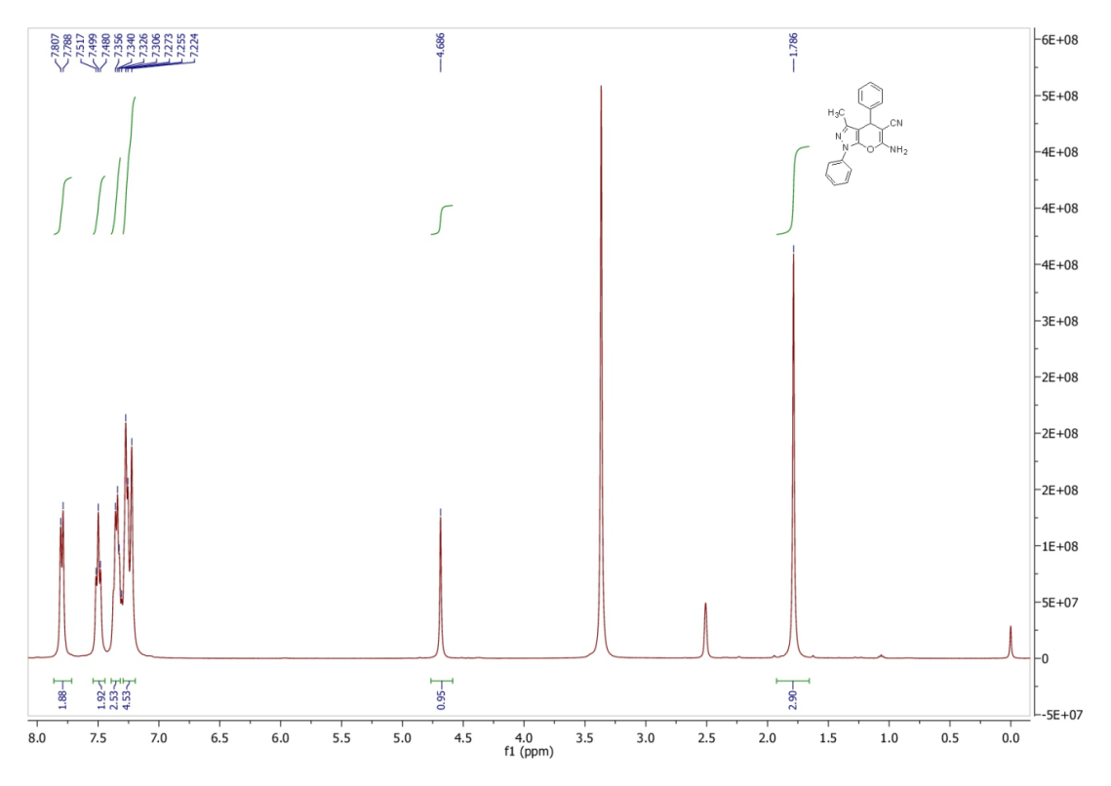
Fig. 2: ¹³CNMR spectrum of the compound 4a.
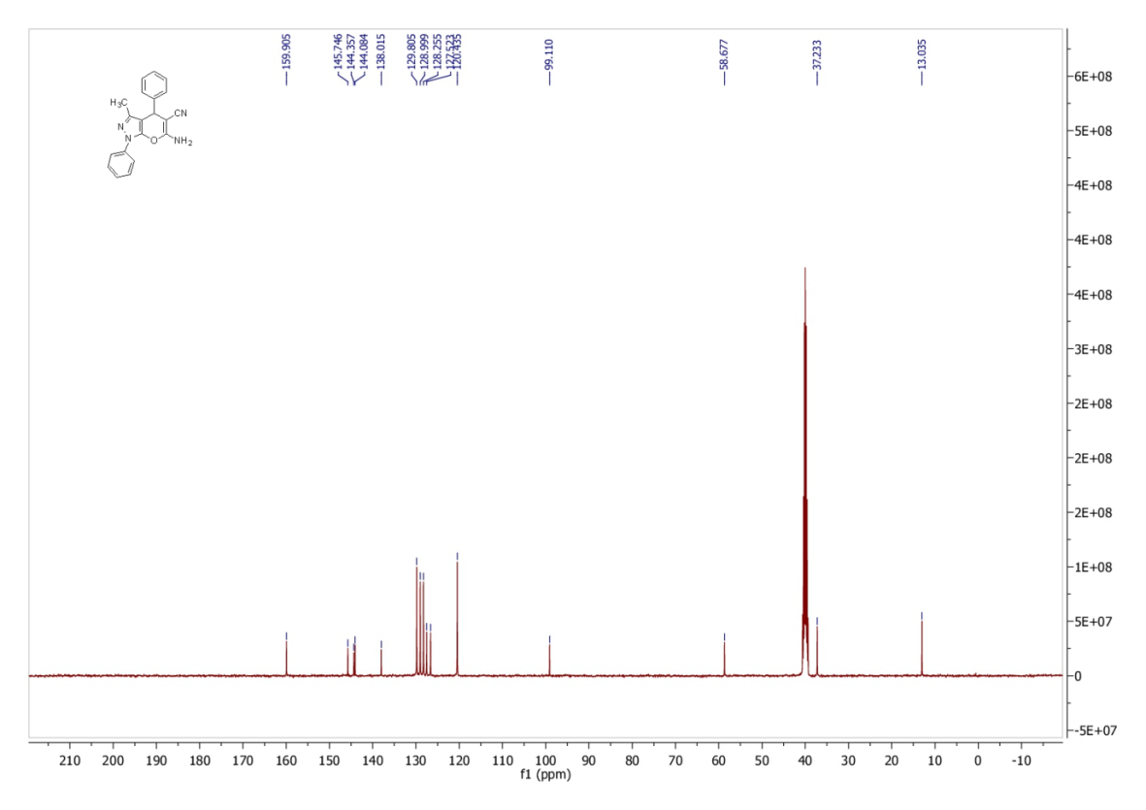
Fig. 3: ¹HNMR spectrum of the compound 4b.
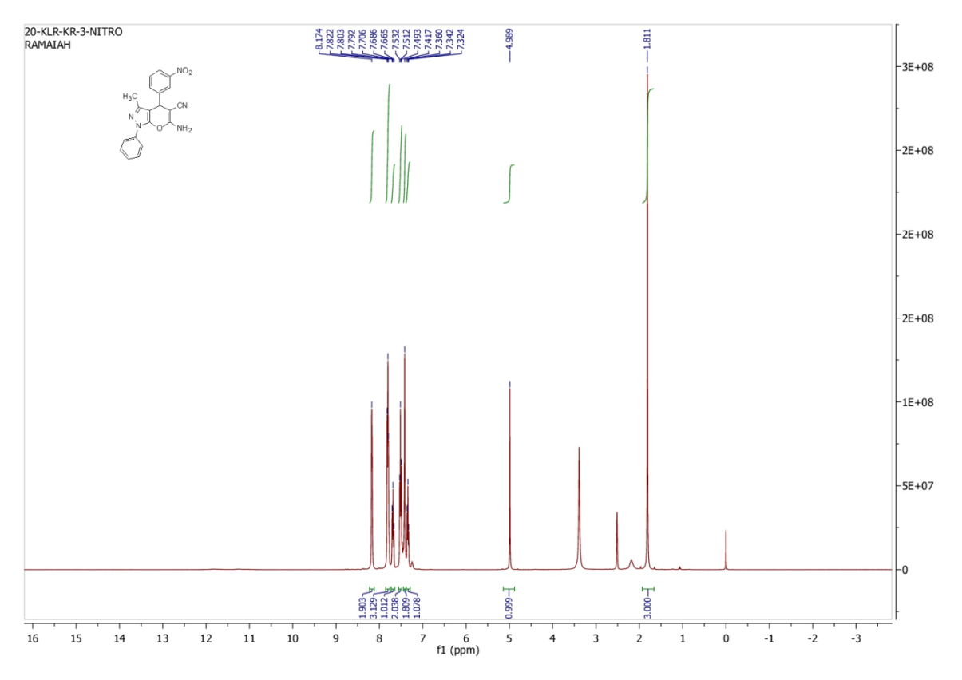
Fig. 4: ¹³CNMR spectrum of the compound 4b.
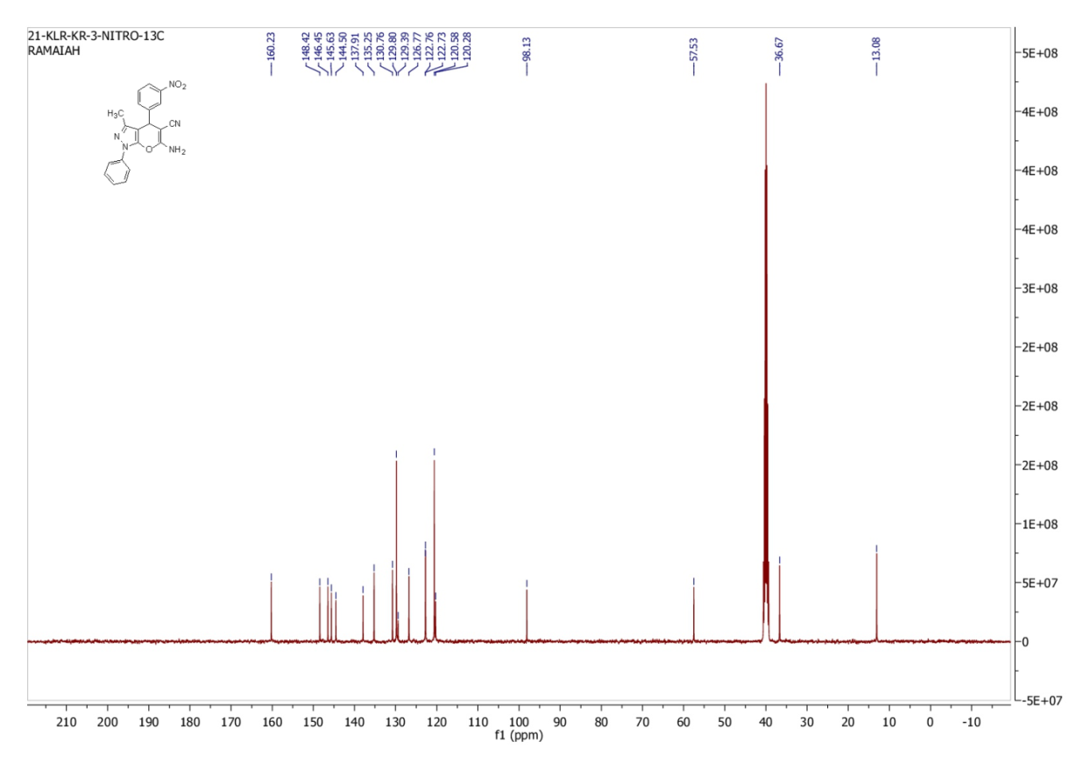
Fig. 5: ¹HNMR spectrum of the compound 4c.
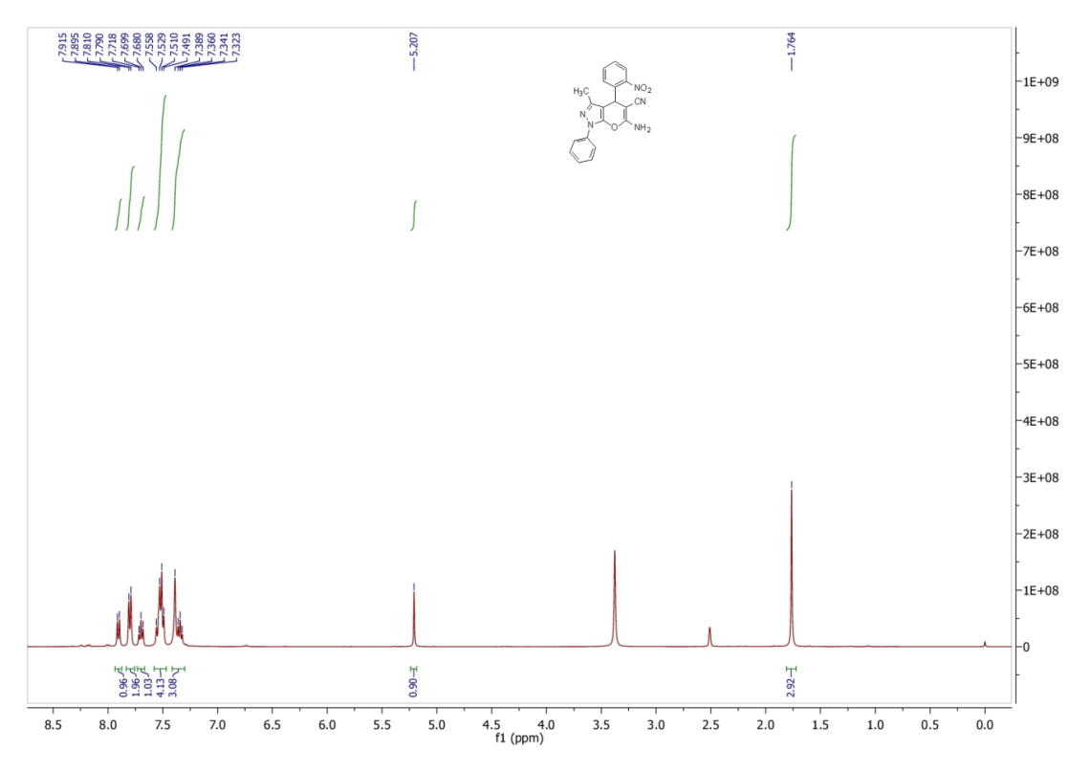
Fig. 6: ¹³CNMR spectrum of the compound 4c.
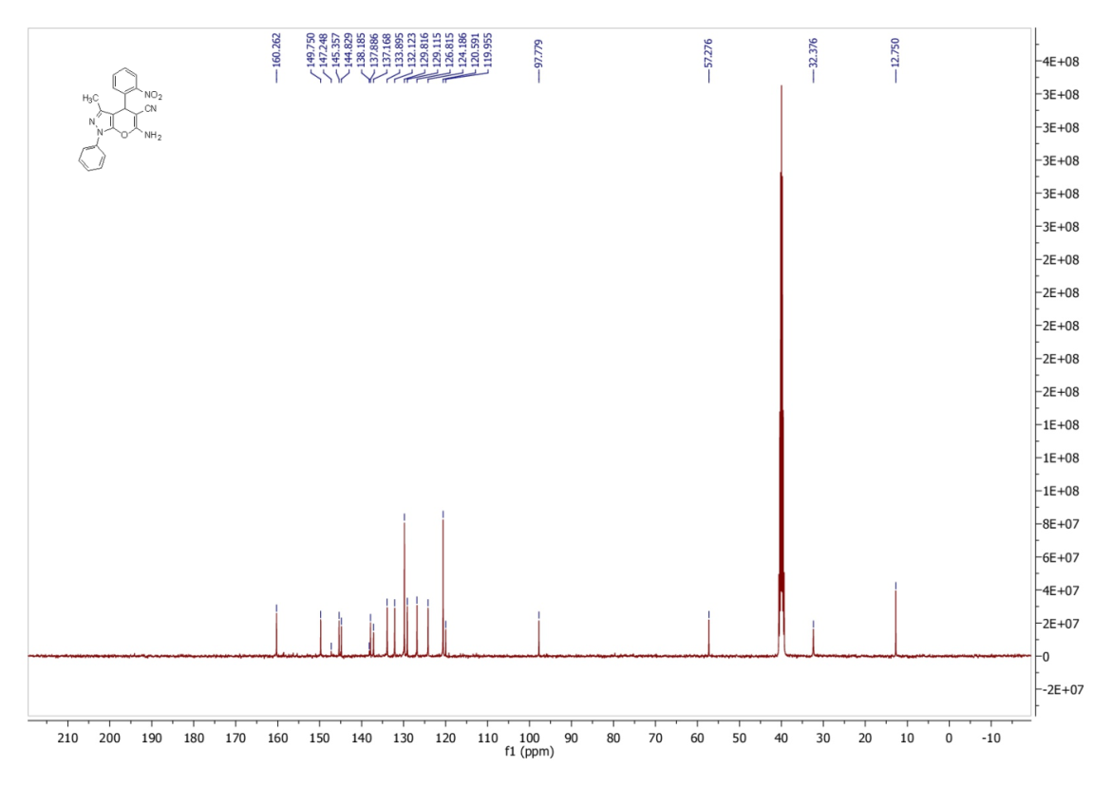

Fig. 7: ¹HNMR spectrum of the compound 4d.
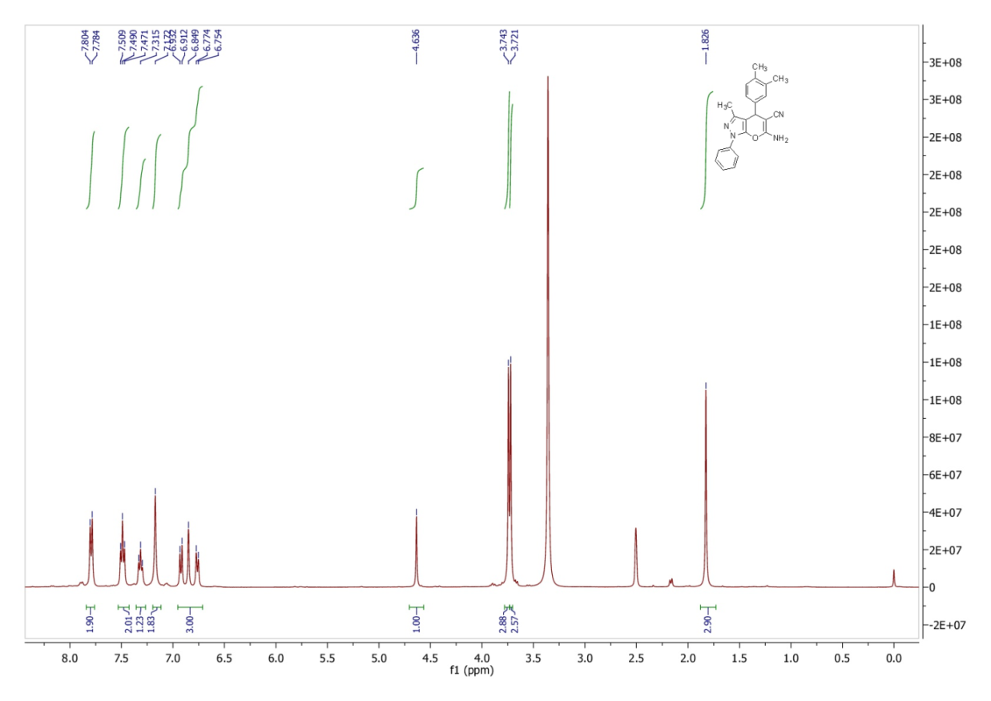
Fig. 8: ¹³CNMR spectrum of the compound 4d.
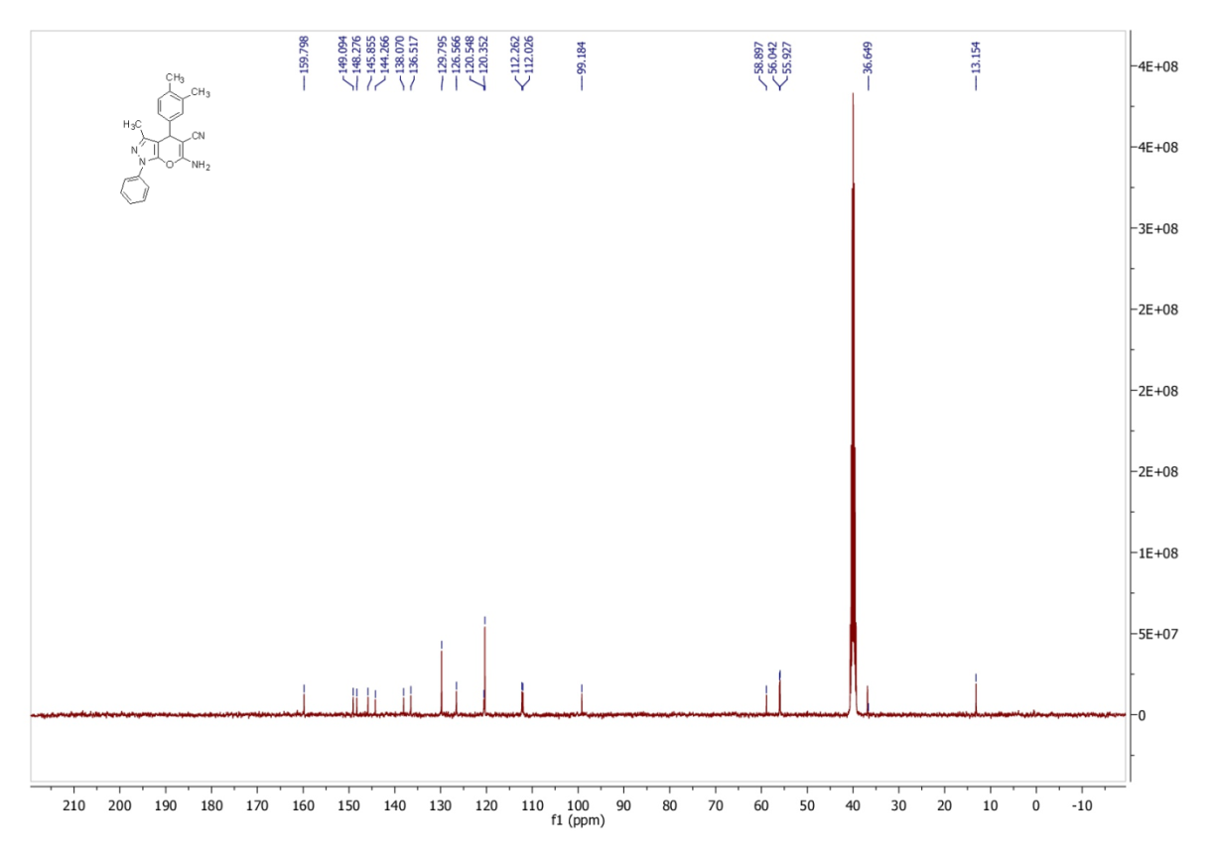
Fig. 9: ¹HNMR spectrum of the compound 4e.
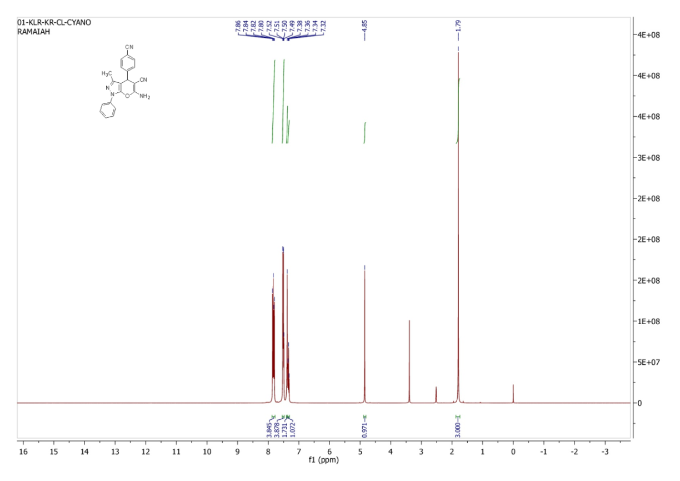
Fig. 10: ¹³CNMR spectrum of the compound 4e.
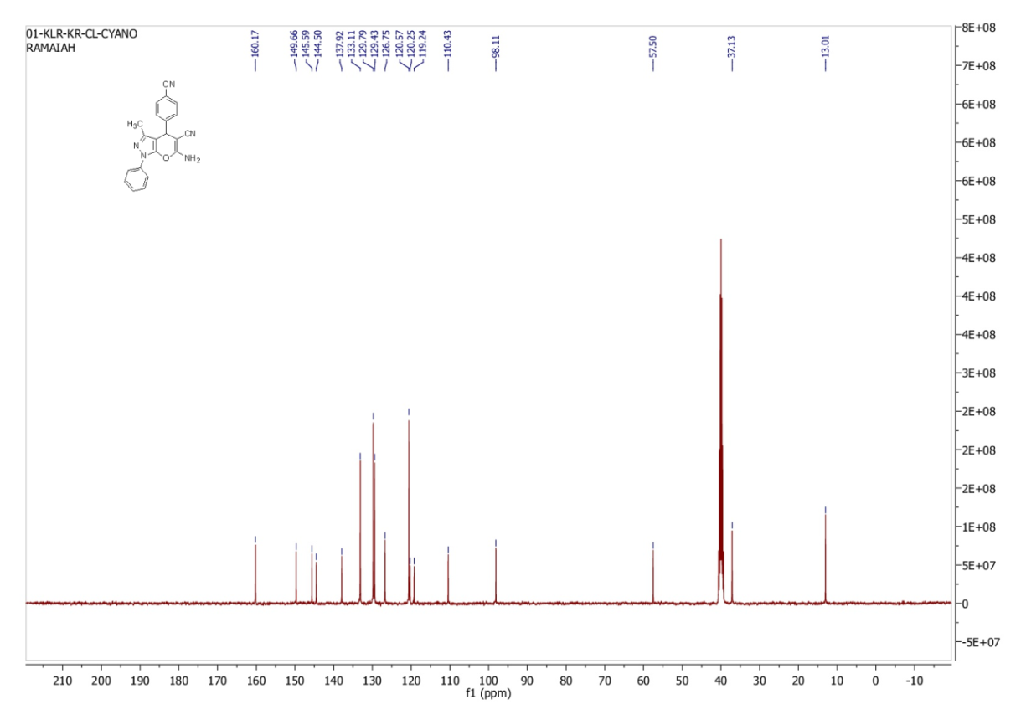
Fig. 11: ¹HNMR spectrum of the compound 4f.
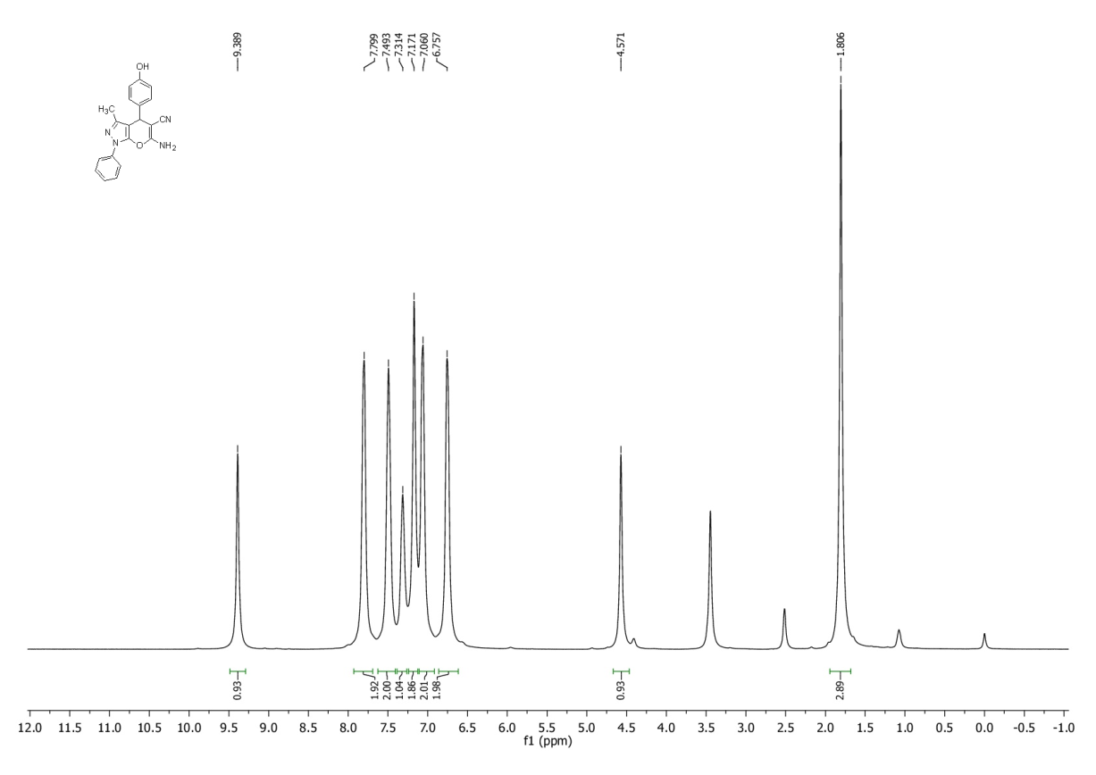
Fig. 12: ¹³CNMR spectrum of the compound 4f.
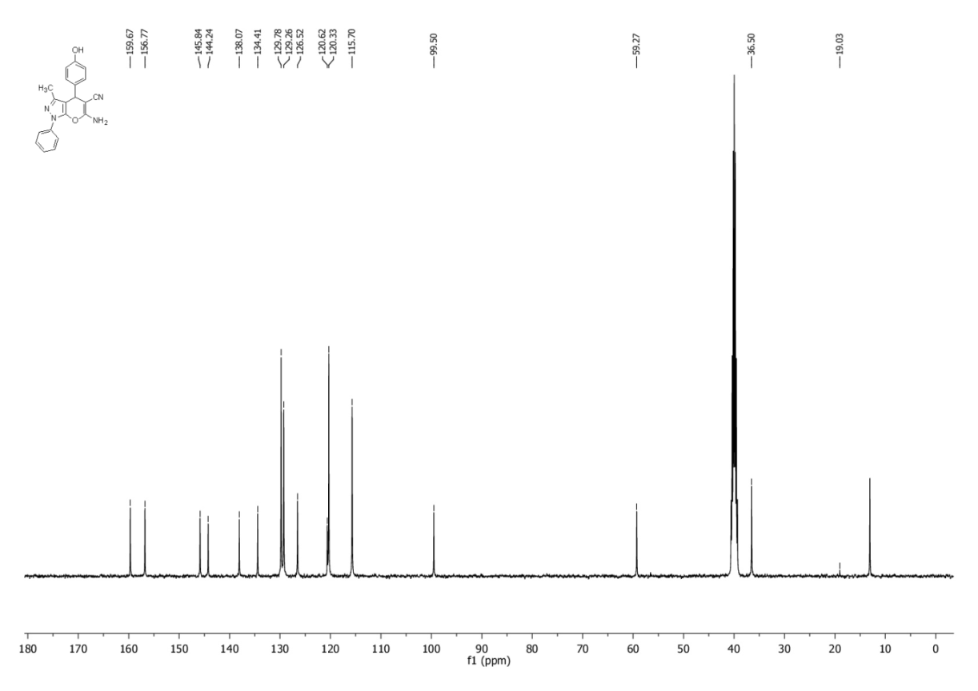
Fig. 13: ¹HNMR spectrum of the compound 4g.
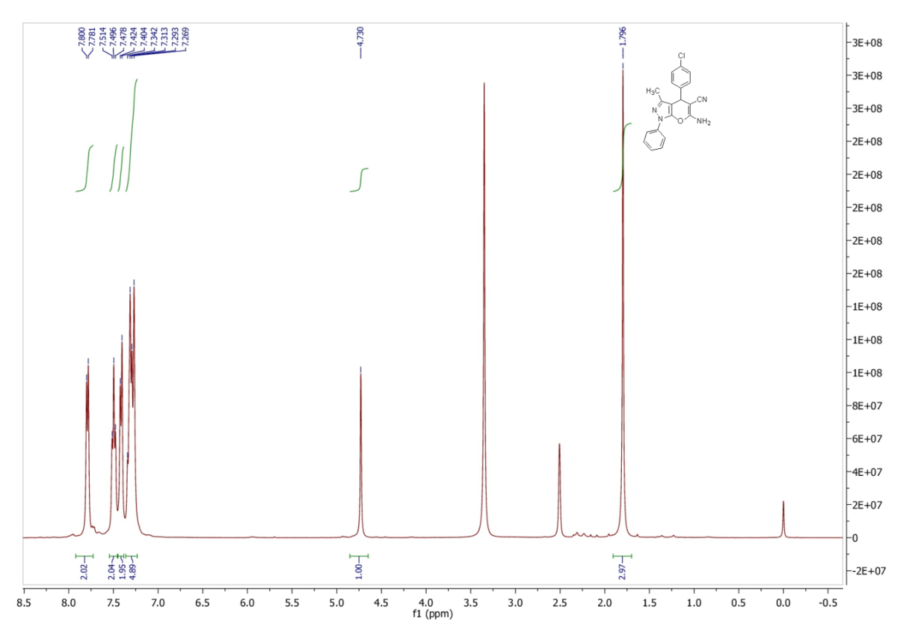
Fig. 14: ¹³CNMR spectrum of the compound 4g.
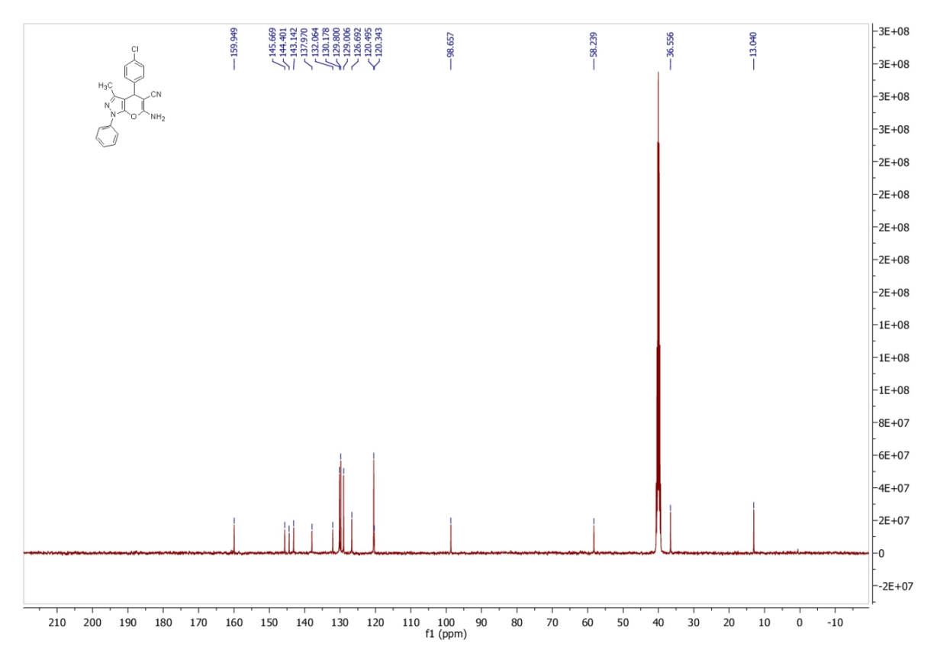
Fig. 15: ¹HNMR spectrum of the compound 4h.
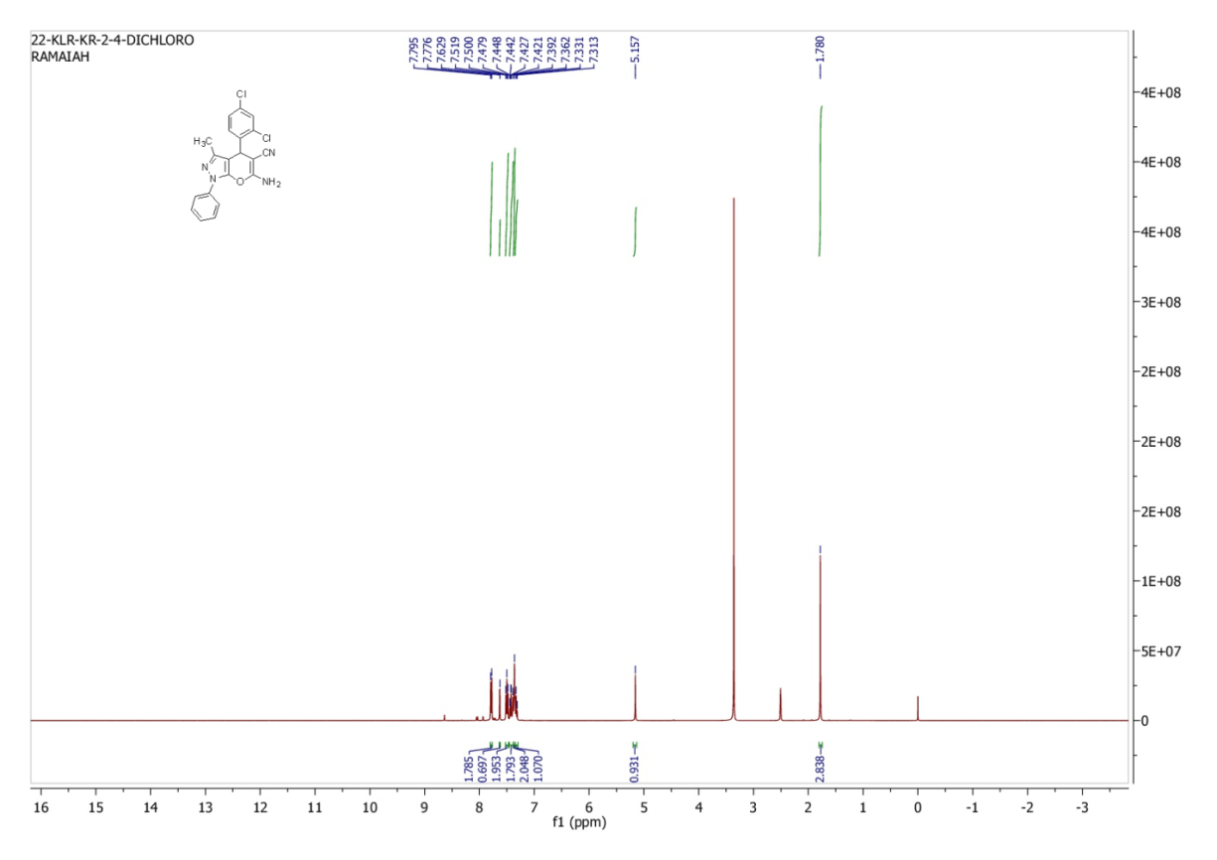
Fig. 16: ¹³CNMR spectrum of the compound 4h.
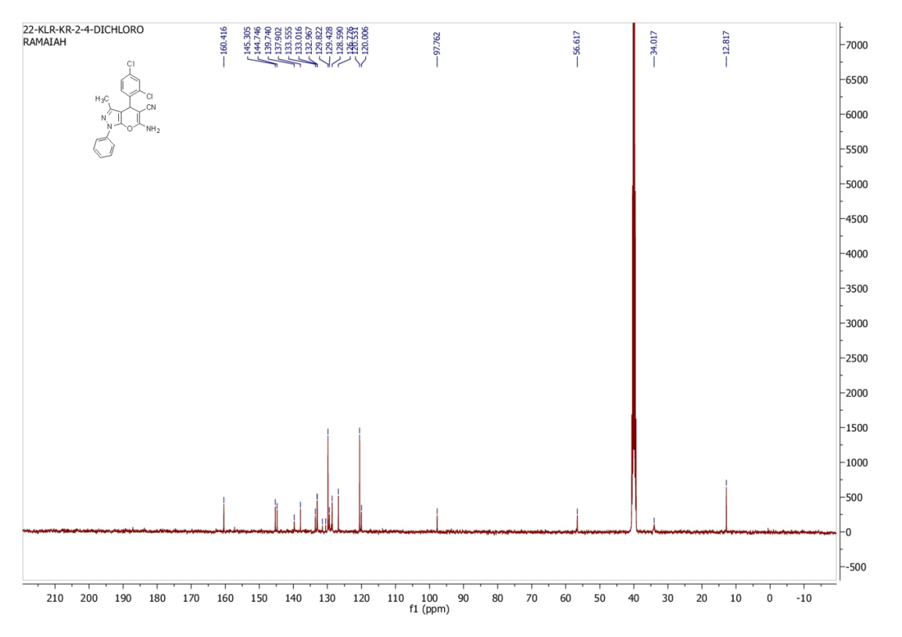
Fig. 17: ¹HNMR spectrum of the compound 4i.
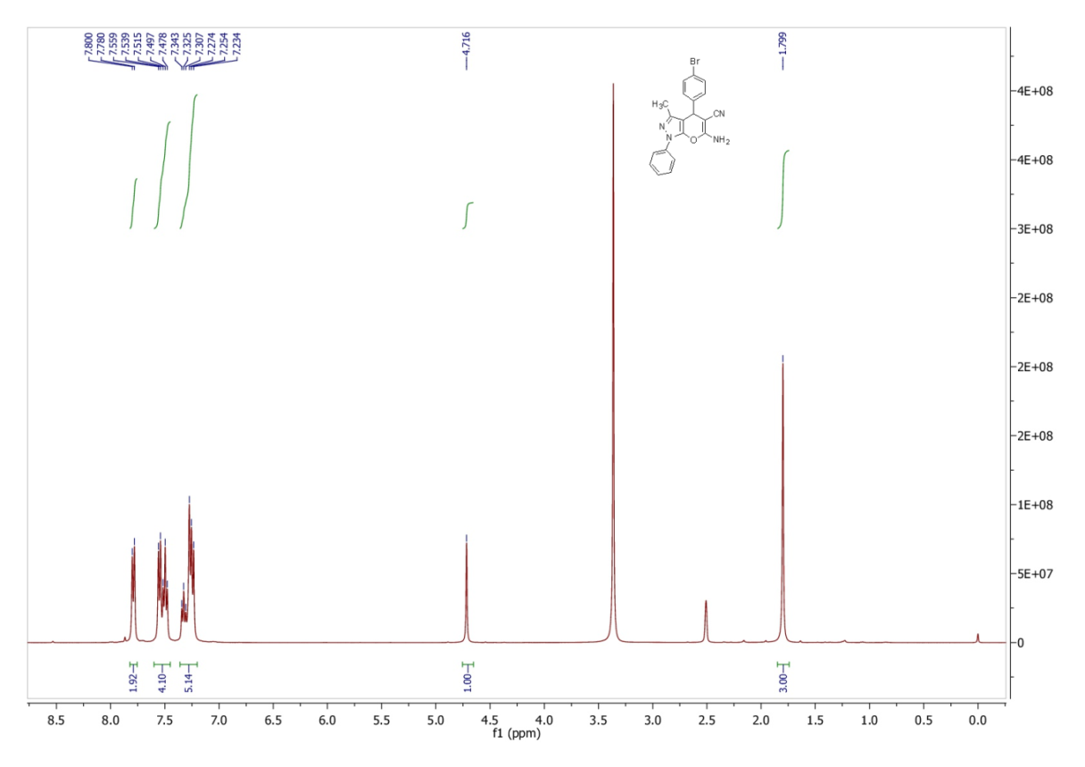
Fig. 18: ¹³CNMR spectrum of the compound 4i.
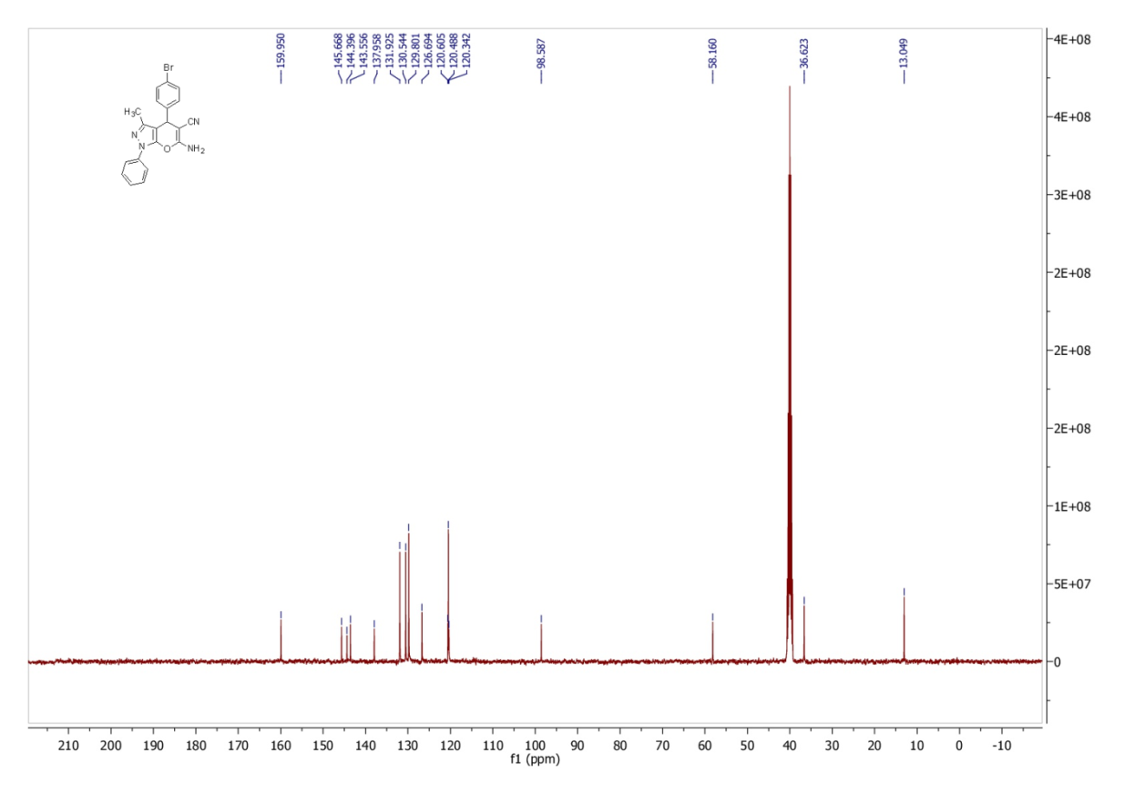
Fig. 19: ¹HNMR spectrum of the compound 4j.
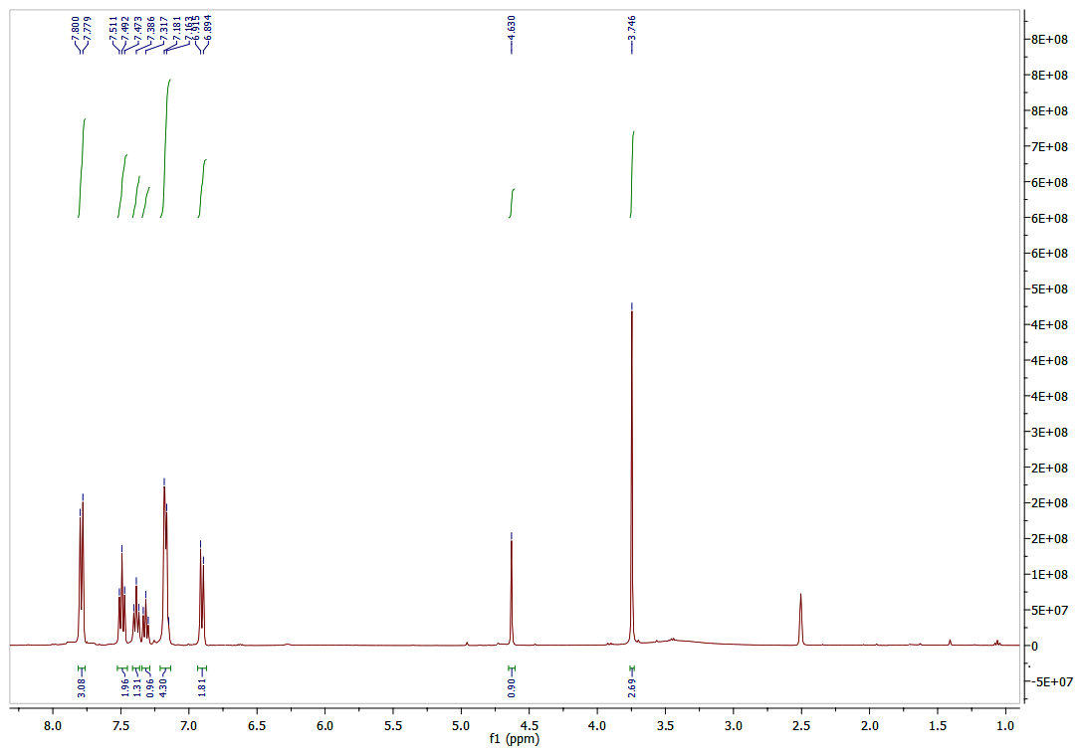
Fig. 20: ¹HNMR spectrum of the compound 4k.
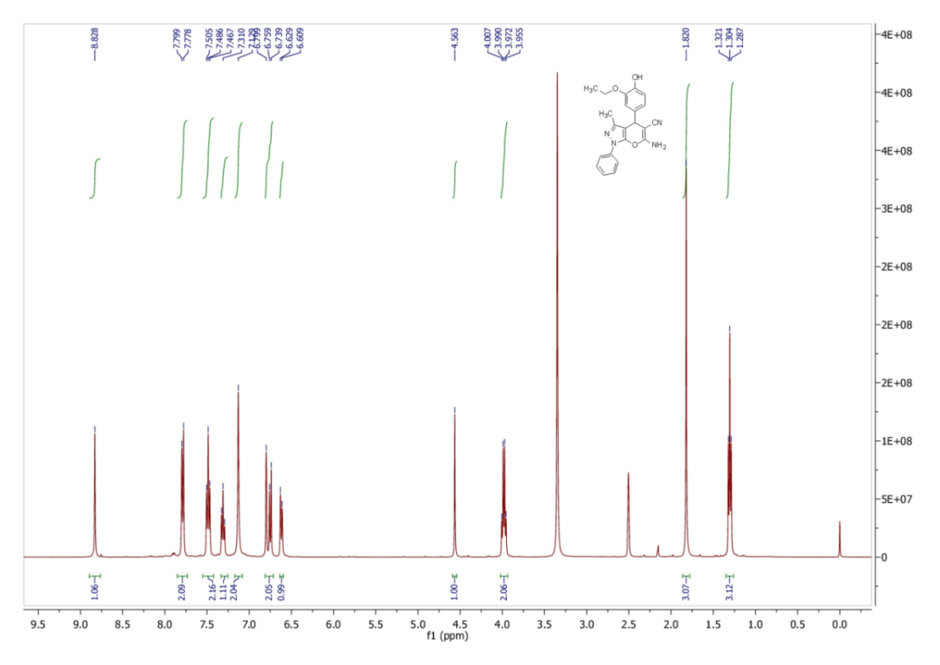
Fig. 21: ¹³CNMR spectrum of the compound 4k.
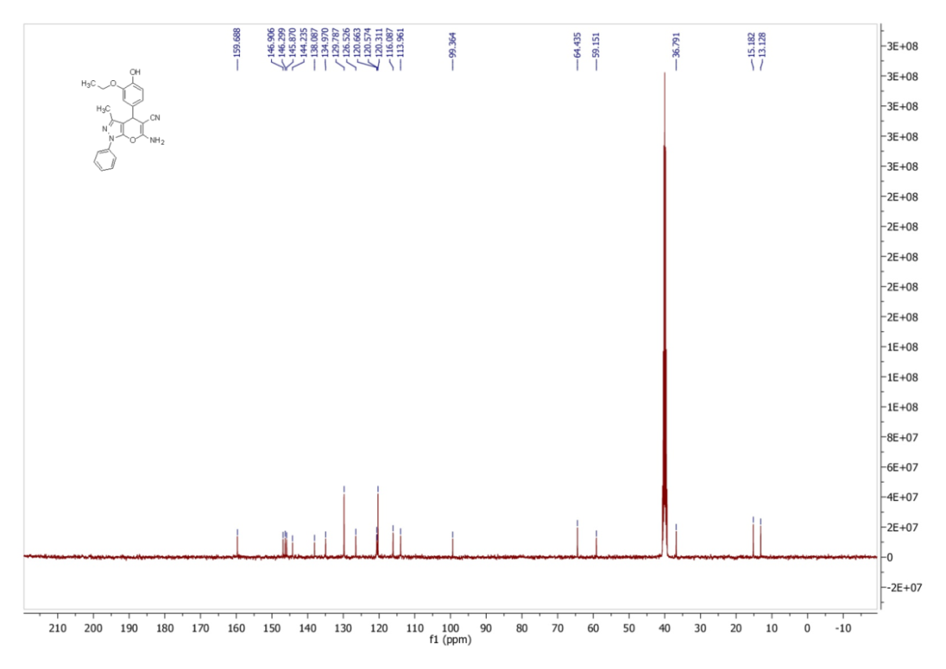
Fig. 22: ¹HNMR spectrum of the compound 4l.
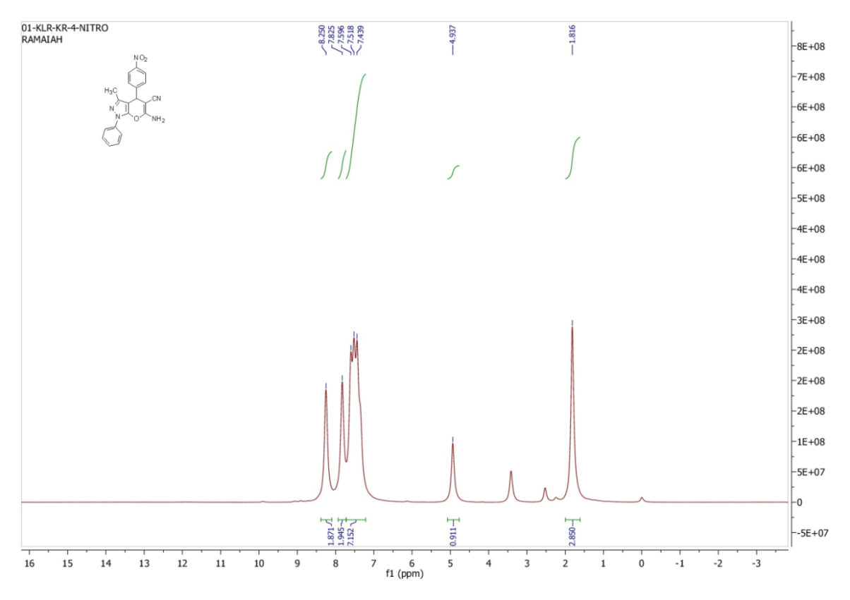
Fig. 23: ¹³CNMR spectrum of the compound 4l.
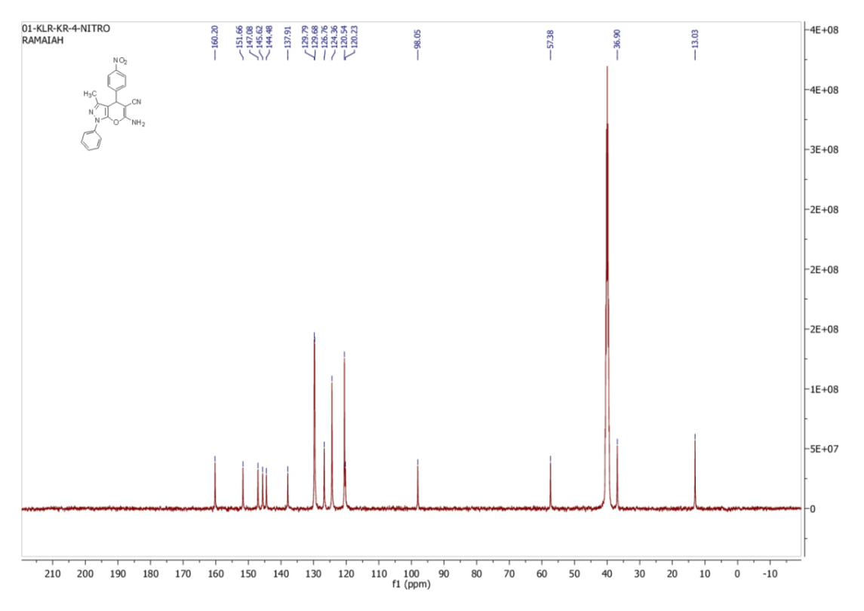
Fig. S1.
The schemetic representaion of Zn catalyst from SXRD method
