---Supplemental Information---

Development and Qualification of a VH-TDMA for the Study of Pure Aerosols

*Christopher R. Oxford1, Charles M. Rapp1, Yang Wang2, Purushottam Kumar3, Daniel Watson4, Julianna L. Portelli1, Eric A. Sussman1, Steven Dhawan1, Jingkun Jiang5, and Brent J. Williams1,\**

*1Department of Energy, Environmental, and Chemical Engineering, Washington University in St. Louis, St. Louis, Missouri 63130*

*2 Environmental and Climate Sciences Department, Brookhaven National Laboratory, Upton, New York, 11973*

*3Disciplineof Chemical Engineering, Indian Institute of Technology Gandhinagar, Palaj, Gujarat, 382355*

*4Department of Chemical and Biomolecular Engineering, Case Western Reserve University, Cleveland, Ohio 44106*

*5 School of Environment, Tsinghua University, Beijing 100084, China*

* Corresponding Author  
 E-mail address: brentw@wustl.edu; Postal address: 1 Brookings Drive, Campus Box 1180, Saint Louis, MO 63130 United States of America;

Phone:1-314-935-9279.

S1. Atomization procedures

Figure S1 documents the atomizer/pretreatment apparatus. All experiments in this paper use this apparatus to generate test aerosols. House air provides the source air, which is regulated to 20 psi unless otherwise noted. The supply air is then scrubbed of organics and particles through a Pall 12011 carbon capsule filter and a Pall 12144 HEPA filter. The flow then splits into two supply flows. One supply provides flow to an atomizer (custom), and the second provides dilution flow. The two flows then recombine and enter 17 foot coil of 3/8 inch copper tubing. At the coil exit, the excess flow is sent through a filter to an exhaust vent. The remaining 1.5 LPM passes through either an activated carbon denuder or silica gel drier. Both the carbon denuder and silica gel drier had 33 inch long denuding sections. For all experiments, the regulator is set to the specified pressure and the flow control valve was adjusted to obtain a desired excess flow rate.

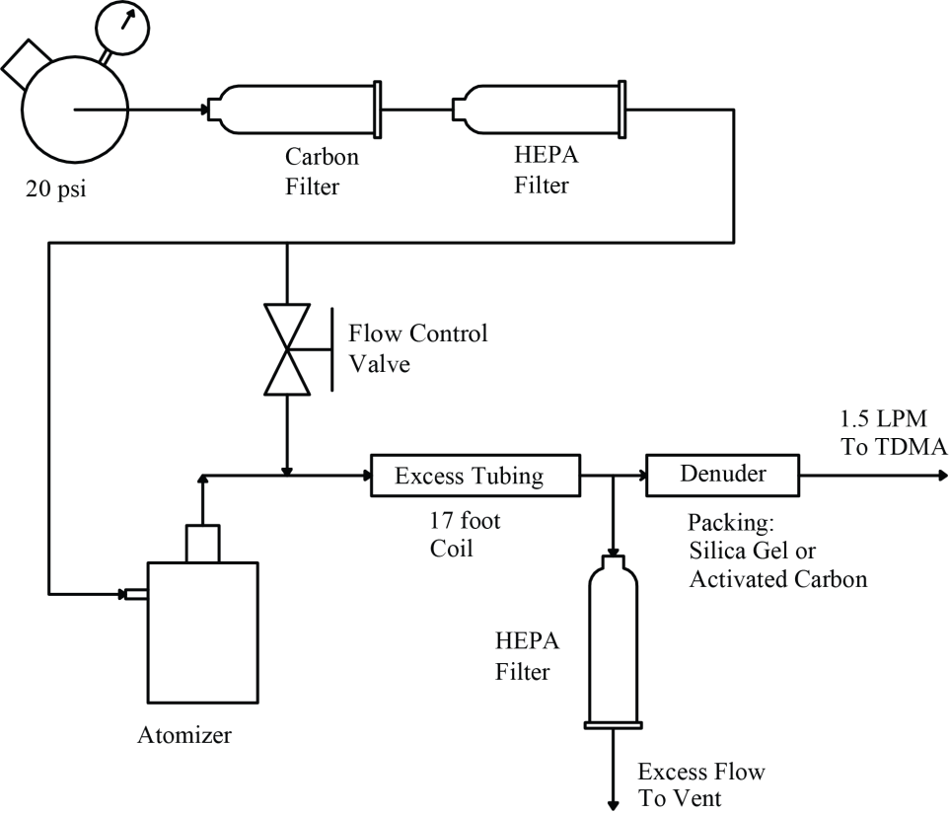

Figure S1. Aerosol pretreatment apparatus.

For some experiments (especially volatility), we altered the pretreatment apparatus shown above to present the aerosol to the Tandem Differential Mobility Analyzer (TDMA) near equilibrium. The dilution flow was introduced after the denuders. A 20 gallon mixing tank was placed between the exit of the pretreatment apparatus and the TDMA. The excess flow was then removed after the tank. Residence times in the tank were between 2-10 min for all experiments. The tank residence time in conjunction with the aerosol concentration ensured the aerosol and gas phase was in near equilibrium prior to the TDMA entry. When the first Differential Mobility Analyzer (DMA1) is operated in high flow, the aerosol sample is diluted by a factor of 10. This dilution allows for evaporation of the aerosol in volatility.

S2. Equipment

The TDMA should be able to accurately measure diameters at both DMA1 and DMA2 (TSI-3081). There are two components to this accuracy: DMA voltage and DMA flow rates. Both need to be checked. Accuracy to within 2% is required (Wiedensohler et al. 2012). For hygroscopicity, the TDMA should be able to accurately control and measure relative humidity. Lastly, volatility needs accurate and representative temperature in order to reproduce accurate enthalpies. This equipment section will explain in detail the flow diagram in Figure 1. We will see that through a mass balance, we can measure the aerosol flow calibration errors and sheath stability using the aerosol flow meters. Then, we will explain the relative humidity control and measurement methodology. We will end by explaining the volatility oven set up and why only one characteristic temperature prevails.

S2a. Aerosol Flow through the Equipment.

The aerosol sample flow enters the inlet on the top left of Figure 1. The inlet flow rate is measured using a custom-built differential pressure flow meter (FM1). The aerosol is then neutralized by a single NRD 2U500 Staticmaster Polonium 210 strip in a Particle Technology Laboratory (University of Minnesota) neutralizer case. The sample then enters an automatic 3-way valve (AV1). This valve selects either: a) Differential Mobility Particle Sizer (DMPS) bypass, or b) DMA1 inlet. If DMPS is chosen, the automatic 3-way valve (AV2) must be turned toward the auxiliary conditioner, and the manual 3-way valve (MV1) in the auxiliary conditioner must be vented. These valve settings prevent potential flow between DMA2 and DMA1 through the auxiliary conditioner. The optional DMPS measurement channel utilizes DMA2 and the Condensation Particle Counter (CPC) to determine particle size distributions.

If DMA1 inlet is selected (option b on valve AV1), the aerosol flow is classified in DMA1. The outlet from DMA1 then enters into automatic valve AV2. This valve selects the: a) auxiliary conditioner, or b) the experimental conditioners. Throughout this paper, the auxiliary conditioner is a single tube with a manual 3-way valve. Assuming the experimental conditioners are selected (option b above on valve AV2), the sample enters the next automatic 3-way valve (AV3). This valve selects either: a) the humidifiers, or b) the oven. These options are the two built-in experimental conditioners. Finally, the treated sample then leaves the experimental section of the TDMA and enters the second custom-built differential pressure flow meter (FM2). The aerosol sample then enters DMA2 to be size-classified. The classified aerosol then passes to the CPC for particle counting.

If a hygroscopicity measurement is desired (option a above on valve AV3), the sample is humidified by splitting the total sample flow (1.5 LPM) between two Permapure MH-110-24S-4 Nafion humidifiers. The aerosol flows inside the Nafion membrane while humidified air passes through the outer sheath in counter current flow. The humidity measured at the DMA2 inlet determines the amount of wet air mixed with the constant dry air supplied to the humidifier sheath. The humidifier surface temperature is controlled, and the humidifiers are insulated.

If a volatility measurement is desired (option b above on valve AV3), the sample passes to the custom 0.12 m3 insulated oven. A manual 3-way valve (MV2) prior to the oven allows the flow to bypass the oven and pass through only a diffusion denuder. If the oven is chosen, the aerosol stream passes through a 15 m coil of 3/8 inch thin wall copper tubing suspended inside the oven. Heat for the oven is provided by a 100 CFM equipment fan attached to a 400 W heater. Two additional equipment fans help circulate the air inside the insulated oven. The maximum oven temperature during our initial testing was 100 °C. Gradients within the oven, at a set point of 100 °C, are less than 2.5 °C. Mean residence time in the oven, with a flow of 1.5 LPM, is approximately 25 seconds. The length of tubing is necessary to: 1) increase the oven residence time to include measured vapor pressures lower than 1x10-5 Pa, and 2) justify neglecting the entrance and exit lengths. Once exiting the oven or bypass, the sample passes through a custom 12 inch diffusion denuder filled with activated carbon to remove any vapors that were released from sample particles.

Once through DMA2, the selected particles are counted by a CPC. The TDMA uses a single TSI 3776 Ultrafine CPC. The CPC, throughout this paper, is operated at a 1.5 LPM sample flow rate and not intended to be used at 0.3 LPM. The sampled aerosol flow from the second DMA travels through 13 inches of ¼ inch stainless steel tubing to the CPC providing a small nominal delay. The pump inside the CPC has been disabled, and the exit flow from the CPC is connected to the vacuum source. The CPC internal orifice maintains flow.

S2b. Manufacture and Calibration of Differential Pressure Flow Meters (FM1 and FM2)

The two differential pressure flow meters are of identical construction. The sample aerosol flow passes from ¼ inch stainless tube to a ⅛ inch tube (5 and half inches long). The pressure drop across this ⅛ inch tube is measured by Dwyer 605-3 differential pressure meter with 4-20 mA output. The output is passed through a 250 milliohm resistor to provide a 1 to 5 volt signal to the Data AcQuisition module (DAQ). Both assemblies are calibrated using a Gillibrator bubble flow meter. A quadratic equation is fit to both calibrations as shown in Figure S2. The two differential flow meters are slightly different, but have high resolution. Nominal operation is an aerosol sample flow of 1.5 LPM, which is in center of the measurement range. Although the flow rate through the tube is clearly in the laminar regime, the curve is not linear. This small curvature is attributed to no entrance length.

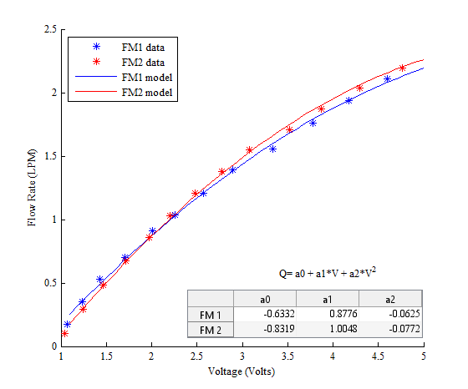

Figure S2. Calibration of the two differential pressure flow meters. Both flow meters are of same manufacture and should have nearly the same calibration. The flow meters are fit with a quadratic form which indicated insufficient entry length.

S2c. Sheath Flow through the Equipment

There are five O’Keefe critical orifices utilized for flow restriction. Two are on the exit of DMA1, two are on the exit of DMA2, and the fifth is on the exit flow of the dew point meter (Edgetech Dewmaster). All orifices, along with the CPC outlet, are connected to a single vacuum line. A ¼ horsepower Gast vacuum pump provides continuous vacuum. This does not provide enough vacuum to choke flow, but is close and very stable. Each DMA outlet flow is calibrated under operating conditions using the mass flow controllers and differential pressure flow meters.

There are four MKS GE-50A Mass Flow Controllers (MFC), labeled 1, 2, 3, and 4, in Figure 1. The first mass flow controller provides dry air from a compressor or house air to DMA1 sheath. Mass flow controller 2 and 3 provide either dry air, or a mixture of wet and dry air to DMA2 sheath. The fourth mass flow controller supplies wet air to the aerosol humidifiers. All four mass flow controllers are run by the analog outputs from either a National Instruments USB-6343 or a National Instruments USB-6001 data acquisition module (DAQ).

The sheath flow for DMA1 and DMA2 is set and controlled by a combination of orifices and MFCs. DMA2 uses one of two orifices to determine the outlet sheath flow: 5.45 LPM low flow or a 14.4 LPM high flow orifice. DMA2 also has a 1.07 LPM stream feeding the chilled mirror hygrometer. So the total outlet flow for DMA2 is a combination of both the high or low flow orifice and the flow to the hygrometer. The classified aerosol outlet from DMA2 is controlled by two internal orifices inside the CPC. The inlet aerosol sample, through FM2, to DMA2 is the difference between all orifice outlet flows to vacuum, including CPC, and the total flow from MFC2 and MFC3 to DMA2.

The combination of flows from MFC2 (wet) and MFC3 (dry) determines the total sheath flow and relative humidity of the DMA2 sheath. When relative humidity is controlled, the automatic valve (AV4) diverts dry air from MFC2 to the sheath humidification tank (see section S2e). This air saturates with water and is mixed with dry air from MFC3. The mixed stream then passes through a Pall 12144 HEPA filter to remove suspended particles. The sheath can then be pre-heated if necessary. Throughout these experiments, the sheath heating option is not used. If only dry air is desired, automatic valve (AV4) diverts flow from MFC2 directly to the sheath omitting humidification.

DMA1 is similar to DMA2. The sheath flow exiting DMA1 is maintained by one of two orifices: high or low flow, but without the hygrometer orifice. Since the sheath outlet is limited by orifice and the flow from DMA1 to DMA2 is controlled by the flows in DMA2, the aerosol inlet to the TDMA is maintained by the MFC1 set point. Therefore, to balance flow throughout the entire TDMA, the total sheath mass flow rate to DMA 2 is first set to obtain 1.5 LPM at FM2, then the MFC1 set point is altered to obtain 1.5 LPM at FM1.

The temperature and pressure of the DMAs is monitored in many ways. The pressure inside the two DMAs is measured using two (one for each DMA) Honeywell 785-PX2EN1XX050PAAAX pressure transducers. The temperature inside the first DMA is not directly measured and assumed to be equal to the aerosol temperature measured at the inlet of the second DMA. The second DMA temperature is assumed to be equal to the same aerosol temperature measured at the inlet. There is a RTD inside DMA2 measuring temperature, but is only used for humidity analysis.

S2d. Aerosol and Sheath flow accuracy and stability

In this section and sections S2e through S2f, we will cover a few equipment requirements in detail. These requirements include stable sheath and aerosol flows, control and measurement of aerosol and sheath relative humidity, and the determination of the characteristic oven temperature.

We use the aerosol flow meters to calibrate the sheath orifices. These actions are all performed with the TDMA sampling at laboratory air. The calibration is performed by placing the TDMA in DMPS mode. The sheath MFCs are slowly increased until the aerosol flow through FM2 is 1.5 LPM (equal to the CPC flow alone). This flow rate becomes the standard flow rate through the DMA2 orifices. The orifice flow rates are then calculated using the MFC flow rate, DMA2 pressure, and DMA2 temperature. Once complete, the AV1 is turned to DMA1. Then the MFC to DMA1 is slowly increased until all aerosol flow rates are 1.5 LPM. Then the orifice flow rate is calculated using the MFC flow rate, DMA1 pressure, and the DMA2 temperature.

The accuracy of the aerosol flow calibration can be estimated using FM1 and FM2 while in DMPS mode. Since all flow is passes through both flow meters, and both flow meters are calibrated individually; the variation between the two flow meters can be used to determine calibration error. This action resulted in an accuracy of 0.003 LPM. We run at 1.5 LPM aerosol flow, so this calibration error represents 0.2% error in aerosol flow rate. Changes in temperature and pressure under lab conditions could create additional errors of 1.3%. This underscores the importance of calibrating the differential pressure flow meters with a change in environment. All known errors are below the required 5%.

Stability of DMA sheath can be estimated using the aerosol flow as well. The CPC is on an orifice and the sheath exit is on orifice. These flows represent all exiting flow from the DMAs. The MFCs provide inlet flows. The balance of the flow into and out of the DMA passes through the aerosol flow meters. Therefore, any variation in exiting or entering flows is easily seen in the aerosol flow meters. The aerosol flow varies by 0.01 LPM. Therefore, this variation represents variability in sheath flow rate. At the low sheath flow rate 6 LPM, the variation is well below the required 2%. This variability matches the manufacturer specifications for the mass flow controller.

S2e. Aerosol and Sheath relative humidity

Dry air supply to the TDMA is maintained at 30 psi and is filtered and scrubbed of organics. This dry air supplies all MFCs and also provides constant dry air supply to the aerosol humidifiers. The aerosol humidifier dry air supply is controlled by a precision pressure regulator. Pressure normally operates at 2.5 psi, but can be manually altered to facilitate drying or humidification. A 1/8 inch Swagelok flow control valve sets the flow. The flow can be stopped automatically using normally closed solenoid valve. This dry air is mixed with wet air from MFC4 and sent to the shell side of the Nafion membranes.

The TDMA uses two, 2.5 gallon, stainless steel pressure tanks to humidify the air streams. Air enters the tanks through a ¼ inch stainless steel tube at the top and is released through a manifold at the bottom of the tank. The manifold is circular with small holes through which the air is released. The bottom of each tank is heated externally by electric tank heaters. The temperature of the water is measured internally by k-type thermocouples (Omega HKQSS-18U-18). Neither tank is insulated. The aerosol tank was operated at 33 °C, and the DMA2 sheath tank was operated at 24 °C.

DMA2 is only lightly insulated (a single layer of insulation tape) and the inlet streams (sheath and aerosol) have no insulation. Therefore, changes in environmental temperature will influence the inlet streams and DMA2 unequally. When environmental temperature decreases, the aerosol and sheath temperature quickly equilibrate and nearly parallel the environment. That is not true of the atmosphere inside DMA2. The insulation around DMA2 along with the large metal structure limits the environmental influence. Therefore, a temperature difference exists between the inside of the DMA2 and the inlet streams.

Control of the aerosol relative humidity can actually occur by three methods. Currently, only two are used. The first is the typical Proportional Integral Derivative (PID) control. When using this control method, the TDMA program alters the flow of wet air that is mixed with the constant supply of dry to obtain the requested aerosol relative humidity. The second method that is used sets the ratio between the two flow rates. This effect is similar to dew point control. Only minor manual changes are made to place the aerosol flow near the correct relative humidity. Changes in environmental temperature alter the actual aerosol relative humidity, so manual adjustments are only made to ensure relative humidity oscillates around the desired set point. The third method, which is not used, ensures the aerosol relative humidity follows the sheath inlet relative humidity.

Control of the sheath relative humidity occurs by two methods. The first method is the traditional PID control. The TDMA program alters the ratio of wet air with dry air to obtain a relative humidity prior to DMA2 entry. The second method fixes the ratio of wet and dry air. This second method is similar to dew point control. The relative humidity prior to DMA2 entry oscillates with the environmental temperature, but the relative humidity in DMA2 is near stable.

Relative humidity in the system is quantified in one of two ways. The first is by use of Vaisala HMP60C12C0A3B0 relative humidity and temperature (RH&T) probes. There are three of these in the system. One measures the relative humidity and temperature of the aerosol stream prior to DMA2 entry. A second measures the relative humidity and temperature of the sheath flow entering DMA2. The last measures relative humidity and temperature exiting DMA2. Relative humidity is also measured by combining a dew point measurement from an Edgetech Dewmaster chilled mirror hygrometer and an Omega SA1-RTD class A platinum resistance temperature device (RTD). The small RTD has been placed inside DMA-2 under the lower diffusion screen at the sheath flow outlet. We use ammonium sulfate aerosol to calibrate the RTD (covered later). To calibrate the RH&T probes in the relative humidity conditioner, the DMA2 sheath flow is raised high enough to back flow through the aerosol sample line filling the entire TDMA system with only humidified sheath flows. The relative humidity is calculated using the dew point from the chilled mirror hygrometer and the temperature measured by each RH&T probe. In laboratory experiments, ammonium sulfate is atomized either at the beginning or end of the experiments to ensure accurate calibration of the instrument. If out of specification, a calibration is performed.

When in operation, we wait 1 hour to measure the aerosol after set point is achieved. This allows all surfaces within the TDMA to equilibrate with the new humidity. When increasing relative humidity, water absorbs to the surfaces (especially the sheath filter) and raises the gas temperature. When deceasing relative humidity, the gas phase temperature drops. We should note here that the manufacturer reported error in dew point measurement is 0.2° C, and the manufacturer reported error in temperature (RTD) is 0.15° C. At 90% relative humidity, the error in relative humidity is expected to be 1.2%.

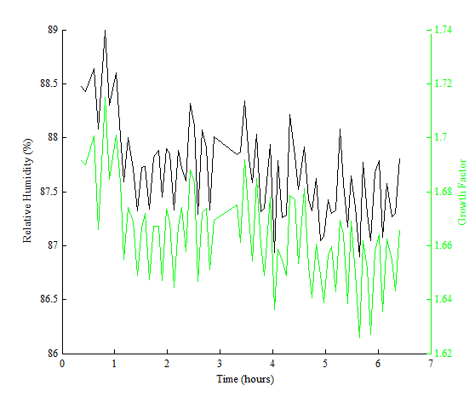

**Figure S3.** Growth Factor and measured relative humidity over the course of a day. At time zero, we set the flow rates to achieve near 90% relative humidity. After 30 minutes, we began scans. From this data, we chose to begin experimental scans 1 hour after. We could probably start at 30 minutes (growth factor follows relative humidity), but accuracy is reduced due to temperatures not completely equilibrated. The drop in relative humidity shown (at ~1hr) is due to a small change in wet/dry flow ratio adjusting for temperature. Oscillations are due to changes in room temperature.

S2f. Oven Temperature

The oven is a 0.12 m3 insulated ice chest. The ice chest, typically used for chilling drinks, has the advantage of maintaining heat quite well. Fresh air flow is passed through the drain of the ice chest and a small vent hole is drilled in the lid. The fresh air flow passes through a 400 W heater when entering the ice chest. Two additional equipment cooling fans operate inside the ice chest. The heat from all the fans establishes a minimum heated temperature of 28° C. To cool the ice chest or to run at room temperature, the ice chest is opened. Unfortunately, high temperatures (near 100° C) will eventually make the ice chest unusable.

15 m of thin wall copper tubing was manually coiled and suspended inside the oven. The coil was spread so that air could easily flow around all aspects of the tubing. The residence time was estimated at 25 seconds by comparing 2 second pulses of ammonium sulfate aerosol through the oven and through the oven bypass.

Two thermocouples were placed inside the oven (outside the tubing). One thermocouple controlled the oven temperature while the second measured the variation within the oven. The maximum variation found within the oven was 2.5° C when operating at a 100°C set point. The room temperature was 21.5° C. Another 1 foot long thermocouple was inserted into the exiting aerosol flow from the oven. This thermocouple passes beyond the exit length to measure the evaporation temperature within the oven.

Figure S4, a plot of a Graetz model, is used to estimate the temperature pattern within the oven. The x-axis is the distance from the entrance of the oven while the y-axis is shown as equation 1. If the aerosol temperature is equal to the room temperature (inlet temperature), the dimensionless temperature has a value of one. If the aerosol temperature is equal to the oven temperature, the dimensionless temperature has a value of zero. To create the exit length, the entrance length was mirrored. This mirrored region is intended to represent the 4 exposed inches of tubing just outside the oven where the inlet and exit connections to external tubing are made.

Due to heat transfer limitations between the oven and the tubing wall, the actual aerosol temperature does not achieve the oven temperature. We see from the figure that the aerosol temperature begins and ends at room temperature, but quickly achieves an intermediate value between entrance and exit lengths. For all volatility experiments, we recorded the measured oven temperature and the internal temperature. For all cases, the dimensionless temperature had an average value of 0.286. This value repeated to within 1% for all cases. Additionally, we measured the external surface temperature of the tubing inside the oven using a non-contact pyrometer. In all cases, the temperature measured is within ±2.5 degrees of the measured internal temperature over the tubing length. So the horizontal line in this model is only an estimate of the internal temperature in the oven. After this study, an additional 100 CFM equipment fan was placed within the oven and flow limitations on the original inlet fan were removed. The dimensionless temperature is now 0.05 at 50 C.

$$U=\frac{\left(T_{O}-T\right)}{\left(T_{O}-T_{rm}\right)} (1)$$

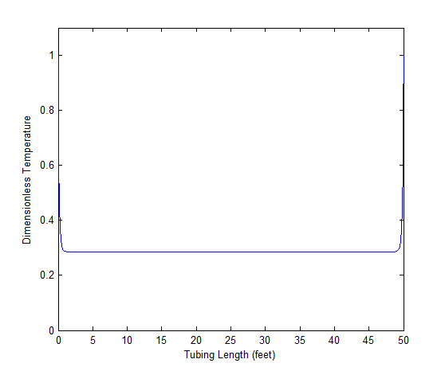

**Figure S4.** Temperature response of the oven. A Graetz model along with internal temperature measurement was used to create the response. A dimensionless temperature of 1 means the aerosol temperature is equal to room temperature, and a dimensionless temperature of 0 means the aerosol temperature is equal to the oven temperature. The exit length of the tubing is assumed to be exposed to room temperature. The exit length has been assumed to be a mirror of the entrance length as estimation (see paragraph above).

Fifteen meters of tubing justifies neglecting the entrance and exit lengths, but exposes the oven to particle losses. To determine particle loss, ammonium sulfate was atomized using the pretreatment apparatus (Supplemental Information S1) with the adjustments for volatility. A size was selected by DMA1, and DMA2 was scanned to determine the peak of the curve. Then the voltage of DMA2 was set to the peak concentration value. Once set, an average concentration was determined over 30 seconds for ammonium sulfate particles passing through the oven. The valve used to bypass the oven was switched allowing particles to bypass the oven. Then the averaging procedure was repeated for the bypass. The penetration is the ratio of the average particle count through the oven divided by the average particle count through the bypass line. This process was repeated for 20 nm through 430 nm. For diameters below and equal to 240 nm, high flow was used for both DMA1 and DMA2. For diameters above 240 nm, low flow was used for both DMA1 and DMA2. This procedure provides only an estimate of the actual particle losses. Evaporation of the particles, increases in particle diffusivity with increased temperature, and increases in thermal phoresis effects with increased temperature will alter these results when under normal operation.

The data taken from this experiment were fitted using equations 2 through 4 below. A least squares routine was used to fit the model which resulted in an effective length of 162 meters. A 70 nm particle has a measured penetration efficiency of 0.8. The fit of equations 2 through 4 to the measured data is pictured in Figure S5.

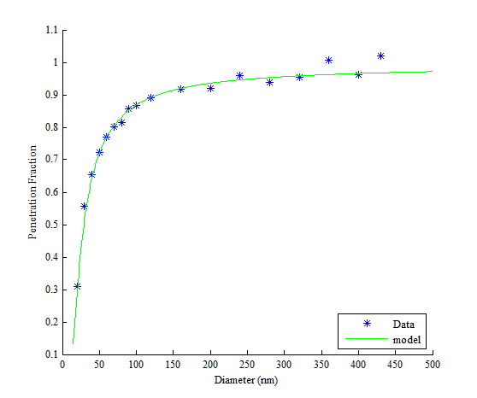

Figure S5. Particle loss through the 15 m tubing coil inside the oven. Data represent measured penetration fraction while the model represents equations 2 through 4 with an effective length of 162 meters. This experiment was performed at room temperature (21.5° C).

When operating the oven, we wait 30 minutes for equilibrium to occur. This can be seen in Figure S6. The figure displays that we still needed some more time, but were close to the desired value. We chose the 30 minute time frame as a memorable time. So, all experiments wait 30 minutes for steady state to be established. Future experiments should delay for one hour. This time would match the delay for hygroscopicity.

The equipment requirements, listed above in sections S2d through S2f, meet previously mentioned requirements. The DMA flows are accurate and extremely stable. The relative humidity is measured in several places and controlled by several equivalent methods. By controlling the ratio of dry to wet air, we enable near constant dew point. In this mode, the relative humidity inside DMA2 is calculated from the internal DMA2 temperature and the measured dew point. For field experiments, we intend to control inlet relative humidity. Since the instrument alters the dew point of the sheath air to maintain inlet relative humidity, use of the dew point meter to calculate relative humidity can cause error. If excess condensate occurs, the dew point meter must evaporate all condensate before returning to measurement. Therefore, the measured dew point can be significantly different from the actual dew point. Therefore, when in this control mode, the DMA2 outlet RH&T sensor is used to measure the characteristic relative humidity. The internal aerosol temperature measured is the characteristic temperature of the evaporating aerosol. We accomplish this using 15 meters of thin wall tubing. Particle losses in this tubing can be substantial at small diameters but acceptable at larger diameters.

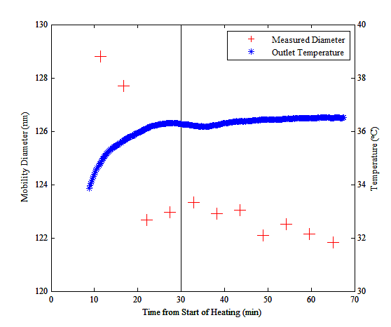

**Figure S6.** Final evaporated diameter from oven. The x-axis is time after heating of the oven. We begin measurements after 30 minutes (marked with a vertical line). A small error in vapor pressure may exist in our measurements.

S3. Evaluation of DMA accuracy and alignment

Accuracy of DMA1 and DMA2 depends on both the flow rate and voltage. In section S2d, the flow accuracy was shown to be less than 2%. We now determine the accuracy of the power supplies. We use Polystyrene Latex Spheres (PSL) to test the accuracy of DMA1 and DMA2 while using only the DMA2 power supply. Then we end with placing both DMAs on independent power supplies and testing alignment using atomized ammonium sulfate. These two experiments will display the combined accuracy of flow rate with the power supplies. This should be less than 2% (Wiedensohler et al. 2012).

The two DMAs are TSI 3081 long DMAs, and the voltage is supplied by two Spellman 205B-10R high voltage power supplies. Error in the voltage supplied is a combination of three factors. The first is the power supply itself. The second is the set point error due to error in voltage signal (0-5 V) and interpretation between the DAQ and the power supply. The third is the measurement error due to error in the voltage signal (0-5 V) and interpretation between the DAQ and the power supply when recording the actual set point voltage. The combination of all these errors along with flow is investigated in this section.

S3a. Accuracy between DMA1 and DMA2 and accuracy to PSL standard

A Polystyrene Latex (PSL) microsphere standard was used to test the alignment of DMA2. Several drops of Fisher Scientific 09980024 PSL were atomized in 18 MΩ water using the pretreatment setup (*Supplementary Information S1*). The standard was NIST traceable with a mean diameter of 203 nm +/- 5 nm. This standard was the only diameter chosen. There are 2 reasons for this: 1) smaller diameters are difficult to characterize due to noise from other solutes in the standard and 2) the maximum measurable diameter in high flow is 230 nm, limiting comparability between low flow and high flow. Continuing with the experiment, the instrument was placed in DMPS mode, and 5 scans were performed around 200 nm in both low and high flow. The average of both high flow and low flow is shown in figure S7. A log-normal curve was fit to the average response of both curves to determine the diameter at peak. The grey area in Figure S7 represents the accuracy of the PSL standard. Both the high flow and low flow agrees with the standard mean within 1 nm, and the two are within 0.5 nm of one another. These diameters are well within the reported error in the PSL mean. Therefore, DMA2 with its corresponding power supply agrees well within the error of the standard.

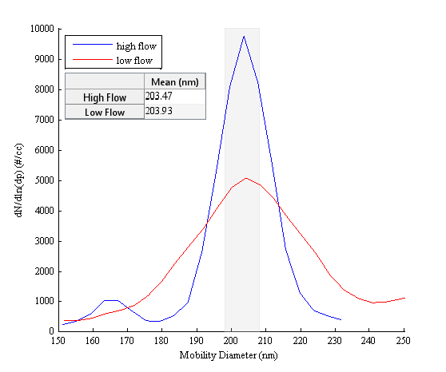

Figure S7. DMA2 sizing experiment with 203 nm PSL standard. The grey area represents the nominal size of the PSL standard with published error. Blue line represents measurement in high flow while the red line represents measurement in low flow.

To measure the accuracy of DMA1, the 200 nm PSL standard was atomized using the pretreatment apparatus (*Supplemental Information S1*). The first automated valve was turned toward DMA1. The second automated valve was turned to the auxiliary conditioner. A ¼ inch copper tube was plumbed from the second automated valve directly to the 3776 CPC. The power supply feeding DMA2 was connected to DMA1. This allowed the instrument to perform a DMPS scan using DMA1. This experiment was done at both low flow and high flow.

Figure S8 shows the results of this experiment. The greyed area represents the accuracy of the PSL standard: 203 nm +/- 5 nm. The blue line represents high flow scan while the red line represents low flow scan. A lognormal curve was fit to both scans and the mean is displayed in the table. The high flow scan agrees with the standard mean within 1 nm, while the low flow scan just over 1 nm from the standard mean. Both scans fall well within the PSL standard area. Like the experiment above, DMA1 powered by the DMA2 power supply measures the standard to within 2%.

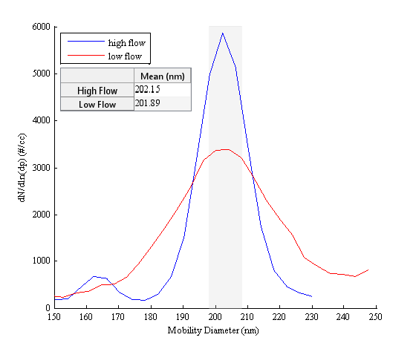

Figure S8. Sizing accuracy of DMA1 using DMA2 power supply. The grey area represents the published size of the PSL including mean and standard deviation. The red line is low sheath flow while the high sheath flow is represented by the blue line.

Both the DMA2 and DMA1 comparison to standard used the same calculation routines and the same power supply. Therefore, the error between DMA1 and DMA2 can be associated with the geometry (obstructions etc.) and the error in sheath flow rate in and orifice flow out. In high flow at 200 nm, DMA2 is 1.32 nm above DMA1. This discrepancy represents an error in average sheath flow of 0.15 LPM at high flow. This error will be distributed between DMA1 and DMA2 assuming the geometry between DMA1 and DMA2 is identical. The largest discrepancy in diameter occurs when both DMA1 and DMA2 are in low flow. The difference is 2.04 nm and represents an average sheath flow discrepancy of 0.1 LPM in low flow. Again this error could be distributed between both DMA1 and DMA2. These two errors represent 0.65 % (high flow) and 1.01% (low flow) of the DMA1 set point, which is well within the required 2 percent accuracy in sheath flow.

We compared the entire diameter range by placing the instrument in TDMA mode and using the auxiliary conditioner. We then atomized a solution of 0.2 g of ammonium sulfate in 100 ml deionized water using the pretreatment apparatus (*Supplemental Information S1*). We then selected a diameter with DMA1, and scanned the area around that diameter with DMA2. DMA2 scanned up once and scanned down once for a total of two scans per diameter. Five diameters were chosen at every flow rate combination, and a log-normal curve was fit to every DMA2 response to determine the mean response diameter. In this experiment all factors are considered including power supply output and the error in the 0-5 V signal to and from the power supplies. These results are shown in Figure 2.

In Figure 2, the x-axis is the average diameter of DMA1, while the y-axis is the percent error calculated by subtracting the difference between the two DMA diameters and dividing by the DMA1 diameter. Points above the zero line represent DMA2 being biased larger than DMA1, while below the line represents DMA1 being biased higher. The results from the PSL experiment above can also be used to estimate error. The greyed area in the plot represents the error ranges calculated from the 203 nm standard above. The legend shows which flow rate was chosen for the two DMAs. For example, the red asterisks represent DMA1 being in low sheath flow, and DMA2 being set to high flow.

The error from the comparison in S7 and S8, represented by the grey area in Figure 3, only explains a small portion of the bias between the two DMAs, and we can see that the graph agrees with the previous conclusions at 203 nm. However, since both power supplies are included in this experiment, additional bias is also included. It appears that inclusion of the DMA1 power supply further biases the 203 nm results depending on the sheath flow rates chosen in the DMAs. When low flow is chosen for DMA1, DMA1 is biased above DMA2. If high flow is chosen, then the bias approaches the previously measured flow rate bias.

The rising trend at smaller diameters is an indication of a voltage error between power supplies. If we assume that a single DMA is shifted by a constant voltage and no other errors exist, then with both DMA1 and DMA2 in high flow, the voltage error would need to be 30 volts at 40 nm and 70 volts at 200 nm. With DMA1 and DMA2 in low flow, the voltage error would need to be 20 volts at 80 nm and 140 volts at 400 nm. The stated equipment error by the manufacturer of the two power supplies allows for the majority, and in some cases all, of the known error. At this point, no attempt to change the original, NIST certified calibration has been made. Errors in diameter exceeding 2 percent exist below 70 nm. Therefore, no investigations were made in this range.

We see from these experiments that with both the power supply and flow rate, the TDMA can measure to within 2%. This occurs at mobility diameters larger than 70 nm. Below this level, errors larger than 2% are possible. We chose to not explore measurements in this area.

S4. Differential Mobility Particle Sizer

The requirements for size distribution measurement systems, to ensure their accuracy and intercomparability, are given by Wiedensohler et al (2012). The instrument must measure relative humidity and have controls to reduce or maintain relative humidity in both the aerosol flow and sheath flow to less than 40% (See Supplemental Information S2). The aerosol flow rate should be measured by a differential flow meter to an error of less than 5%, and the sheath flow rate should be measured by either a differential pressure flow meter or a mass flow controller and should vary by less than 2% (See Supplemental Information S2). The temperature and pressure in the DMA should be measured prior to entrance (See Supplemental Information S2). Particle losses through the tubing, neutralizer, and DMA should be quantified. CPC counting efficiencies should be incorporated in the inversion, and the DMA alignment should be checked against a polystyrene latex (PSL) size-calibration standard (See Supplemental Information S3). This section will cover particle loss characterization of the DMPS channel, the inversion process, and the experimental setup used to compare the DMPS channel to our standard size distribution measurement system.

S4a. Particle loss characterization

The atomization and pretreatment setup (*Figure S1*) was used to supply a dry ammonium sulfate aerosol to a TSI 3080 classifier with a TSI 3081 long DMA. A solution of 0.2 grams of ammonium sulfate in 100 ml of deionized water was used in the atomizer. The exit of the classifier was connected to a Swagelock 3-way valve. A short piece of copper tubing, labeled C in Figure S9, connected the 3-way valve to the TDMA inlet. Then the tubing at DMA2 inlet was disconnected and connected with the short piece of tubing that normally connects the classified aerosol exit from DMA2 to the CPC. The result of these connections is that all tubing and devices, excluding DMA2, from the Differential Mobility Particle Sizer (DMPS) channel were connected together in series. This series of tubing from the TDMA was connected to line B. The end of the B tubing was then connected to a three way valve which was directly connected to the 3776 CPC. A second line, A, bypassed the DMPS channel of the TDMA and directly connected the two three way valves. The length of line A was roughly equivalent to line B making sure that similar bends occurred and no kinks were present. We should note that the length of line C was much less than line B. The Polonium source was removed from the TDMA’s neutralizer so that only the housing remained.

A diameter would be selected on the classifier, and the CPC pulled particles through the system at 1.5 LPM. The number of penetrating particles detected by the CPC was recorded after a 20 second equilibration time. Both 3-way valves were turned and the process was repeated 10 times per diameter. The particle penetration, PT, was expressed as the ratio of the particles detected through the TDMA-B-C path divided by the number of particles detected through path A.



**Figure S9.** Particle loss experimental apparatus. The length of C is much less than B.

The model (Friedlander 2000) used to calculate penetration, PT, is reproduced as equation 2 through 4. In equation 2, k is the Boltzmann constant, T is the temperature, dp is the particle diameter, C is the Cunningham correction factor, and D is the diffusivity of a particle of size dp. The Cunningham correction factor, C, and mean free path in air, λ, are calculated using relations published by Kim et al (2005). The gas viscosity, μ, is calculated using the expression by Allen and Raabe (1985) . In equation 3, Q is the CPC flow rate of 1.5 LPM. CPC low flow, 0.3 LPM, was not characterized and is not intended for use. Leff is the effective length of straight tubing (incorporating straight tubing with equivalent particle losses from tubing bends), which was determined to be 30 meters. The minimum scanned diameter is intended to be 20 nm with the TSI long DMA. The modeled penetration is 0.7 at 20 nm.

$$D=\frac{kTC}{3πμd_{p}} (2)$$

$$Π=\frac{πDL_{eff}}{Q} (3)$$

$$P_{T}=\left\{\begin{aligned}1-2.56Π^{0.666}+1.2Π+0.1767Π^{1.333} for Π<0.02 \\ 0.819e^{\left(-3.66Π\right)}+0.0975e^{\left(-22.3Π\right)}+0.0325e^{\left(-57.0Π\right)} for Π>0.02\end{aligned}\right\} (4)$$

The average penetration values of the experiment are shown as blue asterisks in Figure S10. The error bars are the 95% confidence intervals of the mean. High sheath flow was used in the classifier for 230 nm or less. For diameters 230 nm and above, low sheath flow was used. At 230 nm, both sheath flows were used. Penetration under low sheath flow appears slightly higher than high sheath flow. We have yet to determine the reason for the mismatch at 230 nm.

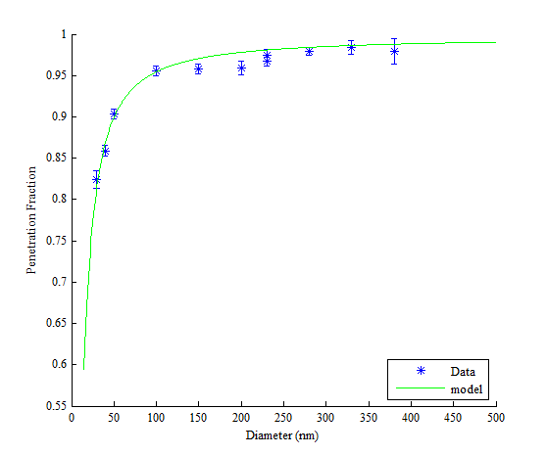

**Figure S10.** Particle penetration through DMPS tubing and corresponding model. The data are measured values from the DMPS particle penetration experiment. Error bars represent the 95% confidence interval for the mean of the measured values. The green line is the fitted model defined by equations 2 through 4. The fitted effective length is 30 meters.

S4b. Inversion of DMPS data

Variables and equations used in the inversion of the DMPS data follow ISO 15900 requirements. The bipolar charge fraction, η, is calculated using the expression published by Wiedensohler (2012) with constants from Baron (2001). For charges greater than 2, the expression from Gunn (1956), along with the assumption that the ratio of the electrical mobility of the positive to negative ions is 1.4/1.6 (Wiedensohler 1988), is used for a total of 10 charges in the inversion routine. The equation for the CPC detection efficiency, ω, used in the inversion was generated by Hermann et al (2007).

The inversion routine uses equation 5 to obtain the inlet size distribution **N**. The measured CPC response is arranged into the **Rc** array. The **Q** array represents fractional contributions to the inversion including the DMA2 transfer function, CPC detection efficiency, TDMA tubing losses, and charging fraction. Each DMA2 voltage bin is represented by the subscript *i*. The inversion is completed by performing non-negative least squares (Lawson and Hanson 1974) on equation 5.

$$R_{c}\left[ i × 1\right]=Q\left[i × i\right]*N\left[i × 1\right]=∆*H[i × j]*F[j × i]*N[i × 1] (5)$$

To increase the resolution of the charge correction, the DMA2 voltage bins are further sub-divided into 300 diameter bins denoted by the subscript *j*. The limits of the *j* diameter bins extend beyond the limits of voltages *i*. The lowest *j* diameter bin is equal to 1.1 times the mobility of the smallest voltage bin *i*. This extension covers the transfer function resulting from bin *i*. The largest diameter bin *j* is equal to the 3 charge diameter equivalent of the last bin *i* mobility. This extension allows for charge correction of the maximum bin *i* and requires an assumption of the shape of the size distribution beyond the measured *i* bins. In equation 5, Δ is the logarithmic diameter spacing of the *j* diameter bins. The **F** array calculates the particle concentrations in the *j* diameter bins, while the array **H** contains the previously mentioned fractional information using bin *j* diameters and bin *i* voltages. The product of the **H** and **F** array results in the **Q** array.

$$F\left[j,i\right]=\frac{N\left(j\right)}{N\left(i\right)}={\left[\frac{d_{p}^{*}(i)}{d_{p}(j)}\right]}^{P_{i}} for \left|P_{i}\right|<8 or {\frac{N\left(j\right)}{N\left(i\right)}=exp}^{\left[γ_{i}\left(d_{p}\left(j\right)-d_{p}^{*}\left(i\right)\right)\right]} for \left|P_{i}\right|≥8 (6)$$

The **F** array calculates the size distribution at each diameter bin by either relating the diameter bins to the voltage bins by a power law expression or by a logarithm. The slope for the power law relationship is *Pi*, and *γi* provides the slope for the logarithmic relationship. Pi and γi are calculated for each voltage bin *i*. This calculation is done by performing a least squares fit of the nearest 5 voltage bins (*i*-2, *i*-1, *i*, *i*+1, *i*+2) for both relationships. If the slope, *Pi*, relating the nearest 5 voltage bins is less than 8, then the power law relation holds. However, if the slope is greater than or equal to 8, then the least squares logarithmic fit is used. When the voltage bin *i* is less than 3, the smallest 5 voltage bins are used in the relationship. Likewise, if the nearest voltage bin is less than 3 bins from the largest voltage bin *i*, the largest 5 voltage bins are used for equation 6. In these relations, *dp\** represents the diameter associated with the centroid of voltage bin *i,* and *dp* represents the diameter bin *j*. To calculate F[j,i], each *dp(j)* is related to the nearest voltage bin *i*. The equation for **F** is reproduced as equation 6.

The array **H** contains all the ratio information: the DMA transfer function *Ω*, the charging fraction *η*, the CPC efficiency *ω*, and the losses in the TDMA, *PT*. The expression for **H** is shown in equation 7. The DMA transfer function used is shown as equations 8 through 13 (Hagen and Alofs 1983) In the DMA transfer function equations, *qm* is the main sheath exit flow, *qc* is the clean inlet sheath flow, *qa* is inlet aerosol flow, and *qs* is the classified aerosol flow. *L* is the length of the 3081 DMA, and Vt is the voltage. The inside and outside radius of the DMA are *a* and *b* respectively. The number of charges is *ξ*, and *e* is the charge of an electron. We should note that a more economical and concise form of the transfer function is now available (Stolzenburg and McMurry 2008).

$$H\left[i,j\right]=\sum_{ν}{\frac{q_{a}}{q_{s}}Ω\left(i,j\right)η\left(ξ,j\right)d_{p}\left(j\right)ω\left(d_{p}\left(j\right)\right)P_{T}\left(q_{a},d_{p}\left(j\right)\right)} (7)$$

$$v_{1}=\frac{\left(q_{c}+q_{m}-q_{s}-q_{a}\right)}{4π} (8)$$

$$v_{2}=\frac{\left(q_{c}+q_{m}-\left|q_{s}-q_{a}\right|\right)}{4π} (9)$$

$$v_{3}=\frac{\left(q_{c}+q_{m}+\left|q_{s}-q_{a}\right|\right)}{4π} (10)$$

$$v_{4}=\frac{\left(q_{c}+q_{m}+q_{s}+q_{a}\right)}{4π} (11)$$

$$v=\frac{LV_{t}ξeC}{ln\left(\frac{b}{a}\right)3πμd_{p}} (12)$$

$$Ω=\left\{\begin{aligned}0 for v<v_{1} \\ \min\left(1,\frac{q_{s}}{q_{a}}\right)\frac{v-v_{1}}{v_{2}-v_{1}} for v_{1}≤v<v_{2} \\ min\left(1,\frac{q_{s}}{q_{a}}\right) for v_{2}≤v<v_{3} \\ min\left(1,\frac{q_{s}}{q_{a}}\right)\left[1-\frac{\left(v-v_{3}\right)}{\left(v_{4}-v_{3}\right)}\right] for v_{3}<v<v_{4} \\ 0 for v≥v_{4}\end{aligned}\right\} (13)$$

S4c. Experiment to test inter-comparability to TSI 3696 SMPS

A solution of 0.2 g of >99% pure ammonium sulfate, Sigma Aldrich A4915, in 100 ml of 18 MΩ DI water was made. The solution was placed into the pretreatment atomizer (*Supplemental Information S1*). The excess flow from the pretreatment apparatus was closed so that all flow exits the apparatus and enters into a 20 gallon mixing tank as shown in Figure S11. After the mixing tank, the excess flow, 0.65 LPM was removed. The total flow into the tank was 2.45 LPM providing an average residence time of approximately 31 minutes. This residence time ensured that the aerosol was at equilibrium with the gas phase. The Po-210 strip in the TDMA Particle Technology Lab (PTL) housing was removed, and the housing was reinstalled inside the TDMA. Two Po-210 strips in a single PTL housing were used as a common neutralizer for both the SMPS and the TDMA to ensure no neutralizer bias existed. The CPC used in the TSI SMPS pulled 0.3 LPM. The sheath flow rate used in the SMPS classifier was 6.0 LPM which matched the TDMA operating in low flow. The complete test apparatus is shown in Figure S11. Ten scans were performed while the TDMA was in low flow, and then the sheath flow in DMA2 was increased. A second set of ten scans was performed. The average of the 10 scans from this experiment is shown in Figure 3. Ten scans from the TSI instrument were also obtained and the reported response is also an average of those scans.

Nearly all system specifications were met by the TDMA. The dry sheath was selected for the experiment and has a relative humidity of less than 10%. The relative humidity measured by the aerosol RH&T was 38%. Both are less than the required 40%. Flow rate variability and accuracy were displayed in Supplemental Information S3 and exceed standard. The temperature is measured by the sheath RH&T sensor prior to DMA entry, and the absolute pressure comes from DMA pressure transducer. This pressure transducer is located in a ⅜ inch tube at the exit of DMA-2. This location is in contrast to the recommended requirements.

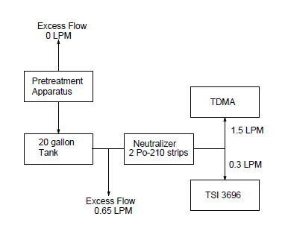

Figure S11. DMPS channel test apparatus.

S5. Inversion of TDMA data

Inversion of TDMA data uses equations 14 through 16 to obtain the size distribution, *N*, prior to DMA2 entry (Stolzenburg and McMurry 2008). The negative of the derivative of the natural log of mobility with respect to the natural log of diameter (*a\**) is the only additional variable, with all other variables previously defined. Once inverted, a log-normal curve is fit to the resulting inlet distribution using least squares (Cocker et al. 2001). The mean of this fit is used for further analysis. Equations for mean free path, viscosity of air, Cunningham correction, CPC efficiency, and charging efficiency are as previously defined in the DMPS section. Although the distribution is corrected for single charge efficiency, no multi-charge correction is performed due to the mono-disperse nature of the distribution. Last, the inversion routine also calculates the diameter associated with the centroid of the DMA1 mobility so bias can be investigated. This method is a DMPS inversion method, and use of this method will incur error.

$$N=\frac{R_{c}*a^{*}}{\frac{q_{a}}{q_{s}}β\left(1+δ\right)ωη} (14)$$

$$β=\frac{\left(q_{s}+q_{a}\right)}{\left(q_{m}+q_{c}\right)} (15)$$

$$δ=\frac{\left(q_{s}-q_{a}\right)}{\left(q_{s}+q_{a}\right)} (16)$$

There are four errors associated with this inversion method. 1) The size distribution can manipulate the distribution exiting DMA1 (Rader and McMurry 1986). 2) The mobility transformation ratio, mobility exiting the conditioner divided by the mobility entering the conditioner (Rader and McMurry 1986), may not be the same between the charges (1st, 2nd, 3rd, etc). 3) The convolution of the two DMA transfer functions shifts the final response. 4) The distribution exiting the conditioner is not significantly larger than the width of the DMA2 transfer function. All four errors influence the accuracy of the log-normal fit to the inversion at DMA2.

During all hygroscopicity measurements, the centroid of the DMA1 transfer function was equal to or greater than the mean of the atomized log-normal distribution. Under these conditions, multi-charging will be low. This will reduce, but not eliminate, the error due to item 2 above. By measuring the dry diameter, the error associated with item 1 above is taken into consideration. The convolution error, item 3, will be present in both the dry and wet diameter measurements. But in both measurements, the TDMA is in high flow, which will reduce the convolution error. The fourth item could be a problem. In using this method, we are assuming that the mean of the fitted log-normal size distribution equates to the peak of the size distribution exiting the conditioner. Since the recovered size distribution using the above method could be in error, this equality is not guaranteed. Only proper DMA2 inversion of narrow distributions, especially when sampling complex atmospheric aerosols, can reduce item 4 above. We expect error.

For volatility, the DMA1 centroid was well above the mean of the atomized log-normal size distribution in all cases. Like hygroscopicity, this sampling method minimized item 2 and item 1 above. For item 3 above, both DMA1 and DMA2 were in high flow and the convolution will be low. For volatility, the width of the distribution exiting the volatility conditioner expands quickly. The response widening is the result of the residence time distribution in the oven. Assuming laminar flow, particles traveling along the centerline of the tubing exit more quickly than those traveling along the walls of the tubing. This difference in residence time spreads the size distribution exiting the volatility conditioner. Additionally, the mean particle size decreases, which narrows the DMA2 transfer function. The widening of the size distribution entering DMA2 and narrowing of the DMA2 transfer function facilitates inversion as the size distribution entering DMA2 becomes larger than the DMA2 transfer function. But, only proper DMA2 inversion will guarantee recovery of the size distribution exiting the volatility conditioner in all cases. Like above, we expect error with this inversion method.

S6. Hygroscopicity

In this section, we highlight the additional requirements for hygroscopicity. The accuracy of the diameter measurements of DMA1 and DMA2 are discussed in Supplemental Information S3. The relative humidity control and measurement is discussed in Supplemental Information S2. Here we will detail the stability and accuracy of relative humidity in DMA2, calculation of hygroscopicity, obtaining the data for the calculation, and the errors assumed in reporting the hygroscopicity values.

S6a. Stability and Accuracy of Relative Humidity in DMA2

To determine the relative humidity stability, we atomized 0.2 grams of ammonium sulfate (part #A4915 Sigma-Aldrich) in 100 ml of 18 MΩ water using the pretreatment apparatus (Supplementary Information S1). Both DMA1 and DMA2 were placed in high flow. Four dry (15% relative humidity) scans at 70 nm were performed. The relative humidity was then increased by setting the dew point to obtain relative humidity values near 90%. This humidity was maintained for over 4 hours. During this time, 64 measurements of wet diameter were made. The growth factor of each wet diameter measurement was calculated by dividing the wet diameter by the mean dry diameter of the four dry scans.

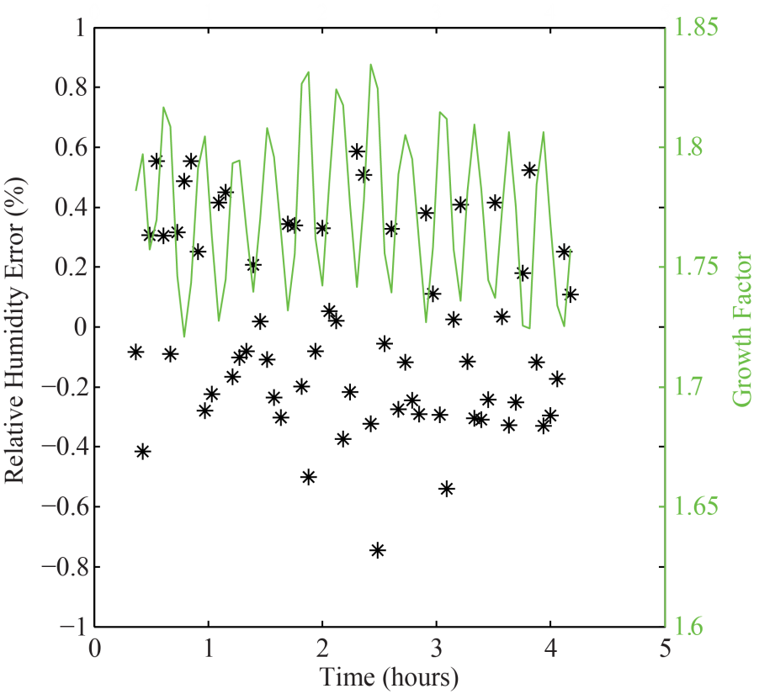

**Figure S12.** Data resulting from the atomization of ammonium sulfate for 4 hours in the laboratory. The primary y-axis is the difference between measured relative humidity (from dew point temperature and absolute temperature corrected for bias) and the calculated value relative humidity from the measured growth factor. The second y-axis is measured growth factor.

Figure 4 plots growth factor on the right axis and measured relative humidity, calculated from the dew point and DMA2 temperature, on the left in black (Buck 1981). The calculated relative humidity from Figure 4 can be compared to the relative humidity derived from the growth factor (Tang and Munkelwitz 1994) plotted in red. Time zero in this plot represents approximately one hour after setting the dew point to achieve a relative humidity of near 90%. The oscillations in relative humidity and growth factor are caused by oscillations in laboratory room temperature. We see that the mean in measured relative humidity and calculated curves in Figure 4 do not match. To calibrate the instrument, we adjusted the RTD values down by 0.27 °C to eliminate the bias. Therefore, after adjustment, the mean of the black curve was shifted up to match the mean of the red curve. Under these conditions, one standard deviation in growth factor is 0.032, which is within the required value of 0.07 (Massling et al. 2011).

Figure S12 displays the difference in the measured relative humidity, adjusted for bias, and the calculated relative humidity from the growth factor. The stated accuracy in the dew point measurement is ±0.2 °C, and the stated error in the DMA2 temperature measurement is ± 0.15°C. If we assume that the stated error from those temperatures is equal to ± 3 standard deviations, the error in calculated relative humidity should be ± 1.2%. However, Figure 5 clearly displays errors of ± 0.6, half of the stated manufacturer error. We assume the remaining error must be long term instrument error occurring beyond the experimental time frame. The long term error can be corrected with occasional calibration. We conclude that the TDMA, once calibrated, will maintain accuracies of ± 0.6 in our laboratory experiments.

Table S1. Equilibrium requirements for water with a flat interface and a spherical interface.

|  |  |  |
| --- | --- | --- |
|  | **Flat** | **Spherical** |
| **Chemical Equilibrium** | $$yP_{g}=xP^{*}exp{\left[\frac{\tilde{v}}{RT_{g}}\left(P_{L}-P^{*}\right)\right]}_{PCF}$$ | $$yP_{g}=xP^{*}exp{\left[\frac{\tilde{v}}{RT_{g}}\left(P_{L}-P^{*}\right)\right]}_{PCF}$$ |
| **Thermal Equilibrium** | $$T_{L}=T_{g}=T$$ | $$T_{L}=T_{g}=T$$ |
| **Mechanical Equilibrium** | $$P_{L}=P_{g}$$ | $$P_{L}=P_{g}+\frac{4σ}{d_{p}}$$ |
| **Combined Equilibrium** | $$yP_{g}=xP^{*}exp\left[\frac{\tilde{v}}{RT}\left(P_{g}-P^{*}\right)\right]$$ | $$yP_{g}=xP^{*}exp\left[\frac{4σ\tilde{v}}{RTd_{p}}\right]exp\left[\frac{\tilde{v}}{RT}\left(P_{g}-P^{*}\right)\right]$$ |

S6b. Derivation of relation to determine Hygroscopicity from DMA2 measurements

To calculate hygroscopicity, a relation must be developed to relate hygroscopicity to relative humidity, dry diameter, and wet diameter. We begin with the three requirements for water equilibrium shown in Table S1: chemical, thermal, and mechanical (Tester and Modell 1997) . In these relations, we have assumed that both the liquid phase and gas phase are ideal, the droplet is spherical, and a Gibb’s dividing surface. The *g* subscript represents the gas phase, and the *L* subscript represents the liquid phase. Temperature is *T*. *P\** represents the pure component saturation vapor pressure of water at temperature *T*. The mole fractions of water in the gas and liquid phases are denoted by *y* and *x* respectively. *R* is the gas constant, *ṽ* is the molar volume of water, and *σ* is the surface tension of pure water. The combined equilibrium expression is made by combining the three equilibrium requirements in two steps: 1) equating the gas and liquid phase temperature in the chemical equilibrium expression and replacing with the variable *T* without a subscript and 2) substituting the mechanical equilibrium expression for the liquid phase pressure in the chemical equilibrium expression. The spherical combined equilibrium expression has an extra exponential term that arrives from the Kelvin effect of curvature. The other exponential term is the integrated form of the Poynting correction factor (PCF). This factor is approximately equal to 1 under atmospheric conditions and is neglected here.

The combined equilibrium requirement for the spherical droplet is further altered to approach the desired hygroscopicity relation. First the saturation vapor pressure is moved to the left side of the equality. The left side of the equality, which has become the partial pressure of water divided by vapor pressure, is replaced by relative humidity, RH. This yields equation 17. In equation 17, we have replaced the mole fraction, *x*, with mole fraction of water, *xw*, in the liquid phase.

$$RH=x_{w} exp\left[\frac{4σ\tilde{v}}{RTd_{p}}\right] (17)$$

We then begin development of an expression, equation 18, for the mole fraction of water by equating the mole fraction to the moles of water, *nw*, divided by the sum of the moles of water and the moles of solute ions. The moles of ions in solution are equal to the number of ions, *ζ*, times the moles of solute, *ns*. We then divide both the numerator and denominator by moles of water. The final term in the denominator is equivalent to the ratio of volumes (*V*), densities (*ρ*), and molecular weights (*M*). The final step is to replace the hygroscopicity, κ, for the ratio of densities, molecular weights, and number of disassociated ions (Farmer, Cappa and Kreidenweis 2015).

$x_{w}=\frac{n_{w}}{ζn_{s}+n_{w}}=\frac{1}{1+\frac{ζn_{s}}{n_{w}}}=\frac{1}{1+\frac{V_{s}ζρ_{s}M_{w}}{V_{w}ρ_{w}M_{s}}}=\frac{1}{1+κ\frac{V_{s}}{V_{w}}} (18)$

We now assume that the volume of water and the dry volume of solute is additive. This assumption along with assuming the initial aerosol particle is spherical creates equation 19, and associated equation 20. In these equations, the mean diameter associated with the dry scan is substituted into *Ddry*. Each wet scan provides the *Dwet* diameter. Growth factor is the ratio of the wet diameter to the dry diameter and is denoted as gf. Temperature comes from the resistance temperature device (RTD) inside DMA2. The surface tension is assumed as pure water, 0.072 N/m. The molar volume of water is assumed to be 0.000018 meters cubed per mole.

$$RH=\frac{{g_{f}}^{3}-1}{{g_{f}}^{3}-1+κ}exp\left(\frac{4σ\tilde{v}}{RTg_{f}D_{dry}}\right) (19)$$

$$g_{f}=\frac{D_{wet}}{D_{dry}} (20)$$

S6c. Calculation of hygroscopicity from DMA2 measurements

The TDMA must provide particle diameters at two relative humidities (i.e., dry and wet) for the calculation of hygroscopicity. A set of low humidity dry scans are used to determine the dry diameter at DMA2, and a single, high humidity wet scan is used for the wet diameter. The low humidity scans are obtained at a relative humidity of 15%, while the high humidity scans are at approximately 90%.

To determine the values of dry and wet diameters, the data from the CPC is inverted and fit with a log-normal curve (see Supplemental Information S5). The mean of the dry lognormal curve fit is used for *Ddry* while the mean of the wet log normal curve fit is used for *Dwet*. It is important that enough points (more than 5) exist in the curve fit to obtain an accurate estimate of the diameter.

Figure S13 is an example scan of an ammonium sulfate run. This wet scan was the 36th observation in the group of 63 and is close to the mean of the population. The dry scan shown was the first of the four dry scans. The number of points within each curve is representative of the typical scan. There are seven points in the dry scan log normal fit and nearly eleven points in the wet. The two diameters are used to calculate growth factor (equation 20), and the growth factor along with the measure relative humidity and dry diameter are used to calculate the hygroscopicity using equation 19.

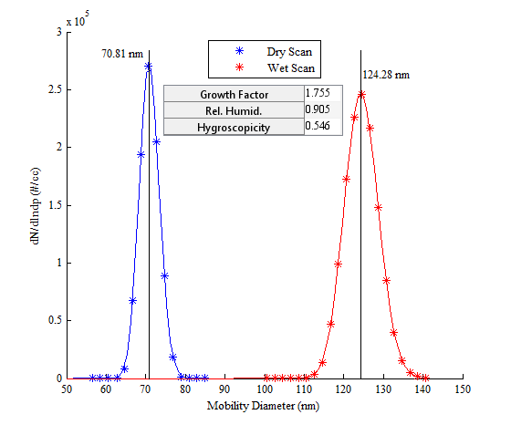

Figure S13. Example Hygroscopicity scan using Ammonium Sulfate. The blue asterisks represent measured concentrations under dry conditions (15%). Red asterisks represent measured concentrations under wet conditions (90.5%). The blue and red lines are the log-normal curve fits of the blue and red asterisks respectively.

S6d. Errors in calculated hygroscopicity

The errors in the calculation of hygroscopicity can come from many sources. The measurement of dry and wet diameter can be reduced to both accuracy and repeatability of measurements by DMA2 (see Supplemental Information S3) and accuracy and repeatability of the curve fit. The accuracy of relative humidity is discussed in Supplemental Information S6a. Here, we will compare the errors associated with hygroscopicity.

To measure DMA2 repeatability in both measurement and curve fit, repeated dry scans in this run were compared. This eliminates relative humidity as a factor. The four dry scans yielded a mean dry diameter of 70.78 nm with a sample standard deviation of 0.03 nm. The scans were performed under high flow conditions in both DMA1 and DMA2. From the DMA alignment experiments (Supplemental Information S3), both the dry scan and wet scan are measured high by DMA2. The value of the bias changes with diameter, and we can conclude from the changing bias that the wet scan would be high by 0.5 nm. This alignment error is 16 times the size of the previously mentioned standard deviation. Assuming 0.5 nm as the error in size measurement, instead of 0.03, this small bias in diameter would lower the reported growth factor to 1.748 from 1.755. The reduction in growth factor alters the hygroscopicity reported in Figure S13 by 0.008. From this we conclude that the errors in measurement of diameter by DMA1 and DMA2 do not significantly impact the reported hygroscopicity.

However, if we assume the manufacturer error in relative humidity accuracy from Supplementary Information S2e, the hygroscopicity would be between 0.48 and 0.61 for Figure S13. The relative humidity error produces an error 10 times the size of the diameter error. It is for this reason we estimate the error in hygroscopicity using relative humidity alone.

S6e. Experiments to determine hygroscopicity of standards

In addition to ammonium sulfate, 5 additional standards were atomized through the pretreatment apparatus (Supplemental Information S1) to check hygroscopicity:1) 0.18 grams of levoglucosan (Aldrich 316555) in 100ml 18 MΩ DI water, 2) 0.23 g of glutaric acid (Adrich G3407) in 100ml of 18MΩ DI water, 3) 0.24 g of malonic acid (Sigma-Aldrich M1296) in 100 ml of 18 MΩ DI water, 4) 0.11 g of oleic acid (Sigma-Aldrich 75090) in 100 ml of methanol (Sigma-Aldrich 179337), 5) 0.20 g of fructose (Sigma F0127) in 100 ml of 18 MΩ DI water. Table 1 lists the measured hygroscopicities of these standards. When using water as a solvent, the denuder in the pretreatment apparatus was filled with silica. For methanol, the denuder was filled with activated carbon. A dry diameter of 70 nm was chosen for all species, and wet scans were performed at a relative humidity of around 90%. Each standard contained between 44 wet scans (Fructose) and 64 wet scans (ammonium sulfate).

S7. Volatility

In this section, we highlight the additional requirements for volatility. The accuracy of the diameter measurements of DMA1 and DMA2 are discussed in Supplemental Information S3. The oven temperature control and measurement is discussed in Supplemental Information S2. Here we will detail the derivation of the equation to calculate vapor pressure, obtaining the data for the calculation of vapor pressure, the calculation of enthalpy, and the errors assumed in reporting the values for vapor pressure and enthalpy.

S7a Derivation of vapor pressure relationship

The calculation of vapor pressure begins with equation 21. The mass of the particle is *m*, *t* is time, *A* is the surface area of the particle, *dp* is the diameter of the particle, and *J* is the mass flux of the gas to or from the surface of the particle. Equation 21 represents a mass balance on the particle. The material flux to or from the particle will either positively or negatively change the mass of the particle respectively. In this expression, we have assumed a continuum fluid regime model.

$$\frac{dm}{dt}=AJ (21)$$

We assume that the particle is spherical and that the particle has one uniform density, *ρi*. These assumptions change the mass differential to one of particle diameter and replace the surface area of the particle with an expression for the spherical surface area. We also replace *J* with Fick’s law where *Ci\** is the concentration of the species *i* gas at the interface assumed to be saturated and always in equilibrium with the surface of the particle. *C∞* is the gas concentration far away from the particle and is assumed to be negligible. The diffusivity of the gas phase is *Dij*where component *i* is the component of interest and *j* is air. Because the particles of interest are between the continuum and kinetic regime, we must apply a correction factor, *F*. The resulting expression is shown as equation 22.

$$\frac{dd}{dt}=\frac{-4D_{ij}F}{ρ_{i}d_{p}}C_{i}^{*} (22)$$

Next we assume that concentration of species *i* on the surface of the particle is described by the ideal gas law where *R* is the gas constant, *T* is the gas temperature, *Mi* is the molecular weight, and *Pi*\* is the flat interface pressure of species *i*. Since the particles can achieve sizes at which curvature effects must be included, the Kelvin effect is used. In the Kelvin effect expression, *σi* is the surface tension. Substitution of these equations creates equation 23. *F* is expressed as equation 24(Fuchs and Sutugin 1971). In this equation, *Kni* is the Knudsen number, and *αi* is the mass accommodation coefficient. The Knudsen number is calculated using equation 26. In equation 26, λi is equal to the mean free path of species *i*. The mean free path of species i is defined by equation 27. Equation 25 displays how to calculate the mean speed of species *i*.

$$\frac{dd_{p}}{dt}=\frac{-4D_{ij}M_{i}}{ρ_{i}RTd_{p}}F\left({Kn}_{i},α_{i}\right)P_{i}^{*}\exp^{\left[\frac{4σ_{i}M_{i}}{ρ_{i}RTd_{p}}\right]} (23)$$

$$F\left(N_{kn},α\right)=\frac{1+{Kn}_{i}}{1+0.3773{Kn}_{i}+\frac{1.33{Kn}_{i}\left(1+{Kn}_{i}\right)}{α_{i}}} \left(24\right)$$

$$c_{i}={\left[\frac{8RT}{πM_{i}}\right]}^{\frac{1}{2}} (25)$$

$${Kn}_{i}=\frac{2λ_{i}}{d_{p}} (26)$$

$$λ_{i}=\frac{3D_{ij}}{c_{i}} (27)$$

To determine vapor pressure, equation 23 must be separated and integrated. This is shown as equation 28. Due to the complexity, this integration is performed numerically. Values for surface tension/surface energy, molecular weight, and density must be assumed. The diffusivity is calculated using Chapman-Enskog kinetic theory (Bird, Stewart and Lightfoot 2002). Equations 29 through 33 outline the diffusivity calculation. In equation 29, the diffusivity, *Dij*, is in cm2/s, the collision diameter, *Θij* is in angstroms, temperature, *T*, is in Kelvin, and the pressure, *P*, is in atmospheres. The collision diameter and characteristic energy, *εij*, are calculated by the mixing rules outlined by equations 30 and 31. Equation 32 is used to calculate the dimensionless temperature, *T\**. Equation 33 is a curve fit to the collision integral, *ΩD,ij*. The values assumed for each diacid as well as levoglucosan and oleic acid are shown in Table S2. The values used for collision diameter and characteristic energy are also shown in Table S2 and are calculated from the melting temperature and critical volume (Hirschfelder et al. 1965) for all but levoglucosan and oleic acid. The values for levoglucosan and oleic acid are calculated from critical temperature and critical volume (Hirschfelder et al. 1965). The residence time in the oven is Δt.

$$P_{i}^{*}=\frac{ρ_{i}RT}{-4D_{ij}M_{i}∆t}\int_{d_{0}}^{d_{f}}{\frac{d_{p}}{F\left({Kn}_{i},α_{i}\right)\exp^{\left[\frac{4σ_{i}M_{i}}{ρ_{i}RTd_{p}}\right]}}dd_{p}} (28)$$

Table S2. Variables used in equation 26.

|  |  |  |  |  |  |
| --- | --- | --- | --- | --- | --- |
| Compound | Surface Tension/Energy | Density | Molecular Weight | Collision Diameter | Characteristic Energy (ε/*k*) |
|  | (J/m2) | (Kg/m3) | (g/mole) | (Å) | (K) |
| Malonic AcidA | 0.2 | 1616 | 104.06 | 5.33 | 784.80 |
| Succinic AcidA | 0.125 | 1566 | 118.09 | 5.69 | 885.41 |
| Glutaric AcidA | 0.215 | 1424 | 132.12 | 6.01 | 708.77 |
| Adipic AcidA | 0.6 | 1362 | 146.14 | 6.30 | 818.21 |
| Pimelic AcidA | 0.08 | 1281 | 160.17 | 6.56 | 722.21 |
| Suberic AcidA | 0.1 | 1272 | 174.20 | 6.81 | 797.09 |
| Azelaic AcidA | 0.18 | 1251 | 188.22 | 7.03 | 728.93 |
| Levoglucosan | 0.022B | 1640C | 162.14 | 5.97 | 608.3 |
| Oleic AcidD | 0.0325 | 895 | 282.46 | 8.41 | 601.37 |

A-(Bilde et al. 2003); B-(Topping et al. 2007); C-(Koehler et al. 2006); D-(Yaws 2008). Collision diameter and characteristic diameter estimate for levoglucosan provided by email communication from NIST.

$$D_{ij}=0.0018583\sqrt{T^{3}\left(\frac{1}{M_{j}}+\frac{1}{M_{i}}\right)}\frac{1}{Pθ_{ij}^{2}Ω_{D,ij}} (29)$$

$$Θ_{ij}=\frac{1}{2}\left(Θ_{i}+Θ_{j}\right) (30)$$

$$ε_{ij}=\sqrt{ε_{i}ε_{j}} (31)$$

$$T^{*}=\frac{kT}{ε_{ij}} (32)$$

$$Ω_{D,ij}=\frac{1.06036}{{T^{*}}^{0.1561}}+\frac{0.193}{exp\left(0.47635T^{*}\right)}+\frac{1.03587}{exp\left(1.52996T^{*}\right)}+\frac{1.76474}{exp\left(3.89411T^{*}\right)} (33)$$

S7b. Calculation of vapor pressure

Figure S14 displays one of four non-heat treated scans and one heat-treated volatility scans for adipic acid. The red asterisks are the resulting non-heat treated scan while bypassing the oven. The blue pluses are the resulting scan after passing the aerosol through the heated oven. Both curves are fit with a log-normal curve, and the mean determined (*Supplemental Information S5*). The mean of the red curve provides the lower limit for the integral in equation 26, while the mean of the blue curve provides the upper limit. With the supporting variables from Table S2, the integral is performed numerically, and the vapor pressure is calculated. The vapor pressure from this example in Figure S14 was found to be 2.3x10-4 Pa. Particle loss in the oven is not considered in the estimation of vapor pressure. Evaporating particles adhered to the oven tubing walls will add to the gas phase. The calculated value should be slightly lower than actual due to the assumption of a gas phase concentration of zero (see *Supplemental Information S7a*).

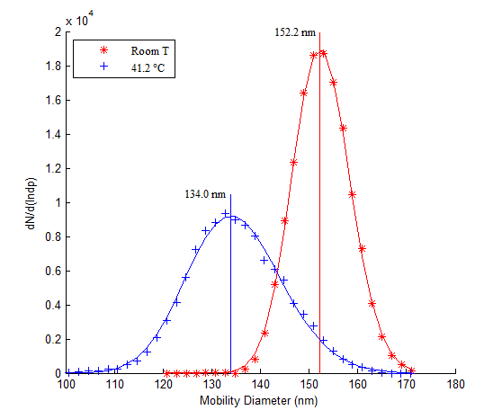

Figure S14. The result of the evaporation of Adipic Acid at an internal temperature of 41.2 C. The unevaporated aerosol is plotted as red asterisks. The aerosol evaporated through the oven is shown as blue pluses. The red and blue lines are log-normal curve fits of the unevaporated and evaporated aerosols respectively.

This process is repeated for several different oven temperatures. A plot of the natural log of vapor pressure as a function of inverse temperature is created. Then a linear curve fit is performed. Then the slope is multiplied by *–R* to determine the enthalpy of phase transition (see equation 34). For the diacids and levoglucosan, the phase transition is assumed to be solid-to-gas (sublimation). For Oleic Acid, the phase transition is assumed to be liquid-to-gas (vaporization).

$$\frac{\ln\left(P_{2}^{*}\right)}{\ln\left(P_{1}^{*}\right)}=-\frac{∆H_{sub}}{RT}\left(\frac{1}{T_{2}}-\frac{1}{T_{1}}\right) (34)$$

S7c. Errors in the calculated vapor pressure and enthalpy

As with hygroscopicity measurements, we need to consider any possible errors that could arise in our measurement of vapor pressures. First, the curve fit error (Figure S14) should be quite small since all curves have well over five points. Second, both DMAs are in high flow. The misalignment error between the two DMAs is relatively constant down to 70 nm (Figure 2). This means that any bias due to DMA misalignment is constant throughout the investigated range. Some error in inversion will occur, but assumed minimal (*Supplemental Information S5*). Last, and most importantly, it is possible to fill the gas phase with the evaporating component suppressing further evaporation or causing re-condensation upon oven exit.

High gas phase concentration can occur by either high initial gas concentrations, evaporation of high particle concentrations, or both. We created a routine that included equation 26 and a mass balance to calculate gas phase concentration. Since the gas phase is saturated upon entry into DMA1, the initial concentration at the oven is assumed to be a tenth (high sheath flow) of the room temperature saturation concentration. We measured the length of tubing between the oven exit and the denuder as well as the length of tubing to DMA2. We use those two lengths and the aerosol flow rate to compare the impact of re-condensation.

In Figure S15, we plot the error associated with the initial gas concentration for all diacids. The grey area represents the measurable vapor pressures under the current design. At 6.1 x 10-6 Pa and lower, evaporation of the particles cannot be detected. At 9.1 x 10-4 Pa and above, the particles completely evaporate. When the initial gas phase concentration is in the capability range of the oven, C∞ cannot be assumed as zero. In this figure, we assume only a single particle enters the oven in equilibrium with the gas phase with no possibility of re-condensation upon oven exit. A positive error means that the zero *C∞* assumption biases the measurement high. We see from the plot that the error in the enthalpy of sublimation increases as the room temperature vapor pressure increases. For room temperature vapor pressures below the capability of the oven, the error is effectively zero. The error for malonic acid is approximately 10%, and represents the maximum bias associated with this error since higher vapor pressures are unmeasurable by the TDMA.

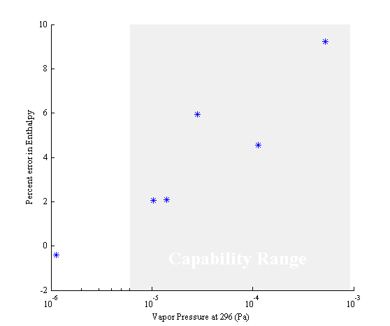

**Figure S15**. Error associated with equilibrium assumption. The data points are the percent error in enthalpy for the diacid series resulting from assuming the gas phase concentration is equal to zero. The greyed area represents the measurement capability of the oven. A positive error means that assuming a gas phase concentration of zero will bias the measured enthalpy high.

In Figure S16, we have used the suberic acid system as a model. The impact of initial concentration (Figure S15) is effectively zero, but we included the initial concentration bias in Figure S16. Two situations are compared by this figure: recondensation occurs until the denuder and recondensation continues until DMA2 (no denuder). Included in both situations is the error associated with high gas phase concentration within the oven due to excess particle mass evaporation. We see that no detectable error in either situation occurs below a particle concentration of 1000 particles per cubic centimeter. A small error in vapor pressure occurs at 3000 particles per cubic centimeter, and enthalpy error does not occur until about 30,000 particles per cubic centimeter. In situations where a denuder is necessary to prevent re-condensation, errors will still be large due to evaporation suppression in the oven. In this experiment, the zeroth moment of the DMA2 response never exceeded 2000 particles for the diacids. For suberic acid, the zeroth moment was approximately 330 particles per cubic centimeter. Since the TDMA has a denuder and particle concentrations are low, no significant re-condensation error is expected by this method.

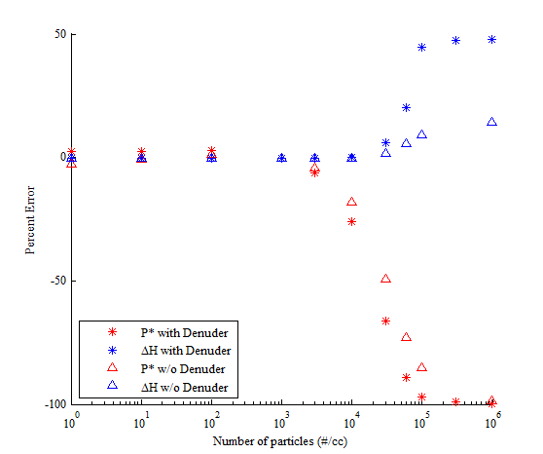

**Figure S16.** Percent error in vapor pressure and enthalpy of sublimation due to high gas phase concentration and re-condensation upon particle exit. Suberic acid is the model compound. Particle concentrations as measured by the zeroth moment of the measured DMA2 size distribution. Calculations assume all particles are equal to the mean diameter. Red is the error in vapor pressure, and blue is the error in enthalpy. Asterisks assume that all re-condensation ends at the denuder. Triangles assume that all re-condensation ends at DMA2. A positive error means that assuming a gas phase concentration of zero will bias the measurement high.

**S8. List of Variables used in this document.**

*A* - Surface Area of particle.

*a* - Inside radius of DMA annulus.

*a\**- Negative differential of the natural log of mobility with respect to natural log of diameter.

*b* - Outside radius of DMA annulus.

*c* – Intercept of the Clausius-Clapeyron equation.

*Ci\** - Concentration of gas species i in equilibrium with the particle surface.

*C∞* - Concentration at infinite distance from center of particle.

*ci*– Mean speed of gas molecules of component i.

*C –* Cunningham correction factor.

*D –* Diffusivity of particle.

*Dij –* Diffusivity of gas species i in j (air).

*Dwet* – Diameter of particle in high humidity environment (~90%).

*Ddry* – Diameter of particle in low humidity environment (~15%).

*dp* – Particle Diameter.

*e* – Charge of an electron.

*F* – Correction for the transition between kinetic theory and continuum regimes.

*gf –* Growth Factor.

*H –* H array. This includes the ratios determining transfer efficiencies impacting that particle diameter. Bold denotes and array.

*i –* Bin number or evaporating species.

*J –* Flux of species to or from particle surface.

*j* – Sub bin number or air.

*k* – Boltzman’s Constant.

*Leff* – Effective length of straight tubing with the same particle loss of system with straight tubing, bends and valves.

*L –* Length of the DMA.

*M* – Molecular Weight.

*m* – particle mass.

*N* – Size distribution. Bold denotes and array

*Nkn –* Knudsen number.

*n –* Number of moles. The subscript s denotes solute and the subscript w denotes water

*Ps* – slope of linear relation relating the sub bin j to nearest bin i.

*P* – Pressure of phase. Subscript L denotes the liquid phase while g denotes gas phase.

*Pi* -* Vapor pressure of species i.

*PCF –* Integrated form of the Poynting Correction Factor.

*PT –* Particle penetration fraction.

*Q* – Product of the H and F arrays. Bold denotes an array.

*q* – Flow rate. Subscripts denote locations.

*R –* Gas Constant

*Rc –* CPC response. Bold denotes and array.

*T* – Temperature or Temperature of a phase. Subscript *L* denotes liquid phase while subscript *g* denotes gas phase. The subscript *rm* denotes room temperature. The subscript *O* denotes the oven temperature.

*t* – Time.

*U* – Dimensionless temperature. A value of 1 means the gas phase is equal to room temperature. A value of 0 means the gas phase is equal to the oven temperature.

*V* – Volume.

*Vt –* Voltage of DMA.

*x –* Mole fraction in the liquid phase.

*y –* Mole fraction in the gas phase.

*α* – Mass accommodation coefficient. Assumed to be 1 throughout document.

*β* – DMA non-dimensionalized flow for use in transfer function.

*γ* – Slope of logarithmic relationship relating bin i to sub bin j.

*Δt* – Time in oven.

*Δ* – Logarithmic spacing of sub bin diameters.

*ΔHsub* – Enthalpy of sublimation (solid) or enthalpy of vaporization (liquid).

*δ* – DMA nondimensional flow used in transfer function.

*ζ* – Number of disassociated ions.

*η –* Fraction of particles with charge.

*κ* – Hygroscopicity.

*λi* – Mean Free Path of species *i*. If no subscript present, then the variable is the mean free path of air.

*μ* – Dynamic Viscosity of Air.

*ν –* Flow rates used in DMA transfer function.

$\tilde{ν}$*–* Molar volume.

*ξ –* Number of charges.

*ρ* – Density of particle.

*σi* – Surface tension of component i. If no subscript is present, the variable is the surface tension of water.

*Ω* – DMA transfer function. When the subscript *D,ij* is used, the variable denotes the collision integral.

*ω* – CPC detection efficiency.

*Θ-* Collision diameter.

*ε-* Characteristic energy.

S9. References

Allen, M. D. and O. G. Raabe. 1985. Slip correction measurements of spherical solid aerosol particles in an improved millikan apparatus. *Aerosol Sci Tech* 4:269-286. doi: 10.1080/02786828508959055.

Baron, P. A. 2001. *Aerosol measurement principles, techniques, and applications*. Wiley, New York.

Bilde, M., B. Svenningsson, J. Monster, T. Rosenorn. 2003. Even-odd alternation of evaporation rates and vapor pressures of c3-c9 dicarboxylic acid aerosols. *Environ Sci Technol* 37:1371-1378. doi: Doi 10.1021/Es0201810.

Bird, R. B., W. E. Stewart, E. N. Lightfoot. 2002. *Transport phenomena*. J. Wiley, New York.

Buck, A. L. 1981. New equations for computing vapor pressure and enhancement factor. *Journal of applied meteorology* 20:1527-1532. doi.

Cocker, D. R., N. E. Whitlock, R. C. Flagan, J. H. Seinfeld. 2001. Hygroscopic properties of pasadena, california aerosol. *Aerosol Sci Tech* 35:637-647. doi: Doi 10.1080/027868201316899992.

Farmer, D. K., C. D. Cappa, S. M. Kreidenweis. 2015. Atmospheric processes and their controlling influence on cloud condensation nuclei activity. *Chem Rev* 115:4199-4217. doi: 10.1021/cr5006292.

Friedlander, S. K. 2000. *Smoke, dust, and haze : Fundamentals of aerosol dynamics*. Oxford University Press, New York.

Fuchs, N. A. and A. G. Sutugin. 1971. High-dispersed aerosols, in *Topics in current aerosol research*, Hidy, G. M. and J. R. Brock, eds., Pergamon, 1.

Gunn, R. 1956. The hyperelectrification of raindrops by atmospheric electric fields. *J Meteorol* 13:283-288. doi: Doi 10.1175/1520-0469(1956)013<0283:Thorba>2.0.Co;2.

Hagen, D. E. and D. J. Alofs. 1983. Linear inversion method to obtain aerosol size distributions from measurements with a differential mobility analyzer. *Aerosol Sci Tech* 2:465-475. doi.

Hermann, M., B. Wehner, O. Bischof, H. S. Han, T. Krinke, W. Liu, A. Zerrath, A. Wiedensohler. 2007. Particle counting efficiencies of new tsi condensation particle counters. *Journal of Aerosol Science* 38:674-682. doi: <http://dx.doi.org/10.1016/j.jaerosci.2007.05.001>.

Hirschfelder, J. O., C. F. Curtiss, R. B. Bird, University of Wisconsin. Theoretical Chemistry Laboratory. 1965. *Molecular theory of gases and liquids*. Wiley, New York.

Kim, J. H., G. W. Mulholland, S. R. Kukuck, D. Y. H. Pui. 2005. Slip correction measurements of certified psl nanoparticles using a nanometer differential mobility analyzer (nano-dma) for knudsen number from 0.5 to 83. *Journal of Research of the National Institute of Standards and Technology* 110:31-54. doi: 10.6028/jres.110.005.

Koehler, K. A., S. M. Kreidenweis, P. J. DeMott, A. J. Prenni, C. M. Carrico, B. Ervens, G. Feingold. 2006. Water activity and activation diameters from hygroscopicity data - part ii: Application to organic species. *Atmos Chem Phys* 6:795-809. doi.

Lawson, C. L. and R. J. Hanson. 1974. *Solving least squares problems*. Prentice-Hall, Englewood Cliffs, N.J.,.

Massling, A., N. Niedermeier, T. Hennig, E. O. Fors, E. Swietlicki, M. Ehn, K. Hameri, P. Villani, P. Laj, N. Good, G. McFiggans, A. Wiedensohler. 2011. Results and recommendations from an intercomparison of six hygroscopicity-tdma systems. *Atmos Meas Tech* 4:485-497. doi: 10.5194/amt-4-485-2011.

Rader, D. J. and P. H. McMurry. 1986. Application of the tandem differential mobility analyzer to studies of droplet growth or evaporation. *Journal of Aerosol Science* 17:771-787. doi.

Stolzenburg, M. R. and P. H. McMurry. 2008. Equations governing single and tandem dma configurations and a new lognormal approximation to the transfer function. *Aerosol Sci Tech* 42:421-432. doi: 10.1080/02786820802157823.

Tang, I. N. and H. R. Munkelwitz. 1994. Water activities, densities, and refractive-indexes of aqueous sulfates and sodium-nitrate droplets of atmospheric importance. *J Geophys Res-Atmos* 99:18801-18808. doi: Doi 10.1029/94jd01345.

Tester, J. W. and M. Modell. 1997. *Thermodynamics and its applications*. Prentice Hall PTR, Upper Saddle River, N.J.

Topping, D. O., G. B. McFiggans, G. Kiss, Z. Varga, M. C. Facchini, S. Decesari, M. Mircea. 2007. Surface tensions of multi-component mixed inorganic/organic aqueous systems of atmospheric significance: Measurements, model predictions and importance for cloud activation predictions. *Atmos Chem Phys* 7:2371-2398. doi.

Wiedensohler, A. 1988. An approximation of the bipolar charge-distribution for particles in the sub-micron size range. *Journal of Aerosol Science* 19:387-389. doi.

Wiedensohler, A., W. Birmili, A. Nowak, A. Sonntag, K. Weinhold, M. Merkel, B. Wehner, T. Tuch, S. Pfeifer, M. Fiebig, A. M. Fjaraa, E. Asmi, K. Sellegri, R. Depuy, H. Venzac, P. Villani, P. Laj, P. Aalto, J. A. Ogren, E. Swietlicki, P. Williams, P. Roldin, P. Quincey, C. Huglin, R. Fierz-Schmidhauser, M. Gysel, E. Weingartner, F. Riccobono, S. Santos, C. Gruning, K. Faloon, D. Beddows, R. M. Harrison, C. Monahan, S. G. Jennings, C. D. O'Dowd, A. Marinoni, H. G. Horn, L. Keck, J. Jiang, J. Scheckman, P. H. McMurry, Z. Deng, C. S. Zhao, M. Moerman, B. Henzing, G. de Leeuw, G. Loschau, S. Bastian. 2012. Mobility particle size spectrometers: Harmonization of technical standards and data structure to facilitate high quality long-term observations of atmospheric particle number size distributions. *Atmos Meas Tech* 5:657-685. doi.

Yaws, C. L. 2008. *Thermophysical properties of chemicals and hydrocarbons*. William Andrew, Norwich, NY.