Supplemental Material

Characterization and in vitro biological effects of ambient air PM₁₀ from a rural, an industrial and an urban site in Sulaimani City, Iraq

Ali Talib Arif^{1, 2, 6, 7}, Christoph Maschowski⁶, Polla Khanaqa^{1, 7}, Patxi Garra^{3, 4}, Manuel Garcia-Käufer², Nadja Wingert²,Volker Mersch-Sundermann², Richard Gminski², Gwenaëlle Trouvé³, Reto Gieré⁵

¹ Sulaimani Polytechnic University (SPU), Technical College of health, Sulaimani, Iraq
² Institute for Infection Prevention and Hospital Epidemiology, University Medical Center Freiburg, University of Freiburg, Faculty of Medicine, University of Freiburg, D- 79106 Freiburg, Germany
³ Laboratoire Gestion des Risques et Environnement (LGRE), Université de Haute-Alsace, F-68093 Mulhouse Cedex, France
⁴ Laboratoire Modélisation Intelligence des Procédés et des Systèmes (MIPS), Université de Haute-Alsace, F-68093 Mulhouse Cedex, France
⁵ Department of Earth and Environmental Science and Center of Excellence in Environmental Toxicology, University of Pennsylvania, Philadelphia, PA 19104-6316, USA
⁶ Institute of Earth and Environmental Sciences-Geochemistry, University of Freiburg, D-79104 Freiburg, Germany
⁷ Kurdistan Institution for Strategic Studies and Scientific Research (KISSR), Qirga - Sulaimani, Iraq

2. SUPPLEMENTAL MATERIALS AND METHODS

2.1. Transmission electron microscopy (TEM)
PM₁₀ samples were dispersed in Millipore water (1 mg/mL) and sonicated in an ultrasonic water bath (Ultrasonic water bath, Badelin electronic, Berlin, Germany) at 37°C for 10 min. A 1% (v/v) glutaraldehyde solution (Polysciences Europe, Eppelheim, Germany) was prepared by dilution with 1 × HEPES buffer (Bichrom, Berlin, Germany). At the same time, a Petri dish (Greiner Bio‐One, Kremsmünster, Austria) was covered with Parafilm® (Bemis, Soignies, Belgium). On this hydrophobic surface, 10 μL of the dispersion containing the PM₁₀ sample materials were pipetted, and a lacey carbon copper grid (plano-em) was placed on the drop. Next, the 1% glutaraldehyde solution was used for fixation of the PM₁₀ sample materials for 5 min. The grid with the fixed PM₁₀ sample materials was then rinsed four times for 30 s with double-distilled water. Finally, the lacey-carbon copper grid was stained with 1% (v/v) uranylacetate solution (Sigma Aldrich, Taufkirchen, Germany), and the grid was allowed to dry prior to performing the TEM analysis (Hitachi H600, Tokyo, Japan) at the Institut und Poliklinik für Arbeits- und Sozialmedizin der Justus Liebig Universität Gießen (Germany).

2.2. Endotoxin determination

The samples were incubated at 37°C and assayed in 96-well microplate to read the absorbance of each reaction at 545 nm following the methods described by the manufacturer. Endotoxin content of samples and blanks are evaluated by interpolation against a standard curve prepared using an endotoxin standard. This method has a sensitivity range from 0.01 to 0.1 endotoxin units per mL (EU/mL).

2.3. Cell viability

The Water Soluble Tetrazolium assay (WST-1) was used to measure cell viability in cultured cells. Briefly, after PM₁₀ exposure, cells were washed with PBS. The cells were incubated in serum-free DMEM, supplemented with WST-1 reagent at 5% (v/v) and incubated for 1 h at 37°C, protecting the plate from light. At the end of incubation, absorbance was measured at a wavelength of 570 nm with a spectrophotometric Microplate reader (Infinite® 200 PRO Tecan Group Ltd., Männedorf, Switzerland). Cell viability was defined as the ratio (expressed as a percentage) of absorbance of treated cells to untreated cells.

2.4. Detection of Intracellular ROS in A549 cells

For this purpose, 4 × 10⁵ A549 cells were seeded in 12-well plates, incubated with 2 mL of culture medium for 24 h, and then exposed to the prepared PM₁₀ samples in 2 mL of culture medium. After exposure, cells were gently washed once with HBSS and incubated with HBSS containing the spin probe, CAT1-H (200 µM) for 4 h at 37° C and 5 % CO₂ (v/v). Next, the amount of ROS generated in the cell supernatant was evaluated by using the Bruker E-SCAN EPR spectrometer with a temperature and gas controller and the following instrumental settings: center field g = 2.01; microwave power, 20 mW; modulation amplitude, 0.98 G; sweep rate, 10 G/5.24 s; number of scans, 3; for 1024-point spectrum. For quantification, the amplitudes of all EPR spectrum peaks were measured, and the calculated data were presented as mean ± SD from three independent experiments.
Menadione (Sigma Aldrich, Taufkirchen, Germany) was used as a Positive Control (PC) for detection of intracellular ROS production compared to control cells without particle treatment. This compound causes generation of intracellular ROS at multiple cellular sites through futile redox cycling (Criddle et al. 2006)

2.5. Measurement of DNA damage in A549 cells by the DNA Alkaline Unwinding Assay (DAUA)

PM₁₀-induced strand breaks in DNA of A549 cells were evaluated by the alkaline unwinding assay (DAUA) using the hydroxyapatite batch procedure (Hartwig and Schlepegrell 1995; Arif et al. 2017) with minor modifications. Briefly, following exposure to PM₁₀ and the positive control ethyl methane sulfonate (EMS; Alfa Aesar, Karlsruhe, Germany; 5 mmol/L) for 24 h, the medium was aspirated and the cells were washed twice with cold PBS. Subsequently, the cells were immediately placed on ice and subjected to alkaline unwinding by rapid addition of 1.5 mL of 0.06 N NaOH in 0.01 M Na₂HPO₄, pH 12.3. Alkaline unwinding was allowed to complete in darkness for 30 min. The pH of the reaction mixture was then neutralized to pH 7.0 by adding 0.1 N HCl (500 µL). Directly after sonication, sodium dodecyl sulfate (SDS; Serva electrophoresis, Heidelberg, Germany) was added to a final concentration of 0.05% (w/v). Hydroxyapatite column chromatography was performed in a specially designed heating block (handmade) heated to 60 °C in a water bath (Memmert, Schwabach, Germany). The 1 mL hydroxyapatite columns (Sigma Aldrich, Schnelldorf, Germany) were also prepared at 60 °C. The first step in chromatography is activation of the hydroxyapatite columns. For this purpose, 1.5 mL of 0.5 M potassium phosphate buffer was added. Next, the column was washed with 1.5 mL of 0.01 M sodium phosphate buffer before the samples were added. The columns were then washed a second time with 2.5 mL 0.01 M sodium phosphate buffer. The single-stranded DNA was eluted in a 12-well cell-culture plate with 1.5 mL of 0.5 M potassium phosphate buffer. The 12-well cell-culture plate, where the eluted DNA was collected, was then kept in the dark to protect the DNA because of its light sensitivity. A new 12-well cell-culture plate was placed under the columns and the double-stranded DNA was eluted with 0.35 M potassium phosphate buffer. The fluorescence dye Hoechst 33258 (Sigma Aldrich, Schnelldorf, Germany) was added to each well to a final concentration of 7.5 x 10⁻⁷ M and the samples were then placed in the dark for 30 min. After the incubation time, the fluorescence was measured with spectrophotometric Microplate reader (Infinite® 200 PRO Tecan Group Ltd., Männedorf, Switzerland) at an excitation wavelength of 360 nm and an emission wavelength of 455 nm. The fractions of double-stranded and single-stranded DNA were calculated as described by Hartwig et al., 1995 (Hartwig and Schlepegrell 1995). A blank (buffer only) was prepared for each plate.

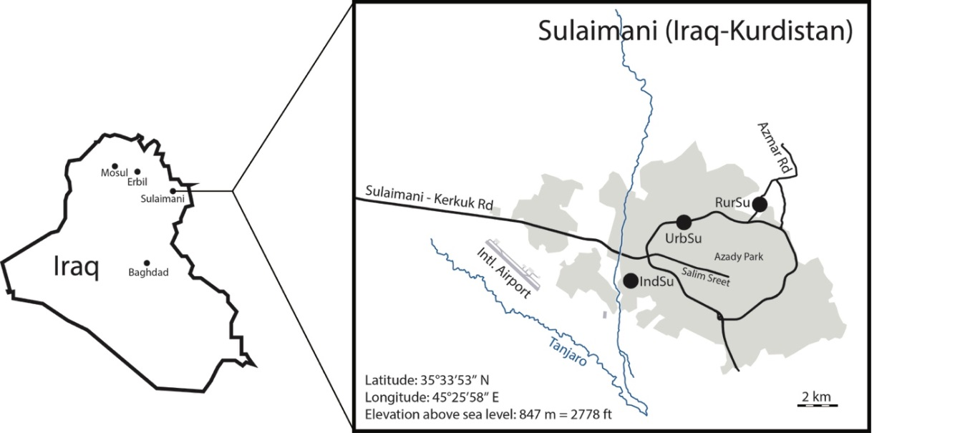

Fig.S1. Map showing the locations of sample collection sites in Sulaimani City. Sampling sites are marked by black dots (RurSu, IndSu, UrbSu).

SUPPLEMENTAL RESULTS

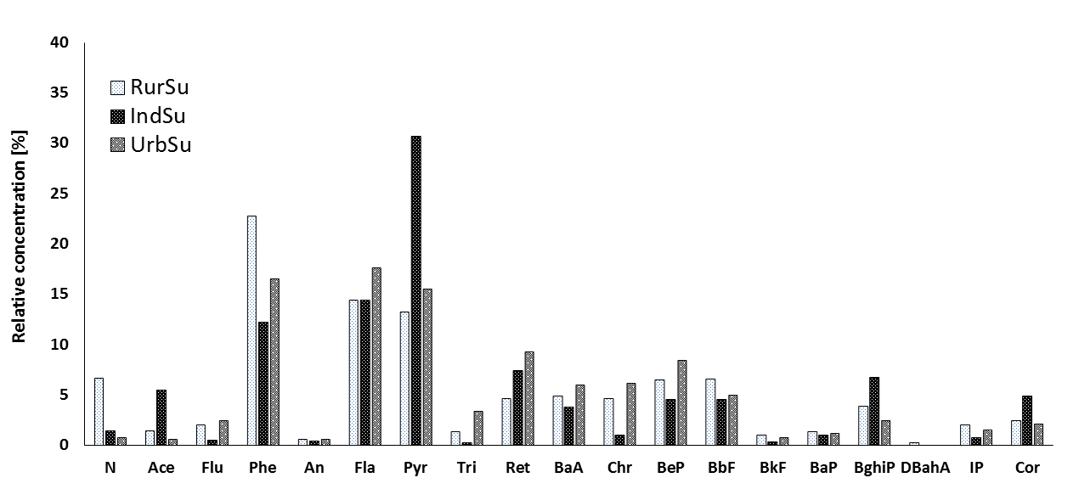
Fig.S2. PAH profile of the PM₁₀ from the three sampling sites RurSu, IndSu, and UrbSu in Sulaimani City

The PAH profiles, calculated as relative concentrations, are presented in (Fig.S2). The relative concentrations were calculated considering the total PAHs concentrations for a given PM₁₀ sample as 100 % (e.g. 241.83 ng/g) in Table 2 for RurSu. Phenanthrene (Phe) is the most abundant PAH in RurSu PM₁₀ with 22.75 %, whereas Fluoranthene (Fla) is most abundant in UrbSu PM₁₀ with 17.57 %, and Pyrene (Pyr) is the most abundant PAH for IndSu PM₁₀. Other PAHs do not show notable variations of their relative concentrations in regard to the chosen sampling sites.
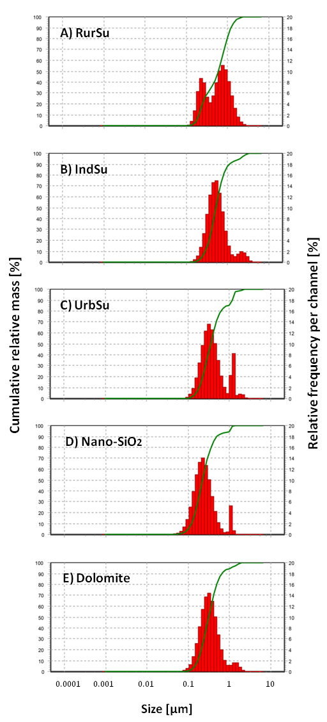
Fig.S3. Hydrodynamic size distributions of PM₁₀ samples and control substances suspended in distilled water and measured by Dynamic Light Scattering (DLS). Size curves are shown for concentrations of 100 µg/mL of A) RurSu, B) IndSu, C) UrbSu, D) nano-SiO₂, E) dolomite. Green line indicates the relative cumulative mass in percent (left axis); red columns hold relative frequency per channel for each size range in percent.
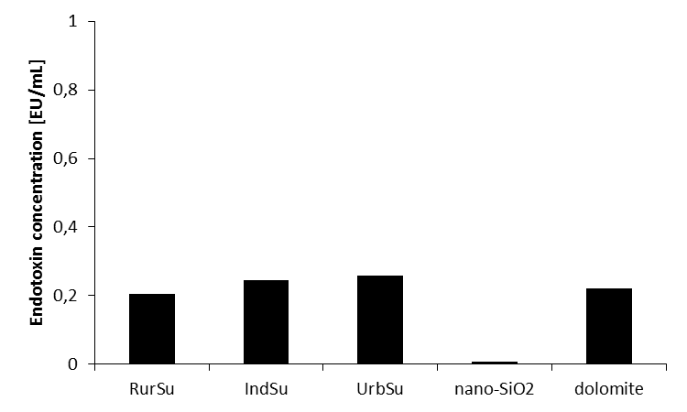

Fig.S4. Detection of endotoxin (in EU/mL) induced by PM₁₀ samples and control substances (all tested at a concentration of 1 mg/mL) by the Limulus Amebocyte Lysate (LAL) test.

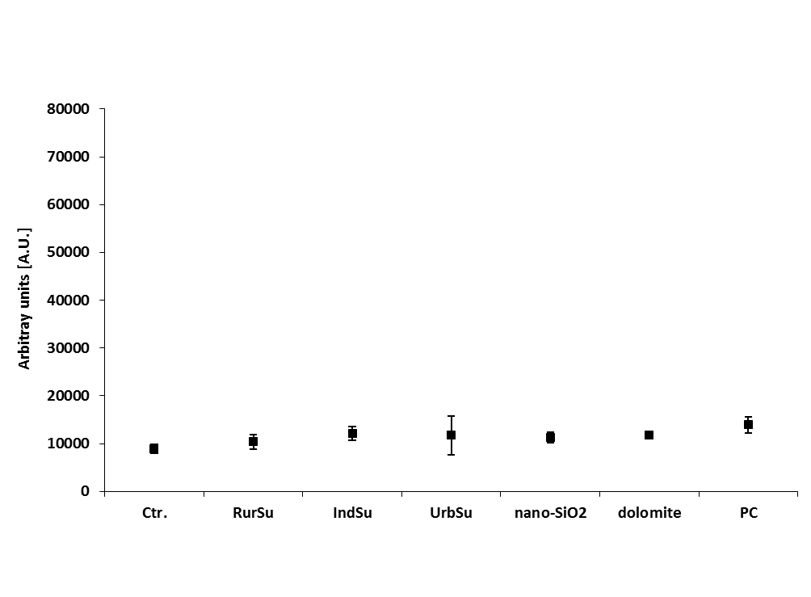
Fig.S5. Acellular ROS production as measured by EPR spectroscopy for the studied PM₁₀ samples, the control substances nano-SiO₂ and dolomite, each at a concentration of 100 µg/mL. Positive control (PC): menadione (conc. 100 mmol/L). All results are expressed as arbitrary units (A.U.) and compared to autoxidation of CAT1-H (without particle treatment and without cell exposure; control [Ctr.]). All data represent the mean ± SD of at least three independent experiments; determined by one-way-ANOVA followed by Dunnett’s post-hoc test to compare between exposed and non-exposed groups. P values < 0.05 were considered significant.

Fig.S6. Cellular ROS production in A549 cells, as measured by EPR spectroscopy after 4 h exposure to PM₁₀ samples and the control substances nano-SiO2 and dolomite. All results are expressed as arbitrary units (A.U.) and compared to autoxidation of CAT1-H (without particle treatment; control [Ctr.]). Positive Control (PC): menadione at a concentration 100 mmol/L. All data represent the mean ± SD of at least three independent experiments; determined by one-way-ANOVA followed by Dunnett’s post-hoc test to compare between exposed groups and control. P values of *p < 0.05, **p < 0.01, and ***p < 0.001 were considered significant.

Fig.S7. Release of various cytokines and chemokines from cell culture supernatants of A549 cells after 24 h exposure to PM₁₀ samples from RurSu, IndSu, UrbSu and to dolomite (each at concentrations of 30 µg/mL) and to nano-SiO₂ (conc. 10 µg/mL). Conc. for LPS: 0.01– 0.1 µg/mL. All data are the mean of two technical duplicates from one experiment.

Table S1. Sample information and mass deposition rates of dust collected in Sulaimani City

Sample  name | Sample  ID | Sampling  site | GPS  Co-ordinates | Mass deposition  [g/0.4 m²/month]ª
 |  |  |  | sampler 1  sampler 2 | average
Rural  Sulaimani | RurSu | Azmar  Mountain area | N 35°36′ 44.03′′  E 045°28′ 39.50′′ | 0.74  0.56 | 0.65
Industrial Sulaimani | IndSu | Tanjaro  Industrial area ^{b} | N 35°30′ 24.07′′  E 045°26′ 37.30′′ | 1.15  0.87 | 1.01
Urban Sulaimani | UrbSu | Malik Mahmud  Urban area ^{c} | N 35°34′ 29.87′′  E 045°23′ 31.09′′ | 1.81  2.3 | 2.06

a. Sampling was done for two months continuously from 1st July through 31st August 2014 and data are listed for one month
b. A municipal solid waste incinerator power plant is located in this area
c. Sulaimani City ring road

Table S2. Qualitative ranking of bulk mineralogical contents in dust samples obtained by XRD

Method | RurSu | IndSu | UrbSu
XRD | Quartz > calcite > muscovite > chlorite | not tested ª | Quartz > muscovite > calcite > chlorite

a. Dust sample IndSu could not be analyzed by XRD because of insufficient sample material

Table S3. Particle-size characterization of PM₁₀ samples, nano-SiO₂ and dolomite

Sample | Size [µm] ª | maxima in the distribution spectrum [µm] ^{b} | PM size [µm] ^{c} | Zeta potential ^{d} (mV) ± SD
RurSu  IndSu  UrbSu | <10  <10  <10 | 0.22 and 0.74  0.48 and 2.18  0.31, 1.16 and 1.86 | ≈ 1  ≈ 1  ≈ 0.2 | - 36.78 ± 0.78  - 41.29 ± 1.34  - 49.43 ± 1.32
nano-SiO₂ | 0.016 ^{e} | 0.21 and 1.04 | ≈ 0.2 | - 32.56 ± 1.11
dolomite | 3-5 ^{e} | 0.29 and 1.35 | ≈ 1 | - 28.43 ± 1.56
a. PM₁₀ fraction of sieved dust according to their aerodynamic diameter using Berner-type low-pressure impactor (BLPI)
b. Hydrodynamic particle size distribution as determined by DLS analysis
c. Physical diameter, determined by Transmission Electron Microscopy (TEM)
d. Surface charge (Zeta potential) measurement by Nanoparticle Tracking Analysis (NTA)
e. Size distribution according to manufacturer’s certification data sheet

SUPPLEMENTAL REFERENCES
Arif, Ali Talib, Christoph Maschowski, Patxi Garra, Manuel Garcia-Käufer, Tatiana Petithory, Gwenaëlle Trouvé, Alain Dieterlen, et al. 2017. “Cytotoxic and Genotoxic Responses of Human Lung Cells to Combustion Smoke Particles of Miscanthus Straw, Softwood and Beech Wood Chips.” Atmospheric Environment 163 (August): 138–154. doi:10.1016/j.atmosenv.2017.05.019.
Criddle, David N., Stuart Gillies, Heidi K. Baumgartner-Wilson, Mohammed Jaffar, Edwin C. Chinje, Sarah Passmore, Michael Chvanov, et al. 2006. “Menadione-Induced Reactive Oxygen Species Generation via Redox Cycling Promotes Apoptosis of Murine Pancreatic Acinar Cells.” Journal of Biological Chemistry 281 (52): 40485–40492. doi:10.1074/jbc.M607704200.
Hartwig, Andrea, and Regina Schlepegrell. 1995. “Induction of Oxidative DNA Damage by Ferric Iron in Mammalian Cells.” Carcinogenesis 16 (12): 3009–3013. doi:10.1093/carcin/16.12.3009.

