Supplemental Information,
Numerical modeling of the performance of high flow DMAs to classify sub-2 nm particles

Huang Zhang^{1,2,a}, Girish Sharma^{1,a}, Yang Wang¹, Shuiqing Li², and Pratim Biswas^{1*}
ªEqual contribution
1. Center for Aerosol Science and Engineering, Department of Energy, Environmental and Chemical Engineering, Washington University in St. Louis, MO 63130, USA
2. Department of Energy and Power Engineering, Tsinghua University, Haidian District, Beijing 100084, China

* To whom correspondence should be addressed:
Tel: +1-314-935-5548; Fax: +1-314-935-5464
E-mail address: pbiswas@wustl.edu

This supplemental information consists of the following sections:
1. Navier Stokes equations

2. Boundary condition for sheath flow inlet

2.1 Pressure boundary condition

2.2 Effect of inlet pressure of sheath flow on the flow field

2.3 Effect of inlet length of the trumpet on the flow field

3. Influence of particle size and q/Q on transfer function

4. Mesh Size and Numerical Diffusion
5. Comparison of simulated and theoretical diffusive transfer function

- Navier Stokes equations
For steady flow, the continuity equation is
$∇∙u=0,$ $(S1)$
and the momentum equation is
$u∙∇u=-\frac{1}{ρ}∇p+ν∇^{2}u+g,$ $\left(S2\right)$
where u is the velocity of sheath flow, ν is the kinetic viscosity of sheath gas, and g is the gravity due to acceleration.

2. Boundary condition for sheath flow inlet

2.1 Pressure boundary condition
In our calculation, the boundary condition for the inlet sheath flow is constrained by pressure. It is reasonable to assume that v_{r} = 0, v_{θ} = 0, $\frac{∂v_{z}}{∂z}=0$ at the sheath inlet, where v_{z}, v_{r} and v_{θ} are axial, radial and tangential velocity of the sheath gas. By using these assumptions in the Navier-Stokes equation, it is shown that $\frac{∂p}{∂r}=0$ at the sheath inlet, indicating that p is only a function of z here. It is known that it is the pressure drop (Δp), not the gauge pressure itself, that drives the incompressible gas flow. So we let the gauge pressure (p) = 0, assuming the sheath inlet is atmosphere environment. This setting of boundary conditions is simulating a Half Mini DMA operated under an open loop while the sheath flow is being drawn from the sheath outlet of the DMA. Table S1 summarizes the boundary conditions in our simulation.

Table S1. Boundary conditions used in our simulation
Sheath flow inlet | Gauge pressure = 0
Sheath flow outlet | Flow rate = Q
Aerosol flow inlet | Uniform velocity
Aerosol flow outlet | Flow rate = q

For the sheath flow inlet, different boundary conditions were also explored – uniform inlet velocity profile, parabolic velocity profile, and sheath flow rate as Q, but they all failed to converge.

1.2 Effect of inlet pressure of sheath flow on the flow field
The effect of inlet gauge pressure of the sheath flow is analyzed on the flow field. We compared the flow simulation results for different gauge pressure at sheath flow inlet, which are p = -100, 100, -1000, +1000. Table S2 gives the pressure drop (Δp) between the sheath flow inlet and outlet. We can see that the absolute difference between each magnitude of pressure is within 1.2 Pa.

Table S2. The comparison of Δp at different sheath inlet pressure.
p (Pa) | 0 | 100 | -100 | 1000 | -1000
Δp (Pa) | 1345.8 | 1346.0 | 1345.8 | 1346.7 | 1347.0

Because our interest is on the flow field in the working section of the Half Mini DMA, we compared the axial velocity at different locations that are shown in Figure S1. Figure S2 displays the axial velocity at different z locations in the working section of the DMA. It is seen that the influence of the inlet pressure p on v_{z} is insignificant, because v_{z} profiles for different inlet pressure nearly collapse to one curve at different locations.
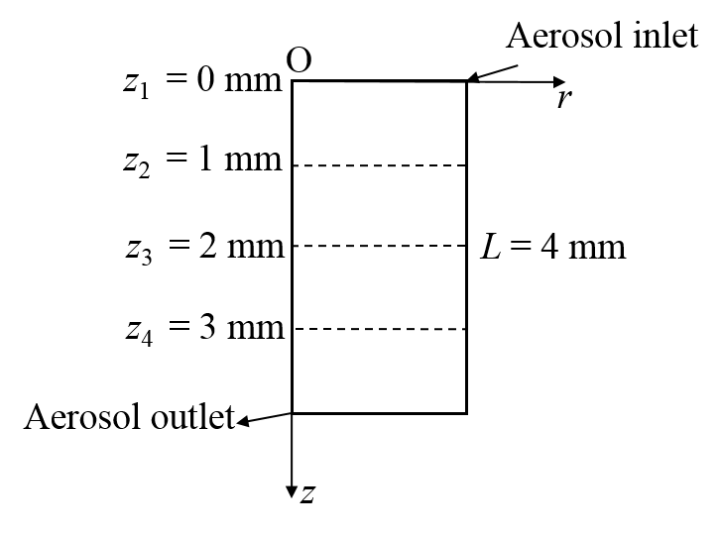
Fig. S1. Different locations in the working section of Half Mini DMA.

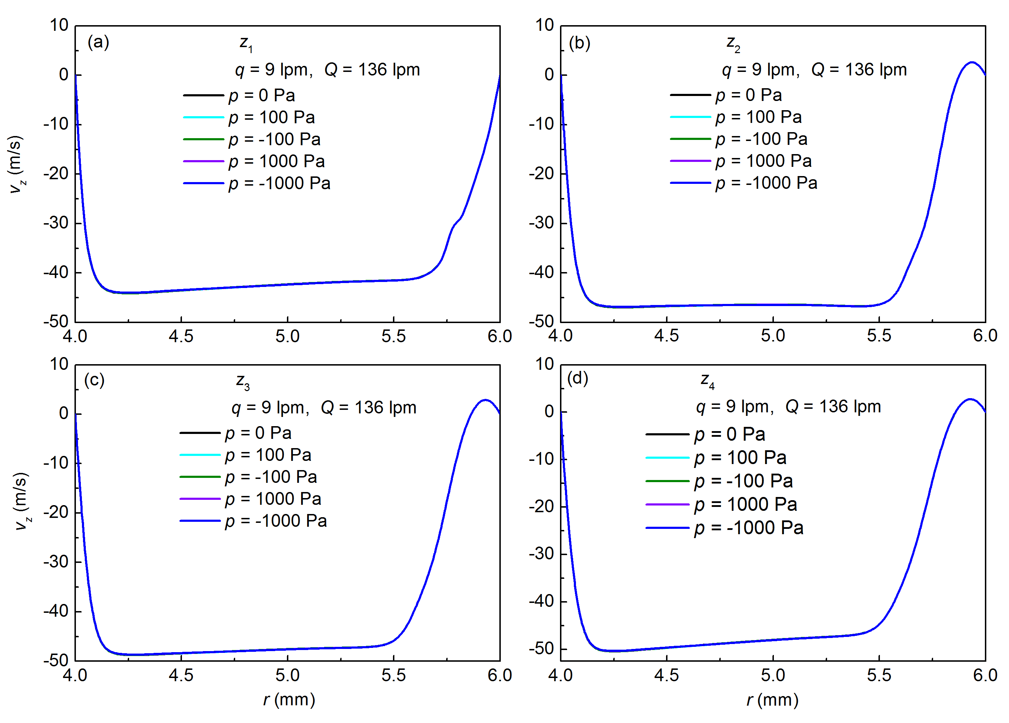
Fig. S2. The comparison of axial velocity profile at different locations with various p in the working section of Half Mini DMA.

1.3 Effect of inlet length of the trumpet on the flow field
In order to understand whether the flow goes through a corner within the flow field, we simulated the flow field with different L_{in}, and the axial velocity profile at different h (Figure S3). Figure S4 shows the streamlines within the flow field in the trumpet part. Indeed, the corner region would disappear as L_{in} increases. Figure S5 shows the axial velocity profile (v_{z}) along the radial axis at different h. v_{z} is found to be greater than zero in the range of r from 12.5 mm to 18 mm. However, the velocity at the corner is very low, and the maximum v_{z} is only 0.12 m/s for h₁₋₄. Because our interest is in the flow field within the working section, we also investigated how the corner region would change the flow field there. Figure S6 shows the axial velocity profile from z₁ to z₄ as we increase L_{in}. The red circles show the relative difference (ε) between the simulation results of L_{in} = 0 mm and 45 mm. v_{z} profiles at the same z for different L_{in} almost overlap each other, except in the regions near r = 4.25 mm and 5.5 mm. But still, ε is below 3.5 % in these two regions. Hence, we conclude that the influence of L_{in} on the flow field in the working section is small. We used L_{in} = 2 mm in our manuscript, because a longer L_{in} leads to more computational burden. Further, setting L_{in} = 2 mm is more helpful in obtaining a convergent result than L_{in} = 0 mm when Q is above 150 lpm. The influence of the laminarization screen will be considered in our future modeling work.
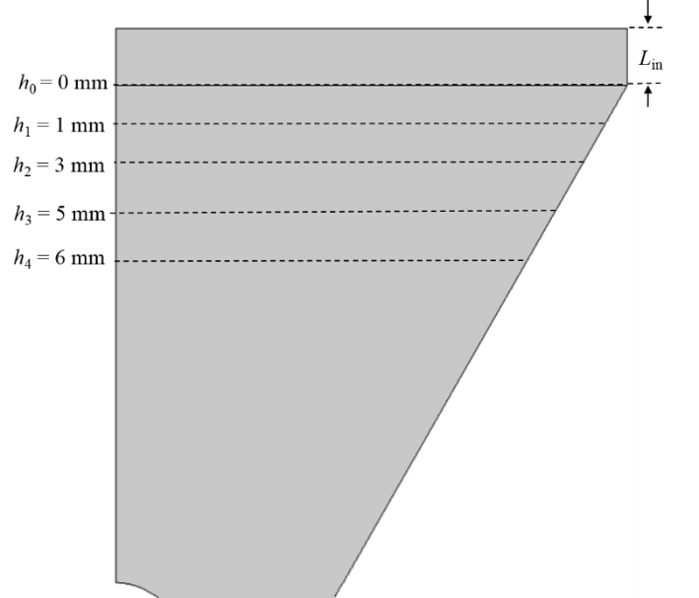
Fig. S3. Schematic of trumpet inlet part.

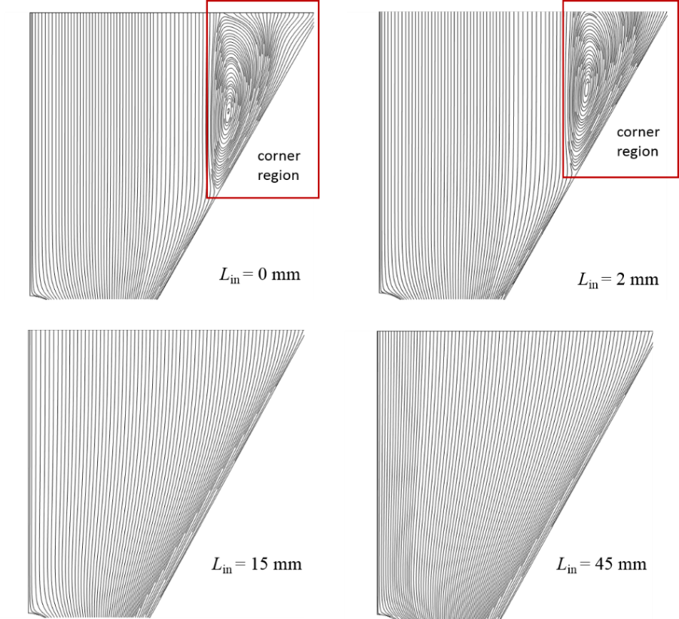
Fig. S4. Streamlines with the flow field of trumpet at various L_{in}. (q = 9 lpm, Q = 136 lpm)

Fig. S5. The axial velocity profile at different h. (q = 9 lpm, Q = 136 lpm)

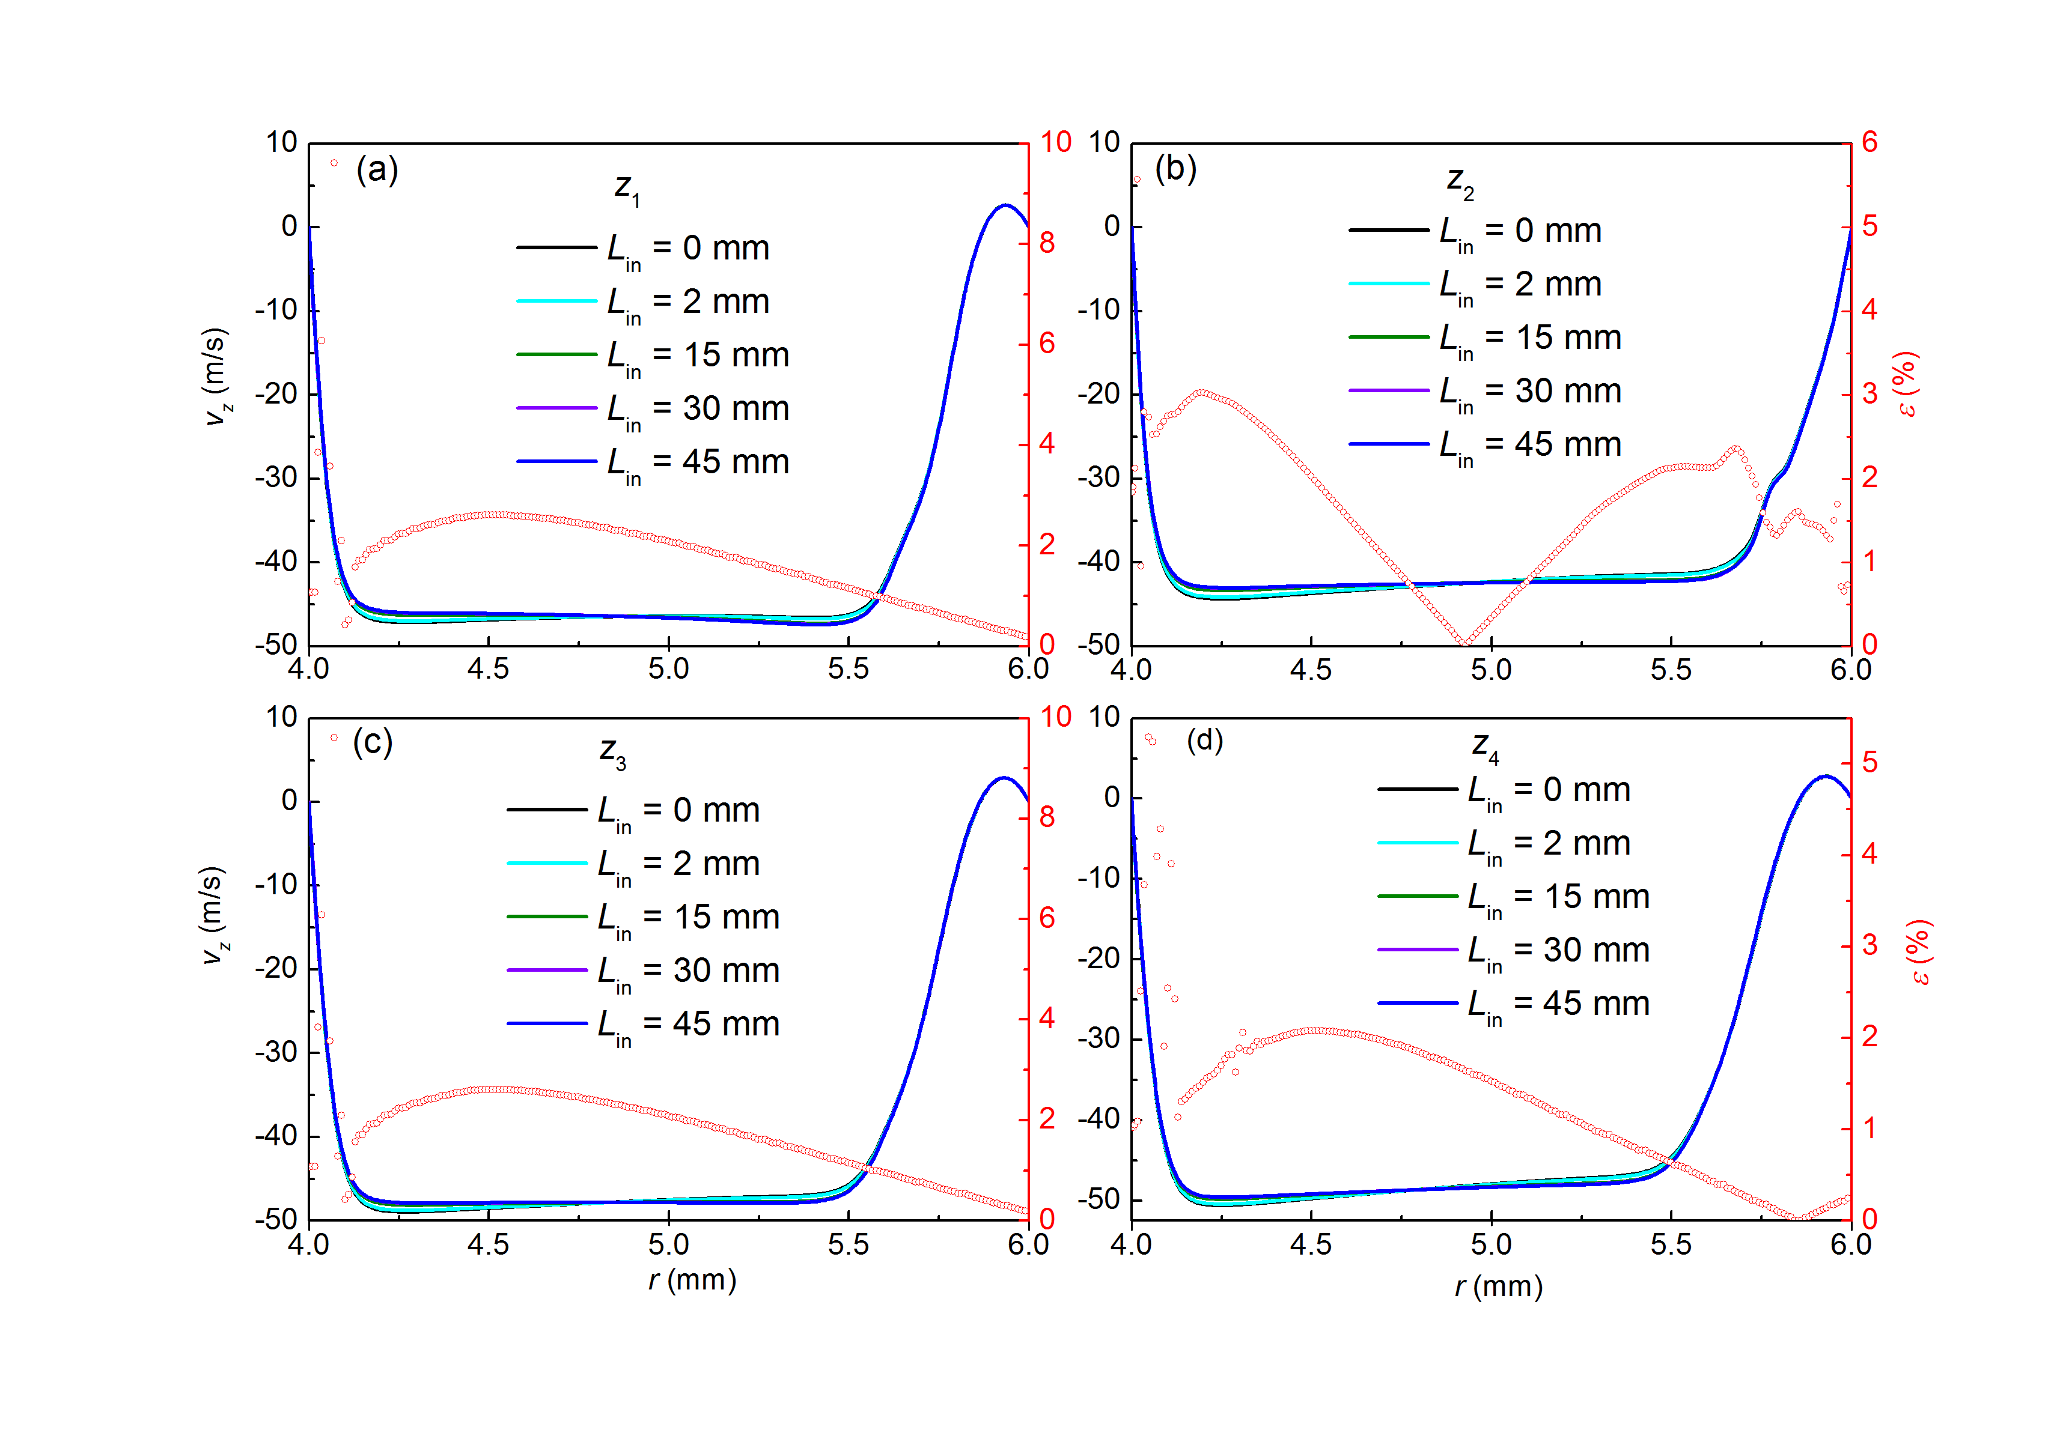
Fig. S6. The axial velocity profile (v_{z}) and relative difference (ε) at different z with various L_{in}. (q = 9 lpm, Q = 136 lpm)

3. Influence of particle size and q/Q on transfer function
The diffusion of sub-2 nm particles and q/Q play important roles in retaining the triangular shape of the transfer functions. Figure S7 displays the resolution and transfer function height (Ω_{max}) as a function of Q/q (q = 3 lpm) for the Half Mini DMA. In Figure S7(a), we can see that the theoretical resolution curve given by Knutson and Whitby (1975) is equal to Q/q, and the simulation values of R are all below the theoretical curve. Increasing the sheath flow rate Q does increase R. Furthermore, R increases with particle sizes. In Figure S7(b), we can see that all simulation height of the transfer function is below the theoretical value (100%) in Knutson and Whitby’s theoretical model. Ω_{max} reduces as Q/q increases. In addition, larger particles have higher transmission efficiency in the working section of the Half Mini DMA.
Fig. S7. Resolution (a) and transfer function height (b) vs. Q/q (q = 3 lpm) for Half Mini DMA.

4. Mesh Size and Numerical Diffusion
Since the Peclet number is much larger than the Reynolds number, numerical diffusion can lead to artificial broadening of the transfer function. This can cause the model to predict lower resolution in the simulations. To ensure that the effect of numerical diffusion is minimal, mesh sensitivity analysis is performed to find the optimal mesh size. Moreover, the mesh is refined in the particle transport zone, which further reduced the effect of numerical diffusion. Figure S8 shows the comparison of non-refined mesh and the refined mesh. It is evident that there is more diffusion broadening of the particle convective flux for non-refined mesh.
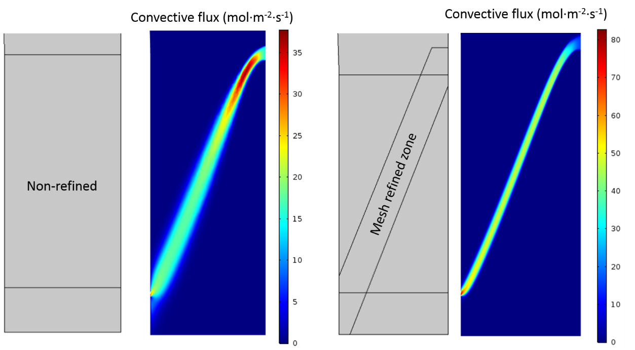
Fig. S8. The convective flux of particles with non-refined (left) and refined (right) mesh. The simulation conditions correspond to d_{p} = 1.4 nm, q = 9 lpm, Q = 136 lpm, inner electrode voltage is -318 V
Figure S9 shows the sensitivity analysis, where the resolution is calculated for increasing mesh number for both refined and non-refined mesh. This analysis is performed for d_{p} = 1.4 nm, q = 9 lpm, Q = 136 lpm. It is found that the resolution increases as the mesh size increases; but it flattens out on further increase in the mesh number. It is important to note that as the mesh size increases, the computational load for the simulations also increases. Keeping this in mind, an optimal mesh number is chosen as 4.18×10⁵, where the resolution for this case is found to be 11.40. Further increase in mesh size to 6.24×10⁵ increases the resolution to 11.45 (relative error < 0.5 %). This further convinces the authors that numerical diffusion is not confounding the results for the transfer function in their simulations.
Fig. S9. Effect of mesh number on the resolution of Half-Mini DMA. The simulation conditions correspond to d_{p} = 1.4 nm, q = 9 lpm, Q = 136 lpm

5. Comparison of simulated and theoretical diffusive transfer function
At the aerosol exit, the non-dimensional form of the standard deviation ($σ_{theo}$) is expressed as $σ_{theo}=G_{DMA}∙\tilde{D}$. $G_{DMA}$ is the non-dimensional geometry factor and $\tilde{D}$ is the non-dimensional particle diffusion coefficient (Stolzenburg and McMurry, 2008). To compare our simulation results with the theoretical value for the standard deviation, our simulation data points are fitted using the Stolzenburg’s formulation of diffusive transfer function in non-dimensional form, as given by Equation (S3).
$Ω_{d}\left({\tilde{Z}}_{p}, β,δ,σ\right)=\frac{σ}{\sqrt{2}β\left(1-δ\right)}\left[\begin{aligned}ε\left(\frac{{\tilde{Z}}_{p}-\left(1+β\right)}{\sqrt{2}δ}\right)+ε\left(\frac{{\tilde{Z}}_{p}-\left(1-β\right)}{\sqrt{2}δ}\right) \\ -ε\left(\frac{{\tilde{Z}}_{p}-\left(1+βδ\right)}{\sqrt{2}δ}\right)-ε\left(\frac{{\tilde{Z}}_{p}-\left(1-βδ\right)}{\sqrt{2}δ}\right)\end{aligned}\right]$ $(S3)$ where $ε\left(x\right)=x∙\operatorname{erf}\left(x\right)+e^{-x^{2}}/\sqrt{π}$, $σ_{fitted}$ is fitting the value of $σ$ in Equation (S3). Figure S10 shows the fitted transfer function to the simulated data points.
Fig. S10. The simulation data fitted by the Stolzenburg’s diffusive transfer function. The simulation conditions correspond to d_{p} = 1.4 nm, q = 9 lpm, Q = 136 lpm.
Fig. S11. The comparison of σ_{fitted} and σ_{theo} as increasing Q
Figure S11 compares $σ_{theo}$ and $σ_{fitted}$ for different flow conditions. It is found that there is a close match between the two values. The difference between them is contributed due to the non-idealities in the flow. It is important to note that the Stolzenburg’s theoretical model for calculating $σ_{theo}$ assumes uniform slug flow or fully-developed Poiseuille flow in the DMA (Stolzenburg, 1988). The simulated flow fields, as can be seen in Figure 3(c) shows a boundary layer near both inner and outer electrode. In Figure S11, there is more mismatch for higher aerosol flow (q) due to more radial component. This leads to the thickening of boundary layer (Figure 3(c)) near the inner electrode, and therefore more deviation from the flow configuration, assumed by Stolzenburg.

References
Knutson, E., and K. Whitby. 1975. Aerosol Classification by Electric Mobility: Apparatus, Theory, and Applications. J. Aerosol Sci., 6:443–451. doi: 10.1016/0021-8502(75)90060-9.
Stolzenburg, M. R. 1988. An Ultrafine Aerosol Size Distribution Measuring System. Minneapolis, MN: University of Minnesota.
Stolzenburg, M. R., and P. H. McMurry. 2008. Equations Governing Single and Tandem DMA Configurations and a New Lognormal Approximation to the Transfer Function. Aerosol Sci. Technol., 42:421-432. doi: 10.1080/02786820802157823.

