Supplementary Material
Synthesis and in vitro evaluation of antiviral and cytostatic properties of novel 8-triazolyl acyclovir derivatives
Dijana Saftićª, Biserka Žinićª, Ljubica Glavaš-Obrovac^{b}, Mirosława Studzińska^{c}, Edyta Paradowska^{c}, and Zbigniew J. Leśnikowski^{c}
ªDivision of Organic Chemistry and Biochemistry, Ruđer Bošković Institute, Zagreb, Croatia; ^{b}Department of Chemistry, Biochemistry and Clinical Chemistry, Faculty of Medicine, Osijek, Croatia; ^{c}Laboratory of Molecular Virology and Biological Chemistry, Institute of Medical Biology of the Polish Academy of Sciences, Łódź, Poland
Email: bzinic@irb.hr

Content Page

¹H NMR and ¹³C NMR spectra for compounds 5, 10–12 S2–S9
2D NMR – COSY (300 MHz, DMSO-d₆) spectra of compound 10 S10–S11
2D NMR – NOESY (300 MHz, DMSO-d₆) spectra of compound 10 S12–S13
General - Cells and viruses S14
Cytotoxic effects of acyclovir and compounds 10–12 on HeLa, NCI-H358, Jurkat,
K562, Raji and HuT78 tumor cell lines growth. S15–S17

Fig. S1. ¹H NMR (300 MHz, DMSO-d₆) spectrum of compound 5.

Fig. S2. ¹³C NMR (75 MHz, APT, DMSO-d₆) spectrum of compound 5.

Fig. S3. ¹H NMR (300 MHz, DMSO-d₆) spectrum of compound 10.

Fig. S4. ¹³C NMR (75 MHz, APT, DMSO-d₆) spectrum of compound 10.

Fig. S5. ¹H NMR (300 MHz, DMSO-d₆) spectrum of compound 11.

Fig. S6. ¹³C NMR (75 MHz, APT, DMSO-d₆) spectrum of compound 11.

Fig. S7. ¹H NMR (300 MHz, DMSO-d₆) spectrum of compound 12.

Fig. S8. ¹³C NMR (75 MHz, APT, DMSO-d₆) spectrum of compound 12.

Fig. S9. 2D NMR – full COSY (300 MHz, DMSO-d₆) spectrum of compound 10.

Fig. S10. 2D NMR – partial COSY (300 MHz, DMSO-d₆) spectrum of compound 10 with proton-proton interactions assigned. Marked rectangles correspond to interactions as follows; black CH-5'' ↔ CH₂-a, red OH-a ↔ CH₂-a, and blue OH-4' ↔ CH₂-4').

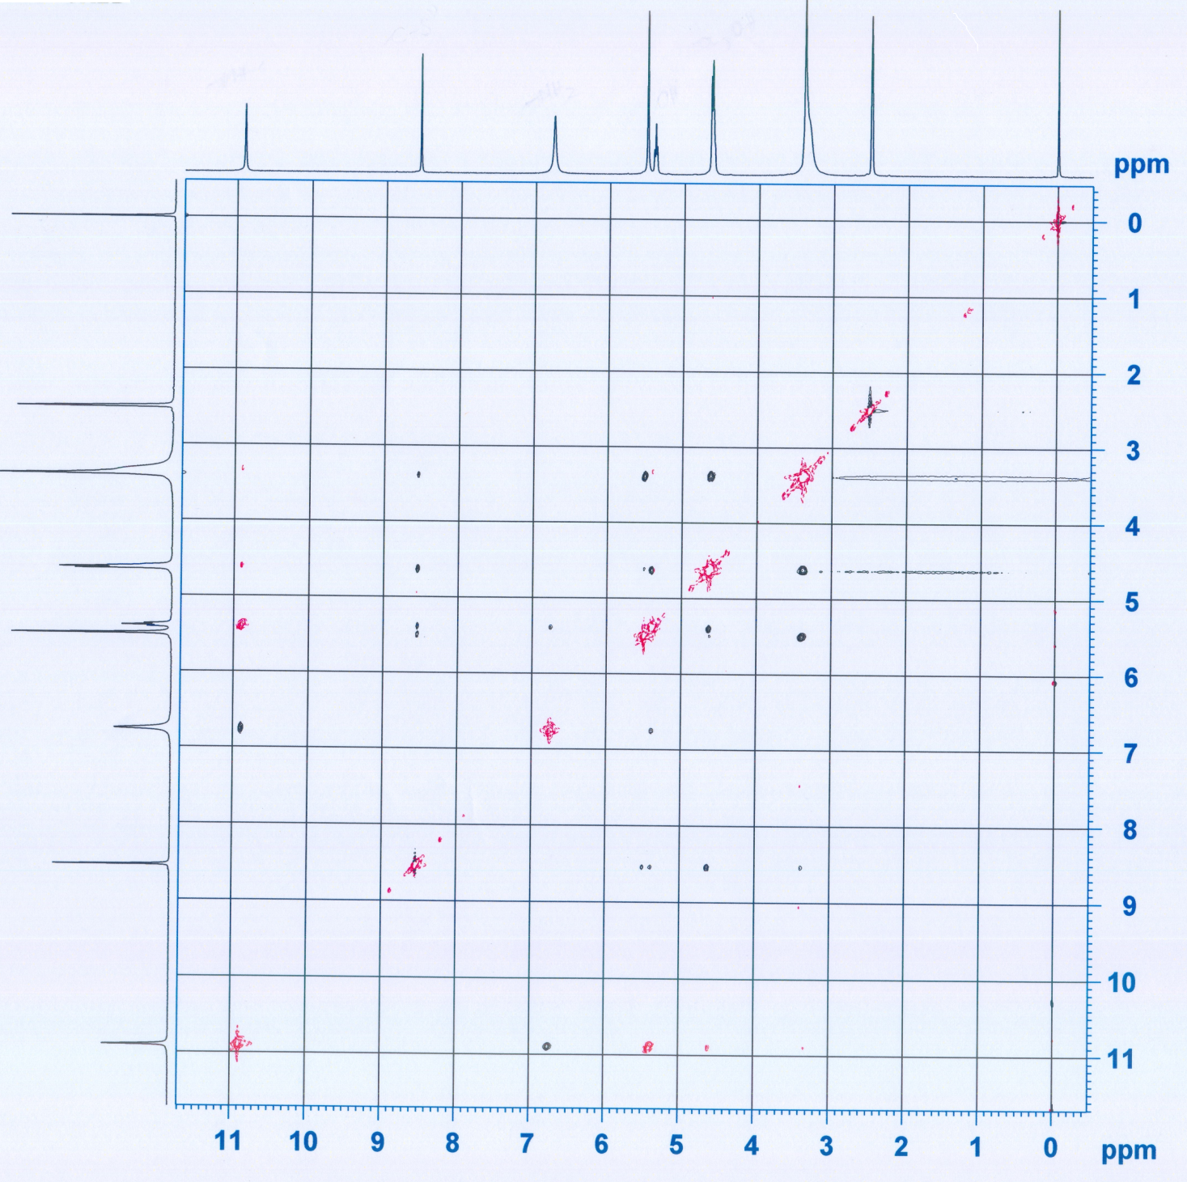

Fig. S11. 2D NMR – full NOESY (300 MHz, DMSO-d₆) spectrum of compound 10.

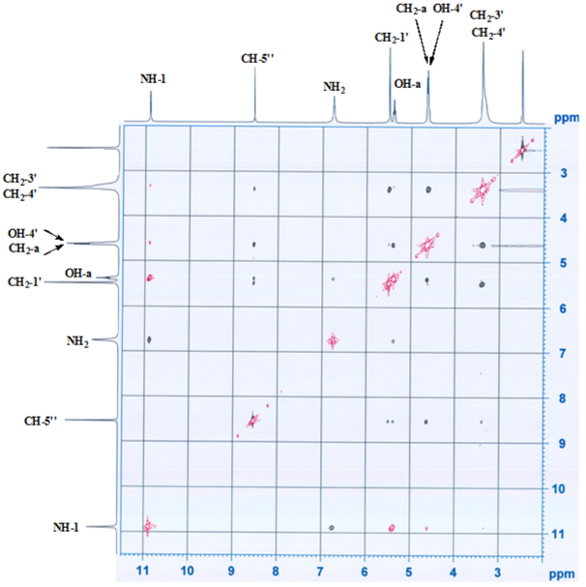

Fig. S12. 2D NMR – partial NOESY (300 MHz, DMSO-d₆) spectrum of compound 10 with proton-proton interactions assigned; a) strong: NH-1 ↔ NH₂, CH₂-1' ↔ CH₂-3'(CH₂-4'), CH₂-a ↔ OH-a, and CH₂-4' ↔ OH-4'; b) medium: CH-5'' ↔ CH₂-4'(CH₂-3'), CH-5'' ↔ CH₂-a, CH-5'' ↔ OH-a, and CH-5'' ↔ CH₂-1'; c) weak: NH₂ ↔ CH₂-1' and CH₂-1' ↔ CH₂-a.
General
Cells and viruses.
The MRC-5 (ATCC CCL-171; American Type Culture Collection, Rockville, MD), Vero (ATCC CCL-81), LLC-MK2 (ATCC-CCL-7.1) and A549 (ATCC CCL-185) cells were propagated in Eagle's minimal essential medium (EMEM) supplemented with 10% inactivated FBS, 2 × 10^{–3} mol dm⁻³, L-glutamine and 100 units/mL penicillin G-100 mg/mL streptomycin (culture medium). The cells were incubated 24 h at 37 ºC in a humidified atmosphere containing 5% CO₂.^{42,43}
Madine Darby canine kidney cells (MDCK I), cervix adenocarcinoma cells (HeLa), human epithelial colorectal adenocarcinoma cells (CaCo-2) were grown in Dulbecco’s Modified Eagle Medium DMEM (Gibco, EU), supplemented with 10% FBS, 2 × 10^{–3} mol dm⁻³ glutamine and 100 U/0.1 mg penicillin/streptomycin; in tissue culture flasks and grown as monolayers. To detach them from the flask surface, cells were trypsinized using a 0.25% trypsin/EDTA solution.
Human caucasian bronchioalveolar carcinoma cells (NCI-H358), human acute T cell leukemia cells (Jurkat), chronic myelogenous leukemia cells (K562), human Burkitt lymphoma cells (Raji) and human T cell lymphoma cells (HuT78) were grown in RPMI 1640 medium (Gibco, EU) supplemented with 10% heat-inactivated fetal bovine serume FBS (Gibco, EU), 2 × 10^{–3} mol dm⁻³ glutamine (Gibco, EU), 1 × 10^{–3} mol dm⁻³ sodium pyruvate (Gibco, EU), 1 × 10^{–2} mol dm⁻³ HEPES (Sigma-Aldrich, USA) and 100 U/0.1 mg penicillin/streptomycin.
The human herpes viruses: HCMV, strain AD-169 (ATCC VR-538) and HSV-1, strain McIntyre (ATCC VR-539), as well as human parainfluenza virus type 3 (HPIV-3, ATCC VR-93), vesicular stomatitis virus (VSV), and encephalomyocarditis virus (EMCV) were used in reduction assays. Viruses were propagated in EMEM supplemented with 2% of FBS, L-glutamine and antibiotics in the following cell lines: MRC-5 (HCMV), Vero (HSV-1), LLC-MK2 (HPIV-3), L929 (VSV), and A549 (EMCV).

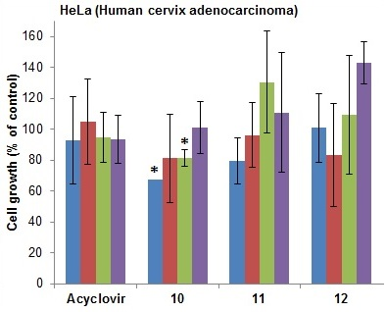
Fig. S13. Cytotoxic effects of acyclovir and derivatives 10−12 on HeLa tumor cell line growth after 72 h of incubation in the final concentration range (10⁻⁴, 10⁻⁵, 10⁻⁶ and 10⁻⁷ mol dm⁻³). Cytotoxicity was analyzed using the MTT survival assay. Data are presented as the mean value ± SD of three independent experiments done in triplicates.

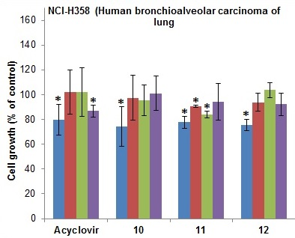
Fig. S14. Cytotoxic effects of acyclovir and derivatives 10−12 on NCI-H358 tumor cell line growth after 72 h of incubation in the final concentration range (10⁻⁴, 10⁻⁵, 10⁻⁶ and 10⁻⁷ mol dm⁻³). Cytotoxicity was analyzed using the MTT survival assay. Data are presented as the mean value ± SD of three independent experiments done in triplicates.

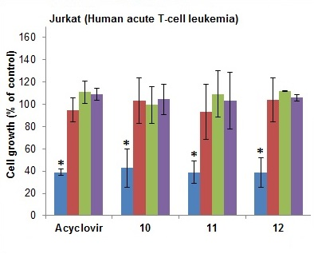
Fig. S15. Cytotoxic effects of acyclovir and derivatives 10−12 on Jurkat tumor cell line growth after 72 h of incubation in the final concentration range (10⁻⁴, 10⁻⁵, 10⁻⁶ and 10⁻⁷ mol dm⁻³). Cytotoxicity was analyzed using the MTT survival assay. Data are presented as the mean value ± SD of three independent experiments done in triplicates.
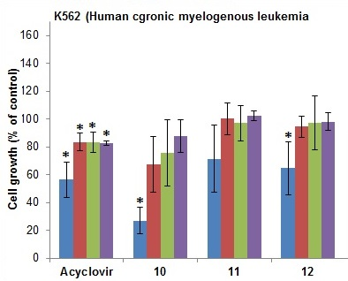
Fig. S16. Cytotoxic effects of acyclovir and derivatives 10−12 on K562 tumor cell line growth after 72 h of incubation in the final concentration range (10⁻⁴, 10⁻⁵, 10⁻⁶ and 10⁻⁷ mol dm⁻³). Cytotoxicity was analyzed using the MTT survival assay. Data are presented as the mean value ± SD of three independent experiments done in triplicates.
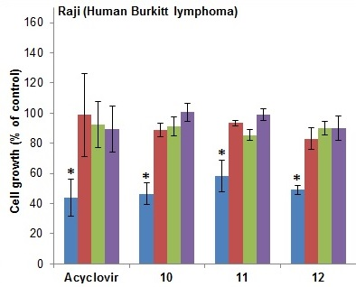
Fig. S17. Cytotoxic effects of acyclovir and derivatives 10−12 on Raji tumor cell line growth after 72 h of incubation in the final concentration range (10⁻⁴, 10⁻⁵, 10⁻⁶ and 10⁻⁷ mol dm⁻³). Cytotoxicity was analyzed using the MTT survival assay. Data are presented as the mean value ± SD of three independent experiments done in triplicates.

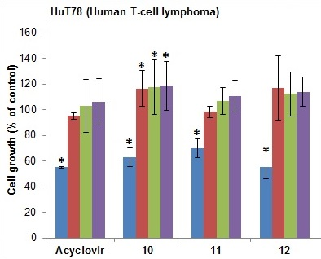
Fig. S18. Cytotoxic effects of acyclovir and derivatives 10−12 on HuT78 tumor cell line growth after 72 h of incubation in the final concentration range (10⁻⁴, 10⁻⁵, 10⁻⁶ and 10⁻⁷ mol dm⁻³). Cytotoxicity was analyzed using the MTT survival assay. Data are presented as the mean value ± SD of three independent experiments done in triplicates.

