Supplementary Material
Spectral and computational chemistry studies for the optimization of geometry of dioxomolybdenum(VI) complexes of some unsymmetrical Schiff bases as antimicrobial agent

MOHAMMAD NASIR UDDIN*, D.A. CHOWDHURY, NOBUYUKI MASE, MOHAMMAD FAZLUR RASHID, MONIRUZZAMAN, AMRIN AHSAN and NOOR MOSTAQ SHAH

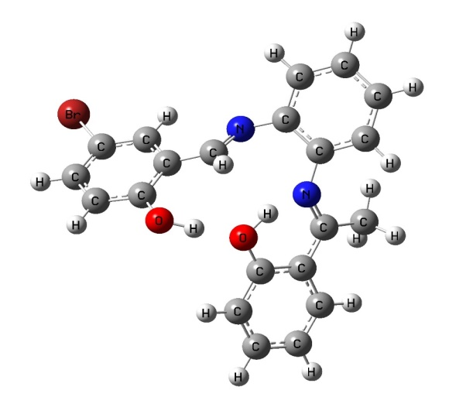  L4 | 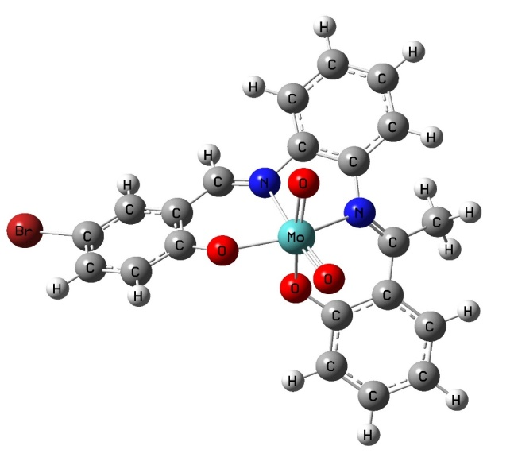  C4
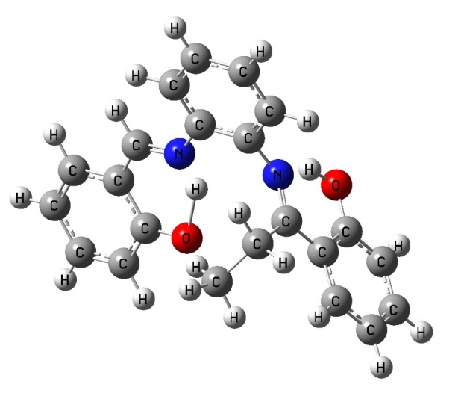  L5 | 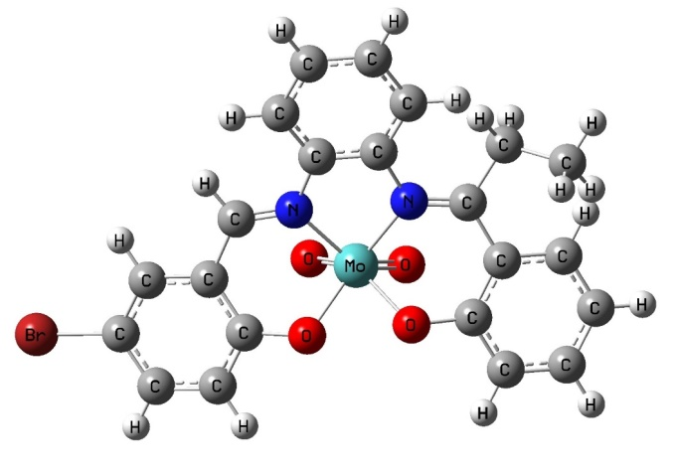  C5
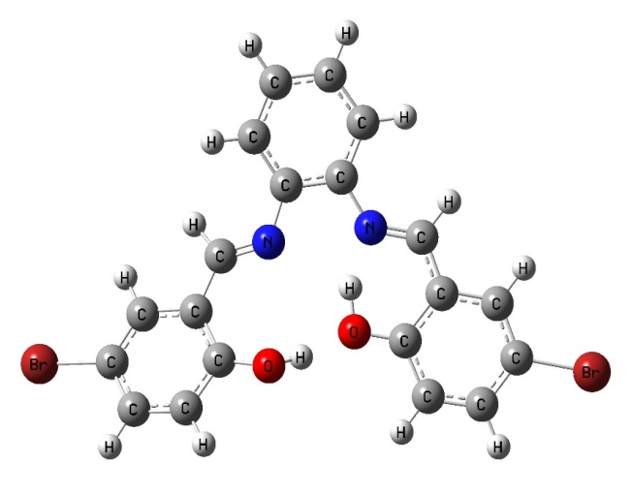  L6 | 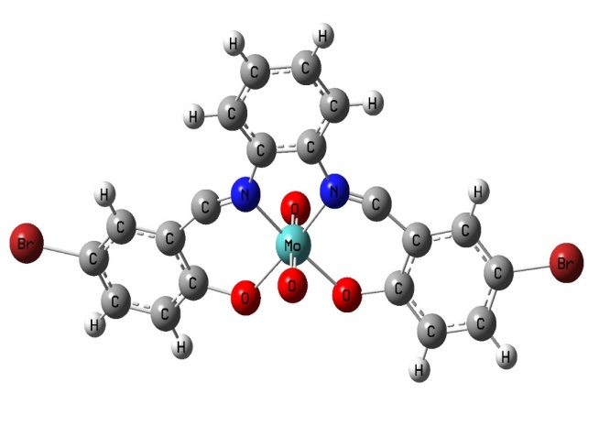  C6

Figure S1. Optimized structure of ligands (L4-L6) and corresponding complexes.

 | HOMO | LUMO
L4 | 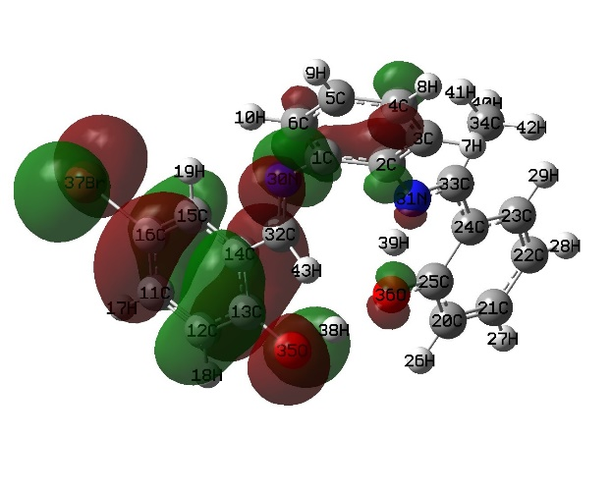 | 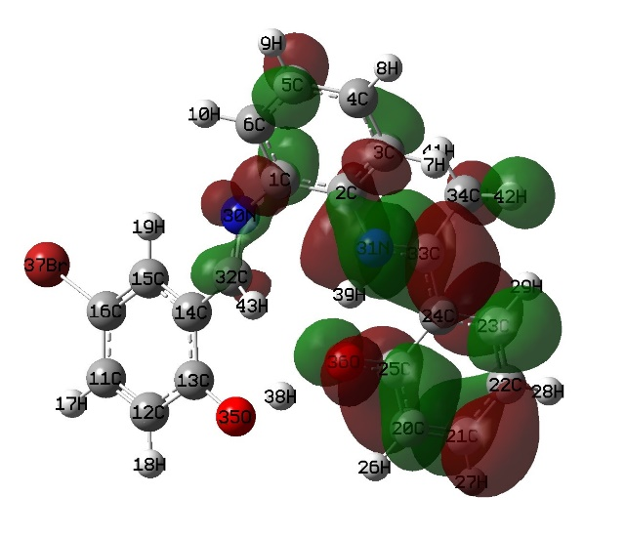
L5 | 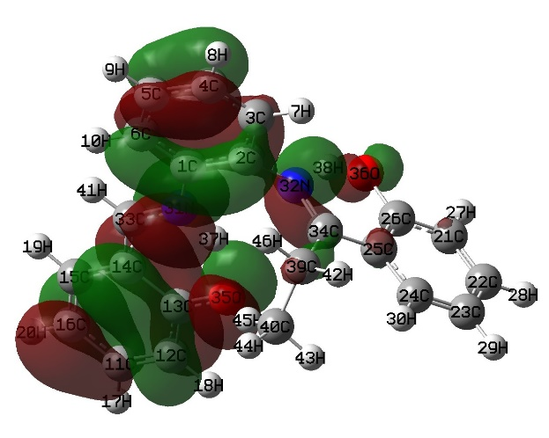 | 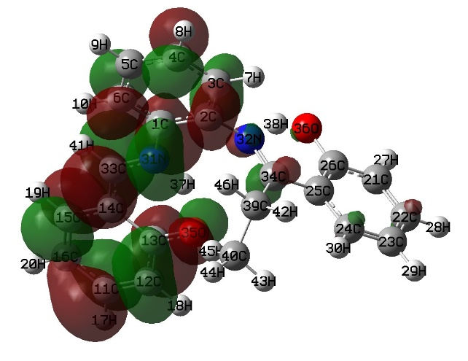
L6 | 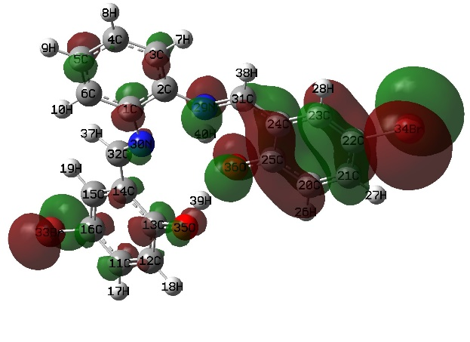 | 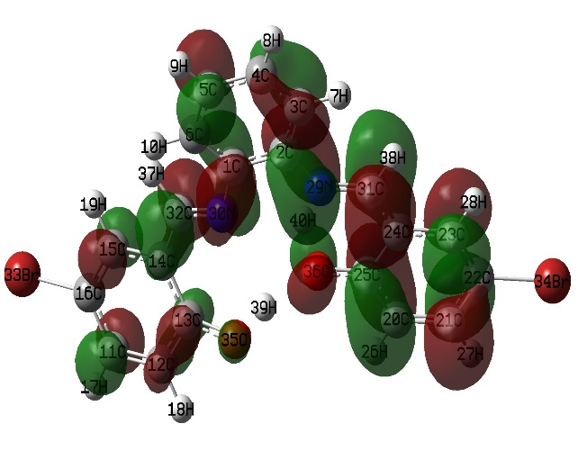

Figure S2. Frontier molecular orbitals, HOMO–LUMO of ligands, (L4-L6).

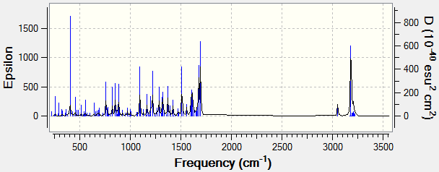
L1
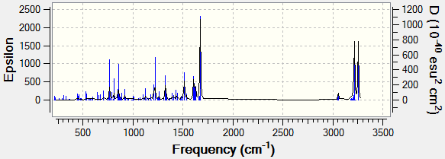
L2
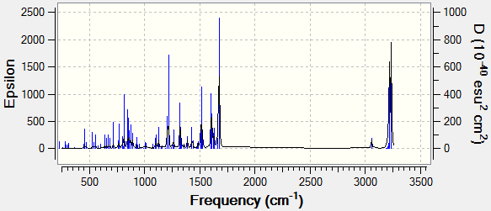
L3
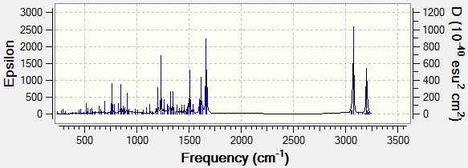
L4
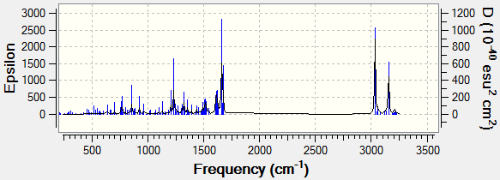
L5
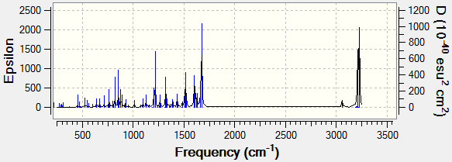
L6
Figure S3. IR spectra (calculated by the program) of all ligands.

Figure S4. Quantum chemical calculations of atomic partial charges of all ligands and complexes.

Table S1. Some physical properties of the ligands and their complexes.
Sl. No. | Ligands | Color | % Yield | M. P. ºC | Sl. No. | Name of the  Complexes | Color | % Yield | M. P.  ºC
L1 | ^{Br}Sal-OPD-HNPH₂ | Orange | 85 % | 180 | C1 | MoO₂(^{Br}Sal-  OPD-HNP) | Black | 75 % | >250
L2 | ^{Br}Sal-OPD-SalH₂ | Deep Orange | 75 % | 168-170 | C2 | MoO₂(^{Br}Sal-  OPD-Sal) | Brownish Black | 90 % | >250
L3 | ^{Br}Sal-OPD-^{Cl}SalH₂ | Orange | 70 % | 208 | C3 | MoO₂(^{Br}Sal-  OPD-^{Cl}Sal) | Black | 85 % | >250
L4 | ^{Br}Sal-OPD-HAPH₂ | Yellowish Orange | 55 % | 201 | C4 | MoO₂(^{5Br}Sal-  OPD-HAP) | Black | 75 % | >250
L5 | ^{Br}Sal-OPD-HPPH₂ | Yellow | 70 % | 220 | C5 | MoO₂(^{5Br}Sal-  OPD-HPP) | Black | 70 % | >250
L6 | ^{Br}Sal-OPD-BzPH₂ | Light Orange | 85 % | 204 | C6 | MoO₂(^{5Br}Sal-  OPD-BzP) | Greenish Black | 90 % | >250

Table S2. FTIR and UV-vis spectral data of the ligands
Sl. No. | Ligands | Infrared spectral data (cm⁻¹) |  |  |  |  | Electronic spectral  bands (nm)
 |  | ν _{O-H} | ν _{C=N} | ν _{C-C} | ν_{C-N} | ν _{C-O}
L1 | ^{Br}Sal-OPD-HNPH₂ | 3390 | 1618 vs | 1437 w | 1352 ms | 1276 s | 352, 336, 322, 274, 253
L2 | ^{Br}Sal-OPD-SalH₂ | 3510 | 1616 vs | 1458 s | 1352 ms | 1276 s | 372, 337, 313, 308, 248, 235
L3 | ^{Br}Sal-OPD-^{Cl}SalH₂ | 3566 | 1616 vs | 1458 s | 1352 ms | 1277 vs | 385, 335, 313, 300, 249, 238
L4 | ^{Br}Sal-OPD-HAPH₂ | 3420 | 1585ms | 1449 s | 1313 ms | 1275s | 358, 336, 314, 278, 251
L5 | ^{Br}Sal-OPD-HPPH₂ | 3450 | 1612 vs | 1383 s | 1348 ms | 1273 vs | 375, 336, 313, 273, 253, 235
L6 | ^{Br}Sal-OPD-BzPH₂ | 3505 | 1581s | 1381 s | 1346 ms | 1273 vs | 394, 344, 293 (sh), 273
- Calculated values are given in parentheses
- vs = very strong, s = strong, ms = medium strong, w = weak, sh = shoulder, flsh = flat shoulder, br = broad
- Electronic spectral bands were carried out in DMF solvent

Table S3. Energy (eV) of HOMO, LUMO, HOMO-LUMO gap, hardness, and softness of ligands and complexes.
Name | HOMO−1 | HOMO | LUMO | LUMO+1 | Gap | Hardness | Softness
L1 | -5.687 | -5.387 | -2.395 | -1.768 | 2.99 | 1.49 | 0.67
L2 | -5.714 | -5.496 | -2.340 | -1.687 | 3.15 | 1.58 | 0.63
L3 | -5.905 | -5.687 | -2.639 | -1.796 | 3.05 | 1.52 | 0.66
L4 | -5.986 | -5.469 | -2.285 | -1.442 | 3.18 | 1.59 | 0.63
L5 | -8.626 | -8.245 | -5.823 | -5.306 | 2.42 | 1.21 | 0.83
L6 | -5.768 | -5.578 | -2.530 | -1.796 | 3.05 | 1.52 | 0.66
C1 | -5.850 | -5.387 | -3.864 | -2.748 | 1.52 | 0.76 | 1.31
C2 | -6.231 | -5.768 | -2.476 | -2.394 | 3.29 | 1.65 | 0.60
C3 | -6.689 | -6.122 | -2.966 | -2.557 | 3.15 | 1.58 | 0.63
C4 | -6.122 | -5.333 | -3.129 | -2.802 | 2.20 | 1.10 | 0.91
C5 | -6.068 | -5.714 | -2.449 | -2.204 | 3.26 | 1.63 | 0.61
C6 | -6.394 | -5.932 | -3.319 | -2.639 | 2.61 | 1.32 | 0.77

Table S4. Bond distances of all ligands and complexes.
L1 |  |  | L2
Atom number | Distances (Å) |  | Atom number | Distances(Å)
C3-C4 | 1.3932 |  | C5-C6 | 1.3935
C3-C2 | 1.4028 |  | C6-C4 | 1.4017
C2-N26 | 1.4106 |  | C1-N30 | 1.4120
N26-C28 | 1.3012 |  | N30-C33 | 1. 2931
C28-C20 | 1.4428 |  | C15-H19 | 1. 0833
C22-C20 | 1.4221 |  | C14-C13 | 1. 4271
C22-O30 | 1.3438 |  | C13-O35 | 1. 3424
O30-H46 | 1.0188 |  | C16-Br36 | 1. 9310
C1-N36 | 1.3977 |  | O35-H37 | 1. 0318
C13-O29 | 1.2986 |  | C32-N31 | 1.3226
C16-Br35 | 1.9304 |  | C32-C24 | 1.4139
 |  |  | C25-034 | 1.3046
L3 |  |  | L4
Atom number | Distances (Å) |  | Atom number | Distances (Å)
C5-C6 | 1.3932 |  | C5-C6 | 1.3888
C6-C1 | 1.4019 |  | C6-C1 | 1.4074
C1-N29 | 1.4120 |  | C1-N30 | 1.4009
N29-C32 | 1.2938 |  | N30-C32 | 1.2909
C32-C14 | 1.4502 |  | C32-H43 | 1.0918
C16-Br33 | 1.9302 |  | C13-035 | 1.3559
C13-O35 | 1.3443 |  | C16-Br37 | 1.9338
O45-H39 | 1.9579 |  | C33-N31 | 1.3260
C25-O36 | 1.3004 |  | C25-O36 | 1.3246
N30-C31 | 1.3213 |  | O36-H39 | 1.4693
C22-Cl34 | 1.8327
L5 |  | L6
C5-C6 | 1.3913 |  | C5-C6 | 1.3933
C6-C1 | 1.4021 |  | C6-C1 | 1.4018
C1-N31 | 1.4730 |  | C1-N30 | 1.4122
N31-C33 | 1.3349 |  | N30-C32 | 1.2935
C14-C13 | 1.4649 |  | C16-Br33 | 1.9304
C13-O35 | 1.2944 |  | C13-O35 | 1.3439
O35-H33 | 1.5564 |  | O35-H39 | 1.0269
C2-N32 | 1.4208 |  | C22-Br34 | 1.9299
C26-O30 | 1.3437 |  | C25-O36 | 1.3015
O36-H38 | 1.0646 |  | O36-H40 | 1.5292
C1 |  |  | C2
C6-C1 | 1.4490 |  | C5-C6 | 1.3961
C1-N30 | 1.4836 |  | C1-N31 | 1.4307
N30-C27 | 1.2850 |  | N31-N30 | 1.3182
N36-Mo47 | 2.0112 |  | C2-N32 | 1.4225
029- Mo47 | 1.9723 |  | 037-Mo35 | 1.7377
Mo47-037 | 1.7503 |  | Mo35-O33 | 2.1526
O38- Mo47 | 1.7512 |  | C13-O33 | 1.3131
C22-O30 | 1.4439 |  | C16-Br38 | 2.9291
C2-N26 | 1.4808 |  | C25-O34 | 2.3417
C26-N26 | 1.2749 |  | C40-N32 | 1.2989
C10-Br35 | 1.9085
C3 |  |  | C4
C5-C6 | 1.3893 |  | C5-C6 | 1.3956
C6-C1 | 1.4035 |  | C6-C1 | 1.3961
C1-N29 | 1.4147 |  | C1-N30 | 1.4203
N29-C37 | 1.3232 |  | N30-C32 | 1.2967
C16-Br31 | 1.9272 |  | C16-Br39 | 1.9279
C13-O32 | 1.3166 |  | C13-O35 | 1.3380
Mo34-O32 | 2.1062 |  | N30-Mo34 | 2.3564
Mo34O36 | 1.7327 |  | O38- Mo34 | 1.7398
C38-N30 | 1.3227 |  | C33-N31 | 1.3255
C38-N30 | 1.3227 |  | C25-O36 | 1.3249
C5 |  |  | C6
C4-C3 | 1.3982 |  | C10-C11 | 1.3869
C3-C2 | 1.3929 |  | C11-C12 | 1.4090
C2-N31 | 1.4420 |  | C12-N30 | 1.4048
N31-C33 | 1.3214 |  | N30-C32 | 1.2890
C25-O36 | 1.3279 |  | N29-Mo39 | 2.1548
O36-Mo47 | 2.1168 |  | Mo39-O30 | 1.7143
Mo47-O38 | 1.7291 |  | C24-O34 | 1.7354
N30- Mo47 | 2.3655 |  | C21-Br38 | 1.9211
C16-Br43 | 1.9281 |  | C29-C31 | 1.2436
C32-N30 | 1.2964 |  | C5-Br27 | 1.9264

Table S5. Bond angles of all ligands and complexes.
L1 |  |  | C1
Atom number | Angles (⁰) |  | Atom number | Angles (⁰)
C4-C3-C2 | 120.92 |  | C5-C6-C1 | 119.17
C3-C2-N26 | 125.65 |  | C6-C1-N36 | 126.25
C2-N26-C28 | 120.57 |  | C1-N36-C27 | 127.70
C22-O30-H46 | 119.16 |  | C1-N36-Mo47 | 114.45
C15-C16-Br35 | 120.79 |  | N36-Mo47-O29 | 98.12
C14-C13-O29 | 121.16 |  | O29-Mo47-O30 | 81.68
 |  |  | C15-C16-Br35 | 119.86
L2 |  |  | C2
C5-C6-C1 | 120.85 |  | C5-C6-C1 | 119.76
C1-N30-C33 | 121.28 |  | 1-N31-C30 | 121.44
C2-N31-C32 | 131.92 |  | N31-Mo35-N33 | 70.05
C14-C13-O35 | 128.01 |  | O33-Mo35-O39 | 86.10
C13-O35-H37 | 121.21 |  | O33-Mo35-O39 | 107.96
C15-C16-Br36 | 120.55 |  | C24-C25-O34 | 123.67
 |  |  | C15-C16-Br38 | 120.73
L3 |  | C3
C5-C6-C1 | 120.82 |  | C5-C6-C1 | 120.44
C6-C1-C29 | 125.35 |  | C1-N29-C35 | 121.38
C1-C29-C32 | 121.08 |  | C13-O32-Mo34 | 122.66
C15-C16-Br33 | 121.54 |  | N29-Mo34-N30 | 70.99
C14-C13-O35 | 127.85 |  | O32-Mo34-O33 | 161.38
C23-C22-Cl34 | 119.76 |  | N35-Mo34-O36 | 115.08
 |  |  | C15-C16-Br31 | 120.65
 |  |  | C23-C22-Cl41 | 119.65
L4 |  |  | C4
C5-C6-C1 | 121.60 |  | C5-C6-C1 | 120.22
C1-N30-C32 | 124.61 |  | C6-C1-N30 | 124.75
N30-C32-H43 | 122.57 |  | C1-N30-C32 | 124.08
C14-C13-O35 | 124.54 |  | C14-C13-O35 | 123.93
C13-O35-H38 | 114.91 |  | O35-Mo34-O36 | 85.34
C15-C16-Br37 | 120.47 |  | N30-Mo34-N31 | 70.27
 |  |  | O38-Mo34-O37 | 101.68
 |  |  | C15-C16-Br39 | 120.39
L5 |  |  | C5
C5-C6-C1 | 120.82 |  | C5-C6-C1 | 120.11
C1-N31-C33 | 128.80 |  | C1-N30-C32 | 124.26
N31-C33-C14 | 121.27 |  | C14-C13-O35 | 124.01
C14-C13-O35 | 121.81 |  | C15-C16-Br34 | 120.40
C13-O35-H37 | 103.35 |  | N30-Mo47-N31 | 69.96
C26-O36-H38 | 105.77 |  | O35-Mo47-O38 | 108.00
 |  |  | O37-Mo47-O38 | 101.91
L6 |  |  | C6
Atom number | Angles (⁰) |  | Atom number | Angles (⁰)
C5-C6-C1 | 120.84 |  | C10-C11-C12 | 122.42
C6-C1-N30 | 125.37 |  | C12-N30-C32 | 124.46
C1-N30-C32 | 121.14 |  | C20-C21-Br38 | 120.09
C15-C16-Br33 | 121.56 |  | C24-O34-Mo39 | 115.17
C13-O35-H39 | 120.69 |  | O34-Mo39-O33 | 87.80
C14-C13-O35 | 127.86 |  | N30-Mo39-N29 | 63.03
 |  |  | O35-Mo39-O36 | 128.96

Table S6. Comparison on experimental and theoretical IR frequencies of all ligands.
Molecules | Experimental  FT-IR | Calculated FT-IR |  |  | Assignment
 |  | Scaled | Unscaled
L1 | 3390 | 3664 |  | 3812 | υO-H
 | 1618 | 1627 |  | 1693 | υC=N
 | 1352 | 1317 |  | 1370 | υC-N
 | 1276 | 1271 |  | 1322 | υC-O
 | 1437 | 1450 |  | 1509 | υC-Cª
L2 | 3510 | 3127 |  | 3253 | υO-H
 | 1616 | 1606 |  | 1671 | υC=N
 | 1352 | 1317 |  | 1370 | υC-N
 | 1276 | 1276 |  | 1327 | υC-O
 | 1458 | 1453 |  | 1511 | υC-Cª
L3 | 3566 | 3109 |  | 3234 | υO-H
 | 1616 | 1608 |  | 1673 | υC=N
 | 1352 | 1333 |  | 1387 | υC-N
 | 1277 | 1267 |  | 1318 | υC-O
 | 1458 | 1454 |  | 1513 | υC-Cª
L4 | 3420 | 3098 |  | 3223 | υO-H
 | 1585 | 1606 |  | 1671 | υC=N
 | 1313 | 1336 |  | 1390 | υC-N
 | 1275 | 1271 |  | 1322 | υC-O
 | 1449 | 1450 |  | 1509 | υC-Cª
L5 | 3450 | 3098 |  | 3223 | υO-H
 | 1612 | 1606 |  | 1671 | υC=N
 | 1348 | 1336 |  | 1390 | υC-N
 | 1273 | 1271 |  | 1322 | υC-O
 | 1383 | 1457 |  | 1516 | υC-Cª
L6 | 3505 | 3102 |  | 3227 | υO-H
 | 1614 | 1608 |  | 1673 | υC=N
 | 1346 | 1335 |  | 1389 | υC-N
 | 1273 | 1269 |  | 1320 | υC-O
 | 1449 | 1455 |  | 1514 | υC-Cª
To scale the theoretical IR intensities scaling factor 0.9613 is applied in gas phase at B3LYP with 6-31G (d) basis set (J. Phys. Chem. B, 113, 6378–6396 (2009)).

Table S7. Selected pharmacokinetic parameters of all ligands and complexes.
Name | Blood brain barrier | Human intestinal absorption | P-glyco  protein inhibitor | Human ether –a-go-go-related gene inhibition | Carcinogen | Rat acute toxicity  LD₅₀  (mol/kg) | Acute oral toxicity
L1 | + (0.7702) | + (0.5348) | NI (0.7133) | WI (0.8675) | NC (0.6466) | 2.2149 | III
L2 | + (0.7739) | + (0.6682) | NI (0.7920) | WI (0.8841) | NC (0.5883) | 2.3355 | III
L3 | + (0.8077) | + (0.5000) | NI (0.8082) | WI (0.8314) | NC (0.5466) | 2.3470 | III
L4 | + (0.9774) | + (0.9912) | NI (0.9717) | WI (0.8808) | NC (0.7874) | 2.3727 | III
L5 | + (0.6680) | + (0.5000) | NI (0.8327) | WI (0.7922) | NC (0.5204) | 2.0988 | III
L6 | + (0.7739) | + (0.6682) | NI (0.7920) | WI (0.8841) | NC (0.5883) | 2.3355 | III
C1 | + (0.7129) | + (0.5140) | NI (0.9740) | WI (0.9205) | NC (0.7239) | 2.3209 | III
C2 | + (0.7141) | + (0.6230) | NI (0.9719) | WI (0.9089) | NC (0.6903) | 2.4214 | III
C3 | + (0.7503) | + (0.4988) | NI (0.9827) | WI (0.9100) | NC (0.6571) | 2.4410 | III
C4 | + (0.8604) | + (0.9030) | NI (0.8974) | WI (0.9372) | NC (0.8130) | 2.4702 | III
C5 | + (0.6002) | + (0.4808) | NI (0.9003) | WI (0.9034) | NC (0.6329) | 2.2017 | III
C6 | + (0.7302) | + (0.5368) | NI (0.8975) | WI (0.9403) | NC (0.6603) | 2.4178 | III
- NI = non inhibitor, wide inhibition, NC = non carcinogenic, LD₅₀ = lethal dose 50; Toxicity category III indicates slightly toxic and slightly irritating.

