**Supplemental Information for**

Stabilizing nanoprecipitates in Al-Cu alloys for creep resistance at 300oC

Y. H. Gao1, C.Yang1, J.Y.Zhang1, L.F.Cao2, G. Liu1,*, J. Sun1,*, E. Ma3,4*

*1.* *State Key Laboratory for Mechanical Behavior of Materials,*

*Xi’an Jiaotong University,* *Xi’an, 710049, P.R. China*

*2. College of Materials Science and Engineering, Chongqing University,*

*Chongqing, 400044, P. R. China*

*3. Center for Advancing Materials Performance from the Nanoscale (CAMP-Nano), State Key Laboratory for Mechanical Behavior of Materials, Xi’an Jiaotong University,*

*Xi’an 710049, China*

*4. Department of Materials Science and Engineering, Johns Hopkins University, Baltimore, Maryland 21218, USA*

*Corresponding authors E-mail: [lgsammer@xjtu.edu.cn](mailto:lgsammer@xjtu.edu.cn), [junsun@xjtu.edu.cn](mailto:junsun@xjtu.edu.cn), [ema@jhu.edu](mailto:ema@jhu.edu)

1. Materials and methods
   1. *Alloy compositions and processing*

Alloys with compositions of Al-0.3 wt.%Sc and Al-2.5 wt.%Cu-X wt.%Sc (X=0, 0.3) were melted and cast in an argon stream by using 99.99 wt. % pure Al, Al-50 wt.% Cu, and Al-2.0 wt. % Sc master alloy. The melt was kept for about 1 hour at 750oC, degassed using C2Cl6 and then cast in a steel mould that was pre-heated to 200 oC. The solidification completed within 20-30 s. Results of composition analysis are presented in Table S1, measured by optical emission spectrometer (OES) and atom probe tomography (APT). The Si and Fe impurities were controlled below 0.02~0.03 wt.%. Specimens of $ϕ$ 12mm in size were cut from the ingots and subjected to further heat treatments as follows: (i) *Step I* (traditional treatment, artificial ageing). This step started with a homogenization at 450oC for 5 h, followed by solid solution treatment at 590 oC for 3 h. The alloy was quenched into cold water immediately, and artificially aged at 250 oC for 8 h. (ii) *Step II* (regression treatment). Samples after Step I were heated at 450 oC for 20 minutes and quenched into cold water immediately. (iii) *Step III* (re-aging treatment). This step was performed at 250 oC for 6 h. The Step I (artificial ageing only) is hereafter abbreviated as AA (e.g., Al-Cu-Sc AA), while RR stands for the steps through regression and re-aging (*e.g.*, Al-Cu-Sc RR).

**Table S1. Chemical composition of the present Al-Cu-Sc, Al-Cu and Al-Sc alloys.**

|  |  |  |  |  |  |  |
| --- | --- | --- | --- | --- | --- | --- |
| Nominal (at.%) | Measured alloy composition (OES) | | | | | |
| Cu (wt.%) | Sc (wt.%) | Si (wt.%) | Cu (at.%) | Sc (at.%) | Si (at.%) |
| *Al-1.08Cu-0.18Sc* | 2.461 | 0.242 | 0.028 | 1.060 | 0.147 | 0.027 |
| *Al-0.18Sc* | - | 0.260 | 0.020 | - | 0.156 | 0.019 |
| *Al-1.08Cu* | 2.526 | - | 0.025 | 1.090 | - | 0.024 |
|  | Measured alloy composition (APT) | | | | | |
|  | Cu(wt.%) | Sc (wt.%) | Si(wt.%)* | Cu(at.%) | Sc(at.%) | Si(at.%)* |
| *Al-1.08Cu-0.18Sc* | 2.372** | 0.220 | 0.022 | 1.021** | 0.134 | 0.021 |
| *Al-0.18Sc* | 0.071 | 0.207 | 0.018 | 0.030 | 0.123 | 0.017 |

*: Atomic concentration of 28Si2+ ions in APT.

**: Cu concentration was measured in samples after solid solution or regression (Step II).

* 1. *Microstructural characterization*

Microstructures of the alloys were characterized using transmission electron microscopy (TEM) and high-resolution TEM (HRTEM) in a JEOL Ltd. JEM-F200 microscope operated at 200 kV. TEM foils were prepared following standard electropolishing procedures for Al alloys. Quantitative statistics of the average size *L* and number density $N_{v}$ of the second phase particles (Al3Sc particles and *θ′*-Al2Cu precipitates) were obtained from more than 500 measurements on average. The foil thickness was obtained through convergent beam electron diffraction patterns. Using the raw radius data of particles and the foil thickness in each area, the precipitate size distributions were calculated after correction for the truncation effects. More details can be found in our previous publications[1-4]. Atom probe tomography (APT) was performed on a Cameca LEAP 4000 HR to detect the microstructural features at atomic length scale. 3D-APT sample blanks were prepared in size of ~0.3×0.3×10 mm3 by a combination of slicing and mechanical grinding. A two-step electropolishing procedure was used for making sharp tips from these blanks. A 10 vol.% perchloric acid in methanol solution was used for coarse polishing, and the final polishing used a solution of 2 vol.% perchloric acid in butoxyethanol. APT data collection using the electrical pulsing mode was performed at a specimen temperature of 30 ± 0.3 K, with a voltage pulse fraction (pulse voltage/steady-state DC voltage) of 20%, a pulse repetition rate of 200 kHz and a background gauge pressure of <6.7×10-8 Pa (5×10-10 torr).

* 1. *Mechanical property testing*

Creep test samples with 25 mm gauge length and $ϕ$ 5 mm section were tested under a constant uniaxial tensile load at 300 ± 1oC. Creep samples were quenched into room-temperature water immediately after creep test to avoid microstructure change during furnace cooling before APT and TEM analysis. Conventional tensile test at 300oC was performed using the same sample size as in tensile creep experiments under the strain rate of 1×10-3 s-1. All the mechanical tests were repeated at least three times to ensure the measurement reliability.

1. Reduction in interfacial free energy caused by interfacial Sc segregation

In multicomponent alloys, a thermodynamic model suggested by Prof. Seidman’s group [5-9] can be used based on our APT results of Sc segregation. Quantitively, the interfacial segregation of solute *i* leads to a Gibbs interfacial excess of $Γ_{i}^{rel}$ relative to other elements at heterophase interfaces [5-7, 10]. The relative Gibbsian interfacial excess is determined to provide a quantitative thermodynamic evaluation for Sc segregation at α-Al/*θ′* in the ternary Al–Cu–Sc alloys [11]:

$$Γ_{Sc}^{rel}=Γ_{Sc}-Γ_{Cu}\frac{c_{Al}^{α}c_{Sc}^{θ^{'}}-c_{Al}^{θ^{'}}c_{Sc}^{α}}{c_{Al}^{α}c_{Cu}^{θ^{'}}-c_{Al}^{θ^{'}}c_{Cu}^{α}}-Γ_{Al}\frac{c_{Sc}^{α}c_{Cu}^{θ^{'}}-c_{Sc}^{θ^{'}}c_{Cu}^{α}}{c_{Al}^{α}c_{Cu}^{θ^{'}}-c_{Al}^{θ^{'}}c_{Cu}^{α}} \left(S1\right)$$

where $Γ_{Sc}^{rel}$ is the Gibbsian interfacial excess of Sc relative to Cu and Al; $Γ_{Sc}$, $Γ_{Cu}$ and $Γ_{Al}$ are the Gibbsian interfacial excess of Sc, Al and Cu, respectively; and $c_{i}^{α}$ and $c_{i}^{θ^{'}}$ are the concentrations of an element (*i* = Al, Cu or Sc) in the α-Al matrix and *θ'*-Al2Cu precipitates.

The values of $Γ_{i}$ are determined using proxigram concentration profiles from representative proxigram as shown in Figure 3(b)-(c) with the individual $Γ_{i}$ in shaded areas.

$$Γ_{i}=ρΔx\sum_{m=1}^{q}{\left(c_{i}^{m}-c_{i}^{k}\right)} (S2)$$

where $ρ$ is the atomic density, $Δx$ is the distance between the $q$ concentration data points in the proxigram, $c_{i}^{k}$ is the concentration of an element $i$ at each data point and $k=α$ on the $α$-Al matrix side and $k=θ’$ on the precipitate side of the heterophase interface.

Based on the Gibbs adsorption theorem [5-7, 10], the coefficient of reduction of interfacial energy $γ$ due to segregation of component $i$ with concentration $c_{i}$ at the interface is given by [5-7]

$${\frac{∂γ}{∂c_{i}}|}_{T,P,μ_{1},…,μ_{i-1},μ_{i+1},…,μ_{n}}=-k_{B}T\frac{Γ_{i}^{rel}}{c_{i}} (S3)$$

where Henry’s law for dilute solution is assumed, $μ_{i}$ the chemical potential of component $i$, $k_{B}$ is Boltzmann’s constant and $T$ is the absolute temperature. As to the interfacial Sc segregation in the present Al–Cu–Sc alloys, the reduction in $γ$ induced by the interfacial Sc solute excess can be calculated by the following expression [1, 12]

$$-\frac{1}{k_{B}TΓ_{Sc}^{rel}}\int_{γ_{initial}}^{γ_{final}}{dγ}=\int_{c_{initial}}^{c_{final}}{\frac{dc_{Sc}}{C_{Sc}}} (S4)$$

where $c_{initial}$ and $c_{final}$ are the Sc concentration in the α-Al matrix and the peak concentration of Sc at the α-Al/*θ'* interface, respectively.

Since the interfacial Sc segregation is further enhanced in the Al-Cu-Sc RR alloy, the Gibbsian interfacial excess of Sc relative to Cu and Al, $Γ_{Sc}^{rel}$, increase up to ~3 times greater than its AA counterpart, as evaluated from Eqs. (S1) - (S2). Thus, a greater reduction in interfacial free energy $∆γ$ is caused by further Sc segregation, which can be quantitatively derived from Eqs. (S3) - (S4). The reduction in interfacial free energy ($∆γ$) is quantitatively evaluated to be ~ –41.2±5.4 and ~ –110.4±10.8 mJ m-2 for the Al–Cu–Sc AA and RR alloys, respectively. Note that the $∆γ$ quantified here is that for the coherent interfaces (CIs) $∆γ_{CI}$, because the semi-coherent interfaces (SCIs) at the periphery of *θ'*-Al2Cu plate is hard to capture using APT. The CI has an interfacial energy of 170 mJ m-2[13], which implies a ~64.9% reduction in the interfacial energy caused by the interfacial Sc segregation in the Al-Cu-Sc RR alloy.

1. Si segregation

Besides the Sc segregation, we found some Si segregation (albeit in a very low concentration) at the α-Al/ $θ’$ interfaces, see Figure 3(b)-(c). The peak Si concentration at the α-Al/ $θ’$ interface is 0.22 ± 0.09 at.% in the present Al-Cu-Sc AA alloy, which is consistent with the 0.16 ± 0.04 at.% Si segregation at the α-Al/ $θ’$ interfaces as reported in [9] with a similar overall Si content (about 0.02 to 0.03 at.%) in the alloy. The Si segregation profile is delocalized, even decaying gradually into the precipitate core, similar to that in [8]. In the present Al-Cu-Sc RR alloy, the interfacial Si concentration is slightly increased (0.25 ± 0.07 at.%) when compared with the Al-Cu-Sc AA alloy, which is in accord with the increase in interfacial Sc concentration.

The Si segregation is likely to affect the *θ'-*Al2Cu precipitation by reducing the interfacial energy $γ$, similar to but much less than the interfacial Sc segregation*.* Biwas *et al.* [9] have quantified the Si segregation with a concentration of ~0.16 at.% at the α-Al/ $θ’$ interface, which slightly reduced interfacial free energy: =-7.0 mJ m-2. Similarly, a limited effect associated with Si segregation was reported in [8]: a Si concentration of ~1.60 at.% caused almost no change in the coherent interfacial energy of *θ'-*Al2Cu. Therefore, in the present Al-Cu-Sc AA and RR alloys, the effect of Si segregation is minor, compared with the much more significant interfacial Sc segregation effect.

1. Precipitate stability

During the creep test, the average size of *θ*′-Al2Cu precipitates is almost unchanged, remaining at about 250 nm after creep test at 300oC/30MPa for ~220h, see Figure 5(a). Also, no appreciable change in thickness of the *θ'*-Al2Cu was detected after creep test at 300oC/30MPa for ~350 h, based on the HRTEM measurements (7.2 ± 1.2 nm before creep and 6.8 ± 1.5 nm after crept for ~350 h, correspondingly) on at least 30 precipitates.

**Table S2. Statistical data measured for Sc-enriched heterogeneities, coherent Al3Sc particles and *θ*′-Al2Cu precipitates in the Al-Sc AA, Al-Cu AA, Al-Cu-Sc AA alloys, and Al-Cu-Sc RR alloys before and after creep test.**

|  |  |  |  |  |  |
| --- | --- | --- | --- | --- | --- |
| **Alloys** | ***θ*′-Al2Cu precipitate** | | **Al3Sc precipitate** | | **Sc-enriched heterogeneities \*** |
| $$L_{θ’-{Al}_{2}Cu}$$ (nm) | Number density  (1018 m-3) | (nm) | Number density  (1020 m-3) | Number density  (1023 m-3) |
| *Al-Sc AA* | - | - | 4.4±0.2 | 75.2±1.5 | - |
| *Al-Cu AA* | 539±22 | 1.3±0.2 | - | - | - |
| *Al-Cu-Sc AA* | 330±12 | 3.3±0.5 | - | - | 3.83±0.87 |
| *Al-Cu-Sc RR Step II* | - | - | 3.4±0.8 | 138.7±7.7 | - |
| *Al-Cu-Sc RR Step III* | 248±12 | 7.5±0.1 | 3.4±0.3 | 104.1±5.3 | - |
| *Al-Cu-Sc RR crept for 220h* | 237±8 | 7.6±0.6 | 3.5±0.8 | 101.5±5.6 | - |
| *Al-Cu-Sc RR crept for 350h* | 182±10 | 14.1±1.0 | 3.7±0.6 | 116.0±16.1 | - |

*: Only the Sc-enriched heterogeneities containing more than 10 solute atoms were counted.

Meanwhile, the heterogeneous formation of precipitates during re-aging (Figure 2(l) and Figure S1) gives a much narrower precipitate size distribution when compared with the AA condition, see Figure 1(b), which is also attributed to high coarsening resistance of the *θ*′-Al2Cu precipitates. One reason is that in the AA treatment, the precipitation is much more stochastic: the precipitates nucleate across a wide time span and those nucleated earlier tend to grow to larger sizes. In re-ageing after regression, in contrast, precipitation is aided by the existing sites, see Figure S1, becoming less time-dependent. This helps towards our goal ii), a precipitate size distribution narrower than in the AA treatment (see comparison in Figure 1(b)), thus reducing Ostwald ripening [14-16], the main mechanism underlying the coarsening. This is because the thermodynamic driving force for coarsening is the difference in chemical potential, which scales with 1/*L*. If the size disparity is large during service (and creep test), that would drive the small precipitates to dissolve and large ones to grow [17-20], accelerating the reduction of precipitate population.

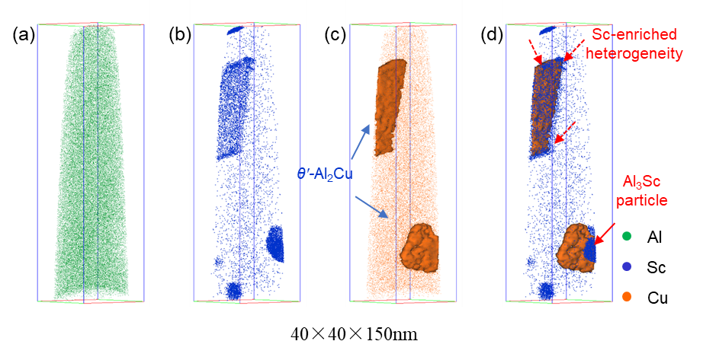

**Figure S1.** 3D-APT maps showing the *θ′-*Al2Cu precipitates nucleated on the Al3Sc particles or Sc-enriched heterogeneities. The distribution of (a) Al, (b) Sc, (c) Cu are shown using green, blue and orange spots, respectively. The *θ′-*Al2Cu plate is highlighted using the 10 at. % Cu iso-concentration surface in (c) and (d). Both the Cu iso-concentration surfaces and the Sc mapping are presented in (d) to illustrate the nucleation sites provided by Al3Sc particle (red solid arrow) or Sc-enriched heterogeneities (dash arrows) after re-aging for 15 minutes.

We note that Sc segregates even more, to ~6.05±2.35 at.% from APT, after creep test in the Al-Cu-Sc RR alloys, see Figure 2(p) and Figure S3(a), from ~2.4 at.% before creep. Similarly, Si segregation was also found, but merely increasing from 0.25 at.% to 0.33 at.%, implying a weak impact on the microstructural stabilization, as mentioned earlier. The continued segregation of Sc solutes, which were left untapped into after Step III, continues until the creep fracture occurs, further improving the thermal stability of *θ*′-Al2Cu during the long period of creep, as reflected by the obviously decreased population of Sc-enriched heterogeneities and the Sc solute content in the matrix ( $c_{Sc}^{heter}$ + $c_{Sc}^{m}$) in Table S3. This is to be contrasted with the Al-Cu-Sc AA alloy. There, after creep at 300oC/30 MPa for 35h, Sc only increased to ~3.0 at.% from ~0.8 at.% before creep, just reaching the similar level of its RR counterpart before creep. This explains the fast coarsening of the *θ*′-Al2Cu from 330 ± 12 nm before creep to 491 ± 48 nm after only 35 hours.

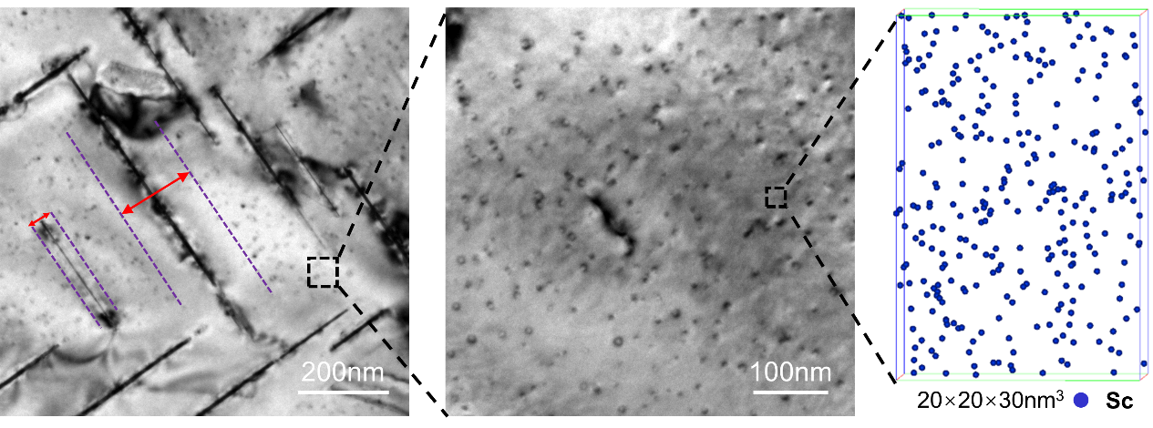

(c)

(b)

(a)

**Figure S2.** (a) A representative TEM image of underaged Al-Cu-Sc RR alloy in Step III, showing wider PDZs (marked using red arrows between dashed purple lines) around coarser *θ*′-Al2Cu precipitates, in comparison with small precipitates with narrow PDZs, indicating *θ′*-Al2Cu precipitates collecting nearby Al3Sc particles during coarsening. TEM and APT map to show the multi-scaled microstructure features of (a) *θ′*-Al2Cu precipitates, (b) remaining Al3Sc particles and (c) Sc-enriched heterogeneities/atoms distributed in the matrix and enclosed by *θ′*-Al2Cu in the Al-Cu-Sc RR alloy in Step III.

In addition, TEM examinations reveal that the half length of *θ*′-Al2Cu actually decreased to ~180 nm after creep test for 350h, see Figure 1(b) and Table S2, as a result of splitting in some of the *θ*′-Al2Cu precipitates (Figure 2(n) and Figure 5(a)). The splitting spots are in close proximity to the Al3Sc phases locally formed on the α-Al/*θ*′ interfaces during creep test at 300 oC, see sketch in 2(m) and 3D-APT image in Figure 2(o). The evidence that the Sc-rich layer is Al3Sc comes from the proxigram corresponding to the APT image in Figure 2(o), showing the distribution of Cu and Sc atoms cross a α-Al/*θ′*-Al2Cu interface in the crept RR alloy, see Figure S3(b). It is evident that the Sc-rich layer contains ~25.0 at.% Sc, agreeing well with the composition of Al3Sc quantitatively. The HRTEM image given in Figure S3(c) shows that Al3Sc locally formed on the α-Al/*θ*′ interfaces during creep test at 300oC, which can be compared with the *θ*′-Al2Cu with only Sc segregation before creep (Figure S3(d)). This Al3Sc formation uses up Sc and opens up nearby areas where Cu atoms lose Sc protection and dissolve into the surrounding Al matrix, leading to eventual precipitate splitting and reduction in precipitate size*.* The details of this interesting “splitting” phenomenon will be discussed elsewhere. Overall, the vast majority of *θ*′-Al2Cu precipitates remained stable. During the creep test the *θ*′-Al2Cu volume fraction remained at *fv*=1.97±0.10%, in comparison with *fv* =2.13±0.19% before creep.

No obvious difference is detected in the Al3Sc precipitates in the matrix after the RR treatment (3.4±0.8 nm, 3.4±0.3 nm and 3.7±0.6 nm after Step II, Step III and creep test for ~350h, respectively, see Figure 4(c)-(d) and Table S2), and their number density is almost unchanged. The PDZs also remain similar to that before creep test, as seen in the 3D-APT image in Figure 2(p).

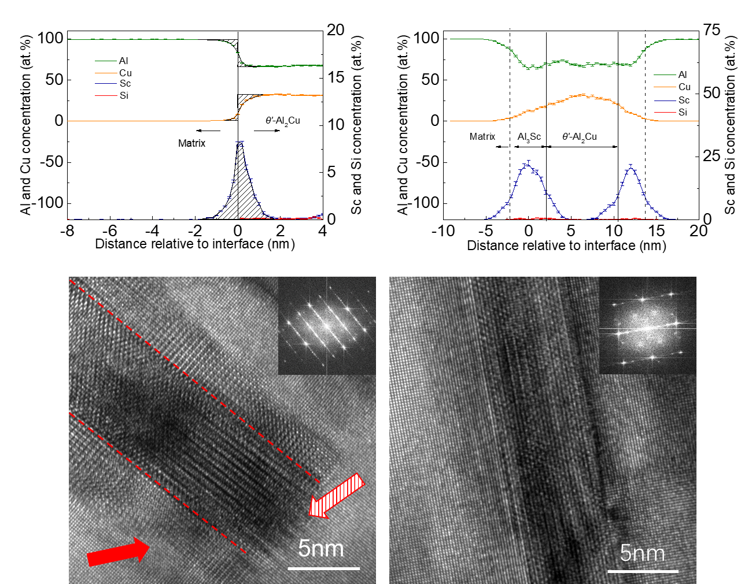

(a)

(b)

(d)

(c)

**Figure S3.** Representative proxigram of Al, Cu Sc and Si across the α-Al/*θ*′ interface decorated with Sc segregation and Al3Sc layer in the Al-Cu-Sc RR alloys after creep test at 300oC/30MPa for (a) 220h and (b) 350h, respectively. (b) Representative HRTEM images showing the thickness of a *θ′*-Al2Cu precipitate in the Al-Cu-Sc RR alloy (a) after creep test and (b) before creep, respectively, with corresponding FFT images in the upper right corner. The interfacial Al3Sc layers were marked using red solid arrow in (a), and the *θ′*-Al2Cu was indicated by hatched arrow, corresponding to the APT image in Fig. 2(o).

1. High-temperature tensile properties

It should be noted that the high-temperature tensile strength is for a short-term load, while the steady-state creep rate $\dot{ε}$ reflects the creep resistance to a long-term load [21-23]. The Al-Cu-Sc RR alloy we developed has a yield strength of 127 ± 12 MPa at 300oC, which is much higher than that of the Al-Cu AA (59 ± 5 MPa) and Al-Sc AA (34 ± 2 MPa) alloys, and close to the commercial alloys (*i.e.* 7075, 2219 Al) as mentioned in [24]. However, the high-temperature strength of the present Al-Cu-Sc RR alloy is lower than those presented in [24-27], ~200 MPa yield strength at ~300°C for Al-6.3Cu-0.5Mg-0.5Ag-0.5Mn-0.2Zr and its derivatives, due to their higher Cu content.

Regarding the contribution from the Al3Sc particles to strengthening, we have made the following estimate. The Orowan loopingmechanisms are involved when the radius of spherical Al3Sc particles is larger than 2.1nm at 300oC [28-30]:

(S5)

where the $M$ =3.06 is the Taylor factor; $G$, $b$, and $ν$ are the shear modulus of the α-Al matrix (28 GPa [31]), Burgers vector (0.286 nm [23]), and Poisson's ratio (0.34 [23]) of the Al matrix, respectively. The decrease of shear modulus with increasing temperature is given by ∂G/∂dT=-13.6 MPa/K for α-Al matrix [23]. $f$ is the volume fraction of Al3Sc precipitates; and =0.5 J/m2 is an average APB energy of the Al3Sc for the (111) plane [28]; $α_{ε}$ = 2.6 and $m$ =0.85 are constants [29, 30]; ${\overline{r}}_{{Al}_{3}Sc}$ is the mean radius of Al3Sc particles; $ε≈0.0083$ is the constrained lattice parameter mismatch at room temperature [28, 32]; $∆G$ =42.5 GPa is the shear modulus mismatch between the α-Al matrix and the Al3Sc precipitates; $λ_{ave}$ is the inter-precipitate spacing [33]. The strength contribution, $σ_{{Al}_{3}Sc}$, is then estimated to be 76 MPa at 300oC.

The contribution of the {100}*α* unshearable *θ′*-Al2Cu plates, $σ_{θ^{'}}$, can be predicted as [34-36]:

$σ_{θ^{'}}=0.13MG\frac{b}{2\sqrt{L_{θ^{'}}h}}×[{f_{v}}^{\frac{1}{2}}+0.75{\left(\frac{{2L}_{θ^{'}}}{h}\right)}^{\frac{1}{2}}f_{v}+0.14\left(\frac{{2L}_{θ^{'}}}{h}\right){f_{v}}^{3/2}]ln⁡(\frac{0.158L_{θ^{'}}}{r_{0}}$)

(S6)

where $L_{θ^{'}}$ and $h$ are the average half length and thickness of *θ′* precipitates, respectively. $r_{0}$ ~0.572 nm [37] is the inner cut-off radius for the calculation of dislocation line tension. All other parameters have been defined. We find that $σ_{θ^{'}}$ =91 MPa.

This comparison suggests that the strengthening effect of *θ′*-Al2Cu(protected by Sc segregation) is larger than Al3Sc particles. However, the contribution from the latter is also very important.

**Table S3. The fraction of Sc atoms, out of the total Sc in the alloy, in the coherent Al3Sc (), interfacial Sc segregation ($c_{Sc}^{int}$) and the equivalent Sc concentration ($c_{Sc}^{θ^{'}}$) within the $θ^{'}$** **phase volume after various treatments. The rest of Sc atoms are present in Sc-enriched heterogeneities and as solutes in the matrix, ( $c_{Sc}^{heter}$ + $c_{Sc}^{m}$), or large Al3Sc dispersoids and Sc consumption at grain boundaries, ${{(c}_{Sc}^{d}+c}_{Sc}^{GB}=\frac{Average Sc composition in APT}{Average Sc composition in OES }$).**

|  |  |  |  |  |  |
| --- | --- | --- | --- | --- | --- |
| **Stage** | $c_{Sc}^{Al_{3}Sc}$ (%Sc) | $c_{Sc}^{int}$ (%Sc) | $c_{Sc}^{θ^{'}}$ (%Sc) | $c_{Sc}^{heter}+c_{Sc}^{m}$ (%Sc) | $c_{Sc}^{GB}{+c}_{Sc}^{d}$ (%Sc) |
| *AA* | - | 2.6 | 0.8 | 86.8 | 9.8 |
| *Regression* | 71.0 | - | - | 18.3 | 10.7 |
| *Re-aging* | 66.0 | 12.8 | 2.2 | 10.1 | 8.8 |
| *RR crept* | 65.0 | 20.5 | 0.4 | 0.5 | 13.6 |

Note:

1. Some Al3Sc dispersoids (*r*~ 100 nm in size) inevitably form during solution treatment at 590 0C in Al-Cu-Sc alloy and hard to eliminate. However, these dispersoids have a very low volume fraction and cost only ~2% of the total Sc atoms[1, 2].
2. $c_{Sc}^{Al_{3}Sc}+c_{Sc}^{int}+c_{Sc}^{θ^{'}}$ ${+\left(c_{Sc}^{heter}+ c_{Sc}^{m}\right)+ (c}_{Sc}^{GB}+c_{Sc}^{d})$ = 100% Sc atoms (these fractions are given in percentage).
3. Creep mechanism

The minimum creep rate can be expressed by using the following power-law equation:

|  |  |
| --- | --- |
| $$\dot{ε}=Aσ^{n_{a}}exp⁡(\frac{-Q_{a}}{RT})$$ | (S7) |

where $A$ is a material-dependent parameter, $σ$ is the applied stress, $n_{a}$ is the apparent stress exponent, $Q_{a}$ is the apparent activation energy, $R$ is the ideal gas constant and $T$ is the absolute temperature. The apparent stress exponent is derived from the slopes of the straight lines of log $\dot{ε}$ vs log $σ$, as shown in Figure 5(b). Metallic materials strengthened by particles are characterized by a high stress exponent (always >20) [28, 38-50]. In contrast, the present Al-Cu-Sc RR alloy exhibits a much lower value of *na*=7.97±0.56, compared with the Al-Sc AA (31.9±3.0), Al-Cu AA (9.82±0.32), and Al-Cu-Sc AA (8.34±0.39) alloys. This indicates a weaker dependence of the Al-Cu-Sc RR alloy on the applied tensile stress.

A modified power-law equation including threshold stress describes the minimum creep rate:

|  |  |
| --- | --- |
| $$\dot{ε}=A{'(σ-σ_{th})}^{n_{0}}exp⁡(\frac{-Q}{RT})$$ | (S8) |

where $A'$ is the structure dependent parameter, $σ$ is the applied stress, $σ_{th}$ is the threshold stress, $n_{0}$ is the true stress exponent, $Q$ is the true activation energy, $R$ is the ideal gas constant and $T$ is the absolute temperature. We used the procedure suggested in [49, 51] via plotting a linear weighted least-squares regression of ${\dot{ε}}^{1/n_{0}}$ vs. $σ$ by using different $n_{0}$ to predict the most suitable stress exponent, see Figure S4. A set of values of $n_{0}$ =1, 3, 5 are usually used for Al-based alloys, which correspond to different creep mechanisms, *i.e.*, the diffusional creep [52], viscous glide of dislocation[53-55], dislocation climb controlled by lattice diffusion [54-56], respectively. In the results as shown in Figure S4, ${\text{n}}_{\text{0}}\text{=5}$ gives the best linear fit for all the studied alloys (coefficient of correlation R=0.981 for Al-Cu-Sc RR), see Figure S4(c). This suggests the dislocation climb mechanism [22, 57]. The corresponding revision has been made accordingly.

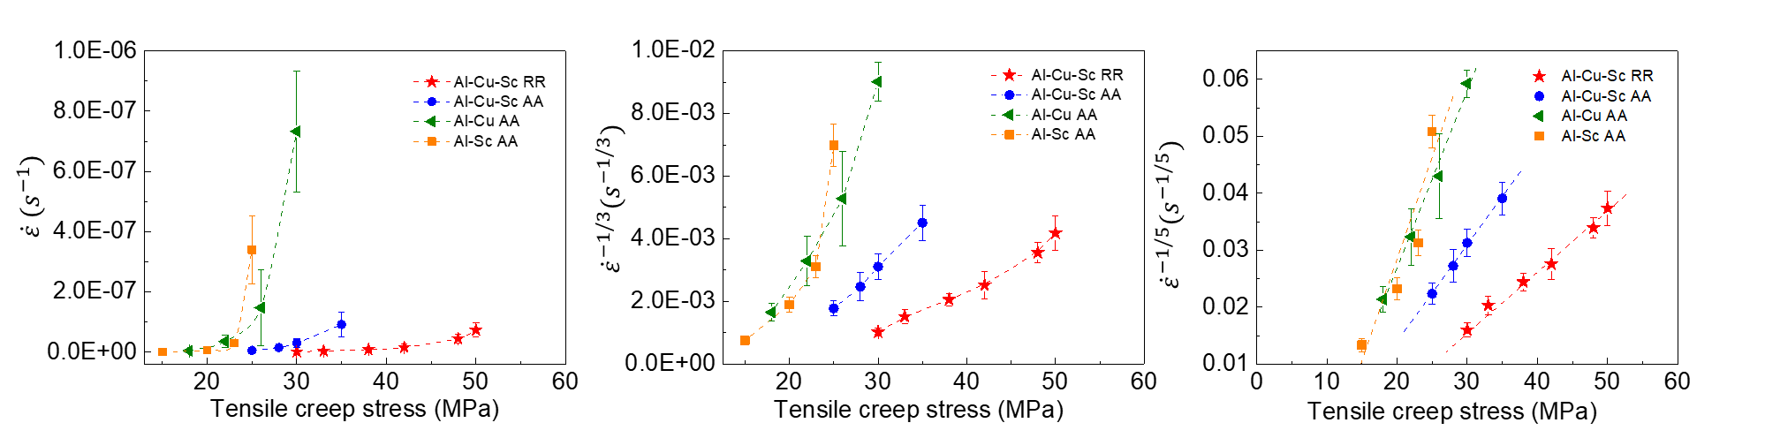

(a)

(b)

(c)

**Figure S4.** Plots of ${\dot{ε}}^{1/n_{0}}$ vs. for *n0* = (a) 1, (b) 3, (c) 5 on linear scales.

**References cited in SI:**

[1] Chen BA, Liu G, Wang RH, Zhang JY, Jiang L, Song JJ, Sun J. Effect of interfacial solute segregation on ductile fracture of Al-Cu-Sc alloys. Acta Mater. 2013;61:1676-90.

[2] Yang C, Zhang P, Shao D, Wang RH, Cao LF, Zhang JY, Liu G, Chen BA, Sun J. The influence of Sc solute partitioning on the microalloying effect and mechanical properties of Al-Cu alloys with minor Sc addition. Acta Mater. 2016;119:68-79.

[3] Liu G, Sun J, Nan CW, Chen KH. Experiment and multiscale modeling of the coupled influence of constituents and precipitates on the ductile fracture of heat-treatable aluminum alloys. Acta Mater. 2005;53:3459-68.

[4] Liu G, Zhang GJ, Wang RH, Hu W, Sun J, Chen KH. Heat treatment-modulated coupling effect of multi-scale second-phase particles on the ductile fracture of aged aluminum alloys. Acta Mater. 2007;55:273-84.

[5] Krakauer BW, Seidman DN. Subnanometer scale study of segregation at grain boundaries in an Fe(Si) alloy. Acta Mater. 1998;46:6145-61.

[6] Marquis EA, Seidman DN, Asta M, Woodward C, Ozolins V. Mg segregation at Al/Al3Sc heterophase interfaces on an atomic scale: experiments and computations. Phys Rev Lett. 2003;91:036101.

[7] Marquis EA, Seidman DN, Asta M, Woodward C. Composition evolution of nanoscale Al3Sc precipitates in an Al–Mg–Sc alloy: Experiments and computations. Acta Mater. 2006;54:119-30.

[8] Biswas A, Siegel DJ, Seidman DN. Simultaneous segregation at coherent and semicoherent heterophase interfaces. Phys Rev Lett. 2010;105:076102.

[9] Biswas A, Siegel DJ, Wolverton C, Seidman DN. Precipitates in Al–Cu alloys revisited: Atom-probe tomographic experiments and first-principles calculations of compositional evolution and interfacial segregation. Acta Mater. 2011;59:6187-204.

[10] Defay R, Prigogine I, Bellemans A, Everett DH. Surface tension and adsorption. Longmans. 1966.

[11] Dregia SA, Wynblatt P. Equilibrium segregation and interfacial energy in multicomponent systems. Acta Metall Mater. 1991;39:771-8.

[12] Krug ME, Dunand DC, Seidman DN. Effects of Li additions on precipitation-strengthened Al–Sc and Al–Sc–Yb alloys. Acta Mater. 2011;59:1700-15.

[13] Vaithyanathan V, Wolverton C, Chen LQ. Multiscale modeling of θ′ precipitation in Al–Cu binary alloys. Acta Mater. 2004;52:2973-87.

[14] Radmilovic V, Ophus C, Marquis EA, Rossell MD, Tolley A, Gautam A, Asta M, Dahmen U. Highly monodisperse core–shell particles created by solid-state reactions. Nat Mater. 2011;10:710-5.

[15] Li J, Guo C, Ma Y, Wang Z, Wang J. Effect of initial particle size distribution on the dynamics of transient Ostwald ripening: A phase field study. Acta Mater. 2015;90:10-26.

[16] Wettergren K, Schweinberger FF, Deiana D, Ridge CJ, Crampton AS, Rötzer MD, Hansen TW, Zhdanov VP, Heiz U, Langhammer C. High sintering resistance of size-selected platinum cluster catalysts by suppressed Ostwald ripening. Nano Lett. 2014;14:5803.

[17] Greenwood GW. The growth of dispersed precipitates in solutions. Acta Metall. 1956;4:243-8.

[18] Lifshitz IM, Slezov VV. Kinetics of diffusive decomposition of supersaturated solid solutions. Soviet Physics Jetp Ussr. 1959;8:331-9.

[19] Lifshitz IM, Slyozov VV. The kinetics of precipitation from supersaturated solid solutions. J Phys Chem Solids. 1961;19:35-50.

[20] Wagner C. Theorie der Alterung von Niederschlägen durch Umlösen (Ostwald‐Reifung). Z Elektrochem. 1961;65:581-91.

[21] Knipling KE, Dunand DC, Seidman DN. Criteria for developing castable, creep-resistant aluminum-based alloys - A review. Z Für Met. 2006;97:246-65.

[22] Čadek J. Creep in metallic materials: Elsevier; 1988.

[23] Frost HJ, Ashby MF. Deformation-mechanism maps. Oxford: Pergamon Press; 1982.

[24] Polmear IJ, Couper MJ. Design and development of an experimental wrought aluminum alloy for use at elevated temperatures. Metall Trans A. 1988;19:1027-35.

[25] Sims ZC, Rios OR, Weiss D, Turchi PEA, Perron A, Lee JRI, Li TT, Hammons JA, Baggehansen M, Willey TM. High performance aluminum–cerium alloys for high-temperature applications. Materials Horizons. 2017;4.

[26] Kumar Makineni S, Sugathan S, Meher S, Banerjee R, Bhattacharya S, Kumar S, Chattopadhyay K. Enhancing elevated temperature strength of copper containing aluminium alloys by forming L12 Al3Zr precipitates and nucleating θ″ precipitates on them. Sci Rep. 2017;7:11154.

[27] Mondol S, Kashyap S, Kumar S, Chattopadhyay K. Improvement of high temperature strength of 2219 alloy by Sc and Zr addition through a novel three-stage heat treatment route. Mater Sci Eng, A. 2018;732:157-66.

[28] Seidman DN, Marquis EA, Dunand DC. Precipitation strengthening at ambient and elevated temperatures of heat-treatable Al(Sc) alloys. Acta Mater. 2002;50:4021-35.

[29] Ardell AJ. Precipitation hardening. Metall Trans A. 1985;16:2131-65.

[30] Argon AS. Strengthening Mechanisms in Crystal Plasticity. Oxford: Oxford University; 2007.

[31] Metals Handbook (Ninth Edition) V. Properties and Selection: Nonferrous Alloys and Pure Metals: American Society for Metals; 1979.

[32] Røyset J, Ryum N. Scandium in aluminium alloys. Int Mater Rev. 2005;50:19-44.

[33] E N. Particle strengthening of metals and alloys. New York: NY: John Wiley; 1997.

[34] Nie JF, Muddle BC. Strengthening of an Al–Cu–Sn alloy by deformation-resistant precipitate plates. Acta Mater. 2008;56:3490-501.

[35] da Costa Teixeira J, Cram DG, Bourgeois L, Bastow TJ, Hill AJ, Hutchinson CR. On the strengthening response of aluminum alloys containing shear-resistant plate-shaped precipitates. Acta Mater. 2008;56:6109-22.

[36] Zhu AW, Starke EA. Strengthening effect of unshearable particles of finite size: a computer experimental study. Acta Mater. 1999;47:3263-9.

[37] Kelly PM. The effect of particle shape on dispersion hardening. Scripta Metall. 1972;6:647-56.

[38] Rösler J, Bäker M. A theoretical concept for the design of high-temperature materials by dual-scale particle strengthening. Acta Mater. 2000;48:3553-67.

[39] Jansen AM, Dunand DC. Creep of metals containing high volume fractions of unshearable dispersoids—Part II. Experiments in the Al-Al2O3 system and comparison to models. Acta Mater. 1997;45:4583-92.

[40] Fuller CB, Seidman DN, Dunand DC. Mechanical properties of Al(Sc,Zr) alloys at ambient and elevated temperatures. Acta Mater. 2003;51:4803-14.

[41] van Dalen ME, Seidman DN, Dunand DC. Creep- and coarsening properties of Al–0.06 at.% Sc–0.06 at.% Ti at 300–450 °C. Acta Mater. 2008;56:4369-77.

[42] van Dalen ME, Dunand DC, Seidman DN. Nanoscale precipitation and mechanical properties of Al-0.06 at.% Sc alloys microalloyed with Yb or Gd. J Mater Sci. 2006;41:7814-23.

[43] Van Dalen ME, Dunand DC, Seidman DN. Microstructural evolution and creep properties of precipitation-strengthened Al–0.06Sc–0.02Gd and Al–0.06Sc–0.02Yb (at.%) alloys. Acta Mater. 2011;59:5224-37.

[44] van Dalen ME, Dunand DC, Seidman DN. Effects of Ti additions on the nanostructure and creep properties of precipitation-strengthened Al–Sc alloys. Acta Mater. 2005;53:4225-35.

[45] Yao D, Zhao W, Zhao H, Qiu F, Jiang Q. High creep resistance behavior of the casting Al–Cu alloy modified by La. Scr Mater. 2009;61:1153-5.

[46] Čadek J, Kuchařová K, Zhu SJ. Creep behaviour of an oxide dispersion strengthened Al–5Mg alloy reinforced by silicon carbide particulates — an oxide dispersion strengthened Al–5Mg–30SiCp composite. Mater Sci Eng, A. 1999;272:45-56.

[47] Čadek J, Pahutová M, Šustek V. Creep behaviour of a 2124 Al alloy reinforced by 20 vol.% silicon carbide particulates. Mater Sci Eng, A. 1998;246:252-64.

[48] Ma Y, Langdon TG. Creep behavior of an Al-6061 metal matrix composite produced by liquid metallurgy processing. Mater Sci Eng, A. 1997;230:183–7.

[49] Kloc L, Spigarelli S, Cerri E, Evangelista E, Langdon TG. Creep behavior of an aluminum 2024 alloy produced by powder metallurgy. Acta Mater. 1997;45:529-40.

[50] Dieringa H, Huang Y, Maier P, Hort N, Kainer KU. Tensile and compressive creep behaviour of Al2O3 (Saffil®) short fiber reinforced magnesium alloy AE42. Mater Sci Eng, A. 2005;410:85-8.

[51] Lagneborg R, Bergman B. The stress/creep rate behaviour of precipitation-hardened alloys. Met Sci. 1976;10:20-8.

[52] Booth-Morrison C, Seidman DN, Dunand DC. Effect of Er additions on ambient and high-temperature strength of precipitation-strengthened Al–Zr–Sc–Si alloys. Acta Mater. 2012;60:3643-54.

[53] Weertman J. Steady‐State Creep of Crystals. J Appl Phys. 1957;28:1185-9.

[54] Sherby OD, Burke PM. Mechanical Behavior of Crystalline Solids at Elevated Temperature. Progress in Materials Science. 1968;13:323-90.

[55] Mohamed FA, Langdon TG. The transition from dislocation climb to viscous glide in creep of solid solution alloys. Acta Metall. 1974;22:779-88.

[56] Weertman J. Steady-State Creep through Dislocation Climb. J Appl Phys. 1957;28:362-4.

[57] Vagarali SS, Langdon TG. Deformation mechanisms in h.c.p. metals at elevated temperatures—I. Creep behavior of magnesium. Acta Metall. 1981;29:1969-82.