Supplementary Figures:

1. Supplementary Figure
*******************Insert Supplementary Figure S1 about here ********************

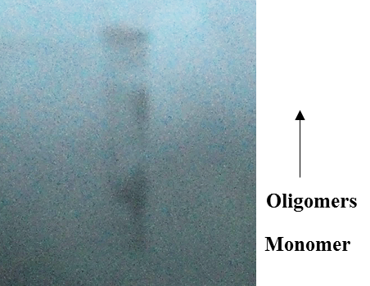
Supplementary Figure S1. Western blot analysis of Aβ₁₋₄₂ oligomers. Aβ₁₋₄₂ oligomers were run on SDS polyacrylamide gels, transferred to nitrocellulose and probed with anti- β-Amyloid antibodies. Oligomeric samples contain bands that react with anti- β-Amyloid ranging from monomer up to the size of material that accumulates at the top of the gel.

2. Supplementary Figure
******************Insert Supplementary Figure S2 about here ********************

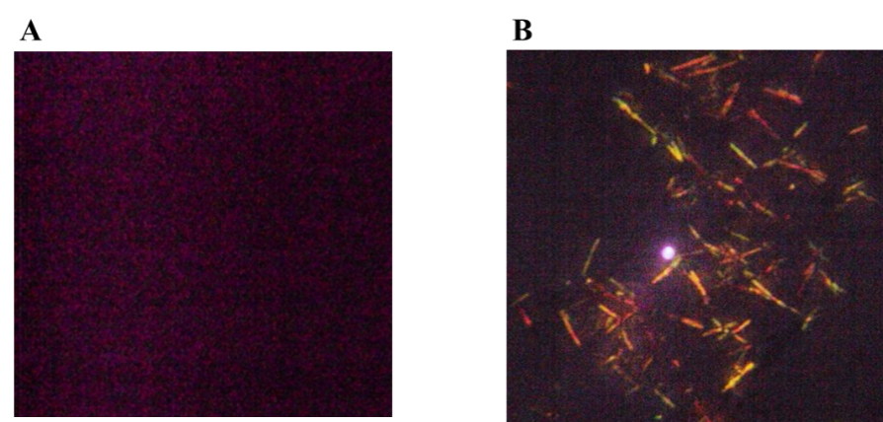
Supplementary Figure S2. Green/yellow birefringence under Polarized optical microscopy image of oligomeric Aβ₁₋₄₂. A, air dried buffer, B, oligomeric Aβ₁₋₄₂ was incubated with D-PBS, pH-7.4 at 37° C for 72 hours and stained with Congo red dye.

3. Supplementary Figure
****************Insert Supplementary Figure S3 about here ********************

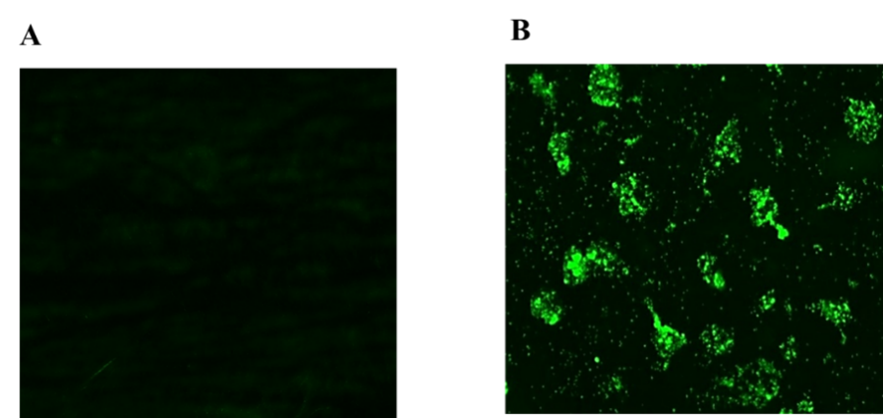
Supplementary Figure S3. Direct observation of Aβ₁₋₄₂ oligomerization followed by Fluorescence microscopic analysis using Thioflavin T as fluorescent dye A, air dried buffer, B, after 72 hours incubation in D-PBS, pH-7.4 at 37° C and stained with Thioflavin-T dye.

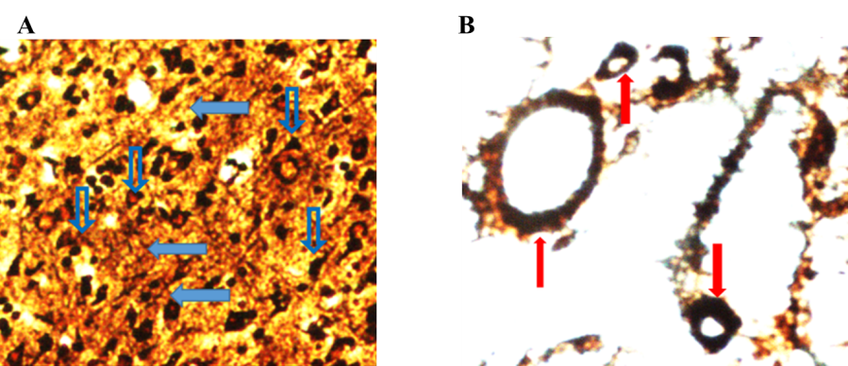

Supplementary Figure S4. Hirano’s silver staining of neuritic plaques and nerve fibers of rat brain treated with oAβ₁₋₄₂ peptide. (A) AD model group shows neuronal loss and dystrophic neurites (open and closed arrows). (B). Parenchymal, extracellular deposits (red arrows) were observed in hippocampal region of rat brain. Scale bar 10 µM.

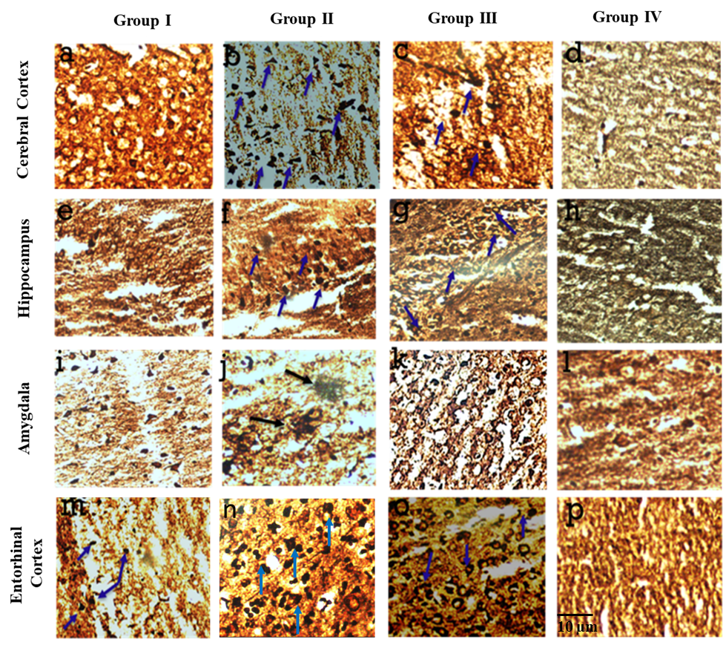
Supplementary Figure S5. Modified Hirano’s silver staining of oAβ₁₋₄₂ injected rat brain (a-p) Representative microphotographs of Hirano’s silver stained (a-d) cerebral cortex, (e-h) hippocampus, (i-l) amygdala and (m-p) entorhinal cortex of Aβ1-42 injected rats after 8, 15, and 30 days post-injection compared to sham-control group. Extracellular amyloid deposits (blue arrow) were observed in hippocampus and entorhinal cortex of rat brain after 15 days post injection of oligomeric Aβ₁₋₄₂ compared to other groups. No morphologic changes were observed in sham control rat brain (magnification 40X). Scale bar 10 µM.

