Supplementary Information Items
This research study contains supplementary files below available to readers.

Supplementary Table 1. Effect of ozonation, packaging and storage time on tomato fruit resistance to penetration (mean±SD)
Days | Treatments
 | control | 0.5ppm O₃ | 0.5ppm O₃-LDPE | 1ppm O₃ | 1ppm O₃-LDPE | 2ppm O₃ | 2 ppm O₃-LDPE
0 | 16.27±0.87 | 16.27±0.87 | 16.27±0.87 | 16.27±0.87 | 16.27±0.87 | 16.27±0.87 | 16.27±0.87
7 | 14.59±0.86 | 14.70±0.83 | 14.94±0.79 | 15.23±0.84 | 15.54±0.80 | 15.77±0.81 | 16.19±0.82
14 | 11.14±0.42 | 12.01±0.43 | 12.91±0.40 | 13.80±0.45 | 14.65±0.37 | 15.41±0.32 | 16.08±0.33
21 | 9.64±0.29 | 11.75±0.26 | 12.54±0.27 | 13.28±0.28 | 14.16±0.26 | 14.79±0.28 | 15.44±0.30
28 | 8.96±0.32 | 11.13±0.28 | 11.86±0.25 | 12.88±0.21 | 13.58±0.28 | 14.12±0.21 | 14.83±0.25
35 | 7.32±0.31 | 9.93±0.26 | 10.69±0.27 | 12.37±0.22 | 12.99±0.27 | 13.61±0.25 | 14.14±0.22
42 | - | 9.36±0.24 | 10.38±0.26 | 11.95±0.28 | 12.48±0.21 | 12.98±0.23 | 13.52±0.25
49 | - | 8.88±0.21 | 9.42±0.24 | 10.79±0.26 | 11.32±0.23 | 11.83±0.22 | 12.77±0.29
t | 4.004 | 12.851 | 15.048 | 21.274 | 24.116 | 26.970 | 31.870
df | 5 | 7 | 7 | 7 | 7 | 7 | 7
p | <0.01 | <0.001 | <0.001 | <0.001 | <0.001 | <0.001 | <0.001
Mean: average value of six replicates, SD: standard deviation, comparison of means using T-test at the significance level p<0.05, df: degrees of freedom.

Supplementary Table 2a. Effect of ozonation, packaging and storage time on tomato texture scores (mean±SD)
Days | Treatments
 | control | 0.5ppm O₃ | 0.5ppm O₃-LDPE | 1ppm O₃ | 1ppm O₃-LDPE | 2ppm O₃ | 2ppm O₃-LDPE
0 | 5.0±0.4 | 5.0±0.5 | 5.0±0.4 | 5.0±0.4 | 5.0±0.5 | 5.0±0.4 | 5.0±0.4
7 | 5.0±0.4 | 5.0±0.5 | 5.0±0.5 | 5.0±0.4 | 5.0±0.4 | 5.0±0.5 | 5.0±0.4
14 | 4.8±0.3 | 5.0±0.5 | 5.0±0.4 | 5.0±0.4 | 5.0±0.5 | 5.0±0.4 | 5.0±0.4
21 | 4.2±0.4 | 4.8±0.4 | 4.8±0.4 | 5.0±0.4 | 5.0±0.4 | 5.0±0.4 | 5.0±0.4
28 | 3.6±0.2 | 4.4±0.4 | 4.5±0.4 | 4.6±0.5 | 4.7±0.5 | 4.8±0.5 | 5.0±0.5
35 | 3.1±0.2 | 3.7±0.3 | 4.0±0.4 | 4.1±0.4 | 4.2±0.5 | 4.3±0.5 | 4.4±0.5
42 | - | 3.6±0.4 | 3.7±0.4 | 3.8±0.4 | 4.0±0.4 | 4.1±0.4 | 4.1±0.4
49 | - | 3.3±0.4 | 3.3±0.4 | 3.5±0.4 | 3.6±0.4 | 3.7±0.4 | 3.8±0.4
t | 4.340 | 17.253 | 18.728 | 20.647 | 23.938 | 25.524 | 26.770
df | 6 | 6 | 6 | 6 | 6 | 6 | 6
p | <0.01 | <0.001 | <0.001 | <0.001 | <0.001 | <0.001 | <0.001
Mean: average values of a ten member sensory panel, SD: standard deviation values, comparison of means using T-test at the significance level p<0.05, df: degrees of freedom

Supplementary Table 2b. Effect of ozonation, packaging and storage time on tomato taste scores (mean±SD)
Days | Treatments
 | Control | 0.5ppm O₃ | 0.5ppm O₃-LDPE | 1 ppm O₃ | 1ppm O₃-LDPE | 2ppm O₃ | 2ppm O₃-LDPE
0 | 5.0±0.5 | 5.0±0.4 | 5.0±0.5 | 5.0±0.4 | 5.0±0.5 | 5.0±0.4 | 5.0±0.5
7 | 5.0±0.4 | 5.0±0.4 | 5.0±0.4 | 5.0±0.4 | 5.0±0.4 | 5.0±0.5 | 5.0±0.4
14 | 4.2±0.4 | 4.6±0.4 | 4.8±0.4 | 5.0±0.4 | 5.0±0.4 | 5.0±0.5 | 5.0±0.4
21 | 3.6±0.3 | 4.4±0.4 | 4.5±0.4 | 4.8±0.4 | 4.8±0.4 | 4.8±0.4 | 4.8±0.5
28 | 3.3±0.3 | 4.1±0.4 | 4.3±0.4 | 4.6±0.4 | 4.6±0.5 | 4.7±0.4 | 4.7±0.4
35 | 2.8±0.2 | 3.6±0.4 | 3.8±0.4 | 3.9±0.4 | 4.1±0.4 | 4.2±0.4 | 4.4±0.5
42 | - | 3.4±0.3 | 3.6±0.3 | 3.7±0.3 | 3.8±0.3 | 3.8±0.3 | 3.9±0.3
49 | - | 3.2±0.3 | 3.3±0.3 | 3.5±0.3 | 3.5±0.3 | 3.6±0.3 | 3.7±0.3
t | 4.230 | 16.701 | 18.497 | 19.779 | 21.201 | 22.419 | 25.043
df | 6 | 6 | 6 | 6 | 6 | 6 | 6
p | <0.01 | <0.001 | <0.001 | <0.001 | <0.001 | <0.001 | <0.001
Mean: average values of a ten member sensory panel, SD: standard deviation values , comparison of means using T-test at the significance level p<0.05, df: degrees of freedom

Supplementary Table 2c. Effect of ozonation, packaging and storage time on tomato aroma scores (mean±SD)
Days | Treatments
 | control | 0.5ppm O₃ | 0.5ppm O₃-LDPE | 1 ppm O₃ | 1 ppm O₃-LDPE | 2 ppm O₃ | 2 ppm O₃-LDPE
0 | 5.0±0.4 | 5.0±0.4 | 5.0±0.5 | 5.0±0.4 | 5.0±0.5 | 5.0±0.4 | 5.0±0.5
7 | 5.0±0.4 | 5.0±0.5 | 5.0±0.5 | 5.0±0.4 | 5.0±0.4 | 5.0±0.5 | 5.0±0.4
14 | 4.4±0.5 | 4.8±0.4 | 5.0±0.4 | 5.0±0.4 | 5.0±0.4 | 5.0±0.4 | 5.0±0.4
21 | 3.9±0.3 | 4.7±0.4 | 4.8±0.4 | 4.8±0.4 | 4.8±0.4 | 4.8±0.5 | 4.8±0.4
28 | 3.3±0.2 | 4.5±0.4 | 4.5±0.4 | 4.6±0.3 | 4.6±0.3 | 4.7±0.4 | 4.7±0.4
35 | 3.1±0.2 | 3.8±0.4 | 3.9±0.4 | 4.0±0.4 | 4.1±0.4 | 4.2±0.4 | 4.3±0.3
42 | - | 3.7±0.4 | 3.7±0.4 | 3.9±0.3 | 3.9±0.4 | 4.0±0.3 | 4.0±0.3
49 | - | 3.4±0.3 | 3.5±0.3 | 3.6±0.4 | 3.7±0.4 | 3.7±0.3 | 3.8±0.4
t | 4.305 | 19.945 | 19.807 | 22.295 | 23.826 | 25.101 | 26.940
df | 6 | 6 | 6 | 6 | 6 | 6 | 6
p | <0.01 | <0.001 | <0.001 | <0.001 | <0.001 | <0.001 | <0.001
Mean: average values of a ten member sensory panel, SD: standard deviation values, comparison of means using T-test at the significance level p<0.05, df: degrees of freedom

Supplementary Table 3a. Microbial growth rate (mean values) of TVC with respect to treatment and storage time
Days | control | 0.5ppm O₃ | 0.5ppm O₃-LDPE | 1 ppm O₃ | 1 ppm O₃-LDPE | 2 ppm O₃ | 2 ppm O₃-LDPE
0-7 | 0.49 | 0.46 | 0.44 | 0.41 | 0.39 | 0.35 | 0.31
7-14 | 0.22 | 0.20 | 0.18 | 0.17 | 0.14 | 0.15 | 0.09
14-21 | 0.15 | 0.15 | 0.06 | 0.14 | 0.10 | 0.07 | 0.10
21-28 | 0.12 | 0.09 | 0.15 | 0.10 | 0.07 | 0.12 | 0.08
28-35 | 0.06 | 0.05 | 0.08 | 0.04 | 0.05 | 0.05 | 0.04
35-41 | - | 0.04 | 0.03 | 0.02 | 0.02 | 0.01 | 0.04
41-49 | - | 0.02 | 0.02 | 0.02 | 0.05 | 0.02 | 0.01
t | 2.783 | 2.498 | 2.476 | 2.458 | 2.442 | 2.480 | 2.510
df | 4 | 6 | 6 | 6 | 6 | 6 | 6
p | p<0.05 | p<0.05 | p<0.05 | p<0.05 | p<0.05 | p<0.05 | p<0.05
Comparison of means using T-test at the significance level p<0.05, df: degrees of freedom .

Supplementary Table 3b. Microbial growth rate (mean values) of psychrotrophic counts with respect to treatment and storage time
Days | control | 0.5ppm O₃ | 0.5ppm O₃-LDPE | 1 ppm O₃ | 1 ppm O₃-LDPE | 2 ppm O₃ | 2 ppm O₃-LDPE
0-7 | 0.44 | 0.43 | 0.38 | 0.35 | 0.29 | 0.20 | 0.15
7-14 | 0.15 | 0.13 | 0.08 | 0.09 | 0.10 | 0.07 | 0.10
14-21 | 0.08 | 0.08 | 0.11 | 0.08 | 0.09 | 0.10 | 0.07
21-28 | 0.15 | 0.06 | 0.08 | 0.09 | 0.08 | 0.12 | 0.10
28-35 | 0.21 | 0.19 | 0.16 | 0.14 | 0.14 | 0.15 | 0.14
35-41 |  | 0.03 | 0.03 | 0.04 | 0.02 | 0.05 | 0.03
41-49 |  | 0.02 | 0.03 | 0.06 | 0.04 | 0.02 | 0.05
t | 3.251 | 2.456 | 2.694 | 2.981 | 3.297 | 4.438 | 5.383
df | 4 | 6 | 6 | 6 | 6 | 6 | 6
p | p<0.05 | p<0.05 | p<0.05 | p<0.05 | p<0.05 | p<0.01 | p<0.01
Comparison of means using T-test at the significance level p<0.05, df: degrees of freedom .

Supplementary Table 3c. Microbial growth rate (mean values) of yeasts and molds with respect to treatment and storage time
Days | control | 0.5ppm O₃ | 0.5ppm O₃-LDPE | 1 ppm O₃ | 1 ppm O₃-LDPE | 2 ppm O₃ | 2 ppm O₃-LDPE
0-7 | 0.32 | 0.31 | 0.29 | 0.28 | 0.25 | 0.20 | 0.14
7-14 | 0.20 | 0.15 | 0.08 | 0.07 | 0.07 | 0.03 | 0.03
14-21 | 0.07 | 0.06 | 0.08 | 0.05 | 0.04 | 0.09 | 0.06
21-28 | 0.09 | 0.06 | 0.09 | 0.08 | 0.06 | 0.06 | 0.09
28-35 | 0.15 | 0.09 | 0.04 | 0.08 | 0.09 | 0.08 | 0.07
35-41 |  | 0.09 | 0.10 | 0.04 | 0.07 | 0.07 | 0.09
41-49 |  | 0.02 | 0.09 | 0.12 | 0.08 | 0.09 | 0.08
t | 3.728 | 3.007 | 3.516 | 3.37 | 3.622 | 4.328 | 6.499
df | 4 | 6 | 6 | 6 | 6 | 6 | 6
p | p<0.05 | p<0.05 | p<0.05 | p<0.05 | p<0.05 | p<0.01 | p<0.01
Comparison of means using T-test at the significance level p<0.05, df: degrees of freedom .

Estimation of the parameters of the microbial growth modeling-Equations

R-squared can be defined as follows:
R² = 1 – SS_{resid}/SS_{model} + SS_{resid}= 1 + SS_{error}/SS_{total} (Eq.1)

The R_{pred}² and the R_{adj}² have been obtained using Eqs. (2) and (3).
R²_{ad}j= 1 – (n – 1/n – p) (SS_{error}/SS_{total}) = 1 − (n − 1)/(n = p)(1 − R²) (Eq.2)

R²_{pred}= (1 – PESS) / (SS_{total} − SS_{block)} (Eq.3)

where n is the number of experiments, p is the number of model parameters including intercept and any block coefficient, and PESS is the prediction error of sum of squares:

PESS=$\sum_{i=1}^{n}{\left(ei,-i\right)2}$ , e _{i, -i} = y_{i}- ȳ _{i, -i} (Eq.4)
where e_{i,−i} is residual, y_{i} is the experimental value, and ȳ_{i,−1} is the predicted value.

Supplementary Figures

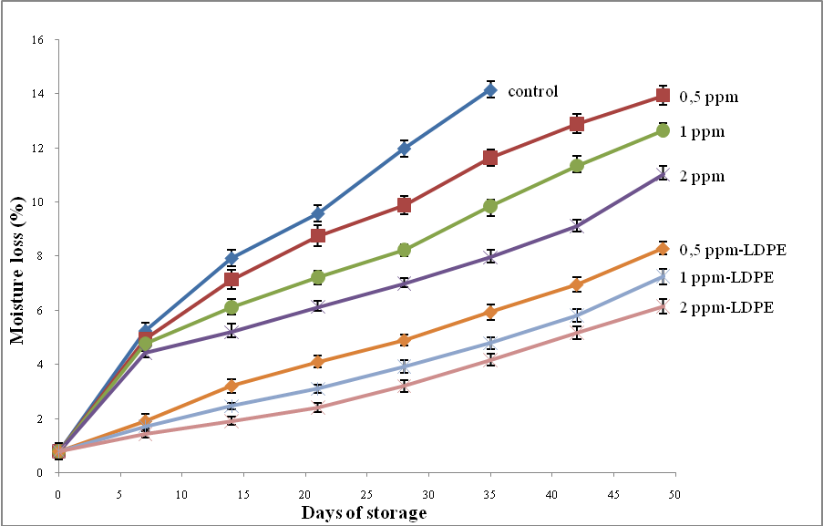
Supplementary Fig.1. Effect of ozonation, packaging and storage time on moisture loss (%) in tomatoes stored at 4±1 °C

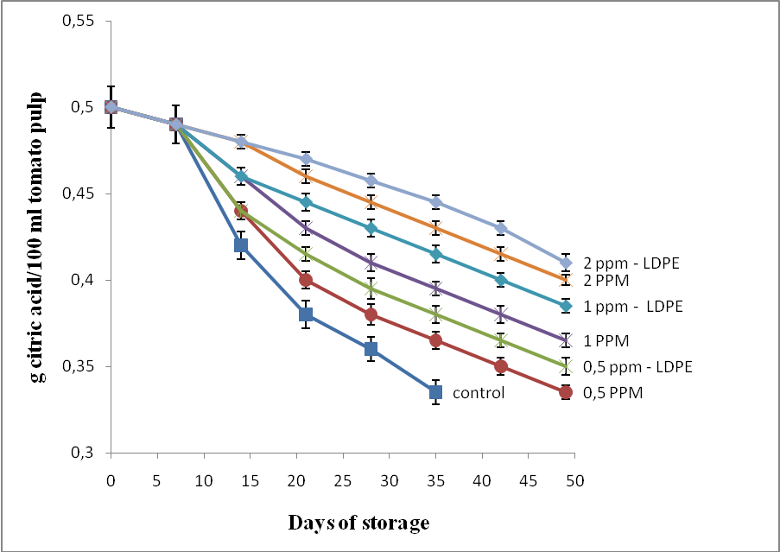
Supplementary Fig. 2. Effect of ozonation, packaging and storage time on acidity of tomato pulp stored at 4±1 °C

