Supplementary information

Table 1S. Target analytes and their application/origin

Name of compound | Therapeutic class | Chemical Structure | Log K_{OW} | pKa | Property
Caffeine | Stimulants/Caffeine metabolites | C₈H₁₀N₄O₂ | −0.1 | 10.4 | Basic
Diclofenac | Analgesics/Anti- inflammatories | C₁₄H₁₁Cl₂O₂ | 4.5 | 4.2 | Acidic
Ibuprofen | Analgesics/Anti- inflammatories | C₁₃H₁₈O₂ | 3.9 | 4.9 | Acidic
Mefenamic acid | Analgesics/Anti-inflammatories | C₁₅H₁₅NO₂ | 5.1 | 4.2, −1.6 | Acidic
Nifedipine | Antihypertensive | C₁₇H₁₈N₂O₆ | 2.2 | 5.3, 3.9 | Basic/ Acidic
Perindopril | Antihypertensive | C₁₉H₃₂N₂O₅ | 2.6 | 3.7, 5.4 | Acidic
Simvastatin | Lipid lowering agent | C₂₅H₃₈O₅ | 4.6 | 14.9, −2.8 | Basic/ Acidic

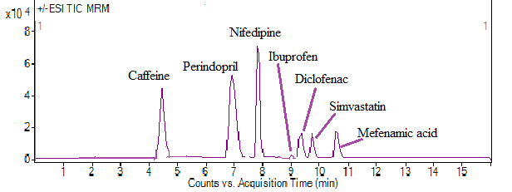
Fig. 1S. TIC chromatogram of a standard mixture of 1 mg L⁻¹ for targeted compounds analyzed by negative and positive ionization (ESI) modes of UPLC-MS.

