Supplementary material

Long-term relationship between unattended automated blood pressure and auscultatory BP measurements in hypertensive patients
Jitka Seidlerová^{a,b}, Jiří Ceral^{c}, Markéta Mateřánkováª, Petr Königª, Ivan Řiháček^{d},
Petra Vysočanová^{e}, Miroslav Souček^{d}, Jan Filipovský^{a,b},

Supplementary Table 1 Characteristics of the study population (n=112)
Women, n (%) | 55 (49.1)
Age, years | 65.6±10.8
Duration of follow-up, n (%)
> 1 year | 103 (92.0)
6 – 12 months | 8 (7.1)
< 6 months | 1 (0.9)
Diabetes mellitus, n (%) | 24 (21.4)
Hyperlipidemia, n (%) | 79 (70.5)
Current smokers, n (%) | 12 (10.7)
Number of antihypertensive drugs, n | 2.9±1.2
BMI, kg/m² | 29.8±4.9
Data are means±SD or number (percentage).

Supplement Table 2 Determinants of the difference between systolic and diastolic AuscOBP and uAutoOBP
Variables | β±SEM | F | P
Systolic BP
Systolic AuscOBP, mm Hg | 0.30±0.03 | 90.51 | <0.0001
Age, years | 0.09±0.04 | 5.08 | 0.025
Sex , male | -1.81±0.88 | 4.21 | 0.043
BMI, kg/m² | -0.23±0.09 | 6.22 | 0.013
Heart rate, bpm | -0.07±0.04 | 2.41 | 0.12
Diastolic BP
Diastolic AuscOBP, mm Hg | 0.32±0.03 | 116.27 | <0.0001
Age, years | 0.09±0.03 | 8.21 | 0.0044
Sex , male | -2.06±0.67 | 9.32 | 0.0029
BMI, kg/m² | -0.15±0.07 | 4.52 | 0.034
Heart rate, bpm | -0.08±0.03 | 5.72 | 0.017
Multivariate linear regression using mixed model and accounted for repeated measurements in one subject.

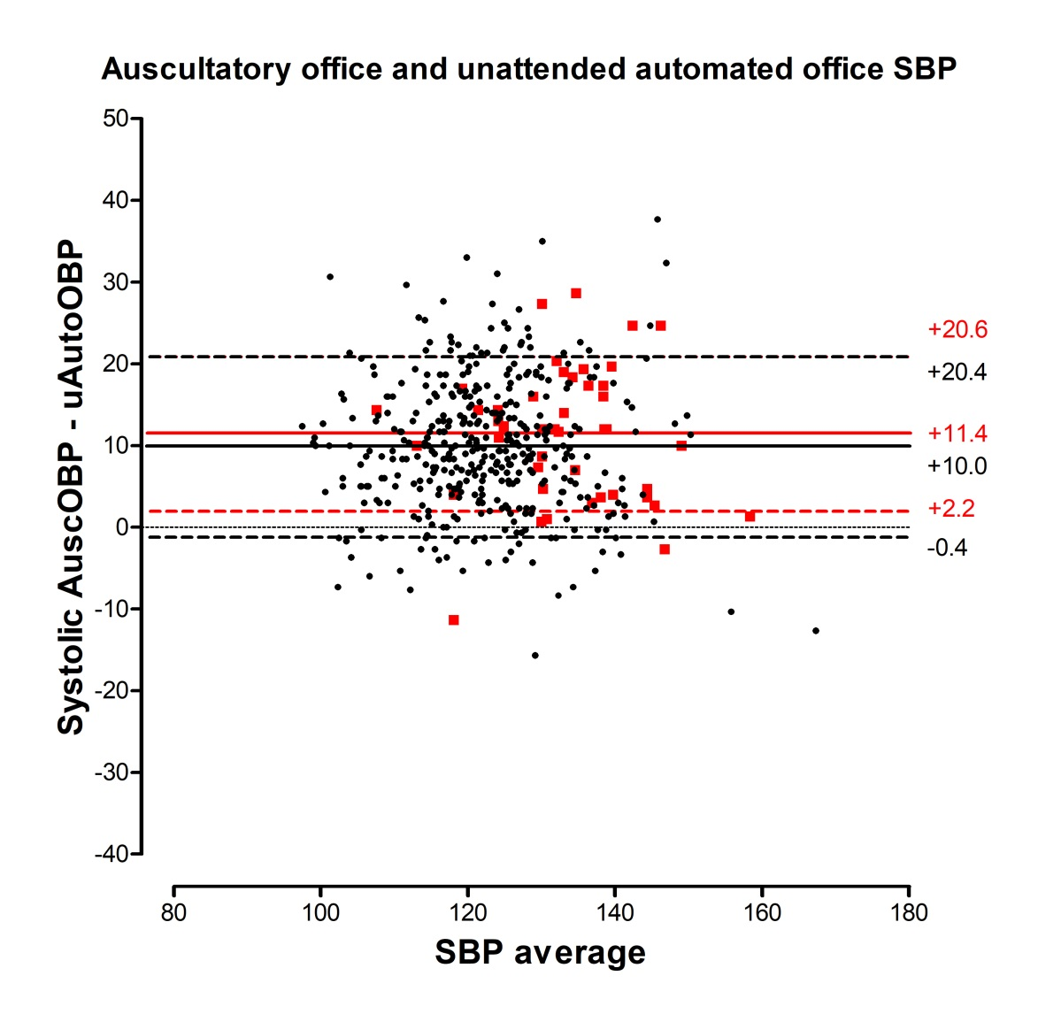
Supplement Figure 1 Bland-Altman analysis comparing systolic auscultatory to unattended automated blood pressure in all four clinical visits.
Mean differences (solid lines) and limits of agreements (±1.96*standard deviation of difference; dash lines) are shown.
In red colour are shown differences in patients with white coat effect according 24-hour blood pressure monitoring, in black colour are shown measurements in other blood pressure categories.

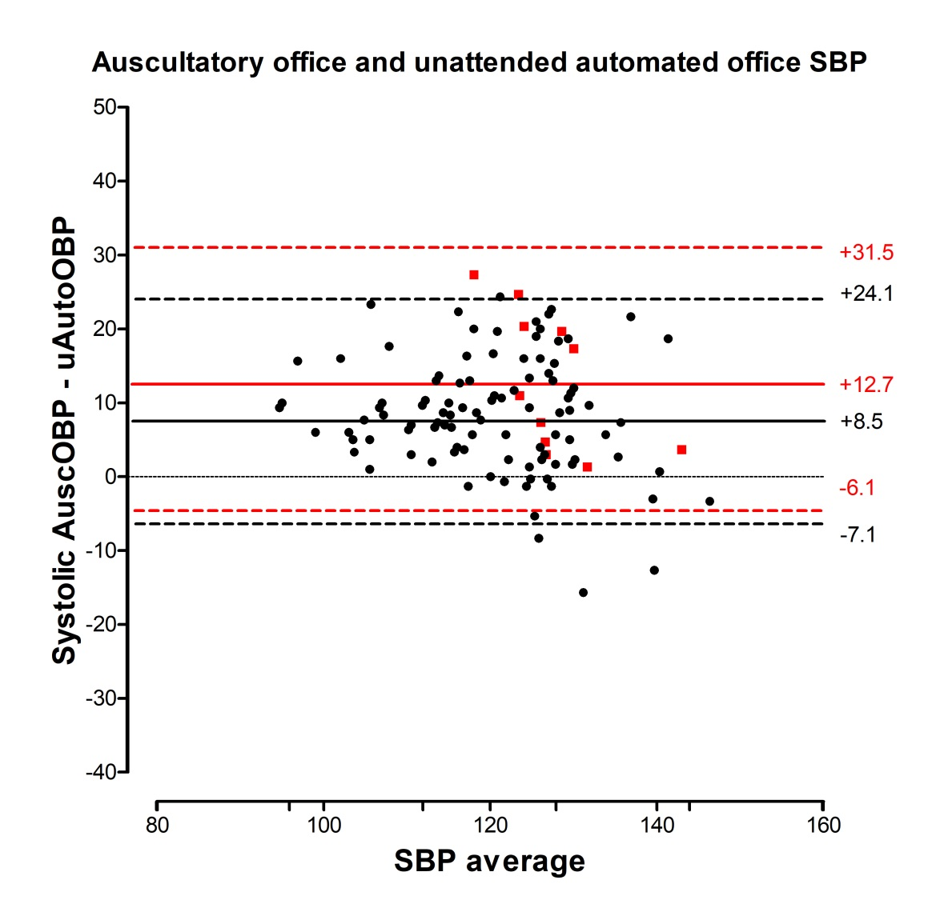
Supplement Figure 2 Bland-Altman analysis comparing systolic auscultatory to unattended automated blood pressure at second clinical visit.
Mean differences (solid lines) and limits of agreements (±1.96*standard deviation of difference; dash lines) are shown.
In red colour are shown differences in patients with white coat effect according 24-hour blood pressure monitoring, in black colour are shown measurements in other blood pressure categories.

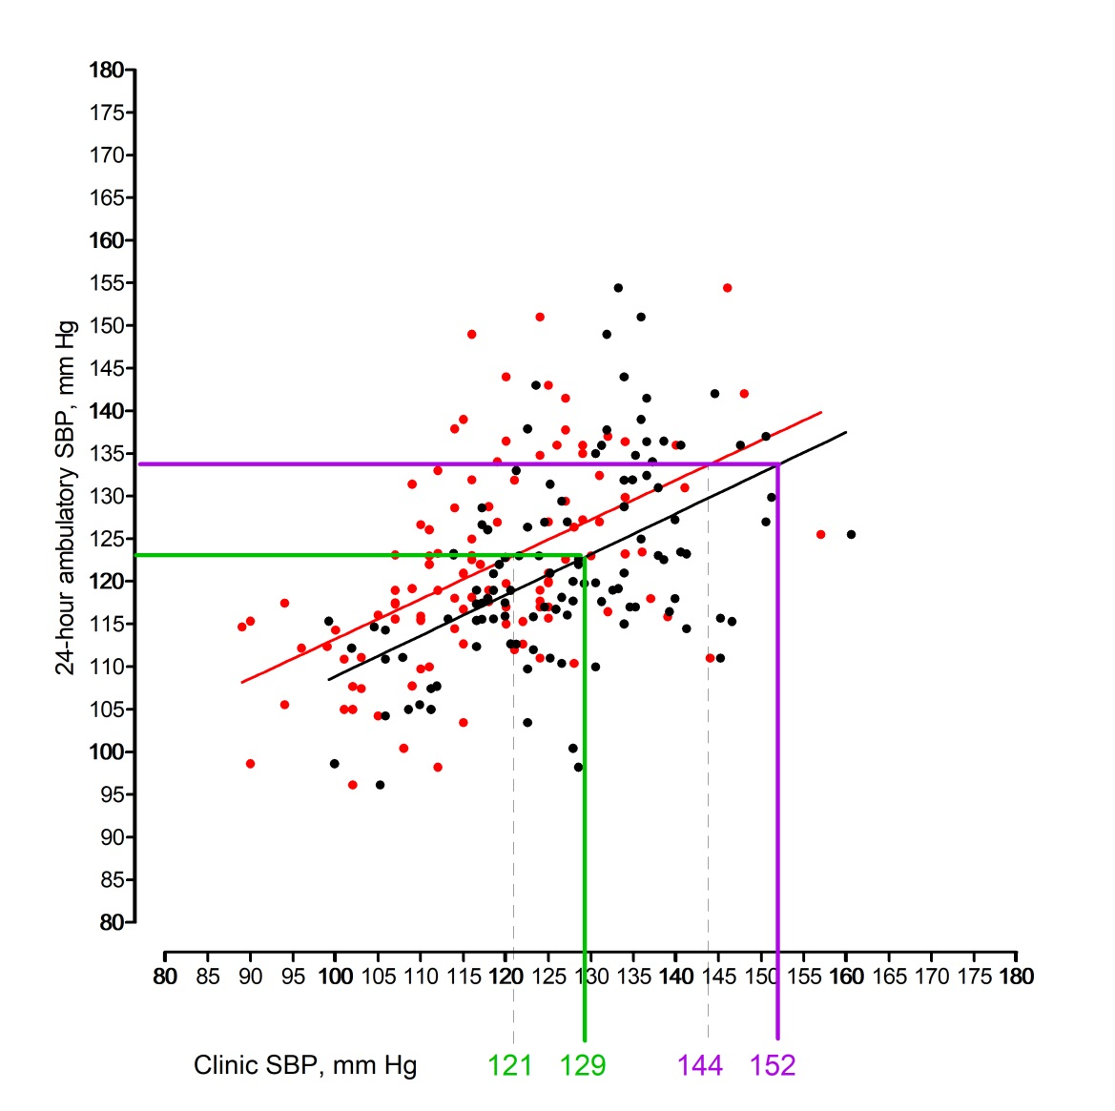
Supplement Figure 3 Relationships of auscultatory (black colour) and unattended automated (red colour) systolic blood pressure with 24-hour ambulatory systolic blood pressure
The solid and dashed vertical lines indicate the conventional (solid lines) and unattended automated (dashed lines) clinic systolic BP values estimated to correspond to the ambulatory BP values in SPRINT trial [N Engl J Med. 2015;373:2103-2116 and Hypertens 2017;69:42-50. In green are shown estimated values in intensive group, in violet in standard group of SPRINT trial.

