A novel poly(ethyleneoxide)-based magnetic nanocomposite catalyst for highly efficient multicomponent synthesis of pyran derivatives
Ali Maleki,^{a,}* Mojtaba Azizi^{a,b} and Zeynab Emdadiª
ªCatalysts and Organic Synthesis Research Laboratory, Department of Chemistry, Iran
University of Science and Technology, Tehran 16846-13114, Iran
^{b}Department of Chemistry, K.N. Toosi University of Technology, P.O. Box 15875-4416, Tehran, Iran
*Corresponding author. Tel.: +98 21 77240640-50; Fax: +98 21 73021584. E-mail: maleki@iust.ac.ir (Ali Maleki).
Table of contents
Subject | Page
Characterization of the selected product(4g)  FT-IR spectrum of compound 4g (Figure S1)…………………………………… | S2
¹H NMR spectra of selected compounds (Figure S2-S4)……………….……….. | S3-S10

Spectral data of the selected products
5-Ethoxycarbonyl-2-amino-4-(3-nitrophenyl)-3-cyano-6-methyl-4H-pyran; IR (KBr) (υ_{max}, cm⁻¹): 3402, 3326, 3080, 2987, 2925, 2191, 1691, 1674, 1647, 1604, 1529, 1344, 1267, 1062, 1000; ¹HNMR (500 MHz, DMSO-d₆): 1.023 (t, 3H, CH_{3,} J = 6.9 Hz), 2.35 (s, 3H, CH₃), 3.95-3.98 (m, 2H, CH₂), 4.52 (s, 1H, CH), 7.08 (s, 1H, NH₂), 7.62-7.66 (m, 2H, Ar), 7.98 (s, 1H, Ar), 8.11 (d,1H , Ar, J = 6.8 Hz).
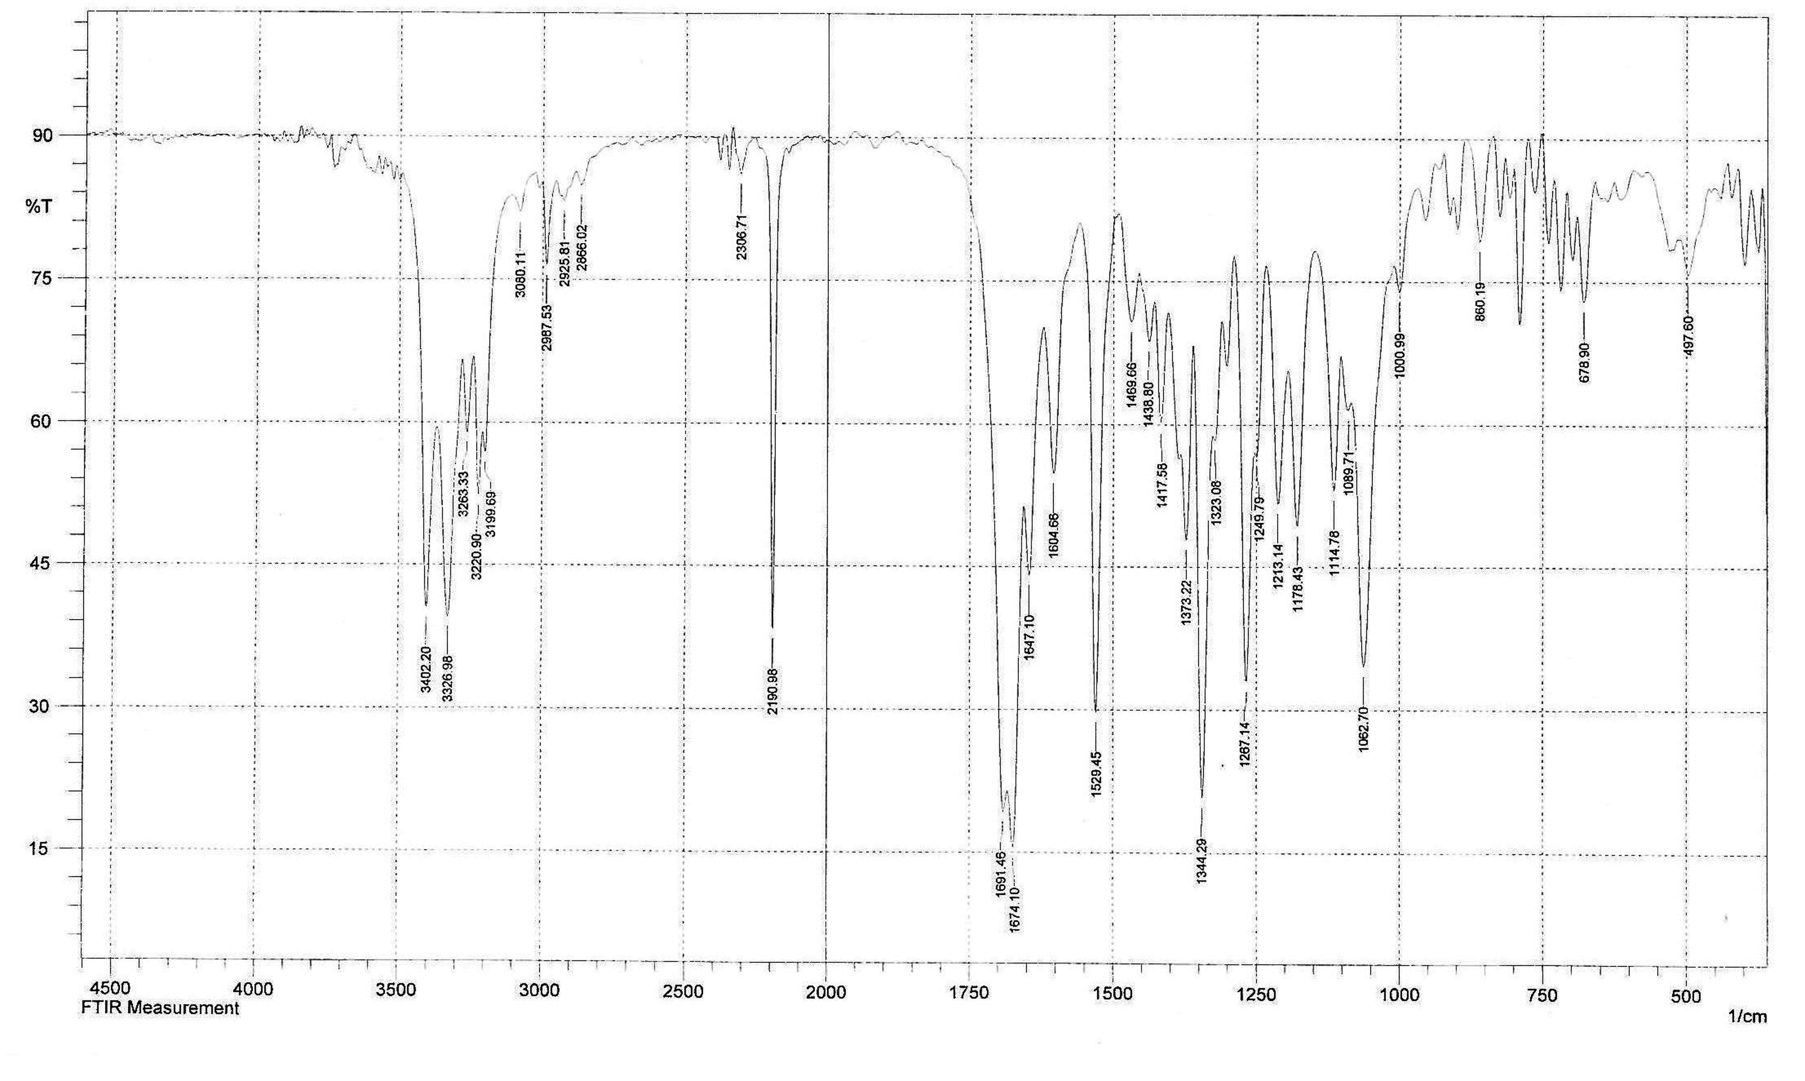
Figure S1. FT-IR spectrum of compound (4g) 3-Nitro-4H-pyran

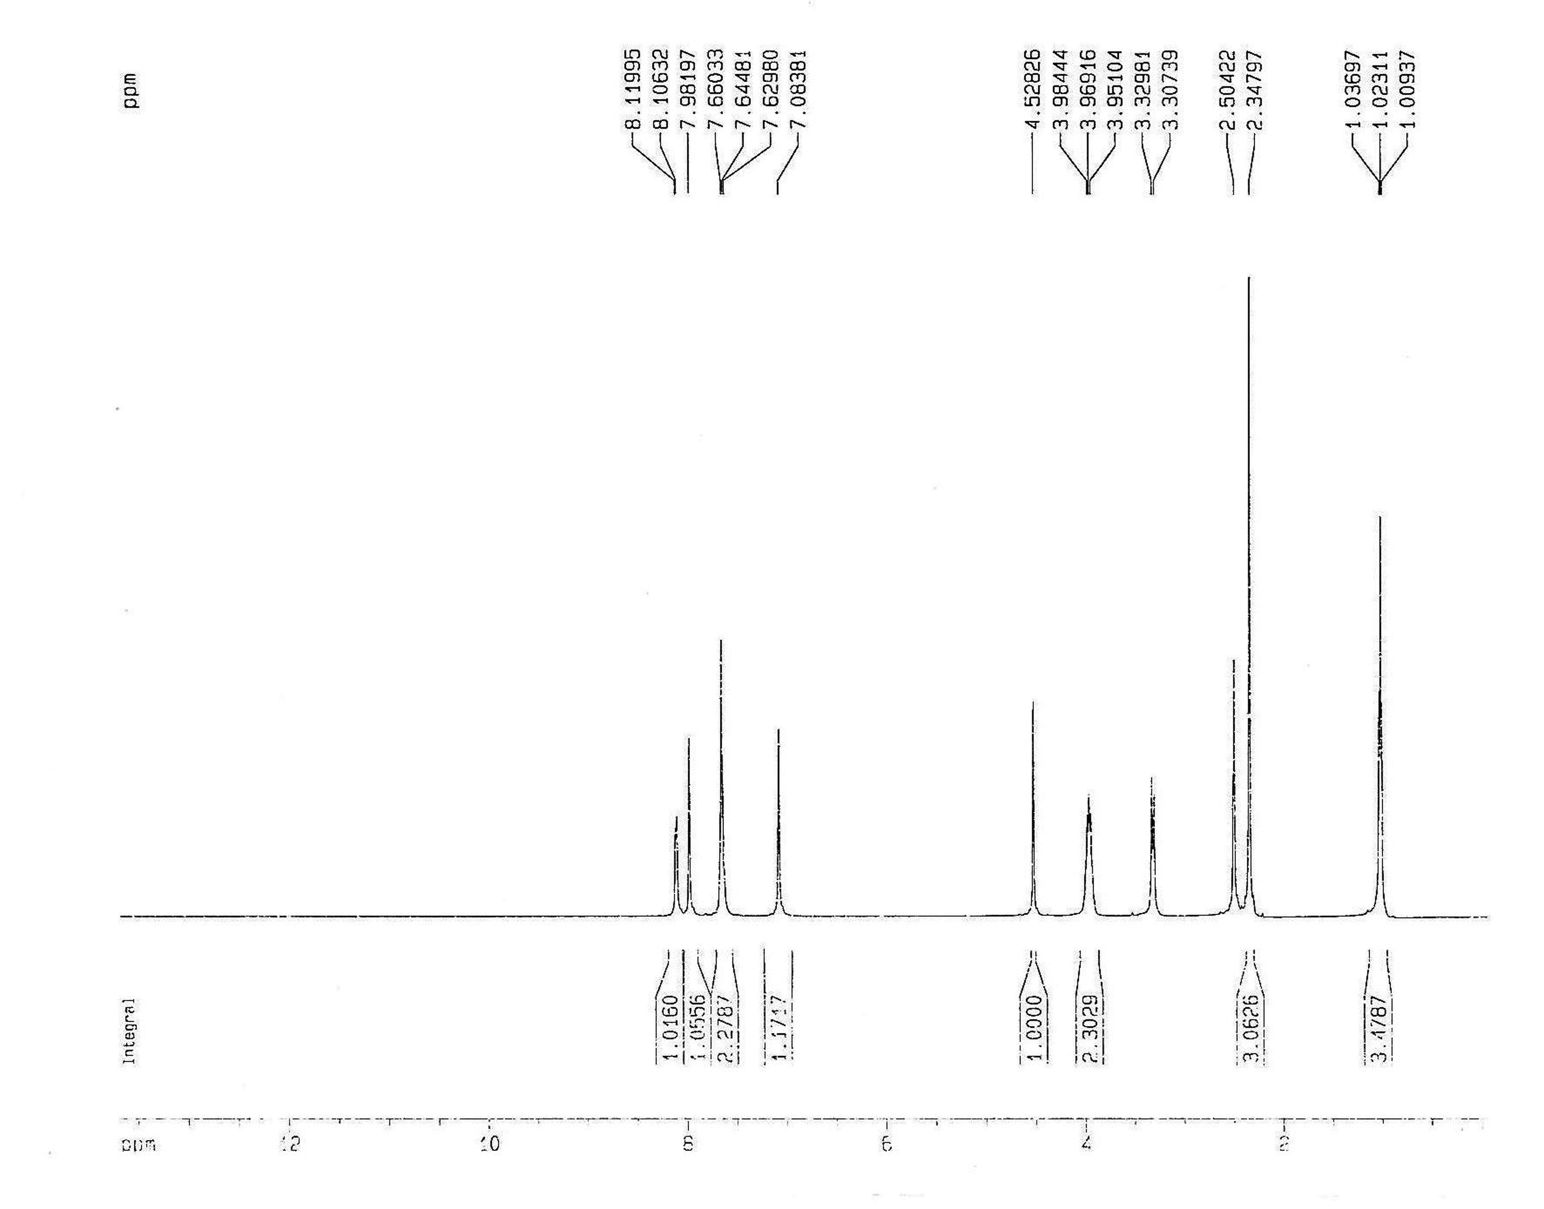
Figure S2. ¹H NMR spectrum of compound (4g) 3-Nitro-4H-pyran

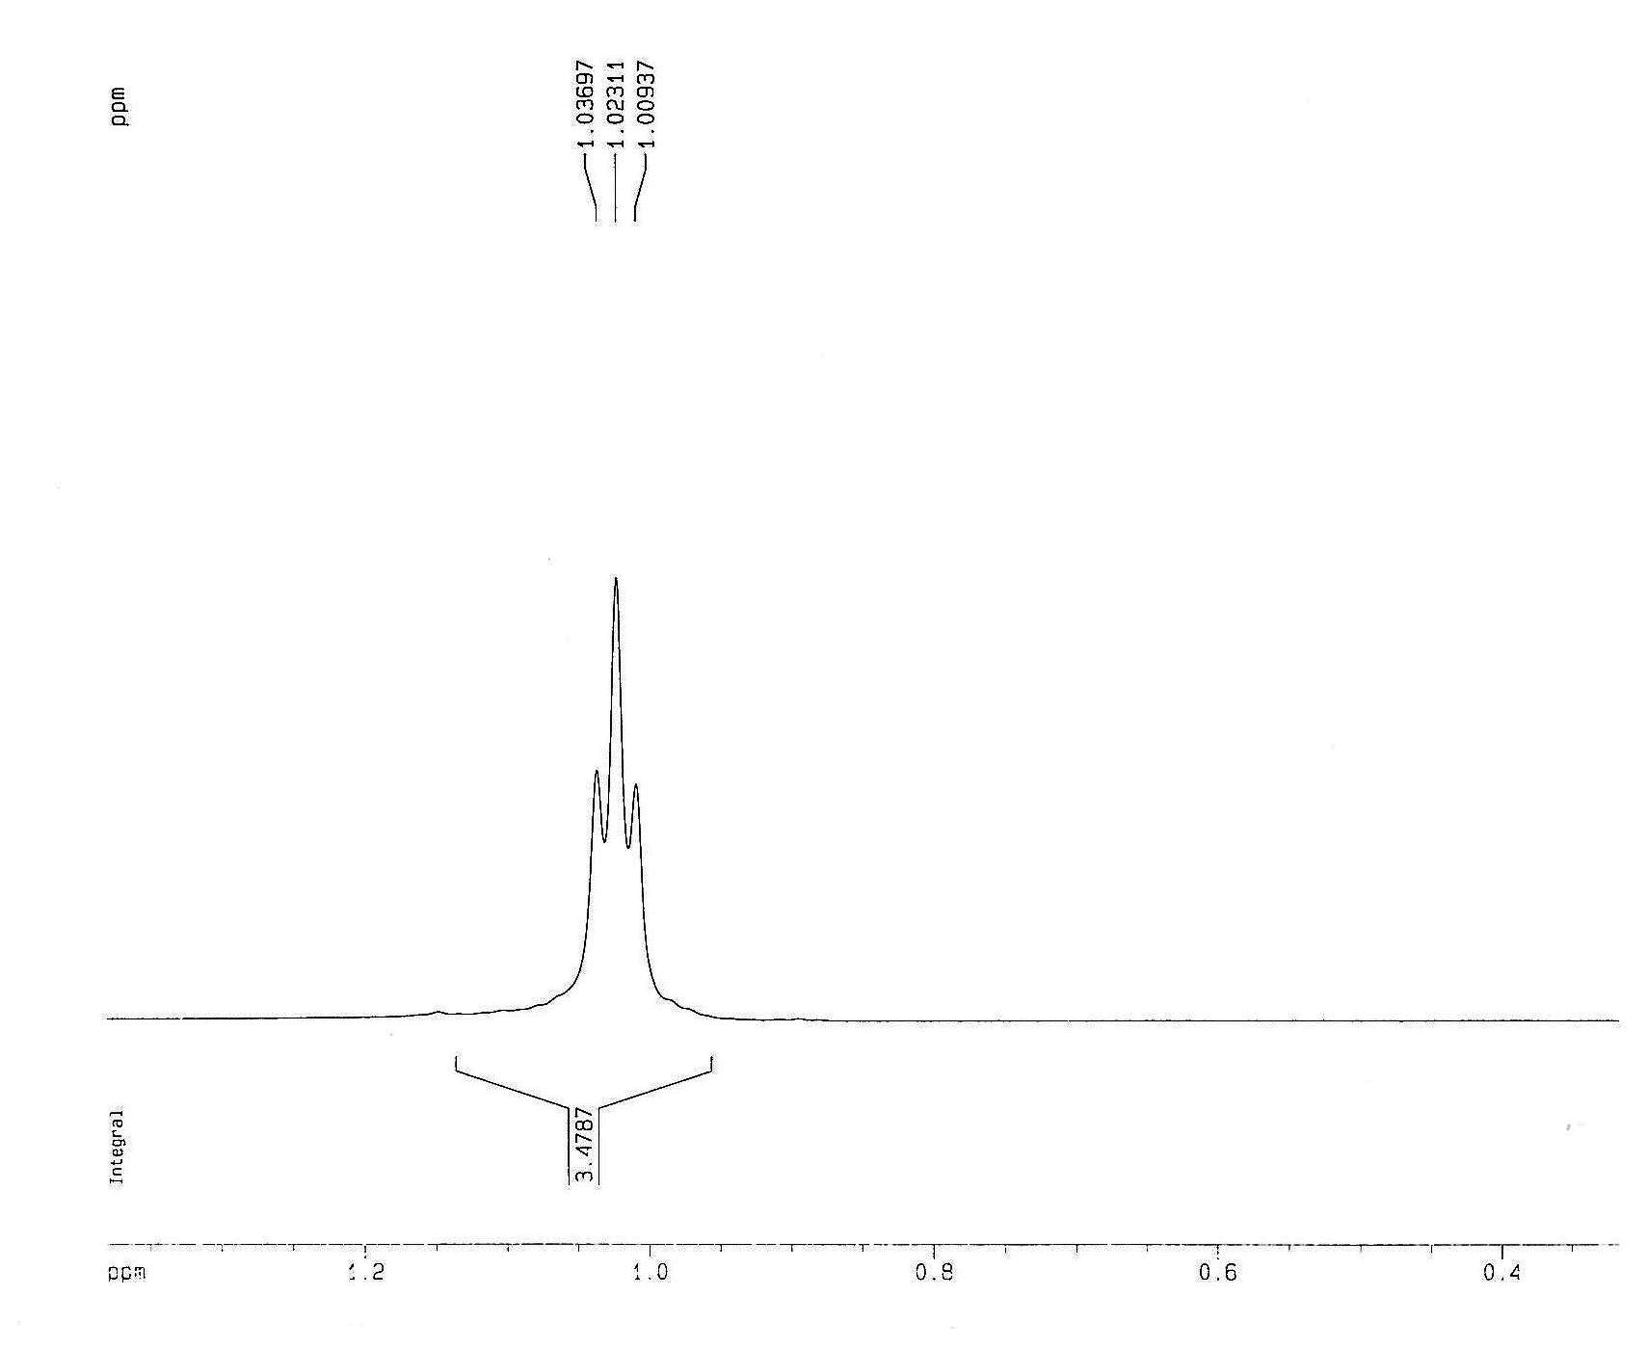
Figure S3. ¹H NMR spectrum of compound (4g) 3-Nitro-4H-pyran

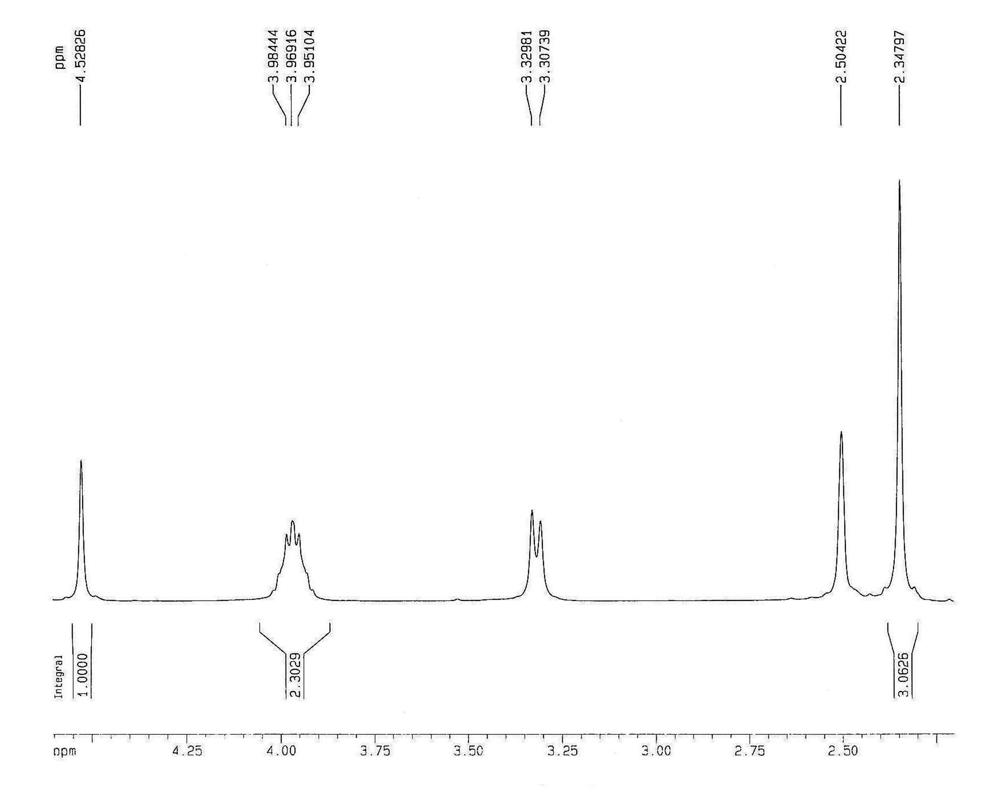
Figure S4. ¹H NMR spectrum of compound (4g) 3-Nitro-4H-pyran

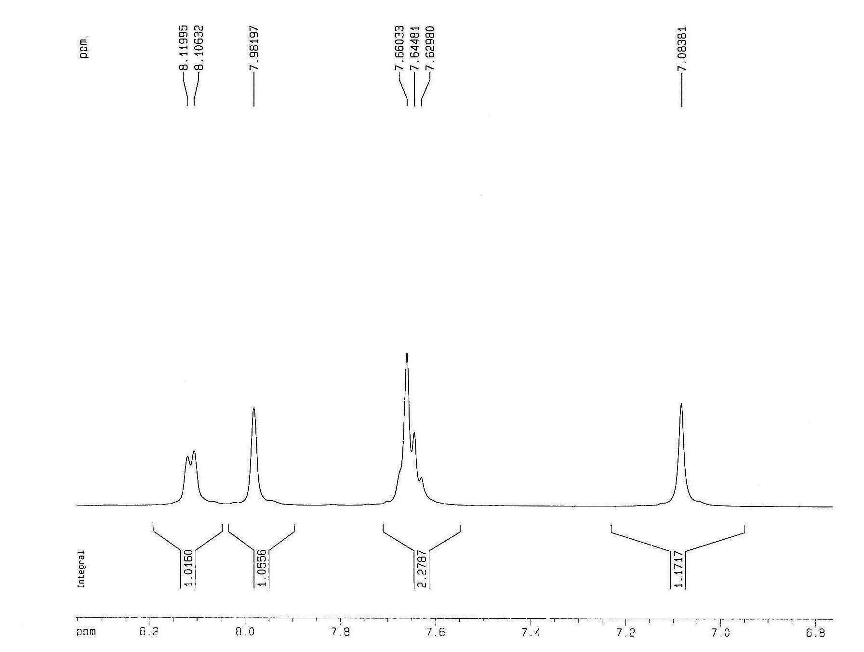

Figure S5. ¹H NMR spectrum of compound (4g) 3-Nitro-4H-pyran

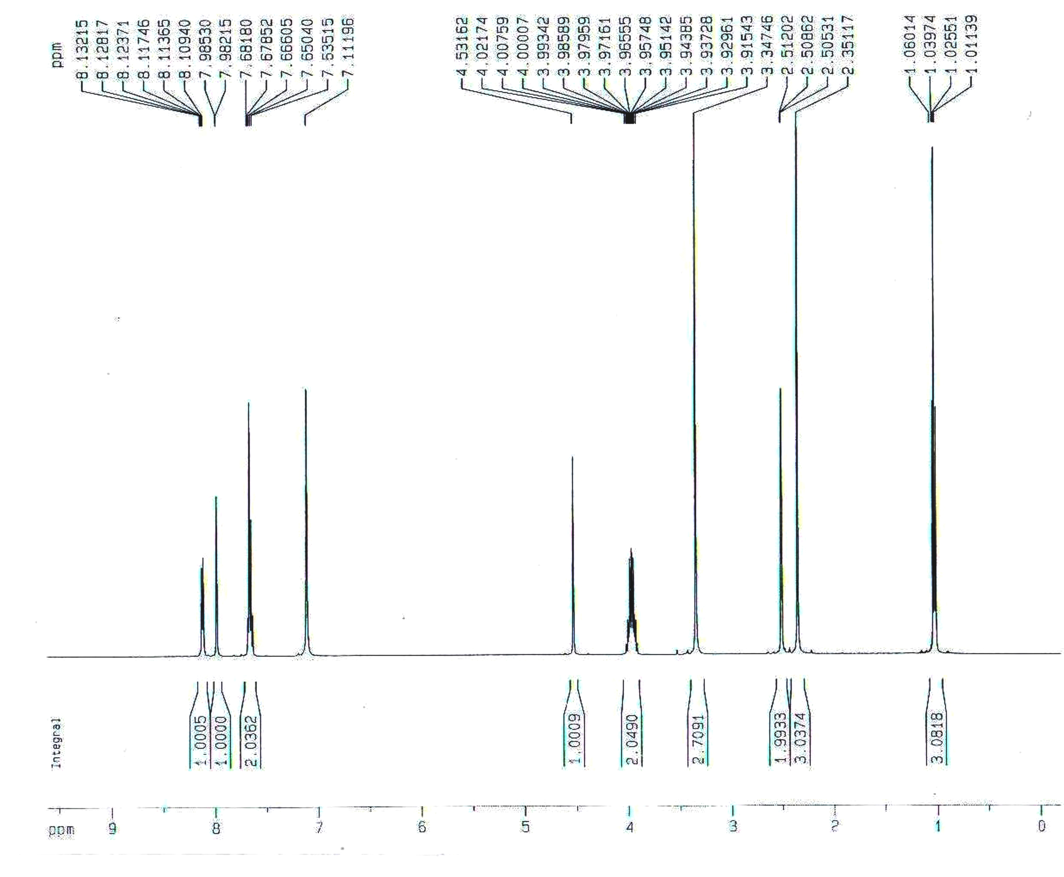
Figure S6. ¹H NMR spectrum of compound (4d)

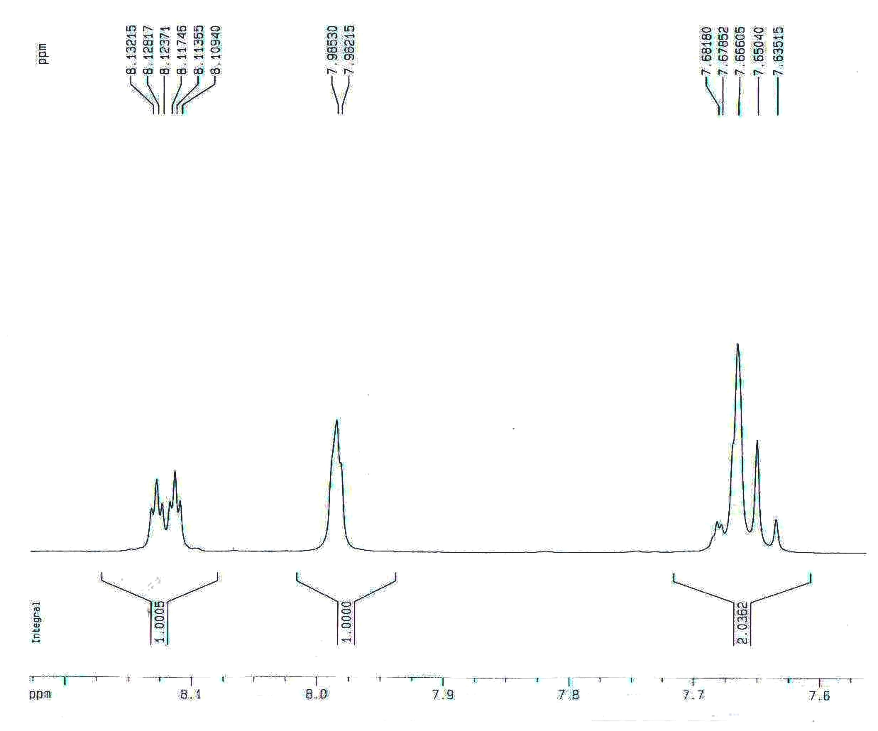
Figure S7. ¹H NMR spectrum of compound (4d)

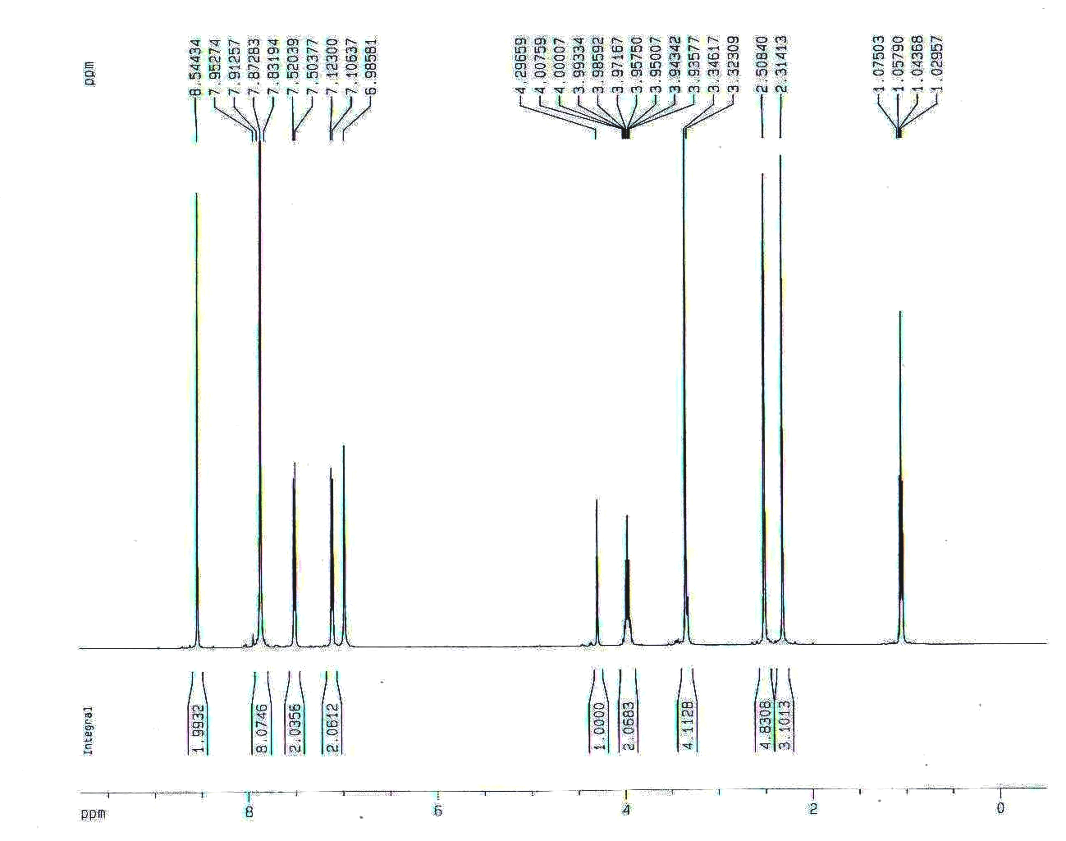
Figure S8. ¹H NMR spectrum of compound (4l)

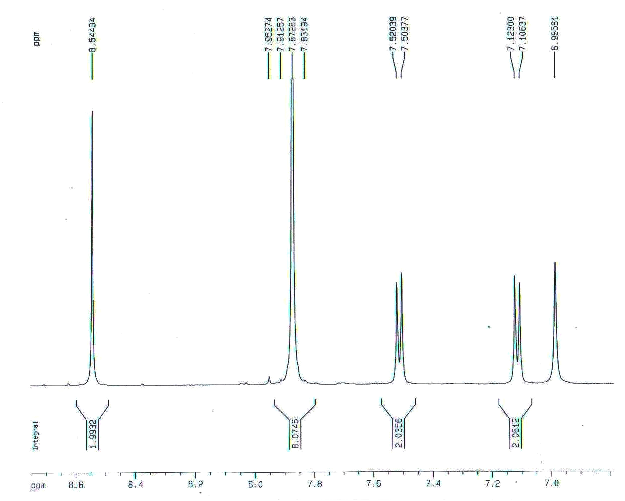
Figure S9. ¹H NMR spectrum of compound (4l)



