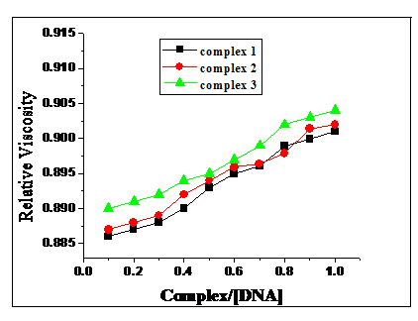

**FIGURGE 1 (S1)**



**FIGURE 2 (S2)**

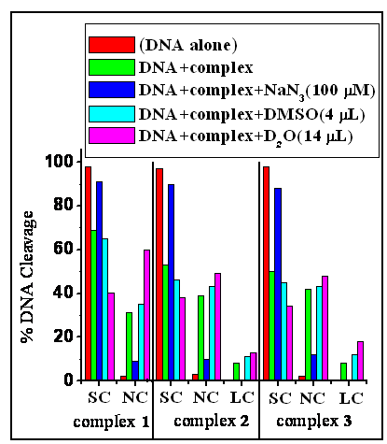

**FIGURE 3 (S3)**

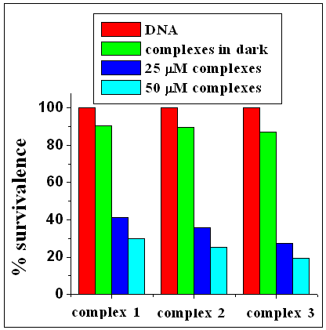

**FIGURE 4 (S4)**

**Figure captions**

**FIGURE 1 (S1)** Plot of relative viscosity vs [Complex]/[DNA]. Effect of Co(II) complexes on the viscosity of CT-DNA at 25 0C. complex = 0-100 μM, [DNA] = 50 μM.

**FIGURE 2 (S2)** Thermal denaturation of CT-DNA in the absence and presence of Co(II) complexes. [DNA]= 50 M, [complex] = 10 M, Buffer: Phosphate.

**FIGURE 3 (S3)** Cleavage of SC pUC19 DNA (50 *μ*M) by complexes **1,** **2** and **3** in the presence of various additives upon photo irradiation at 365 nm in 50 mM *Tris*-HCl / NaCl buffer (pH 7.2)

**FIGURE 4** **(S4)** CFU reduction (%) in *E. coli* after treatments.