**Supplementary Material**

Diorganotin(IV) complexes of 2-chloridophenylacetohydroxamic acid as prospective antimicrobials: Synthesis, characterization and biological properties

VINEET KUMAR CHOUDHARY, ARVIND KUMAR BHATT and NEERAJ SHARMA*



 

**Figure S1.** IR spectrum of (a) 2-ClPhAHK, (b) [Me2Sn(2-ClPhAH)2] and (c) [*n*-Bu2Sn(2-ClPhAH)2].



**Figure S2.** 1H NMRspectrum of (a) [Me2Sn(2-ClPhAH)2] and (b) [*n*-Bu2Sn(2-ClPhAH)2].

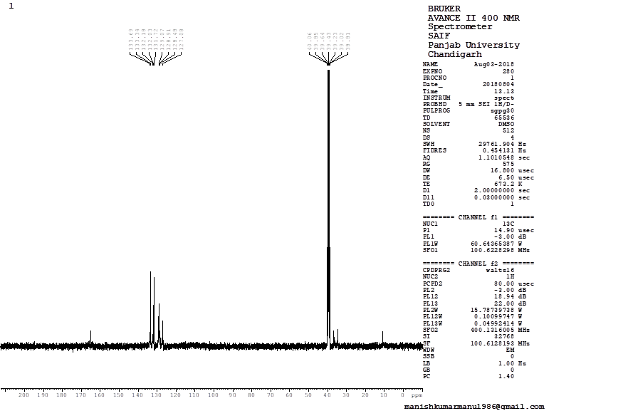

**Figure S3.** 13C NMRspectrum of (a) [Me2Sn(2-ClPhAH)2] and (b) [*n*-Bu2Sn(2-ClPhAH)2].

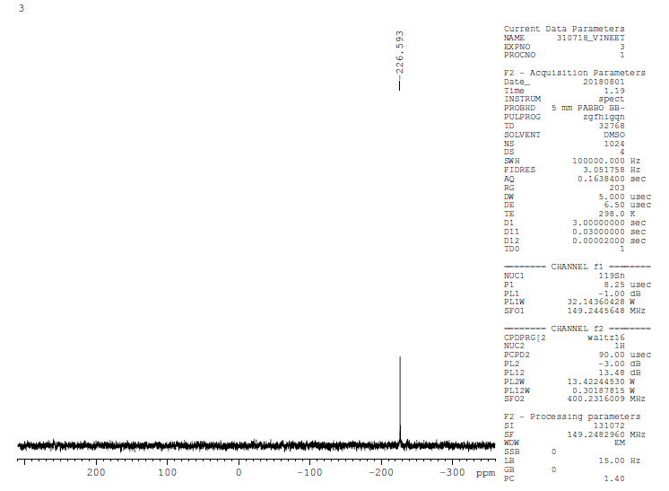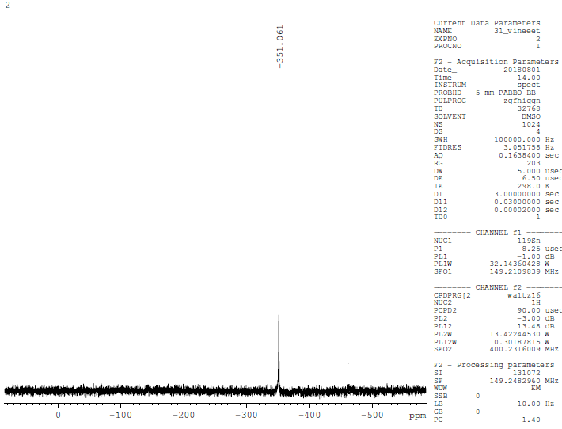

**Figure S4.** 119Sn NMR spectrum of (a) [Me2Sn(2-ClPhAH)2] and (b) [*n*-Bu2Sn(2-ClPhAH)2].

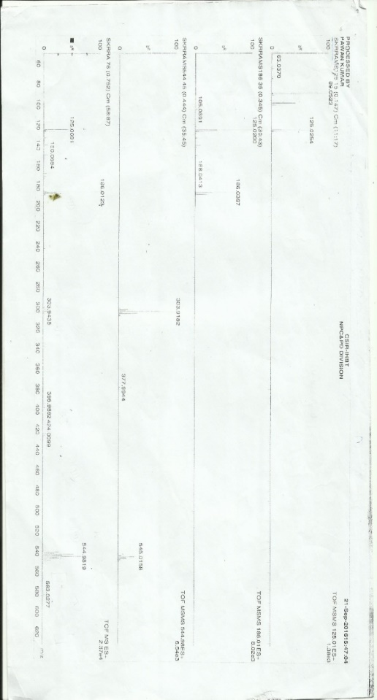

**Figure S5.** Mass spectrum of (a) [Me2Sn(2-ClPhAH)2] and (b) [*n*-Bu2Sn(2-ClPhAH)2].

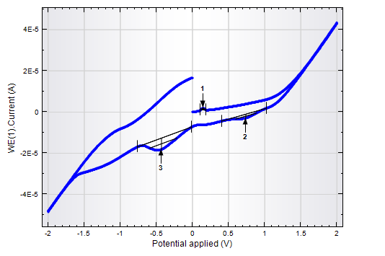

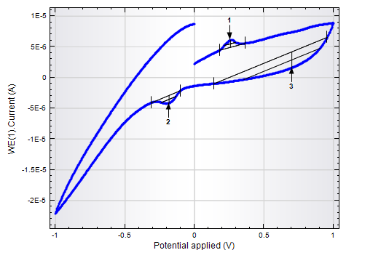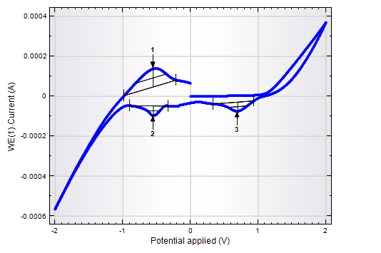

**Figure S6.** Cyclic voltammograms of (a) 2-ClPhAHK, (b) [Me2Sn(2-ClPhAH)2] and (c) [*n*-Bu2Sn(2-ClPhAH)2].

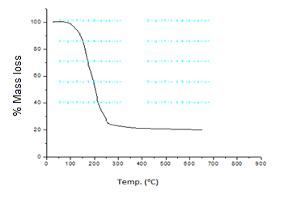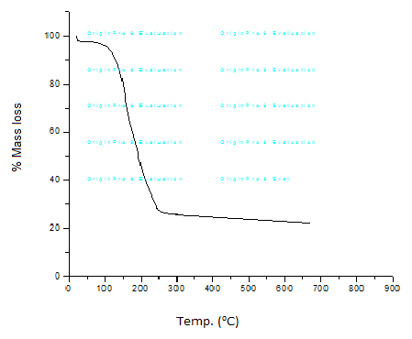

**Figure S7.** TGA curve of (a) [Me2Sn(2-ClPhAH)2] and (b) [*n*-Bu2Sn(2-ClPhAH)2].