Electric Supplemental Information

pH-Dependent assembly of two polyoxometalate-based coordination polymers: Structures and electrocatalytic properties

BORONG LU, YONGCHUAN WU, SHAOBIN LI*, XIUYING YANG, ERYUN YAN*, JIA CHEN, HENGWEI MA, JING WANG, YANXIU ZHU and DAWEI TAO

Table of contents:

- Table S1. Selected bond lengths (Å) and angles (º) for 1 and 2.
- Table S2. The IR stretching frequencies of 1 and 2.
- Figure S1. The images of 1 and 2 under an optical microscope.
- Figure S2. The IR spectra of 1 and 2.
- Figure S3. The simulative (black) and experimental (red) powder X-ray diffraction patterns for 1 and 2.
- Figure S4. The plots of the anodic and the cathodic peak currents for wave III of 1-CPE against scan rates.
- Figure S5. The plots of the anodic and the cathodic peak currents for wave III of 1-CPE against scan rates.
- Figure S6. The 100 consecutive CV cycles of 1-CPE at scan rate of 0.1 V·s⁻¹.
- Figure S7. The 100 consecutive CV cycles of 2-CPE at scan rate of 0.1 V·s⁻¹.
Table S1. Selected bond lengths (Å) and angles (º) for 1 and 2.
Compound 1
Mo(1)-O(1) | 1.881(17) | Mo(1)-O(2)#1 | 2.465(12)
Mo(1)-O(2) | 2.398(12) | Mo(1)-O(7)#2 | 1.848(16)
Mo(2)-O(3) | 1.946(4) | Mo(2)-O(5) | 1.976(8)
O(7)-P(1) | 1.711(16) | P(1)-O(7)#2 | 1.548(16)
Cu(1)-N(1) | 1.872(14) | Cu(1)-O(6) | 2.694(12)
O(1)-Mo(1)-O(2)#1 | 65.82(6) | O(2)#1-Mo(1)-O(6)#2 | 96.30(6)
O(4)-Mo(2)-O(2) | 66.26(5) | O(3)-Mo(2)-O(2) | 40.31(6)
O(4)-Mo(2)-O(5) | 65.09(6) | O(4)-Mo(2)-O(6) | 63.43(6)
O(2)-Mo(2)-O(6) | 41.48(5) | Mo(2)-O(2)-Mo(1) | 137.55(5)
N(1)-Cu(1)-O(6) | 89.30(5) | P(1)-O(7)-Mo(1)#2 | 121.19(6)
N(1)-Cu(1)-N(2) | 172.48(5) | P(1)-O(7)-Mo(2) | 127.15(5)
Compound 2
Mo(1)-O(2) | 1.872(10) | Mo(1)-O(3) | 1.857(3)
Mo(1)-O(1) | 1.936(7) | Mo(1)-O(6)#1 | 1.904(10)
P(1)-O(4)#1 | 1.499(14) | P(1)-O(4) | 1.558(14)
Mo(2)-O(8) | 2.442(14) | Mo(2)-O(5) | 2.433(9)
Cu(1)-O(6) | 2.8658(10) | Cu(1)-N(3) | 1.869(11)
O(2)-Mo(1)-O(3) | 63.92(6) | O(2)-Mo(1)-O(5) | 63.16(5)
O(2)-Mo(1)-O(6)#1 | 63.27(5) | O(3)-Mo(1)-O(6)#1 | 64.12(5)
O(2)-Mo(1)-O(4) | 95.01(5) | O(1)-Mo(1)-O(4) | 44.91(6)
O(4)#1-P(1)-O(4) | 71.13(5) | O(4)-P(1)-O(4)#2 | 71.13(5)
O(8)-Mo(2)-O(6) | 64.65(5) | O(8)-Mo(2)-O(4)#1 | 94.93(6)
N(3)-Cu(1)-O(6) | 90.41(5) | O(6)-Cu(1)-O(6)#3 | 180.0(5)
N(1)#10-Cu(3)-N(1) | 180.0(6) | N(3)-Cu(1)-O(6)#2 | 89.59(5)
Symmetry transformations used to generate equivalent atoms: #1 x,-y+1,z #2 y,x,-z+2.
Table S2. The IR stretching frequencies of 1 and 2.
Compounds | Stretching frequencies  of POM (cm⁻¹) | Stretching frequencies  of bimb ligand (cm⁻¹)
1 | 1089 948 908 786 | 1637 1523 1402 1259
2 | 1049 939 865 782 | 1629 1527 1307 1251

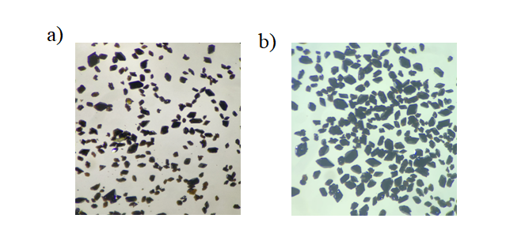
Figure S1. The images of 1 (a) and 2 (b) under an optical microscope.

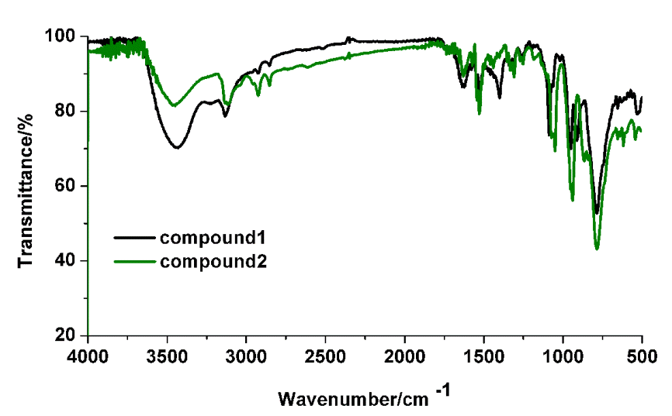
Figure S2. The IR spectra of 1 and 2.
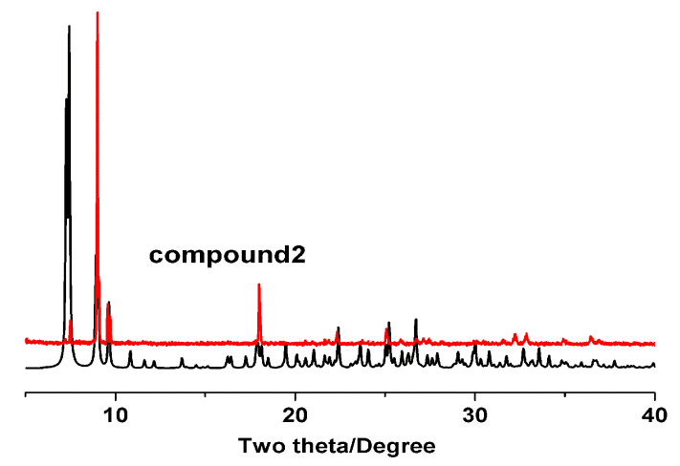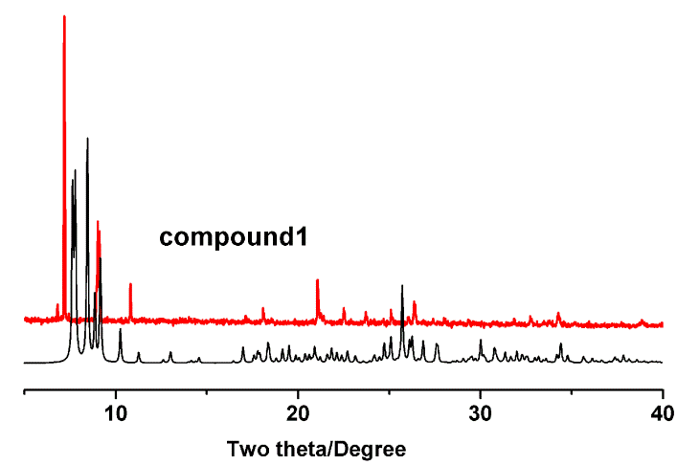
Figure S3. The simulative (black) and experimental (red) powder X-ray diffraction patterns for 1 and 2.

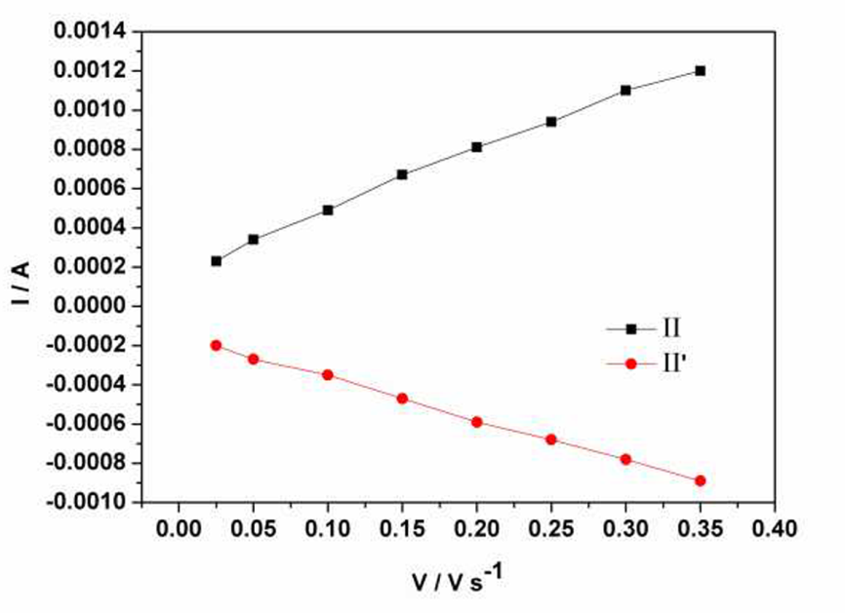
Figure S4. The plots of the anodic and the cathodic peak currents for wave II of 1-CPE against scan rates.
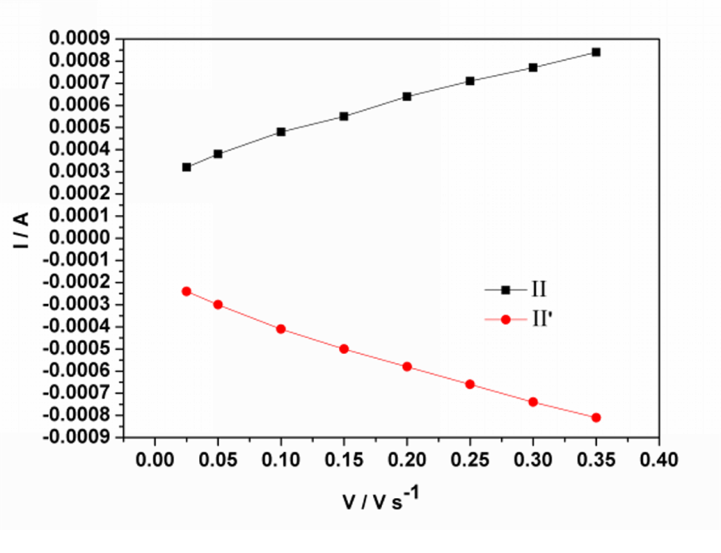
Figure S5. The plots of the anodic and the cathodic peak currents for wave II of 2-CPE against scan rates.

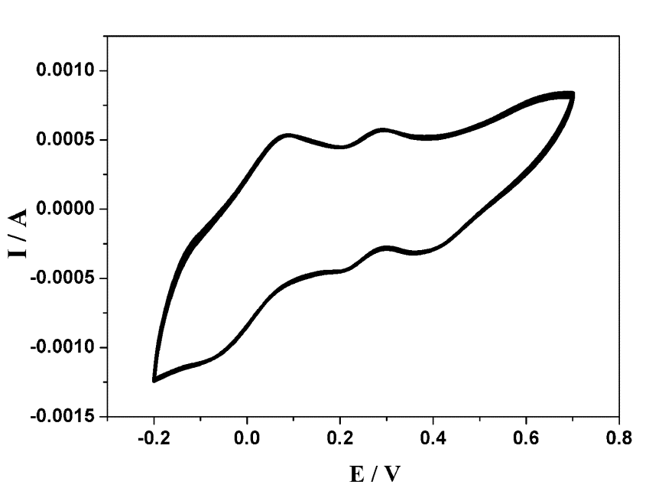
Figure S6. The 100 consecutive CV cycles of 1-CPE at scan rate of 0.1 V·s⁻¹.
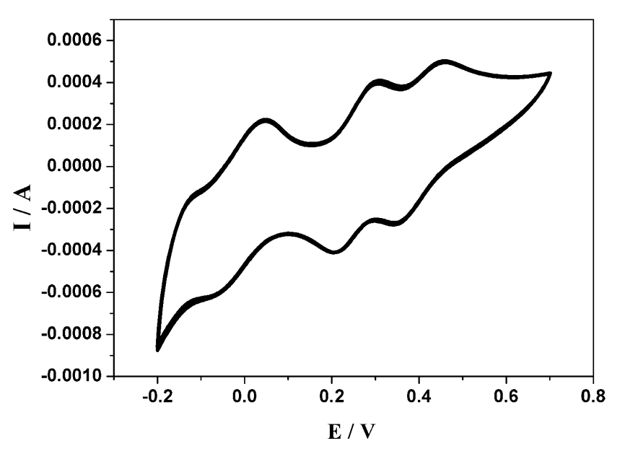
Figure S7. The 100 consecutive CV cycles of 2-CPE at scan rate of 0.1 V·s⁻¹.

