Supplementary Data
A Molecular and computational approaches to understand resistance of New Delhi Metallo β- lactamase variants (NDM-1, NDM-4, NDM-5, NDM-6, NDM-7)-producing strains against carbapenems
Abid Ali¹ , Divya Gupta^{1,3}, Gaurava Srivastava², Ashok sharma², Asad U Khan¹
¹Medical Microbiology and Molecular Biology Lab., Interdisciplinary Biotechnology Unit, Aligarh Muslim University, Aligarh – 202002.
²Biotechnology Division, CSIR-CIMAP , Lucknow-226015, India
³Department of Life sciences, Uttarakhand Technical University, Dehradun, Uttarakhand-248007, India

Running title: comparative analysis of NDM variants for their action

*Corresponding author: Prof. Asad U. Khan, Medical Microbiology and Molecular Biology Lab., Interdisciplinary Biotechnology Unit, Aligarh Muslim University, Aligarh – 202002,UP, India. Ph.: 0091-9837021912, Fax: 0091-571-2721776
Email id: asad.k@rediffmail.com
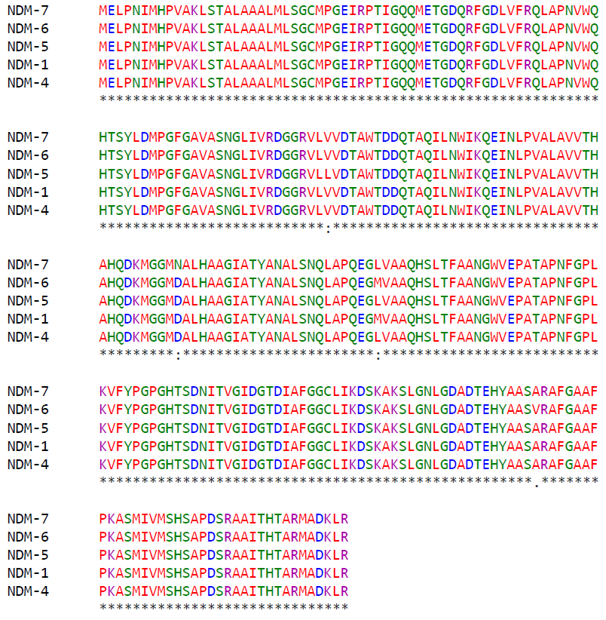
S1

Figure S1: Multiple sequence alignment of NDM variants

S2

Figure S2: Distance (in angstrom) between zinc ion and various mutants.

