# The following supplement accompanies the article

Distributions of settlers suggest greater dispersal and mixing of *Ostrea chilensis* larvae in Foveaux Strait, New Zealand

Keith P Michael 1, 2, 3*

1 School of Biological Sciences, Victoria University of Wellington, PO Box 600, Wellington, New Zealand, 6140.

2 Victoria University Coastal Ecology Laboratory (VUCEL), PO Box 600, Wellington, New Zealand, 6140.

3 National Institute of Water and Atmospheric Research (NIWA), PB 14901, Wellington New Zealand, 6021.

*Corresponding author keith.michael@niwa.co.nz

ORCID ID: 0000-0002-6747-0221

# Study area and *Ostrea chilensis* demographics

Foveaux Strait is located between the South Island and Stewart Island in southern New Zealand. It is exposed to high winds, large oceanic swells (Gorman et al. 2003), and strong currents (Stanton et al. 2001). High primary production (Bradford et al. 1991) supports diverse and abundant benthic communities (Michael 2010) including high densities of *Ostrea chilensis* that comprise the Foveaux Strait oyster fishery.

Management of the fishery assumes a single stock (OYU 5, Ministry for Primary Industries 2017). *O. chilensis* distribution is patchy within the 3300 km2 stock boundary, and the majority of oysters are concentrated in a smaller region of the managed area (the 2007 stock assessment survey area comprised 1072 km2, Fig. 1). Allen and Cranfield (1979) and (Stead 1971b) suggested the oyster fishery comprised a metapopulation of more than 50 discrete, dense localised populations generally separated by extensive areas with low *O. chilensis* densities. High densities of *O. chilensis* occur in a depth range of 25–50 m) throughout the stock area.

Densities of recruit-sized *O. chilensi*s (≥ 58 mm in length) were up to 24 oysters m-2 in the 1960s (Allen and Cranfield 1979) before the mortality from disease (*Bonamia exitiosa*, hereafter Bonamia (Berthe and Hine 2003)) caused significant declines in these densities (Doonan et al. 1994; Cranfield et al. 2005). Oyster densities after the 1986 Bonamia epizootic were low (0.3 oysters m-2 in 1992), and increased to 13 oysters m-2 in 1999, (Michael et al. 2001), but have not incresed further because of the recurrent disease mortality.

# Biology of *Ostrea chilensis* and implications for dispersal

*O. chilensis* is a larviparous, protandrous hermaphrodite (Cranfield 1979). Oysters mature first as males from 19 mm in length, and later as males and females ≥ 50 mm in length (Jeffs and Hickman 2000). Brooding-sized oysters are ≥ 60 mm in length (Jeffs and Hickman 2000). Brooding occurs throughout the year and peaks in November-December in southern areas, including Foveaux Strait (Hollis 1962, 1963; Stead 1971a; Cranfield H.J. 1979; Westerskov 1980; Jeffs 1998). Brooding starts earlier and finishes later (September to January) in warmer, northern areas (Jeffs et al. 1996; Brown S.N. et al. 2010). The numbers of larvae released (cohort size) are determined by the percentage of brooders in localised populations. In Foveaux Strait, only a small proportion of the spawning population brood, whereas 70–90% develop male gonads (Cranfield l979). Between 7% and 10%, and up to 18% brooded in the 1960s and 1970s (Hollis 1962; Stead 1971a; Cranfield 1979), and 1–2% in 1996–2000 (Bluff Oyster Enhancement Company data). In New Zealand, the percentage of brooders increases with a decrease in latitude, which suggests that temperature, is a primary determinant of successful spawning and fertilisation, and therefore brooding. Brooding percentages increase from less than 20% in Foveaux Strait (46⁰S) to 55–78% in Tasman Bay (41⁰S) (Brown et al. 2010) and to 78–90% in northern New Zealand (36⁰S) (Jeffs 1996). Temperature and other factors such as salinity and food availability contribute to differences in the duration of *O. chilensis* brooding in New Zealand (Westerskov1980), though to be between 15 and 38 days (Hollis 1963; Stead 1971a), and in Chile (up to 54 days, Chaparro 1990; Toro and Morande 1998); and for other Ostreidae (e.g., *O lurida*, Rippington 2015).

Larvae are brooded to pediveliger with eyespots (Hollis 1962, 1963; Cranfield 1968; Cranfield H. J. 1968; Stead 1971a), fully competent and ready to settle on release. As larval size increases with development, a small proportion of larvae may be released early (forced out of the pallial cavity by space limitation caused by growing larvae, (Cranfield and Michael 1989), and can continue to develop ex-parent (Hickman 2000). Most larvae are released within two hours, with a few up to 48 hours after the first liberation in laboratory observations (Stead 1971a). Release times are similar for larvae from central New Zealand (Brown S. N. 2011) and in Chile (Disalvo et al. 1983). Cranfield and Michael (1989) suggested the possibility of a more variable release strategy. Laboratory observations of *O. chilensis* larvae suggest they are poor swimmers: larvae swim intermittently upwards, and became inactive after 30–40 mins (Hollis 1962; Stead 1971a). Cranfield (1968b) describes larvae as benthopelagic, remaining near the seabed in strong current conditions; however, larval behaviour differs during slack water depending on light intensity. Almost all settlement in Foveaux Strait occurs between November and February (Michael and Shima 2018).

The larval biology of *O. chilensis* has provided a basis for the hypothesis that localised populations are self-recruiting (Cranfield 1968b; Cranfield 1979; Cranfield and Michael 1989), as was hypothesised for Tasman Bay (Broekhuizen et al. 2011). Moreover, the large ova size and the absence of feeding (lecithotrophy) are associated with limited dispersal potential that should enhance self-recruitment (Levin 2006). In laboratory experiments, most larvae settled within an hour (Stead 1971b) and ten hours (Brown 2011), and settled within centimetres of maternal parents (Cranfield 1979). The mainly rapid settlement in *O. chilensis* underpins the expectation of a very short pelagic larval duration see Siegel et al. 2003) suggesting limited opportunity for larval transport and dispersal.

The short pelagic larval duration of *O. chilensis* implies self-recruitment. The *O. chilensis* habitat and the physical environment of Foveaux Strait are very different to that of other *O. chilensis* populations in New Zealand and Chile. Foveaux Strait is a high-energy system that differs markedly from the estuarine setting of most other studies of *O. chilensis* dispersal (Broekhuizen et al. 2011; Brown 2011) in New Zealand and similar oyster species elsewhere (*Crassostrea virginica,* (Haase et al. 2012); *Ostrea edulis,* (Smaal et al. 2015); *Pinctada margaritifera,* (Thomas et al. 2014). The high energy, hydrodynamic environment of Foveaux Strait (Michael 2010) could enable greater dispersal of *O. chilensis* larvae than reported by Cranfield (1968a), Broekhuizen et al. (2011), and Brown (2011).

# Physical environment relevant to larval transport

*O. chilensis* habitat is characterised by deep (20–60 m) gravel substrates, sometimes overlaid with sand (Cullen 1962), with strong tidal currents. Net current flow through Foveaux Strait is mainly east to southeast (Houtman 1966; Gruning 1971), feeding into the Southland Current along the Southland coast. On the south side of Ruapuke Island, the flow is northwest (Mark Hadfield, NIWA, pers. comm.). Tidal current speeds vary from 1.5 knots in the west to 4.0 knots in the east (Gruning 1971). Current speed measured close to the sampling site in 1993 and 1998 was 1.0–2.2 knots, to the east-southeast. Simulations using the Regional Ocean Model System (ROMS) at 2 km resolution to predict depth-averaged currents in Foveaux Strait showed that wind-driven currents extended throughout the entire water column. The eastward transport increased when winds were from the west and reduced or reversed when winds were from the east. Wind-forcing of current direction is shown in Figure S1 (Mark Hadfield, NIWA pers. comm.).

Net displacement of water mass eastward is between 2.5 km d-1 (Steve Chiswell, NIWA, pers. comm.) and differs from earlier estimates of 7.0 km d-1 (Heath 1973), in the western fishery area, and 22 km in a NW direction each tidal cycle (Cranfield 1968a) in south eastern areas. The residence time of water flowing through the fishing area is about 5 days (Cranfield and Michael 1989) and, based on net displacement, could be as long as 20 days in calm condition and neap tides.

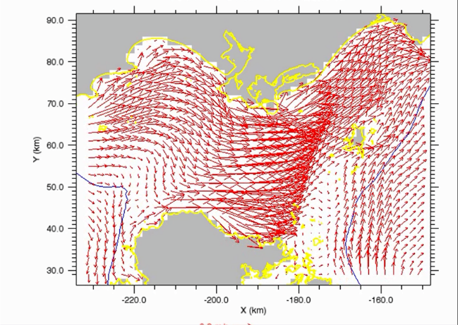

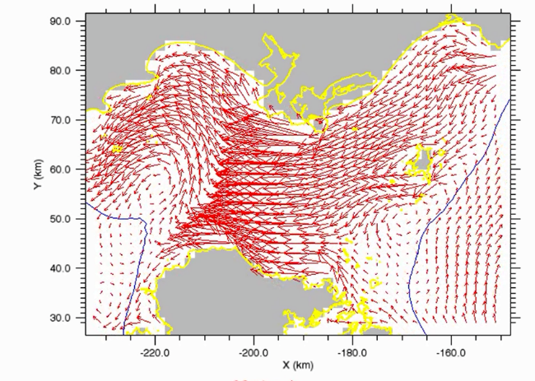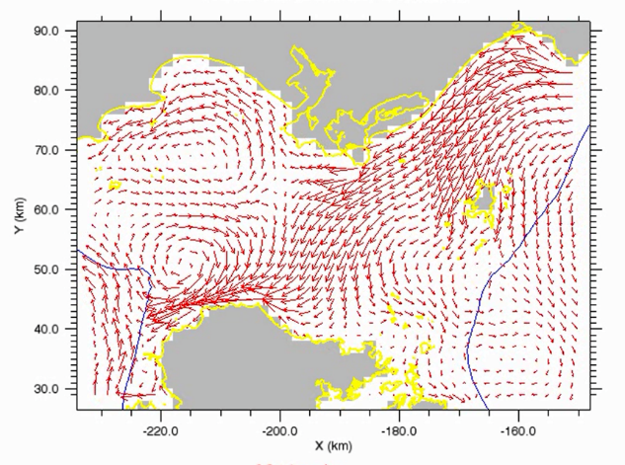

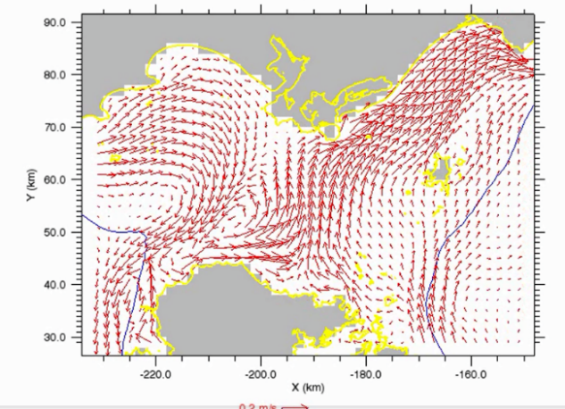

Figure S1. Mean current vectors under different wind directions. Upper left panel, winds from the west; upper right, winds from the north; lower left, from the east; and lower right from the south. Vectors from simulations using ROMS at 2 km resolution from 2008–2012. Land mask (grey) and the coastline (yellow). Bathymetry contour (blue) is at 100 m (Mark Hadfield, NIWA, pers. comm.).

# Estimates of brooding-sized oyster densities

Brooding-sized oysters are ≥ 60 mm in length (Jeffs and Hickman 2000). Estimates of brooding-sized oyster densities used standard dredge sampling methods (Michael et al. 2017) because the sites were deeper than the maximum depth that can be sampled by divers (40 m). Sampling used a 3.3 m wide commercial oyster dredge towed in a straight-line, down tide for a distance of 0.2 nautical mile (371 m), at a target speed of 2.5–3.0 knots. A standard tow sampled 0.1 nautical mile either side of the spat collector sites.

Estimated sampling efficiency of the dredge is 0.17 (95% confidence intervals 0.13–0.22, Dunn (2005). Absolute brooding-sized oyster densities (oysters m-2) were calculated by adjusting catches to a standard tow distance (371 m), scaling for dredge efficiency (0.17), and dividing by the area swept (1224.3 m2).

# Percentage commercial catch

Percentage commercial catch for the 2011 oyster season by reporting area from fishers’ logbook data is shown in Figure S2. The distribution of catch-effort data reflect fisher behaviour and not oyster abundance. However, in 2011, fishers’ targeted high-density areas that resulted in the best catch rates; and therefore catch-effort data from the 2011 OYU 5 fishery broadly reflect the relative abundance of oysters. The OYU 5 stock assessment model (Fu et al. 2016) used catch effort data as abundance indices.



Figure S2. The percentage annual commercial catch (oysters, *Ostrea chilensis*) by reporting area, from skippers’ 2011 season (1 March to 31 August, Michael 2012) logbooks. Percentage of the total annual catch shown as 5–10% (red), 3–4.9% (orange), 1–2.9% (yellow), and <1% (light blue). The white background represents cells where no fishing took place. Labels for the reporting cells that comprise the sampling design are shown in black text. The sampling grid is shown as red lines.

# REFERENCES

Allen RL, Cranfield HJ. 1979. A dredge survey of the oyster population in Foveaux Strait. Rapports et Procès-verbaux des réunions Conseil Permanent International pour l'Exploration de la Mer. 175:50-62.

Berthe FCJ, Hine PM. 2003. *Bonamia exitiosa* Hine et al. 2001 is proposed instead of *Bonamia exitiosus* as the valid name of Bonamia sp. infecting flat oysters *Ostrea chilensis* in New Zealand. Dis Aquat Org. 57:181.

Bradford JM, Cranfield HJ, Michael KP. 1991. Phytoplankton biomass in relation to the surface hydrography of southern New Zealand and possible effects on the food chain. New Zealand Journal of Marine and Freshwater Research. 25(2)):133-144.

Broekhuizen N, Lundquist CJ, Hadfield MG, Brown SN. 2011. Dispersal of oyster (*Ostrea chilensis*) larvae in Tasman Bay inferred using a verified particle tracking model that incorporates larval behavior. Journal of Shellfish Research. 30(3):643-658.

Brown SN. 2011. Ecology and Enhancement of the flat oyster *Ostrea chilensis* (Philippi, 1845) in central New Zealand. Canterbury, New Zealand. University of Canterbury.

Brown SN, Handley S, Michael K, Schiel D. 2010. Annual pattern of brooding and settlement in a population of the flat oyster *Ostrea chilensis* from central New Zealand [Article]. New Zealand Journal of Marine and Freshwater Research. 44(4):217-227. English.

Chaparro OR. 1990. Effect of temperature and feeding on conditioning of *Ostrea chilensis* Philippi, 1845 reproduction. Aquaculture & Fisheries Management. 21(4):399-405.

Cranfield HJ. 1968. An unexploited population of oysters *Ostrea lutaria* Hutton, from Foveaux Strait. Part 1. Adult stocks and spatfall distribution. New Zealand Journal of Marine and Freshwater Research. 2(1):3-22.

Cranfield HJ. 1968. An unexploited population of oysters *Ostrea lutaria* Hutton, from Foveaux Strait. Part II. Larval Settlement Patterns and spat mortality. New Zealand Journal of Marine and Freshwater Research. 2(2):183-203.

Cranfield HJ. 1979. The biology of the oyster, *Ostrea lutaria*, and the oyster fishery of Foveaux Strait. Rapports et Procès-verbaux des réunions Conseil Permanent International pour l'Exploration de la Mer. 175:44–49.

Cranfield HJ, Dunn A, Doonan IJ, Michael KP. 2005. *Bonamia exitiosa* epizootic in *Ostrea chilensis* from Foveaux Strait, southern New Zealand between 1986 and 1992. ICES J Mar Sci. 62(1):3-13.

Cranfield HJ, Michael KP. 1989. Larvae of the incubatory oyster *Tiostrea chilensis* (Bivalvia: Ostreidae) in the plankton of central and southern New Zealand. New Zealand Journal of Marine and Freshwater Research. 23(1):51–60.

Cullen DJ. 1962. The influence of bottom sediments upon the distribution of oysters in Foveaux Strait, New Zealand. New Zealand Journal of Geology & Geophysics. 5:271-275.

Disalvo LH, Alarcon E, Martinez E. 1983. Induced spat production from *Ostrea chilensis* Philippi 1845 in mid-winter. Aquaculture. 30(1-4):357-362.

Doonan IJ, Cranfield HJ, Michael KP. 1994. Catastrophic reduction of the oyster, *Tiostrea chilensis* (Bivalvia: Ostreidae), in Foveaux Strait, New Zealand, due to infestation by the protistan *Bonamia* sp. New Zealand Journal of Marine and Freshwater Research. 28(4):335–344.

Dunn A. 2005. Stock assessment of Foveaux Strait dredge oysters (*Ostrea chilensis*) for the 2003-04 fishing year. New Zealand Fisheries Assessment Report 2005/25.63 p.

Fu D, Dunn A, Michael K, Hills J. 2016. The development and performance of a length-based stock assessment of Foveaux Strait oysters (*Ostrea chilensis*, OYU 5) in southern New Zealand, and application to management. Fisheries Research. 183.

Gorman RM, Bryan K, Laing AK. 2003. Wave hindcast for the New Zealand region: deep-water wave climate. New Zealand Journal of Marine and Freshwater Research. 37(3):589-612.

Gruning JF. 1971. New Zealand Pilot: The coasts of North and South Islands of New Zealand, Stewart Island and adjacent islands, Kermadec, Chatham, Bounty, Antipodes, Auckland and Campbell Islands. Hydrographic Department, Great Britain. .504 p.

Haase AT, Eggleston DB, Luettich RA, Weaver RJ, Puckett BJ. 2012. Estuarine circulation and predicted oyster larval dispersal among a network of reserves [Article]. Estuarine Coastal and Shelf Science. 101:33-43. English.

Heath R. 1973. Direct measurements of coastal currents around southern New Zealand. New Zealand Journal of Marine and Freshwater Research. 7(4):331-367.

Hickman RW. 2000. Use of premature New Zealand dredge oyster *Tiostrea lutaria* Hutton larvae for spat production [Article]. Aquac Res. 31(6):529-536. English.

Hollis PJ. 1962. Studies on the New Zealand mud-oyster, *Ostrea lutaria*, Hutton, 1873. Wellington, New Zealand: Victoria University.

Hollis PJ. 1963. Some studies on the New Zealand oysters. Zoo Pub Victoria University, Wellington (31):1-28.

Houtman TJ. 1966. A note on the hydrological regime in Foveaux Strait. New Zealand Journal of Science. 9(2):472-483.

Jeffs AG. 1998. Gametogenic cycle of the Chilean oyster, *Tiostrea chilensis* (Philippi, 1845), in north-eastern New Zealand. Invertebrate Reproduction & Development. 34(2-3):109-116.

Jeffs AG, Creese RG, Hooker SH. 1996. Annual pattern of brooding in populations of Chilean oysters, *Tiostrea chilensis*, (Philippi, 1845) from northern New Zealand. Journal of Shellfish Research. 15(3):617-622.

Jeffs AG, Hickman RW. 2000. Reproductive activity in a pre-epizootic wild population of the Chilean oyster, *Ostrea chilensis*, from southern New Zealand [Article]. Aquaculture. 183(3-4):241-253. English.

Levin LA. 2006. Recent progress in understanding larval dispersal: new directions and digressions. Integrative and Comparative Biology. 46(3):282-297.

Michael KP. 2010. A summary of information from Foveaux Strait oyster (*Ostrea chilensis*, OYU 5) strategic research 2000-2009: A context for the 2010 strategic research plan. New Zealand Fisheries Assessment Report 2010/20.37 p.

Michael KP, Dunn A, Andrew. N. L., Breen PA. 2001. Foveaux Strait dredge oyster (*Tiostrea chilensis*) stock assessment, 1999 [*New Zealand Fisheries Assessment Report*]. New Zealand Fisheries Assessment Report 2001/38.42 p.

Michael KP, Forman J, Hulston D, Sutherland J. 2017. A survey of the Foveaux Strait oyster (*Ostrea chilensis*) population (OYU 5) in commercial fishery areas and the status of bonamia (*Bonamia exitiosa*) in February 2016. New Zealand Fisheries Assessment Report 2017/42.

Michael KP, Shima JS. 2018. Four-year decline in *Ostrea chilensis* recruits per spawner in Foveaux Strait, New Zealand, suggests a diminishing stock-recruitment relationship. Marine Ecology Progress Series. 600:85-98.

Ministry for Primary Industries. 2017. Fisheries Assessment Plenary, November 2017: stock assessments and stock status. Compiled by the Fisheries Science Group, Ministry for Primary Industries, Wellington, New Zealand.

Rippington A. 2015. Effects of temperature, salinity and food stress on larval growth and development in the Olympia oyster, *Ostrea lurida.* MSc Thesis, University of Victoria, Australia. .

Siegel DA, Kinlan BP, Gaylord B, Gaines SD. 2003. Lagrangian descriptions of marine larval dispersion [Article]. Marine Ecology Progress Series. 260:83-96. English.

Smaal AC, Kamermans P, van der Have T, Engelsma MY, Sas H. 2015. Feasibility of Flat Oyster (*Ostrea edulis* L.) restoration in the Dutch part of the North Sea. IMARES.

Stanton BR, Goring DG, Bell RG. 2001. Observed and modelled tidal currents in the New Zealand region. New Zealand Journal of Marine and Freshwater Research. 35:397-415.

Stead DH. 1971a. Observations on the biology and ecology of the Foveaux Strait dredge oyster (*Ostrea lutaria*, Hutton). N.Z. Fisheries Technical Report No.68. New Zealand Marine Department, Wellington. 49 p. [New Zealand Fisheries Technical Report].

Stead DH. 1971b. Survey of Foveaux Strait oyster beds 1960-64. New Zealand Fisheries Technical Report No. 16. Published by the New Zealand Marine Department. [N.Z. Fisheries Technical Report]. 29 p.

Thomas Y, Dumas F, Andrefouet S. 2014. Larval Dispersal Modeling of Pearl Oyster *Pinctada margaritifera* following Realistic Environmental and Biological Forcing in Ahe Atoll Lagoon [Article]. PLoS One. 9(4):15. English.

Toro JE, Morande PR. 1998. Effect of food ration and temperature on length of brooding period, larval development and size of pediveligers released in the Chilean oyster *Ostrea chilensis* [Article]. J World Aquacult Soc. 29(2):267-270. English.

Westerskov K. 1980. Aspects of the biology of the dredge oyster *Ostrea lutaria* Hutton, 1873 [PhD Thesis]. Dunedin: University of Otago.