Supplementary:
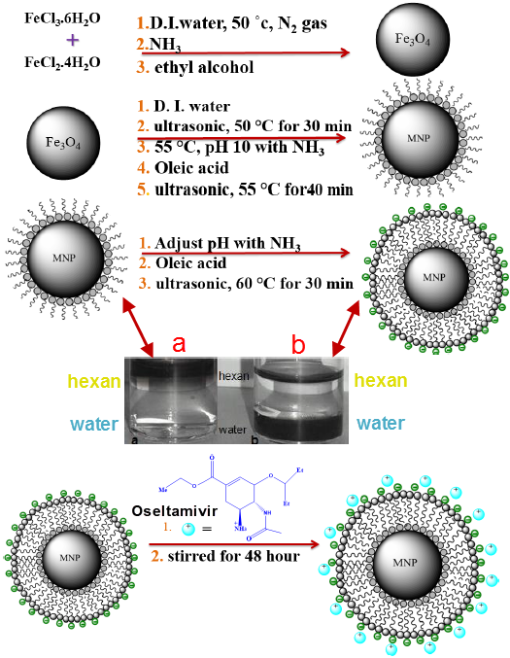
Scheme S1: Schematic presentation of the stages of synthesis of Fe₃O₄@OA/oseltamivir MNPs

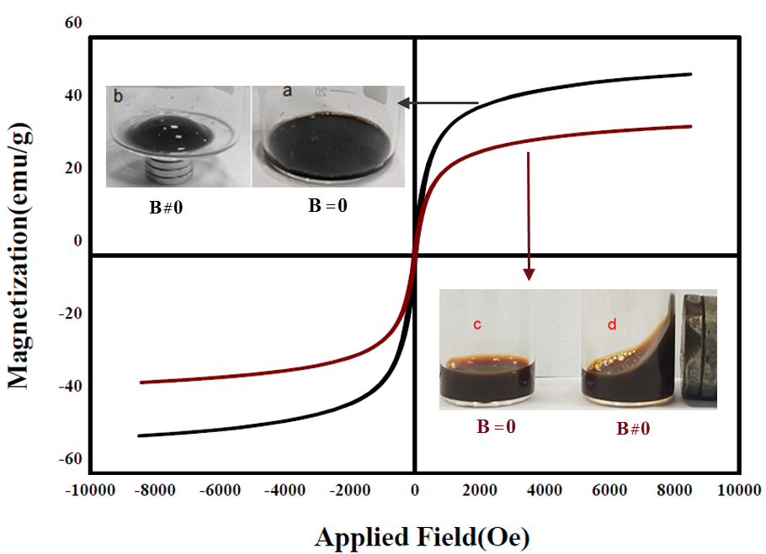
Figure S1: The magnetization curves and saturation magnetizations of Fe₃O₄@OA (black curve, M_{S} =49 emu /g ) and Fe₃O₄@OA/oseltamivir MNPs (brown curve, M_{S} =35 emu/g ). Inset: the photographs of watery suspension of: (a)Fe₃O₄@OA MNPs in absence of magnet outer (b)Fe₃O₄@OA MNPs in presence of magnet outer; (c) Fe₃O₄@OA/oseltamivir MNPs in absence of magnet outer (d) Fe₃O₄@OA/oseltamivir MNPs in presence of magnet outer

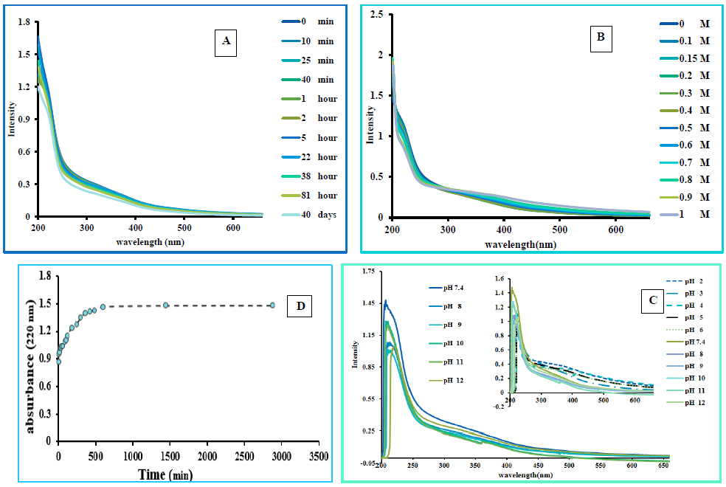
Figure S2: The effects of;(A) time on the stability of Fe₃O₄@OA/oseltamivir MNPs (0 min, 10 min, 25 min, 40 min, 1hour, 2 hour, 5 hour, 22 hour, 38 hour, 81 hour, 40 days) (B) salt concentrations on the stability of Fe₃O₄@OA oseltamivir MNPs in 0.1 M, 0.15 M, 0.2M, 0.3 M, 0.4 M, 0.5M, 0.6 M, 0.7 M, 0.8 M, 0.9 M, 1M of NaCl (C) pHs on the stability of Fe₃O₄@OA/oseltamivir MNPs (D) release profile of oseltamivir from Fe₃O₄@OA/oseltamivir MNPs in acetate buffer (pH = 5)

