Supplementery material For
Probing the Binding Mechanism of Substituted Pyridine Derivatives as Effective and Selective Lysine Specific Demethylase 1 Inhibitors using 3D-QSAR, Molecular Docking and Molecular Dynamics Simulations

Zhi-Zheng Wang, Jing Yang, Xu-Dong Sun, Chao-Ya Ma, Qi-Bing Gao, Lina Ding* and Hong-Min Liu

Collaborative Innovation Center of New Drug Research and Safety Evaluation, Henan Province, Key Laboratory of Technology of Drug Preparation (Zhengzhou University), Ministry of Education of China, Key Laboratory of Henan Province for Drug Quality and Evaluation, School of Pharmaceutical Sciences, Zhengzhou University, Zhengzhou 450001, PR China

*Corresponding author.
E-mail address: dingln@zzu.edu.cn

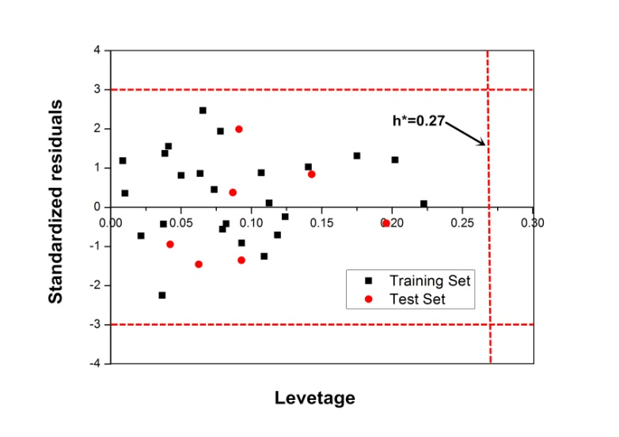
Figure S1. Williams plot of standardized residuals versus leverage values for CoMFA model. The horizontal lines represent ±3 standardized residual, and the vertical line represents warning leverage (h* = 0.27)

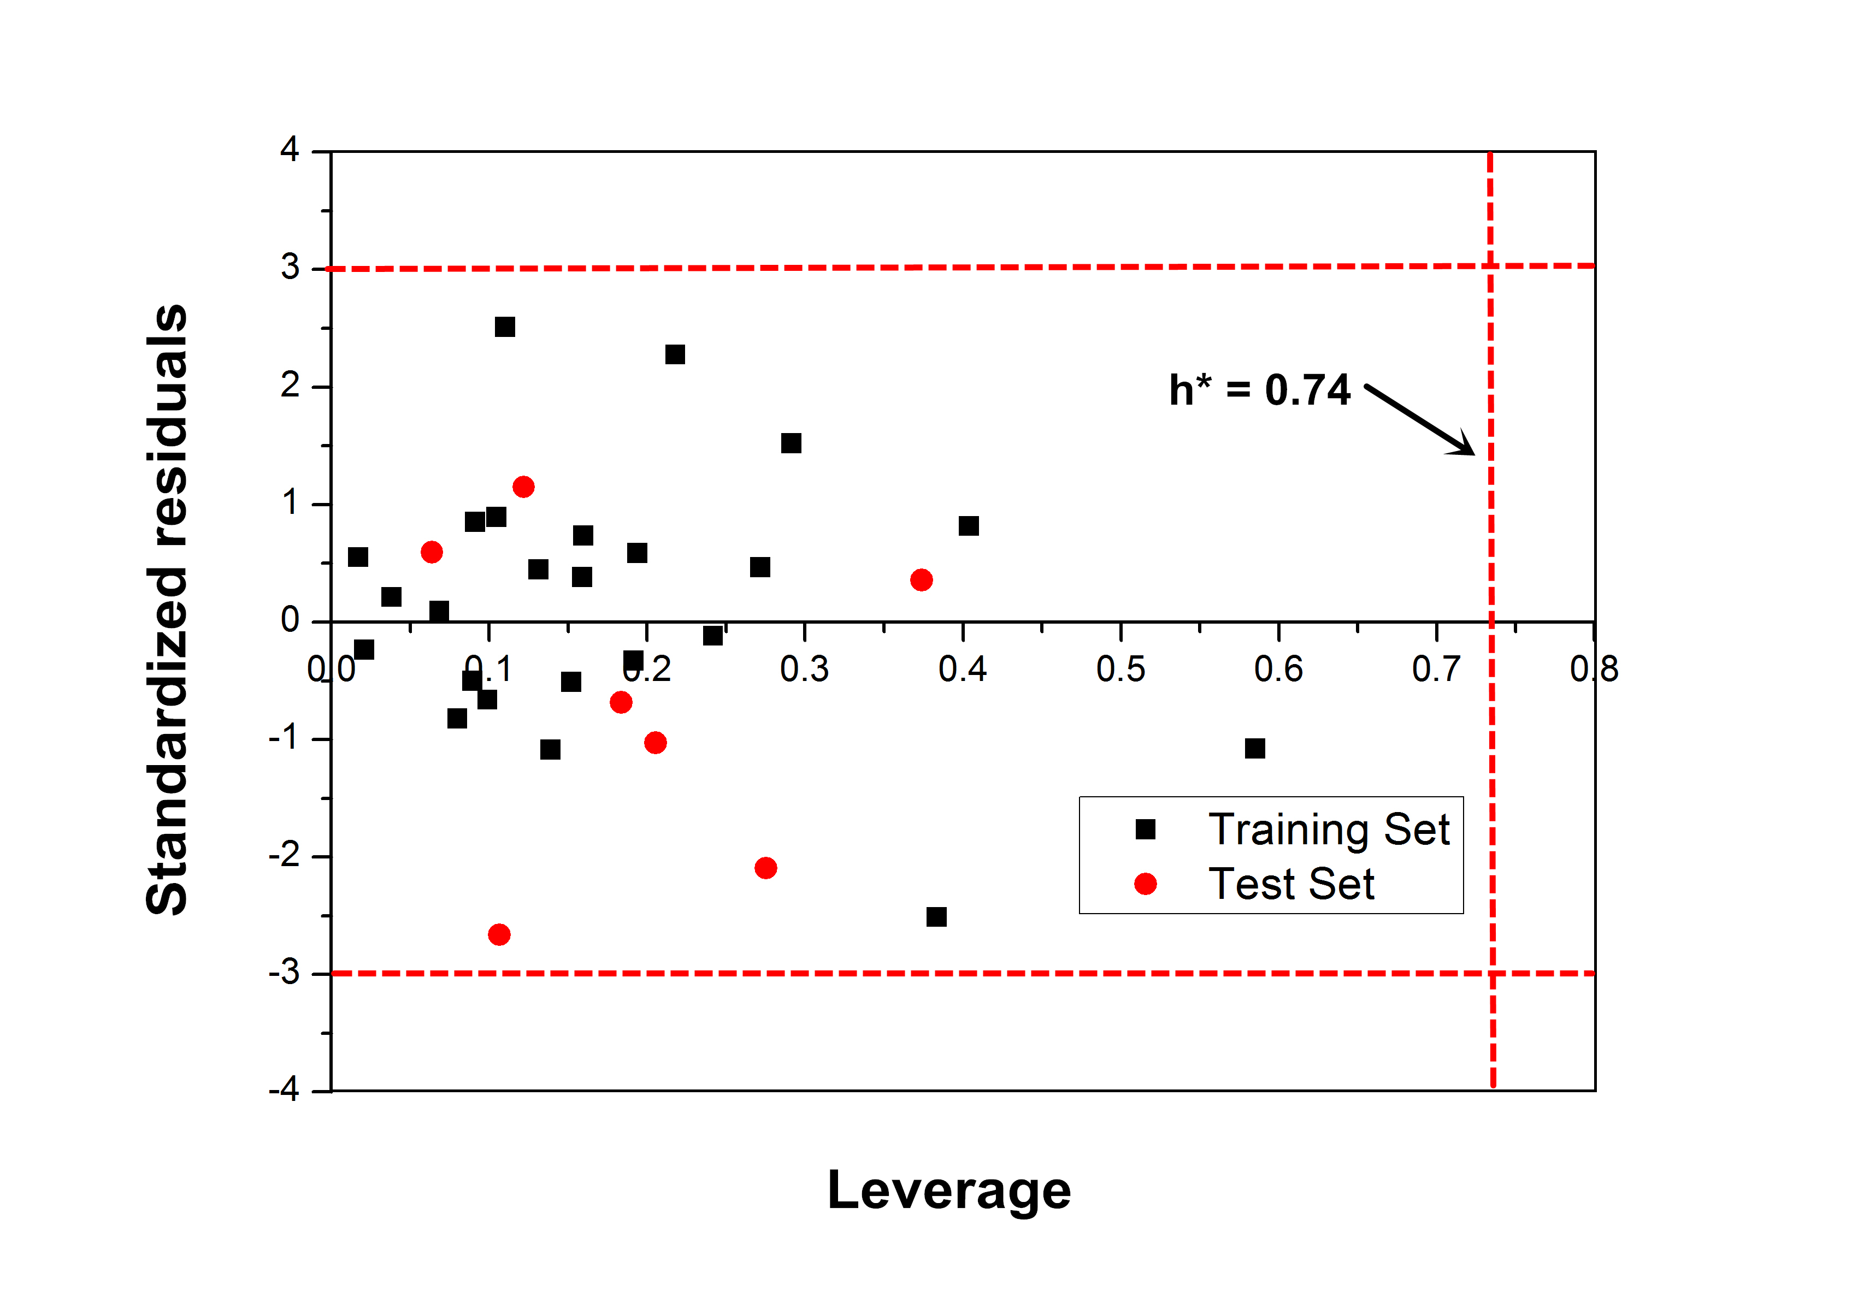
Figure S2. Williams plot of standardized residuals versus leverage values for CoMSIA model. The horizontal lines represent ±3 standardized residual, and the vertical line represents warning leverage (h* = 0.74)

Table S1. Statistical results of CoMFA and different combination of CoMSIA models with structure based alignment by PLS analysis.
NO. | q² | N | r² | SEE | F | fields contribution
 |  |  |  |  |  | S | E | H | D | A
CoMFA | 0.595 | 6 | 0.977 | 0.287 | 130.924 | 0.437 | 0.563 | - | - | -
CoMSIA-SED | 0.601 | 7 | 0.956 | 0.273 | 128.797 | 0.216 | 0.535 | - | 0.250 | -
CoMSIA-SEH | 0.706 | 6 | 0.971 | 0.233 | 142.974 | 0.142 | 0.542 | 0.316 | - | -
CoMSIA-SEA | 0.600 | 3 | 0.881 | 0.358 | 61.109 | 0.123 | 0.445 | - | - | 0.431
CoMSIA-SHD | 0.388 | 6 | 0.844 | 0.440 | 34.092 | 0.183 | - | 0.387 | 0.430 | -
CoMSIA-EHD | 0.658 | 6 | 0.959 | 0.259 | 136.657 | - | 0.443 | 0.333 | 0.224 | -
CoMSIA-HDA | 0.568 | 5 | 0.975 | 0.218 | 156.683 | - | - | 0.259 | 0.365 | 0.377
CoMSIA-SHA | 0.587 | 4 | 0.956 | 0.250 | 157.583 | 0.173 | - | 0.364 | - | 0.463
CoMSIA-EHA | 0.672 | 4 | 0.956 | 0.249 | 157.945 | - | 0.356 | 0.256 | - | 0.388
CoMSIA-SDA | 0.475 | 4 | 0.901 | 0.341 | 73.946 | 0.124 | - | - | 0.386 | 0.490
CoMSIA-EDA | 0.521 | 2 | 0.835 | 0.407 | 47.349 | - | 0.308 | - | 0.293 | 0.399
CoMSIA-SEHD | 0.670 | 7 | 0.973 | 0.237 | 136.069 | 0.109 | 0.429 | 0.249 | 0.213 | -
CoMSIA-SEDA | 0.546 | 4 | 0.906 | 0.332 | 135.730 | 0.090 | 0.277 | - | 0.222 | 0.411
CoMSIA-EHDA | 0.615 | 5 | 0.954 | 0.299 | 164.986 | - | 0.251 | 0.213 | 0.218 | 0.317
CoMSIA-SEHA | 0.683 | 4 | 0.959 | 0.244 | 159.857 | 0.090 | 0.321 | 0.228 | - | 0.362
CoMSIA-SHDA | 0.579 | 5 | 0.952 | 0.253 | 162.994 | 0.090 | - | 0.233 | 0.323 | 0.355
CoMSIA-SEHDA | 0.733 | 5 | 0.983 | 0.193 | 170.916 | 0.072 | 0.233 | 0.193 | 0.203 | 0.298

Table S2. Hydrogen bond analysis from the results of MD simulations
Complex | Donor | Acceptor | Occupancy (%) | Distance (Å) | Angle (°)
LSD1-8 | Lys661@N-H | ligand@C≡N | 5.62 | 2.1 | 142.8
 | WAT@O-H | ligand@C≡N | 91.91 | 1.9 | 155.1
 | WAT@O-H | FAD@N | 97.79 | 2.0 | 159.2
 | Lys661@N-H | WAT@O | 90.22 | 2.7 | 156.4
 | ligand@N⁺-H | Asp555@O | 98.15 | 1.6 | 158.8
LSD1-14 | Lys661@N-H | ligand@C≡N | 7.39 | 2.2 | 140.2
 | WAT@O-H | ligand@C≡N | 90.24 | 1.9 | 154.5
 | WAT@O-H | FAD@N | 96.53 | 1.9 | 156.4
 | Lys661@N-H | WAT@O | 91.36 | 2.6 | 157.7
 | ligand@N⁺-H | Asp555@O | 94.73 | 1.7 | 163.3
LSD1-24 | ligand@N⁺-H | Asp555@O | 95.27 | 1.8 | 166.4
 | ligand@N⁺-H | Gln358@O | 70.86 | 1.9 | 151.3
 | WAT@O-H | FAD@N | 96.60 | 1.9 | 165.3
 | Lys661@N-H | WAT@O | 90.71 | 2.9 | 153.4
LSD1-27 | Lys661@N-H | ligand@C≡N | 6.34 | 2.2 | 148.3
 | WAT@O-H | ligand@C≡N | 92.54 | 2.1 | 161.3
 | WAT@O-H | FAD@N | 94.16 | 2.1 | 167.1
 | Lys661@N-H | WAT@O | 93.90 | 2.6 | 159.4
 | ligand@N⁺-H | Asp555@O | 97.83 | 1.8 | 169.2

