Role of coke-bounded environmentally persistent free radicals in phenanthrene degradation by hydrogen peroxide

Lan Wuª, Song Zhaoª, Kecheng Zhuª, Yafang Shiª, Xiaofeng Nieª, Hanzhong Jia^{a,*}

ª College of Resources and Environment, Northwest A & F University, Yangling 712100, China.

*To whom correspondence should be addressed.
College of Natural Resources and Environment
Northwest A & F University
3# Taicheng Road, Yangling 712100,China.
Phone: +86-911-3835879
Fax: +86-911-3838957
E-mails: jiahz@nwafu.edu.cn

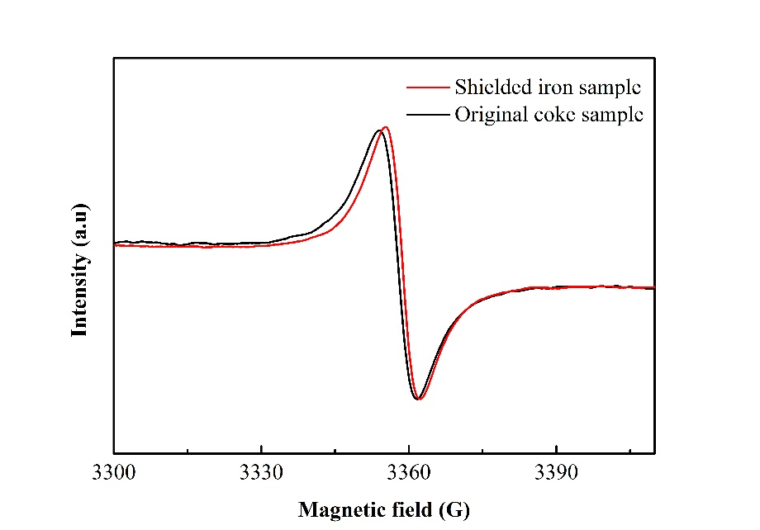
Figure S1. Changes of EPFRs concentration and g value in coke samples with or without Fe removal

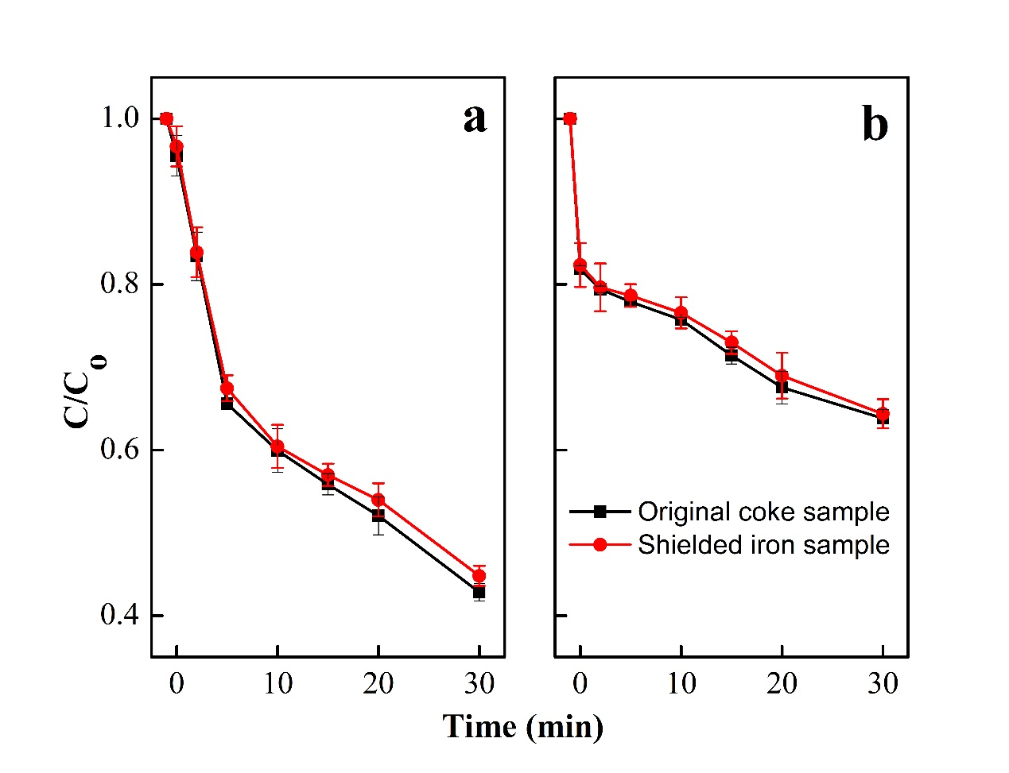
Figure S2. Evolution of PHE before and after coke treatment when the concentration of H₂O₂ are 250 mM (a) and 1000 mM (b), respectively.

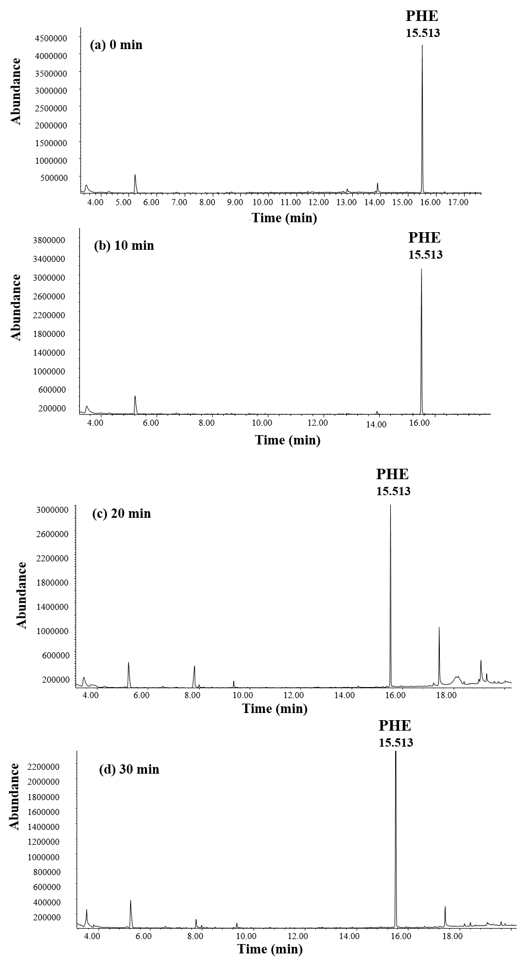
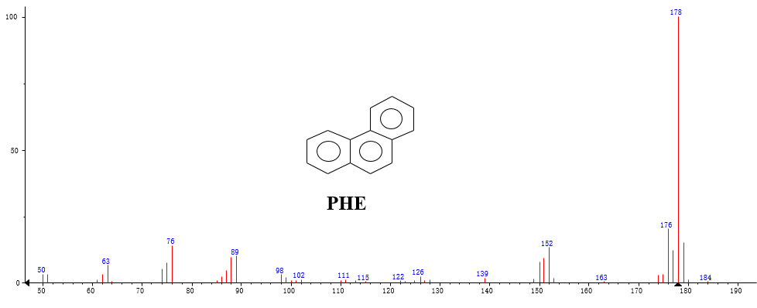
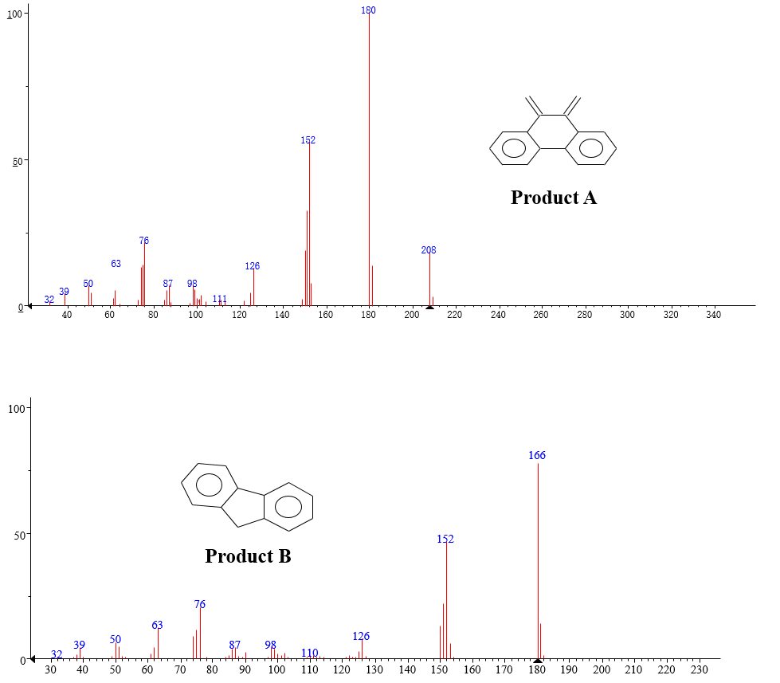
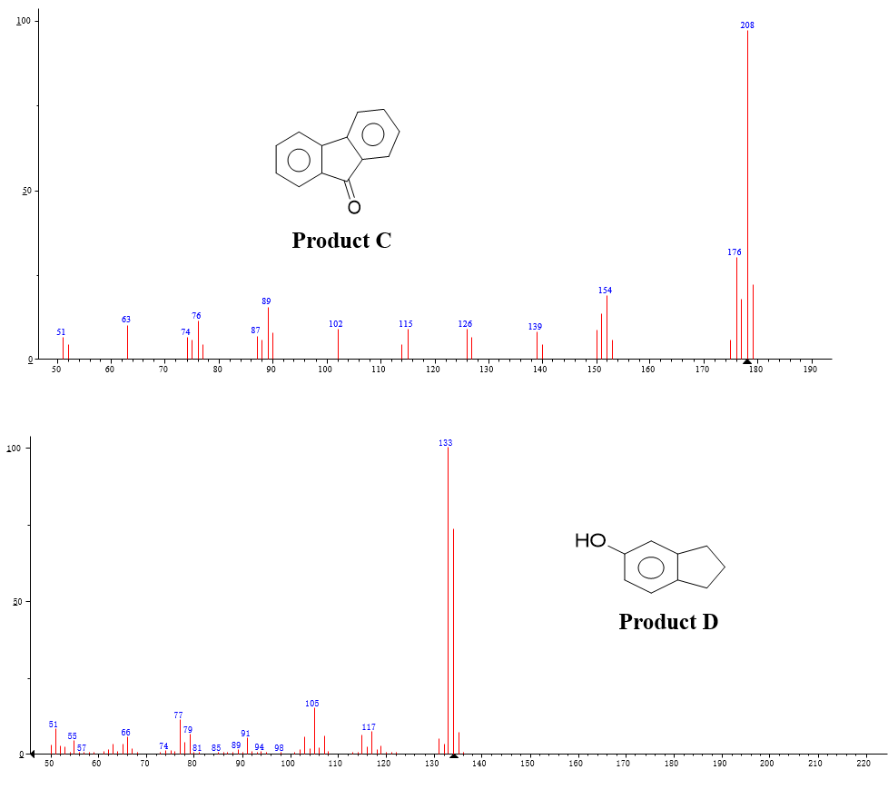
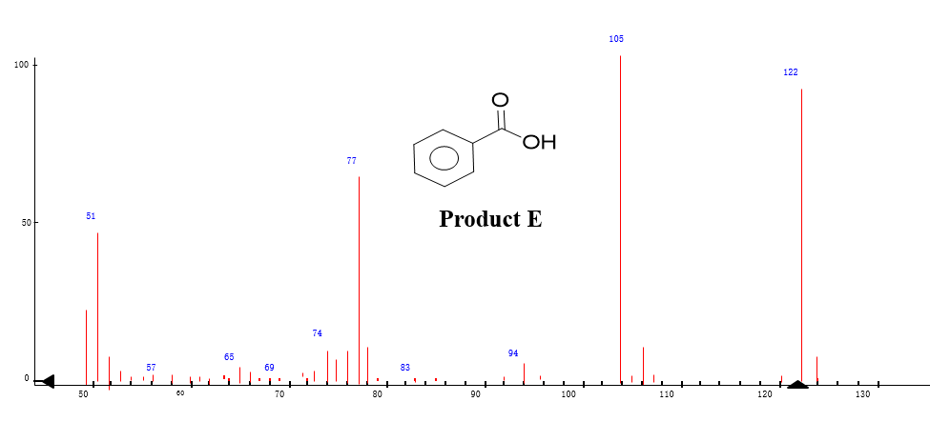
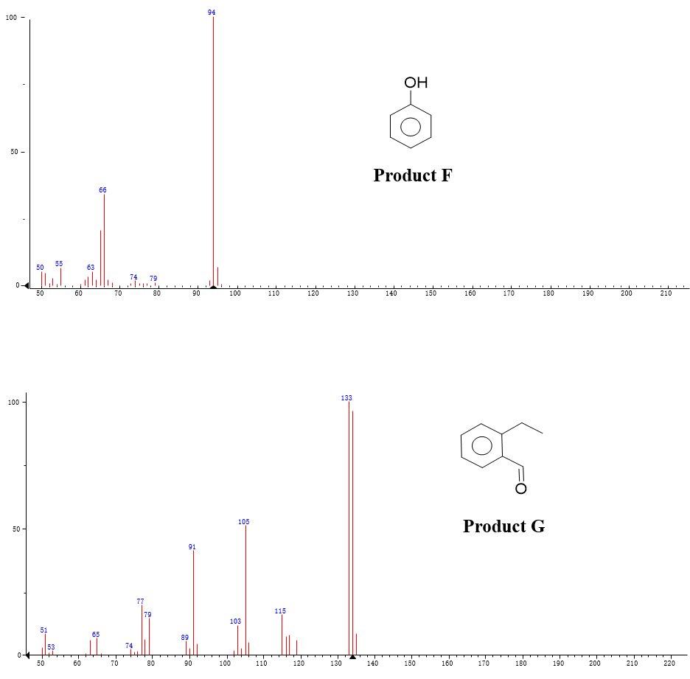
Figure S3. GC-MS chromatograms and mass spectra of products.

