Supplementary Material
Figure captions
Figure S1 Pyrene was cultivated with Klebsiella sp. LZ6 for 10 day under anaerobic conditions, and the supernatant was subjected to GC/MS analysis. Mass spectrogram of (a) Pyrene (R_{T}-13.433min), (b) Pyrene,4,5-dihydro- (R_{T}-13.135min), (c) Phenanthrene (R_{T}-11.835min), (d) allyl tert-butyldimethyl phthalate-TMS derivative (R_{T}-10.154min) and (e) 2'-hydroxypropiophenone-TMS derivative (R_{T}-15.977min).
Figure S2 Mass spectrogram of pyrene, pyrene, 4, 5-dihydro-, penanthrene, ally tert-butyldimethylsilylphalate and propiophenone, 2'-(trimethylsiloxy)- standard
Figure S3 Pyrene was cultivated with Klebsiella sp. LZ6 for 20 day under anaerobic conditions, and the supernatant was subjected to GC/MS analysis. Mass spectrogram of dibenzo-p-dioxin (R_{T}-11.634min).
Figure S4 Mass spectrogram of Dibenzo-p-dioxinstandard.
Figure S5 Phenanthrene was cultivated with Klebsiella sp. LZ6 for 20 day under anaerobic conditions, and the supernatant was subjected to GC/MS analysis. Mass spectrogram of (a) Phenanthrene (R_{T}-13.433min), (b) methyl 4-hydroxycinnamate (R_{T}-12.634min) and (c) p-Cresol -TMS derivative (R_{T}-7.402min).
Figure S6 Mass spectrogram of phenanthrene, 2-propenoic acid, 3-(4-hydroxyphenyl)-, methyl ester and silane, trimethyl (4-methylphenoxy)-standard.
Figure S7 Phenanthrene was cultivated with Klebsiella sp. LZ6 for 30 day under anaerobic conditions, and the supernatant was subjected to GC/MS analysis. Mass spectrogram of 4- hydroxybenzenemethanol -TMS derivative (R_{T}-10.307min)
Figure S8 Mass spectrogram of 4-hydroxybenzenemethanol-TMS derivative standard.

Table captions
Table S1 Characters of physiology and biochemistry (+ Positive reaction; +w weak reaction; - negative reaction.The strains did not assimilate D-cellobiose, D-turanose, α-D-lactose, N-acetyl-β-D-mannosamine, N-Acetyl-D-galactosamine, D-aspartic acid, Gelatin, L-serine, Mucic acid, D-saccharic acid, Methyl pyruvate, D-lactic acid methyl ester, α-hydroxy-butyric acid, α-keto-butyric acid, Acetoacetic acid, Formic acid, 8% NaCl, Lithium chloride, Sodium butyrate, Sodium bromate.)

Figure S1 Pyrene was cultivated with Klebsiella sp. LZ6 for 10 day under anaerobic conditions, and the supernatant was subjected to GC/MS analysis. Mass spectrogram of (a) Pyrene (R_{T}-13.433min), (b) Pyrene,4,5-dihydro- (R_{T}-13.135min), (c) Phenanthrene (R_{T}-11.835min), (d) allyl tert-butyldimethyl phthalate-TMS derivative (R_{T}-10.154min) and (e) 2'-hydroxypropiophenone-TMS derivative (R_{T}-15.977min)
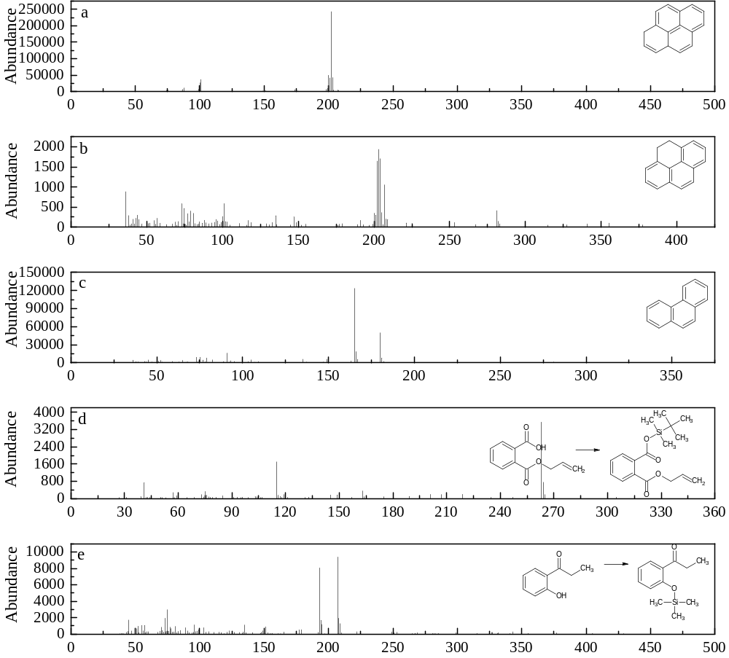

Figure S2 Mass spectrogram of pyrene, pyrene, 4, 5-dihydro-, penanthrene, ally tert-butyldimethylsilylphalate and propiophenone, 2'-(trimethylsiloxy)- standard
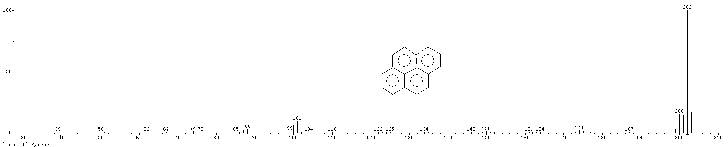
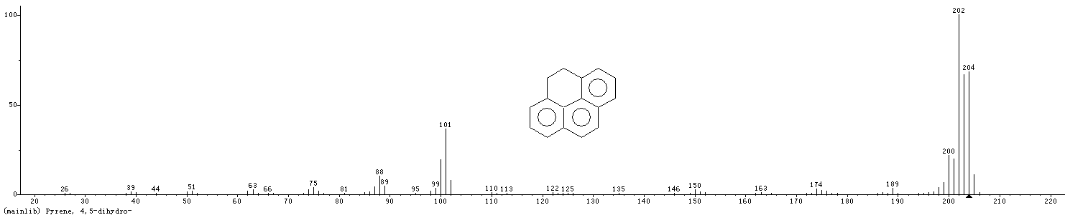
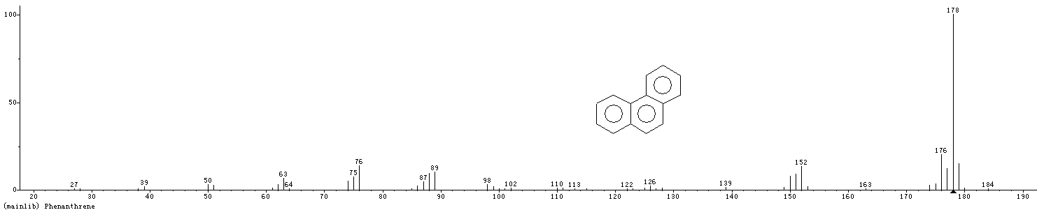
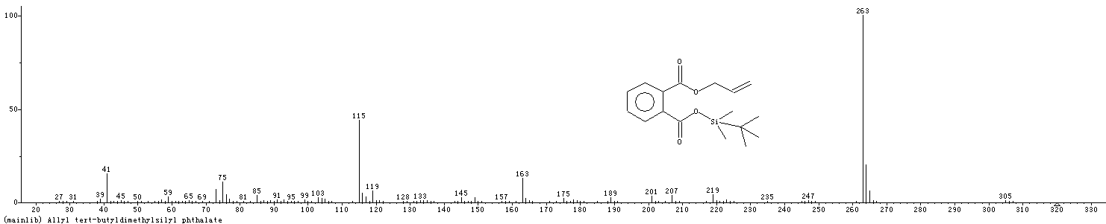
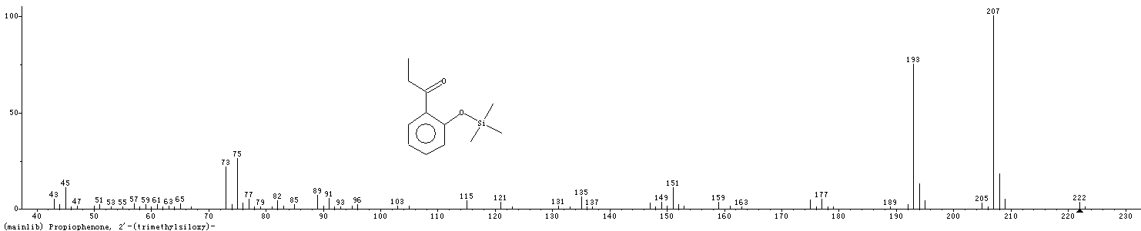
Figure S3 Pyrene was cultivated with Klebsiella sp. LZ6 for 20 day under anaerobic conditions, and the supernatant was subjected to GC/MS analysis. Mass spectrogram of dibenzo-p-dioxin (R_{T}-11.634min)
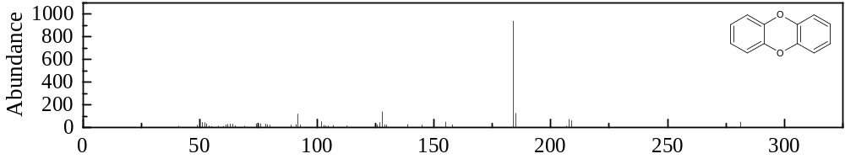
Figure S4 Mass spectrogram of Dibenzo-p-dioxinstandard.
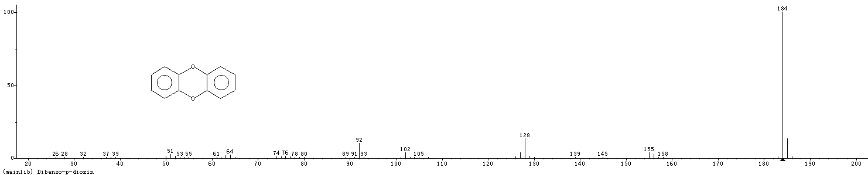

Figure S5 Phenanthrene was cultivated with Klebsiella sp. LZ6 for 20 day under anaerobic conditions, and the supernatant was subjected to GC/MS analysis. Mass spectrogram of (a) Phenanthrene (R_{T}-13.433min), (b) methyl 4-hydroxycinnamate (R_{T}-12.634min) and (c) p-Cresol -TMS derivative (R_{T}-7.402min)
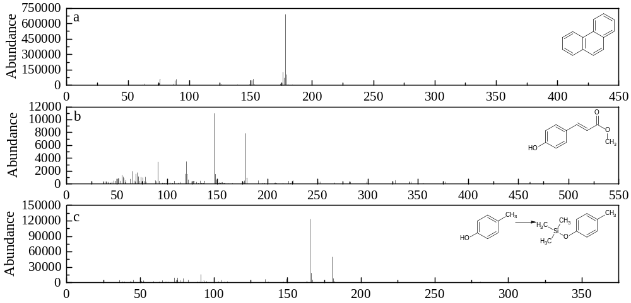

Figure S6 Mass spectrogram of phenanthrene, 2-propenoic acid, 3-(4-hydroxyphenyl)-, methyl ester and silane, trimethyl (4-methylphenoxy)-standard.
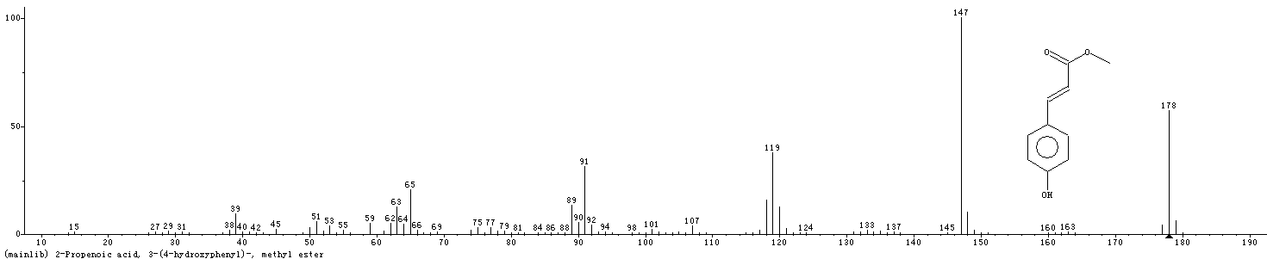
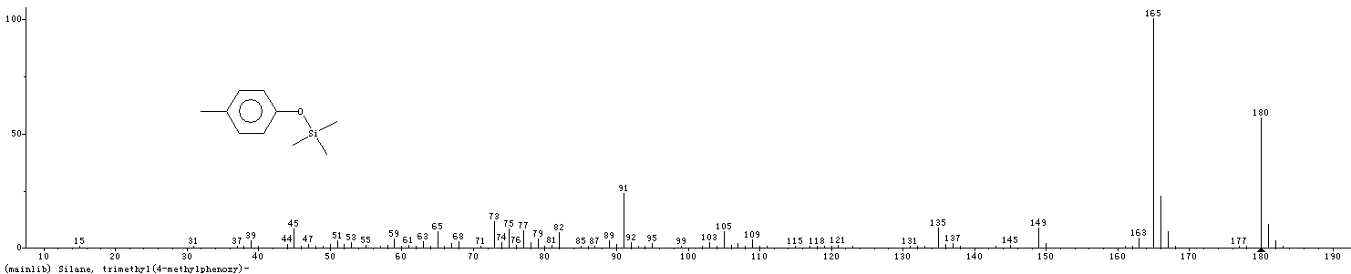

Figure S7 Phenanthrene was cultivated with Klebsiella sp. LZ6 for 30 day under anaerobic conditions, and the supernatant was subjected to GC/MS analysis. Mass spectrogram of 4- hydroxybenzenemethanol -TMS derivative (R_{T}-10.307min)
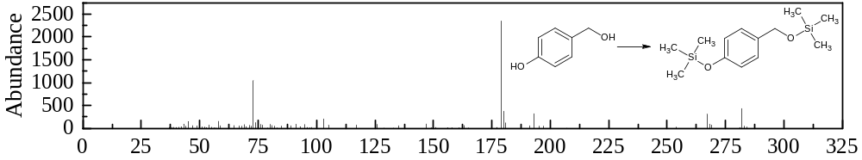
Figure S8 Mass spectrogram of 4-hydroxybenzenemethanol-TMS derivative standard.
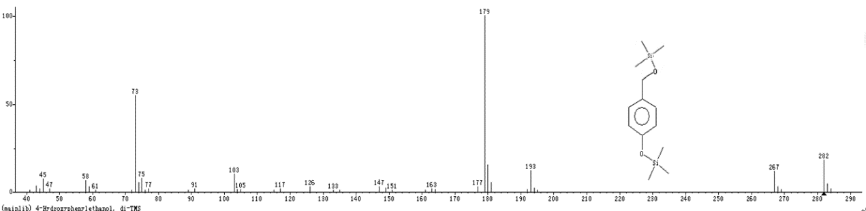

Table S1 Characters of physiology and biochemistry (+ Positive reaction; +w weak reaction; - negative reaction.The strains did not assimilate D-cellobiose, D-turanose, α-D-lactose, N-acetyl-β-D-mannosamine, N-Acetyl-D-galactosamine, D-aspartic acid, Gelatin, L-serine, Mucic acid, D-saccharic acid, Methyl pyruvate, D-lactic acid methyl ester, α-hydroxy-butyric acid, α-keto-butyric acid, Acetoacetic acid, Formic acid, 8% NaCl, Lithium chloride, Sodium butyrate, Sodium bromate.)
Tested item | Reaction | Tested item | Reaction |  | Tested item | Reaction
Dextrin | - | D-maltose |  | +^{w} | D-trehalose |  | +^{w}
D-cellobiose | + | Gentiobiose |  | + | Sucrose |  | +
Stachyose | +^{w} | D-raffinose |  | + | D-melibiose |  | +
β-methyl-D-glucoside | + | D-salicin |  | + | N-acetyl-D-glucosamine |  | +
N-acetyl neuraminic acid | +^{w} | α-D-glucose |  | + | D-mannose |  | +
D-fructose | + | D-galactose |  | + | 3-methyl glucose |  | +^{w}
D-foucose | +^{w} | L-foucose |  | +^{w} | L-rhamnose |  | +^{w}
Inosin | - | D-sorbitol |  | + | D-mannitol |  | +
D-arabito | + | Myo-inositol |  | +^{w} | Glycerol |  | -
D-glucose-6-PO4 | + | D-fructose-6-PO4 |  | + | D-serine |  | +
Glycyl-L-proline | - | D-alanine |  | - | L-arginine |  | -
L-aspartic acid | - | L-glutamic acid |  | - | L-histidine |  | -
L-pyroglutamic acid | - | Pectin |  | + | D-galacturonic acid |  | +
L-galactonic acid lactone | - | D-gluconic acid |  | + | D-glucuronic acid |  | +
Glucuronamid | + | Quinic acid |  | - | p-hydroxy-  phenylacetic acid |  | -
L-lactic acid | - | Citric acid |  | - | α-keto-glutaric acid |  | -
D-malic acid | + | L-malic acid |  | - | Bromo-succinic acid |  | -
Tween-40 | - | γ-amino-butryric acid |  | - | β-hydroxy-D,L-butyric acid |  | -
Propionic acid | - | Acetic acid |  | - | pH6 |  | +^{w}
pH5 | - | 1% NaCl |  | + | 4% NaCl |  | -
1% Sodium lactate | + | FusidicaAcid |  | - | D-serine |  | +
Troleandomycin | +^{w} | Rifamycin SV |  | + | Minocycline |  | -
Lincomycin | + | Guanidine HCl |  | + | Niaproof 4 |  | -
Vancomycin | + | Tetrazolium violet |  | + | Tetrazolium blue |  | +^{w}
Nalidixic acid | - | Potassium tellurite |  | - | Aztreonam |  | +

