Simvastatin delivery on PEEK for bioactivity and osteogenesis enhancements
Li-jun Dengª, Yan-lin Wu^{b}, Xian-hua Heª, Ke-nan Xieª, Lu Xie^{b}*, Yi Deng^{a,c}*
ª School of Chemical Engineering, Sichuan University, Chengdu, 610065, China
^{b} State Key Laboratory of Oral Diseases, West China College of Stomatology, Sichuan University, Chengdu 610041, China
^{c} Department of Mechanical Engineering, The University of Hong Kong, Hong Kong, 999077, China
* Corresponding author:
Lu Xie (xielu2017@163.com); Yi Deng (dengyibandeng@scu.edu.cn)

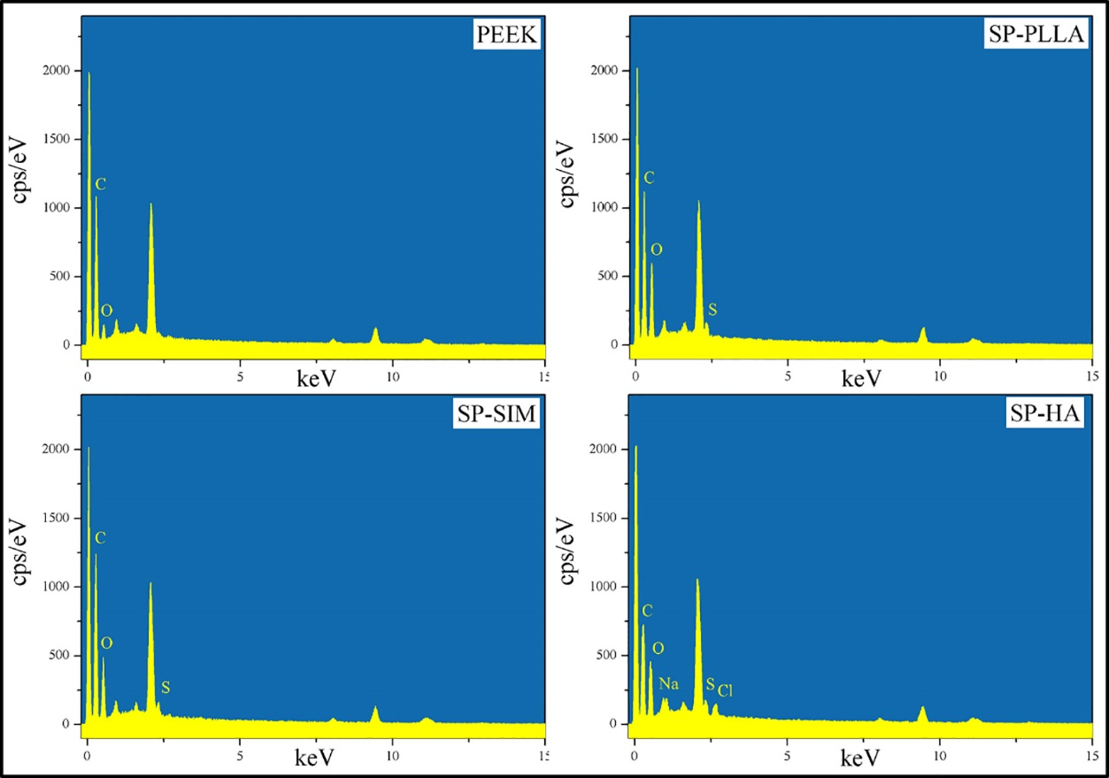Figure S1. The EDS spectra show the elemental compositions of the PEEK, SP-PLLA, SP-SIM, and SP-HA scaffolds.

Figure S2. The survey spectra of different group in XPS result.
Figure S3. The in vitro release profiles of simvastatin from SP-PLLA scaffold.
As shown in Figure S3, 68.41 μg SIM was released from SP-PLLA scaffolds after 8 days, and it is about 16.29 wt% for the amount of released SIM. So, SIM can be released from PLLA film and thus work.
Table S1. The concentration of C-C, C-O, C=O in different scaffolds.
 | PEEK | SP-PLLA | SP-SIM | SP-HA
C-C (%) | 69.65 | 51.04 | 46.73 | 47.83
C-O (%) | 25.05 | 26.23 | 27.04 | 34.77
C=O (%) | 5.29 | 22.73 | 26.23 | 17.39

Table S2. Primer pairs used in real-time PCR analysis.
Gene | Forward primer | Reverse primer
GAPDH | GGTGAAGGTCGGTGTGAACG | CTCGCTCCTGGAAGATGGTG
Col1a1 | GCTCCTCTTAGGGGCCACT | CCACGTCTCACCATTGGGG
Runx2 | AGGAATGCGCCCTAAATCACT | ACCAAGAAGGCACAGACAGAAG
VEGF | GCACATAGAGAGAATGAGCTTCC | CTCCGCTCTGAACAAGGCT

