SUPPLEMENTAL INFORMATION: Characterization of experimental complex fungal bioaerosols: impact of analytical method on fungal composition measurements

Jodelle Degois1, Xavier Simon1, Cyril Bontemps2, Pierre Leblond2, Philippe Duquenne1

1Pollutants metrology division, Institut National de Recherche et de Sécurité (INRS), Vandœuvre-lès-Nancy 54500, France; 2Université de Lorraine, Institut National de la Recherche Agronomique, Dynamique des Génomes et Adaptation Microbienne (DynAMic), UMR INRA 1128, Nancy 54000, France

S1 Generated particle size distribution measured with the OPC-Grimm® and use of the real-time indicator CN(dopt > 1 µm)

Examples of the size distribution of airborne particles as a function of their optical diameter, measured using a Grimm® G1109, are shown in Fig. S1-1.

a.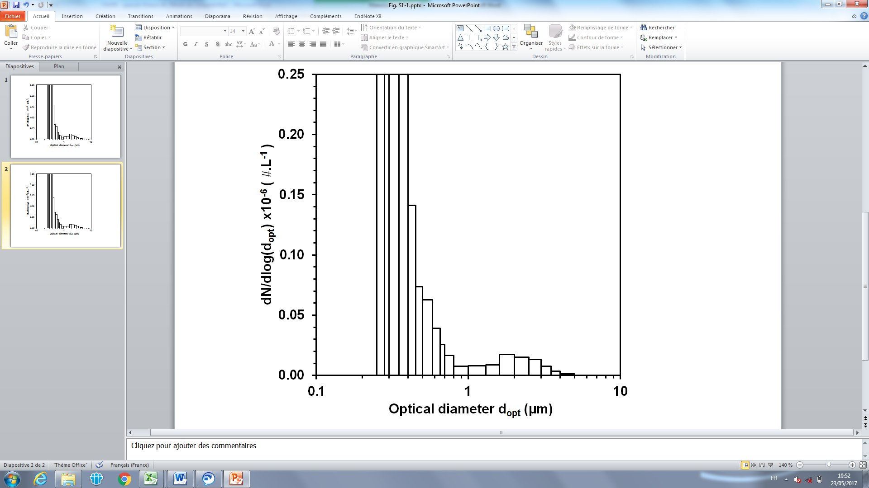b. 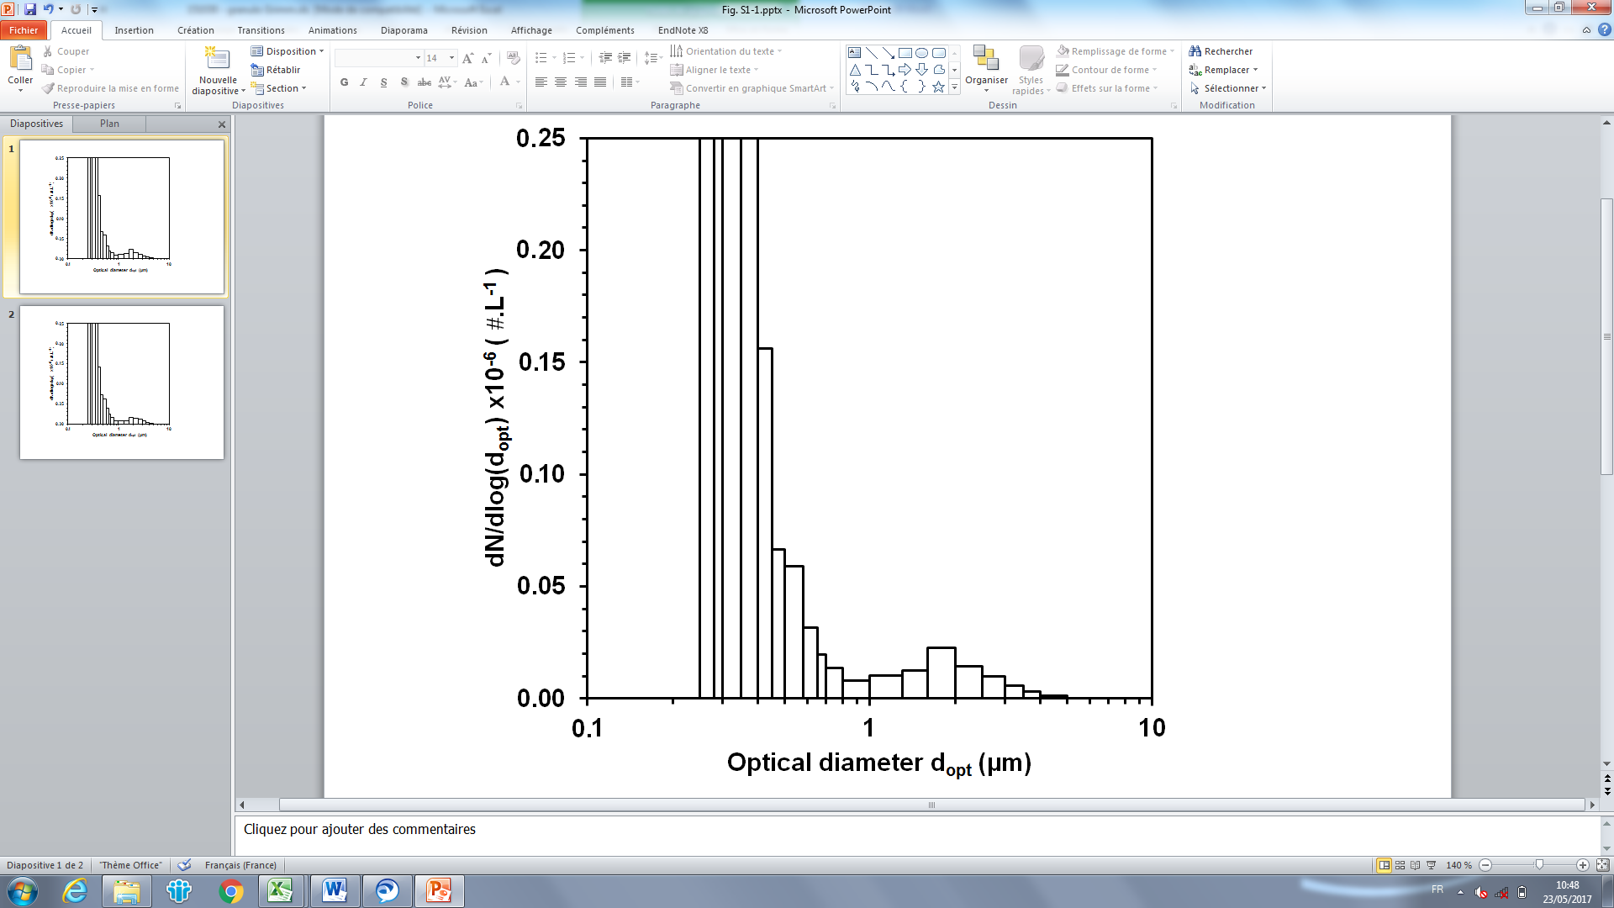

Figure S 1 Size distribution for particles generated measured with Grimm® G1109. Examples for the 4-strains mixing (a) and for *Wallemia melicolla* (b).

The size distributions of the bioaerosols indicate that two distinct particle populations are generated. These two populations are separated around a diameter of 1 µm.

A first population, corresponding to optical diameters between 1 and 5 µm is fully visible. This population presents a median optical diameter close to 1.8 µm with a geometric standard deviation close to 1.35. These descriptive parameters vary little with test day or liquid culture generated: between 1.6 and 2 µm for the median optical diameter and between 1.32 and 1.40 for the geometric standard deviation across all the tests performed.

A second population of particles with a diameter of less than 1 µm is also visible on Fig. S1a and Fig. S1b. This population is not fully characterized by the Grimm® G1109 which is only capable of detecting a portion of the distribution (0.25 < dopt < 1 µm). These residual, undesired particles are, probably, residues of the culture medium or fungal debris still present in the suspension despite the washing steps included in the preparation protocol. Part of this could also be due to impurities or dissolved particles present in the water, resulting in the formation of residual particles after droplet drying. Whatever their origins or nature, the presence of these residual particles is not a problem given that the size distribution of the fungal particles population remains quite discernible and identifiable.

Particles with an optical diameter greater than 1 µm are considered to be fungal entities, whether they are culturable, non-culturable or dead cells. The cumulated particle number concentration with an optical diameter greater than 1 µm, CN(dopt > 1 µm), was considered in our tests as an indicator of the total fungal concentration in the generated bioaerosol. All experiments were performed using a target value for CN(dopt > 1 µm) as close as possible to 7,000 #/L. The operator then attempted to maintain CN(dopt > 1 µm) at the target value to improve stability during aerosol generation or to improve inter-assay reproducibility. In both cases, the same method was used: slight adjustment of the bubbling flow rate to maintain the target value near 7,000 #/L. The OPC is a necessary element of the test rig insofar as it gives real time data. Depending on the day of generation, the seven 60-min averaged values of CN(dopt > 1 µm) were comprised between 6,620 and 7,430 #/L.

S2 Further results concerning size distribution of the particles generated measured with TSITM APS 3321



Day 3

Day 2

Day 1

Figure S 2 Size distributions for particles generated using the 4-strains mixing liquid cultures.

The size distributions of the bioaerosols measured with the TSITM APS indicate that two distinct particle populations are generated. These two populations are separated around a diameter of 1.7 µm.

A first population, corresponding to aerodynamic diameters between 1.7 and 6 µm is fully visible on the figures. This population presents a median aerodynamic diameter of 2.95 µm with a geometric standard deviation close to 1.16. These descriptive parameters vary little with test day.

A second population of particles with a diameter of less than around 1.7 µm is also visible on Fig. S2. These residual, undesired particles are, probably, residues of the culture medium or fungal debris still present in the suspension despite the washing steps included in the preparation protocol. Part of this could also be due to impurities or dissolved particles present in the water, resulting in the formation of residual particles after droplet drying. Whatever their origins or nature, the presence of these residual particles is not a problem given that the size distribution of the fungal particles population remains quite discernible and identifiable.

a. b. 

*Wallemia melicolla*

*Aspergillus niger*

c. d. 

*Cladosporium cladosporoides*

*Penicillium brevicompactum*

Figure S 3 Size distributions and size distributions parameters for particles generated using a liquid culture of a. *Wallemia melicolla,* b. *Aspergillus niger*, c. *Penicillium brevicompactum* andd. *Cladosporium cladosporioides*.The aerodynamic diameter measured was measured using TSITM APS 3321.

Table S 1 Fungal biodiversity determining data in the suspensions and in the bioaerosols.

|  |  |  |  |
| --- | --- | --- | --- |
|  | Suspension 1 | Suspension 2 | Suspension 3 |
| Colony number per generation | 171 | 180 | 166 |
| Number of 18S rDNA reads | 54123 | 50954 | 55928 |
| Number of ITS2 reads | 55721 | 51573 | 62361 |

|  |  |  |  |
| --- | --- | --- | --- |
|  | Generation 1 | Generation 2 | Generation 3 |
| Colony number per generation | 294 | 271 | 302 |
| Average number of colony per CFC | 98±2 | 84±7 | 101±6 |
| Number of 18S rDNA reads | 52705 | 63087 | 58415 |
| Number of ITS2 reads | 60378 | 55623 | 69694 |