Tris(N-methylferrocenyl-N-(2-phenylethyl)dithiocarbamato-S,S′)cobalt(III) for anion sensing and preparation of cobalt-iron sulfide nanoparticles: a new photocatalyst for the degradation of dyes
Subbiah Thirumaran* and Govindasamy Gurumoorthy
Department of Chemistry, Annamalai University, Annamalainagar- 608 002, India.
Email: sthirumaran@yahoo.com
Supplemental Materials
Figure S 1. FT-IR spectrum of complex 1

Figure S 2. FT-IR spectrum of complex 2

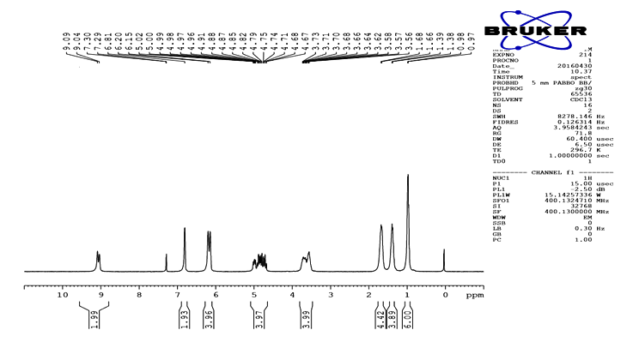
Figure S 3. ¹H NMR spectrum of complex 1

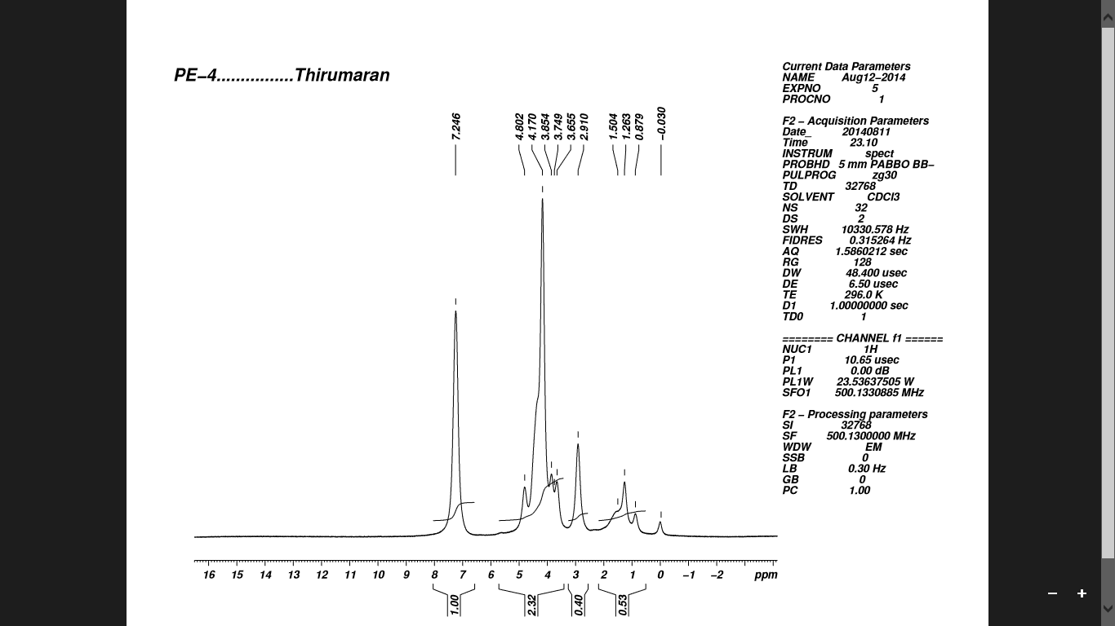
Figure S 4. ¹H NMR spectrum of complex 2

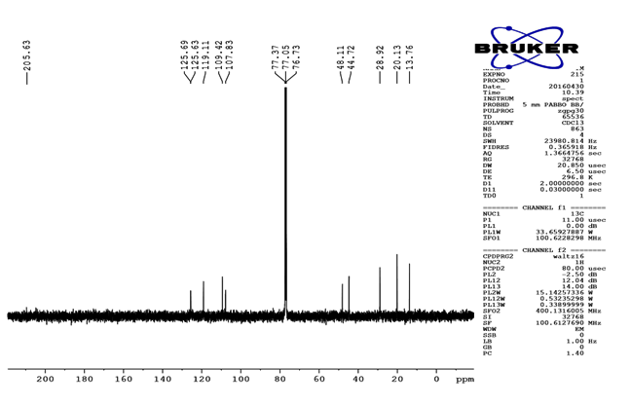Figure S 5. ¹³C NMR spectrum of complex 1
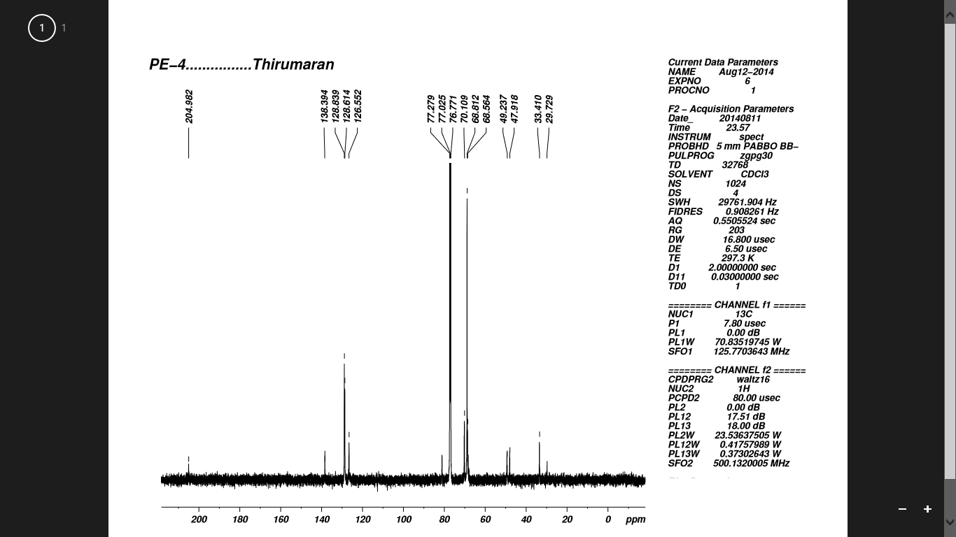
Figure S 6. ¹³C NMR spectrum of complex 2
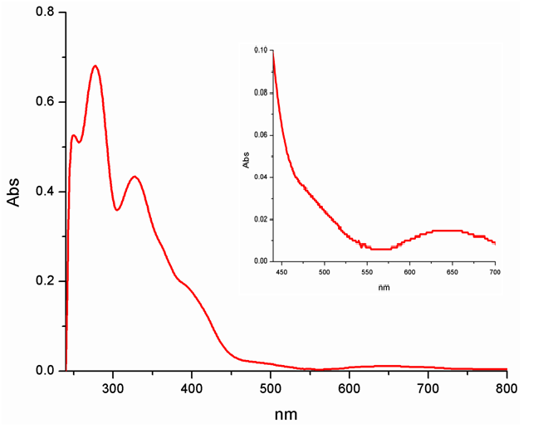Figure S 7. UV-Vis spectrum of complex 1
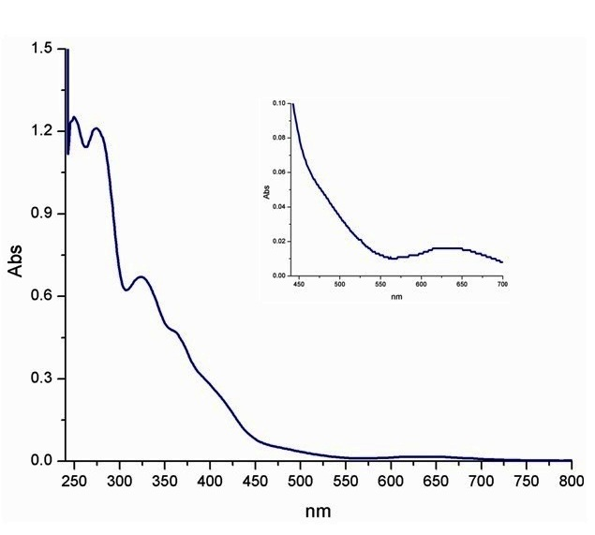
Figure S 8. UV-Vis spectrum of complex2

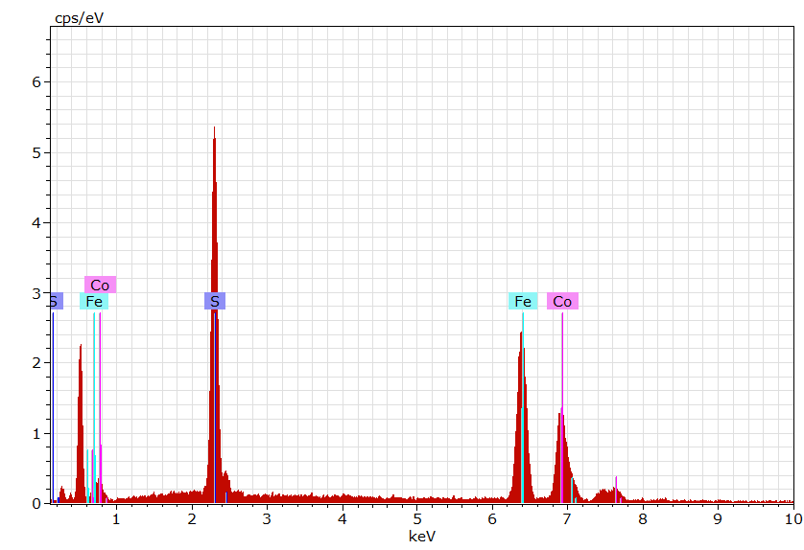

Figure S 9. Energy dispersive X-ray spectrum of cobalt-iron sulfide

Figure S 10. UV-Vis spectrum of cobalt-iron sulfide

Figure S 11. PL spectrum of cobalt-iron sulfide

Figure S 12. IR spectrum of cobalt-iron sulfide

