Supplementary material
Low-cost light manipulation coatings for polymer solar cell photocurrent increase under various incident angles
Takahiro Takumi,ª Savanna Lloyd,^{b} Hideyuki Murata,^{b} Varun Vohraª*
ª Department of Engineering Science, University of Electro-Communications, Chofu, Japan
^{b} School of Materials Science, Japan Advanced Institute of Science and Technology, Nomi, Japan
* Corresponding author: Dr. Varun Vohra
Department of Engineering Science, University of Electro-Communications,
Chofu, 182-8585 Tokyo, Japan
Email: varun.vohra@uec.ac.jp

Materials and Methods

Light transmission measurements
Transmittance spectra were collected either by placing the bare and coated glass substrates on a stage with two rotational arms equipped with optical fibers (direct transmittance and angle-dependent measurements) or using an integration sphere as described schematically in Figure S1. Incident light was produced using a standard tungsten halogen lamp and the sample was irradiated in the normal direction. Transmitted light was collected using a spectrometer (StellarNet Inc.) placed along the substrate’s normal direction for direct transmission measurements and gradually moved to 30º tilt in intervals of 5º for scattered light measurements. For each measurement configuration transmission is calculated relative to bare glass substrate measurements.

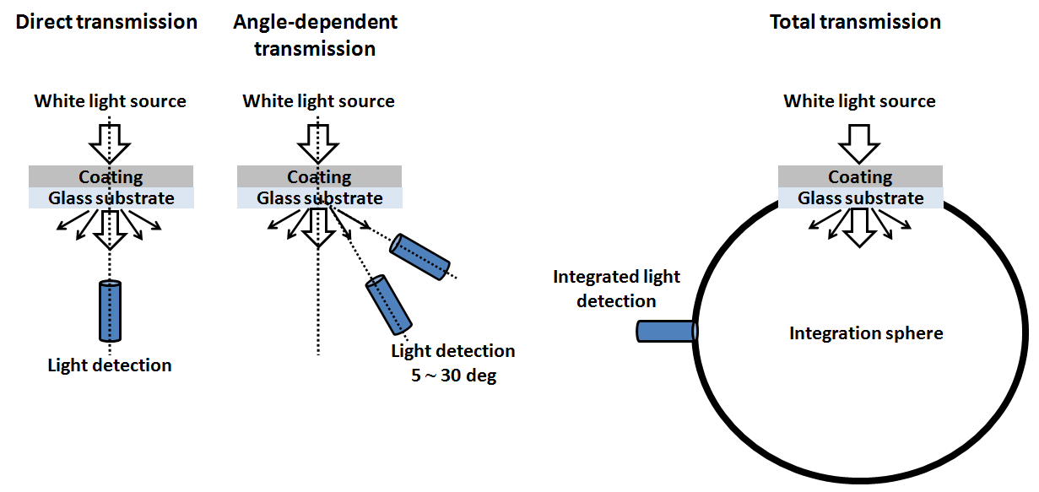
Figure S1: Schematic representations of the 3 configurations employed for light transmission measurement.

Optoelectronic and topographic characterizations
J-V characteristics of the bare and PDMS-coated PSCs were measured using a Keithley 2401 sourcemeter with incident light produced by a solar simulator (SAN-EI Electric) under standard AM 1.5 conditions (100 mW/cm², 1 sun). For tilted incident light measurements, the sample holder was tilted from 0 to 30º in intervals of 10º. The height of the sample holder was adjusted to ensure that the input solar power remains constant at 100 mW/cm² and the area around the device was masked with black material to avoid undesired optical reflections. AFM images of the porous templates and PDMS replica were collected in tapping mode.

Active layer absorbance simulations
Active layer absorbance simulations were performed using the Semiconducting Thin Film Optics Simulation Software (Setfos, Fluxim, version 4.5) in 'Absorption Simulation Mode' with the 'Light Scattering Module'. The illumination spectrum for the simulations corresponds to AM1.5 with an intensity of 1 sun. We defined the dome-like scattering interface as a hexagonally-packed array of 7 domes (number pre-defined by the software) with dome height, dome radius and dome packing radius (half of the peak-to-peak distance between two adjacent domes) of 240 nm, 250 nm and 450 nm, respectively, which correspond to the average dimensions of nanoPDMS measured by AFM (Figure S2). As PDMS is transparent in the studied region, the scattering interface was defined as incoherent to ensure that its thickness would not affect the simulation results.
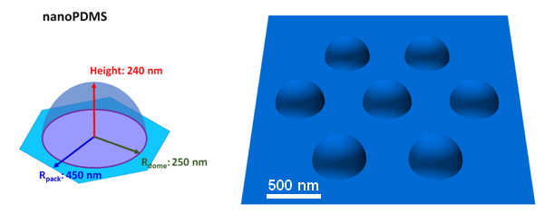
Figure S2: Schematic of dome dimensions and dome arrays used for the light absorption simulations with ideal nanoPDMS.

The absorption mode calculates the field penetration in the absorptive layers in terms of spatially distributed amplitude and energy for each wavelength using the transfer matrix formalism and considering that the sum of the absorbance, the transmittance and the reflectance equals 1 for each wavelength. The simulation software computes the optical field and its phase to generate the absorptive rate profile G at each position z within the active layer as displayed in Figure S3(a) for bare devices.
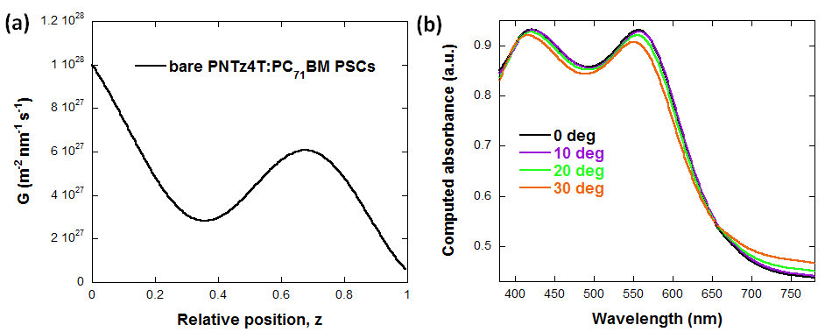
Figure S3: (a) absorptive rate profile and (b) angle-dependent absorbance spectra of computed bare PNTz4T:PC₇₁BM PSCs with a regular device architecture.

The scattering module is based on developments by Santbergen [S1] and Lanz [S2] to extrapolate bidirectional scattering distribution properties. A 3-D ray tracing model uses the geometries defined in Figure S2 to calculate the scattering distribution properties of the interfaces. The calculations performed by the simulation software are integrated over 10,000 rays for each condition in the 'Absorption Simulation Mode' with the 'Light Scattering Module' to produce wavelength dependent simulated absorbance integrated over the whole active layer thickness (Figure 2(b)). For tilted incident light simulations, incident angles between 0 and 30º in intervals of 10º were employed to generate spectra such as those displayed in Figure S3(b) obtained for bare devices. Simulated light absorbance by the active layer in the manuscript and Table S1 were calculated by integrating the generated spectra over the entire studied wavelength range (380~780 nm) and normalized by the integrated bare device active layer absorbance for normal incident light.
incident light (º) | no PDMS | flat PDMS | nanoPDMS
0 | 100% | 100.7% | 102.7%
10 | 100.1% | 100.6% | 102.6%
20 | 99.8% | 100.2% | 102.5%
30 | 99.3% | 99.7% | 102.3%
Table S1. Normalized simulated integrated absorbance from PSC active layers under various incident angles when no PDMS, flat PDMS or nanoPDMS is placed at the glass/air interface.

[S1] Santbergen R, Van Zolingen RC. Modeling the Thermal Absorption Factor of Photovoltaic/Thermal Combi-Panels. ‎Energy Convers Manag. 2006;47:3572–3581.
[S2] Lanz T, Lapagna K, Altazin S, et al. Light trapping in solar cells: numerical modeling with measured surface textures. Opt Express. 2015;23:A539–A546.

