Supplementary Material

Figure S1: Physical activity and working memory performance divided into diagnosis
(schizophrenia and bipolar spectrum illness)

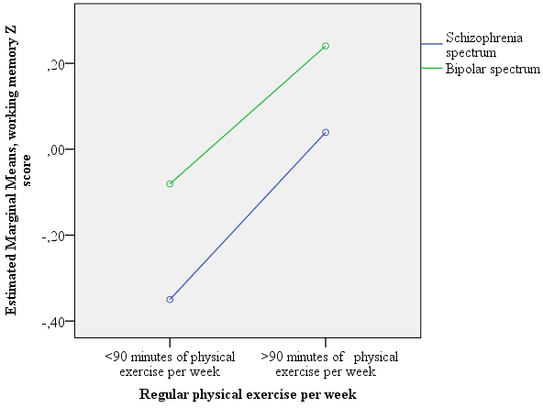

Figure S2: Physical activity and BDNF mRNA levels, divided into percentiles

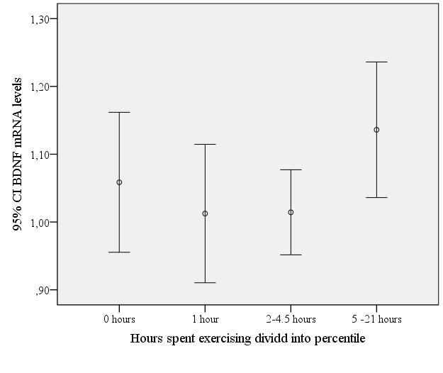

Table S1: Hours of physical activity per week is associated with better performance on
cognitive tasks

Variable Coefficient s.e. t p-value
Working memory
Physical exercise | 0.14 | 0.07 | 2.46 | 0.01
Goodness of fit |  |  |  | p˂0.001
Executive function
Physical exercise | 0.12 | 0.07 | 2.24 | 0.03
Goodness of fit |  |  |  | p˂0.001
Verbal memory
Physical exercise | 0.04 | 0.07 | 0.67 | 0.51
Goodness of fit |  |  |  | p˂0.001
General cognition (WASI)
Physical exercise | 0.04 | 0.07 | 0.72 | 0.47
Goodness of fit |  |  |  | p˂0.001
Data are corrected for age, sex, diagnosis (SZ, BD) and NART errors.

