Supporting Information

Pd(0) nanoparticles immobilized on multi-nitrogen functionalized Halloysite for promoting Sonogashira reaction: Studying the role of the number of surface nitrogens in catalytic performance

SAMAHE SADJADI, MAJID M. HERAVI*, BAHARAK MASOUMI and SHAGHAYEGH SADAT KAZEMI

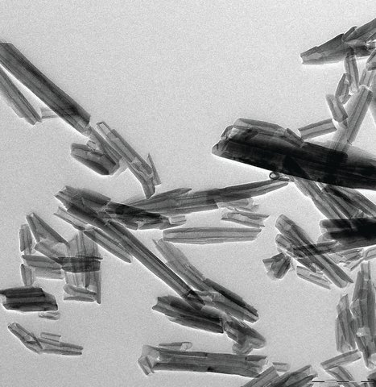
Figure S1. Reported TEM images of pure HNTs.
Reference:
https://www.sigmaaldrich.com/catalog/product/aldrich/685445?lang=en&region=IR
From Sigma-Aldrich website

¹H NMR and ¹³C NMR spectra of some selected samples:

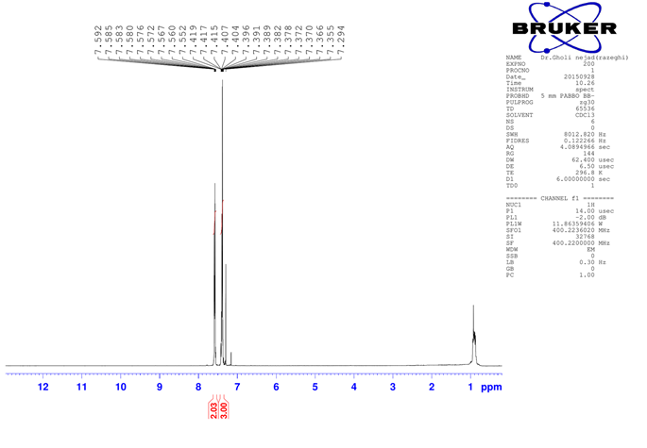
Figure S2. ¹H NMR of 1,2-diphenylethyne.

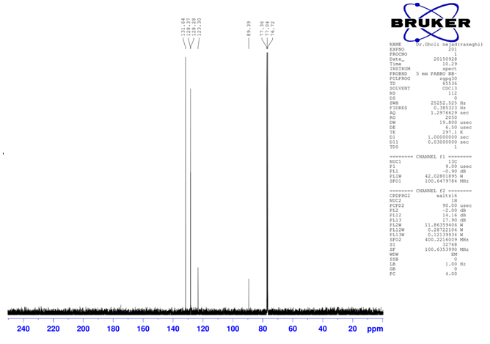
Figure S3. ¹³C NMR of 1,2-diphenylethyne.

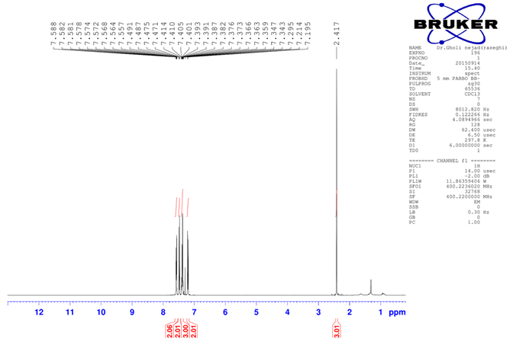
Figure S4. ¹H NMR of 1-methyl-4-(phenylethynyl)benzene.

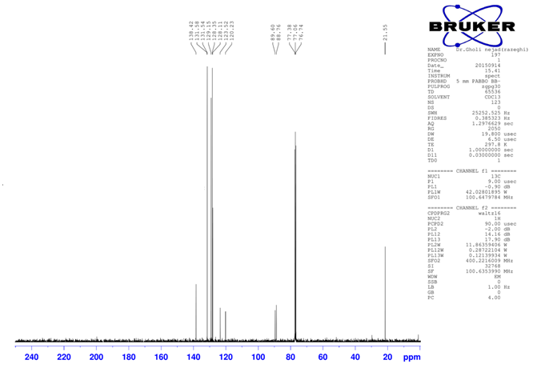
Figure S5. ¹³C NMR of 1-methyl-4-(phenylethynyl)benzene.

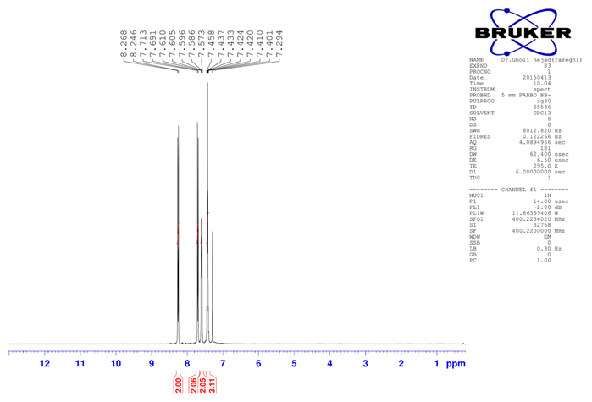
Figure S6. ¹H NMR of 1-nitro-4-(phenylethynyl)benzene.

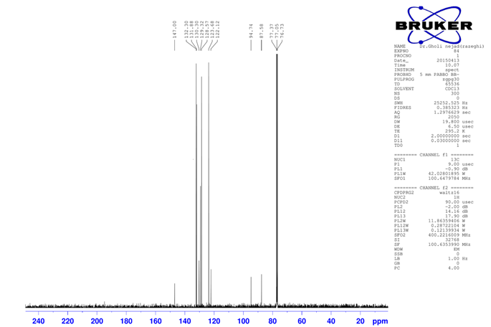
Figure S7. ¹³C NMR of 1-nitro-4-(phenylethynyl)benzene.

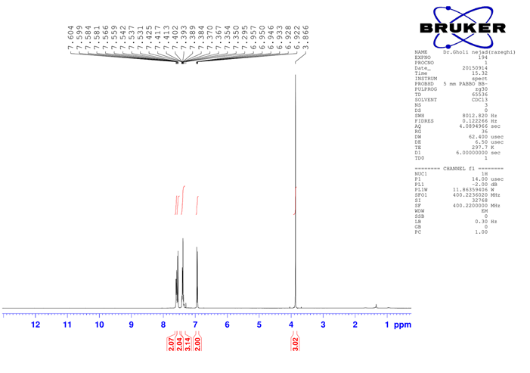
Figure S8. ¹H NMR of 1-methoxy-4-(phenylethynyl)benzene.

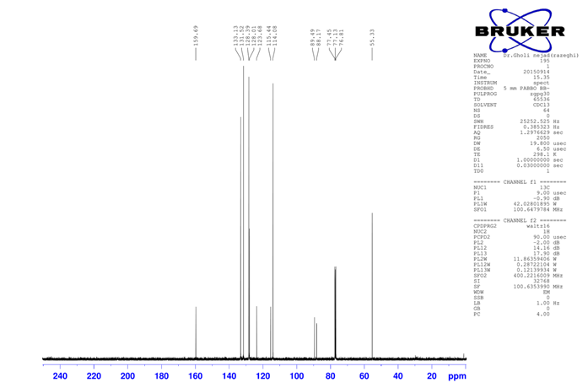
Figure S9. ¹³C NMR of 1-methoxy-4-(phenylethynyl)benzene,

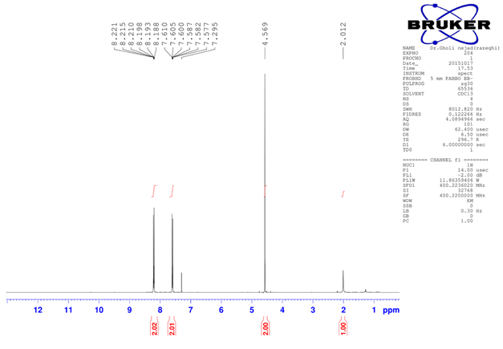
Figure S10. ¹H NMR of 3-(4-nitrophenyl)prop-2-yn-1-ol.

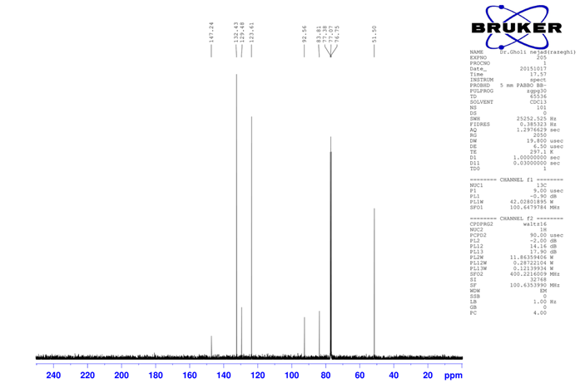
Figure S11. ¹³C NMR of 3-(4-nitrophenyl)prop-2-yn-1-ol.

