**This file contains supplementary materials of Figure S1 and Table S1.**

**Figure S1:   
Residual diagnostic plots, and AIC values, for each of the alternatively CPUE error models (main effects) of gamma inverse-link, lognormal, and normal.** (These plots can be compared with those of the final model in the text shown in Figure S2 for the gamma log-link error model, which had an AIC value of 21179.)

**Gamma inverse-link (AIC = 34192):**

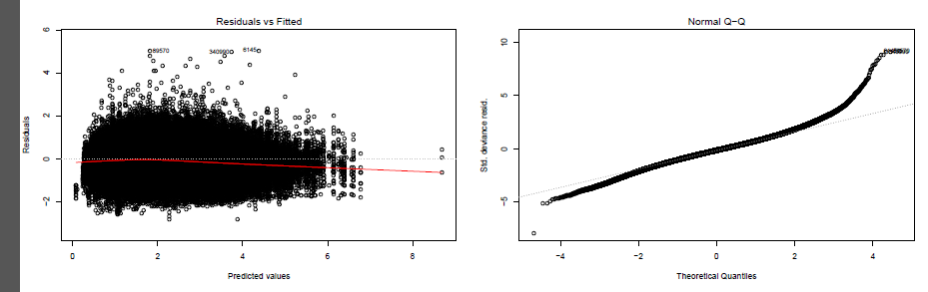

**Lognormal (AIC = 568038): Note:** AIC is not comparable to the AIC of the gamma and normal models because the dependent data is different, i.e. log(CPUE) instead of CPUE.

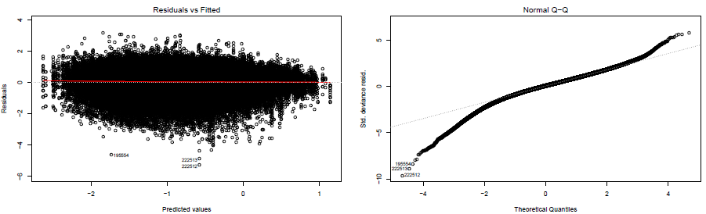

**Normal (AIC = 254637):**

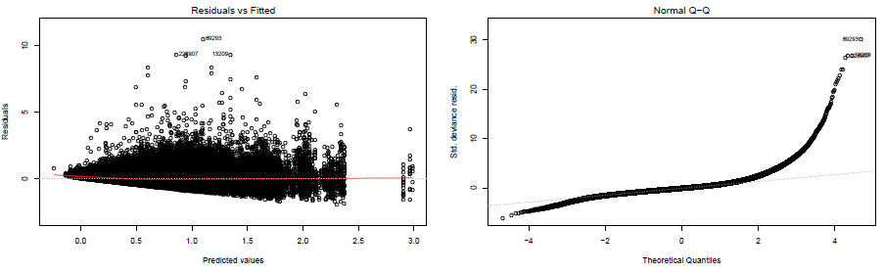

**Table S1:   
Formulae for the influence indices and other quantities described in the Methods of the text.**(The formula for *V* is presented in the text.)

|  |
| --- |
| **Influence index for the *Vessel* effect**    where= number of data points in the data set of fishing year *y*, = number of data points in the data set spanning 1978-2014, andand are estimated coefficients values of the *Vessel* effect for vesselsandrespectively. Analogous formulations apply for each of the covariate effects of *Fisher* (), *Month* (), *Region* (), and *Depth* (). Note that the definition of influence index used here is identical to that of Bentley et al (2012) equation number 4 (i.e.for variable X), which can be seen after algebraic rearrangement. |
| **Influence index for “Non-vessel” combined effects** |
| **Influence index for “All factors” combined effects (total catchability)** |
| **“Exiting” vessel influence** (continued on next page)  where = number of data points in the data set of fishing year *y* involving vessels that have been in the fishery for more than one year and that are exiting in year *y*,  = same definition as   but for year *y*-1 ,  = number of data points in the data set spanning 1979-2013 involving vessels that have been in the fishery for more than one year, and , , and are estimated coefficients values of the *Vessel* effect for vessels indexed by,, andrespectively. Analogous formulations apply for the “Entering” and “Remaining” groups of vessels. |
| **Yearly nominal CPUE**  where  = number of data points in fishing year *y*, and  and  are respectively the weight of landed lobsters and number of pot-lifts per fishing trip *i* in year *y*. |
| **Yearly standardised CPUE**  where *y1* = 1978, *y2* = 2014, *Y* = the number of years = 2014-1978+1 = 37, and is the estimated coefficient value of the *Year* effect for year *y*. |
| **AIC**  where log = natural logarithm, *L* = maximised likelihood, and *p* is the number of estimated parameters in the model. It was calculated using the “AIC()” function in R’s stats package. |
| **R2**   where  is the deviance of the null model (intercept only), and  is the deviance of the fitted model. Deviance = -2 times the maximised log-likelihood, and values for and were taken directly from the specified (in the text) model object as returned by the “glm()” function implemented in R’s stats package, specifically the object’s components “deviance” and “null.deviance”. |
| **Pearson and Spearman correlations** Formulae for these may be found in many textbooks on elementary statistics (e.g. “Statistics in a Nutshell”, 2nd edition, 2012). They were calculated using the “cor.test()” function in R’s stats package, with option “method” set to either “pearson” or "spearman". The two series input into function “cor.test()” were the *Vessel* and *Fisher* term vectors from the “fit” component of the object returned by R’s “predict()” function run with option “type” set to “terms”. |