Table 1s. Diagnoses of non-confirmed potential ALS cases (2002-2014).
Final diagnosis | N. | %
Other motor neuron diseases¹ | 42 | 28.0
Multiple sclerosis | 22 | 14.7
ALS diagnosis written but not confirmable because of clinical data insufficiency | 11 | 7.3
Pseudobulbar syndrome | 11 | 7.3
Vascular encephalopathy² | 12 | 8.0
Neuropathy³ | 9 | 6.0
Progressive sopranuclear paresis | 8 | 5.3
Multisystemic atrophy | 5 | 3.3
Wrong ICD-9-CM code | 4 | 2.7
Cervical myelopathy | 4 | 2.7
Muscular dystrophy⁴ | 3 | 2.0
Cerebral paresis with ataxia | 2 | 1.3
Cerebral ischaemia | 2 | 1.3
Myositis⁵ | 2 | 1.3
Normal pressure hydrocephalus | 1 | 0.7
Algodystrophy of nature to be determined | 1 | 0.7
Upper limb distal atrophy | 1 | 0.7
Cognitive impairment | 1 | 0.7
Hemiparesis | 1 | 0.7
Cerebral haemorrhage in a patient affected by Kennedy’s disease | 1 | 0.7
Severe neonatal hypoxic ischaemic encephalopathy | 1 | 0.7
Lower limbs hypotrophy and weakness of suspected degenerative origin | 1 | 0.7
Transverse myelitis | 1 | 0.7
Neuromyopathy of nature to be determined | 1 | 0.7
Immobilization syndrome in a patient affected by Alzheimer disease | 1 | 0.7
Pseudobulbar syndrome and parkinsonism | 1 | 0.7
Sporadic fasciculations and hand interossei muscles atrophy under observation | 1 | 0.7
Total | 150 | 100.0
¹ Other motor neuron diseases includes: Kennedy’s disease, primary lateral sclerosis, muscular spinal atrophy not otherwise specified, muscular spinal atrophy type 1, 2 or 3, upper motor neuron disease not otherwise specified, lower motor neuron disease not otherwise specified, progressive spinal amyotrophy, monomyelic amyotrophy, hereditary spastic paraplegia, pseudobulbar paralysis, progressive muscular atrophy, Brown-Vialetto-Van Laere syndrome.
² Vascular encephalopathy includes: chronic vascular encephalopathy, ictus cerebri, TIA, parkinsonism of probably neurovascular origin, normal pressure hydrocephalus, vascular encephalopathy.
³ Neuropathy includes: sensitive neuropathy, multifocal neuropathy, chronic polyneuropathy, polyneuritis, meralgia paraesthetica.
⁴ Muscular dystrophy includes: Duchenne muscular dystrophy, muscular dystrophy not otherwise specified.
⁵ Myositis includes: myositis not otherwise specified, inclusion body myositis.

Table 2s. Crude, standardized, age- and sex- specific IRs of ALS and Poisson 95% CIs (2002-2009).
 |  | IR (95%CI)
 |  | Men | Women | Total
ALS incident cases |  | 139 | 137 | 276
Person-years |  | 4,661,841.00 | 4,988,536.49 | 9,650,996.21
Crude IR |  | 2.98  (2.52-3.53) | 2.75  (2.32-3.25) | 2.86  (2.52-3.24)
Standardized¹ IR | Italy 2001 | 2.63  (2.15-3.12) | 2.36  (1.94-2.78) | 2.49  (2.27-2.72)
 | Europe 2000 | 2.27  (1.80-2.74) | 2.10  (1.55-2.64) | 2.18  (1.97-2.40)
 | USA 2010 | 2.26  (1.80-2.73) | 1.92  (1.54-2.30) | 2.09  (1.88-2.30)
Stratified for age category at diagnosis IR | <45 | 0.40  (0.19-0.74) | 0.26  (0.09-0.56) | 0.33  (0.17-0.54)
 | 45-54 | 2.25  (1.26-3.72) | 0.91  (0.33-1.98) | 1.58  (0.97-2.42)
 | 55-64 | 5.55  (3.97-7.55) | 5.03  (3.40-7.20) | 5.29  (4.15-6.72)
 | 65-74 | 10.34  (7.67-13.65) | 8.53  (6.33-11.26) | 9.36  (7.65-11.41)
 | 75-84 | 7.05  (4.31-10.86) | 7.10  (4.95-9.87) | 7.09  (5.46-9.21)
 | ≥85 | 8.41  (3.09-18.34) | 2.38  (0.77-5.55) | 3.91  (1.95-7.00)
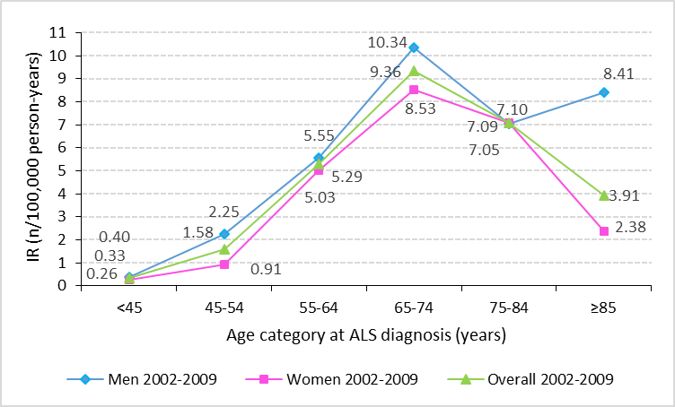

¹ Sex-specific IRs are adjusted for age, while overall IRs are adjusted for age and sex.

Table 3s. Distribution of confirmed ALS cases according to demographic and clinical characteristics (2002-2009).
 | Men (n=139) |  | Women (n=137) |  | Total (n=276)
 | n | % | n | % | n | %
Age at diagnosis
<45 years | 10 | 7.2 | 6 | 4.4 | 16 | 5.8
45-54 years | 15 | 10.8 | 6 | 4.4 | 21 | 7.6
55-64 years | 36 | 25.9 | 34 | 24.8 | 70 | 25.4
65-74 years | 52 | 37.4 | 51 | 37.2 | 103 | 37.4
75-84 years | 20 | 14.4 | 35 | 25.6 | 55 | 19.9
≥85 years | 6 | 4.3 | 5 | 3.7 | 11 | 4.0
Median | 67.0 |  | 69.0 |  | 67.0
IQR | 58-73 |  | 62-75 |  | 61-74
Mean | 65.1 |  | 67.9 |  | 66.5
Standard deviation | 12.1 |  | 11.3 |  | 11.7
Range (min.-max.) | 21-89 |  | 20-88 |  | 20-89
Familial ALS | 6 | 4.3 | 5 | 3.7 | 11 | 4.0
Genetic mutation
SOD1 | 2 | 100 | 1 | 33.3 | 3 | 60.0
SOD1 negative | 0 | 0 | 1 | 33.3 | 1 | 20.0
FUS | 0 | 0 | 1 | 33.3 | 1 | 20.0
Site of disease onset
Bulbar | 30 | 26.3 | 39 | 34.5 | 69 | 30.4
Spinal | 76 | 66.7 | 59 | 52.2 | 135 | 59.5
Bulbar and spinal | 8 | 7.0 | 15 | 13.3 | 23 | 10.1
Spinal site of onset
Cervical | 32 | 39.0 | 23 | 31.9 | 55 | 35.7
Lumbosacral | 41 | 50.0 | 32 | 44.4 | 73 | 47.4
Lumbosacral-cervical | 9 | 11.0 | 15 | 20.8 | 24 | 15.6
Thoracic | 0 | 0.0 | 2 | 2.8 | 2 | 1.3
Lumbosacral-thoracic | 0 | 0.0 | 0 | 0.0 | 0 | 0.0
Not reported | 25 |  | 24 |  | 49

Table 4s. Prevalence of ALS in different studies.
Geographical area | Period | Point prevalence
Iran ⁽⁴⁴⁾ | 21 March 2006 | 1.57
Uruguay ⁽⁴⁵⁾ | 21 March 2002 | 1.90
South-East England ⁽²⁰⁾ | 30 June 30 2006 | 4.91
New Jersey ⁽⁴⁶⁾ | 31 December 2011 | 4.97
Catalonia ⁽³³⁾ | 31 December 2001 | 5.4
Sicily ⁽²⁵⁾ | 31 December 2006 | 6.0
Liguria ⁽²⁴⁾ | 31 December 2014 | 7.85
Cyprus ⁽⁴⁷⁾ | 1 January 2015 | 7.9
FVG | 30 June 2014 | 7.98
The Netherlands ⁽³²⁾ | 31 December 2008 | 10.32
Sardinia ⁽³⁶⁾ | 31 December 2009 | 10.8
Piedmont and Valle d’Aosta ⁽²³⁾ | 31 December 2014 | 12.26

