< Supporting materials>
Studies on preparations and properties of drug-eluting embolization microspheres made from oxidated alginate and carboxymethyl chitosan
Li Guo* and Shaoxiong Qin
( College of Chemistry and Environmental Engineering, Yangtze University, Jingzhou, 434023 P.R. China )
*Email: newsci2015@163.com

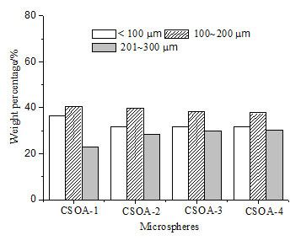
Figure S1 The size distribution for the different microspheres from CSOA-1 to CSOA-4

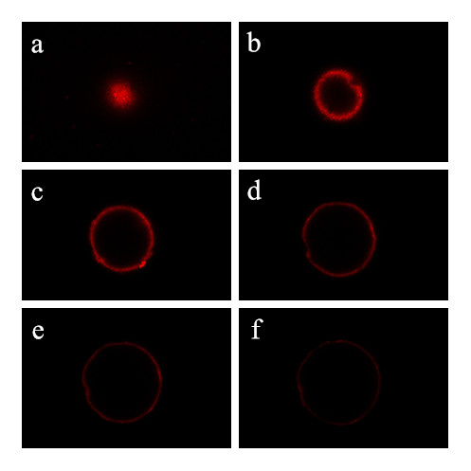
Figure S2 The confocal microscopy images of drug distribution inside the microspheres. From (a) to (f), they represent 6 sections with 20μm interval each other.

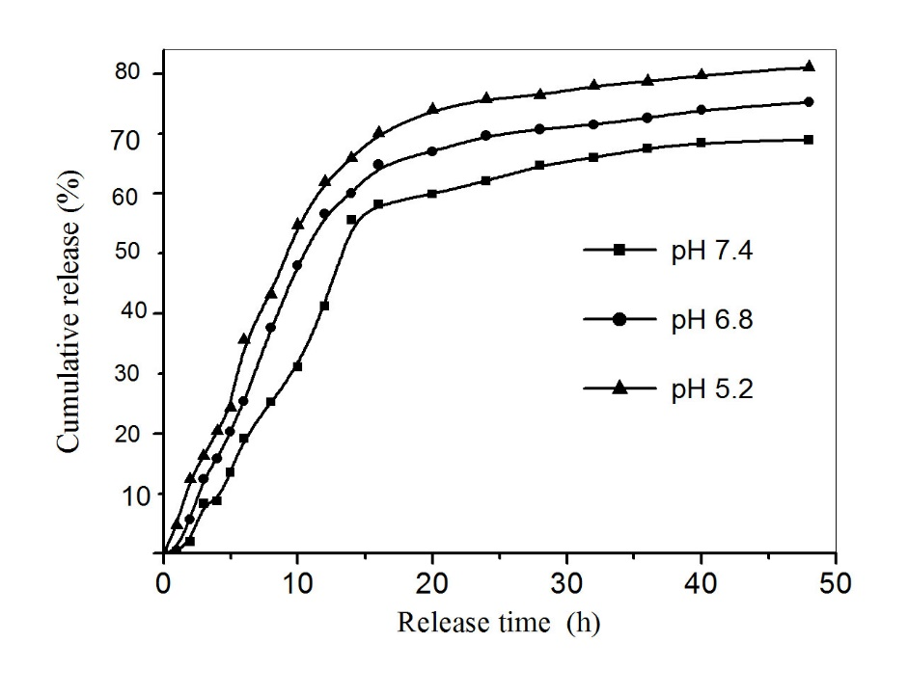
Figure S3 In vitro drug release profiles of the microspheres in different pH PBS solutions

Figure S4 Cell viability of 3T3 after incubation with the leaching solutions of different microspheres

