**Supplementary material**

**In silico studies on potential TNKS inhibitors: a combination of pharmacophore and 3D-QSAR modeling, virtual screening, molecular docking and molecular dynamics**

Jianxin Liu, Kairui Feng, Yujie Ren*

*School of Chemical and Environmental Engineering, Shanghai Institute of Technology, Shanghai 201418, China*

**\*Corresponding author**

**E-mail:** [clab@sit.edu.cn](mailto:clab@sit.edu.cn)

**Table S1.** The PLS statistical results of CoMFA and CoMSIA model

|  |  |  |  |  |  |  |  |  |  |  |  |
| --- | --- | --- | --- | --- | --- | --- | --- | --- | --- | --- | --- |
|  |  | q2 | r2 | SEE | F | ONC | Contribution |  |  |  |  |
|  |  |  |  |  |  |  | S | E | H | D | A |
| CoMFA-SE |  | 0.701 | 0.968 | 0.218 | 106.107 | 6 | 0.725 | 0.275 | - | - | - |
| Topomer CoMFA-SE |  | 0.692 | 0.979 | 0.179 | 138.505 | 6 | - | - | - | - | - |
| CoMSIA-SE |  | 0.449 | 0.865 | 0.438 | 28.196 | 5 | 0.497 | 0.503 | - | - | - |
| CoMSIA-SH |  | 0.584 | 0.989 | 0.133 | 251.011 | 7 | 0.545 | - | 0.455 | - | - |
| CoMSIA-SD |  | 0.684 | 0.964 | 0.244 | 63.076 | 8 | 0.931 | - | - | 0.069 | - |
| CoMSIA-SA |  | 0.653 | 0.995 | 0.094 | 354.883 | 10 | 0.477 | - | - | - | 0.523 |
| CoMSIA-HA |  | 0.313 | 0.677 | 0.635 | 26.208 | 2 | - | - | 0.410 | - | 0.587 |
| CoMSIA-SHE |  | 0.444 | 0.736 | 0.587 | 22.261 | 3 | 0.325 | 0.260 | 0.416 | - | - |
| CoMSIA-SEA |  | 0.621 | 0.997 | 0.077 | 625.776 | 10 | 0.299 | 0.300 | - | - | 0.401 |
| CoMSIA-SED |  | 0.539 | 0.903 | 0.380 | 32.592 | 6 | 0.501 | 0.444 | - | 0.055 | - |
| CoMSIA-SHD |  | 0.528 | 0.986 | 0.146 | 207.618 | 7 | 0.538 | - | 0.425 | 0.037 | - |
| CoMSIA-SHA |  | 0.573 | 0.983 | 0.164 | 163.583 | 7 | 0.291 | - | 0.270 | - | 0.439 |
| CoMSIA-SDA |  | 0.592 | 0.907 | 0.355 | 56.112 | 4 | 0.392 | - | - | 0.157 | 0.451 |
| CoMSIA-SEHD |  | 0.441 | 0.737 | 0.586 | 22.388 | 3 | 0.302 | 0.238 | 0.380 | 0.080 | - |
| CoMSIA-SEHA |  | 0.572 | 0.991 | 0.121 | 265.454 | 8 | 0.227 | 0.194 | 0.211 | - | 0.368 |
| CoMSIA-SHDA |  | 0.537 | 0.936 | 0.295 | 84.281 | 4 | 0.252 | - | 0.249 | 0.098 | 0.402 |
| CoMSIA-SEDA |  | 0.557 | 0.998 | 0.058 | 934.247 | 10 | 0.289 | 0.283 | - | 0.078 | 0.351 |
| CoMSIA-SEHDA |  | 0.555 | 0.999 | 0.048 | 1345.468 | 10 | 0.202 | 0.204 | 0.206 | 0.064 | 0.323 |

**Table S2**. The docking score of the Compound in the data set

|  |  |  |  |  |
| --- | --- | --- | --- | --- |
|  |  |  |  |  |
|  |  |  |  |  |
| No | R1 | R2 | R3 | Docking Score |
| 1 | Me | H | H | 3.564 |
| 2 | H | Me | H | 3.698 |
| 3 | H | H | Me | 5.507 |
| 4 | H | H | Isopropyl | 7.311 |
| 5 | H | H | CN | 5.383 |
| 6 | H | H | CI | 5.151 |
| 7a | H | H | F | 5.113 |
| 8 | H | H | CO2H | 4.492 |
| 9 | H | H | N(Me)2 | 5.814 |
| 10 | H | H |  | 7.334 |
| 11 | H | H |  | 7.723 |
| 12 | H | H |  | 5.707 |
| 13 | H | H |  | 7.152 |
| 14 | H | H |  | 7.437 |
| 15 | H | H |  | 7.909 |
| 16 | H | H |  | 5.136 |
| 17 | H |  | H | 3.786 |
| 18 | H | H |  | 8.312 |
|  |  |  |  |  |
|  |  |  |  |  |
|  |  |  |  |  |
| No | R1 | R2 | R | Docking Score |
| 19 | H | H |  | 5.627 |
| 20 | H | H |  | 6.169 |
| 21a | H | H |  | 8.896 |
| 22 | H | H |  | 6.827 |
| 23a | H | H |  | 5.680 |
| 24 | H | H |  | 7.098 |
| 25 | H | H |  | 6.412 |
| 26 | H | H |  | 7.321 |
| 27a | H | H |  | 6.850 |
| 28a | H | H |  | 7.893 |
| 29 | H | H |  | 7.236 |
| 30 | H | H |  | 7.612 |
| 31 | H | H |  | 7.102 |
| 32 | H | H |  | 6.599 |
| 33 | H | H |  | 7.353 |

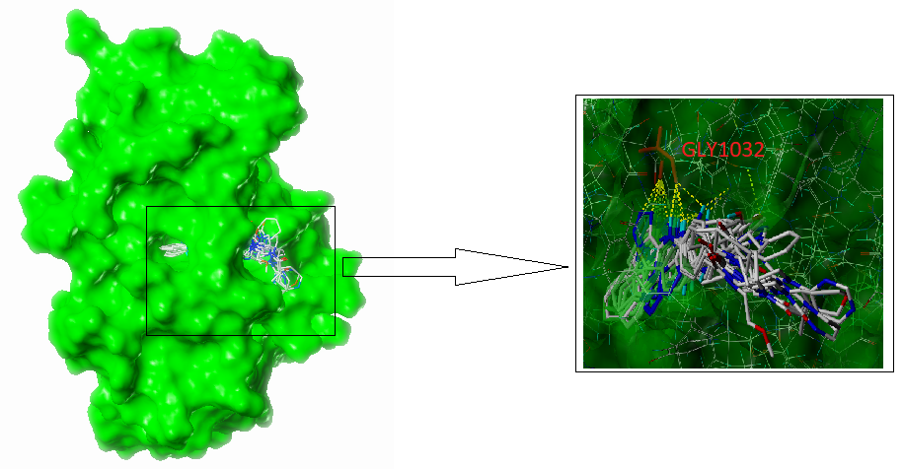

**Fig. S1** Docking results of all the compounds in the study and Surface of the binding site (5DCZ).

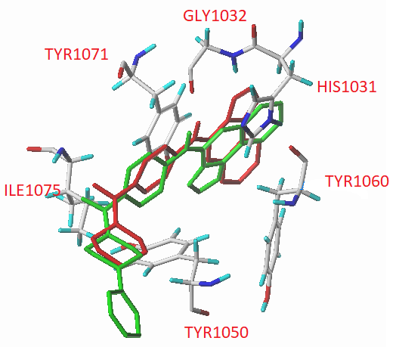

**Fig. S2** The docking results of compound 24 overlapping with the ligand molecules of the original protein.

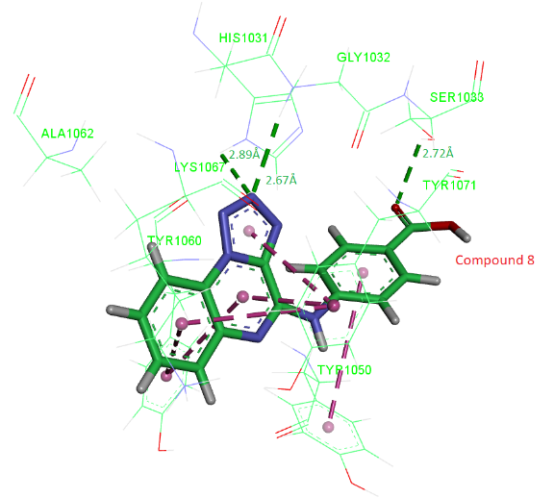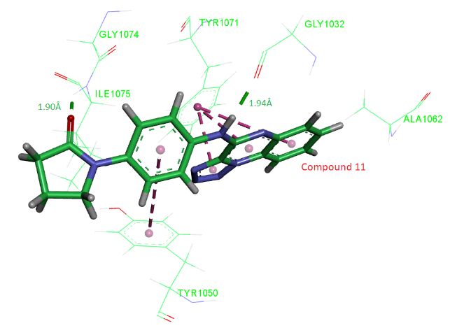

A B

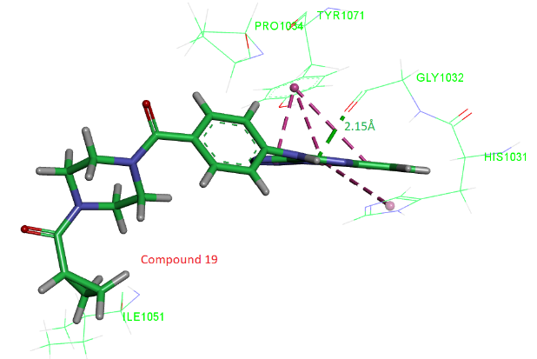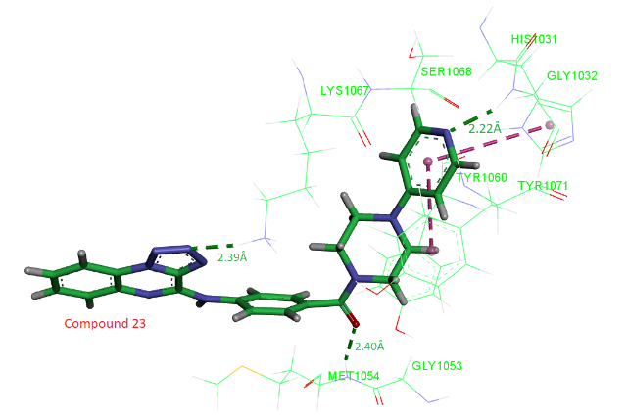

C D

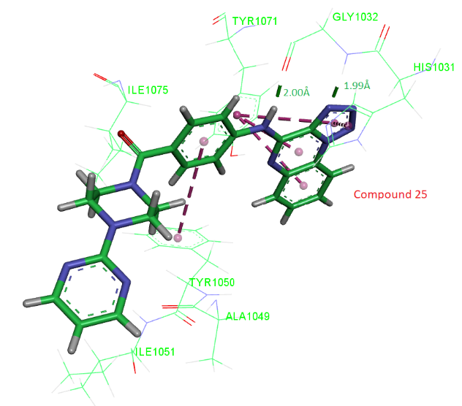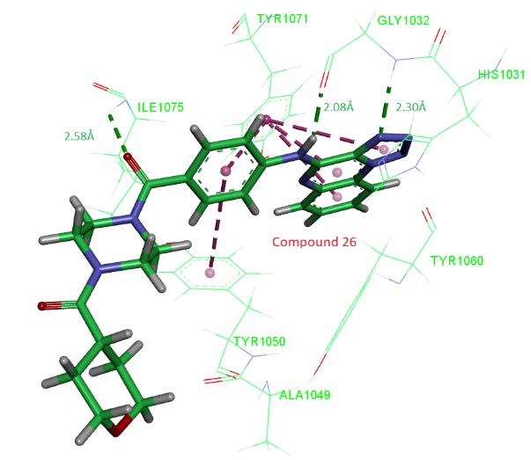

E F

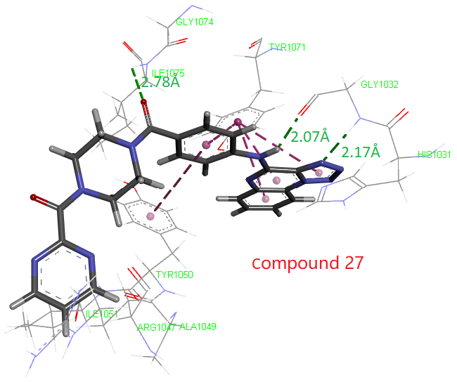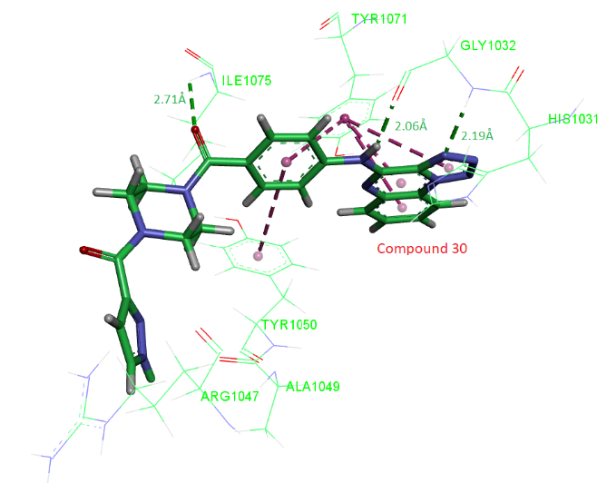

G H

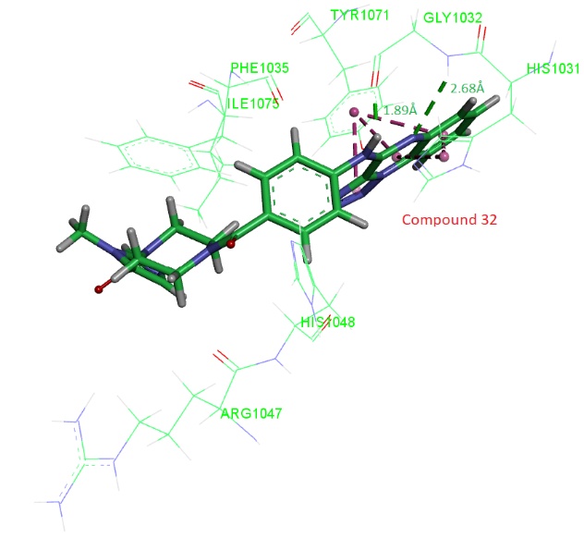 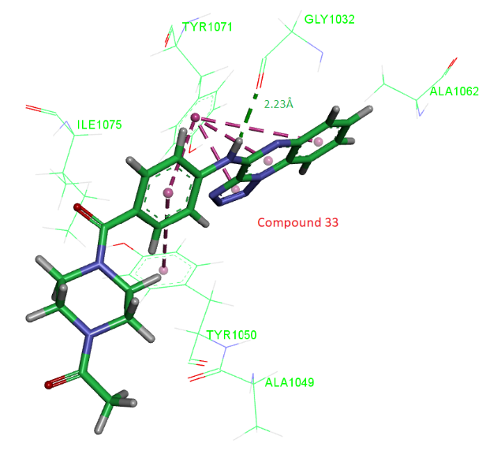

**J K**

**Fig. S3** The docking results of compound 8(A),compound 11(B), compound 19(C), compound 23(D), compound 25(E), compound 26(F), compound 27(G), compound 27(H), compound 30(I), compound 32(J), compound 33(K).



**Fig. S4** Average root-mean-square displacement (RMSD) of the backbone atoms of the ligands-5DCZ complexes (31, TS1,TS2, co-crystallized ligand) versus time.



**Fig. S5** Average root-mean-square fluctuation (RMSF) of the backbone atoms of the ligands-5DCZ complexes (31, TS1, TS2 and co-crystallized ligand) versus residue numbers. The residues a, b, c, d, e. f, g, are HIS1031,GLY1032,SER1033,PHE1035,ILE1051,GLY1052,ILE1075.