Supplementary material:

Arachidonic acid cause lysis of blood cells and ADP-dependent platelet activation responses in platelet function tests.
Sofia Ramström

Supplementary figure S1:
Supplementary figure S1: PRP aggregation in response to arachidonic acid is also partly dependent on ADP. The Multiplate® ASPItest reagent (AA) was used in citrated PRP from normal donors, with or without pre-treatment with the ADP P2Y12 receptor inhibitor cangrelor (10 µM) or aspirin (ASA, 100 µM) (n=4-8). LTA aggregation in response to AA was also evaluated in hirudinized PRP, where responses were much lower than in citrated PRP. Samples with saline solution (NaCl) added instead of agonist are included as reference. Symbols show results for each individual, mean and standard error of the mean (SEM) is also indicated.

Supplementary figure S2:
Typical photos of flow cytometry tubes from the experiments in Figure 3 and 4:
Immediately after dilution:
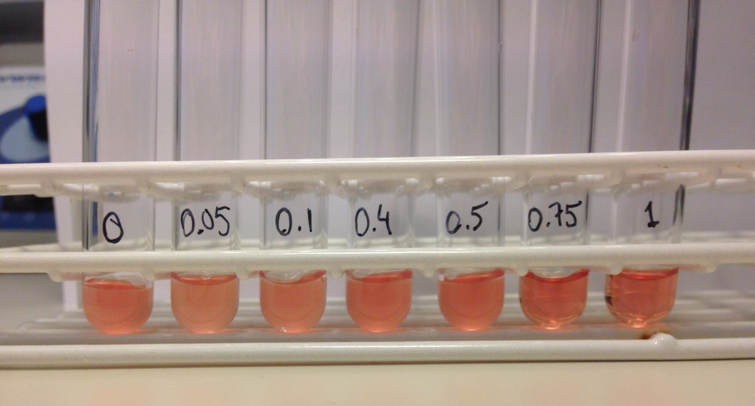

40 minutes after dilution:
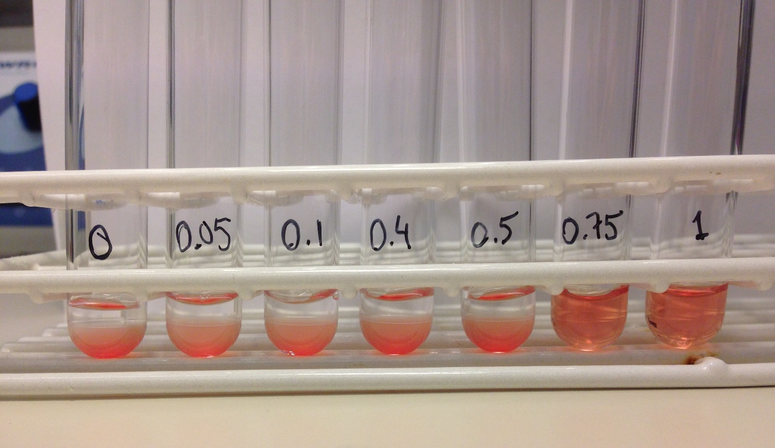
Supplementary figure S3:
Supplementary Figure S3. Arachidonic acid-induced responses with PBS buffer, longer incubation time and different anticoagulants. Change in number of detected platelet-sized CD41-positive particles (filled symbols) and P-selectin exposure on these particles (open symbols) in A) whole blood anticoagulated with hirudin, B) PRP from hirudinized blood and C) PRP from citrated blood. Blood was collected from normal donors, diluted in PBS and treated with increasing concentrations of AA for 10 minutes at 37 degrees followed by 20 minutes at room temperature before final dilution in PBS and analysis by flow cytometry (n=5). Except for the buffer and incubation times, the protocol used was the same as described in the main manuscript. The graphs show mean and standard error of the mean (SEM).

