Supplementary material

3D structure of a Brucella melitensis porin: molecular modelling in lipid membranes
Maximilien Lopes-Rodrigues^{a,b,c,d}, David Zanuy^{c}, Carlos Alemán^{c,d}, Catherine Michaux^{a,b,e*}, Eric A. Perpète^{a,b,f*}
Corresponding author:
E-mail: maximilien.lopesrodrigues@unamur.be, Phone: 0032 81 72 45 57
ª Laboratoire de Chimie Physique des Biomolécules, Unité de Chimie Physique Théorique et Structurale (UCPTS), University of Namur, Rue de Bruxelles, 61, 5000 Namur, Belgium.
^{b} Namur Institute of Structured Matter, University of Namur, Rue de Bruxelles, 61, 5000 Namur, Belgium.
^{c} Departament d’Enginyeria Química, EEBE, Universitat Politècnica de Catalunya, C/Eduard Maristany, 10-14, Ed. I2, 08019, Barcelona, Spain.
^{d} Barcelona Research Center for Multiscale Science and Engineering, Universitat Politècnica de Catalunya, Eduard Maristany, 10-14, 08019, Barcelona, Spain.
^{e} Namur Research Institute for Life Sciences, University of Namur, Rue de Bruxelles, 61, 5000 Namur, Belgium.
^{f} Institute of Life-Earth-Environment, University of Namur, Rue de Bruxelles, 61, 5000 Namur, Belgium.

*C. Michaux and E.A. Perpète contributed equally to this work.

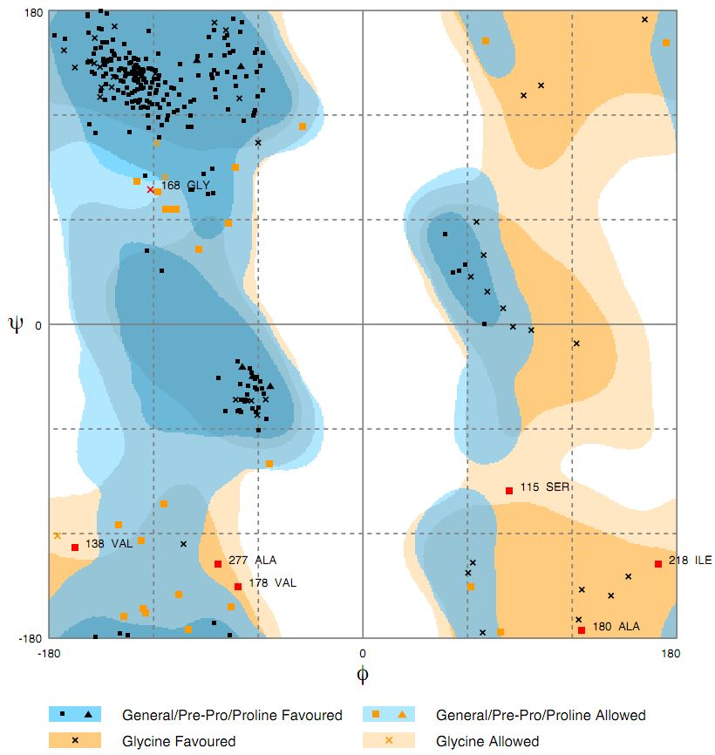
Figure S1: Ramachandran plot of the Omp2a 3D structure built by RaptorX.

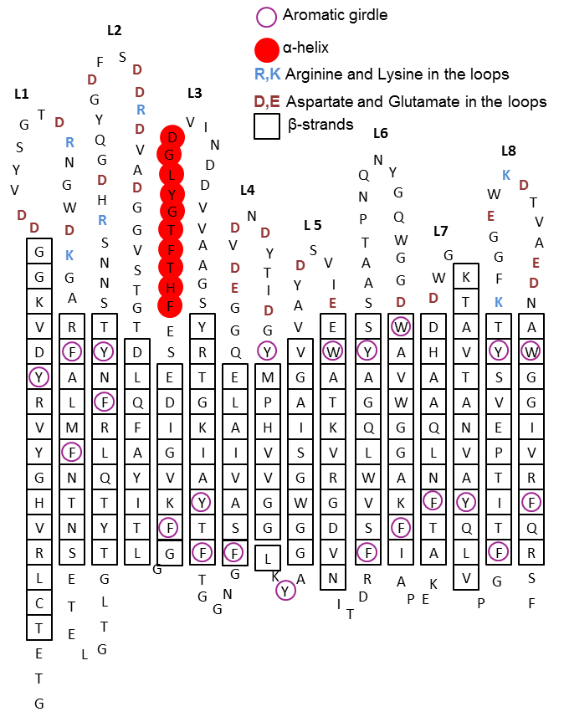
Figure S2: Omp2a topology of the predicted model of Omp2a.

Figure S3: Plot of the minimum radius of the Omp2a channel along the main axis of the protein. The radius was calculated by HOLE using a water probe with a radius of 1.45 Å. The constriction zone of a radius of 3.72 Å is found at Z = 0 Å.

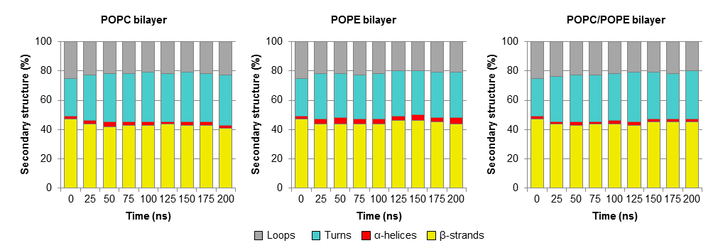
Figure S4: Percentage of secondary structure for the three bilayers POPC, POPE and POPC/POPE. β-strands are represented in yellow, α-helices in red, turns in cyan and loops in grey. The secondary structure was calculated by DSSP for each monomer and averaged for each time.

