Hydrolysis kinetics of silane coupling agents studied by near-infrared spectroscopy plus partial least squares model
Qianqian Zhai^{a,*}, Zhihua Luª, Jing Wangª, Weina Wangª, Yudong Maª, Caili Yue^{b}, and Yanling Zhao^{b}
ªDepartment of Physics and Information Engineering, Jining University, Jining 273155, People’s Republic of China
^{b}School of Materials Science and Engineering, Shandong University, Jinan 250061, People’s Republic of China
Email: nobelqqzhai_2012@163.com
Supplemental Materials

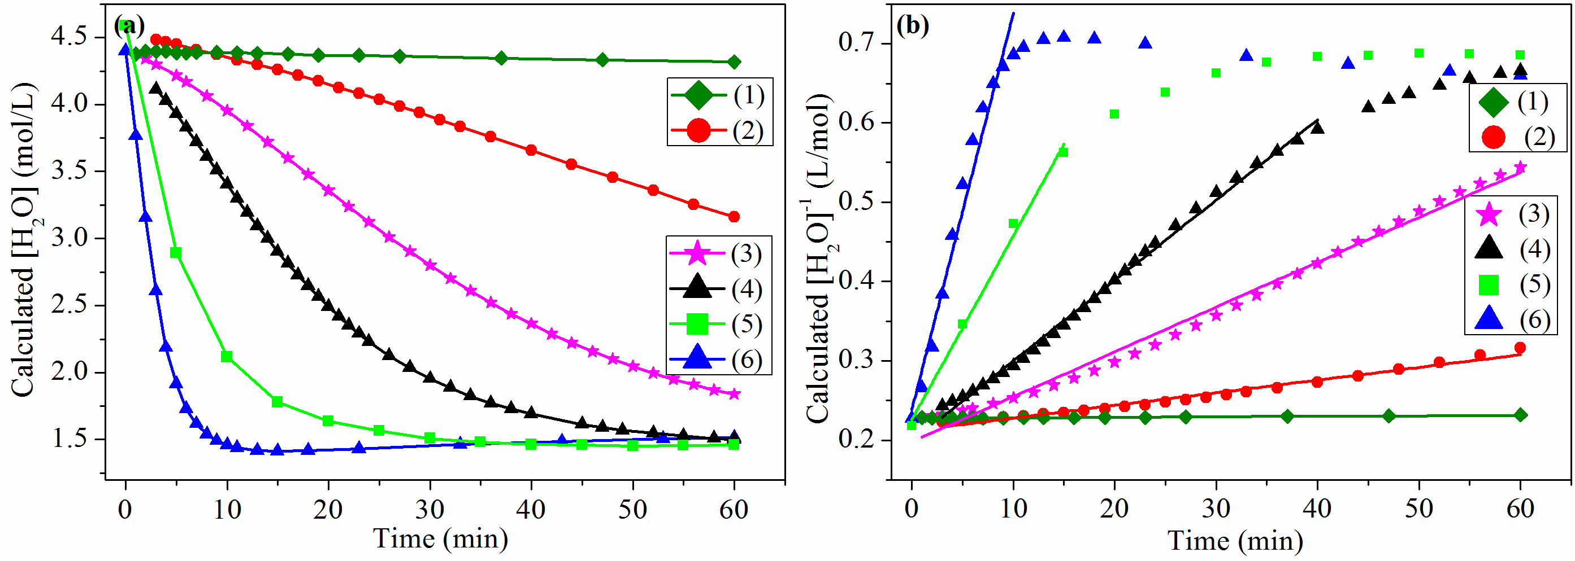
Figure S 1: Calculated [H₂O] (a) and [H₂O]⁻¹(b) during the hydrolysis processes of VTES at 15 ºC with different [H⁺]: (1) 0, (2) 1.43x10⁻⁴ mol/L, (3) 2.86x10⁻⁴ mol/L, (4) 5.71x10⁻⁴ mol/L, (5) 1.31x10⁻³ mol/L, (6) 2.86x10⁻³ mol/L.
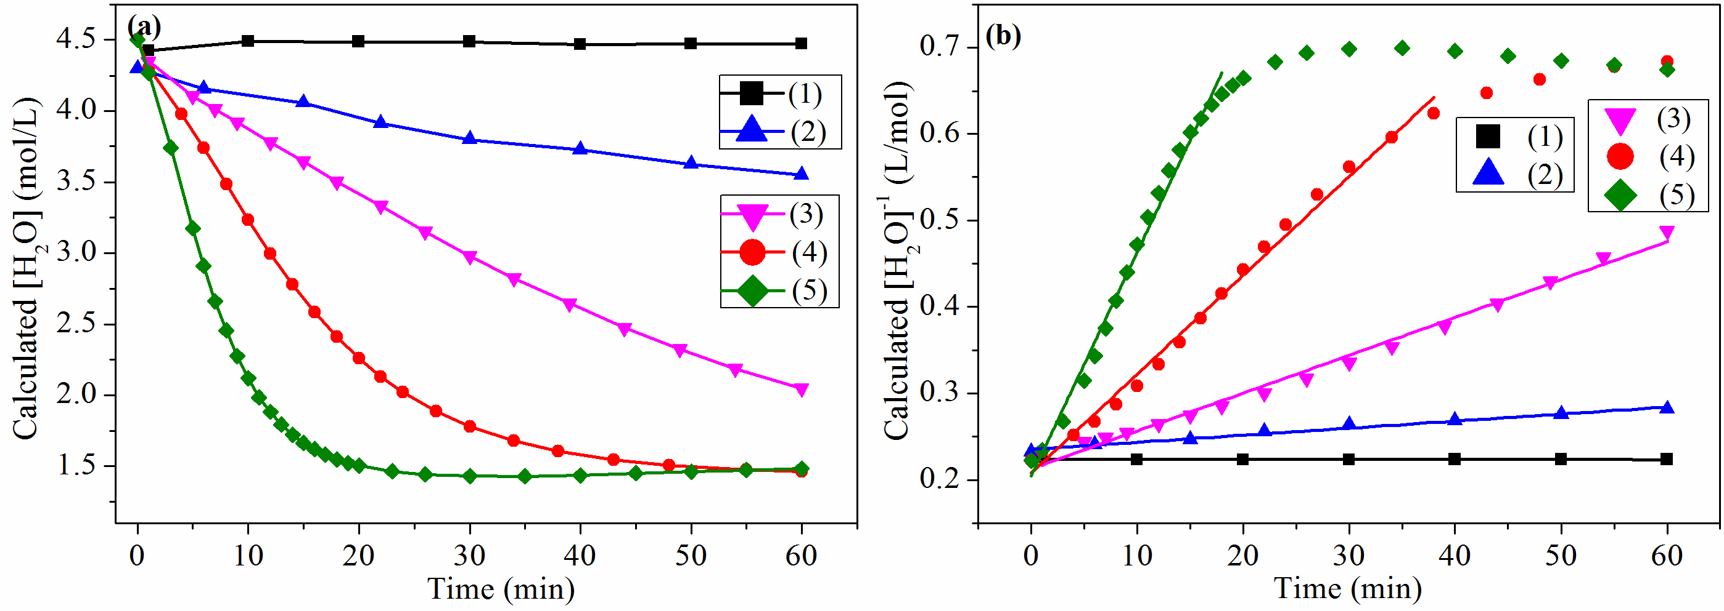
Figure S 2: Calculated [H₂O] (a) and [H₂O]⁻¹(b) during the hydrolysis processes of 3-MTES at 15 ºC with different [H⁺]: (1) 0, (2) 2.63x10⁻⁴ mol/L, (3) 5.26x10⁻⁴ mol/L, (4) 1.31x10⁻³ mol/L, (5) 2.63x10⁻³ mol/L.

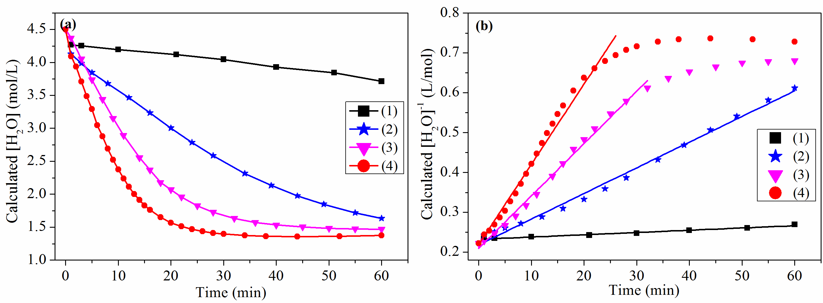
Figure S 3: Calculated [H₂O] (a) and [H₂O]⁻¹(b) during the hydrolysis processes of 3-CTES at 15 ºC with different [H⁺]: (1) 0, (2) 5.28x10⁻⁴ mol/L, (3) 1.31x10⁻³ mol/L, (4) 2.64x10⁻³ mol/L.

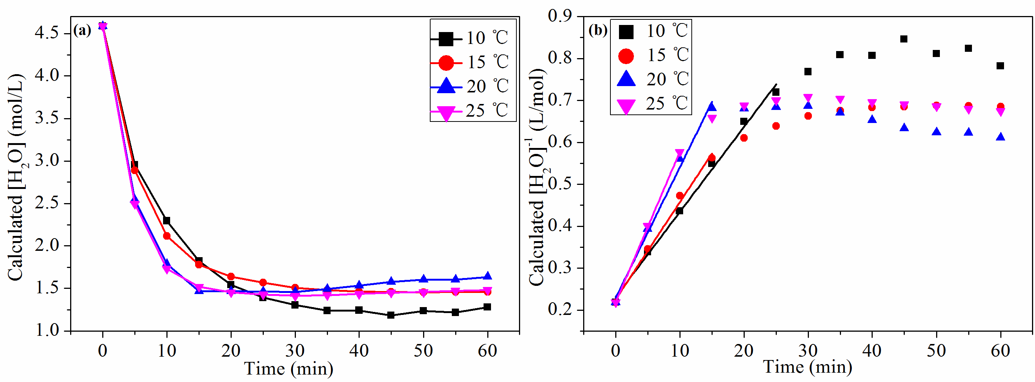
Figure S 4: Calculated [H₂O] (a) and [H₂O]⁻¹(b) during the hydrolysis processes of VTES under different temperatures and [H⁺] is 1.31×10⁻³ mol·L⁻¹.

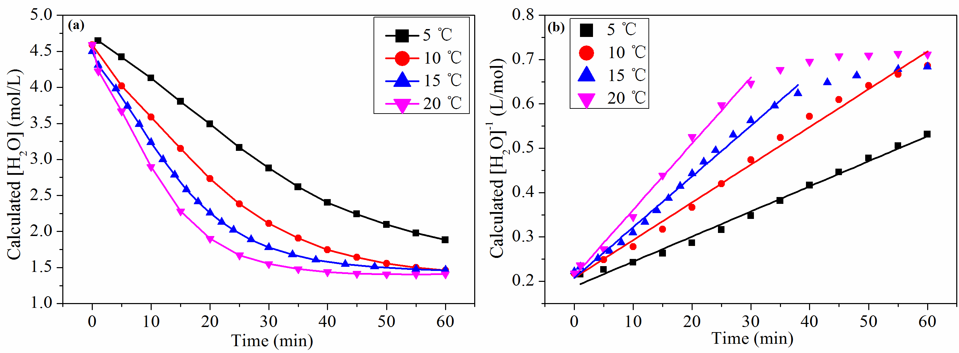
Figure S 5: Calculated [H₂O] (a) and [H₂O]⁻¹(b) during the hydrolysis processes of 3-MTES under different temperatures and [H⁺] is 1.31×10⁻³ mol·L⁻¹.

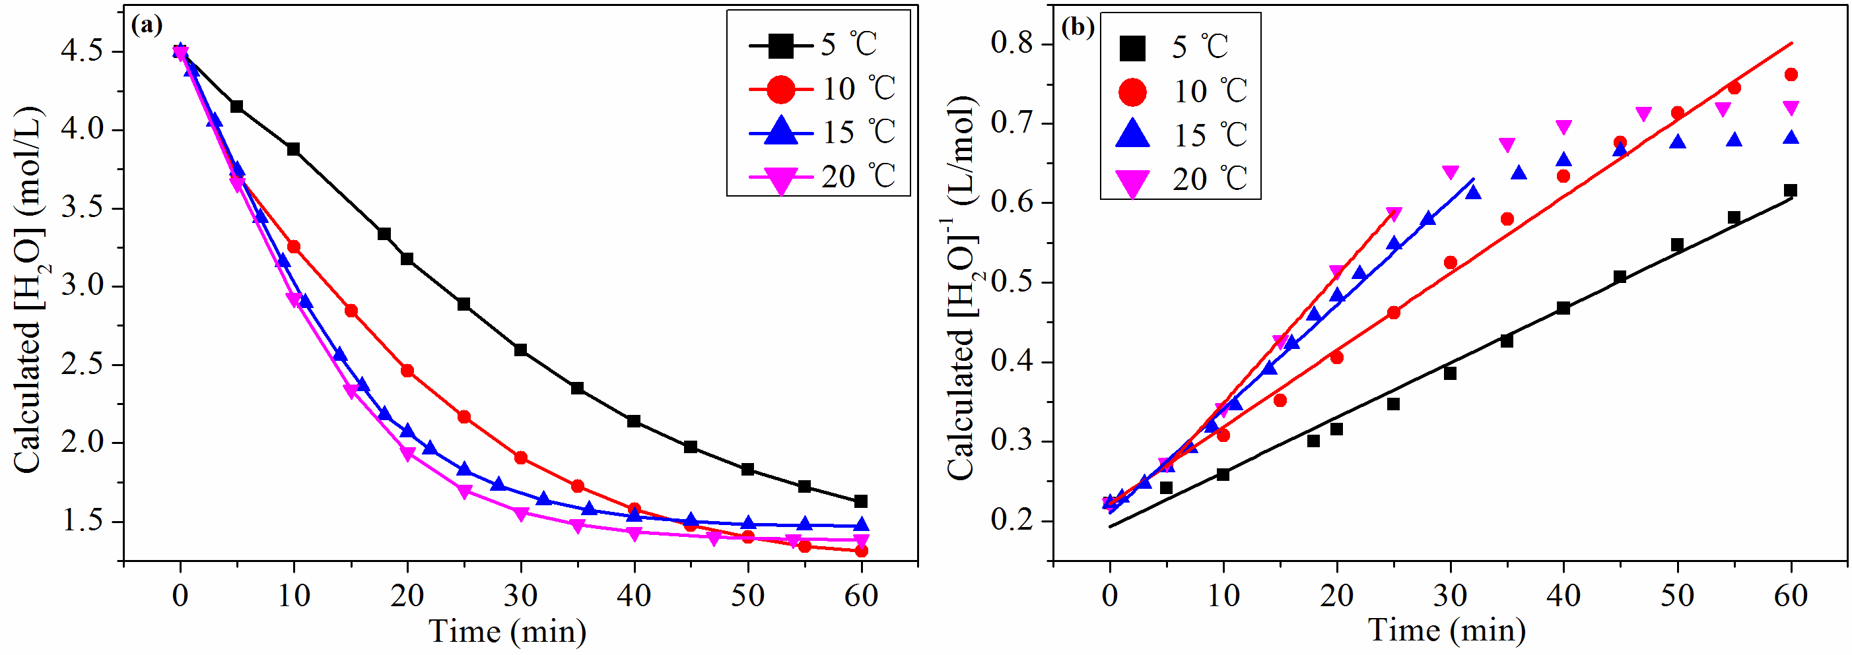
Figure S 6: Calculated [H₂O] (a) and [H₂O]⁻¹(b) during the hydrolysis processes of 3-CTES under different temperatures and [H⁺] is 1.31×10⁻³ mol·L⁻¹.

