Table A1. Sample of steering-induced rollover crash touchdown conditions.
Case ID | Roll Rate (deg/s) | Pitch Rate (deg/s) | Yaw Rate (deg/s) | Roll Angle (deg) | Pitch Angle (deg) | Yaw Angle (deg) | X Velocity (m/s) | Y Velocity (m/s) | Z Velocity (m/s)
1000 | 245.1 | -96.0 | 30.3 | 141.0 | -2.8 | -117.6 | 10.3 | -6.6 | 2.7
1032 | 265.1 | -25.0 | 73.9 | 201.6 | -3.3 | -126.5 | 7.8 | -5.6 | 3.7
1807 | 244.0 | -90.4 | 44.5 | 153.0 | 1.3 | -121.7 | 10.3 | -6.6 | 1.1
3000 | 362.2 | -75.8 | 45.9 | 162.1 | 15.7 | -43.7 | 27.5 | 1.5 | 1.2
3004 | 271.6 | -24.1 | 53.5 | 166.4 | 0.9 | -22.9 | 29.4 | 6.3 | 3.4
3012 | 248.5 | -48.3 | 35.2 | 159.5 | 7.2 | -21.0 | 33.2 | 6.5 | 3.3
3016 | 277.8 | -63.8 | 19.6 | 152.9 | 12.4 | -30.8 | 26.5 | -0.1 | 1.2
3036 | 223.9 | -45.9 | 13.4 | 140.7 | 7.2 | -14.5 | 27.8 | 5.8 | 3.3
3050 | 248.4 | -63.7 | 13.7 | 134.5 | 9.6 | -26.3 | 30.9 | 4.8 | 3.1
3053 | 330.0 | -43.2 | 58.7 | 192.0 | 18.1 | -48.5 | 26.4 | -2.0 | 1.1
3143 | 294.5 | -60.6 | 35.4 | 162.9 | 11.0 | -27.2 | 28.2 | 2.0 | 1.8
3151 | 148.8 | -17.5 | -20.5 | 96.7 | 6.7 | -8.4 | 28.5 | 2.3 | 2.4
1662/1684 | 244.0 | -11.0 | 46.0 | 145.0 | -7.6 | -62.0 | 10.1 | -1.9 | 1.7

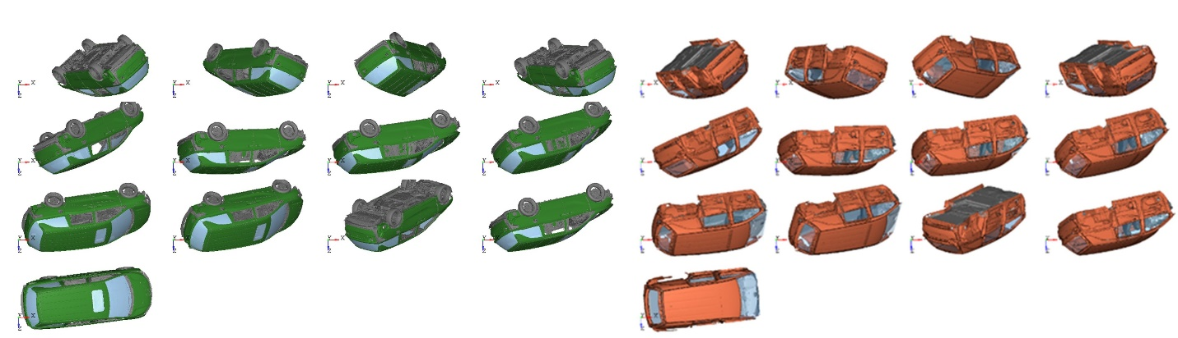
Figure A1. Touchdown conditions for the FE rollover simulations based on real-world data (left), and corresponding MADYMO simulations (right).

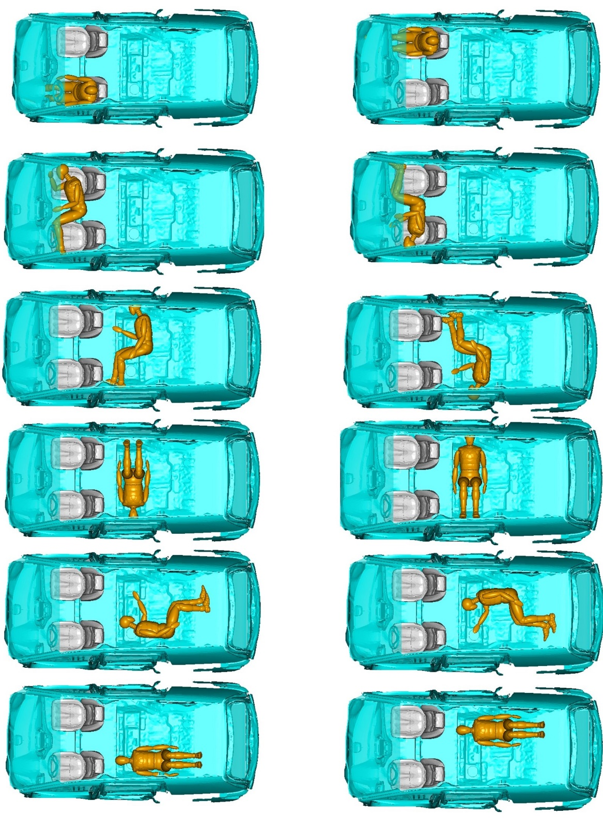
Figure A2. Occupant initial positions.
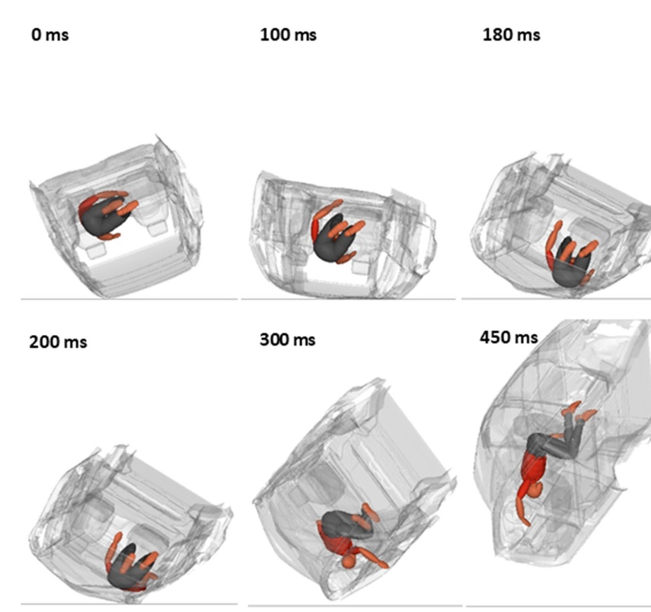
Figure A3. Rollover sequence for the worst case impact scenario, torso posterior impact.
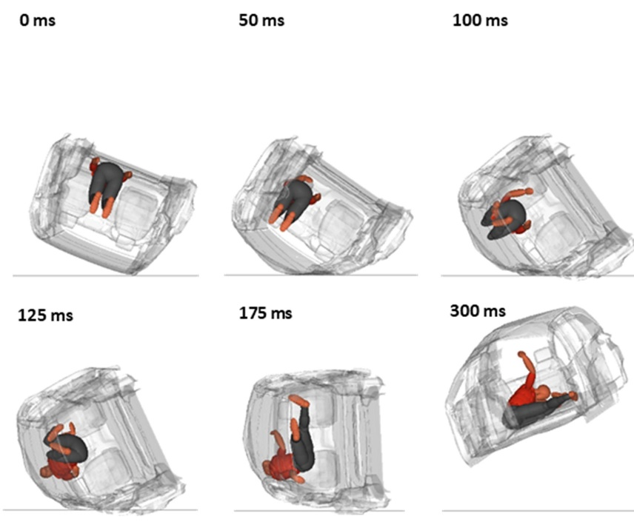
Figure A4. Rollover sequence for the second worst case impact scenario, knee impact.

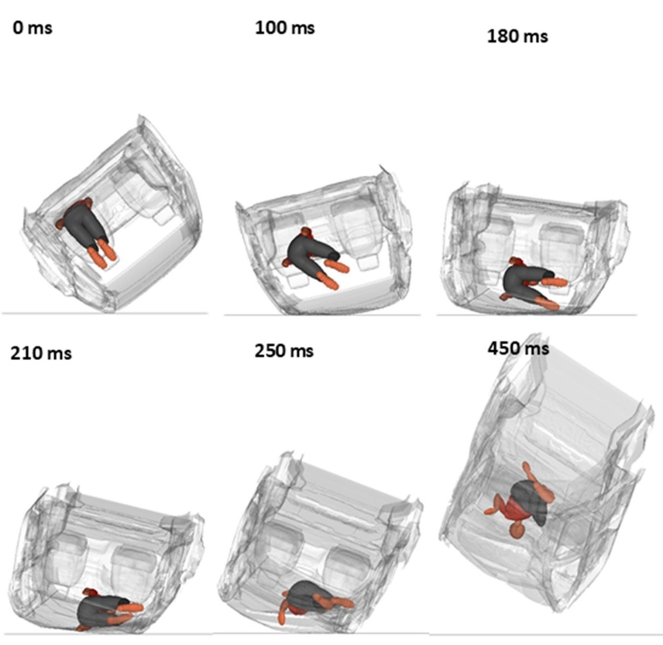
Figure A5. Rollover sequence for the third worst case impact scenario, side impact.
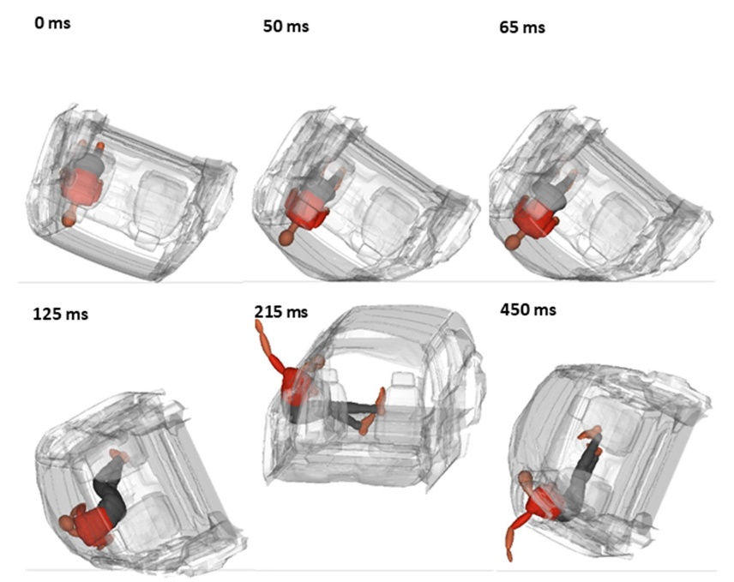
Figure A6. Rollover sequence for the fourth worst case impact scenario, head impact.
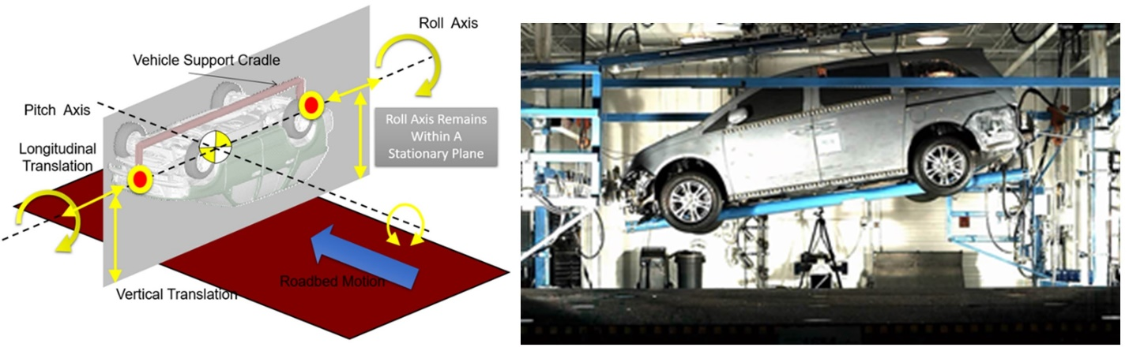
Figure A7. Dynamic rollover test system (Kerrigan et al. 2011) and associated experiment.
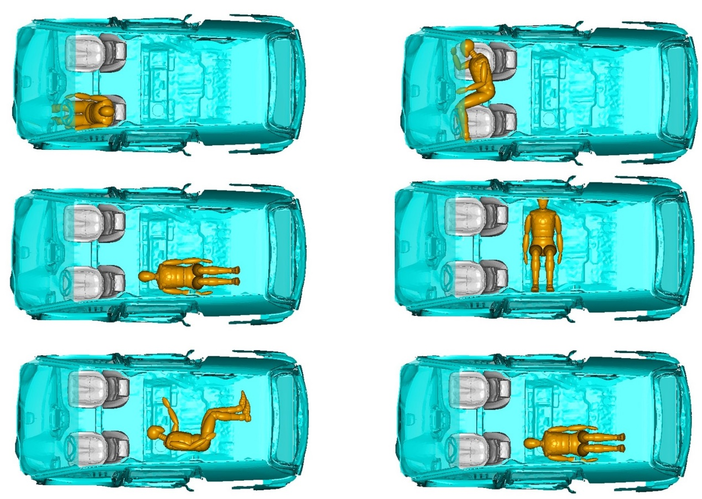
Figure A8. Simulated ATDs positions in DRoTS.

Table A2. Test matrix for DRoTS simulations.
Variables | Parameters
Dummies | 95th | 50th | 5th | 6YO
Positions | 1 | 2 | 3 | 4 | 5 | 6
Roll direction | Driver leading | Passenger leading
Roll rate [deg/s] | 180 | 225 | 270 | 315 | 360
Rotation Angle To Peak Acceleration [deg] | 82 | 126
Acceleration Timing (degree of rotation at peak acceleration) [deg] | 90 | 110 | 130 | 150 | 170 | 190
Total: 2640 simulations

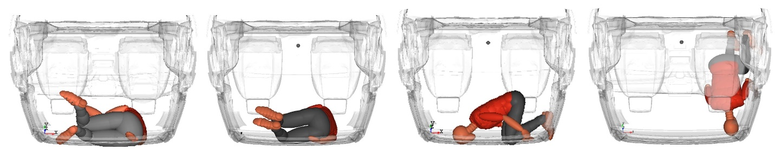
Figure A9. Four of the worst-case ATD-to-roof postures, identified based on MADYMO DRoTS simulations.

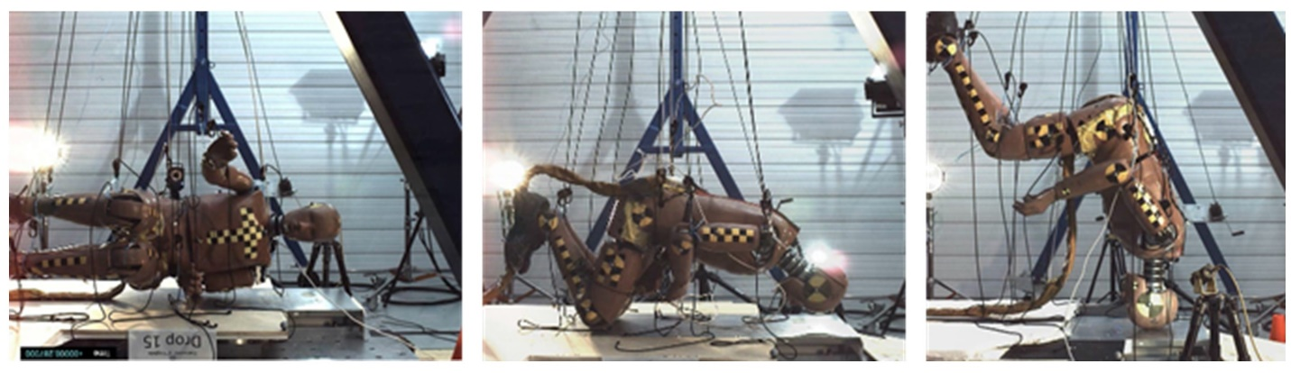
Figure A10. Drop tests conditions with 50th %ile ATD.

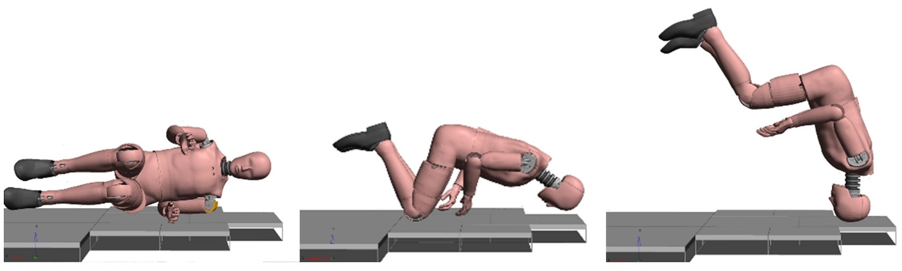
Figure A11. FE model test setup used for ATD drop tests.
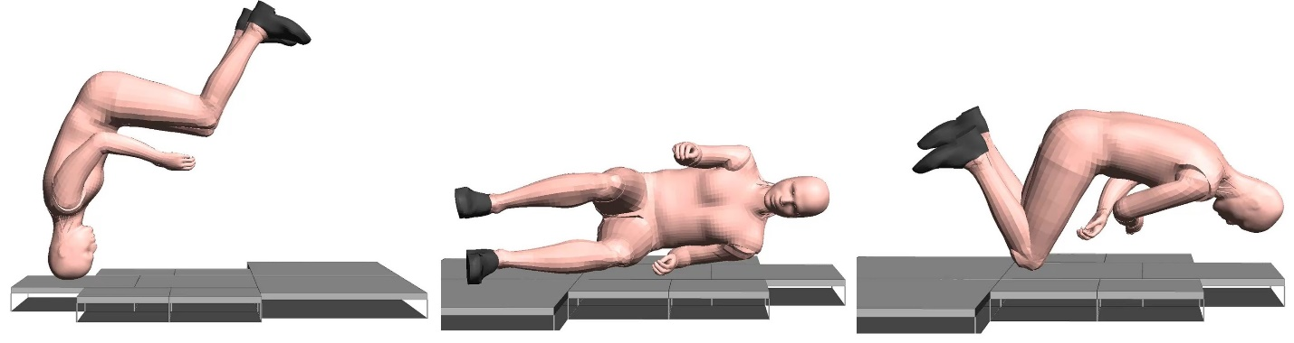
Figure A12. FE model test setup used for GHBMC drop tests.

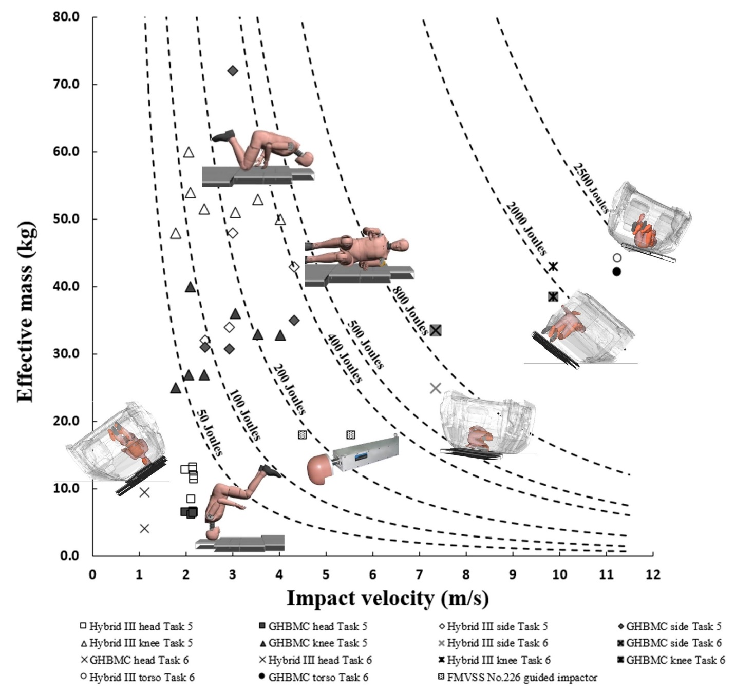
Figure A13. Impact energy distribution.

