Supplemental Material

The Examination of Molecular Structure Properties of 4,4'-oxydiphthalonitrile Compound: A combined spectral and computational analysis approaches

Serpil Eryılmaz^{a*}, Nesuhi Akdemir^{b}, Ersin İnkaya^{c}
ªDepartment of Physics, Faculty of Arts and Sciences, Amasya University, 05100, Amasya, Turkey
^{b}Department of Chemistry, Faculty of Arts and Sciences, Amasya University, 05100, Amasya, Turkey
^{c}Central Research Laboratory, Amasya University, 05100, Amasya, Turkey

*Corresponding author
E-mail address: srpleryilmaz@gmail.com.tr (S. Eryılmaz)

S.1 Atom-by-atom superimposition of the calculated structure (red) with Becke, three-parameter, Lee-Yang-Parr/6-311G(d,p) over the X-ray structure (black) for the 4,4'-oxydiphthalonitrile compound. The H atoms have been omitted for clarity. (RMSE-Root mean square error=0.227).
S.2 Correlation graph for the bond lengths of the 4,4'-oxydiphthalonitrile.
S.3 Correlation graph for the bond angles of the 4,4'-oxydiphthalonitrile.
S.4 Correlation graphic for experimental and theoretical wavenumbers of the 4,4'-oxydiphthalonitrile.
S.5 Correlation graphic for experimental and theoretical ¹³C-NMR chemical shift values respect to CSGT approach of the 4,4'-oxydiphthalonitrile.

S.6 Correlation graphic for experimental and theoretical ¹³C-NMR chemical shift valuesrespect to GIAO approach of the 4,4'-oxydiphthalonitrile.
S.7 Correlation graphic for experimental and theoretical ¹³C-NMR chemical shift values respect to IGAIM approach of the 4,4'-oxydiphthalonitrile.
S.8 Correlation graphic for experimental and theoretical ¹H-NMR chemical shift values respect to CSGT approach of the 4,4'-oxydiphthalonitrile.
S.9 Correlation graphic for experimental and theoretical ¹H-NMR chemical shift valuesrespect to GIAO approach of the 4,4'-oxydiphthalonitrile.
S.10 Correlation graphic for experimental and theoretical ¹H-NMR chemical shift values respect to IGAIM approach of the 4,4'-oxydiphthalonitrile.
S.11 Molecular electrostatic potential map view have been generated using Becke, three-parameter, Lee-Yang-Parr/6-311G(d,p) method of the 4,4'-oxydiphthalonitrile compound.

S.1 Atom-by-atom superimposition of the calculated structure (red) with Becke, three-parameter, Lee-Yang-Parr/6-311G(d,p) over the X-ray structure (black) for the 4,4'-oxydiphthalonitrile compound. The H atoms have been omitted for clarity. (RMSE-Root mean square error=0.227).

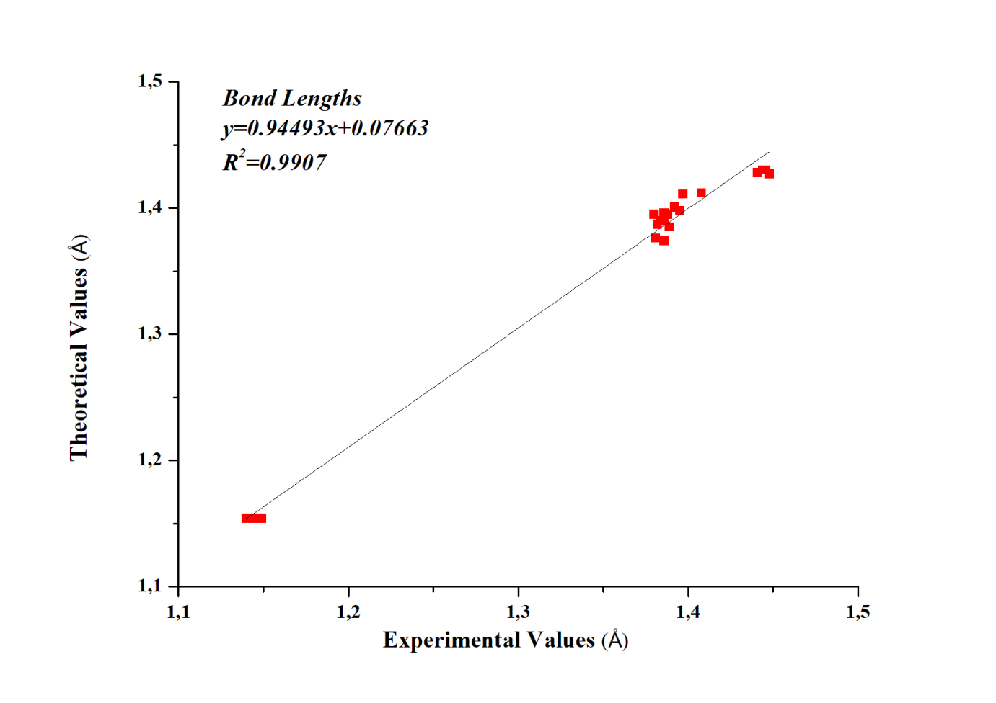
S.2 Correlation graph for the bond lengths of the 4,4'-oxydiphthalonitrile

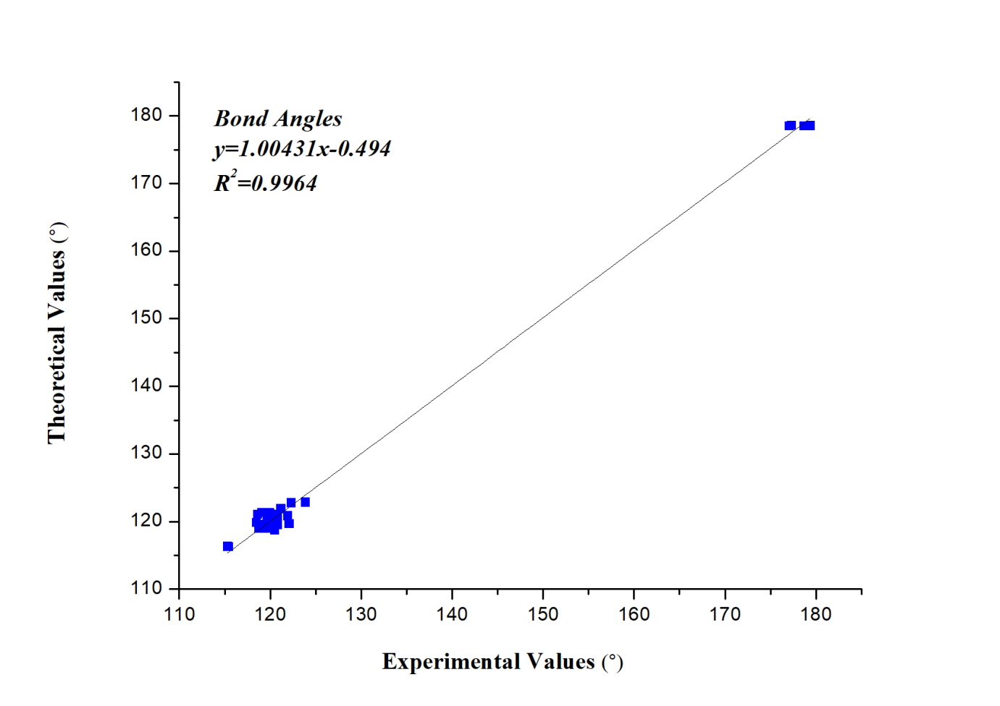

S.3 Correlation graph for the bond angles of the 4,4'-oxydiphthalonitrile

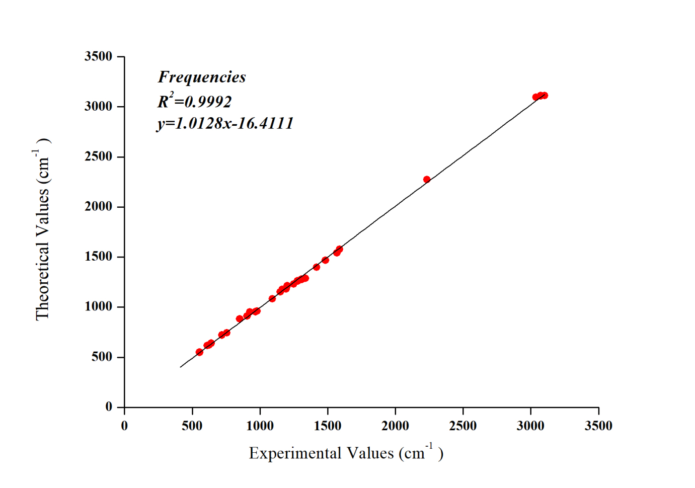
S.4 Correlation graphic for experimental and theoretical wavenumbers of the 4,4'-oxydiphthalonitrile.

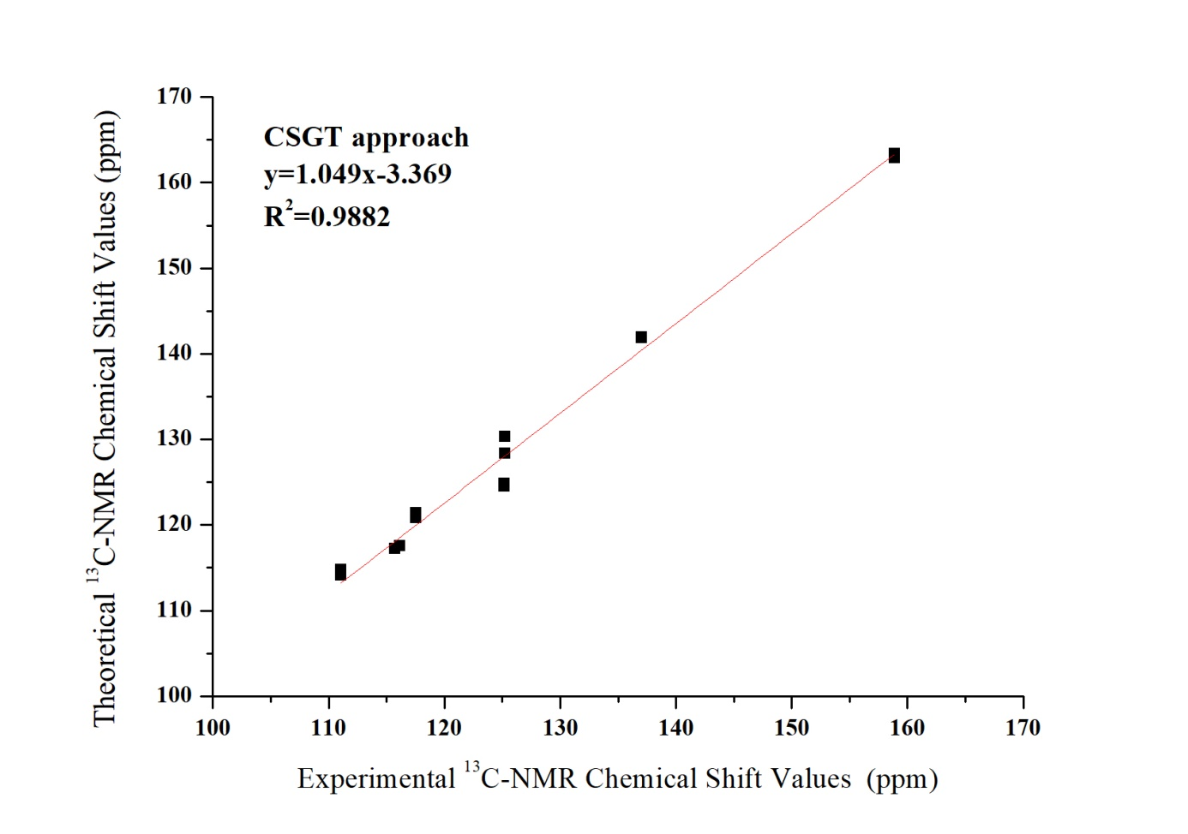
S.5 Correlation graphic for experimental and theoretical ¹³C-NMR chemical shift values respect to CSGT approach of the 4,4'-oxydiphthalonitrile.

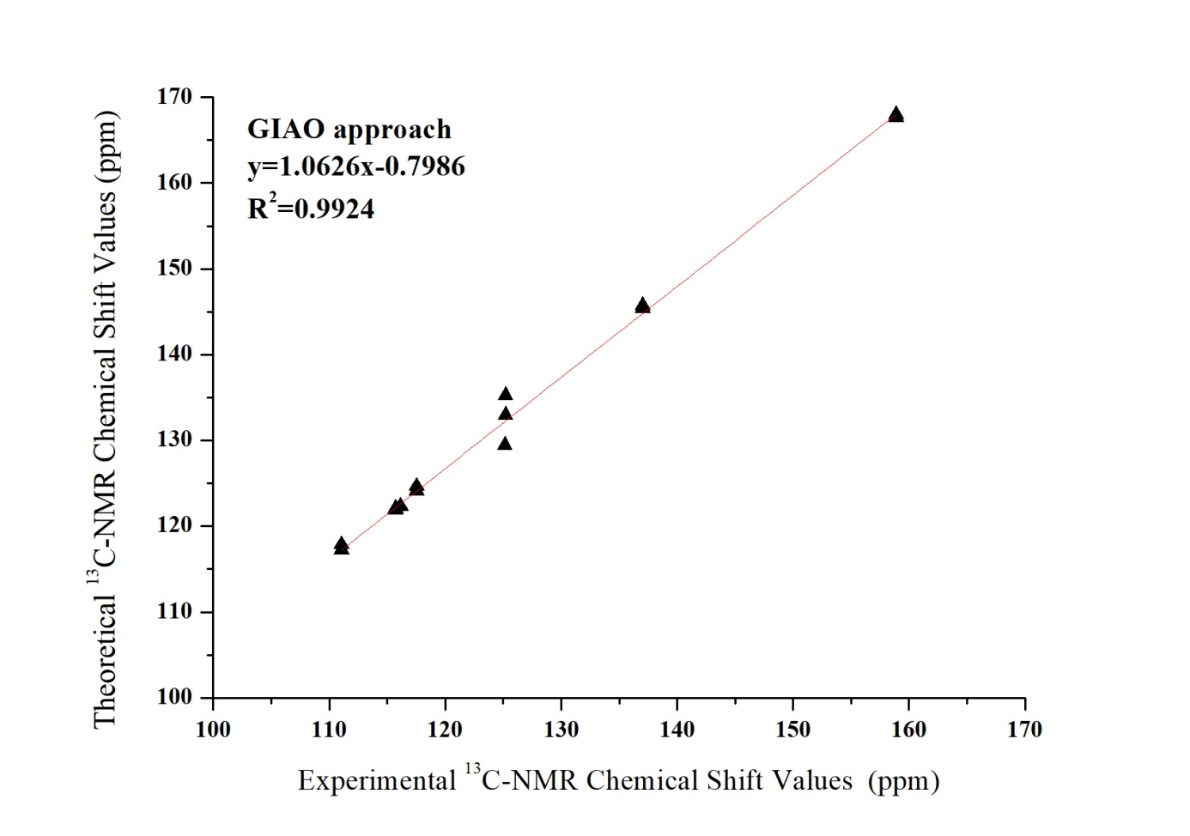
S.6 Correlation graphic for experimental and theoretical ¹³C-NMR chemical shift values respect to GIAO approach of the 4,4'-oxydiphthalonitrile.

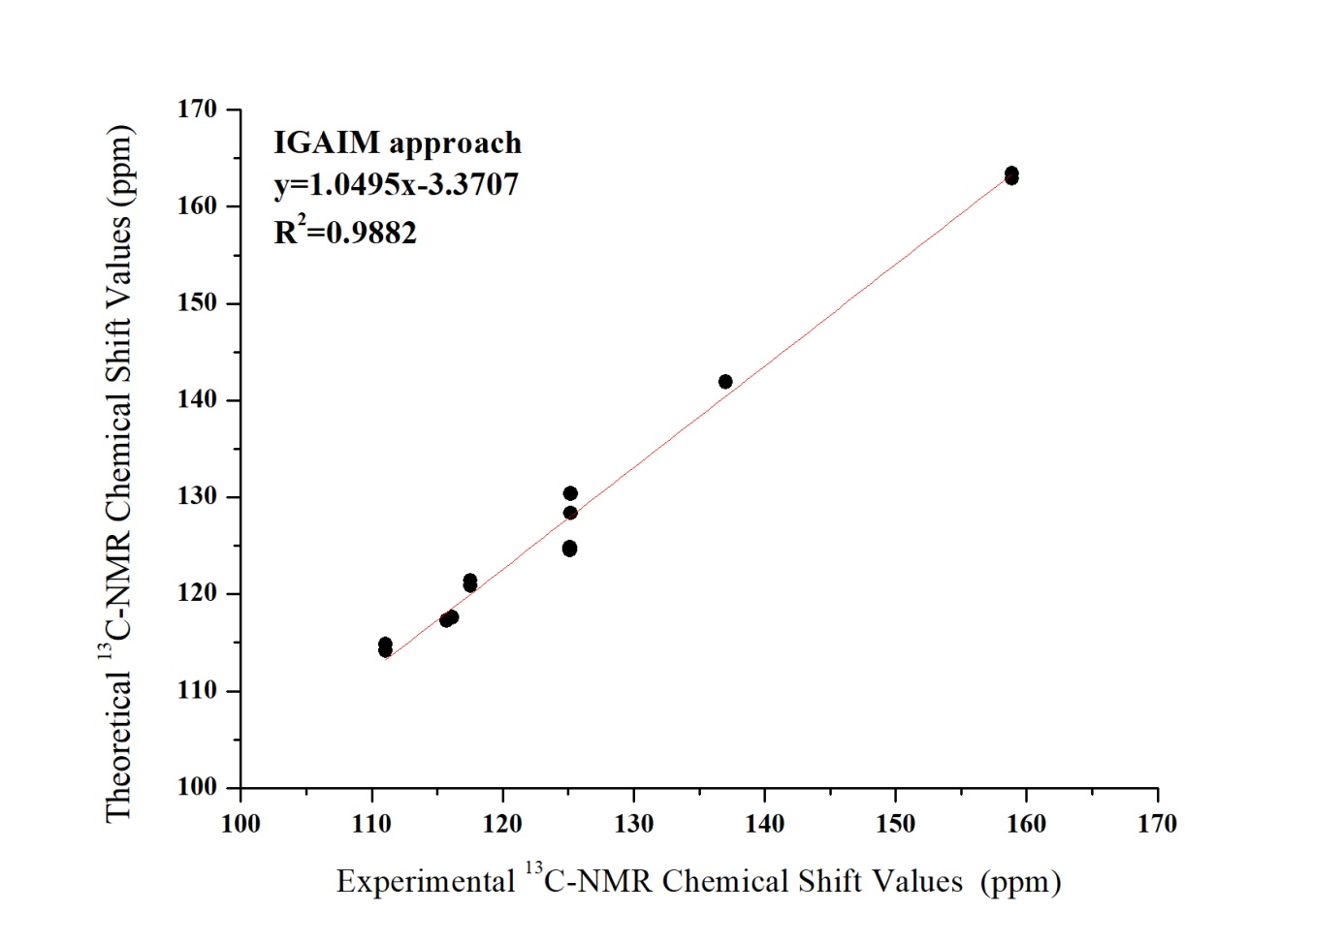
S.7 Correlation graphic for experimental and theoretical ¹³C-NMR chemical shift values respect to IGAIM approach of the 4,4'-oxydiphthalonitrile.

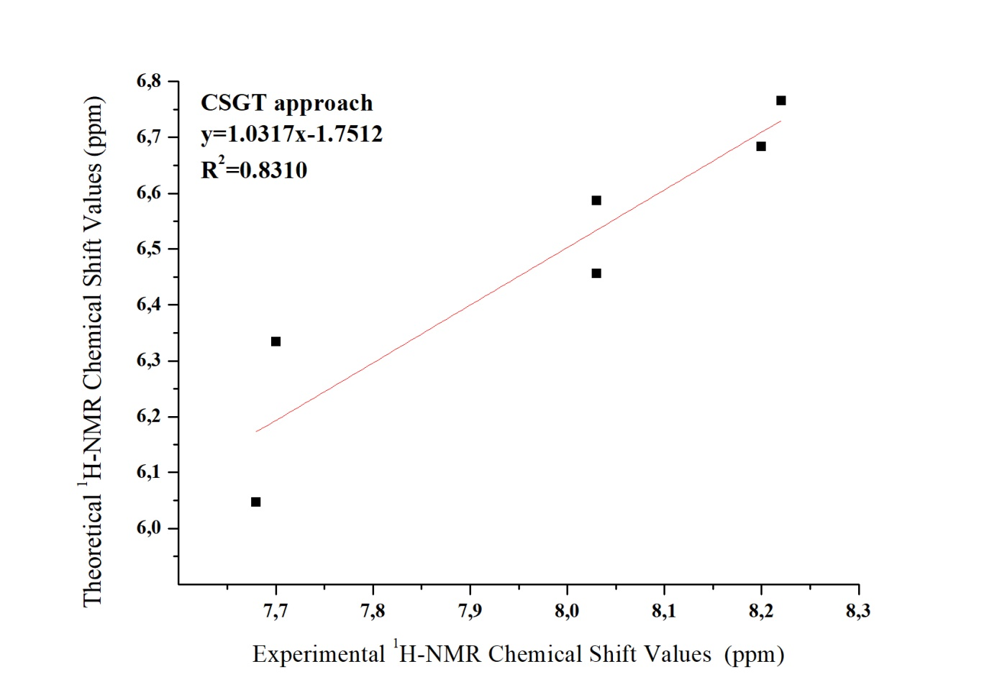

S.8 Correlation graphic for experimental and theoretical ¹H-NMR chemical shift values respect to CSGT approach of the 4,4'-oxydiphthalonitrile.

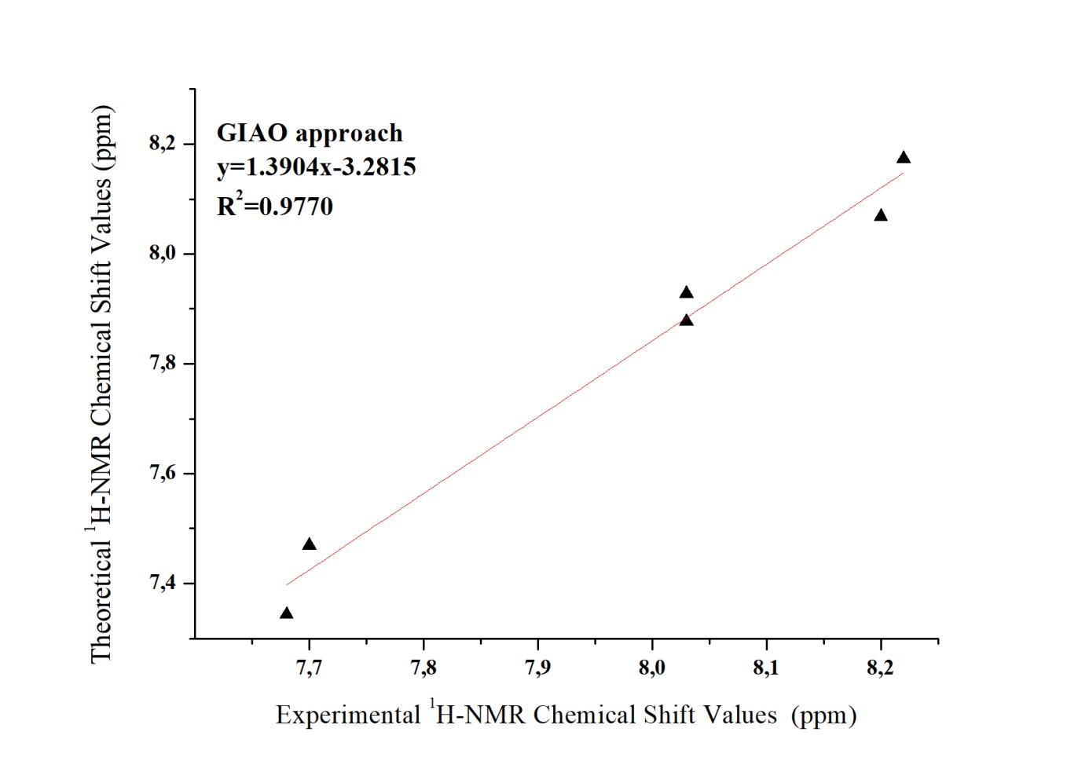

S.9 Correlation graphic for experimental and theoretical ¹H-NMR chemical shift values respect to GIAO approach of the 4,4'-oxydiphthalonitrile.

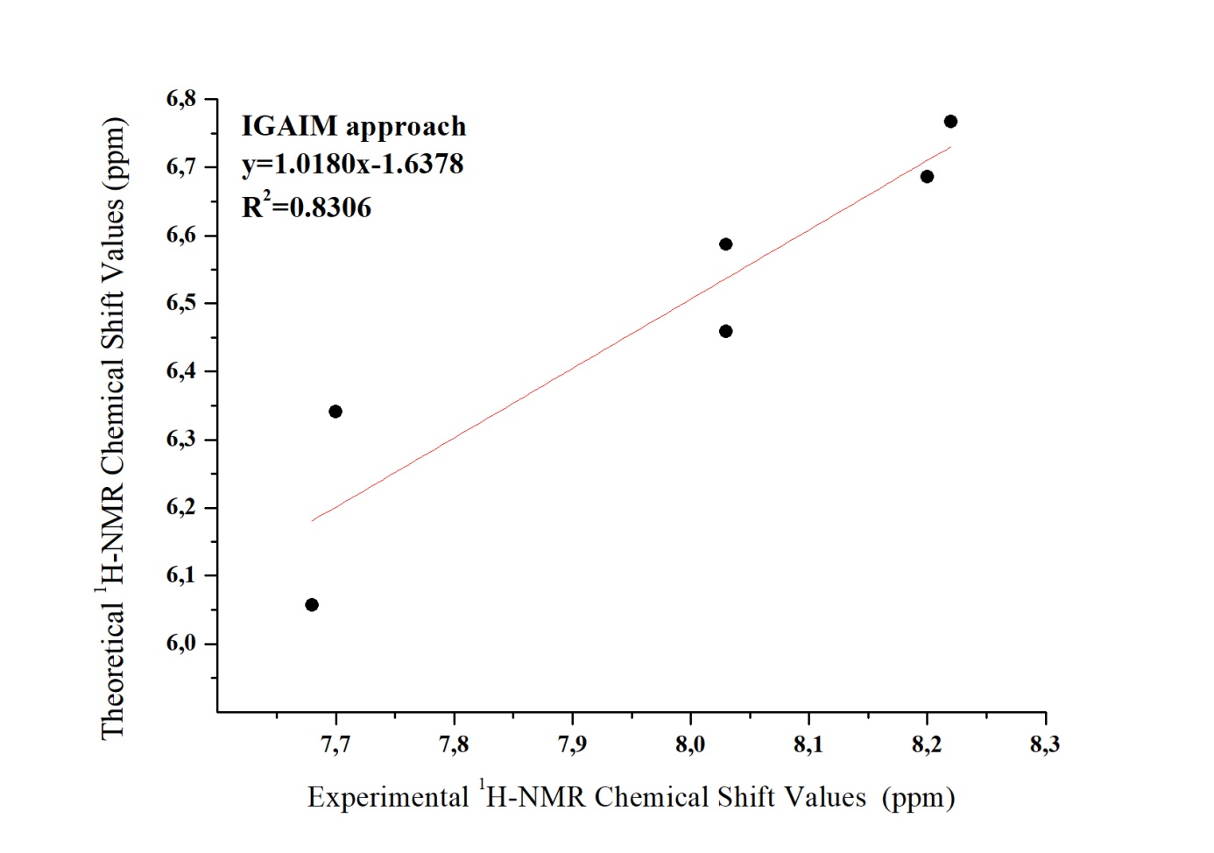

S.10 Correlation graphic for experimental and theoretical ¹H-NMR chemical shift values respect to IGAIM approach of the 4,4'-oxydiphthalonitrile.

S.11 Molecular electrostatic potential map view have been generated using Becke, three-parameter, Lee-Yang-Parr/6-311G(d,p) method of the 4,4'-oxydiphthalonitrile compound.

