Supporting Information for
Structure-guided design of anti-pancreatic cancer ribonucleotide reductase inhibitors
Tessianna A. Misko, Yi-Ting Liu, Michael E. Harris, Nancy L. Oleinick, John Pink,
Hsueh-Yun Lee*, Chris G. Dealwis*

Contents
Figure 1: Predicted binding interactions of TP compounds at the C-site of hRRM1………………………………… 3
Figure 2: Other interaction plots……………………………………………………………………………………………………………..5
Figure 3: Cancer growth-inhibitory activity of A549 lung cancer cell line and HCT116 colon cancer cell line…………………………………………………………………………………………………………………………………………………………..8
Table 1: Compound specific wavelength and extinction coefficient for concentration determination……..9
¹H NMR Spectra …………………………………………………………………………………………………………………………………….10
¹³C NMR Spectra ……………………………………………………………………………………………………………………………………23
HRMS Spectra..……………………………………………………………………………………………………………………………………..36

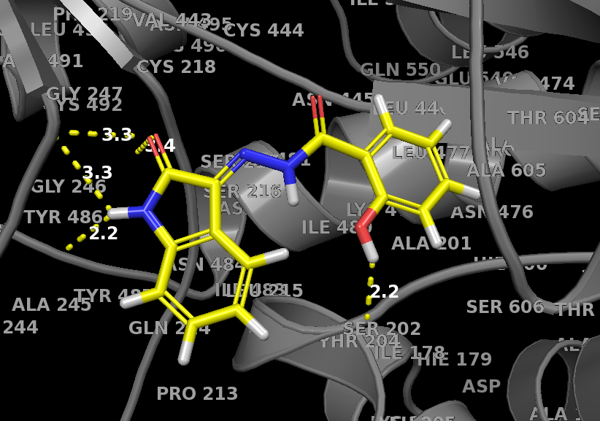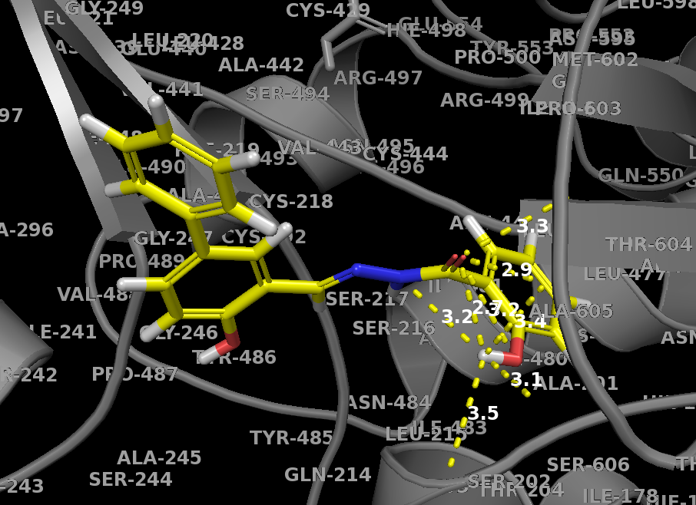
A.
B.
D.
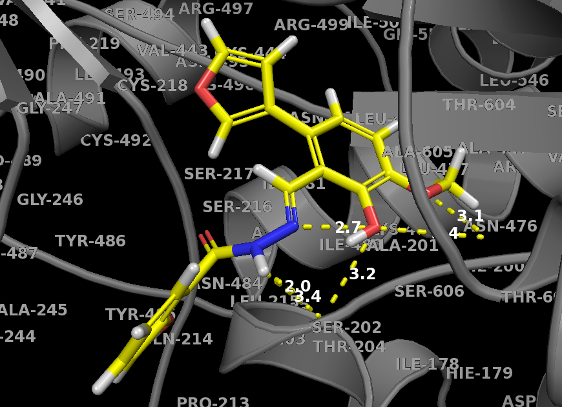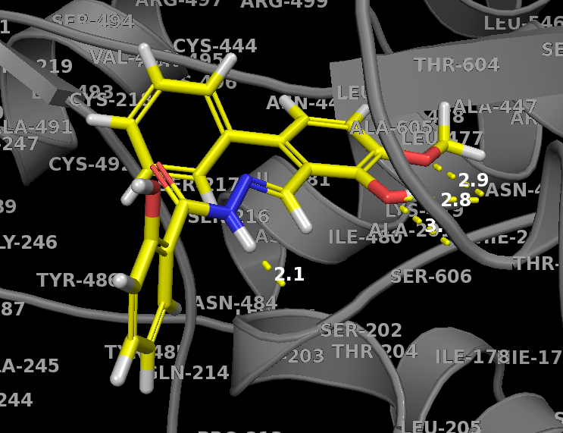
C.
F.
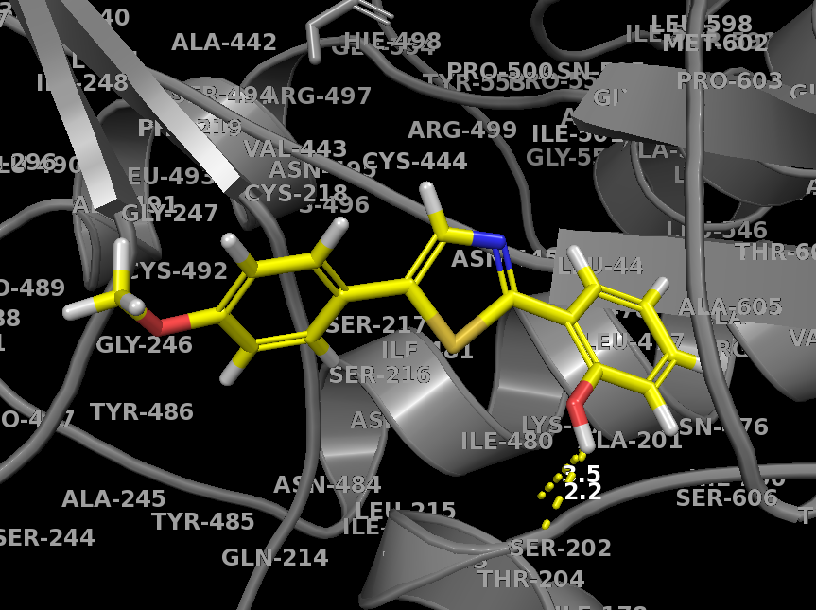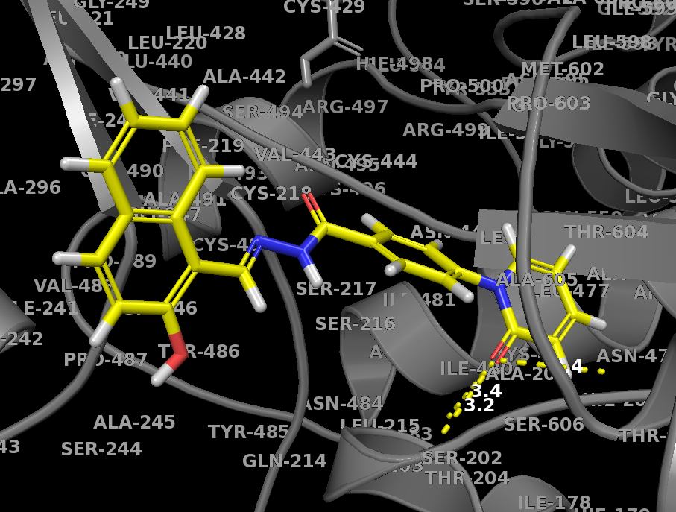
E.
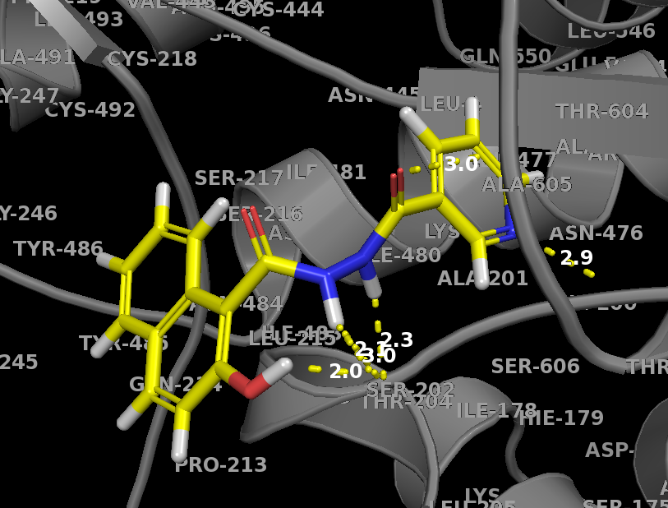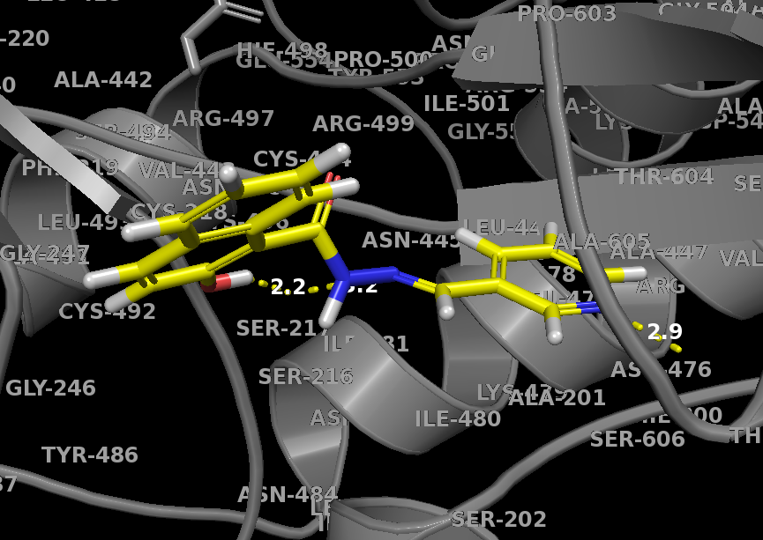
I.
G.
H.
Supplemental Figure 1. Predicted binding interactions of TP compounds at the C-site of hRRM1 based on the X-ray structure PDB ID 5TUS. Gray indicates RR protein residues. Yellow dotted lines indicate favorable hydrogen bond interactions. Yellow structures are TP compounds. (A) TP1 shows predicted binding to the phosphate binding residues (S202) and close to loop 2 (A245 and G247). (B) TP2 shows predicted binding to the phosphate binding residues (A605 and T607). (C) TP4 shows predicted binding to the phosphate binding residues (S202, S606 and T607). (D) TP5 shows predicted binding to the phosphate binding residues (S606 and T607). (E) TP9 shows predicted binding to the phosphate binding residues (S202). (F) TP10 shows predicted binding to the phosphate binding residues (S202 and S606). (G) TP11 shows predicted binding to the phosphate binding residues (S202, S606 and T607). (H) TP12 shows predicted binding to the phosphate binding residues (T607) and S217. (I) TP13 shows predicted binding to the phosphate binding residues (A605 and T607).

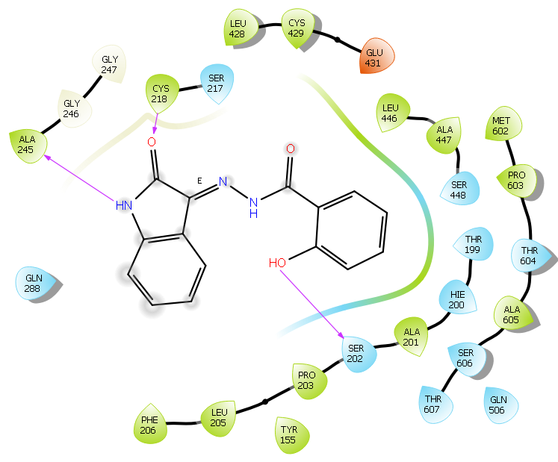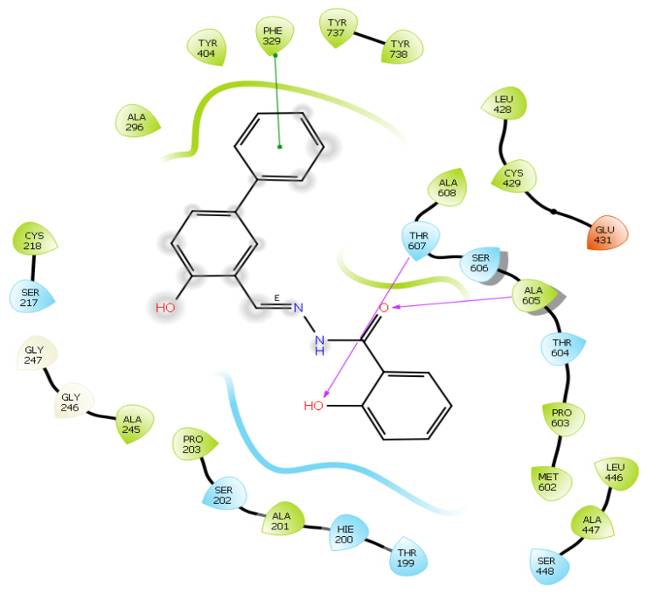
A
B
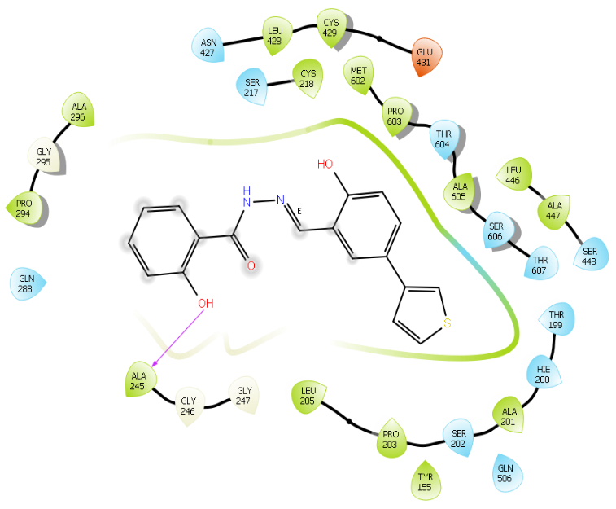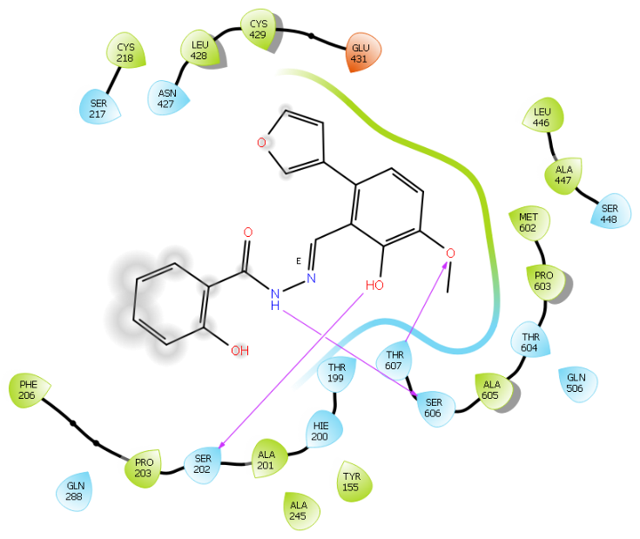
C
D
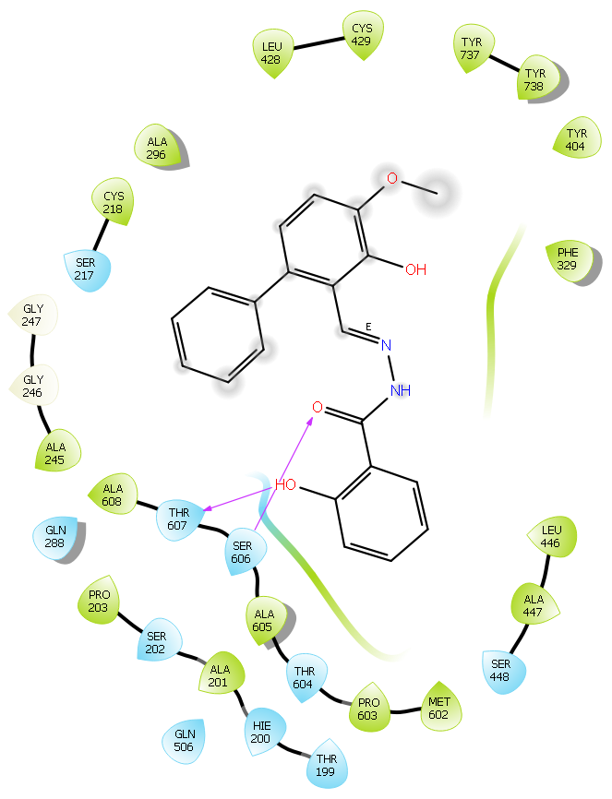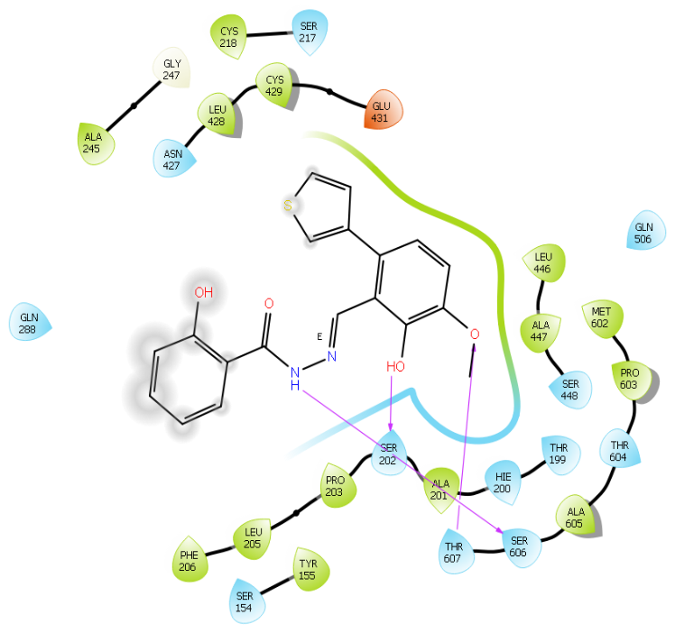
F
E
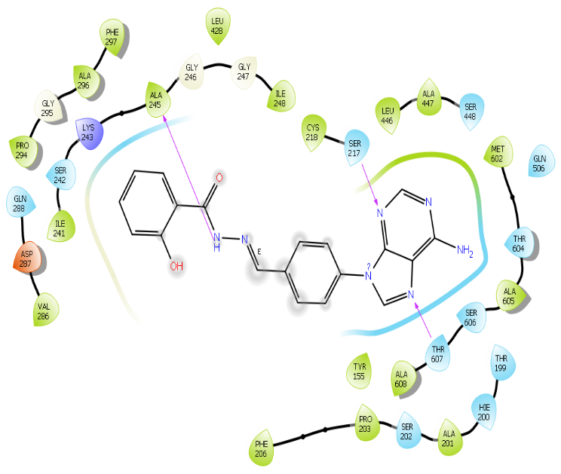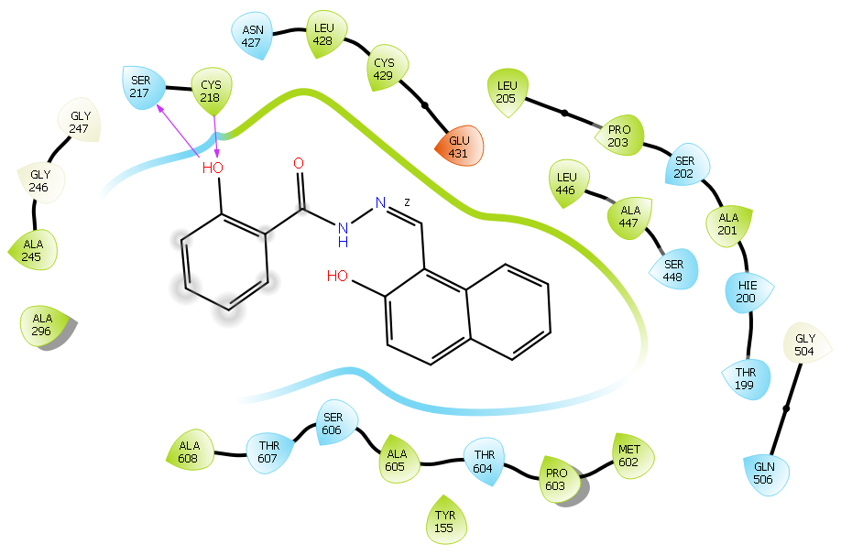
G
H
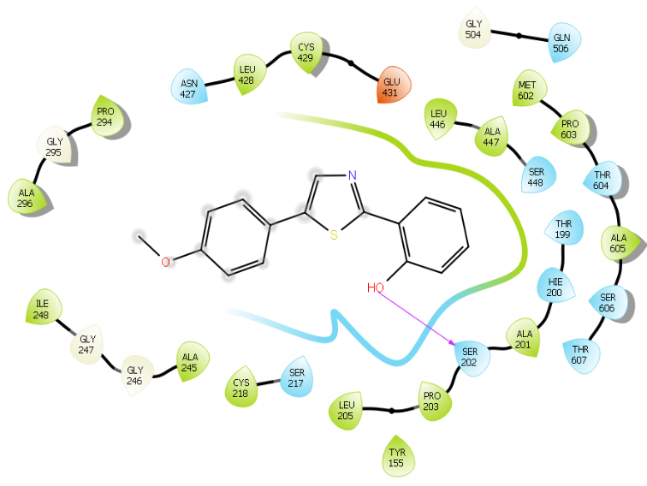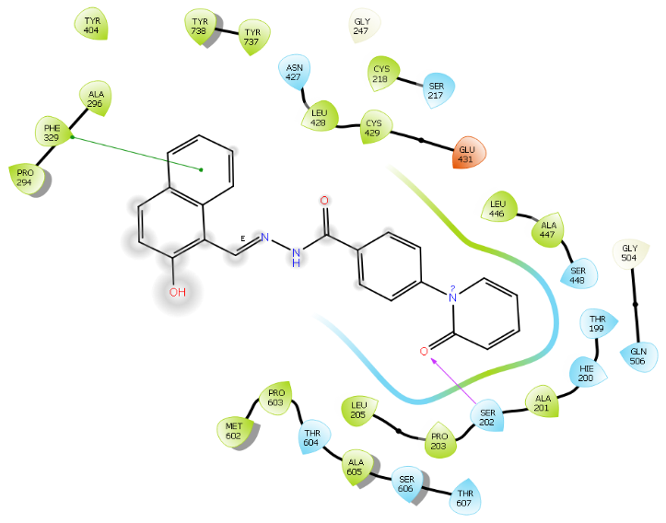
I
J
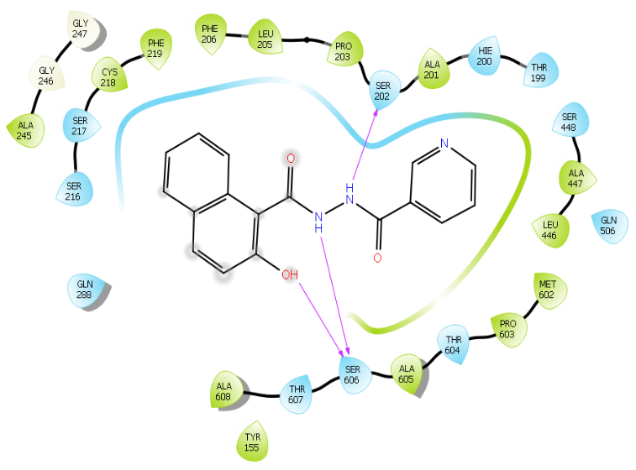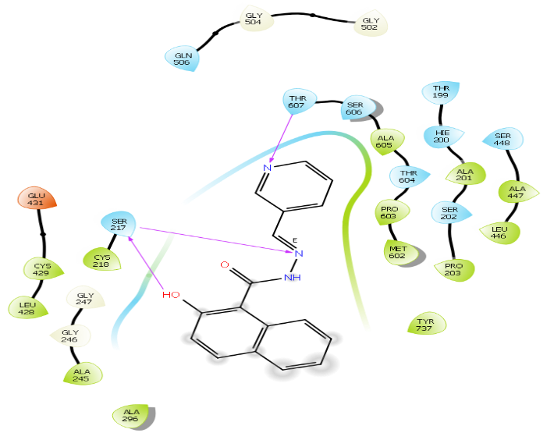
L
K
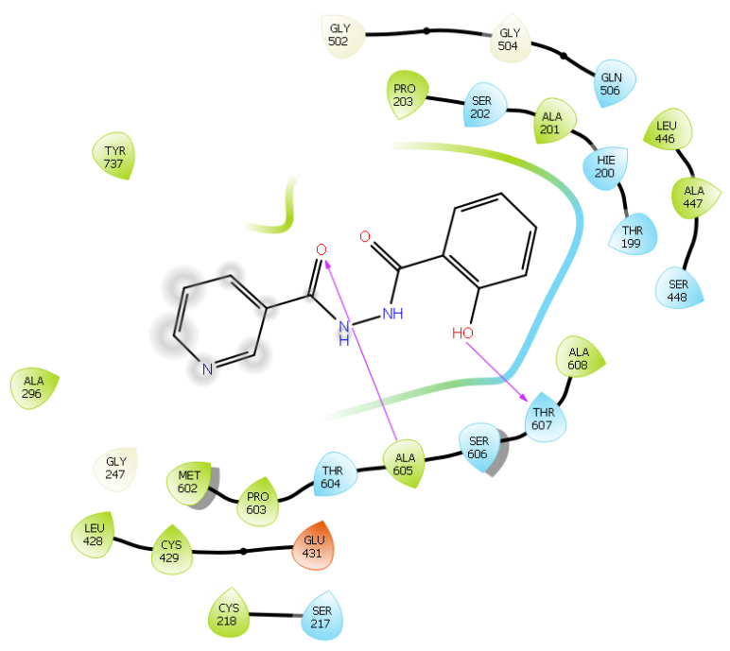
M

Supplemental Figure 2. Other interaction plots. Predicted binding interactions of TP compounds at the C-site of hRRM1 based on the X-ray structure PDB ID 5TUS. Green residues are hydrophobic, cyan residues are polar, white residues are glycine, red residues are negatively charged and blue residues are positively charged. Purple arrows indicate hydrogen bonds. Green lines indicate Pi-Pi stacking. (A) TP1 (B) TP2 (C) TP3 (D) TP4 (E) TP5 (F) TP6 (G) TP7 (H) TP8 (I) TP9 (J) TP10 (K) TP11 (L) TP12 (M) TP13

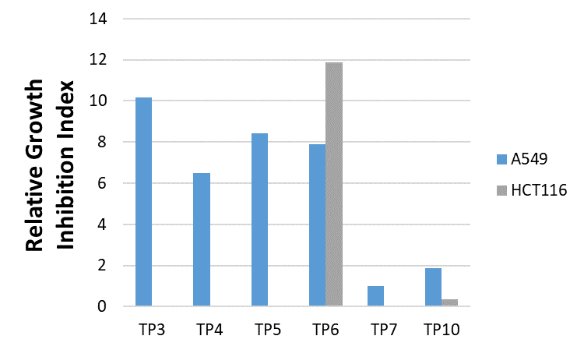

Supplemental Figure 3. Cancer growth-inhibitory activity of A549 lung cancer cell line and HCT116 colon cancer cell line by select TP compounds. Cells were treated with candidate compounds for 3 days in a standard growth inhibition assay in 96 well plates. Growth inhibition was assessed by measuring relative DNA content per well compared with that of untreated cells. Only TP6 and TP10 were assessed in HCT116 cell line.

Supplemental Table 1: Compound specific wavelength and extinction coefficient for concentration determination
Compound | Wavelength peak (nm) | Extinction coefficient (M⁻¹cm⁻¹)
TP1 | 333 | 19.15
TP2 | 268 | 29.49
TP3 | 279 | 28.83
TP4 | 324 | 20.77
TP5 | 324 | 19.98
TP6 | 326 | 25.05
TP7 | 322 | 24.36
TP8 | 326 | 25.46
TP9 | 264 | 21.83
TP10 | 326 | 19.92
TP11 | 288 | 5.44
TP12 | 292 | 19.94
TP13 | 305 | 5.09

¹H Spectra for compound TP1
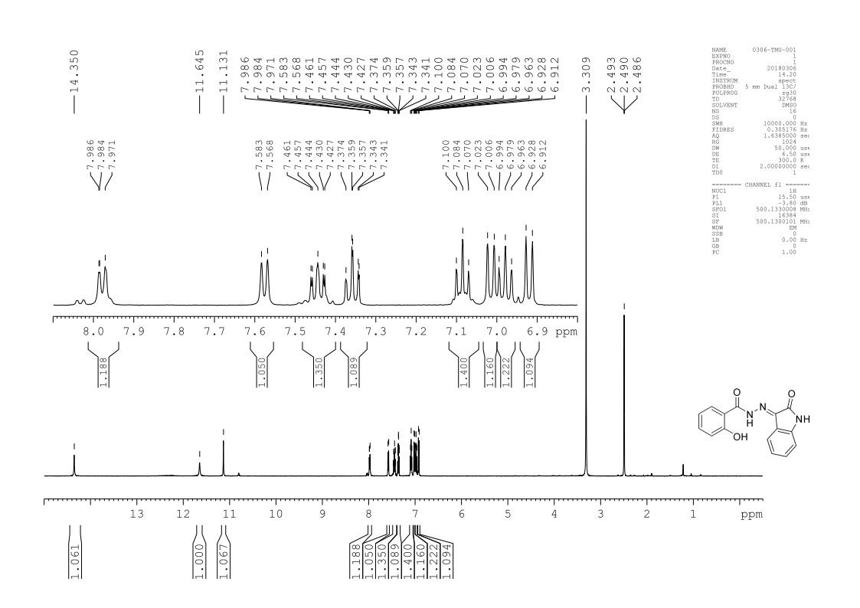
¹H Spectra for compound TP2
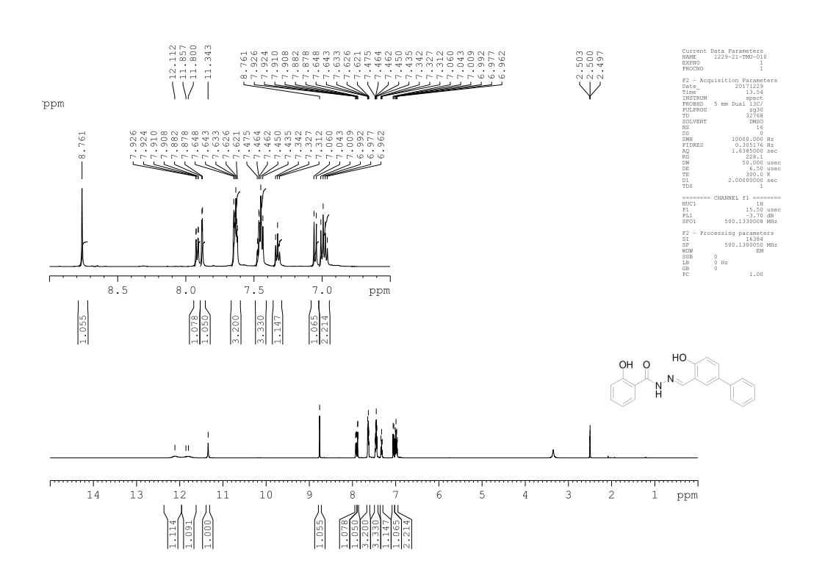
¹H Spectra for compound TP3
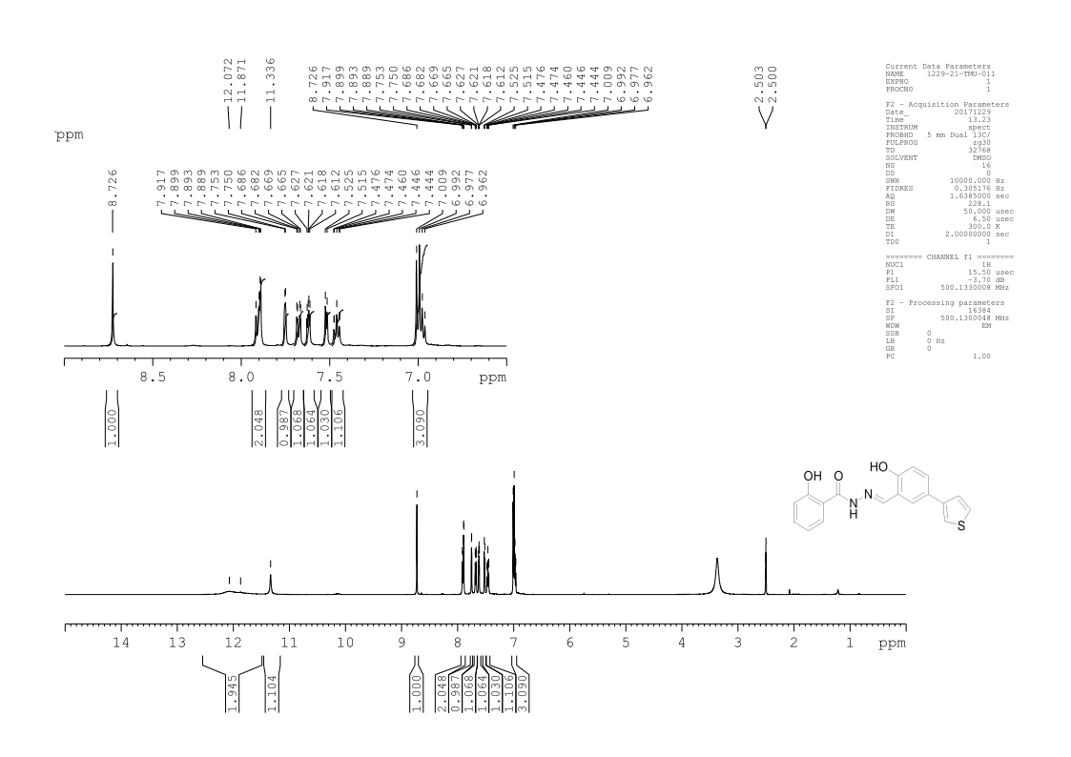
¹H Spectra for compound TP4
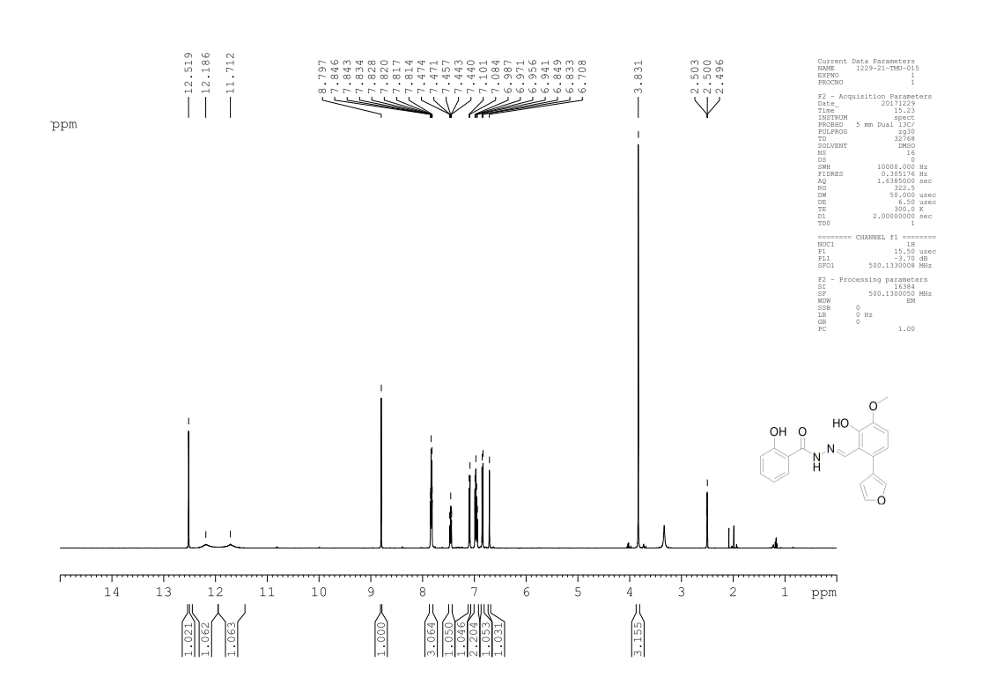
¹H Spectra for compound TP5
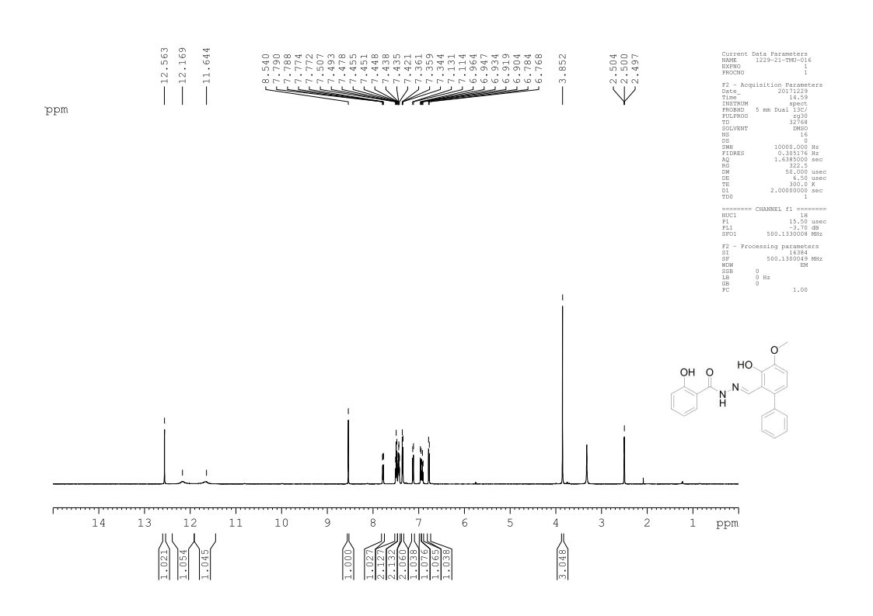
¹H Spectra for compound TP6
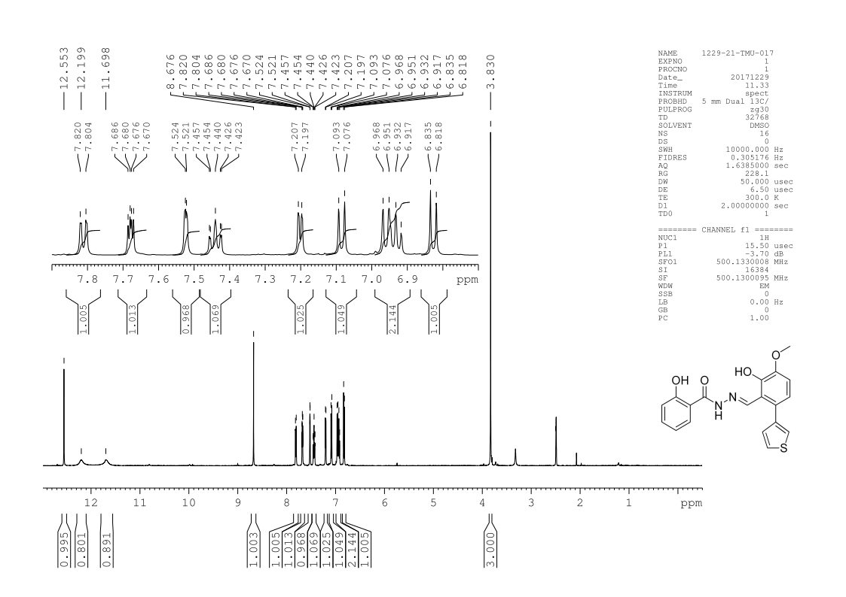
¹H Spectra for compound TP7
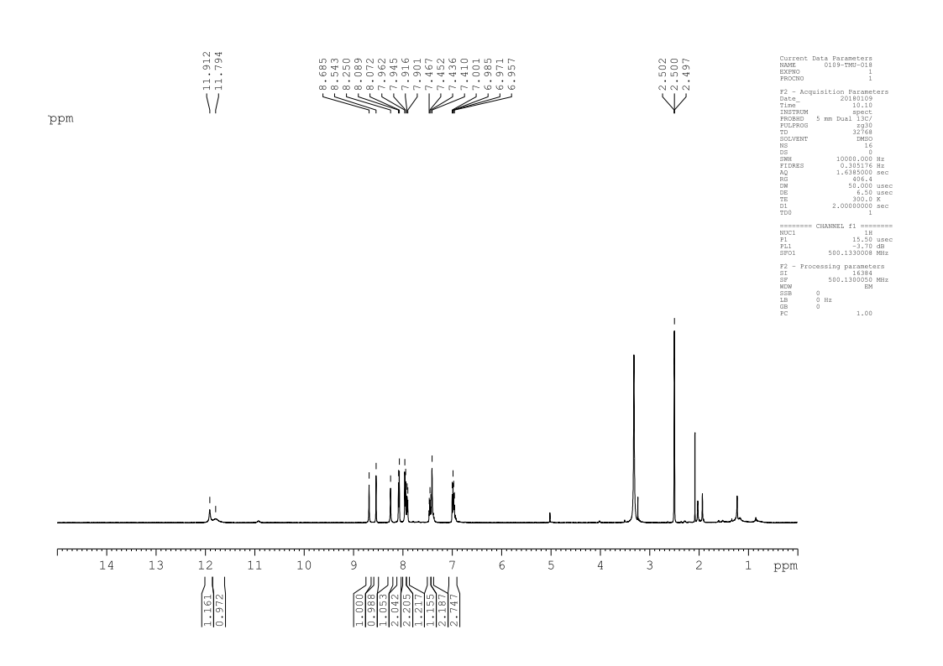
¹H Spectra for compound TP8
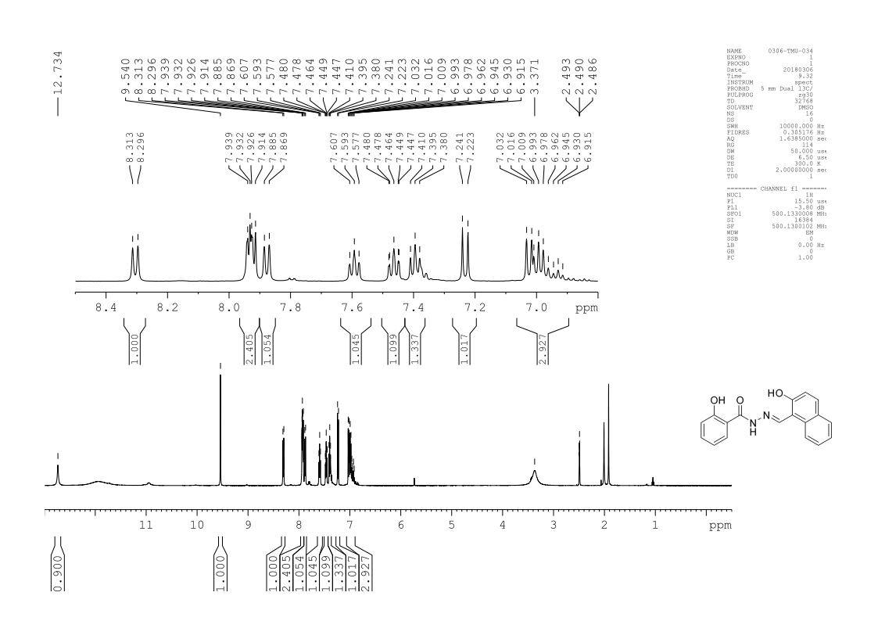
¹H Spectra for compound TP9
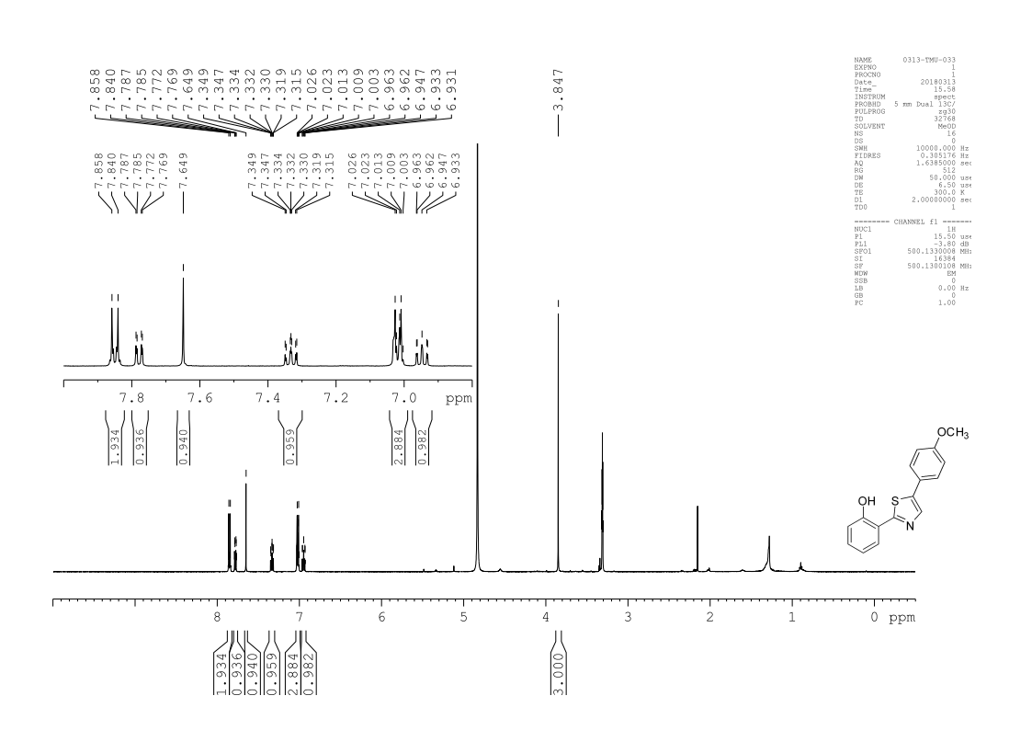
¹H Spectra for compound TP10
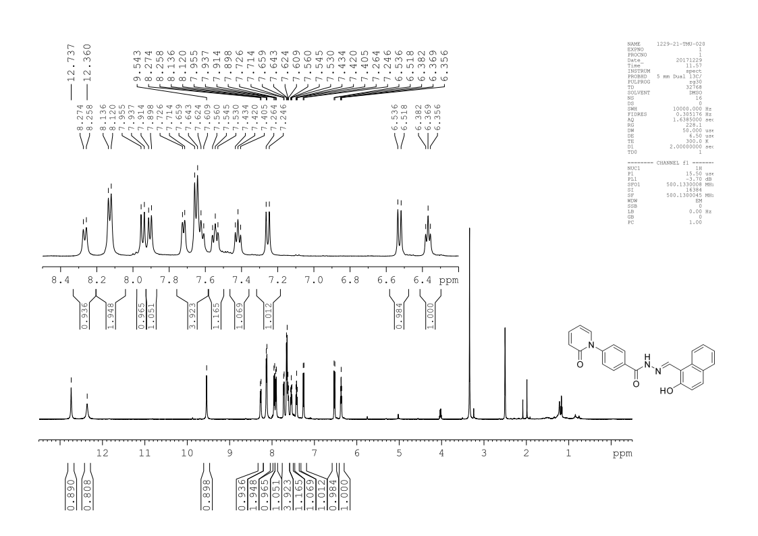
¹H Spectra for compound TP11
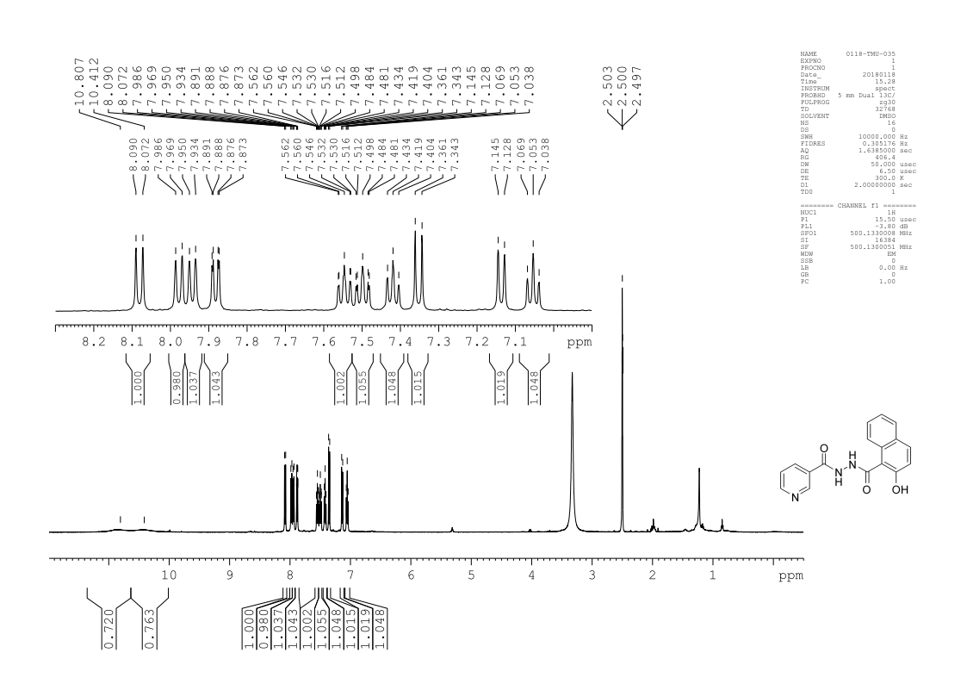
¹H Spectra for compound TP12
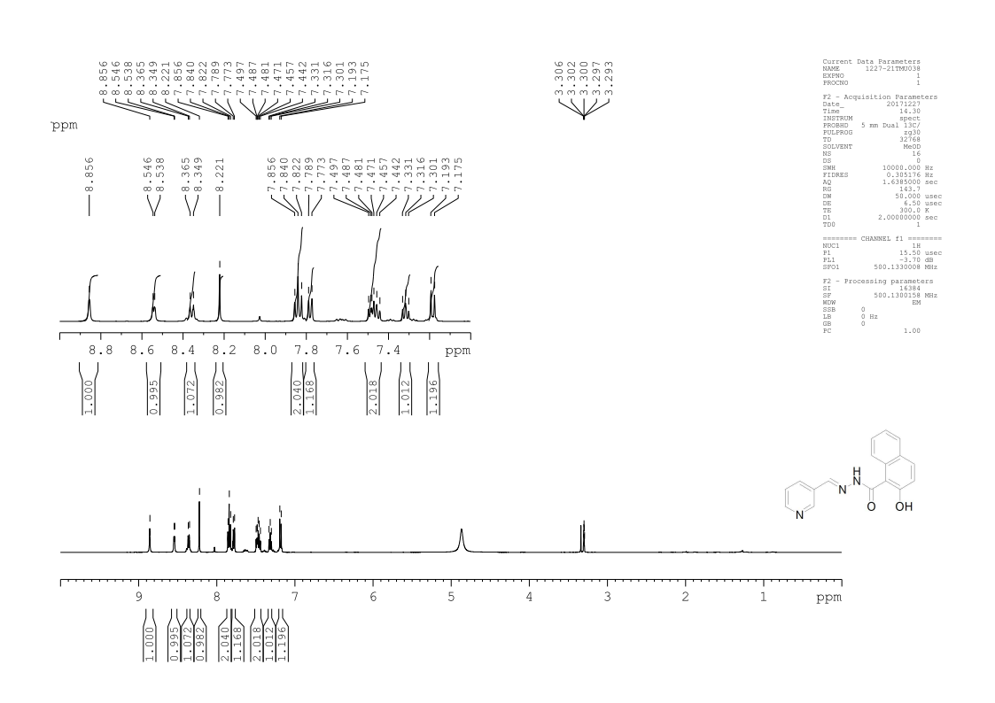
¹H Spectra for compound TP13
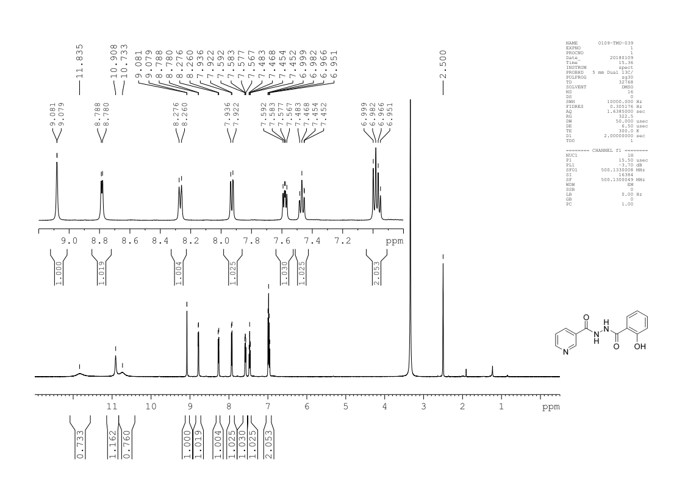
¹³C Spectra for compound TP1
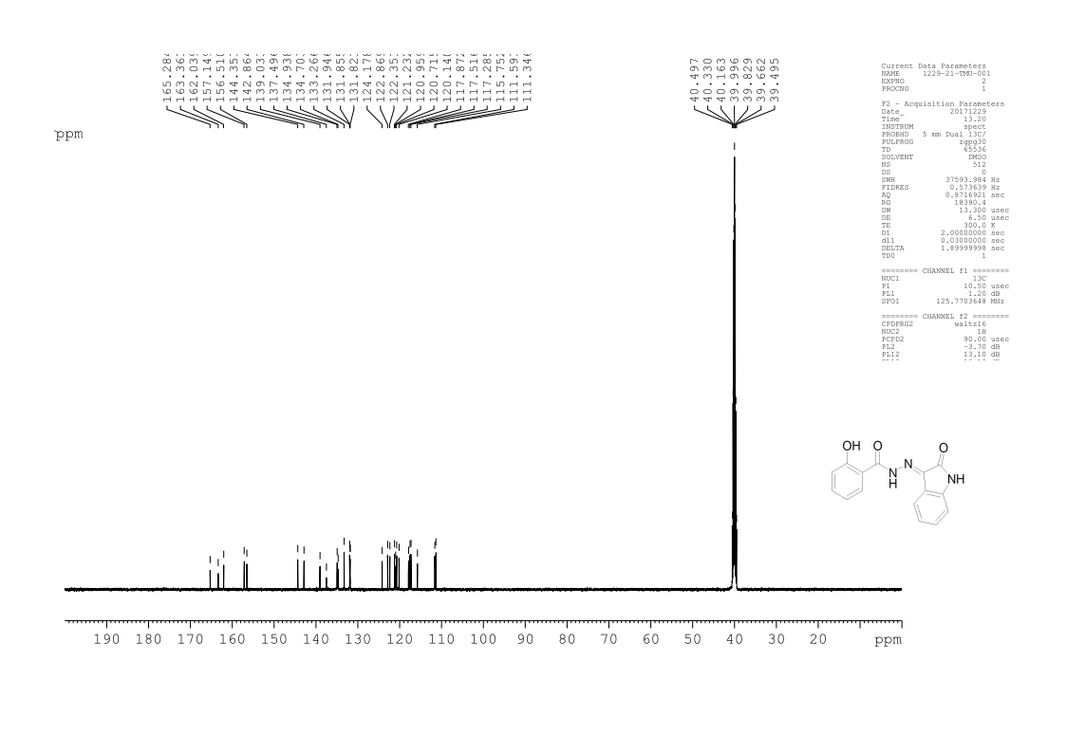
¹³C Spectra for compound TP2
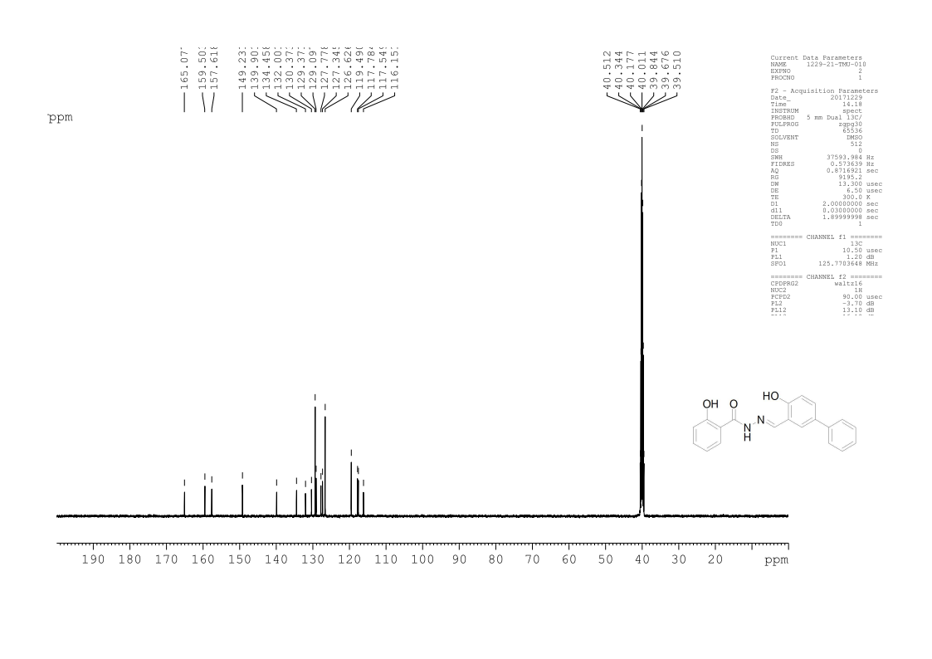
¹³C Spectra for compound TP3
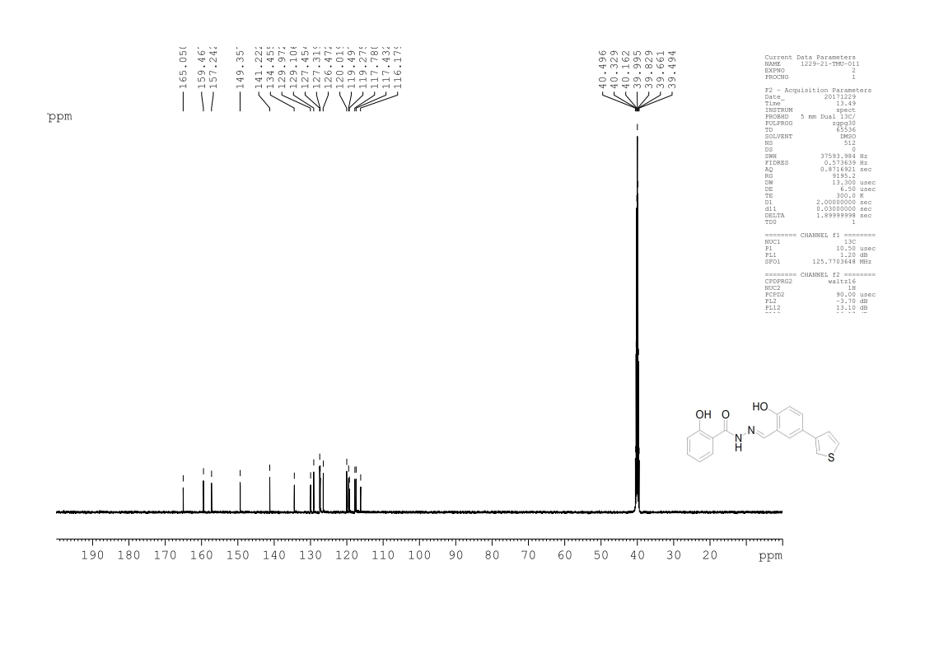
¹³C Spectra for compound TP4
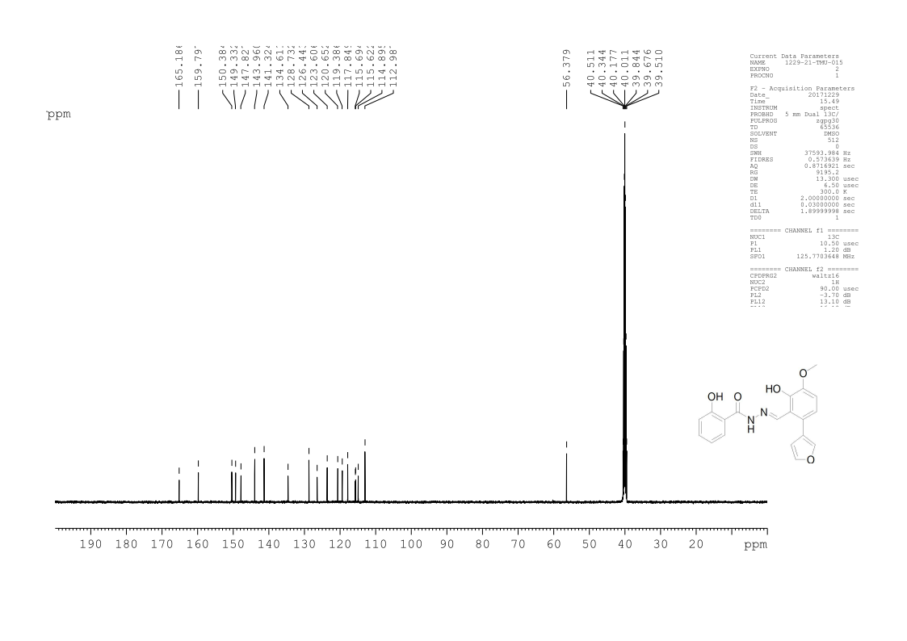
¹³C Spectra for compound TP5
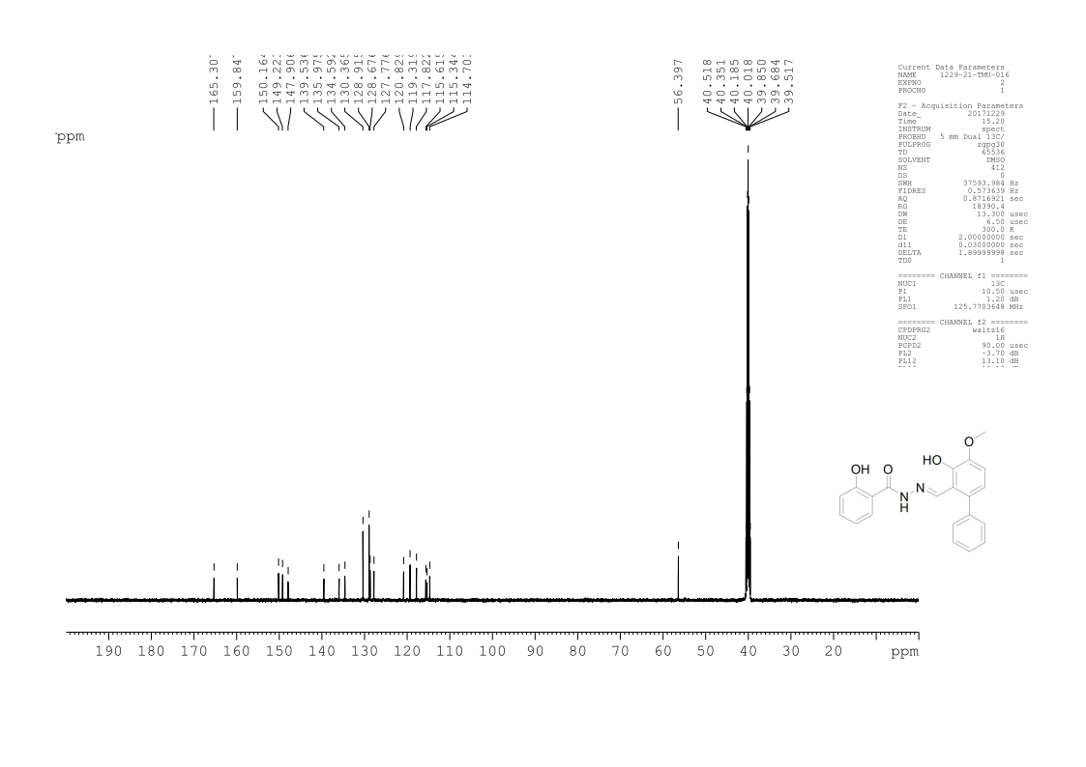
¹³C Spectra for compound TP6
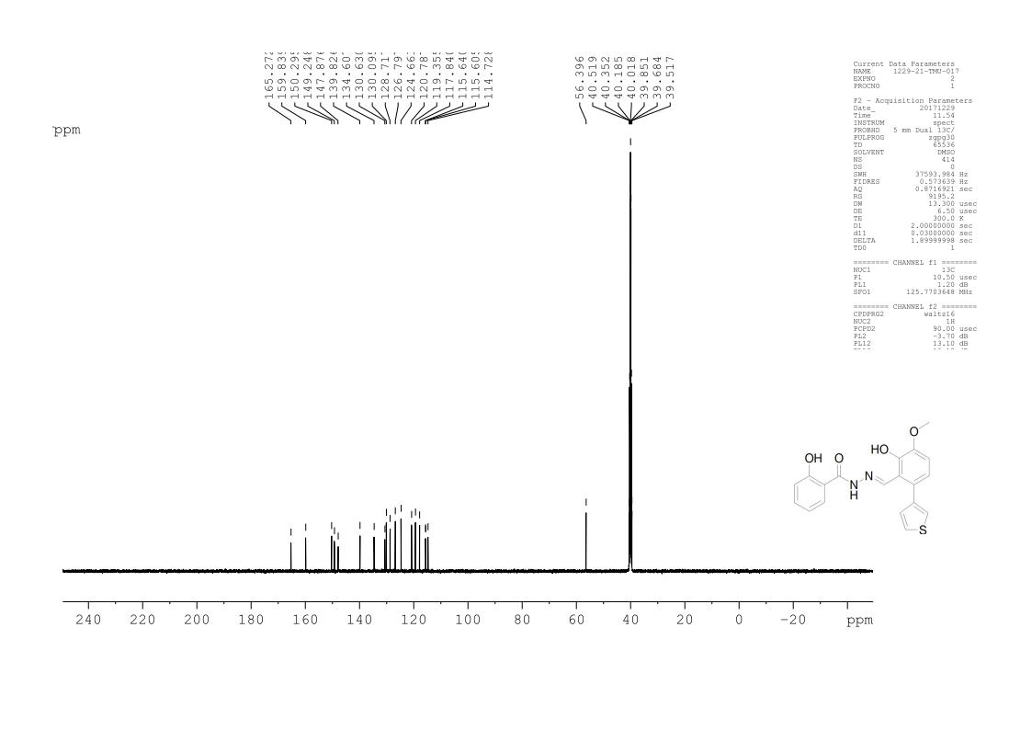
¹³C Spectra for compound TP7
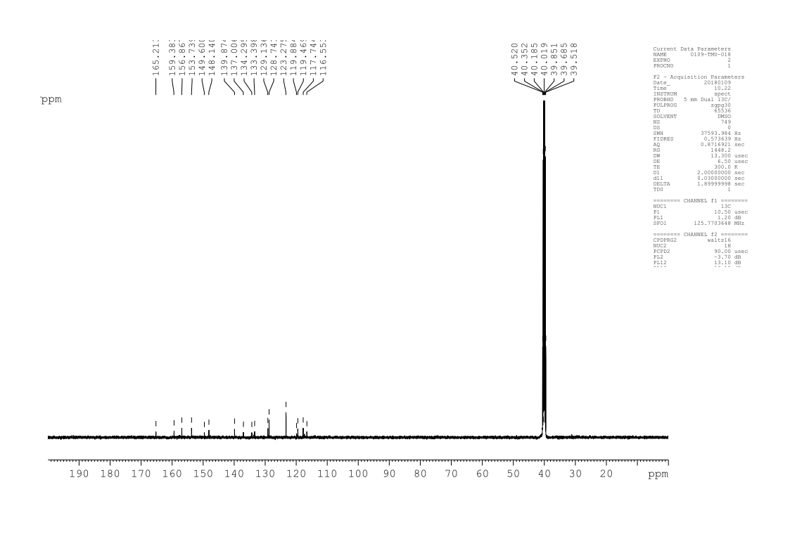
¹³C Spectra for compound TP8
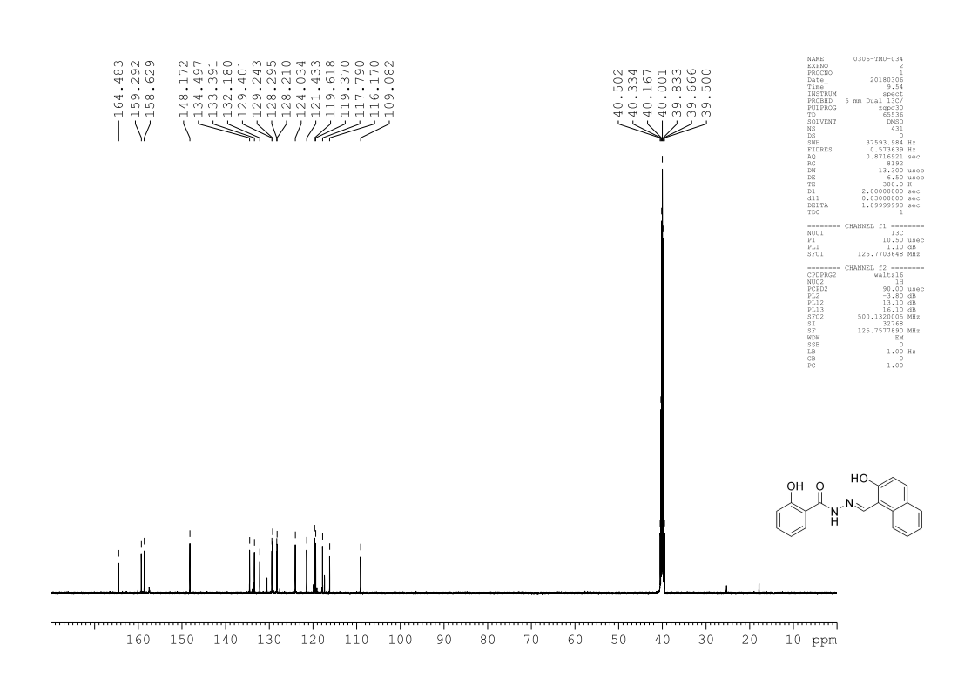
¹³C Spectra for compound TP9
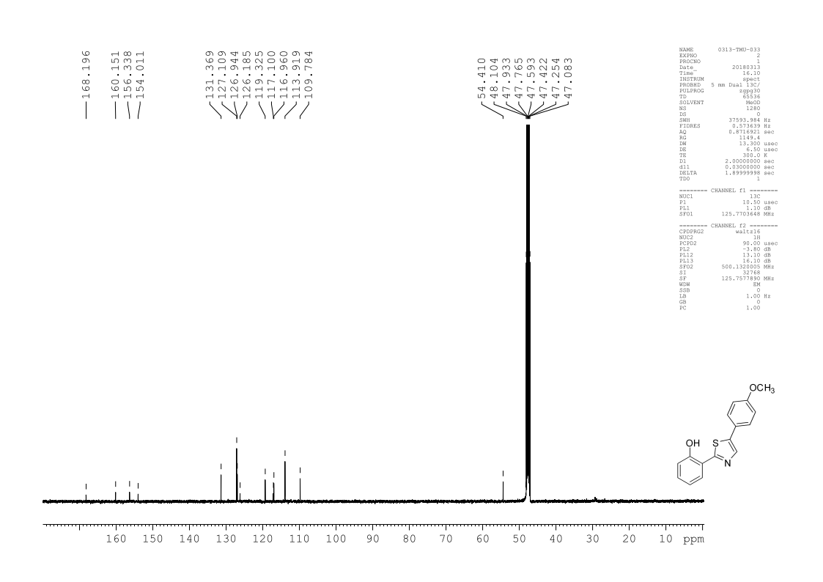
¹³C Spectra for compound TP10
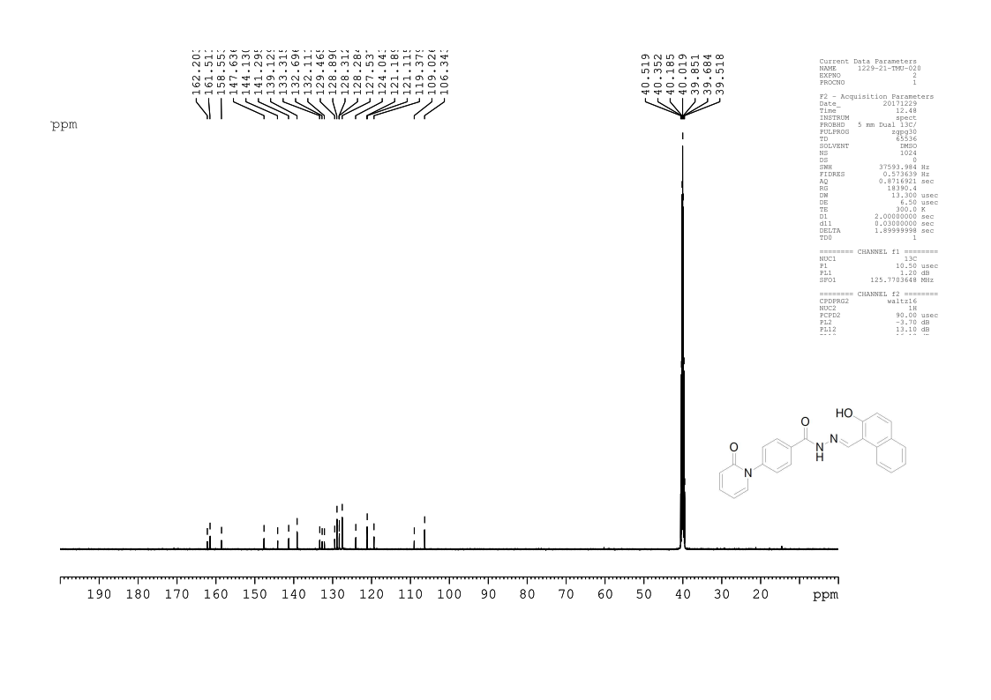
¹³C Spectra for compound TP11
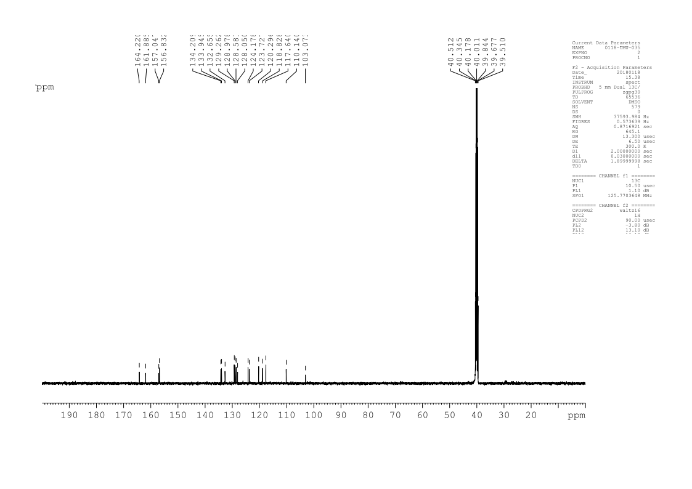
¹³C Spectra for compound TP12
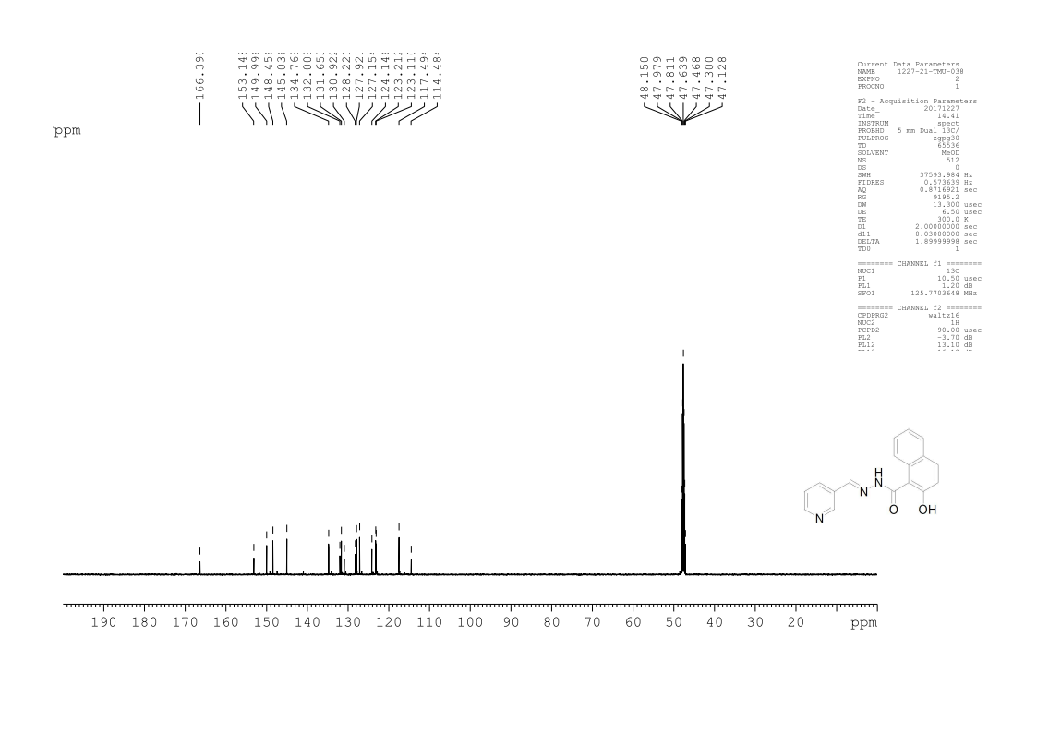
¹³C Spectra for compound TP13
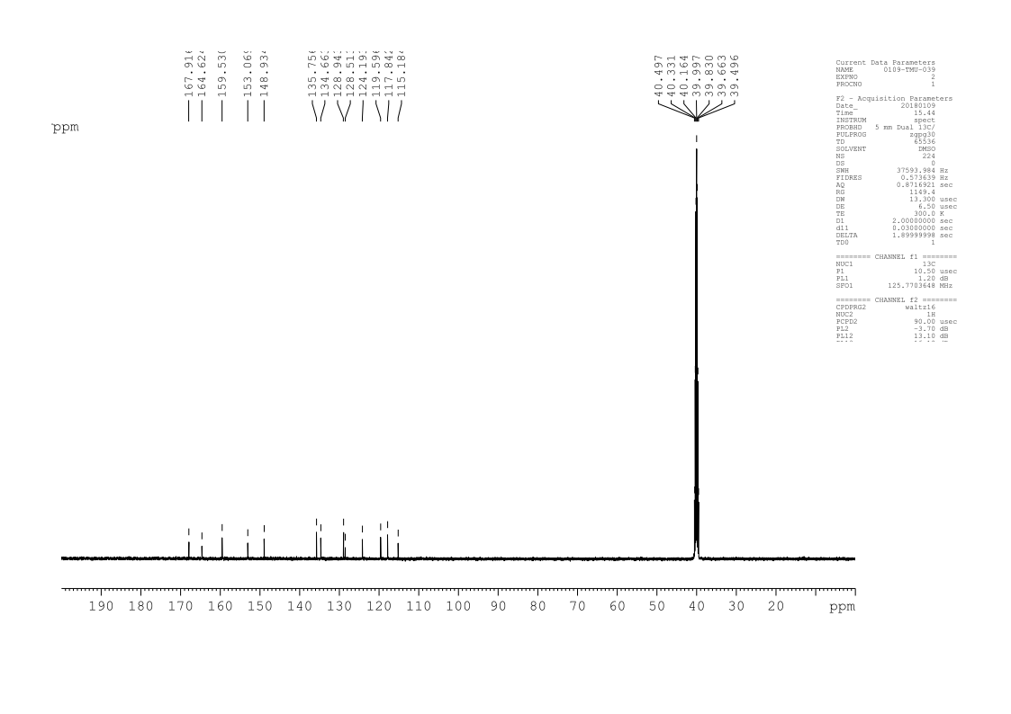

HRMS for compound TP1
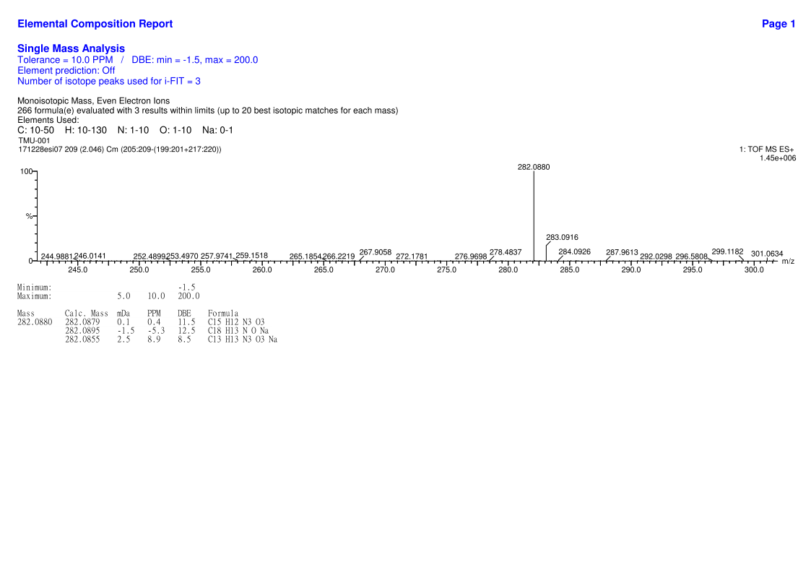
HRMS for compound TP2
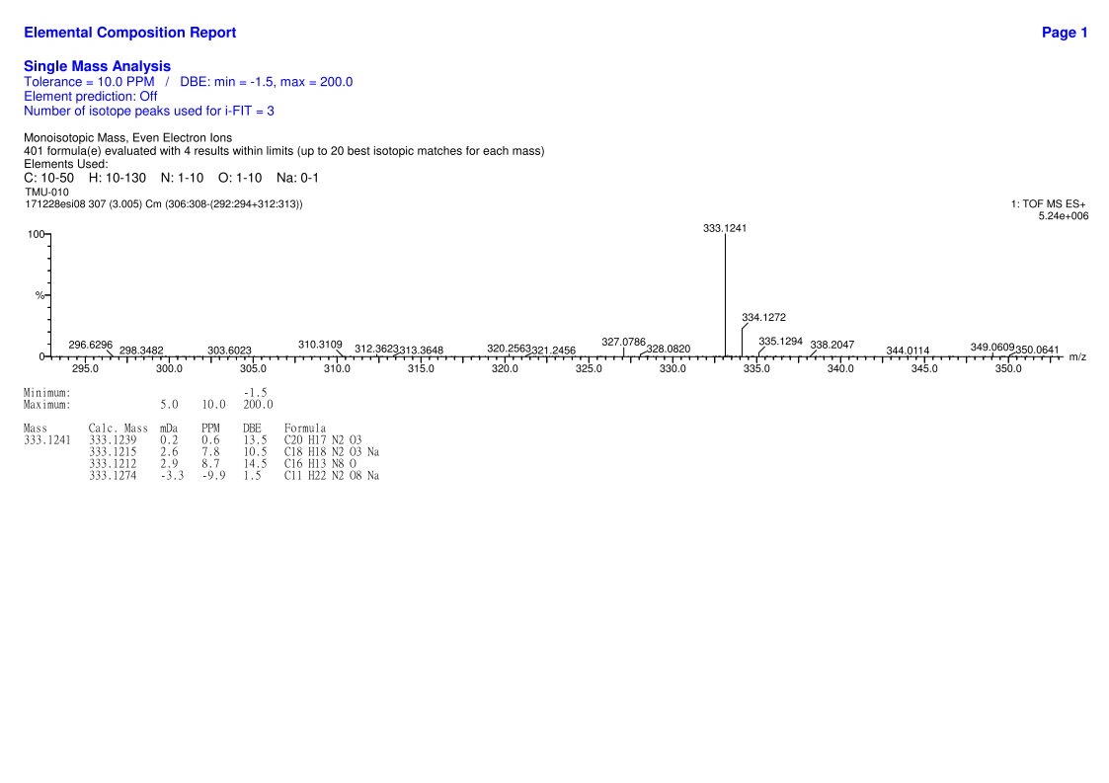
HRMS for compound TP3
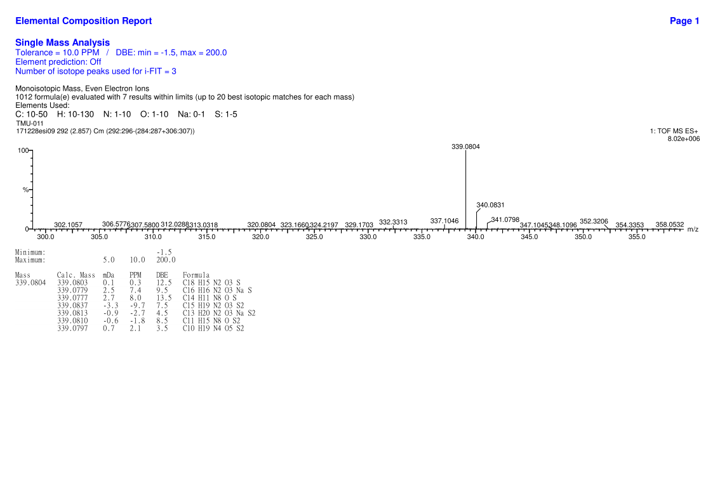
HRMS for compound TP4
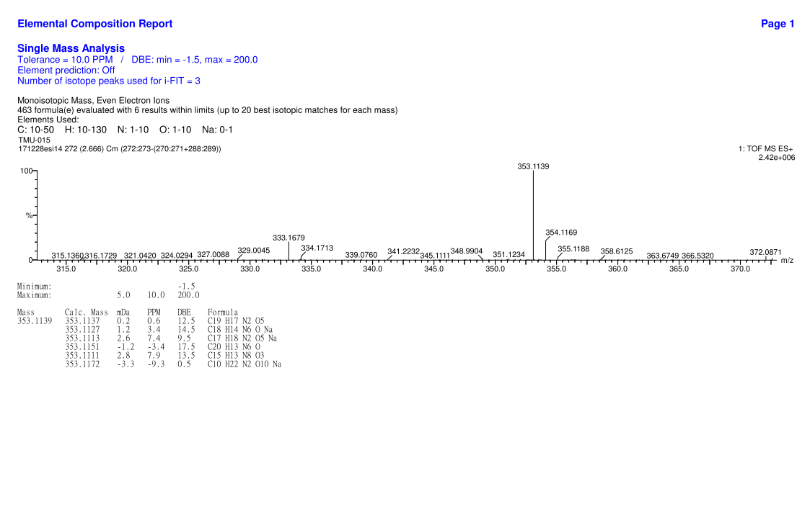
HRMS for compound TP5
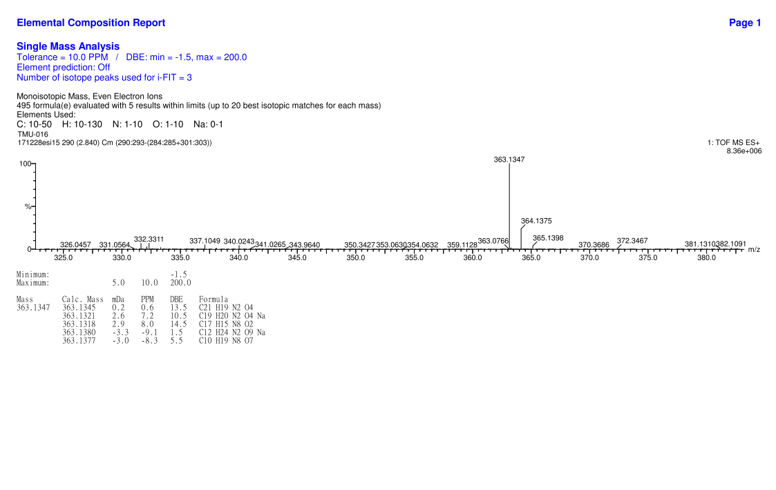
HRMS for compound TP6
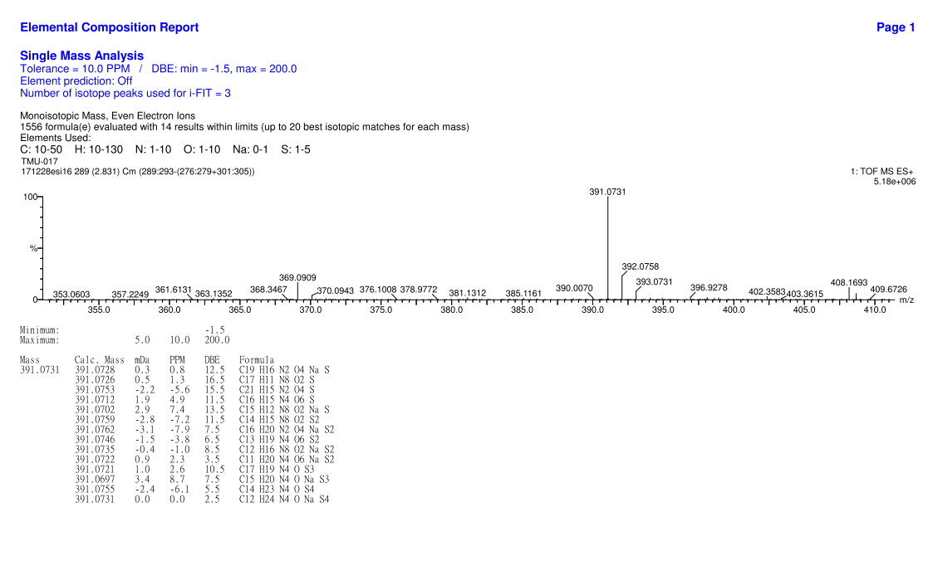
HRMS for compound TP7
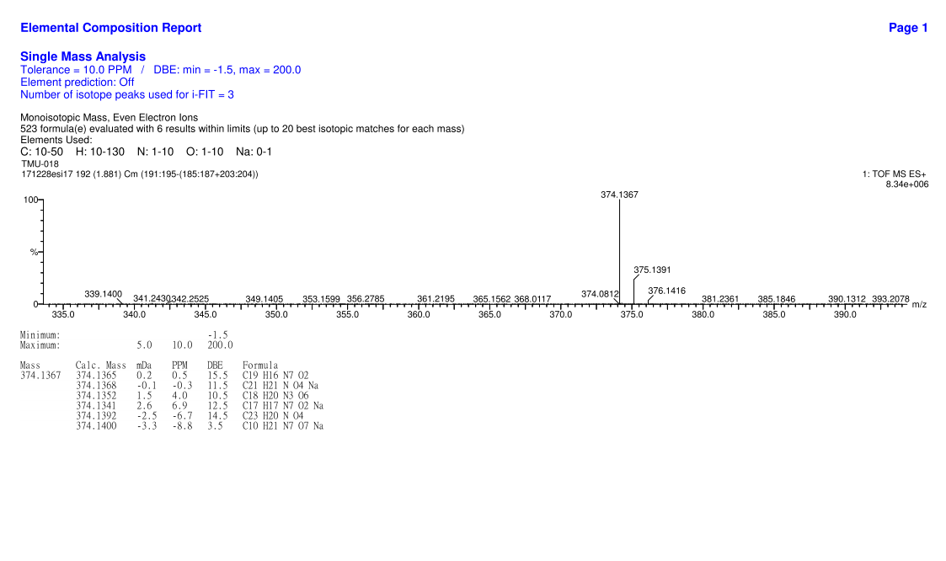
HRMS for compound TP8
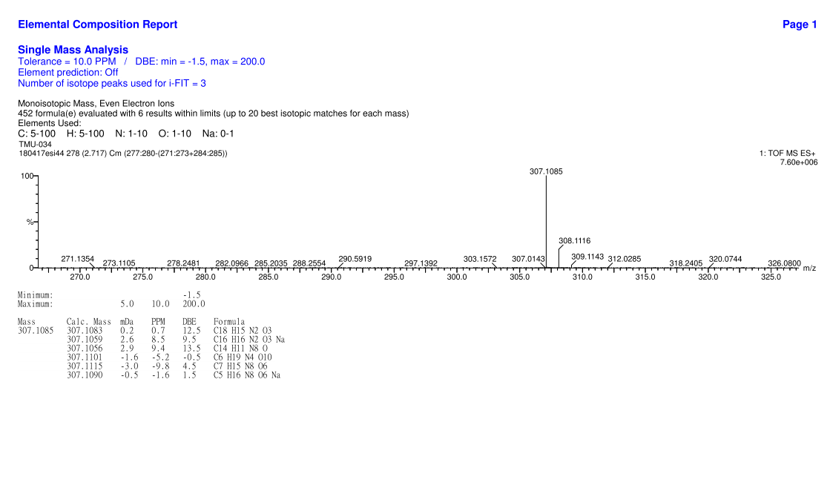
HRMS for compound TP9
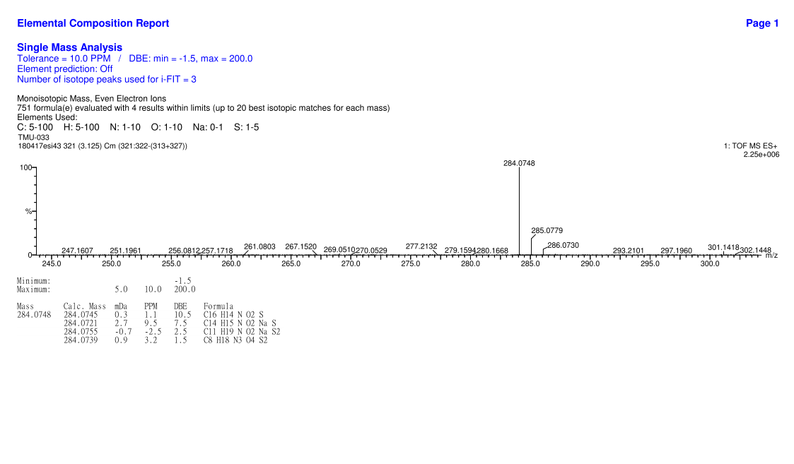
HRMS for compound TP10
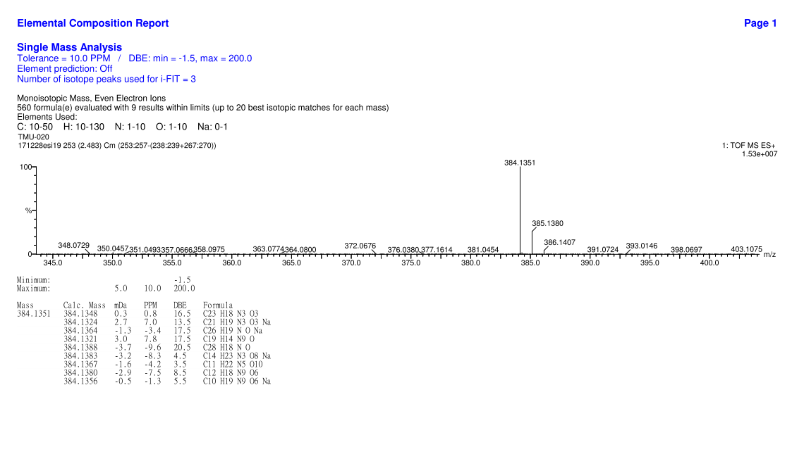
HRMS for compound TP11
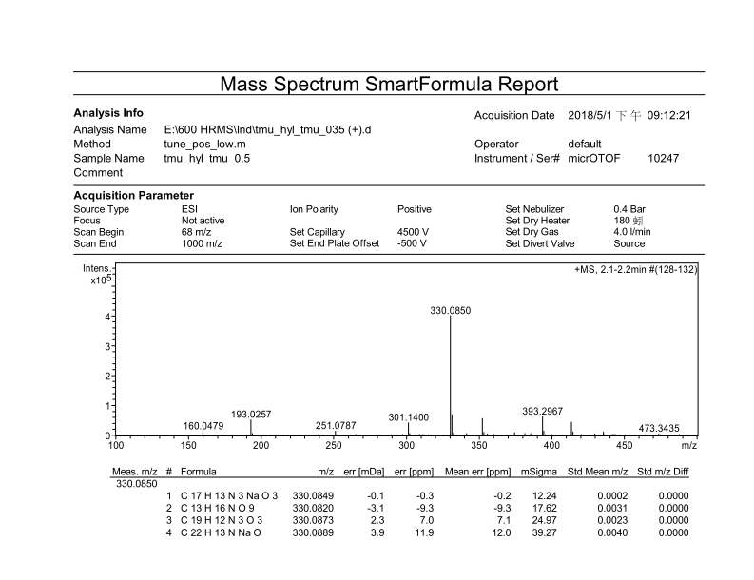
HRMS for compound TP12
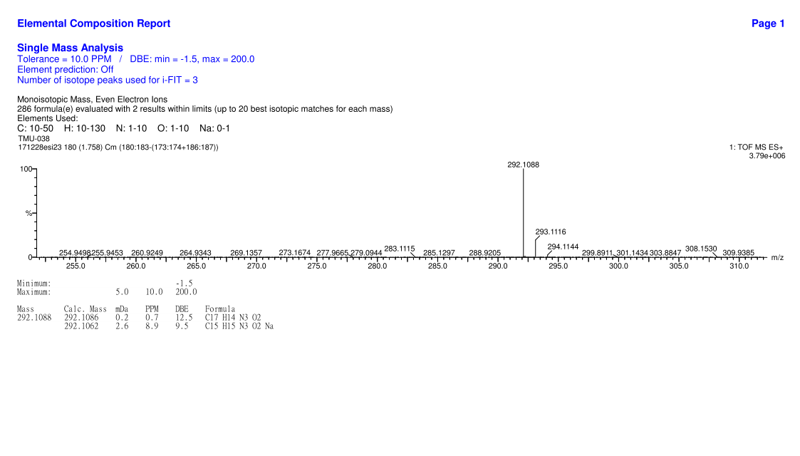
HRMS for compound TP13
