Supplementary Material

Synthesis, textural and magnetic properties of doped and undoped CuO nanoparticles

N. ANJUTHAPRABHA AND MANIMEKALAI R*

Department of Chemistry, Kongunadu Arts and Science College, Coimbatore-641 029, Tamilnadu, India

Figure S1.
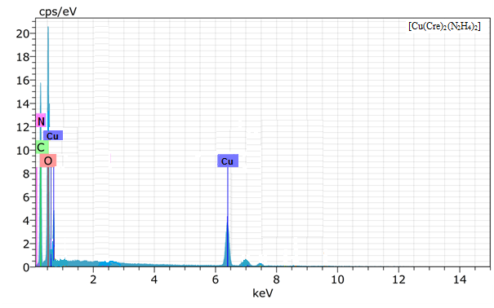

Figure S1 (continued)
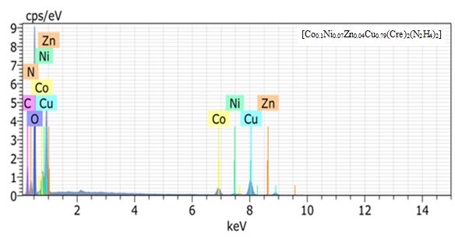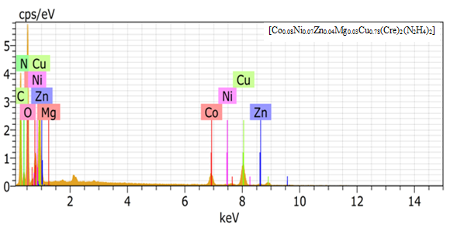
Figure S1. EDS spectra of the precursors-[Cu(Cre)₂(N₂H₄)₂], [Co_{0.1}Ni_{0.07}Zn_{0.04}Cu_{0.79}(Cre)₂(N₂H₄)₂] and [Co_{0.08}Ni_{0.07}Zn_{0.04}Mg_{0.03}Cu_{0.78}(Cre)₂(N₂H₄)₂].

Figure S2.

Figure S2 (continued)

Figure S2. IR spectra of the precursors [Cu(Cre)₂(N₂H₄)₂], [Co_{0.1}Ni_{0.07}Zn_{0.04}Cu_{0.79}(Cre)₂(N₂H₄)₂] and [Co_{0.08}Ni_{0.07}Zn_{0.04}Mg_{0.03}Cu_{0.78}(Cre)₂(N₂H₄)₂].

Figure S3.

Figure S3 (continued)
Figure S3. TG-DTA of the precursors [Cu(Cre)₂(N₂H₄)₂], [Co_{0.1}Ni_{0.07}Zn_{0.04}Cu_{0.79}(Cre)₂(N₂H₄)₂] and [Co_{0.08}Ni_{0.07}Zn_{0.04}Mg_{0.03}Cu_{0.78}(Cre)₂(N₂H₄)₂].

Figure S4.

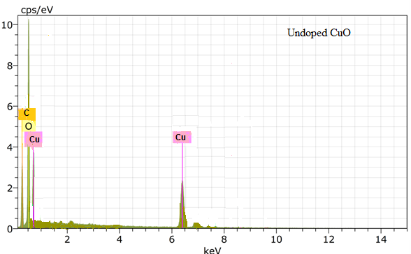

Figure S4 (continued)
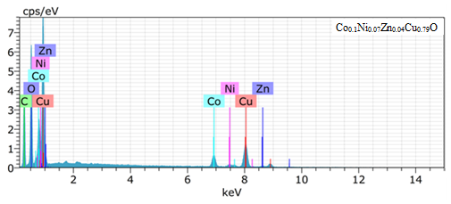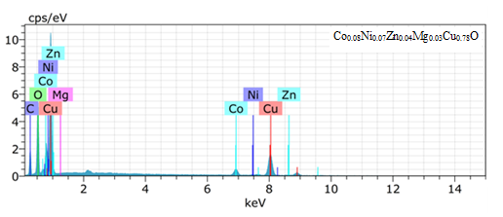
Figure S4. EDS spectra of the undoped CuO, Co_{0.1}Ni_{0.07}Zn_{0.04}Cu_{0.79}O and Co_{0.08}Ni_{0.07}Zn_{0.04}Mg_{0.03}Cu_{0.78}O nanoparticles.

Figure S5.

Figure S5 (continued)
Figure S5. FT-IR spectra of undoped CuO, Co_{0.1}Ni_{0.07}Zn_{0.04}Cu_{0.79}O and Co_{0.08}Ni_{0.07}Zn_{0.04}Mg_{0.03}Cu_{0.78}O nanoparticles.

Table S1. Infrared analysis data of [Cu(Cre)₂(N₂H₄)₂], [Co_{0.1}Ni_{0.07}Zn_{0.04}Cu_{0.79}(Cre)₂(N₂H₄)₂] and [Co_{0.08}Ni_{0.07}Zn_{0.04}Mg_{0.03}Cu_{0.78}(Cre)₂(N₂H₄)₂].
S. No. | Precursor | ν_{(N-H)} cm⁻¹ | ν_{asy(OCO)} cm⁻¹ | ν_{sym(OCO)} cm⁻¹ | Δν cm⁻¹ | ν_{(N-N)} cm⁻¹
1 | [Cu(Cre)₂(N₂H₄)₂ | 3302 | 1612 | 1411 | 201 | 972
2 | [Co_{0.1}Ni_{0.07}Zn_{0.04}Cu_{0.79}(Cre)₂(N₂H₄)₂] | 3300 | 1610 | 1409 | 201 | 970
3 | [Co_{0.08}Ni_{0.07}Zn_{0.04}Mg_{0.03}Cu_{0.78}(Cre)₂(N₂H₄)₂] | 3299 | 1606 | 1409 | 197 | 970

Table S2. TG-DTA of [Cu(Cre)₂(N₂H₄)₂], [Co_{0.1}Ni_{0.07}Zn_{0.04}Cu_{0.79}(Cre)₂(N₂H₄)₂] and [Co_{0.08}Ni_{0.07}Zn_{0.04}Mg_{0.03}Cu_{0.78}(Cre)₂(N₂H₄)₂].
S. No. | Precursor | DTA Peak  (ºC) | TG temp.  Range  (ºC) | TG weight loss (%)  Obt. (calc.) | Final residue
1 | [Cu(Cre)₂(N₂H₄)₂ | 243(-) | 200-300 | 84.9 (85.39) | CuO
2 | [Co_{0.1}Ni_{0.07}Zn_{0.04}Cu_{0.79}(Cre)₂(N₂H₄)₂] | 250(-) | 200-300 | 85.1 (85.47) | Co_{0.1}Ni_{0.07}Zn_{0.04}  Cu_{0.79}O
3 | [Co_{0.08}Ni_{0.07}Zn_{0.04}Mg_{0.03}Cu_{0.78}(Cre)₂(N₂H₄)₂] | 261(-) | 200-300 | 85.3 (85.71) | Co_{0.08}Ni_{0.07}Zn_{0.04}  Mg_{0.03}Cu_{0.78}O

Table S3. ICP-AES data of undoped CuO, Co_{0.1}Ni_{0.07}Zn_{0.04}Cu_{0.79}O and Co_{0.08}Ni_{0.07}Zn_{0.04}Mg_{0.03}Cu_{0.78}O nanoparticles.
S.  No. | Sample | Co(2388)  % | Ni(2216)  % | Zn(2062)  % | Mg(2852)  % | Cu(2247)  % | Molecular mass (g)
1 | Undoped CuO | - | - | - | - | 74.367 | 79.545
2 | Co_{0.1}Ni_{0.07}Zn_{0.04}  Cu_{0.79}O | 7.362 | 5.161 | 3.263 | - | 62.142 | 78.8173
3 | Co_{0.08}Ni_{0.07}Zn_{0.04}  Mg_{0.03}Cu_{0.78}O | 5.195 | 5.097 | 3.208 | 0.860 | 61.257 | 77.7323

Table S4. XPS data of undoped CuO, Co_{0.1}Ni_{0.07}Zn_{0.04}Cu_{0.79}O and Co_{0.08}Ni_{0.07}Zn_{0.04}Mg_{0.03}Cu_{0.78}O nanoparticles.
S. No. | Element | Peak | Undoped CuO | Co_{0.1}Ni_{0.07}Zn_{0.04}Cu_{0.79}O | Co_{0.08}Ni_{0.07}Zn_{0.04}Mg_{0.03}Cu_{0.78}O
1 | Co2p  eV | 2p_{3/2} | - | 780.65 | 780.55
 |  | 2p_{1/2} | - | 796.42 | 796.35
 |  | S1 | - | 788.75 | 788.45
 |  | S2 | - | 803.45 | 803.42
2 | Ni2p  eV | 2p_{3/2} | - | 855.55 | 855.35
 |  | 2p_{1/2} | - | 873.55 | 873.45
 |  | S1 | - | 861.25 | 861.24
 |  | S2 | - | 881.75 | 881.70
3 | Zn2p  eV | 2p_{3/2} | - | 1021.51 | 1021.03
 |  | 2p_{1/2} | - | 1045.53 | 1045.52
4 | Mg1s  eV | 1s | - | - | 1303
5 | Cu2p  eV | 2p_{3/2} | 933.82 | 934.48 | 934.52
 |  | 2p_{1/2} | 954.40 | 954.58 | 954.48
 |  | S₁ | 942.71 | 943.30 | 943.40
 |  | S₂ | 962.52 | 962.52 | 962.52
6 | O1s  eV | 1s | 530.1, 531.2 | 530.12, 531.20 | 531.0
7 | C1s  eV | 1s | 285.3 | 285.10 | 285.5

Table S5. BET surface data of undoped CuO, Co_{0.1}Ni_{0.07}Zn_{0.04}Cu_{0.79}O and Co_{0.08}Ni_{0.07}Zn_{0.04}Mg_{0.03}Cu_{0.78}O nanoparticles.
S. No. | Sample | BET surface area  S_{BET} (m²/g) | Surface area of pores S_{BJH}  (m²/g) | Pore volume  V_{BJH}  (cm³/g) | Average  pore  diameter  D_{P (BJH)} (nm) | Average  particle  size D_{BET} (nm)
1 | Undoped CuO | 41.362 | 55.496 | 0.053 | 3.82 | 22.9
2 | Co_{0.1}Ni_{0.07}Zn_{0.04}Cu_{0.79}O | 22.185 | 30.902 | 0.046 | 5.95 | 42.8
3 | Co_{0.08}Ni_{0.07}Zn_{0.04}Mg_{0.03}Cu_{0.78}O | 15.181 | 26.439 | 0.039 | 5.90 | 62.6

