Ceric Ammonium Nitrate (CAN) catalyzed synthesis and α-glucosidase activity of some novel tetrahydropyridine phosphonate derivatives

Kandula Madhu Kumar Reddyª, Kotha Peddanna^{b}, Mavallur Varalakshmi^{c}, Nemallapudi Bakthavatchala Reddy^{a,d}, Gundala Sravya^{a,d}, Grigory V Zyryanov ^{d,e}, Cirandur Suresh Reddy^{a*}
ªDepartment of Chemistry, Sri Venkateswara University, Tirupati-517 502, Andhra Pradesh, India
^{b}Department of Bio-Chemistry, Sri Venkateswara University, Tirupati-517 502, Andhra Pradesh, India
^{c}Department of Humanities and Sciences, Sri Venkateswara College of Engineering and Technology, Chittoor-517 127, Andhra Pradesh, Indi
^{d}Department of Organic and Biomolecular Chemistry, Chemical Engineering Institute, Ural Federal University, 19 Mira Street, 620002 Yekaterinburg, Russian Federation
^{e}I. Ya. Postovskiy Institute of Organic Synthesis, Ural Division of the Russian Academy of Sciences, 22 S. Kovalevskoy Street, 620219 Yekaterinburg, Russian Federation
E-mail: csrsvu@gmail.com

Supplemental Materials

Figure S 1: Recyclability of CAN catalyst

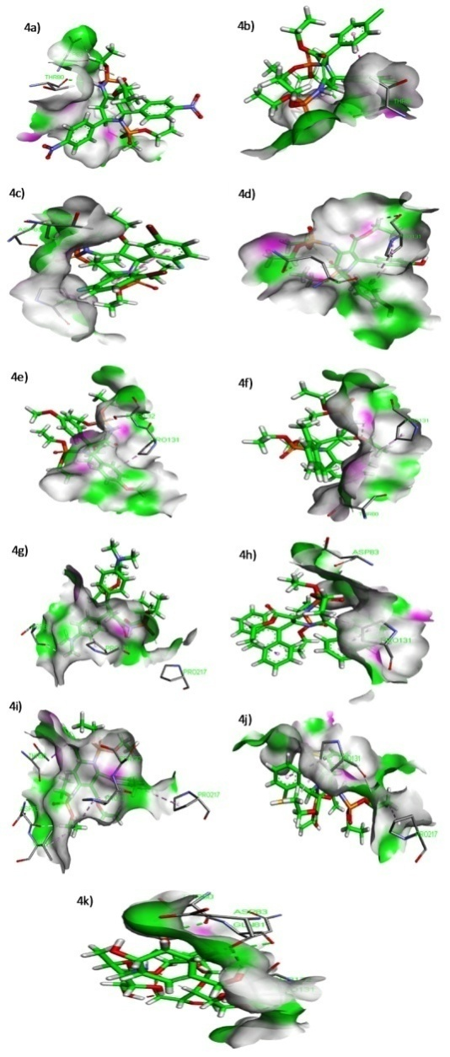

Figure S 2: Molecular Docking Figures of 4a-j

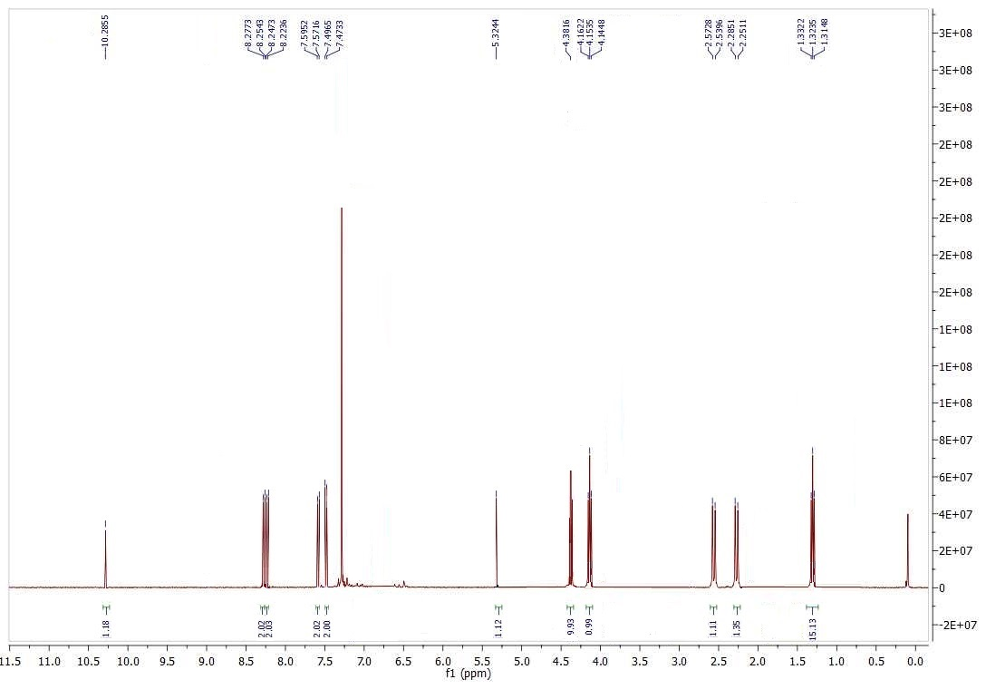
Figure S 3: ¹H - NMR Spectrum of compound 4a

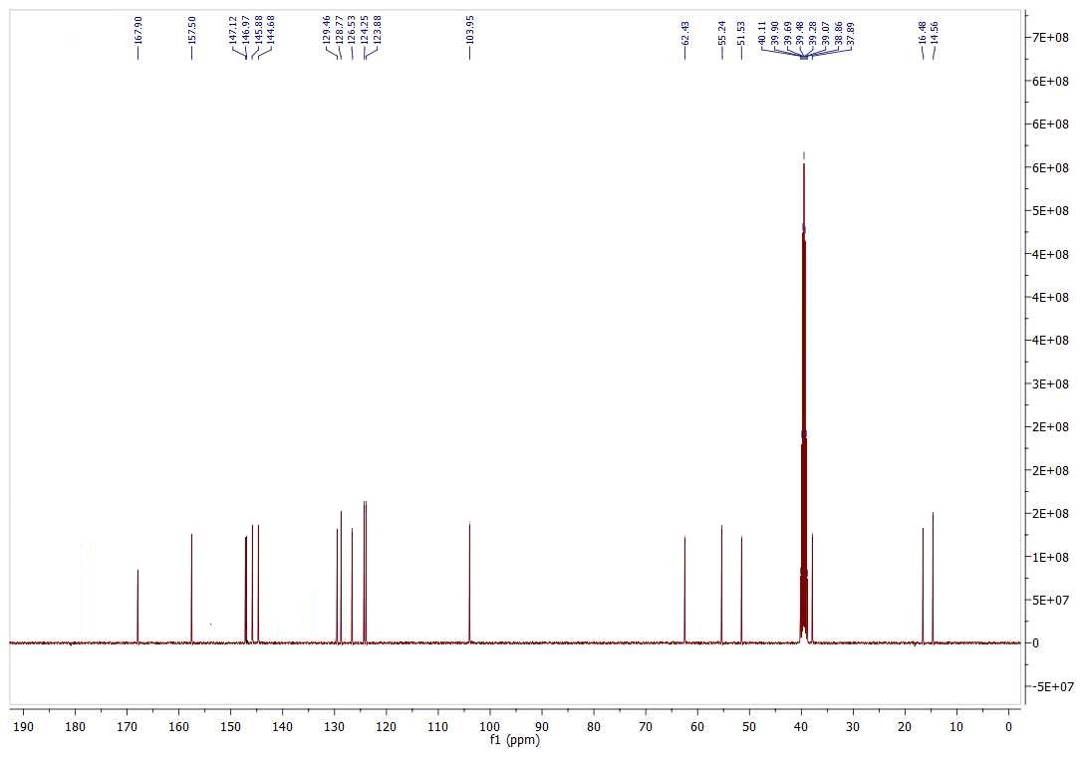
Figure S 4: ¹³C - NMR Spectrum of compound 4a

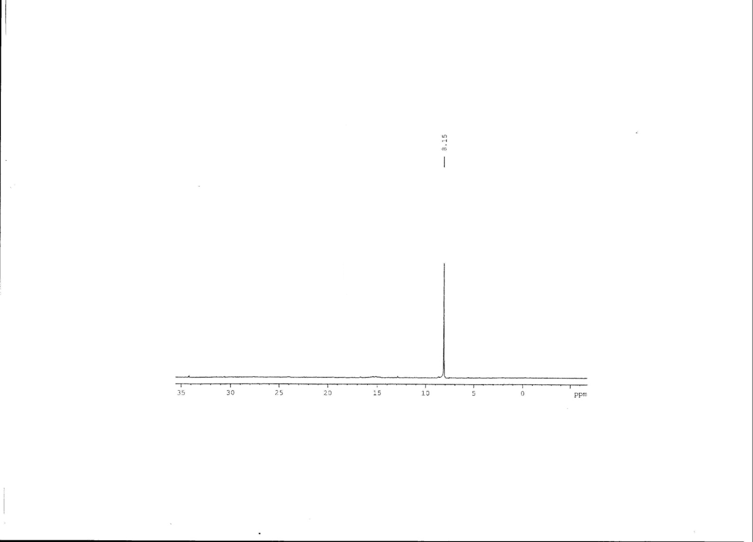
Figure S 5: ³¹P - NMR Spectrum of compound 4a

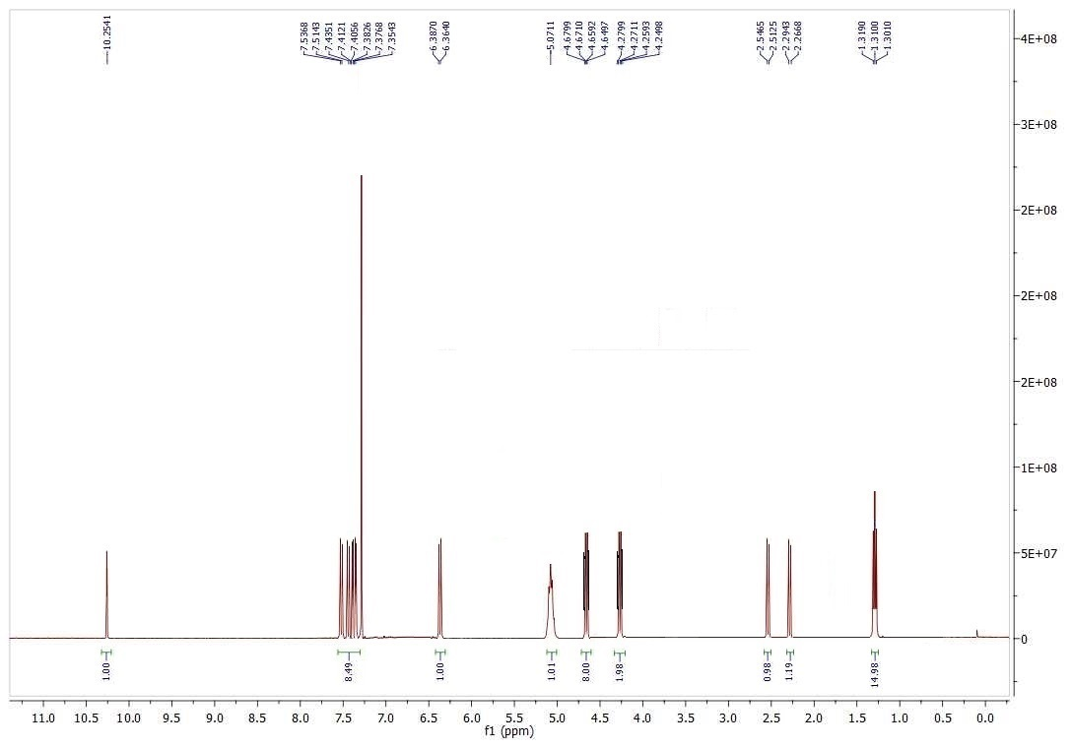
Figure S 6: ¹H - NMR Spectrum of compound 4b

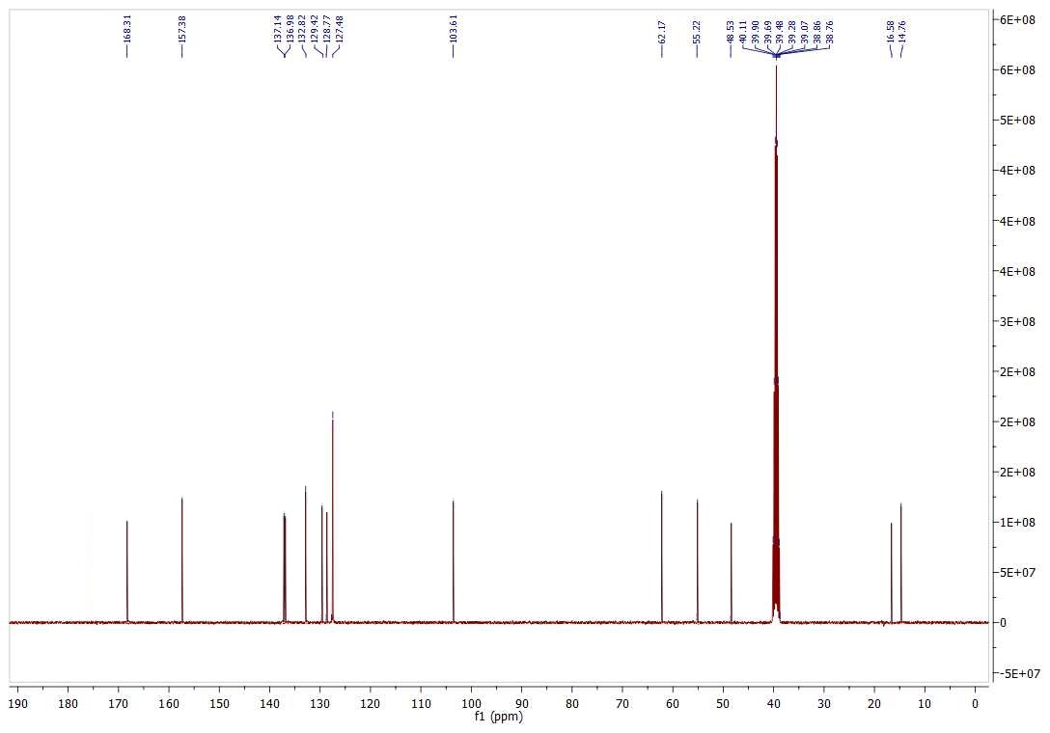
Figure S 7: ¹³C - NMR Spectrum of compound 4b

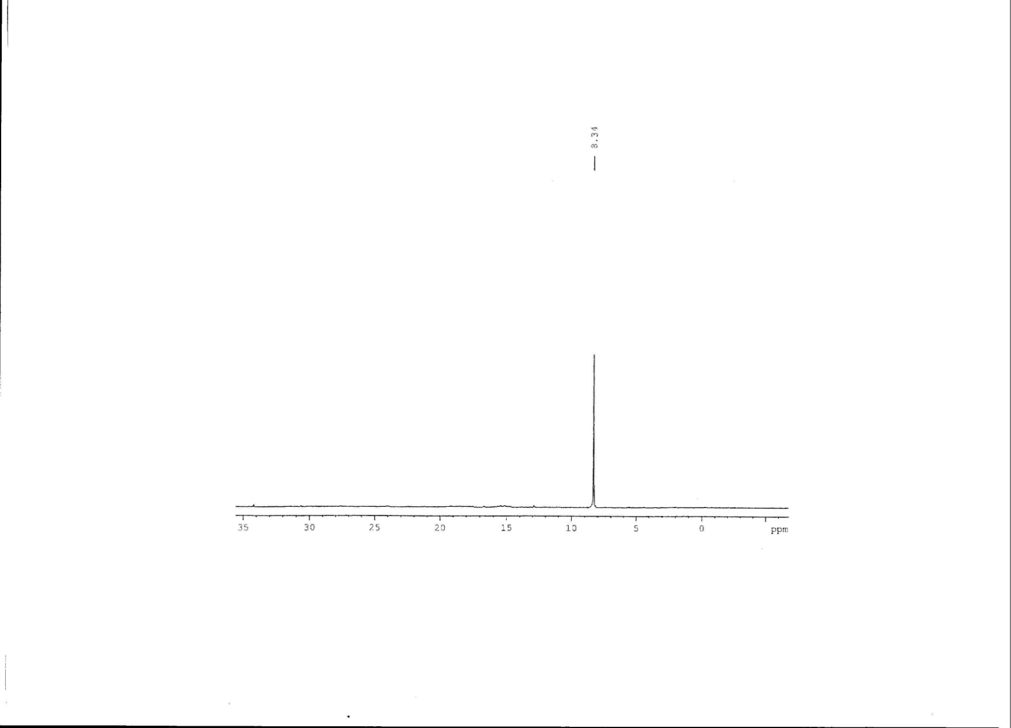
Figure S 8: ³¹P - NMR Spectrum of compound 4b

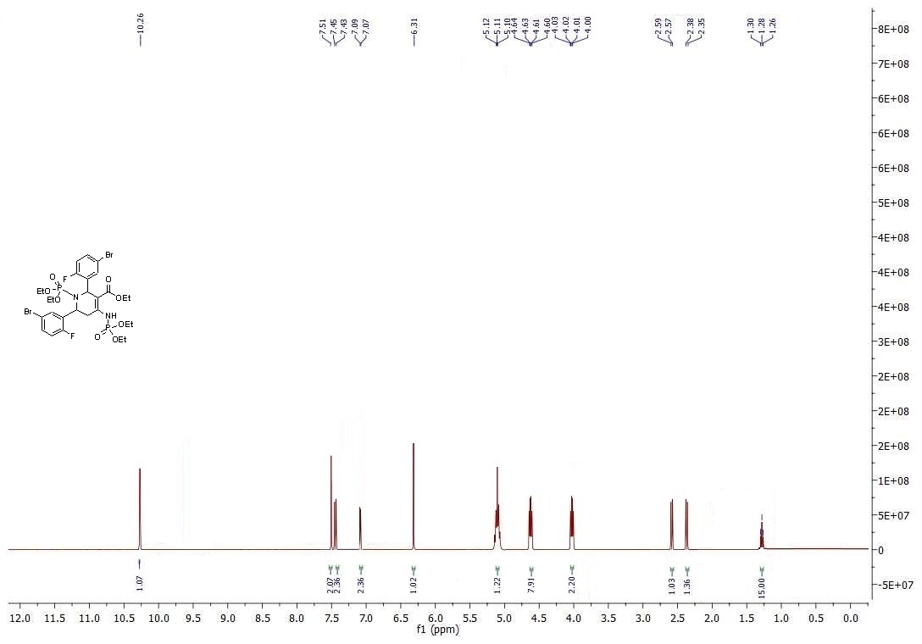
Figure S 9: ¹H - NMR Spectrum of compound 4c
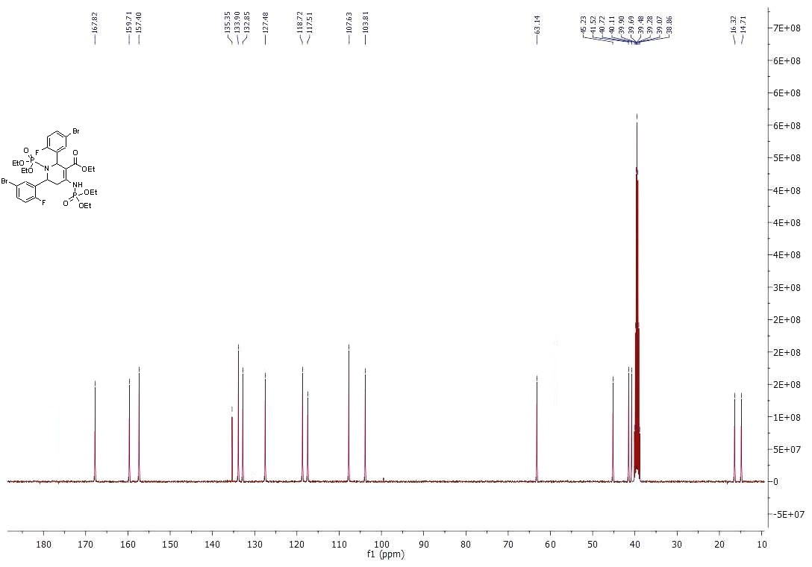
Figure S 10: ¹³C - NMR Spectrum of compound 4c
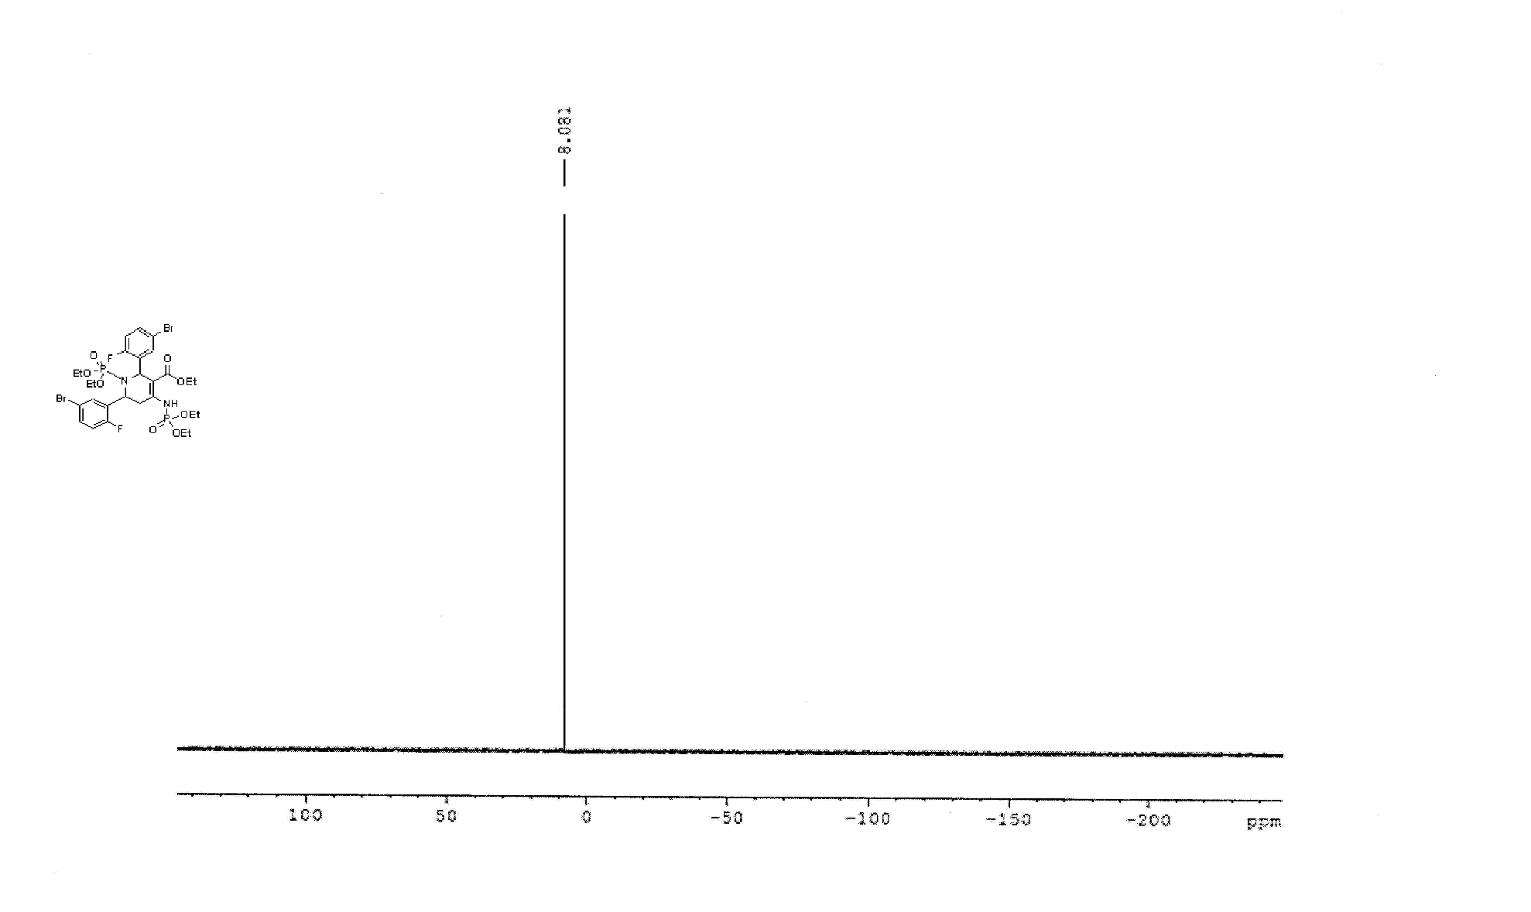
Figure S 11: ³¹P - NMR Spectrum of compound 4c

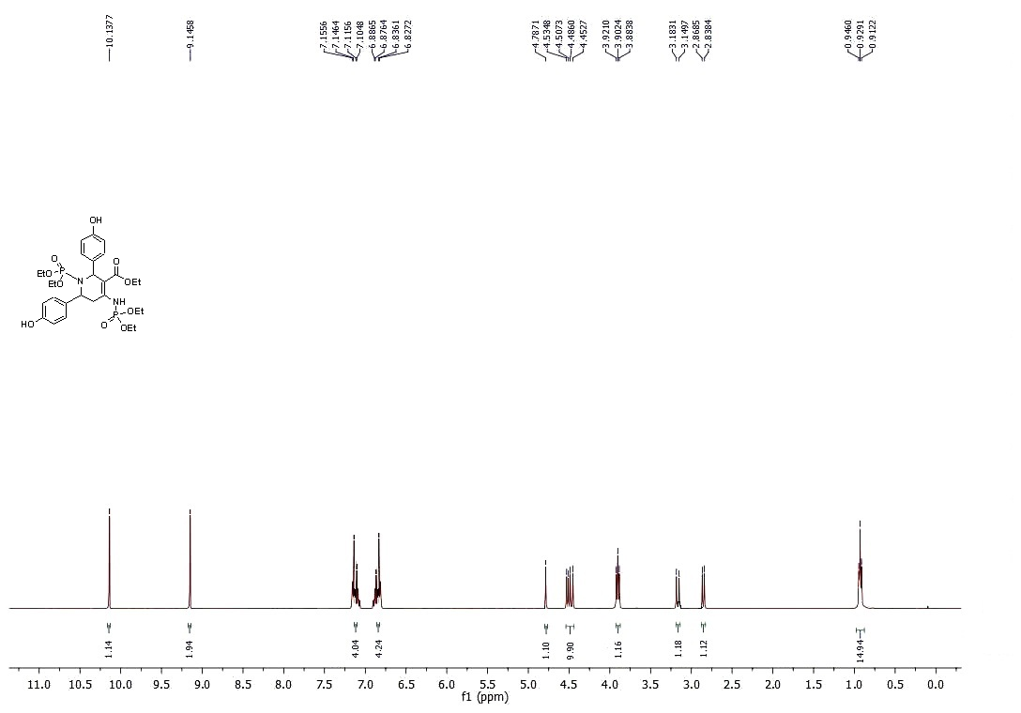
Figure S 12: ¹H - NMR Spectrum of compound 4d
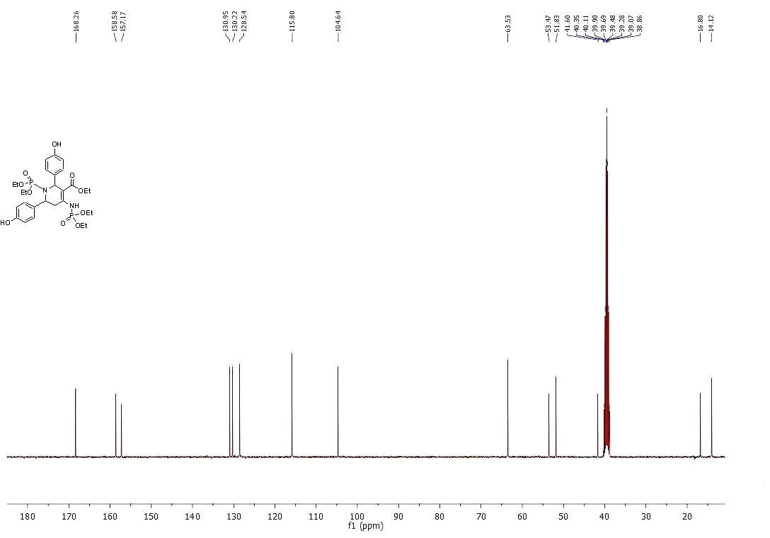
Figure S 13: ¹³C - NMR Spectrum of compound 4d
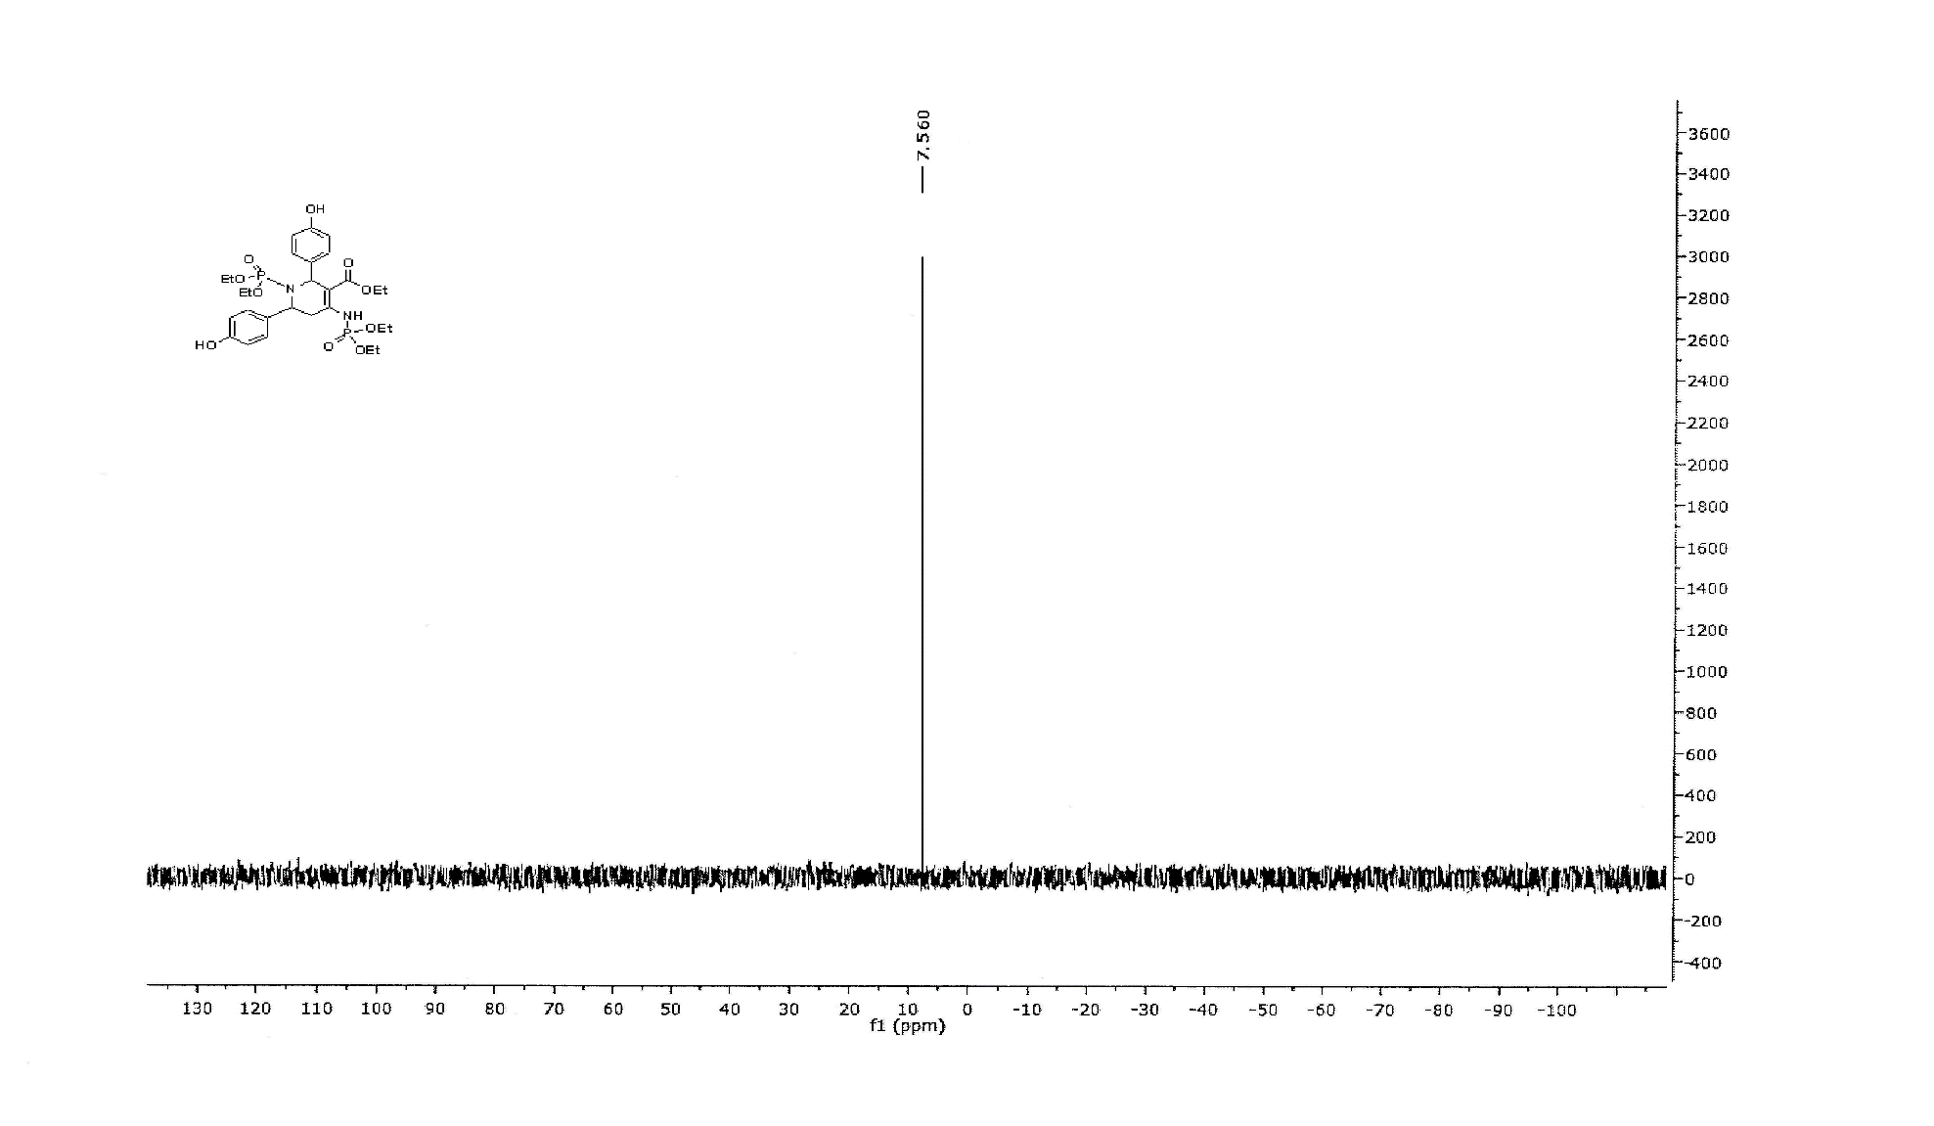
Figure S 14: ³¹P - NMR Spectrum of compound 4d

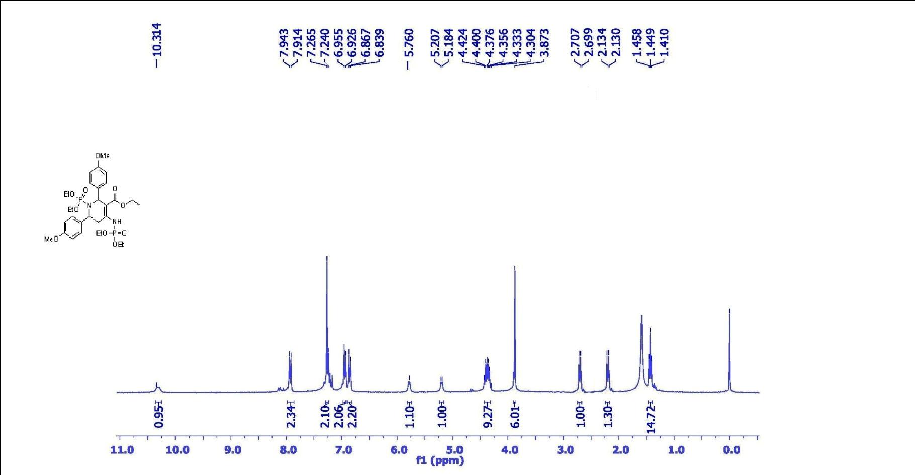

Figure S 15: ¹H - NMR Spectrum of compound 4e

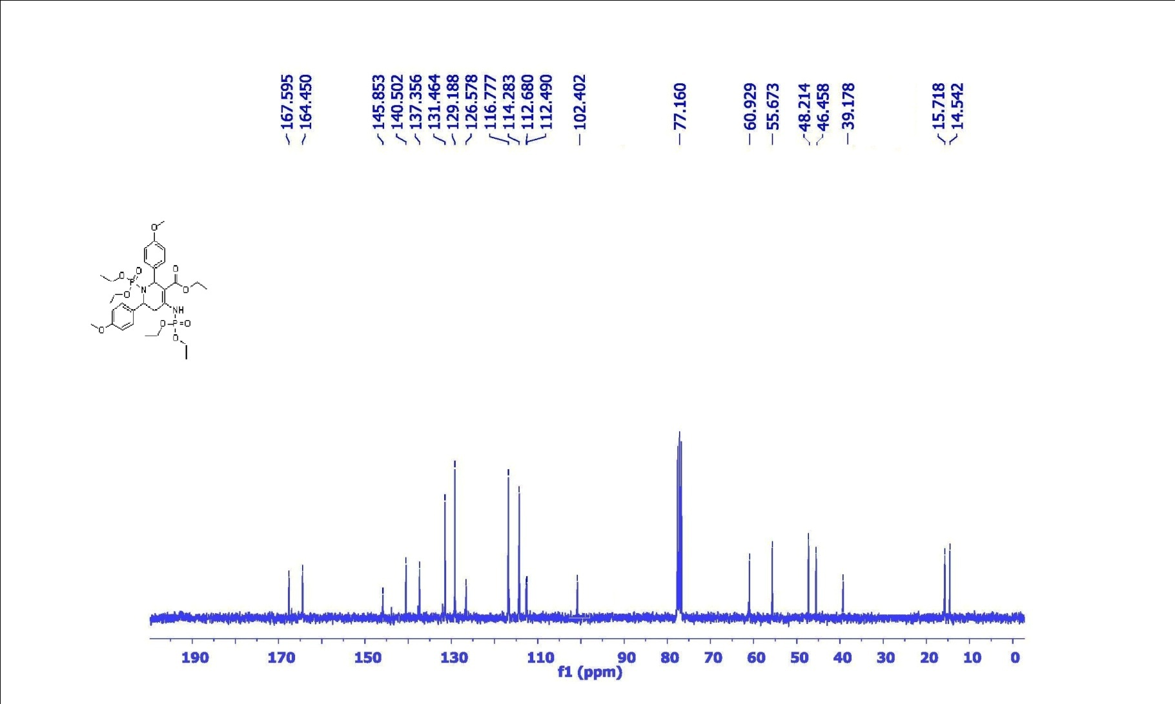
Figure S 16: ¹³C - NMR Spectrum of compound 4e

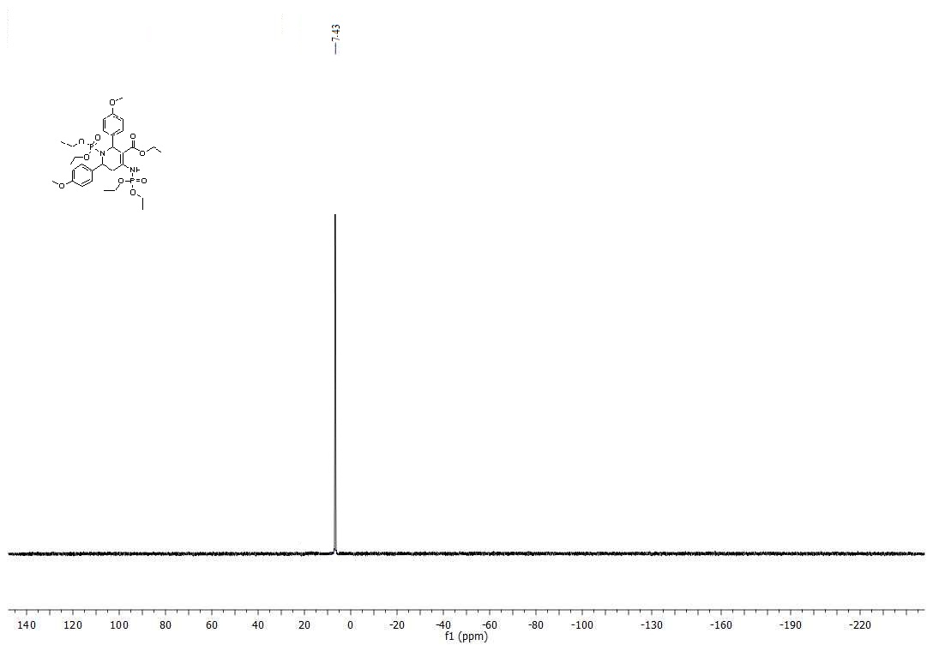
Figure S 17: ³¹P - NMR Spectrum of compound 4e

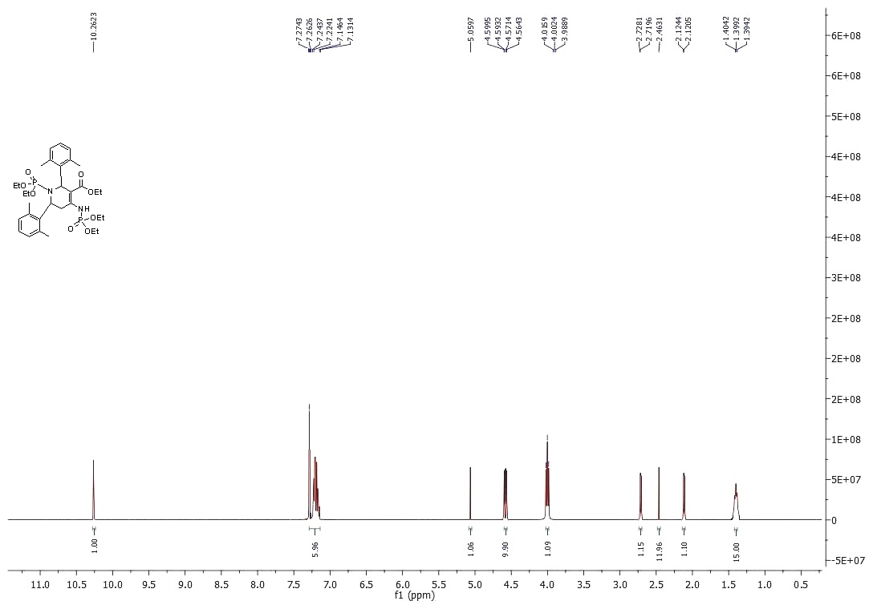

Figure S 18: ¹H - NMR Spectrum of compound 4f

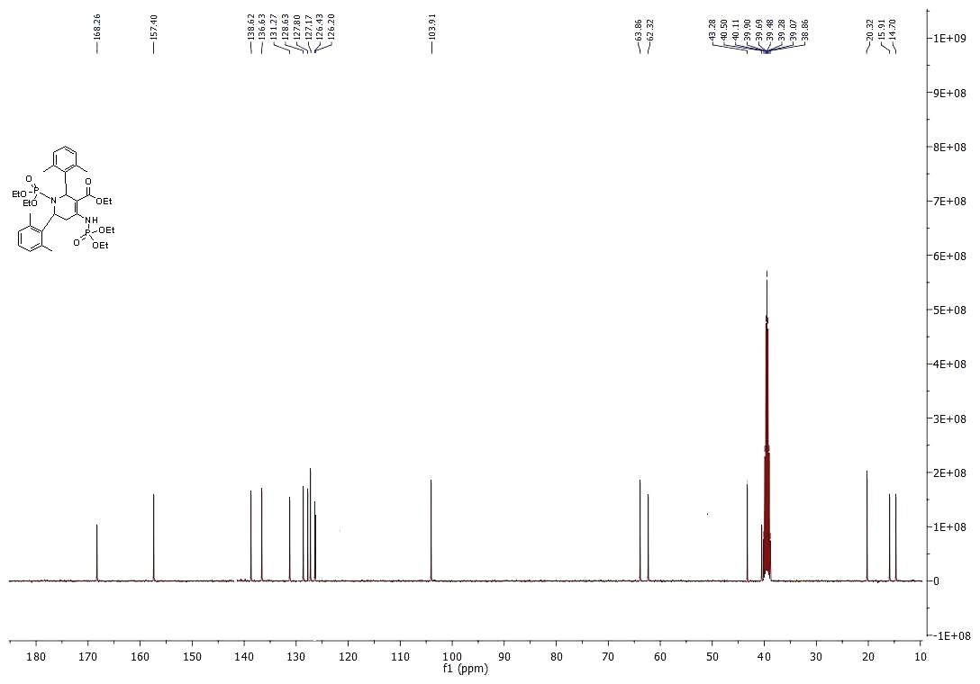

Figure S 19: ¹³C - NMR Spectrum of compound 4f

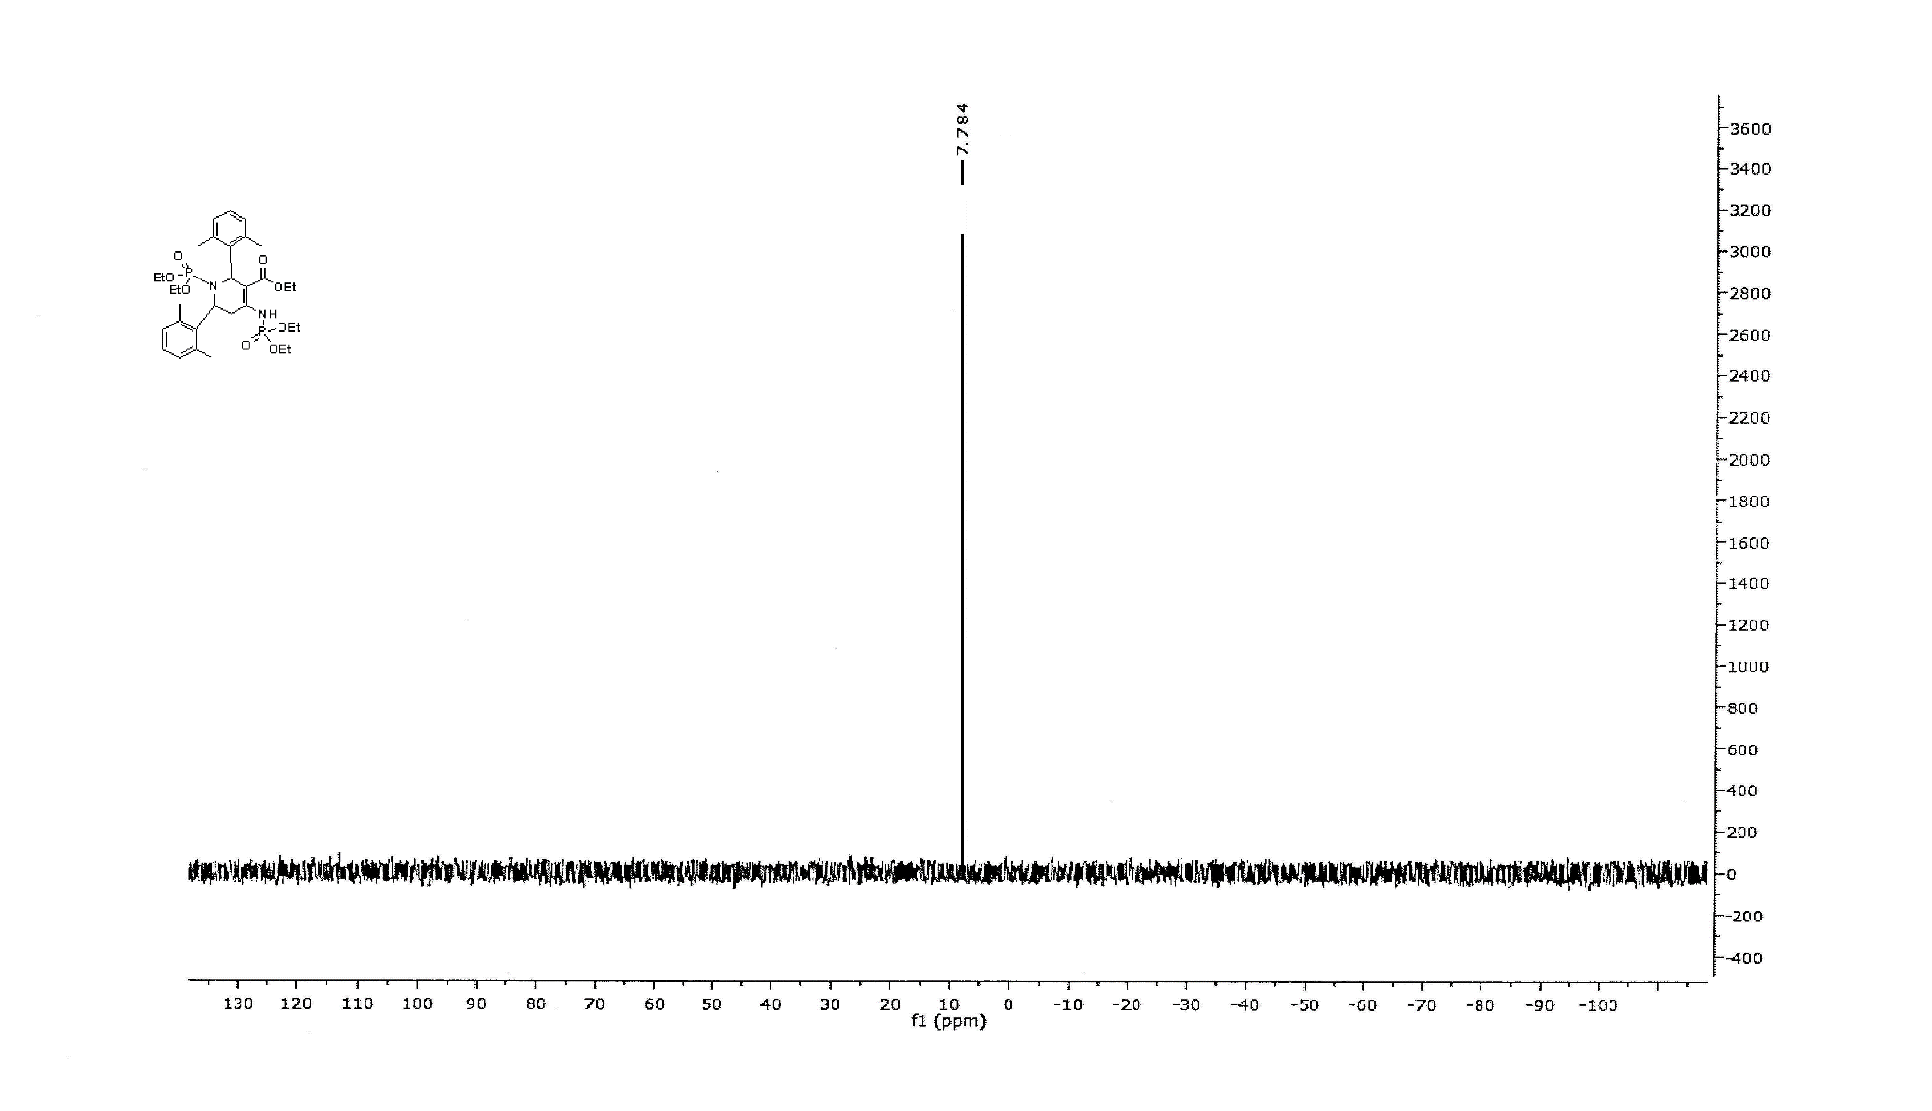
Figure S 20: ³¹P - NMR Spectrum of compound 4f

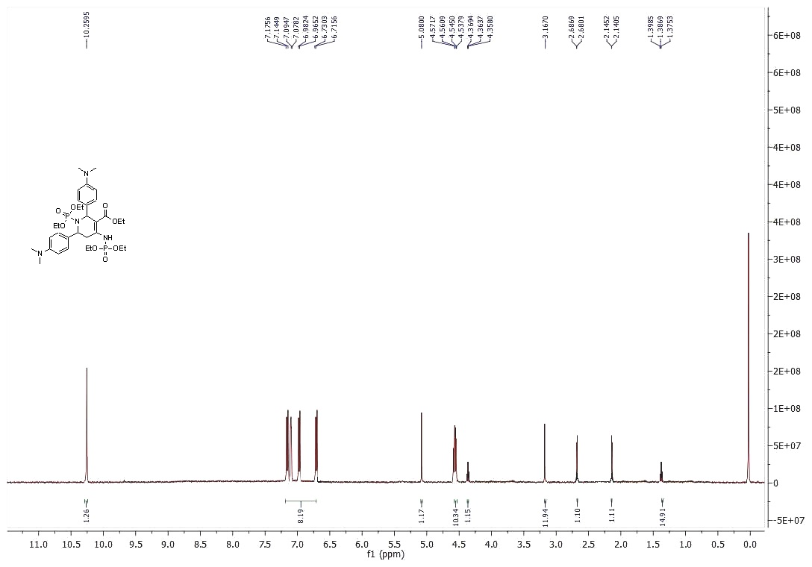

Figure S 21: ¹H - NMR Spectrum of compound 4g

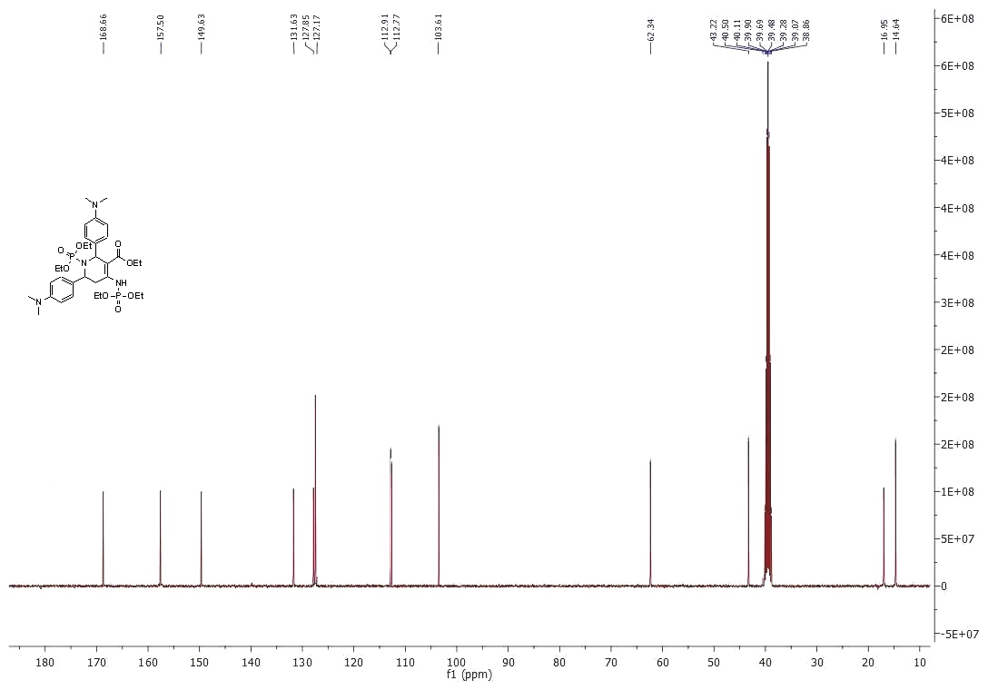

Figure S 22: ¹³C - NMR Spectrum of compound 4g
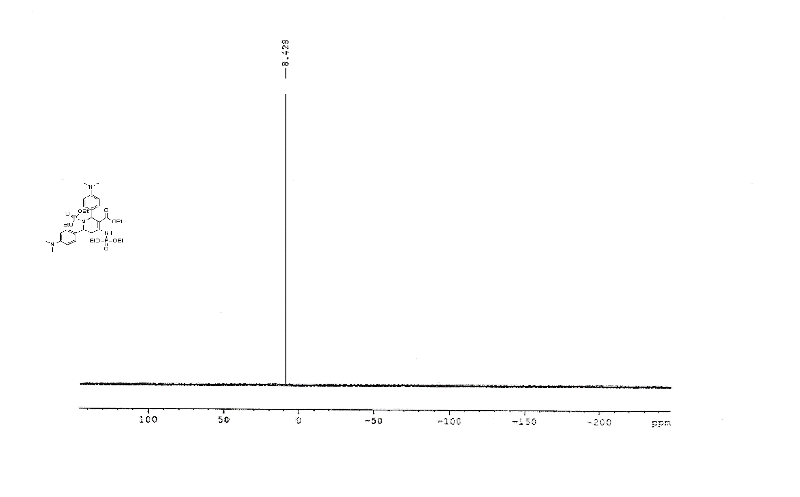

Figure S 23: ³¹P - NMR Spectrum of compound 4g

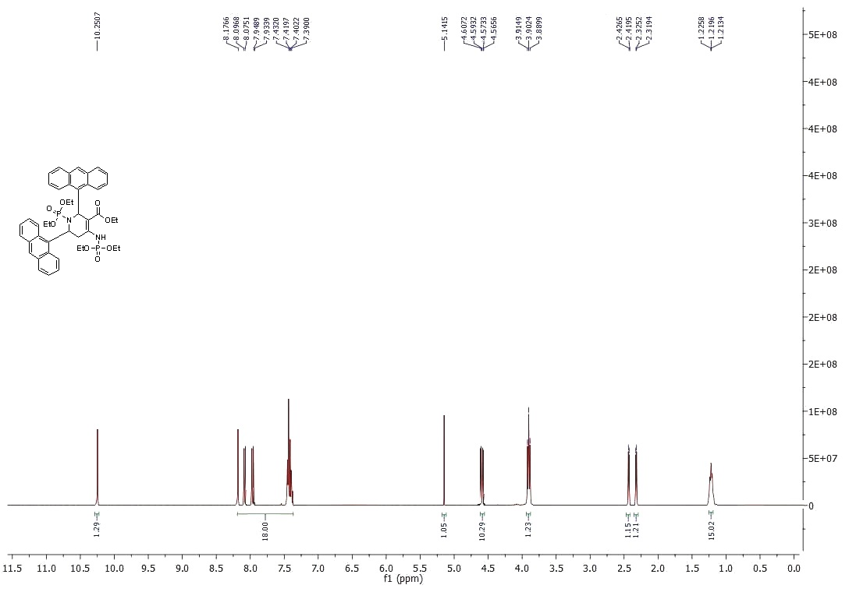

Figure S 24: ¹H - NMR Spectrum of compound 4h

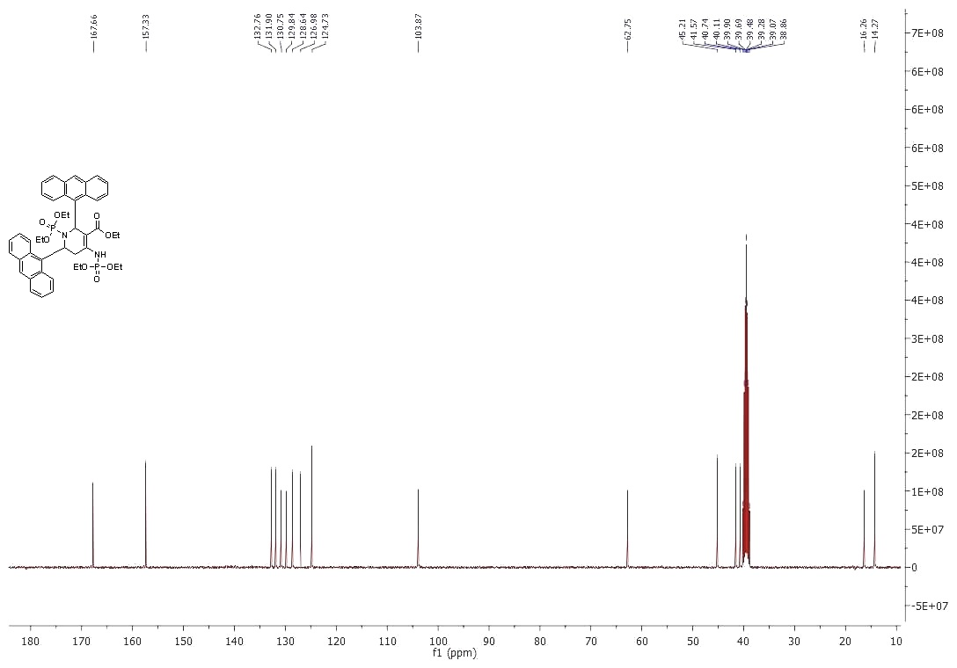
Figure S 25: ¹³C - NMR Spectrum of compound 4h
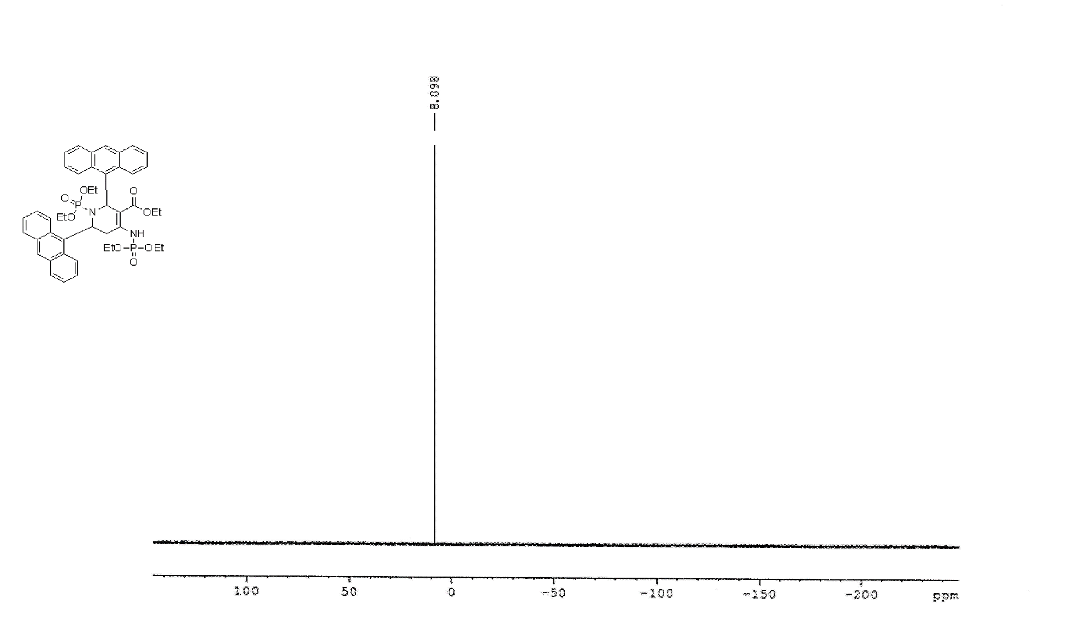

Figure S 26: ³¹P - NMR Spectrum of compound 4h

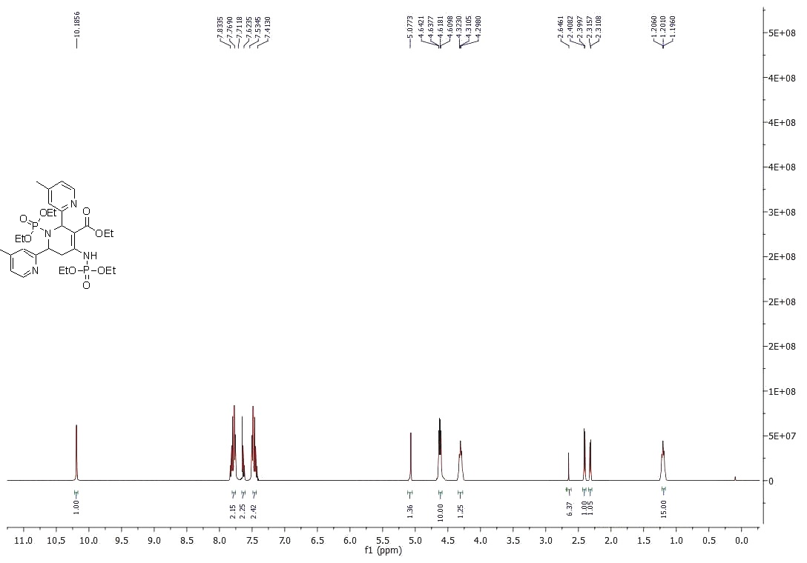

Figure S 27: ¹H - NMR Spectrum of compound 4i
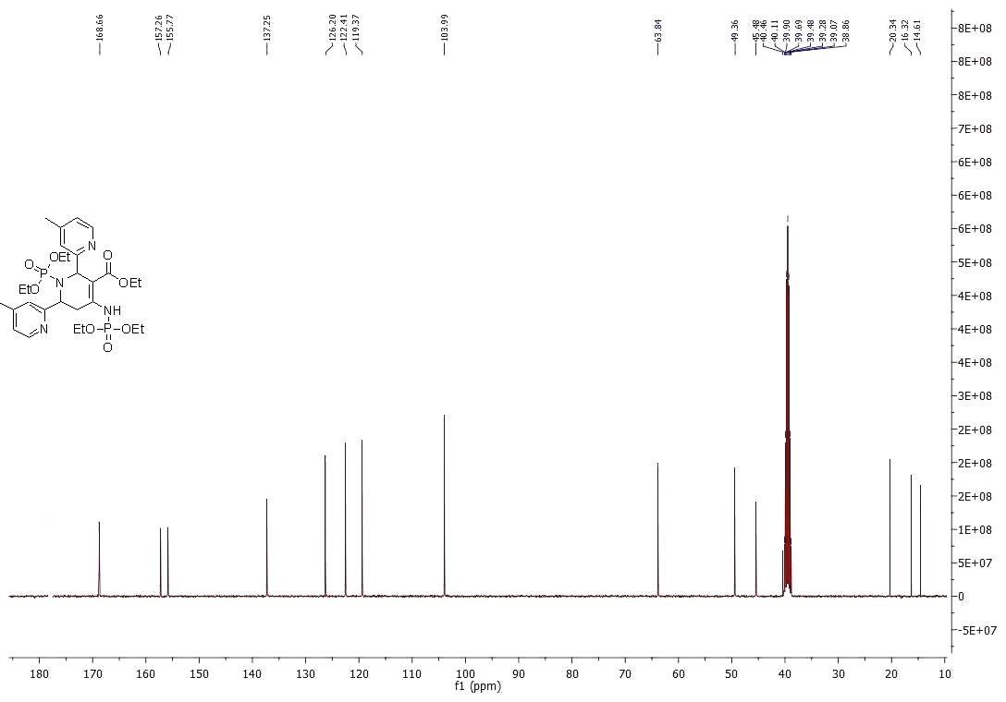
Figure S 28: ¹³C - NMR Spectrum of compound 4i
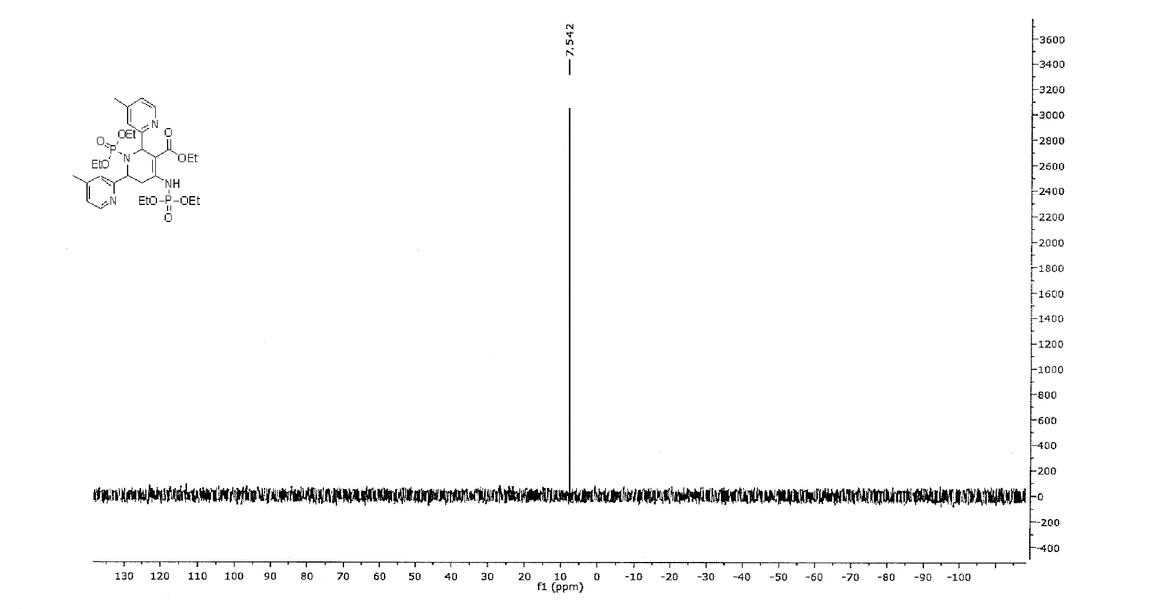
Figure S 29: ³¹P - NMR Spectrum of compound 4i

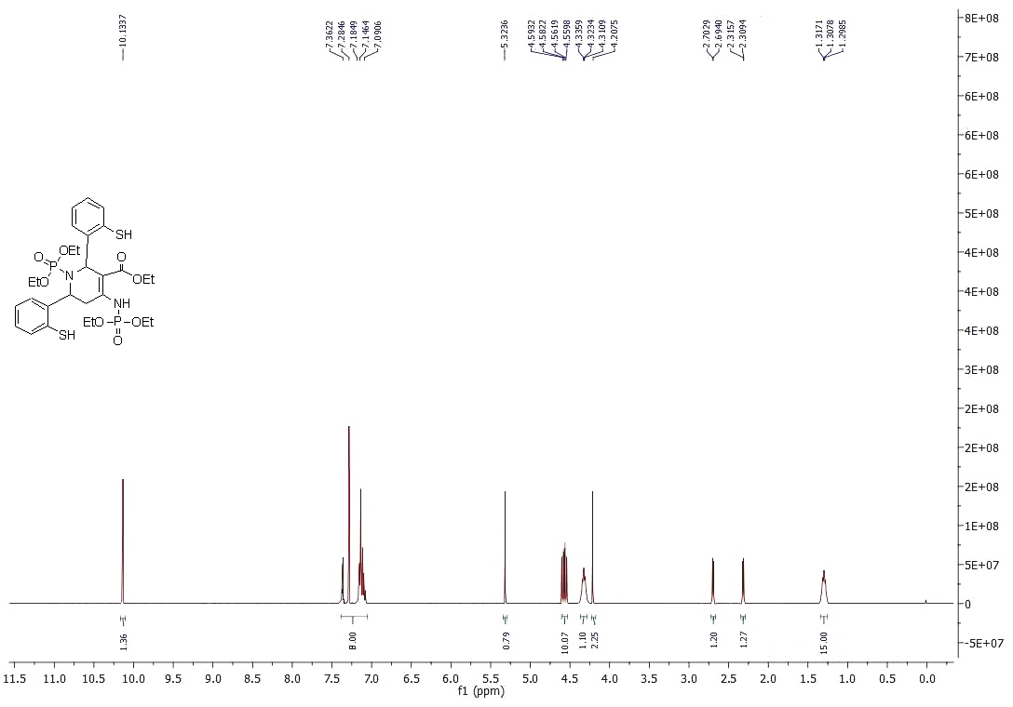
Figure S 30: ¹H - NMR Spectrum of compound 4j
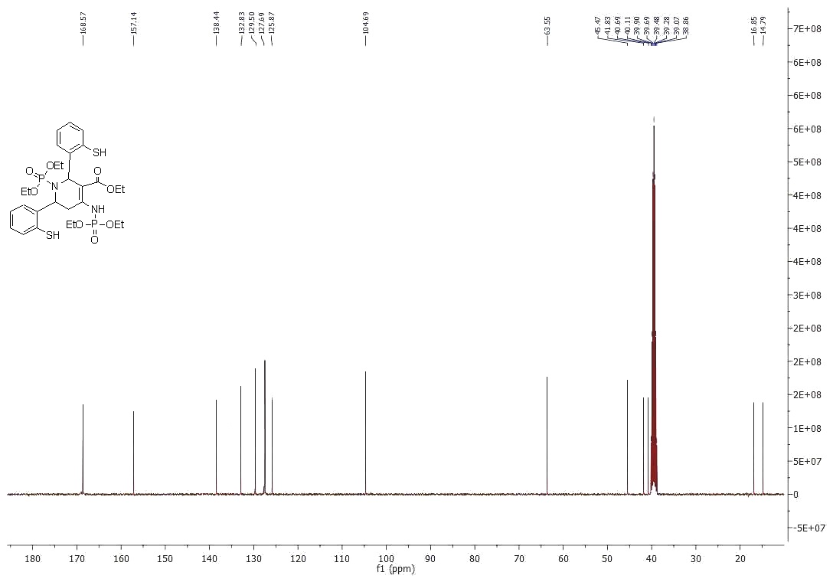
Figure S 31: ¹³C - NMR Spectrum of compound 4j
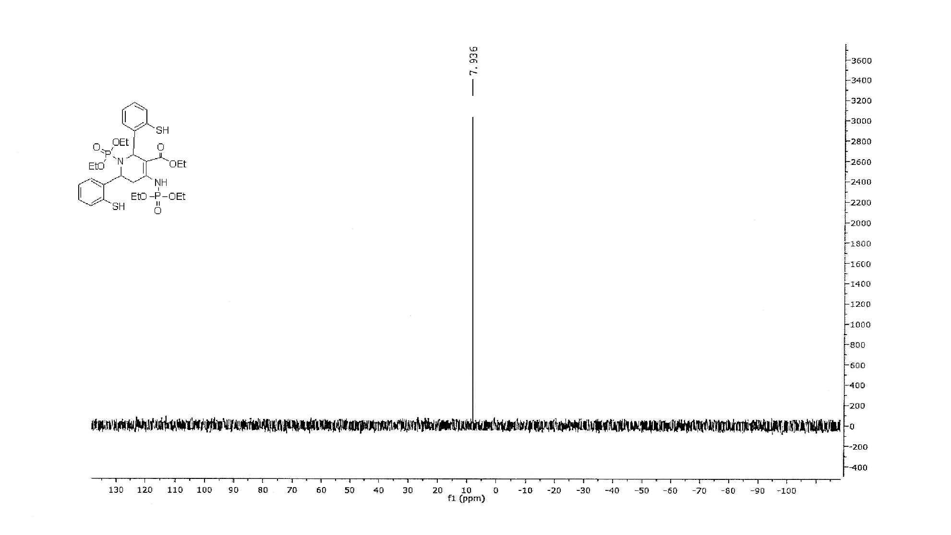Figure S 32: ³¹P - NMR Spectrum of compound 4j

