Supporting information

Concentration and coating time effects of N-acyl sarcosine derivatives for corrosion protection of low carbon steel CR4 in salt water – Defining a suitable application window

Saad E. Kaskahª, Gitta Ehrenhaft^{b}, Jörg Gollnick^{b}, Christian B. Fischer^{a,c*}

ª Department of Physics, University Koblenz-Landau, 56070 Koblenz, Germany
^{b} Institute of mechanics and material science, TH Mittelhessen University of Applied Sciences, 35390 Giessen, Germany
^{c} Materials Science and Nano-engineering department, Mohammed VI Polytechnic University, 43150 Ben Guerir, Morocco

Corresponding author: Christian B. Fischer, e-mail address: chrbfischer@uni-koblenz.de, phone number: +49 261 287 2345, postal address: University Koblenz-Landau, Department of Physics, Universitätsstraße 1, 56070 Koblenz, Germany.

List of contents

Page S3: Experimental work for weight loss study and surface morphology inspection of steel CR4 coupons in 0.1 M NaCl after previous dip coating in different concentrations of sarcosines L, M, and O.
Page S3: Weight loss results and calculated efficiencies for sarcosines L, M, and O at different concentrations to protect low carbon steel CR4 in 0.1 M NaCl.
Page S4: Table S1. Results of weight loss ∆W, corrosion rate CR, surface coverage θ, and inhibition efficiency IE for CR4 combinations with different sarcosine concentrations C_{inh} immersed 24 h in 0.1 M NaCl at room temperature.
Page S5: Figure S1. Efficiency of different sarcosine concentrations during weight loss measurements. Blank material is displayed as black dotted line (0 % efficiency), for sarcosine L (squares), M (circles) and O (triangles) solid lines are inserted for clarity.
Page S6: Microscopic examination of steel CR4 probes without and with present sarcosines L, M, and O at 25 mmol/L and 100 mmol/L according to weight loss.
Figure S2. Optical microscope images for weight loss measurements of steel CR4 with present sarcosines. The series show results after 24 h at lowest sarcosine concentrations of 25 mmol/L and highest of 100 mmol/L compared to blank material at 0 h.

Experimental work for weight loss study and surface morphology inspection of steel CR4 coupons in 0.1 M NaCl after previous dip coating in different concentrations of sarcosines L, M, and O.

Gravimetric measurements were carried out for the entire coupon (25 × 25 × 1 mm). The area of interest was firstly abraded mechanically with 120 and 220 grades of emery papers respectively (WS FLEX 18c water proof, HERMES, Germany), washed two times with distilled water, rinsed carefully with isopropanol, dried at ambient conditions and weighed accurately (KERN 770, error ± 0.01 mg) to be thereafter immersed in 1 L of 0.1 M NaCl. After 24 h the steel coupons were taken off and washed twice with distilled water. Evolved corrosion products are dissolved by immersion in 0.5 M HCl for 10 s, directly washed with distilled water, rinsed by isopropanol and dried. After that the coupons are checked for any weight difference due to mass loss [A,B].
The corrosion progress on the metal surface during the weight loss measurements was monitored by a digital microscope (KEYENCE VH-S30K, Deutschland GmbH, Germany). The steel coupons were directly surveyed with the microscope to control the impact on the metal surface morphology with lowest and highest sarcosine concentrations of 25 and 100 mmol/L. Each sample was scanned with 100 µm magnification of the processed surface at two different places to ensure reproducibility and homogeneity of corrosion.

Weight loss results and calculated efficiencies for sarcosines L, M, and O at different concentrations to protect low carbon steel CR4 in 0.1 M NaCl.

Low carbon steel CR4 blank and coated with sarcosines L, M, and O at different concentrations (25, 50, 75, 100 mmol/L) was tested according to weight loss measurements. The corrosion rate (CR) is calculated using Eq. 1 [A].
Eq. 1
Where ∆W is the weight loss of low carbon steel, A is the total area of sample, and t is the relevant immersion time of the coupon in the 0.1 M NaCl test solution. The inhibitor efficiency IE (%) of the selected compounds to reduce weight loss is calculated according to Eq. 2 [A].
Eq. 2
In Eq. 2 ∆W is the weight loss without and ∆W_{inh} with inhibitor, respectively. The summary of results for corrosion rate CR, weight loss ∆W, and inhibitor efficiency IE obtained from the weight loss tests according to different sarcosine concentrations C_{inh} is given in Table S1. Further values deducible from weight loss experiments are the surface coverage θ (set by IE/100) [7]:

Table S1. Results of weight loss ∆W, corrosion rate CR, surface coverage θ, and inhibition efficiency IE for CR4 combinations with different sarcosine concentrations C_{inh} immersed 24 h in 0.1 M NaCl at room temperature.
 | C_{inh}  (mmol·L⁻¹) | ∆W  (mg) | CR  (mg cm⁻² h⁻¹)×10⁻⁵ | θ | IE  (%)
Blank | 0 | 0.00570 | 1.900 | - | -
Sarcosine
L | 25 | 0.00345 | 1.150 | 0.3947 | 39.4
 | 50 | 0.00315 | 1.105 | 0.4473 | 44.7
 | 75 | 0.00283 | 0.944 | 0.5029 | 50.2
 | 100 | 0.00267 | 0.891 | 0.5307 | 53.0
M | 25 | 0.00184 | 0.613 | 0.6771 | 67.7
 | 50 | 0.00178 | 0.595 | 0.6867 | 68.6
 | 75 | 0.00173 | 0.577 | 0.6959 | 69.5
 | 100 | 0.00142 | 0.473 | 0.7508 | 75.0
O | 25 | 0.00124 | 0.413 | 0.7824 | 78.2
 | 50 | 0.00114 | 0.380 | 0.8000 | 80.0
 | 75 | 0.00098 | 0.327 | 0.8280 | 82.8
 | 100 | 0.00080 | 0.266 | 0.8596 | 85.9

From Table S1 it is obvious that the corrosion rate CR decreased while the efficiency goes up with increasing sarcosine concentration (Fig. S1). The optimum efficiency is obtained for O up to 85.9 % followed by M up to 75.0 % each at highest concentrations of 100 mmol/L (compare Table S1 and Fig. S1, O in green, M in magenta). L shows until 50 mmol/L neglected effects for corrosion protection and efficiency up to 50.2 % for 75 and 100 mmol/L (compare Table S1 and Fig. S1, blue). According to our earlier results [19] the performance of these sarcosines increases with the carbon chain length.
Additionally, the increasing efficiency with higher concentrations is herein obvious by the raise of the surface coverage θ (Table S1). The reason for improved efficiency with rising inhibitor concentration is a promoted adsorption of these compounds at the surface [A]. Therefore, the contact area of the metal surface decreases as well as the interaction to the surrounding environment.

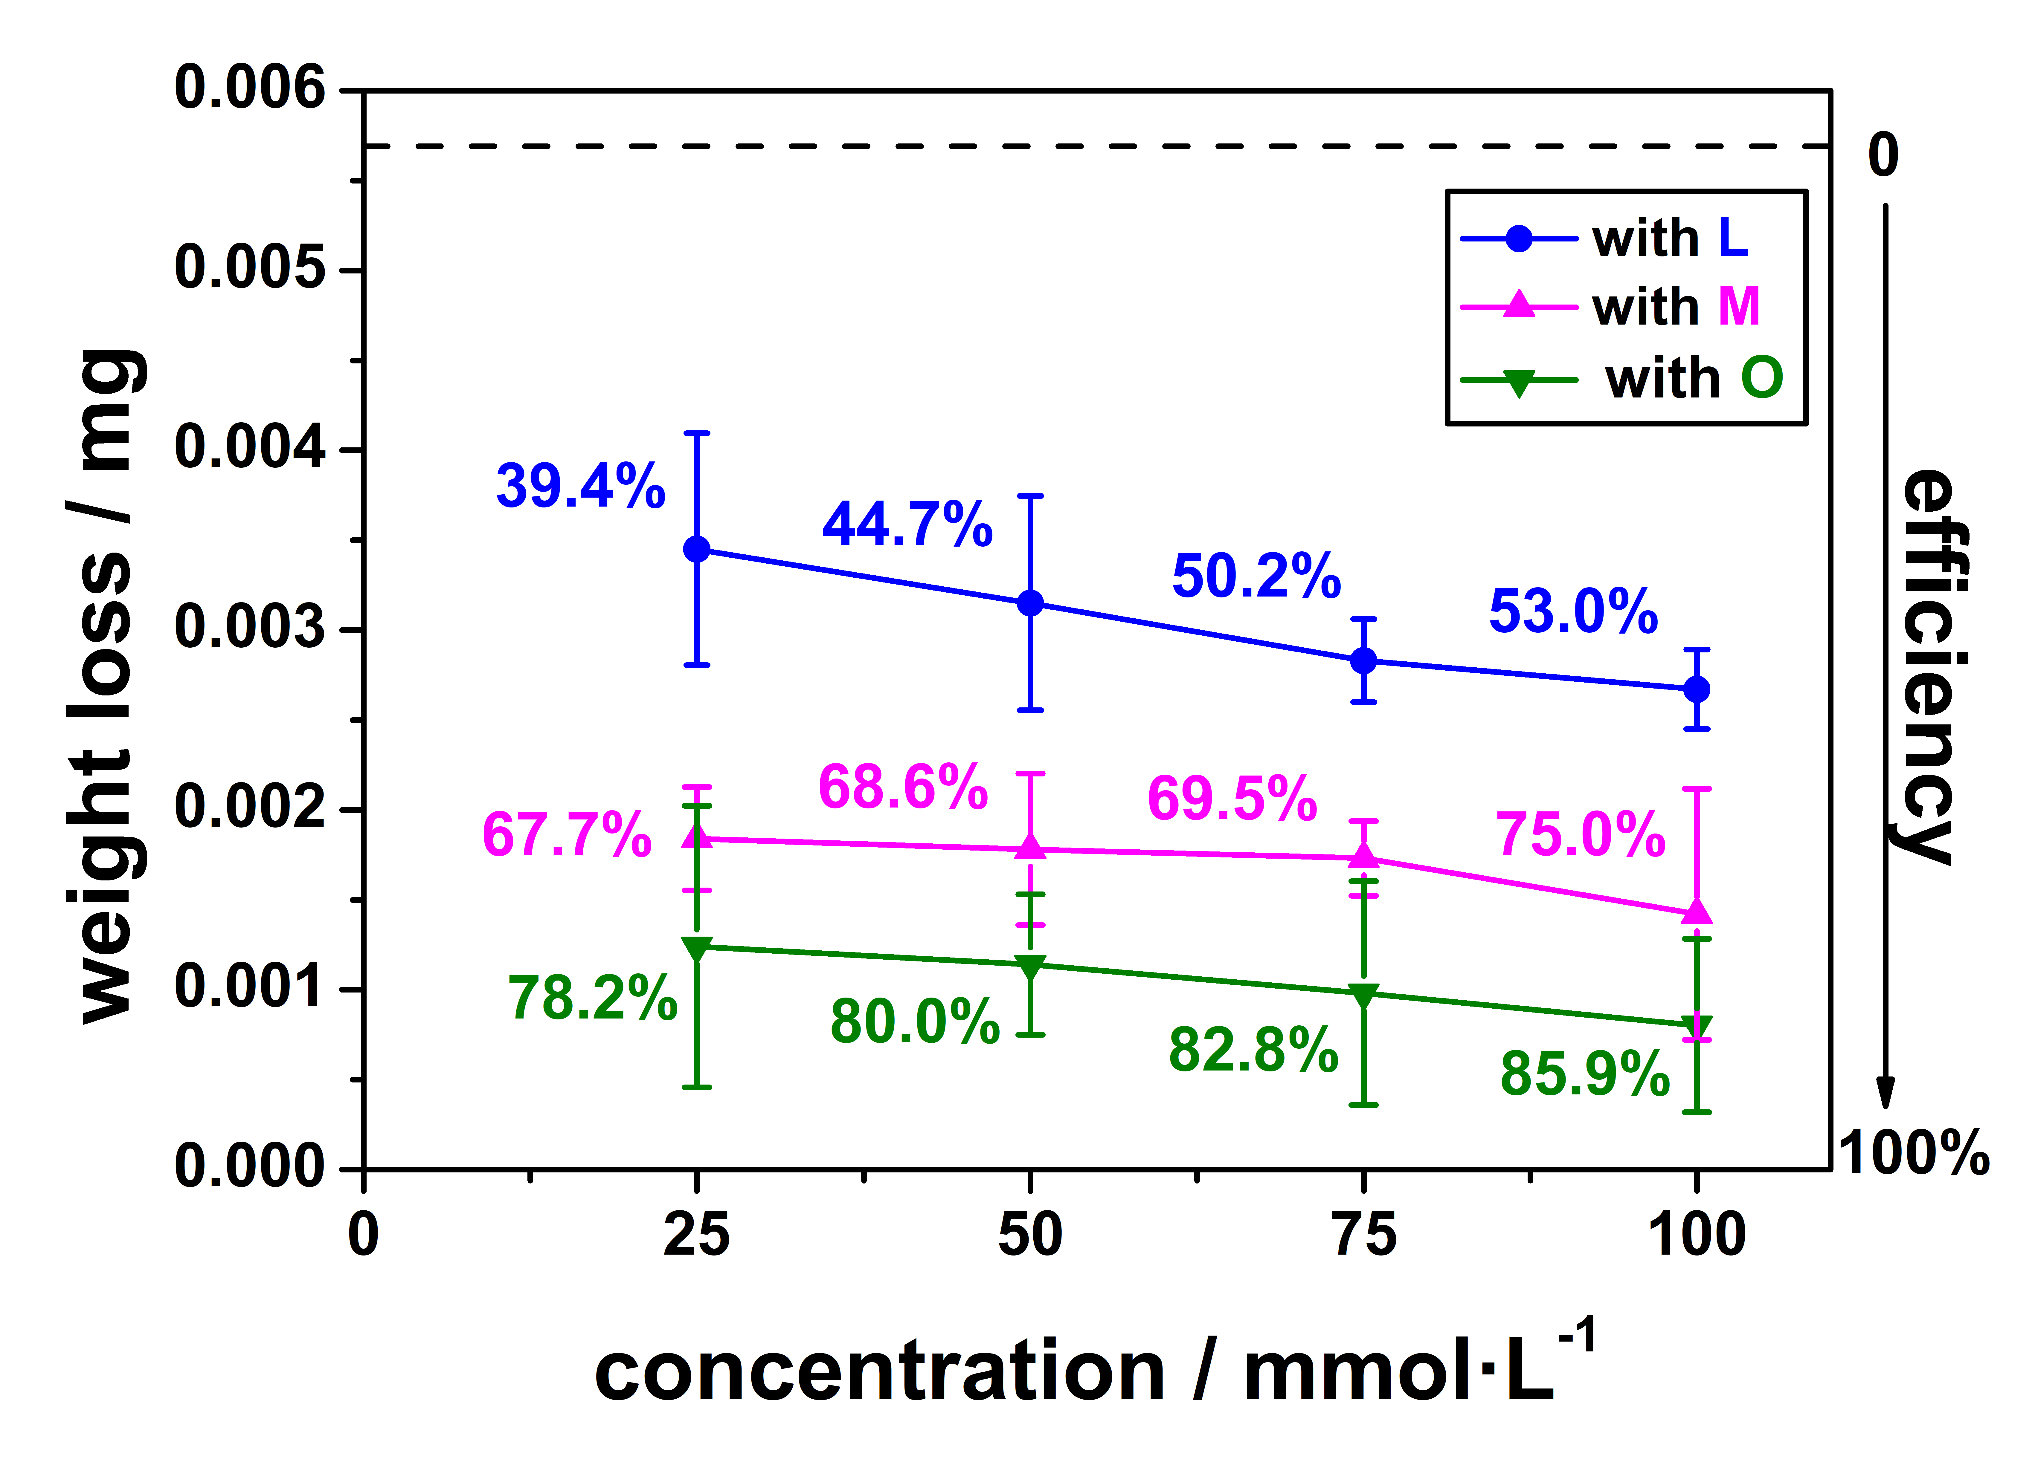
Figure S1. Efficiency of different sarcosine concentrations during weight loss measurements. Blank material is displayed as black dotted line (0 % efficiency), for sarcosine L (squares), M (circles) and O (triangles) solid lines are inserted for clarity.

[A] S.M. Tawfik, N.A. Negm, Vanillin-derived non-ionic surfactants as green corrosion inhibitors for carbon steel in acidic environments, Res. Chem. Intermed. 42 (2016) 3579-3607.
[B] S.M. Tawfik, A.A. Bd-Elaal, I. Aiad, Three gemini cationic surfactants as biodegradable corrosion inhibitors for carbon steel in HCl solution, Res. Chem. Intermed. 42 (2016) 1101-1123.

Microscopic examination of steel CR4 probes without and with present sarcosines L, M, and O at 25 mmol/L and 100 mmol/L according to weight loss.

After gravimetric measurements samples were directly examined with optical microscopy. The image series in Fig. S2 demonstrate the surface changes for low carbon steel CR4 related to corrosion with current sarcosines at concentrations of 25 and 100 mmol/L after 24 h compared to initial blank material (0 h). As expected a lot of corrosion pits are detectable after 24 h on the uncoated steel surface, (Fig. S2, first row, right). For the O coated coupon no corrosion is visible with 100 mmol/L and just indefinite, small corrosion pits with 25 mmol/L after 24 h (Fig. S2, last set). For compound M, the protection is less efficient than for O but still with a good performance at 100 mmol/L (Fig. S2, third set). Sarcosine L has an overall insignificant effect and exhibits a lot of corrosion pits on the metal surface for both concentrations (Fig. S2, second row).

Figure S2. Optical microscope images for weight loss measurements of steel CR4 with present sarcosines. The series show results after 24 h at lowest sarcosine concentrations of 25 mmol/L and highest of 100 mmol/L compared to blank material at 0 h.

