Molecular dynamics analysis of the effects of GTP, GDP, and benzimidazole derivative on structural dynamics of a cell division protein FtsZ from Mycobacterium tuberculosis
Supriya Hakeem,^{1,2} Inderpal Singh,^{1,2}Preeti Sharma,¹Anshul Uppal,³Yugal Khajuria³,Vijeshwar Verma,^{1,2} Vladimir N. Uversky,^{4,5}and Ratna Chandra*¹
¹School of Biotechnology, Shri Mata Vaishno Devi University (SMVDU), Kakryal, Katra 182320, Jammu and Kashmir, India
²Bioinformatics Infrastructure Facility, School of Biotechnology, Shri Mata Vaishno Devi University (SMVDU), Kakryal, Katra, 182320, Jammu and Kashmir, India
³School of Physics, Shri Mata Vaishno Devi University (SMVDU), Kakryal, Katra 182320, Jammu and Kashmir, India
⁴Department of Molecular Medicine and USF Health Byrd Alzheimer’s Research
Institute, Morsani College of Medicine, University of South Florida, University of South Florida, Tampa, FL, USA
⁵Laboratory of New Methods in Biology, Institute for Biological Instrumentation, Russian Academy of Sciences, 142290 Pushchino, Moscow Region, Russia
Abstract
The prevailing multi-drug resistance in Mycobacterium tuberculosis continues to remain one of the main challenges to combat tuberculosis. Hence, it becomes imperative to focus on novel drug targets. Filamenting temperature-sensitive mutant Z (FtsZ) is an essential cell division protein, a eukaryotic tubulin homologue and a promising drug target. During cytokinesis, FtsZ polymerises in the presence of GTP to form Z-ring and recruits other proteins at this site that eventually lead to the formation of daughter cells. Benzimidazoles were experimentally shown to inhibit Mtb-FtsZ, with one of the benzimidazole derivatives, M1, being reported to have the minimum inhibitory concentration (MIC) value of 3.13µg/ml. In the present study, mechanism of destabilization of FtsZ in the presence of M1 was computationally investigated in the presence of its substrate GTP/GDP employing Molecular dynamics (MD) simulation analysis, principal component analysis (PCA), molecular mechanics combined with the generalized Born and surface area continuum salvation (MM-GBSA), and density functional theory (DFT). From the analyses it is proposed that binding of M1 in the inter-domain cleft induces structural changes in the GTP binding region that affect GTP binding, thus switching the preference of this protein towards depolymerised state and eventually inhibiting the cell division. Hence, this study provides mechanistic insights into the design of novel benzimidazole inhibitors against Mtb-FtsZ.
Key-Words: Mtb-FtsZ, Benzimidazole (M1), GTP/GDP, Molecular Dynamics Simulations, MM-GBSA, PCA.

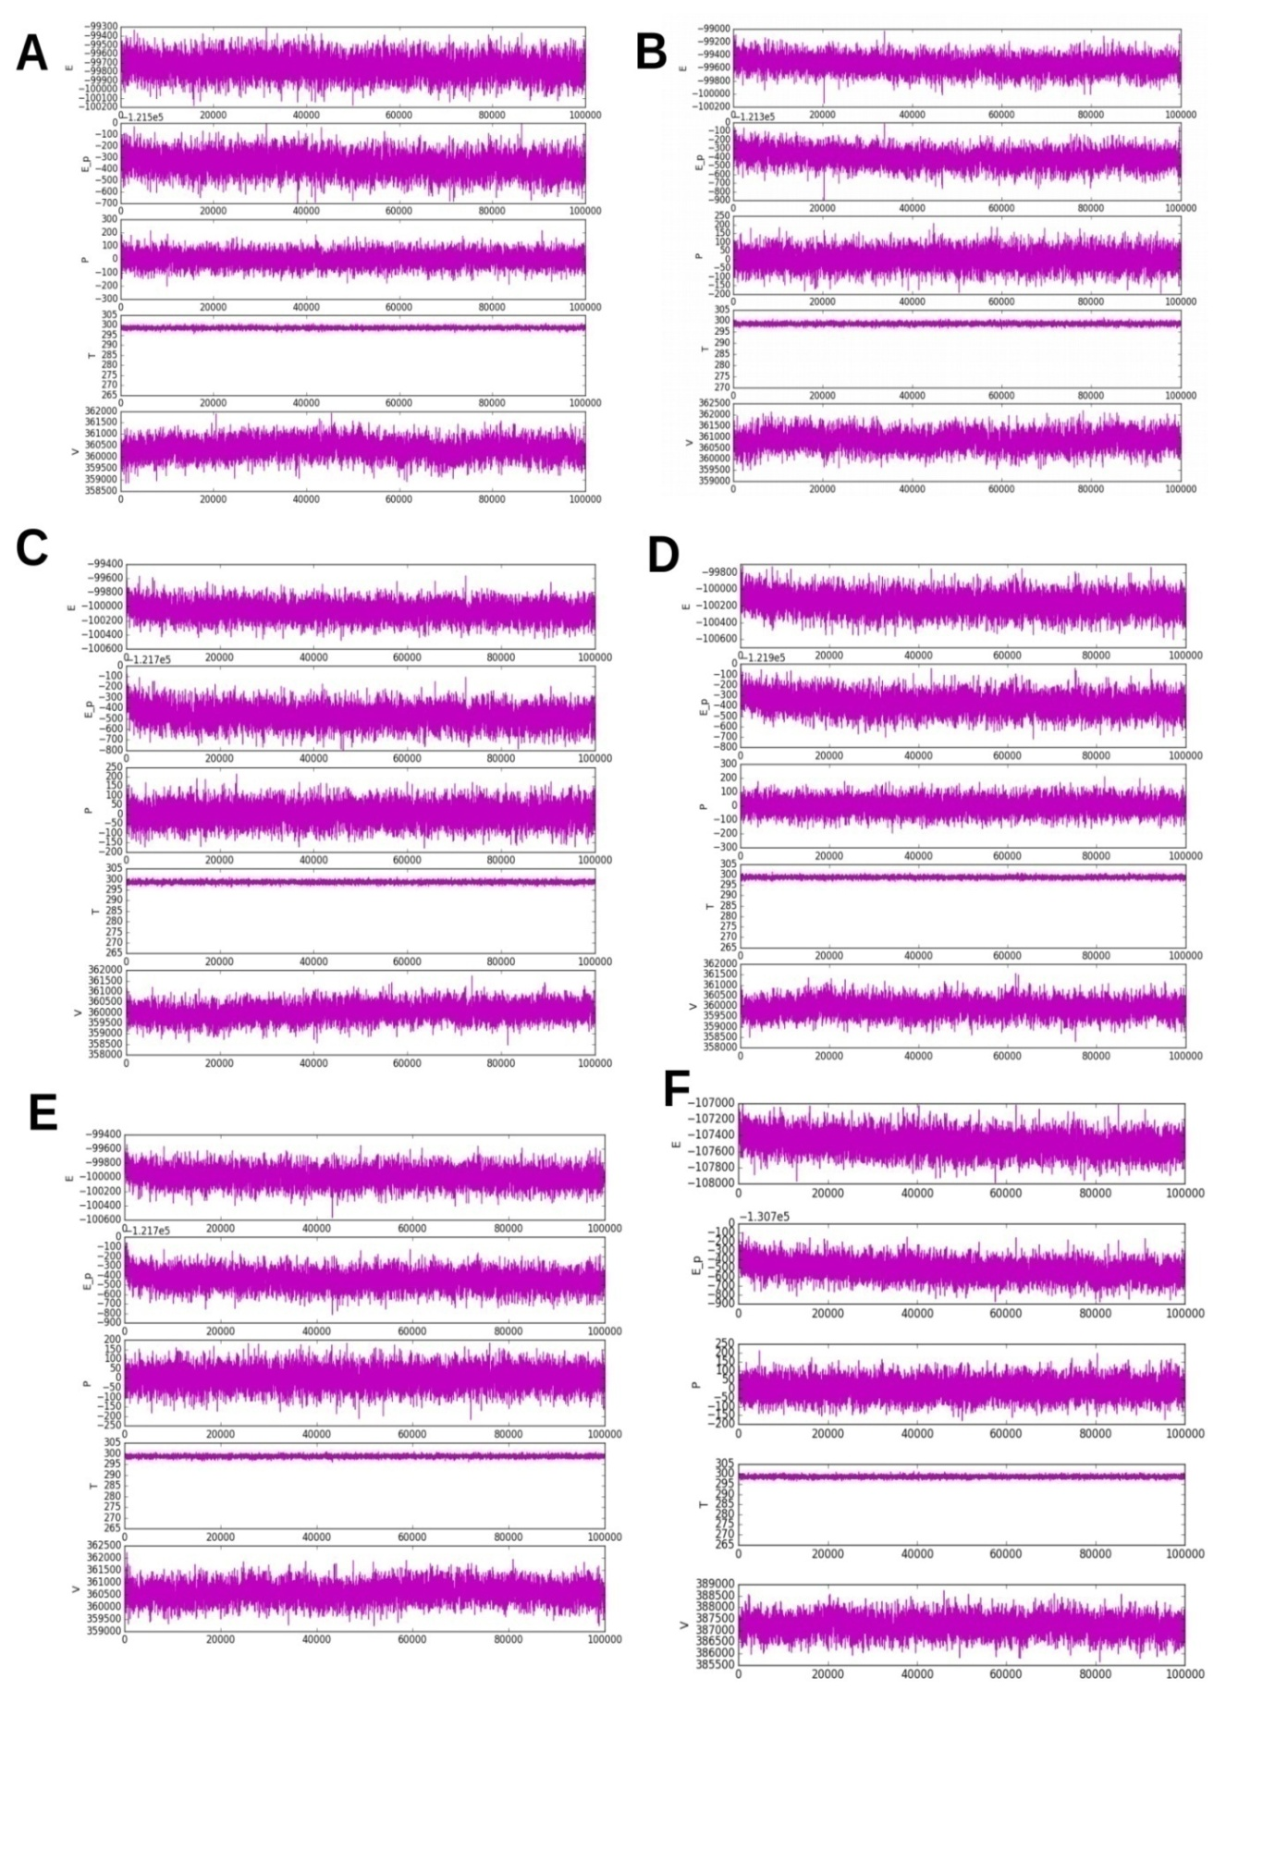
Figure S1. Simulation quality analysis plots including the total energy (E), potential energy (E_p), temperature (T), pressure (P) and volume (V) throughout the length of MD simulations - A. .FtsZ-apo; B. FtsZ-M1 ; C. FtsZ-GDP ; D. FtsZ-GTP ; E. FtsZ-GDP-M1 ; F. FtsZ-GTP-M1

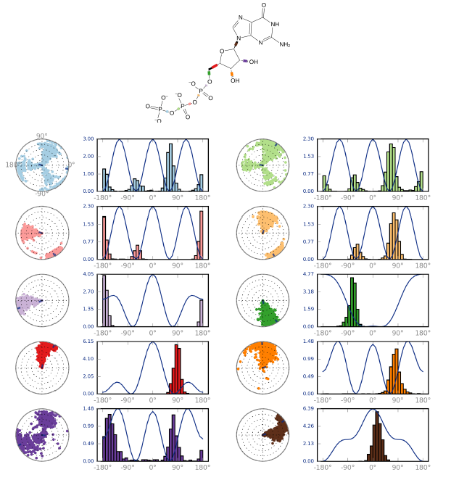
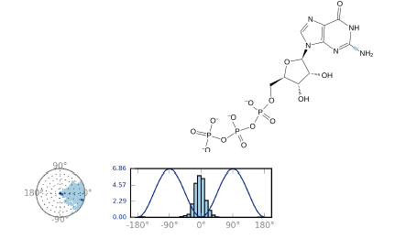
Figure S2. The torsion profile of GTP throughout 100ns trajectory. The rotatable bonds are shown in the colour codes in the GTP molecules and are depicted in the dial/radial and bar plots representative of a particular colour. Dial plots show the torsion angle conformation during the simulation. The bar plot show the probable density of the torsion. The Y-axis in the bar plot is the potential of the rotatable bond.
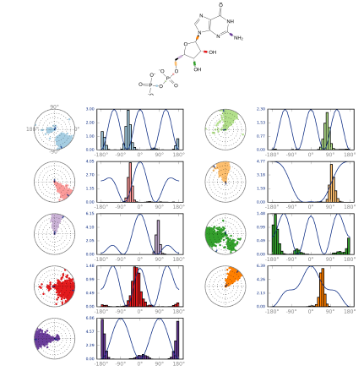
Figure S3. The torsion profile of GDP throughout 100ns trajectory. The rotatable bonds are shown in the colour codes in the GDP molecules and are depicted in the dial/radial and bar plots representative of a particular colour. Dial plots show the torsion angle conformation during the simulation. The bar plot show the probable density of the torsion. The Y-axis in the bar plot is the potential of the rotatable bond.

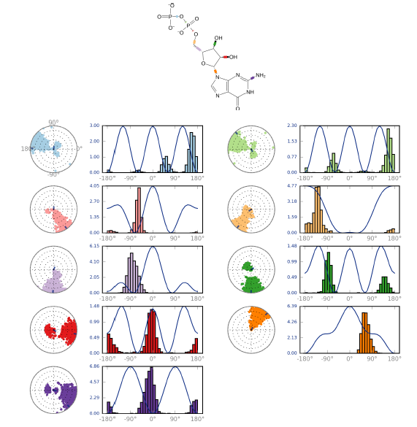
Figure S4. The torsion profile of GDP in the presence of M1 throughout 100ns trajectory. The rotatable bonds are shown in the colour codes in the GDP molecules and are depicted in the dial/radial and bar plots representative of a particular colour. Dial plots show the torsion angle conformation during the simulation. The bar plot show the probable density of the torsion. The Y-axis in the bar plot is the potential of the rotatable bond.

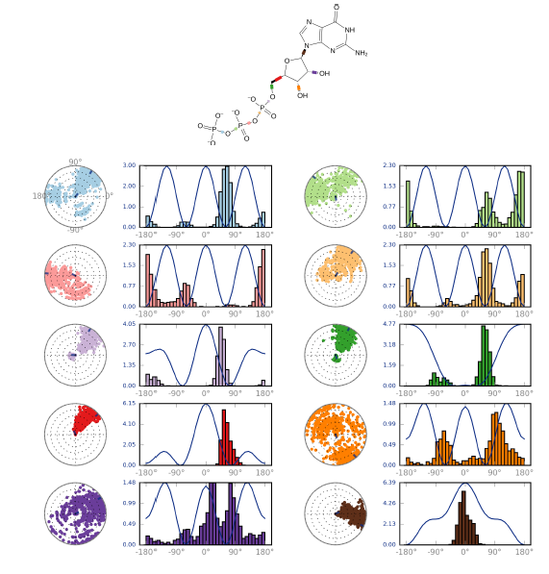

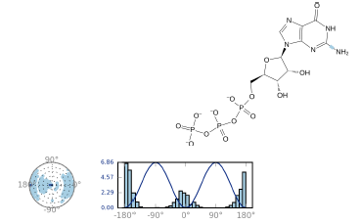
Figure S5. The torsion profile of GTP in the presence of M1 throughout 100ns trajectory. The rotatable bonds are shown in the colour codes in the GTP molecules and are depicted in the dial/radial and bar plots representative of a particular colour. Dial plots show the torsion angle conformation during the simulation. The bar plot show the probable density of the torsion. The Y-axis in the bar plot is the potential of the rotatable bond.

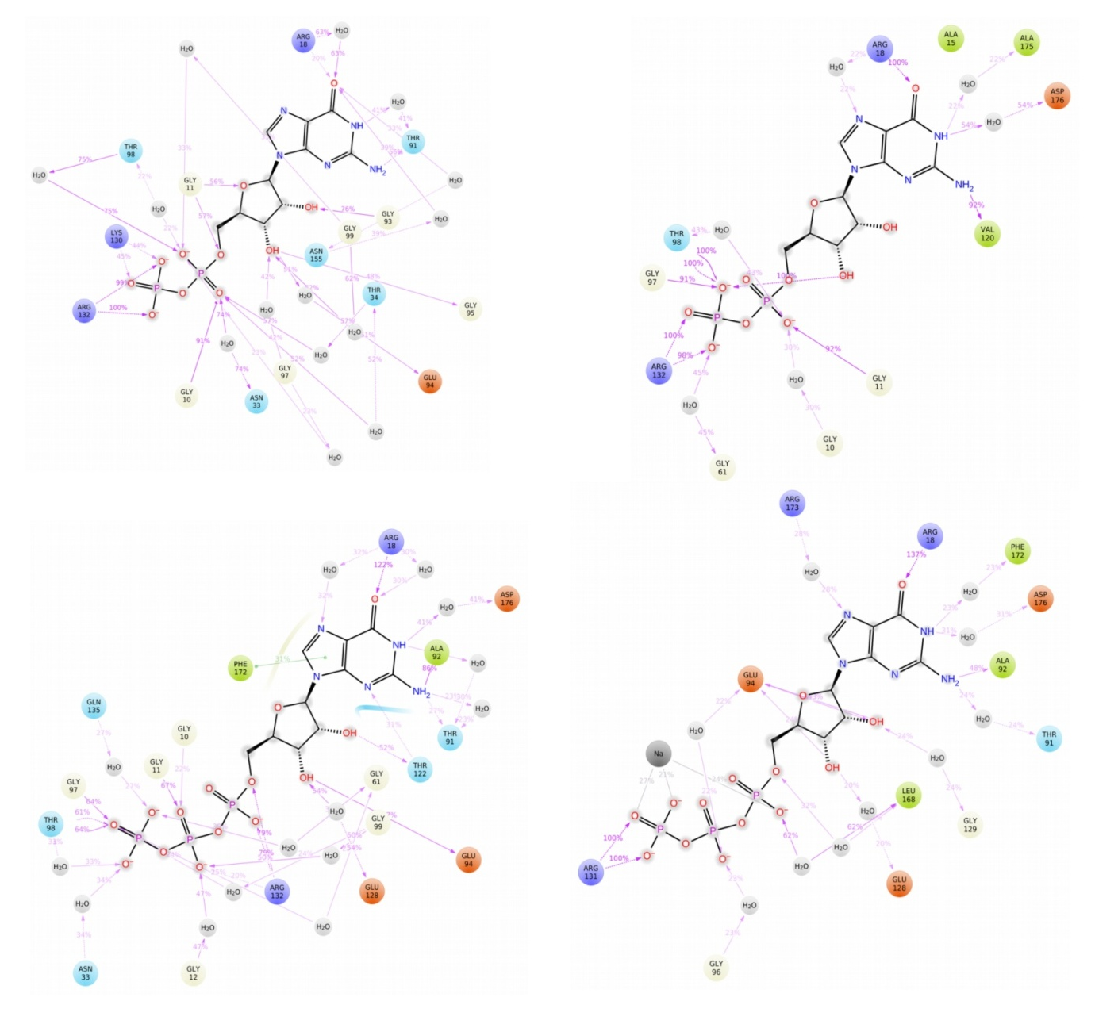
D
C
B
A

Figure S6. Ligand Interaction Diagram taken for the last 20ns of 100ns long MD simulations of the GTP and GDP either in presence or absence of inhibitor M1 i.e FtsZ-GDP (A); FtsZ-GTP (B); FtsZ-GDP-M1(C) and FtsZ-GTP-M1 (D).

