Appendix A: Supplementary materials
Title:
Degradation of RDX, TNT, and HMX during EPA 8330B sample processing and analysis of soils under hydrated lime or sodium dithionite based chemical remediation treatment
Authors: Marc-Olivier Turcotte-Savard, Sylvie Brochu
Affiliations: Defence Research and Development Canada – Valcartier Research Center, 2459 de la Bravoure Road, Quebec, QC, Canada, G3J 1X5

The following table presents soil metal concentrations for the general purpose sand used in the vial experiments.
Table A. 1.
Soil metal concentrations (ICP-AES)
Metals | LOD | General purpose sand
 | (mg/kg) | (mg/kg)
Antimony (Sb) | 0.1 | < 0.1
Silver (Ag) | 0.5 | < 0.5
Arsenic (As) | 2 | < 2
Baryum (Ba) | 4 | 10
Cadmium (Cd) | 0.1 | < 0.1
Calcium (Ca) | 20 | 930
Chromium (Cr) | 1 | < 1
Copper (Cu) | 1 | 1
Cobalt (Co) | 1 | 2
Tin (Sn) | 1 | < 1
Iron (Fe) | 10 | 5100
Magnesium (Mg) | 5 | 830
Manganese (Mn) | 2 | 190
Molybdenum (Mo) | 0.5 | < 0.5
Nickel (Ni) | 0.5 | 1.5
Lead (Pb) | 1 | < 1
Thorium (Th) | 4 | < 4
Uranium (U) | 2 | < 2
Zinc (Zn) | 5 | 5
LOD: Method’s limit of detection

Table A. 2.
Soil water content.
Soil | Empty dish | Soil | Combined weight | Final weight | Water weight | Humidity
 | (g) | (g) | (g) | (g) | (g) | (wt/wt %)
General purpose sand | 100.14 | 50.00 | 150.14 | 150.11 | 0.03 | 0.06

The following table is a description of the soil treatments used in each soil vial for each experiment series.

Table A. 3.
Soil treatment description for each series of experiments.
Series # | Soil treatment description
1 | Control
2 | Potassium carbonate and potassium bicarbonate (pH buffer)
3 | Calcium hydroxide (5 % w/w)
4 | MuniRem 4 mg
5 | MuniRem 90 mg
6 | MuniRem 4 mg, potassium carbonate and potassium bicarbonate
7 | MuniRem 90 mg, potassium carbonate and potassium bicarbonate

The following section contains the detailed result tables for the tables and figures presented within the results and discussion section of the article.

Table A. 3.
Energetic material losses due to remaining remediation reagents
Sample | Composition B - initial concentration | Energetic materials - corrected initial concentration (w/o wax) | Total soil energetic material concentration | Losses | Average | Standard  deviation
 | (mg/kg) | (mg/kg) | (mg/kg) | (%) | (%) | (%)
1A | 105.97 | 104.91 | 115.0 | -9.7 | -2.0 | 14.0
1B | 95.74 | 94.78 | 81.4 | 14.1
1C | 90.44 | 89.54 | 98.8 | -10.4
2A | 97.44 | 96.4656 | 62.2 | 35.5 | 19.4 | 14.2
2B | 98.29 | 97.3071 | 89.1 | 8.5
2C | 101.12 | 100.1088 | 85.9 | 14.2
3A | 97.56 | 96.5844 | 3.6 | 96.3 | 89.9 | 9.8
3B | 109.86 | 108.7614 | 5.6 | 94.9
3C | 102.51 | 101.4849 | 21.6 | 78.7
4A | 92.73 | 91.8027 | 81.8 | 10.9 | 1 | 9.2
4B | 102.62 | 101.5938 | 102.0 | -0.4
4C | 106.14 | 105.0786 | 112.9 | -7.4
5A | 109.99 | 108.8901 | 103.9 | 4.6 | 6 | 8.1
5B | 94.11 | 93.1689 | 94.0 | -0.9
5C | 100.23 | 99.2277 | 84.2 | 15.1
6A | 99.41 | 98.4159 | 60.0 | 39.1 | 32 | 7.1
6B | 106.72 | 105.6528 | 79.3 | 24.9
6C | 96.09 | 95.1291 | 64.4 | 32.3
7A | 96.71 | 95.7429 | 32.2 | 66.3 | 56 | 9.4
7B | 102.01 | 100.9899 | 52.7 | 47.8
7C | 92.89 | 91.9611 | 41.9 | 54.4
¹ Sum of energetic materials analytes included in EPA 8330 standards used in our method described in the manuscript.

Table A. 4.
Comparison of average ratios (HMX concentration/initial energetic material concentration) for each experiment series.
Sample | Initial  Composition B concentrations | Corrected energetic material concentration | HMX soil concentration | Ratio | Average | Standard  deviation
 | (mg/kg) | (mg/kg) | (mg/kg)
1A | 105.97 | 104.9103 | 11.22 | 0.1069 | 0.10508 | 0.012
1B | 95.74 | 94.7826 | 8.73 | 0.0921
1C | 90.44 | 89.5356 | 10.40 | 0.1162
2A | 97.44 | 96.4656 | 8.23 | 0.0854 | 0.10855 | 0.022
2B | 98.29 | 97.3071 | 12.65 | 0.1300
2C | 101.12 | 100.1088 | 11.04 | 0.1103
3A | 97.56 | 96.5844 | 3.47 | 0.0360 | 0.04986 | 0.048
3B | 109.86 | 108.7614 | 1.15 | 0.0106
3C | 102.51 | 101.4849 | 10.45 | 0.1030
4A | 92.73 | 91.8027 | 8.33 | 0.0908 | 0.10633 | 0.014
4B | 102.62 | 101.5938 | 12.02 | 0.1183
4C | 106.14 | 105.0786 | 11.55 | 0.1099
5A | 109.99 | 108.8901 | 11.72 | 0.1076 | 0.11168 | 0.006
5B | 94.11 | 93.1689 | 10.20 | 0.1095
5C | 100.23 | 99.2277 | 11.70 | 0.1179
6A | 99.41 | 98.4159 | 9.49 | 0.0964 | 0.10388 | 0.009
6B | 106.72 | 105.6528 | 12.00 | 0.1135
6C | 96.09 | 95.1291 | 9.68 | 0.1017
7A | 96.71 | 95.7429 | 6.94 | 0.0725 | 0.08504 | 0.012
7B | 102.01 | 100.9899 | 9.67 | 0.0958
7C | 92.89 | 91.9611 | 7.99 | 0.0869

Table A. 5.
Comparison of average ratios (RDX concentration/initial energetic material concentration) from each experiment series.
Sample | Initial Composition B concentrations | Corrected energetic material concentration | RDX soil concentration | Ratio | Average | Standard deviation
 | (mg/kg) | (mg/kg) | (mg/kg)
1A | 105.97 | 104.91 | 57.24 | 0.5456 | 0.5126 | 0.071
1B | 95.74 | 94.78 | 40.88 | 0.4313
1C | 90.44 | 89.54 | 50.21 | 0.5608
2A | 97.44 | 96.47 | 44.56 | 0.4620 | 0.4998 | 0.033
2B | 98.29 | 97.31 | 50.24 | 0.5163
2C | 101.12 | 100.11 | 52.17 | 0.5211
3A | 97.56 | 96.58 | 0.00 | 0.0000 | 0.0502 | 0.056
3B | 109.86 | 108.76 | 4.42 | 0.0406
3C | 102.51 | 101.48 | 11.17 | 0.1100
4A | 92.73 | 91.80 | 41.55 | 0.4526 | 0.4900 | 0.033
4B | 102.62 | 101.59 | 50.93 | 0.5013
4C | 106.14 | 105.08 | 54.23 | 0.5160
5A | 109.99 | 108.89 | 55.94 | 0.5137 | 0.4914 | 0.061
5B | 94.11 | 93.17 | 50.16 | 0.5384
5C | 100.23 | 99.23 | 41.87 | 0.4220
6A | 99.41 | 98.42 | 49.10 | 0.4989 | 0.4956 | 0.022
6B | 106.72 | 105.65 | 54.46 | 0.5154
6C | 96.09 | 95.13 | 44.94 | 0.4724
7A | 96.71 | 95.74 | 25.28 | 0.2641 | 0.3472 | 0.081
7B | 102.01 | 100.99 | 43.04 | 0.4261
7C | 92.89 | 91.96 | 32.31 | 0.3513

Table A. 6.
Comparison of average ratios (final TNT concentration/initial energetic material concentration) from each experiment series.
Sample | Initial Composition B concentrations | Corrected energetic  material concentration | TNT soil  concentration | Ratio | Average | Standard  deviation
 | (mg/kg) | (mg/kg) | (mg/kg)
1A | 105.97 | 104.91 | 46.5909 | 0.4441 | 0.4015 | 0.05907
1B | 95.74 | 94.78 | 31.6618 | 0.3340
1C | 90.44 | 89.54 | 38.1644 | 0.4262
2A | 97.44 | 96.47 | 9.3803 | 0.0972 | 0.1951 | 0.08808
2B | 98.29 | 97.31 | 26.0825 | 0.2680
2C | 101.12 | 100.11 | 22.0211 | 0.2200
3A | 97.56 | 96.58 | 0.0000 | 0.0000 | 0.0000 | 0.00000
3B | 109.86 | 108.76 | 0.0000 | 0.0000
3C | 102.51 | 101.48 | 0.0000 | 0.0000
4A | 92.73 | 91.80 | 31.8831 | 0.3473 | 0.3930 | 0.05077
4B | 102.62 | 101.59 | 39.0074 | 0.3840
4C | 106.14 | 105.08 | 47.0367 | 0.4476
5A | 109.99 | 108.89 | 35.5194 | 0.3262 | 0.3298 | 0.02833
5B | 94.11 | 93.17 | 33.5235 | 0.3598
5C | 100.23 | 99.23 | 30.1169 | 0.3035
6A | 99.41 | 98.42 | 1.3793 | 0.0140 | 0.0788 | 0.05701
6B | 106.72 | 105.65 | 12.8303 | 0.1214
6C | 96.09 | 95.13 | 9.5911 | 0.1008
7A | 96.71 | 95.74 | 0.0000 | 0.0000 | 0.0059 | 0.01018
7B | 102.01 | 100.99 | 0.0000 | 0.0000
7C | 92.89 | 91.96 | 1.6219 | 0.0176

Chromatograms (10.00 µg/mL Standard)
The following standard concentrations were used for calibration standards: 0.05 µg/mL, 0.50 µg/mL, 1.00 µg/mL, 2.5 µg/mL, 5.0 µg/mL, and 10.00 µg/mL. These standards were prepared from an intermediated standard at 50.00 µg/mL, itself prepared from the purchased 1000 µg/mL commercial energetic material standards.
Calibration standard concentrations for ADNTs and DNTs were doubled compared to those previously mentioned for our standards due to both isomers, in each case, being integrated together: 0.1 µg/mL, 1.0 µg/mL, 2.0 µg/mL, 5.0 µg/mL, 10.0 µg/mL, and 20.0 µg/mL.

Figure A.1. shows a chromatogram at 214 nm for the 10.00 µg/mL standard. This wavelength was selected for NG analysis.
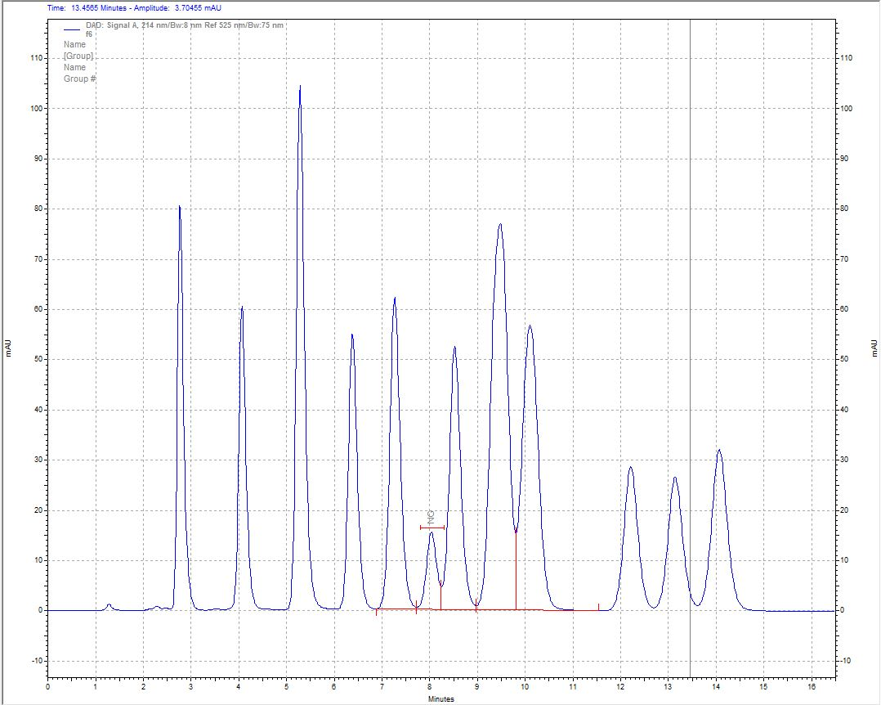
Figure A.1: Chromatogram (214 nm) for the 10.00 µg/mL standard.

Figure A.2. shows the chromatogram at 230 nm for the 10.00 µg/mL standard. This wavelength was selected for HMX, RDX, 1,3,5-TNB, TETRYL, TNT, and ADNTs analyses.
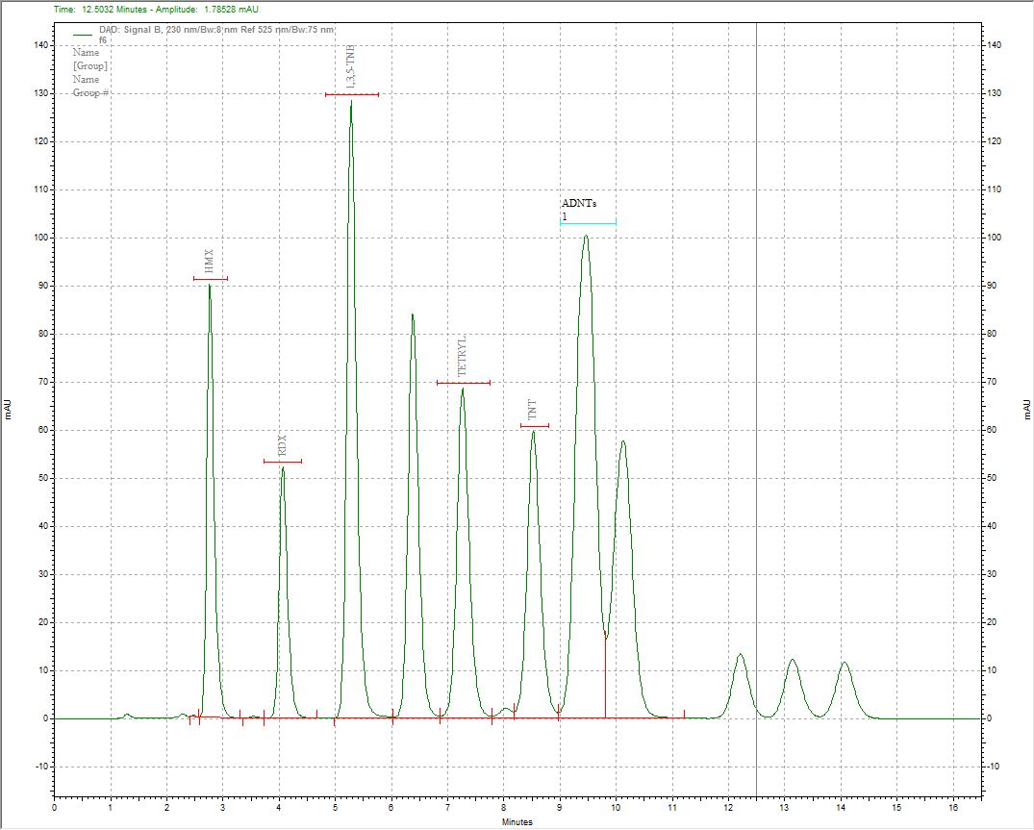
Figure A.2: Chromatogram (230 nm) for the 10.00 µg/mL standard.

Figure A.3 shows the chromatogram at 245 nm for the 10.00 µg/mL standard. This wavelength was selected for 1,3-DNB, and DNTs analyses.
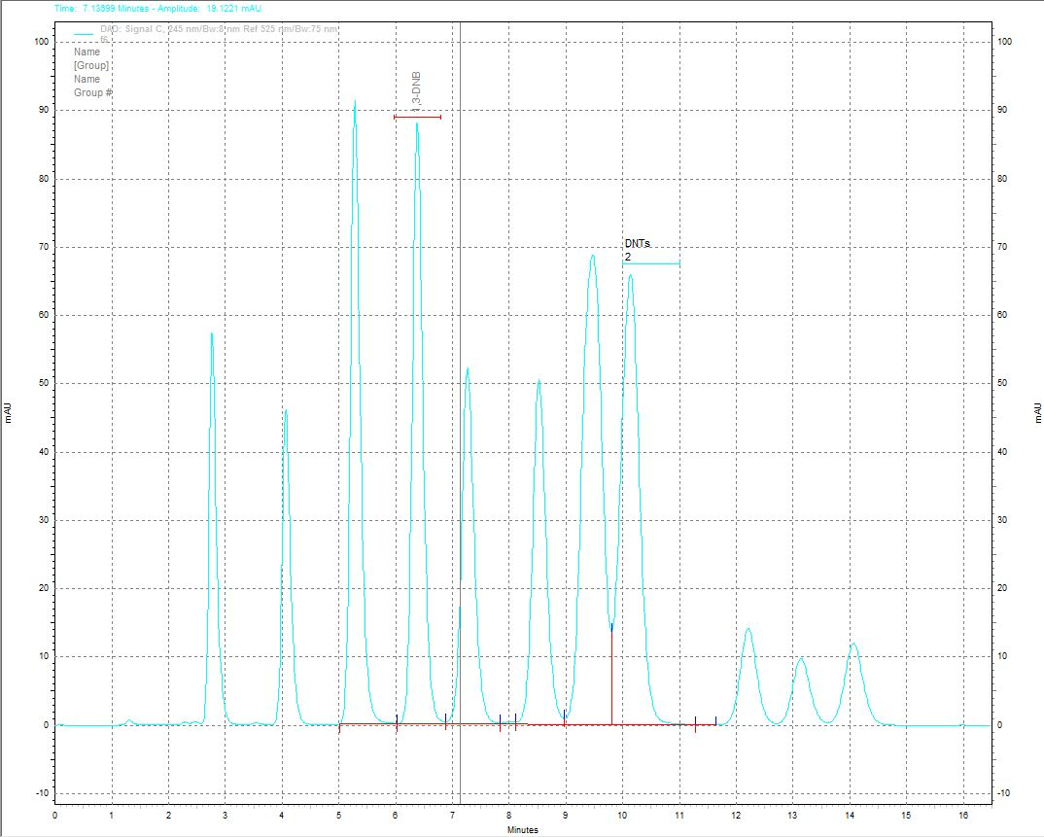
Figure A.3: Chromatogram (245 nm) for the 10.00 µg/mL standard.

Figure A.4 shows the chromatogram at 275 nm for the 10.00 µg/mL standard. This wavelength was selected for 2-NT, 4-NT and 3-NTs analyses, respectively.
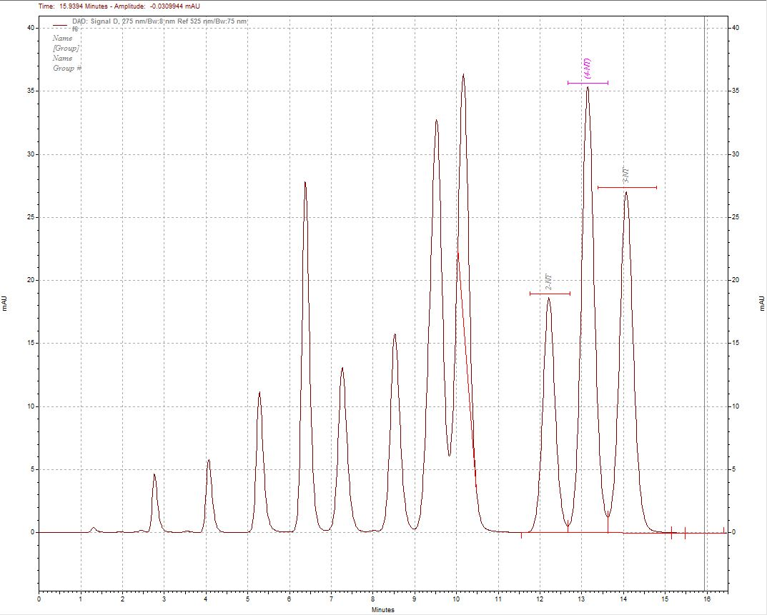
Figure A.4: Chromatogram (275 nm) for the 10.00 µg/mL standard.

