[APPENDICES]

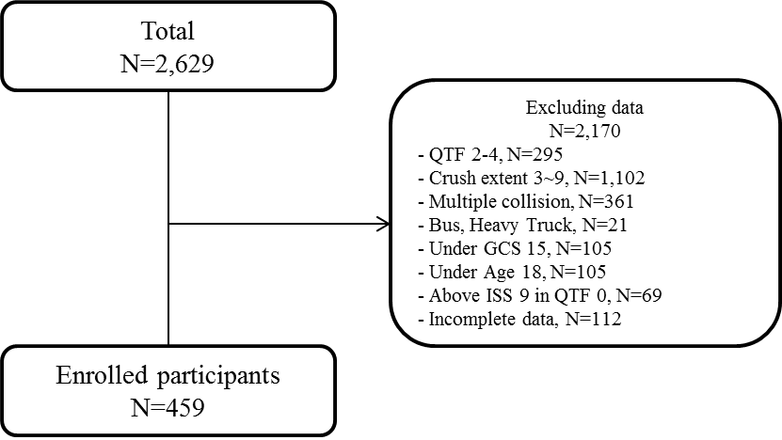
Appendix 1. Flowchart of classifying the data

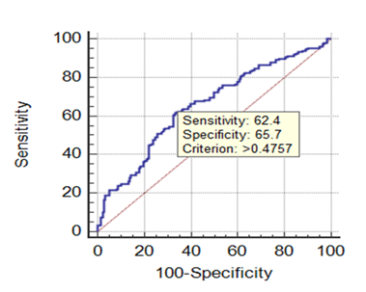
Appendix 2. ROC curve for the prediction model in Equation 2

