Supplementary file
Synthesis and antimicrobial activity of some benzoxazinoids derivatives of 2-nitrophenol and 3-hydroxy-2-nitropyridine

William Gustavo Lima¹, Flávio José Leite dos Santos², Adriana Cristina Soares³, Antonio F. A. Macias⁴, Jose M. G. Molinillo⁴, Jaqueline Maria Siqueira Ferreira¹ and João Máximo Siqueira²
¹Laboratory of Medical Microbiology, Central-West Campus Dona Lindu, Federal University of São João del-Rei, Divinopolis, MG, Brazil.
²Laboratory of Pharmacognosy and Chemistry of Natural Products, Central-West Campus Dona Lindu, Federal University of São João del-Rei, Divinopolis, MG, Brazil.
³Laboratory of Pharmacology of pain and inflammation, Central-West Campus Dona Lindu, Federal University of São João del-Rei, Divinopolis, MG, Brazil.
⁴Allelopathy Group, Department of Organic Chemistry, Institute of Biomolecules (INBIO), Campus CEIA3, School of Science, University of Cadiz, Puerto Real (Cádiz), Spain.

Table of contents:

Chemo-informatics analysis …………………………………………………….……………………… 2
Experimental details ……………...……………………………………….……………………. 2
Table S1 ………………………..………………………………………….….……………….... 3

Spectral and Chemical Data ……………………………………………………………………………. 4
Benzoxazinone series (1a-e) ……………………………………………………………………… 4
Pyridoxazinone series (2a-e) ……………………………………………………………………… 5

Chemo-informatics analysis

Experimental details:
To calculate the physicochemical (LogP, LogS, molecular weight, numbers of acceptor and donor groups of hydrogen bond), toxicological (irritative, tumorigenic, and anti-reproductive effects), and pharmaceutical (drug-likeness) properties of the compounds, we employed chemo-informatics analyses. The two-dimensional chemical structures of the benzoxazinoids analogues were inserted into DataWarrior 4.2.2 software and subsequently, the parameters of interest were calculated.^{[11]} Then, the values of molecular weight, LogP, and the amounts of donor and acceptor groups of the hydrogen bond were compared with the Lipinski rules.^{[12]} Compounds that fit at all points were provided with the descriptor "respect all". However, if any of them were violated, the descriptor "not respect all" was employed, followed by the description of the rule in non-compliance.

Table S1: Chemical structures, physical-chemical properties proprieties and predictors of toxicity to the benzoxazinoids analogs.
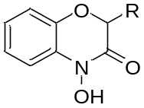
Compound | R | Molecular weight (g/mol) | LogP Oct/Wat | H-Acceptor | H-Donors | Tumorogenic | Reprodutive effect | Lipinski´s rule^{b} | Druglikeness
1a | -H | 165.15 | 0.42 | 4 | 1 | Low | None | Respect all | 0.35
1b | -CH₃ | 179.17 | 0.75 | 4 | 1 | Low | None | Respect all | 1.69
1c | -CH₂CH₃ | 193.20 | 1.20 | 4 | 1 | Low | None | Respect all | 3.20
1d | -CH₂CH₂CH₃ | 207.23 | 1.65 | 4 | 1 | Low | None | Respect all | 0.59
1e | -CH₂CH₂CH₂CH₃ | 221.25 | 2.11 | 4 | 1 | Low | None | Respect all | -3.30

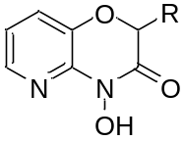
Compound | R | Molecular weight (g/mol) | LogP Oct/Wat | H-Acceptor | H-Donors | Tumorogenic | Reprodutive effect | Lipinski´s rule^{b} | Druglikeness
2a | -H | 166.13 | -0,23 | 5 | 1 | None | None | Respect all | 0.35
2b | -CH₃ | 180.16 | 0.09 | 5 | 1 | None | None | Respect all | 1.69
2c | -CH₂CH₃ | 194.19 | 0.55 | 5 | 1 | None | None | Respect all | 3.20
2d | -CH₂CH₂CH₃ | 208.21 | 1.01 | 5 | 1 | None | None | Respect all | 0.59
2e | -CH₂CH₂CH₂CH₃ | 222.24 | 1.46 | 5 | 1 | None | None | Respect all | -3.30
ªThe physical-chemicals proprieties and predictors of toxicity ware calculated using DataWarrior software version 4.2.2. ^{b}Lipinski´s rule follow the criteria: Molecular less than 500; logP (the logarithm of the partition coefficient between water and 1-octanol) less than 5; Number of groups in the molecule that can donate hydrogen atoms to hydrogen bonds less than 5; Number of groups that can accept hydrogen atoms to form hydrogen bonds less than 10.
Chemicals and spectral details:
Benzoxazinone serie (1a-e)
All chemical and spectral data this series was anteriorly described by Macias et al.^{[6]}.
Compound 1a
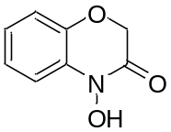
4-hydroxy-2H-benzo[b][1,4]oxazin-3(4H)-one (1a): Yield 71%, 386 mg
Compound 1b
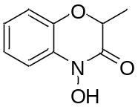
4-hydroxy-2-methyl-2H-benzo[b][1,4]oxazin-3(4H)-one (1b): Yield 59%, 600 mg
Compound 1c
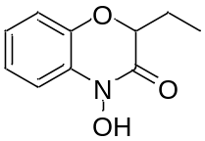
2-ethyl-4-hydroxy-2H-benzo[b][1,4]oxazin-3(4H)-one (1c): Yield 63%, 305 mg
Compound 1d
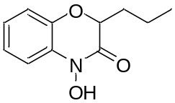
2-propyl-4-hydroxy-2H-benzo[b][1,4]oxazin-3(4H)-one (1d): Yield 54%, 900 mg

Compound 1e
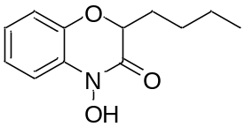
2-buthyl-4-hydroxy-2H-benzo[b][1,4]oxazin-3(4H)-one (1e): Yield 51%, 900 mg

Pyridoxazinone series (2a-e):

Compound 2a
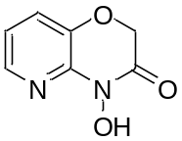
4-hydroxy-2H-pyrido[3,2-b][1,4]oxazin-3(4H)-one (2a): Yield 84%, 810 mg.

Spectral data of compound 2a
¹H NMR (200 MHz, DMSO-d6): H-4 δ 8.03, dd, 0.9; 4.7 Hz; H-5 δ 7.07, dd, 4.8, 7.9 Hz; H-6 δ 7.39, dd, 1.0, 7.8 Hz; H-1´ δ 4.87, s; N-OH δ 10.53, s.
¹³C NMR (50 MHz, DMSO-d6): 141.9 (C-2), 140.1(C-3),123.0 (C-4), 119.7 (C-5), 140.7 (C-6), 67.9 (C-1´), 161.4 (C-2’).
HRMS (ESI): Calculated for C₇H₇N₂O₃ [M+H]⁺, 167.1451; found, 167.1664.

⁻
¹H NMR spectrum
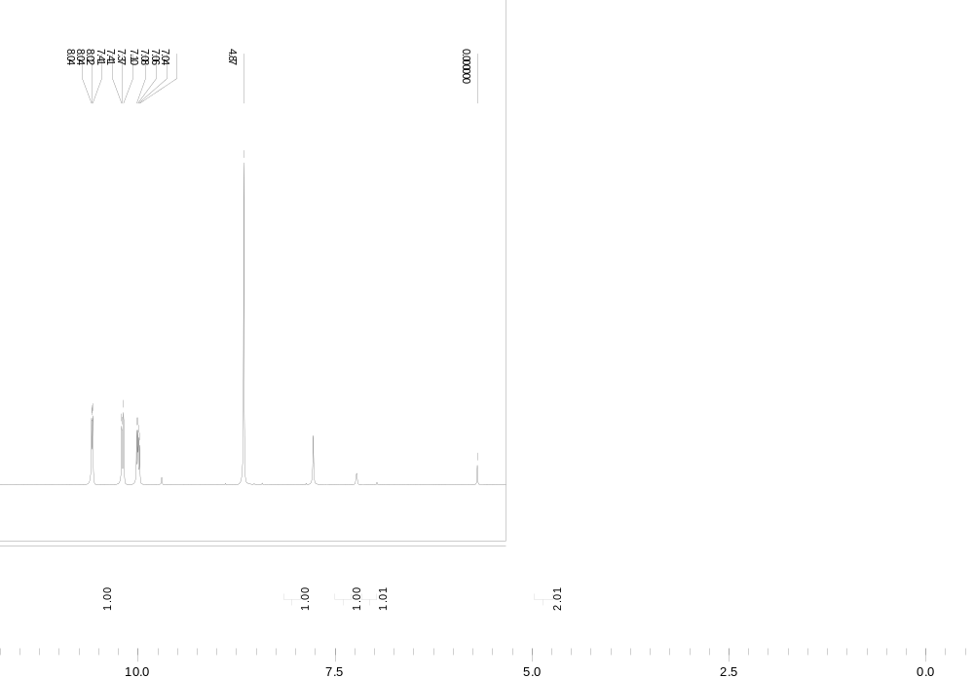
(ppm)

¹³C NMR

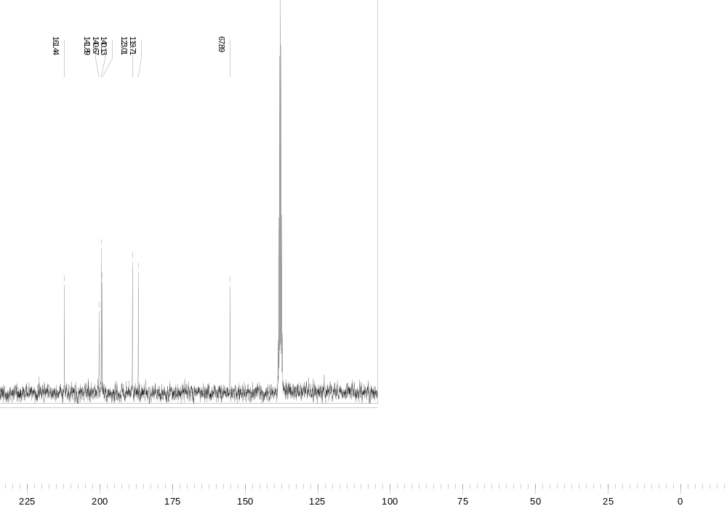
(ppm)

Compound 2b
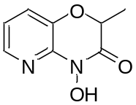
4-hydroxy-2-methyl-2H-pyrido[3,2-b][1,4]oxazin-3(4H)-one (2b): Yield 85%, 220 mg.

Spectral data of compound 2b
¹H NMR (200 MHz, CDCl₃): H-4 δ 8.02, dd, 1.4; 5.2 Hz; H-5 δ 7.02, dd, 5.2, 8.0 Hz; H-6 δ 7.32, dd, 1.4, 7.8 Hz; H-1´ δ 4.84, m; H-1” δ 1.60, d, 4.0 Hz; N-OH d 9.94, br s.
¹³C NMR (50 MHz, CDCl₃): 142.1 (C-2), 140.1(C-3),125.0 (C-4), 119.9 (C-5), 139.4 (C-6), 75.2 (C-1´), 163.74 (C-2’), 16.8 (C-1”).
HRMS (ESI): Calculated for C₈H₉N₂O₃ [M+H] ⁺, 181.0608; found, 181.0610.

¹H NMR spectrum

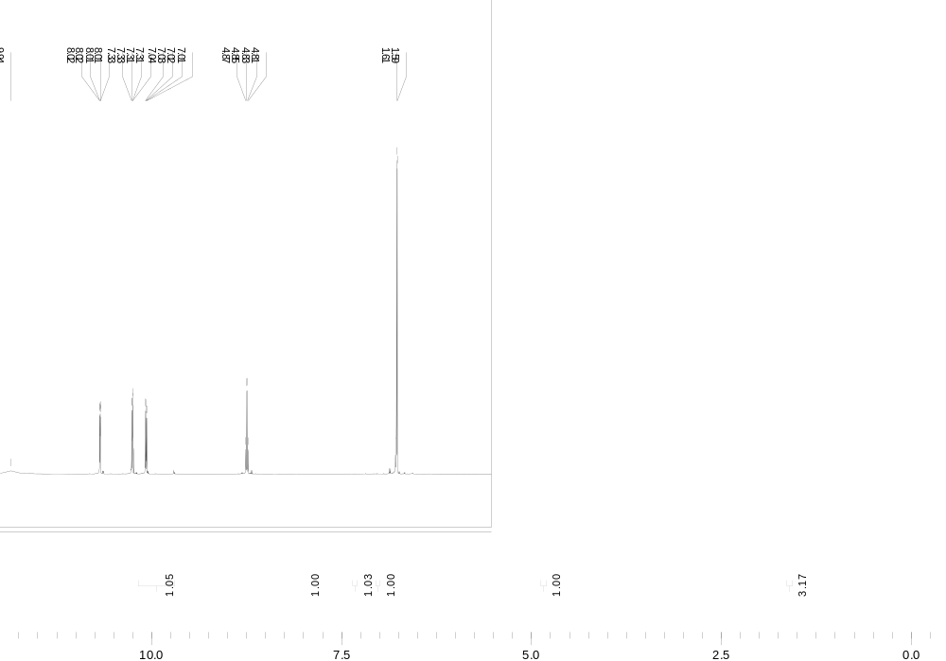
(ppm)

¹³C NMR

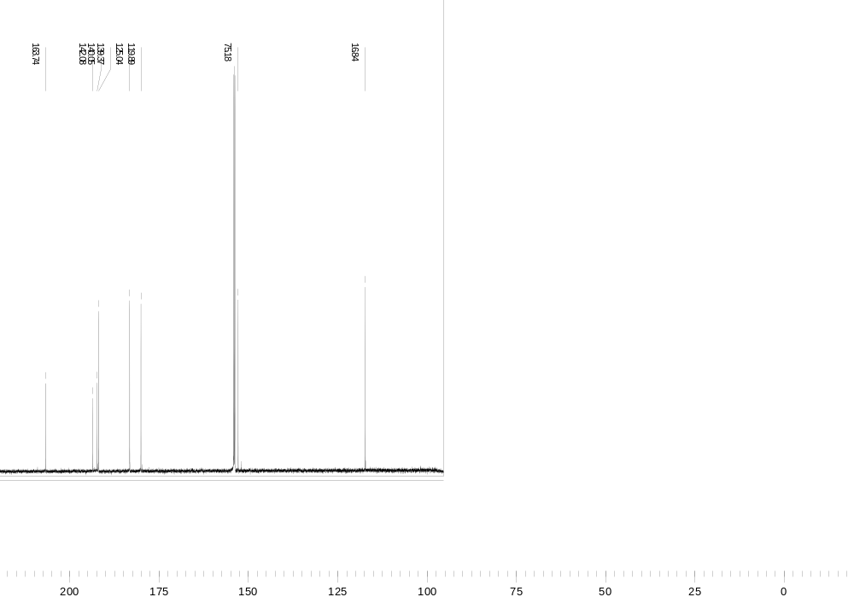
(ppm)

Compound 2c
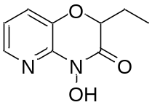
2-ethyl-4-hydroxy-2H-pyrido[3,2-b][1,4]oxazin-3(4H)-one (2c): Yield 71%, 190 mg.

Spectral data of compound 2c
¹H NMR (200 MHz, CDCl₃): H-4 δ 7.99, dd, 1.3; 5.2 Hz; H-5 δ 7.00, dd, 5.2, 8.0 Hz; H-6 δ 7.30, dd, 1.3, 7.8 Hz; H-1´ δ 4.69, m; H-1” δ 1.78-2.03, m; H-2” δ 1.01, t, 7.4 Hz; N-OH δ 9.83, br s.
¹³C NMR (50 MHz, CDCl₃): 141.8 (C-2), 140.0(C-3),125.0 (C-4), 119.9 (C-5), 139.0 (C-6), 79.8 (C-1´), 163.22 (C-2’ ), 24.6(C-1”), 9,04 (C-2”).
HRMS (ESI): Calculated for C₉H₁₁N₂O₃ [M+H]⁺, 195.0764; found, 195.0765.
¹H NMR spectrum

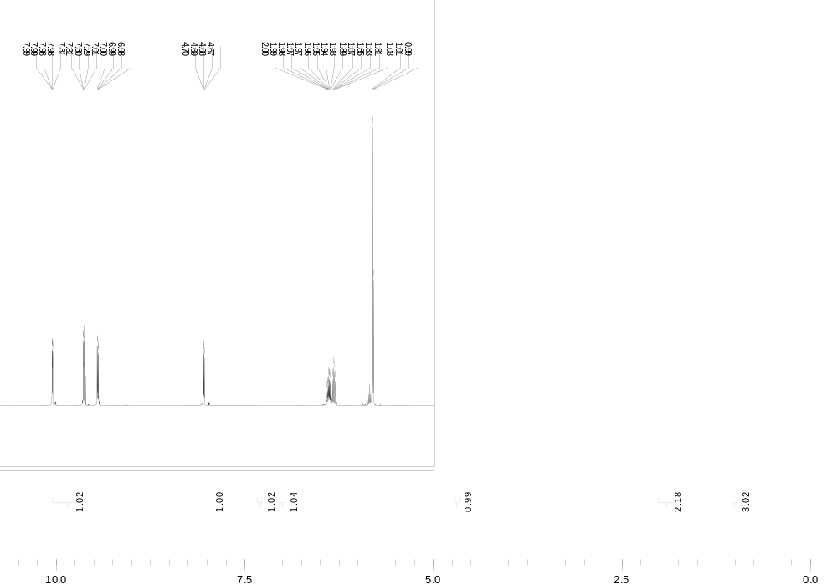
(ppm)
¹³C NMR
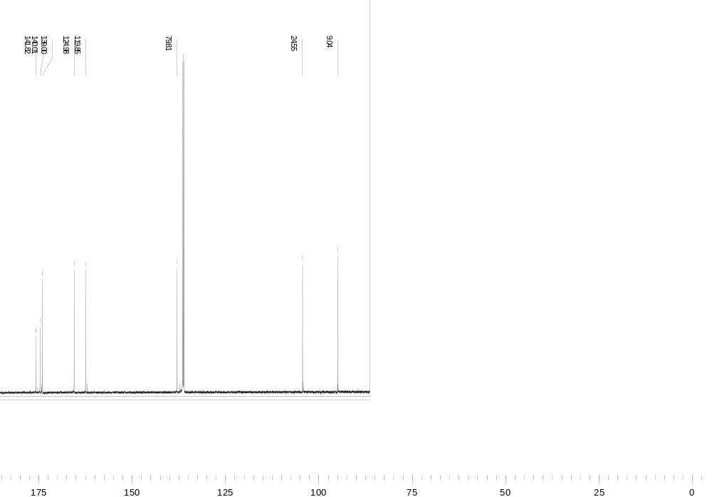
(ppm)
Compound 2d
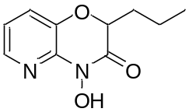
4-hydroxy-2-propyl-2H-pyrido[3,2-b][1,4]oxazin-3(4H)-one (2d): Yield 67%, 625 mg.

Spectral data of compound 2d
¹H NMR (200 MHz, DMSO-d6): H-4 δ 8.04, dd, 1.4, 4.8 Hz; H-5 δ 7.08, dd, 4.8, 7.9 Hz; H-6 δ 7.42, dd, 1.4, 7.7 Hz; H-1´ δ 4.91, m; 1” δ 1.81, m, H-2” δ 1.48, m; H-3” δ 0.92, t, 7.3 Hz; N-OH 10.55, s.
¹³C NMR (50 MHz, DMSO-d6): 142.6 (C-2), 141.5 (C-3),124.1 (C-4), 120.5 (C-5), 139.7 (C-6), 78.2 (C-1’), 163.9 (C-2’), 33.1 (C-1”), 18.2(C-2”), 14,2 (C-3”).
HRMS (ESI): Calculated for C₁₀H₁₃N₂O₃ [M+H]⁺, 209.0921; found, 209.1588

¹H NMR spectrum

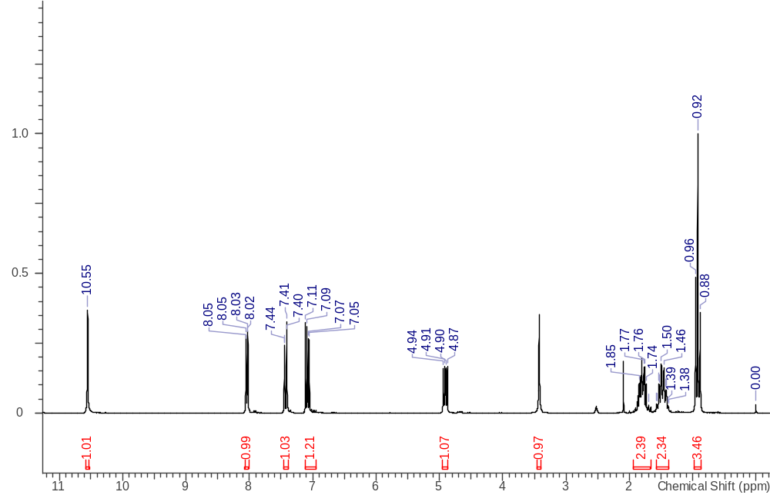

¹³C NMR

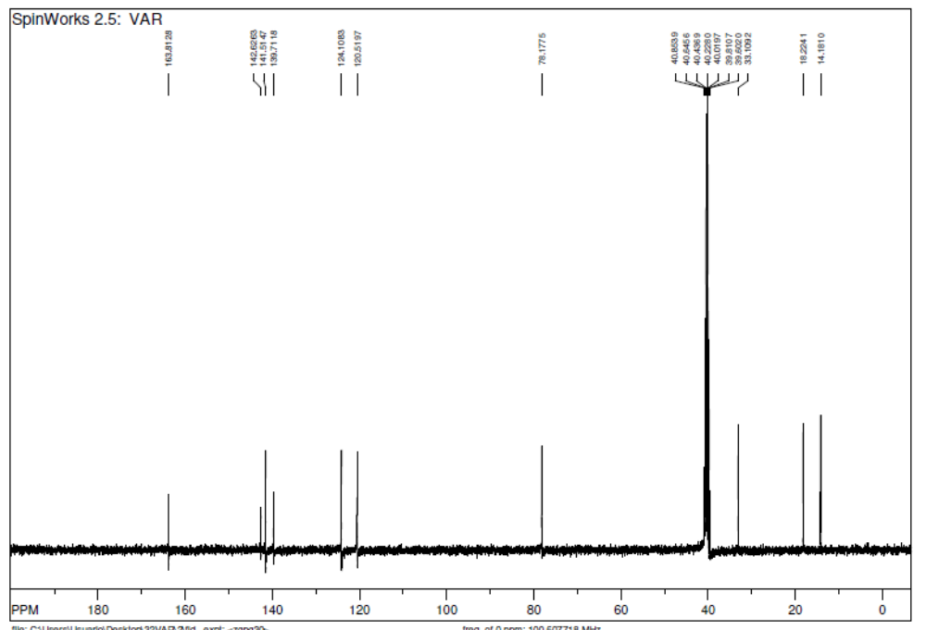

Compound 2e
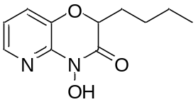
2-butyl-4-hydroxy-2H-pyrido[3,2-b][1,4]oxazin-3(4H)-one (2e): Yield: 59%, (740 mg).

Spectral data of compound 2e
¹H NMR (200 MHz, DMSO-d6): H-4 δ 8.03, dd, 1.4; 4.7 Hz; H-5 δ 7.07, dd, 4.8, 7.9 Hz; H-6 δ 7.42, dd, 1.5, 7.9 Hz; H-1´ δ 4.89, m; H-1” δ 1.81, m, H-2” δ 1.37, m; H-3” δ 1.37, m; H-4’’ δ 0.87, t, 7.1 Hz; N-OH δ 10.53, s.
¹³C NMR (50 MHz, DMSO-d6): 142.6 (C-2), 141.5 (C-3),124.1 (C-4), 120.5 (C-5), 139.7 (C-6), 78.4 (C-1’), 163.9 (C-2’ ), 30.8 (C-1”), 27.00(C-2”), 22.4 (C-3”), 14.5 (C-4”).
HRMS (ESI): Calculated for C₁₁H₁₅N₂O₃ [M+H]⁺, 223.1077; found, 223.1082
¹H NMR spectrum

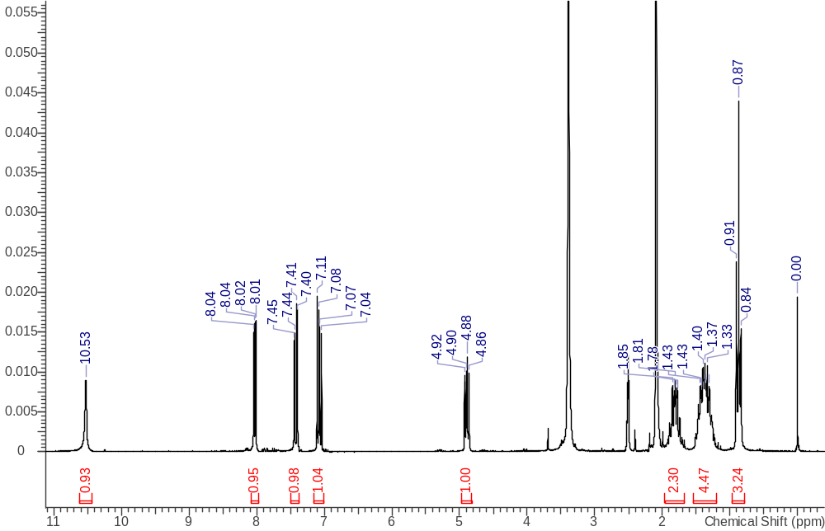

¹³C NMR


