List of tables:
Table S1. Taxonomical classification, habitat, feeding behavior and identifying characters of fish species collected from Dimna Lake, India.
Table S2. Operating condition for AAS (model: Avanta, GBC, Australia).
Fig. F1. Lateral view of a fish showing (a) Morphological (b) Anatomical features and (c) Photographs of six fish species collected from Dimna Lake, Jamshedpur, India. . DF = dorsal fin, ADF = adipose fin, CF = caudal fin, LL = lateral line, AF = anal fin, PF = pelvic fin, PCF = pectoral fin, BL = barbells, A = total length, B = standard length, C = snout length, D = body depth.

Order | Family | Species | Local name | Habitat | Feeding behaviour | Identifying characters ( Rao 1989; Jayaram 1981)
Cypriniformes | Cyprinidae | Labeo calbasu  (Hamilton, 1822) | Kalabakus | Found in slow-moving freshwater rivers and ponds | Bottom feeder and omnivorous that feeds on plants, small insects, filamentous algae, and diatoms. | - Body moderately elongated, round abdomen.  - Caudal fin deeply forked.  - Lips thick, fleshy, fringed, covering both jaws, continuous at an angle of mouth forming a labial fold.  - Simple, unbranched rays in dorsal fin two, 13 – 18 dorsal fin rays.  - No. of lateral line scales varies from 38 – 47.  - Two pairs of maxillary barbels are present.  - Scales between lateral line and pelvic fin base 5 ½ - 6.
Cypriniformes | Cyprinidae | Puntius ticto  (Hamilton, 1822) | Puthi | Found in mountain and sub-mountain region, and floodplains | Omnivorous, feeds on worms, insects and other small invertebrates, as well as plant material and organic detritus. | - Body moderately elongated, deep, compressed.  - Barbells absent.  - Dorsal spines strong, osseous, serrated.  - Lateral line scales less than 30.  - No vertical black color band.  - Branched rays in the dorsal fin eight (8) about 12 rows of transverse scales.  - Body depth 3 to 3.5 in total length.  - Incomplete lateral line. Predorsal scales 11, 4 or 5 rows of scales between lateral line and pelvic fin.
Osteoglossiformes | Notopteridae | Notopterus notopterus  (Pallas, 1769) | Phalat | Inhabits fresh and brackish waters, and appears to thrive well in lentic water | Bottom  feeder, carnivorous, feeds on small organisms,  insects and crustaceans. | - Commonly known as Phalat.  - Body oblong, laterally compressed.  - Long and taper caudal region.  - Maxillaries well toothed forming the greater part of the upper jaw.  - Maxilla and pre-maxilla firmly bound together and have restricted mobility.  - Anal fin long, confluent with caudal fin.  - The gap of mouth not extending beyond the hind edge of orbit.
Cypriniformes | Cyprinidae | Labeo rohita  (Hamilton, 1822) | Rohu | Inhabitant of freshwater rivers and ponds | Bottom feeder, omnivorous and prefers to feed on plant matter including decaying vegetation | - Body moderately elongated, head large and round abdomen.  - Dorsal fin rays 13 – 18.  - Lateral line scales 38 – 47.  - Simple, unbranched rays in dorsal fin three or four.  - Breeding season monsoon.  - Snout not truncated without any lateral lobe.  - Overlapping scales between lateral line and pelvic fin base 6 – 6 ½.
Perciformes | Channidae | Channa punctatus  (Bloch, 1793) | Garai | Prefers stagnant water bodies, also found in rice fields and irrigation channels | Omnivorous feeds on insects, mollusks, annelids and crustaceans and also plant matter | - Body elongated, subcylindrical anteriorly.  - Lateral line abruptly curved or almost interrupted.  - Cephalic pits present.  - Four or five scales between orbit and angle of preopercle, 12 or 13 predorsal scales.  - Pelvic fin more than half length of the pectoral fin.  - Pectoral fin plain and near to pelvic fin.  - Gill four, gill membranes connected beneath isthmus.
Siluriformes | Bagridae | Aorichthys seenghala  (Sykes, 1839) | Tengra | Inhabits large lakes and rivers | Carnivorous, feeds on fishes, insects, prawns, mollusks, amphibians, and crabs | - Body elongated, round snout, occipital process present, toothed mouth.  - Scales absent.  - First pectoral and dorsal rays modified as the hard pungent spine. Adipose dorsal fin present.  - Nostril wide apart, separated by some external space.  - Dorsal spine present. Anal fin with 8 – 16 rays.  - Gill membrane free from each other and also from the isthmus.  - Four pairs of barbels are present, maxillary barbell elongated, extended beyond the pelvic, mandibular barbell is small.
Table S1. Taxonomical classification, habitat, feeding behavior and identifying characters of fish species collected from Dimna Lake, India
Table S2. Operating condition for AAS (model: Avanta, GBC, Australia).
Element | Minimum Detection Limit (mg/kg) | wavelength (nm) | Silt (nm) | Mode | Gases used | Standards prepared (mg/l) | Absorbance (mean)
As | 3.0E-04 | 193.7 | 0.7 | Flame | Nitrous oxide | 20 (µg/l) | 0.075
 |  |  |  |  |  | 40 (µg/l) | 0.151
 |  |  |  |  |  | 60 (µg/l) | 0.277
Cd | 4.0E-03 | 228.8 | 0.7 | Flame | Nitrous oxide | 0.5 (mg/l) | 0.028
 |  |  |  |  |  | 2.5 (mg/l) | 0.134
 |  |  |  |  |  | 5.0 (mg/l) | 0.292
Cr | 3.0E-03 | 357.9 | 0.7 | Flame | Nitrous oxide | 0.5 (mg/l) | 0.034
 |  |  |  |  |  | 2.5 (mg/l) | 0.157
 |  |  |  |  |  | 5.0 (mg/l) | 0.235
Cu | 1.0E-03 | 324.8 | 0.7 | Flame | Nitrous oxide | 0.5 (mg/l) | 0.224
 |  |  |  |  |  | 1.0 (mg/l) | 0.586
 |  |  |  |  |  | 2.5 (mg/l) | 0.825
Hg | 1.0E-04 | 253.7 | 0.7 | Cold vapour process | - | 20 (µg/l) | 0.005
 |  |  |  |  |  | 40 (µg/l) | 0.017
 |  |  |  |  |  | 60 (µg/l) | 0.024
Pb | 1.0E-02 | 283.3 | 0.7 | Flame | Nitrous oxide | 0.5 (mg/l) | 0.021
 |  |  |  |  |  | 2.5 (mg/l) | 0.127
 |  |  |  |  |  | 5.0 (mg/l) | 0.222
Zn | 5.0E-03 | 213.9 | 0.7 | Flame | Nitrous oxide | 1.0 (mg/l) | 0.238
 |  |  |  |  |  | 2.5 (mg/l) | 0.332
 |  |  |  |  |  | 5.0 (mg/l) | 0.752

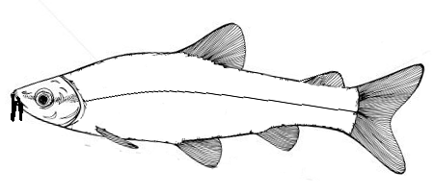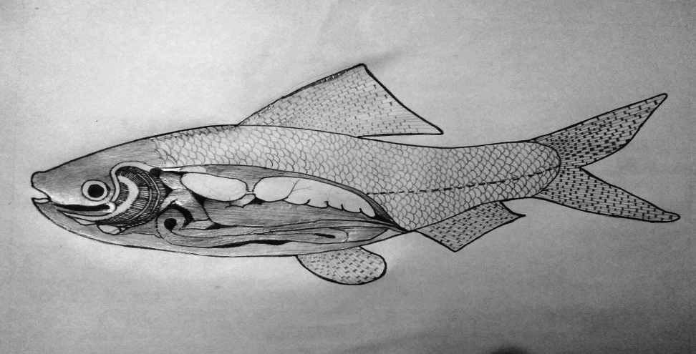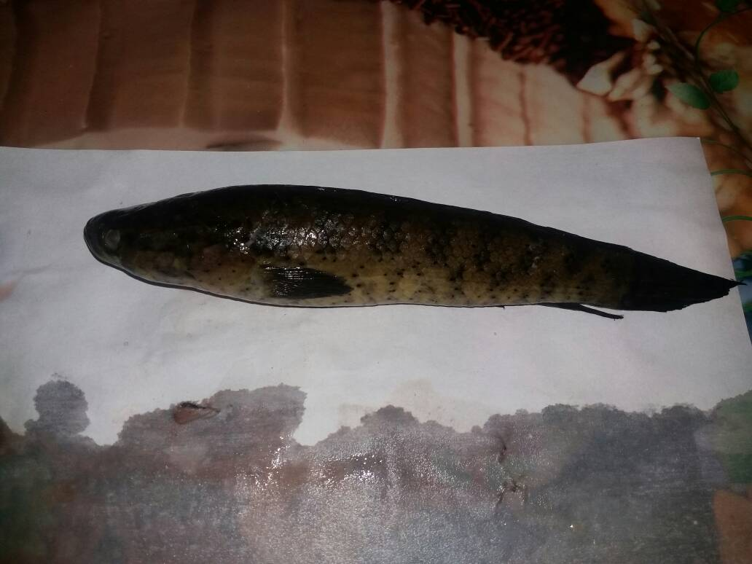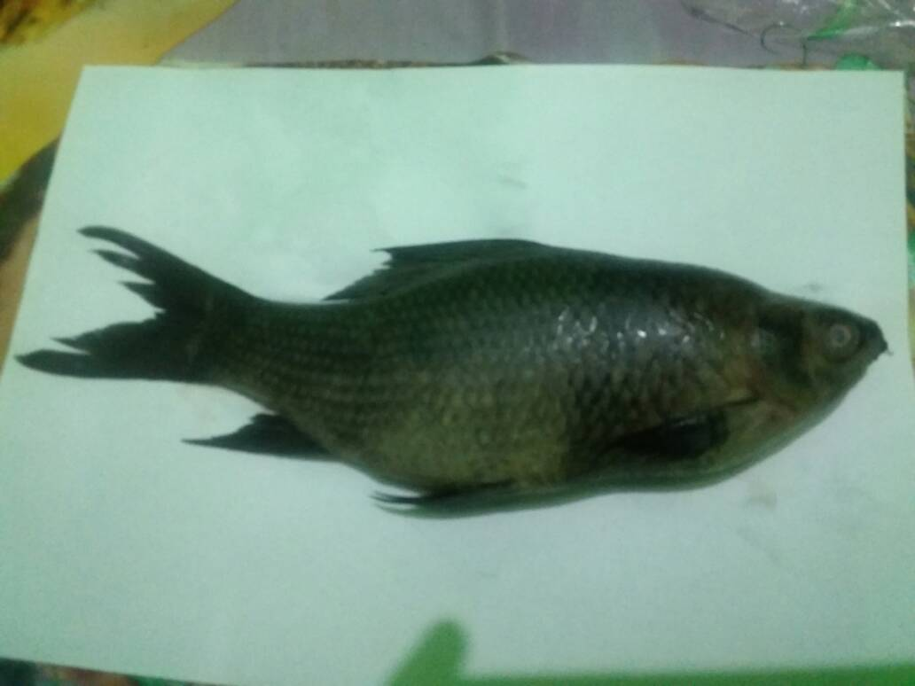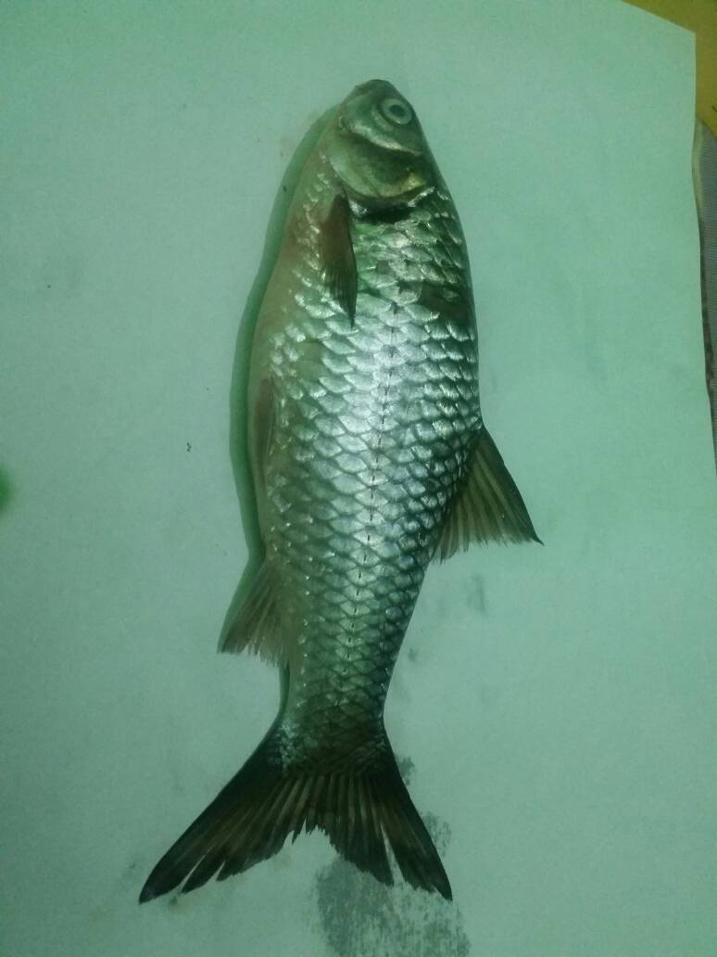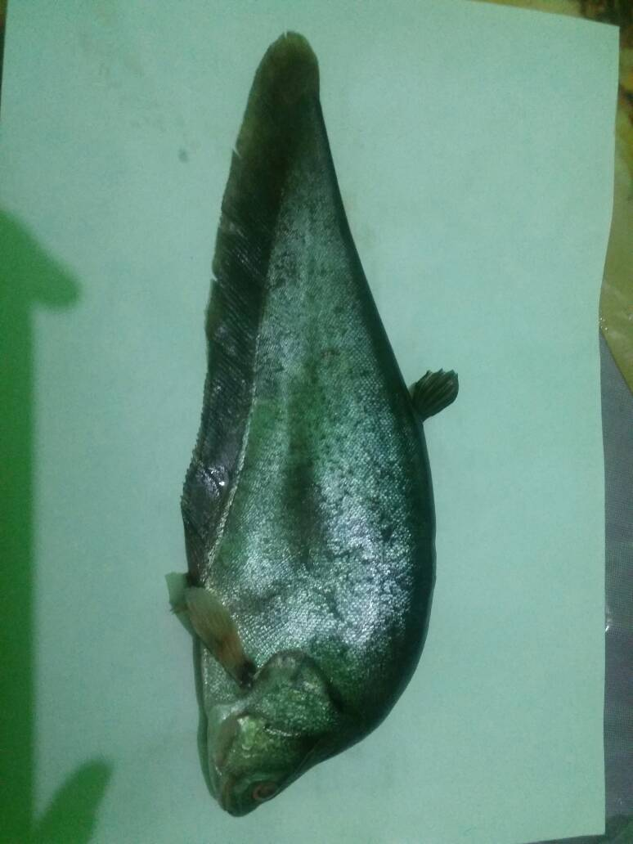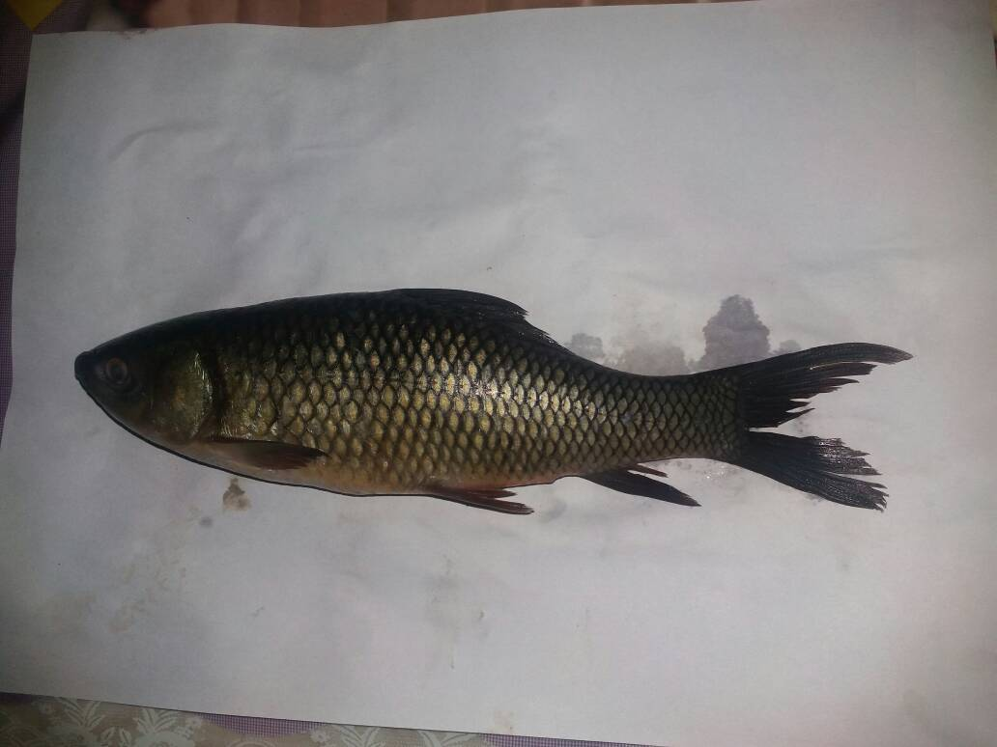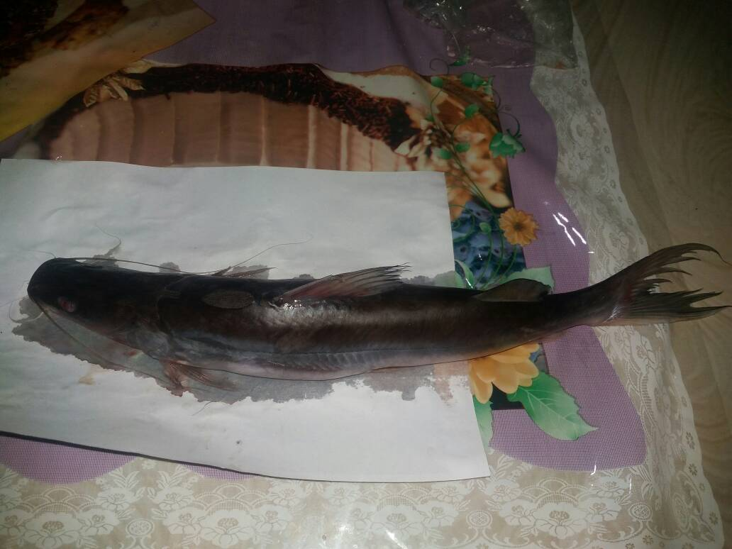
B
C
DF
ADF
CF
LL
AF
PF
PCF
BL
(a)
(b)
A
D
KIDNEY
SWIM BLADDER
STOMACH
INTESTINE
GILLS
LIVER
HEART
Labeo rohita
Labeo calbasu
Notopterus notopterus
Aorichthys seenghala
Puntius ticto
Channa punctatus
(b)
(c)

*Italic letter: Genus name, species name.
Fig. S3. Lateral view of a fish showing (a) Morphological (b) Anatomical features and (c) Photographs of six fish species collected from Dimna Lake, Jamshedpur, India. DF = dorsal fin, ADF = adipose fin, CF = caudal fin, LL = lateral line, AF = anal fin, PF = pelvic fin, PCF = pectoral fin, BL = barbells, A = total length, B = standard length, C = snout length, D = body depth.

